 | Министерство образования и науки Российской Федерации  Калужский филиал федерального государственного бюджетного образовательного учреждения высшего образования  «Московский государственный технический университет  имени Н.Э. Баумана  (национальный исследовательский университет)»  (КФ МГТУ им. Н.Э. Баумана)

ФАКУЛЬТЕТ | "Фундаментальные науки"
КАФЕДРА | "Программное обеспечение ЭВМ, информационные технологии и прикладная математика"

О Т Ч Е Т

Лабораторная работа №3

ДИСЦИПЛИНА: |  | " Мобильные операционные системы "
ТЕМА: | " РАЗРАБОТКА ANDROID-ПРИЛОЖЕНИЙ С НЕСКОЛЬКИМИ ACTIVITY. РАБОТА С INTENT-ОБЪЕКТАМИ "

Выполнил: студент гр. ИТД-81 | Турченко С.А.__________________
Проверил: | Гришунов C.С. _________________

Дата сдачи (защиты) лабораторной работы:
Результаты сдачи (защиты):
Количество рейтинговых баллов
Оценка

Калуга, 2018 г.

Цель:
- Изучить механизм создания многоэкранных приложений на платформе Android
- Научиться разрабатывать приложения с использованием явного и неявного вызова классов
- Понять особенности реализации Android-приложений с использованием Intent-объектов

Задача:
Задание состоит из двух проектов. Все проекты используют Intent объекты. В первом проекте все требуемые параметры устанавливаются в главном Activity и результат отображается на второстепенном Activity. Во втором проекте результат отображается на главном Activity, а для задания соответствующих параметров используется несколько второстепенных Activity. Один из проектов реализовать с использованием неявного вызова (action), второй проект реализовать с явным вызовом класса(-ов).

Вариант 9
С использованием RadioButton выбрать фигуру, с помощью EditText задать цвет в пространстве RGB для выбранной фигуры, с использованием Button определить место вывода фигуры (9 областей). Отобразить фигуру с заданными параметрами.
Код программы

App1

MainActivity.java
public class MainActivity extends AppCompatActivity {

DrawOption option;

@Override
protected void onCreate(Bundle savedInstanceState) {
super.onCreate(savedInstanceState);
setContentView(R.layout.activity_main);

this.option = new DrawOption();
}

public void onPositionPick(View view) {
int id = view.getId();
switch (id) {
case R.id.activity_main_position_top_left:
this.option.PositionX = DrawOption.ePosition.LEFT;
this.option.PositionY = DrawOption.ePosition.TOP;
break;
case R.id.activity_main_position_top_center:
this.option.PositionX = DrawOption.ePosition.CENTER;
this.option.PositionY = DrawOption.ePosition.TOP;
break;
case R.id.activity_main_position_top_right:
this.option.PositionX = DrawOption.ePosition.RIGHT;
this.option.PositionY = DrawOption.ePosition.TOP;
break;
case R.id.activity_main_position_center_left:
this.option.PositionX = DrawOption.ePosition.LEFT;
this.option.PositionY = DrawOption.ePosition.CENTER;
break;
case R.id.activity_main_position_center_center:
this.option.PositionX = DrawOption.ePosition.CENTER;
this.option.PositionY = DrawOption.ePosition.CENTER;
break;
case R.id.activity_main_position_center_right:
this.option.PositionX = DrawOption.ePosition.RIGHT;
this.option.PositionY = DrawOption.ePosition.CENTER;
break;
case R.id.activity_main_position_bottom_left:
this.option.PositionX = DrawOption.ePosition.LEFT;
this.option.PositionY = DrawOption.ePosition.BOTTOM;
break;
case R.id.activity_main_position_bottom_center:
this.option.PositionX = DrawOption.ePosition.CENTER;
this.option.PositionY = DrawOption.ePosition.BOTTOM;
break;
case R.id.activity_main_position_bottom_right:
this.option.PositionX = DrawOption.ePosition.RIGHT;
this.option.PositionY = DrawOption.ePosition.BOTTOM;
break;
}
}

public void parseColor() {
EditText colorEditText = (EditText) findViewById(R.id.activity_main_color);
String colorText = colorEditText.getText().toString();

try {
this.option.Color = Color.parseColor(colorText);
}
catch (Exception e) {
return;
}
}

public void onClick(View view) {
this.parseColor();

Intent intent = new Intent();
intent.setAction("edu.bmstu.stas.lab3.VIEW_TEXT");
intent = this.option.addToIntent(intent);
startActivity(intent);
}

public void onFigurePick(View view) {
int id = view.getId();
switch (id) {
case R.id.activity_main_figure_circle:
this.option.Figure = DrawOption.eFigure.CIRCLE;
break;
case R.id.activity_main_figure_square:
this.option.Figure = DrawOption.eFigure.SQUARE;
break;
case R.id.activity_main_figure_triangle:
this.option.Figure = DrawOption.eFigure.TRIANGLE;
break;
}
}
}

DrawView.java
class DrawView extends View {

Paint paint;
Canvas canvas;
DrawOption option;

public DrawView(Context context, DrawOption option) {
super(context);

this.paint = new Paint();
this.paint.setColor(option.Color);
this.option = option;
}

class Position {
public int X;
public int Y;
}

private Position calculatePosition(int width, int height) {
Position result = new Position();

int shiftX = 100;
int shiftY = 100;
int padding = 50;

result.X = 0;
switch (this.option.PositionX) {
case LEFT:
result.X = padding;
break;
case CENTER:
result.X = width / 2 - shiftX;
break;
case RIGHT:
result.X = width - shiftX * 2 - padding;
break;
}

result.Y = 0;
switch (this.option.PositionY) {
case TOP:
result.Y = padding;
break;
case CENTER:
result.Y = height / 2 - shiftY;
break;
case BOTTOM:
result.Y = height - shiftY * 2 - padding;
break;
}

Log.d("figure", "calculated position as X:" + Integer.toString(result.X) +
" and Y:" + Integer.toString(result.Y));
return result;
}

private void drawTriangle(Canvas canvas, Position position) {
// https://stackoverflow.com/questions/20544668/how-to-draw-filled-triangle-on-android-canvas/22690364

Point p1 = new Point(position.X, position.Y);
Point p2 = new Point(position.X + 200, position.Y + 100);
Point p3 = new Point(position.X, position.Y + 200);

Path path = new Path();
path.setFillType(Path.FillType.EVEN_ODD);
path.moveTo(p1.x, p1.y);
//path.lineTo(p1.x, p1.y);
path.lineTo(p2.x, p2.y);
path.lineTo(p3.x, p3.y);
path.close();

canvas.drawPath(path, paint);
}

@Override
protected void onDraw(Canvas canvas) {
this.canvas = canvas;

// clear screen
this.canvas.drawARGB(255, 255, 255, 255);
Log.d("canvas", "canvas cleared");

Position position = calculatePosition(canvas.getWidth(), canvas.getHeight());

Log.d("figure", "calculating figure and output it");
switch (this.option.Figure) {
case CIRCLE:
Log.d("canvas", "draw circle");
canvas.drawCircle(position.X + 100, position.Y + 100, 100, this.paint);
break;
case SQUARE:
Log.d("canvas", "draw rectangle");
canvas.drawRect(position.X, position.Y, position.X + 200, position.Y + 200, this.paint);
break;
case TRIANGLE:
Log.d("canvas", "draw triangle");
this.drawTriangle(canvas, position);
break;
}
}

}

DrawOption.java
public class DrawOption {

enum eFigure {
CIRCLE,
SQUARE,
TRIANGLE
}

public enum ePosition {
CENTER,
LEFT,
RIGHT,
TOP,
BOTTOM
}

public int Color;
public eFigure Figure;
public ePosition PositionX;
public ePosition PositionY;

public DrawOption() {
this.Figure = eFigure.CIRCLE;
this.PositionX = ePosition.CENTER;
this.PositionY = ePosition.CENTER;
this.Color = android.graphics.Color.BLUE;
}

public DrawOption(Bundle extras) {
this.Figure = (eFigure) extras.getSerializable("figure");
this.PositionX = (ePosition) extras.getSerializable("position_x");
this.PositionY = (ePosition) extras.getSerializable("position_y");
this.Color = extras.getInt("color");
}

public Intent addToIntent(Intent intent) {
intent.putExtra("figure", this.Figure);
intent.putExtra("position_x", this.PositionX);
intent.putExtra("position_y", this.PositionY);
intent.putExtra("color", this.Color);
return intent;
}

}

AboutActivity.java

public class AboutActivity extends Activity {

DrawOption option;
DrawView view;

@Override
protected void onCreate(@Nullable Bundle savedInstanceState) {
super.onCreate(savedInstanceState);
setContentView(R.layout.activity_about);

Intent intent = getIntent();

this.option = new DrawOption(intent.getExtras());

this.draw();
}

private void draw() {
view = new DrawView(this, option);
setContentView(view);
}

}

App2

MainActivity.java

public class MainActivity extends AppCompatActivity {

DrawView canvas;
DrawOption option;

@Override
protected void onCreate(Bundle savedInstanceState) {
super.onCreate(savedInstanceState);
setContentView(R.layout.activity_main);

canvas = (DrawView) findViewById(R.id.canvas);
option = new DrawOption();
}

public void onColor(View view) {
Intent intent = new Intent(MainActivity.this, ColorActivity.class);
startActivityForResult(intent, 0);
}

public void onFigure(View view) {
Intent intent = new Intent(MainActivity.this, FigureActivity.class);
startActivityForResult(intent, 1);

}

public void onPosition(View view) {
Intent intent = new Intent(MainActivity.this, PositionActivity.class);
startActivityForResult(intent, 2);
}

public void onActivityResult(int requestCode, int resultCode, Intent data) {
if (data == null)
return;

switch (requestCode) {
case 0:
this.option.Color = data.getExtras().getInt("color");
break;
case 1:
this.option.Figure = (DrawOption.eFigure) data.getExtras().getSerializable("figure");
break;
case 2:
this.option.PositionX = (DrawOption.ePosition) data.getExtras().getSerializable("position_x");
this.option.PositionY = (DrawOption.ePosition) data.getExtras().getSerializable("position_y");
break;
}
this.canvas.update(this.option);
}
}

PositionActivity.java
public class PositionActivity extends AppCompatActivity {

@Override
protected void onCreate(Bundle savedInstanceState) {
super.onCreate(savedInstanceState);
setContentView(R.layout.activity_position);
}

public void onPositionPick(View view) {
int id = view.getId();

DrawOption.ePosition positionX = DrawOption.ePosition.CENTER;
DrawOption.ePosition positionY = DrawOption.ePosition.CENTER;

switch (id) {
case R.id.activity_main_position_top_left:
positionX = DrawOption.ePosition.LEFT;
positionY = DrawOption.ePosition.TOP;
break;
case R.id.activity_main_position_top_center:
positionX = DrawOption.ePosition.CENTER;
positionY = DrawOption.ePosition.TOP;
break;
case R.id.activity_main_position_top_right:
positionX = DrawOption.ePosition.RIGHT;
positionY = DrawOption.ePosition.TOP;
break;
case R.id.activity_main_position_center_left:
positionX = DrawOption.ePosition.LEFT;
positionY = DrawOption.ePosition.CENTER;
break;
case R.id.activity_main_position_center_center:
positionX = DrawOption.ePosition.CENTER;
positionY = DrawOption.ePosition.CENTER;
break;
case R.id.activity_main_position_center_right:
positionX = DrawOption.ePosition.RIGHT;
positionY = DrawOption.ePosition.CENTER;
break;
case R.id.activity_main_position_bottom_left:
positionX = DrawOption.ePosition.LEFT;
positionY = DrawOption.ePosition.BOTTOM;
break;
case R.id.activity_main_position_bottom_center:
positionX = DrawOption.ePosition.CENTER;
positionY = DrawOption.ePosition.BOTTOM;
break;
case R.id.activity_main_position_bottom_right:
positionX = DrawOption.ePosition.RIGHT;
positionY = DrawOption.ePosition.BOTTOM;
break;
}

Intent intent = getIntent();
intent.putExtra("position_x", positionX);
intent.putExtra("position_y", positionY);
setResult(Activity.RESULT_OK, intent);
this.finish();
}
}

FigureActivity.java
public class FigureActivity extends AppCompatActivity {

@Override
protected void onCreate(Bundle savedInstanceState) {
super.onCreate(savedInstanceState);
setContentView(R.layout.activity_figure);
}

public void onChoice(View view) {
int id = view.getId();

DrawOption.eFigure figure = DrawOption.eFigure.CIRCLE;

switch (id) {
case R.id.activity_figure_circle:
figure = DrawOption.eFigure.CIRCLE;
break;
case R.id.activity_figure_square:
figure = DrawOption.eFigure.SQUARE;
break;
case R.id.activity_figure_triangle:
figure = DrawOption.eFigure.TRIANGLE;
break;
}

Intent intent = getIntent();
intent.putExtra("figure", figure);
setResult(Activity.RESULT_OK, intent);
this.finish();
}
}
DrawView.java
public class DrawView extends View {

Paint paint;
Canvas canvas;
DrawOption option;

// https://stackoverflow.com/questions/12872848/android-view-inflateexception-binary-xml-file-line-when-using-custom-view
public DrawView(Context context, AttributeSet st) {
super(context, st);

this.paint = new Paint();
this.option = new DrawOption();
this.applyColor();
}

class Position {
public int X;
public int Y;
}

private void applyColor() {
this.paint.setColor(option.Color);
}

private Position calculatePosition(int width, int height) {
Position result = new Position();

int shiftX = 100;
int shiftY = 100;
int padding = 50;

result.X = 0;
switch (this.option.PositionX) {
case LEFT:
result.X = padding;
break;
case CENTER:
result.X = width / 2 - shiftX;
break;
case RIGHT:
result.X = width - shiftX * 2 - padding;
break;
}

result.Y = 0;
switch (this.option.PositionY) {
case TOP:
result.Y = padding;
break;
case CENTER:
result.Y = height / 2 - shiftY;
break;
case BOTTOM:
result.Y = height - shiftY * 2 - padding;
break;
}

Log.d("figure", "calculated position as X:" + Integer.toString(result.X) +
" and Y:" + Integer.toString(result.Y));
return result;
}

private void drawTriangle(Canvas canvas, Position position) {
// https://stackoverflow.com/questions/20544668/how-to-draw-filled-triangle-on-android-canvas/22690364

Point p1 = new Point(position.X, position.Y);
Point p2 = new Point(position.X + 200, position.Y + 100);
Point p3 = new Point(position.X, position.Y + 200);

Path path = new Path();
path.setFillType(Path.FillType.EVEN_ODD);
path.moveTo(p1.x, p1.y);
//path.lineTo(p1.x, p1.y);
path.lineTo(p2.x, p2.y);
path.lineTo(p3.x, p3.y);
path.close();

canvas.drawPath(path, paint);

}

@Override
protected void onDraw(Canvas canvas) {
super.onDraw(canvas);
this.canvas = canvas;

// clear screen
this.canvas.drawARGB(255, 255, 255, 255);
Log.d("canvas", "canvas cleared");

Position position = calculatePosition(canvas.getWidth(), canvas.getHeight());

Log.d("figure", "calculating figure and output it");
switch (this.option.Figure) {
case CIRCLE:
Log.d("canvas", "draw circle");
canvas.drawCircle(position.X + 100, position.Y + 100, 100, this.paint);
break;
case SQUARE:
Log.d("canvas", "draw rectangle");
canvas.drawRect(position.X, position.Y, position.X + 200, position.Y + 200, this.paint);
break;
case TRIANGLE:
Log.d("canvas", "draw triangle");
this.drawTriangle(canvas, position);
break;
}
}

// https://stackoverflow.com/questions/25314707/how-to-combine-canvas-drawing-with-android-activity-layout-which-includes-button
public void update(DrawOption option) {
this.option = option;
this.applyColor();
invalidate();
}

}

DrawOption.java
public class DrawOption {

enum eFigure {
CIRCLE,
SQUARE,
TRIANGLE
}

public enum ePosition {
CENTER,
LEFT,
RIGHT,
TOP,
BOTTOM
}

public int Color;
public eFigure Figure;
public ePosition PositionX;
public ePosition PositionY;

public DrawOption() {
this.Figure = eFigure.CIRCLE;
this.PositionX = ePosition.CENTER;
this.PositionY = ePosition.CENTER;
this.Color = android.graphics.Color.BLUE;
}

public DrawOption(Bundle extras) {
this.Figure = (eFigure) extras.getSerializable("figure");
this.PositionX = (ePosition) extras.getSerializable("position_x");
this.PositionY = (ePosition) extras.getSerializable("position_y");
this.Color = extras.getInt("color");
}

public Intent addToIntent(Intent intent) {
intent.putExtra("figure", this.Figure);
intent.putExtra("position_x", this.PositionX);
intent.putExtra("position_y", this.PositionY);
intent.putExtra("color", this.Color);
return intent;
}

}

ColorActivity.java
public class ColorActivity extends AppCompatActivity {

@Override
protected void onCreate(Bundle savedInstanceState) {
super.onCreate(savedInstanceState);
setContentView(R.layout.activity_color);
}

public void onApply(View view) {
EditText colorEditText = (EditText) findViewById(R.id.activity_color_field);
String colorText = colorEditText.getText().toString();

int color;

try {
color = Color.parseColor(colorText);
} catch (Exception e) {
color = Color.BLACK;
}

Intent intent = getIntent();
intent.putExtra("color", color);
setResult(Activity.RESULT_OK, intent);
this.finish();
}
}

Результат
App1
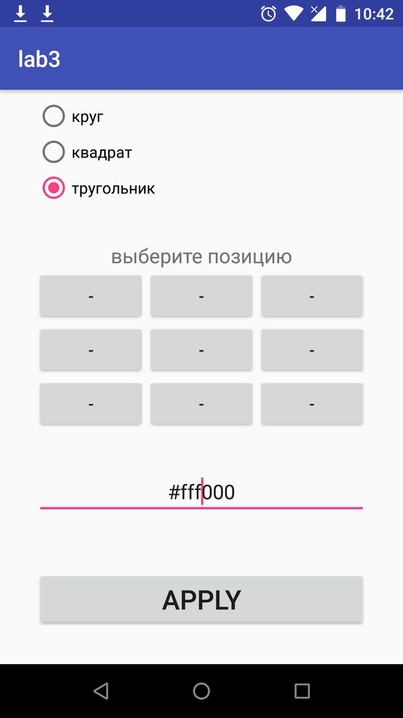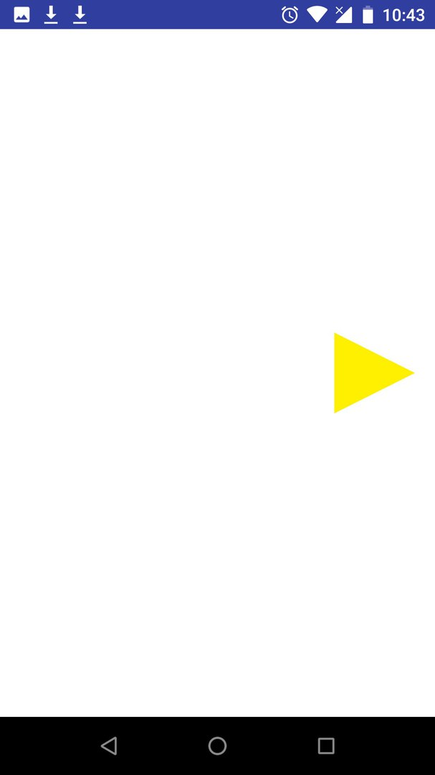

App2
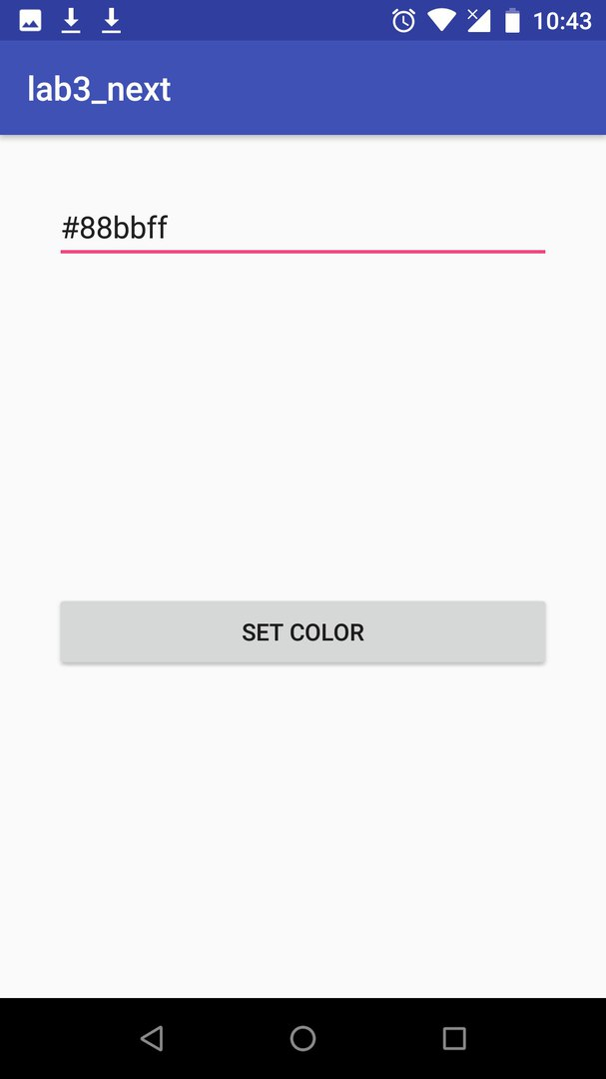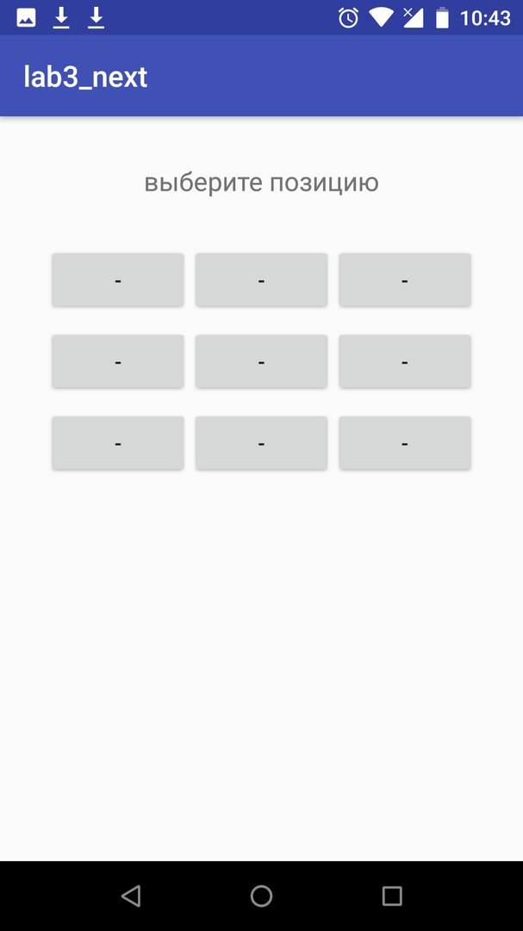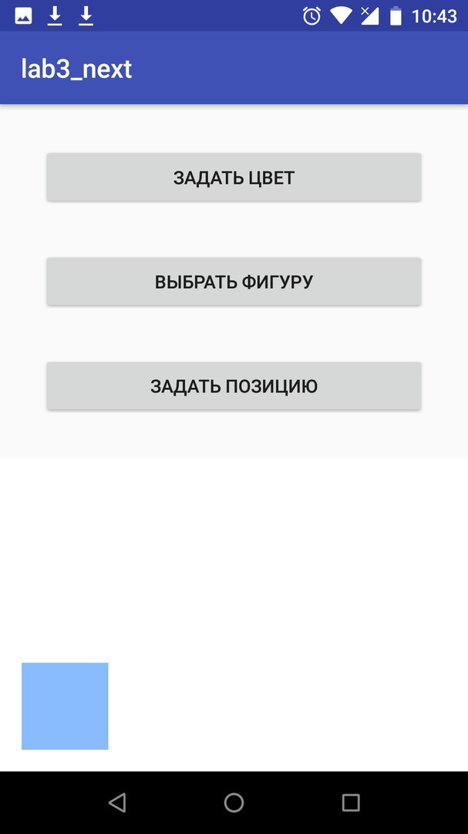
Вывод
Были приобретены практические навыки разработки приложений с несколькими Activity и Intent-объектами.

