**Лабораторная работа №4**

**Невейков Андрей, 2022**

**/*Task_1*/**

-- Step 1

CREATE TABLE t2 AS

SELECT TRUNC( rownum / 100 ) id, rpad( rownum,100 ) t_pad

FROM dual

CONNECT BY rownum < 100000;

-- Step 2

CREATE INDEX t2_idx1 ON t2

( id );

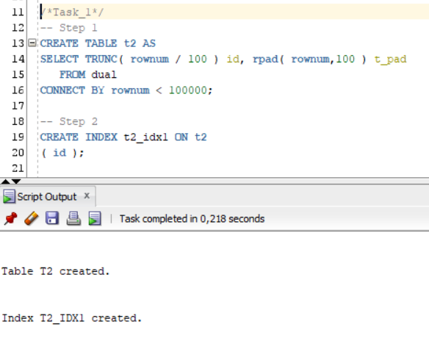

-- Step 3

-- Block count:

select blocks from user_segments where segment_name = 'T2';

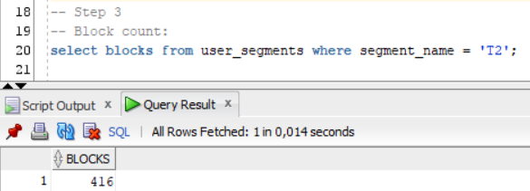

-- Used Block Count:

select count(distinct (dbms_rowid.rowid_block_number(rowid))) block_ct from t2 ;

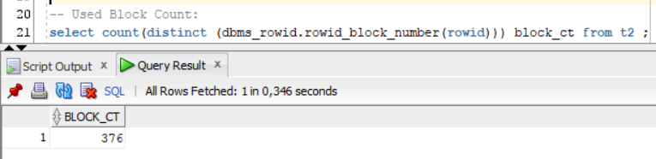

-- Explain Plan:

SET autotrace ON;

SELECT COUNT( * )

FROM t2 ;

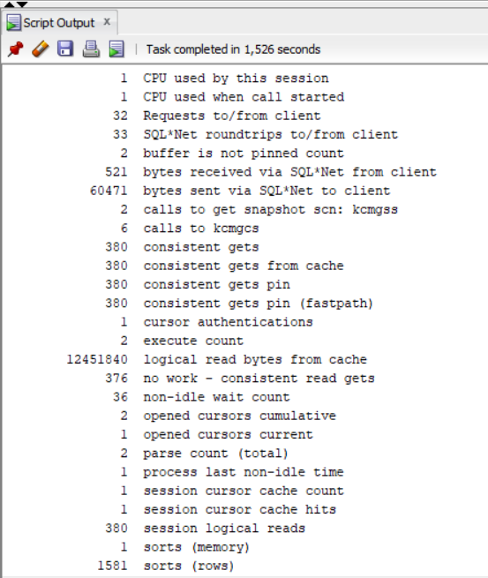

-- Step 4

SET autotrace OFF;

DELETE FROM t2;

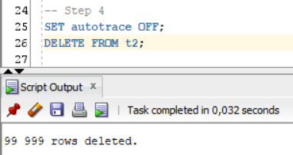

-- Step 5

-- Block count:

select blocks from user_segments where segment_name = 'T2';

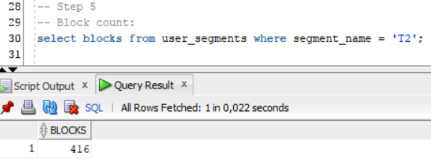

-- Used Block Count:

select count(distinct (dbms_rowid.rowid_block_number(rowid))) block_ct from t2 ;

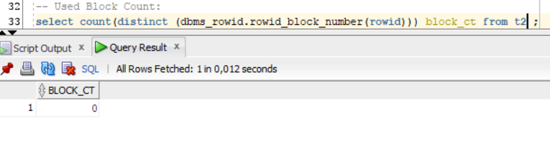

-- Explain Plan:

SET autotrace ON;

SELECT COUNT( * )

FROM t2 ;

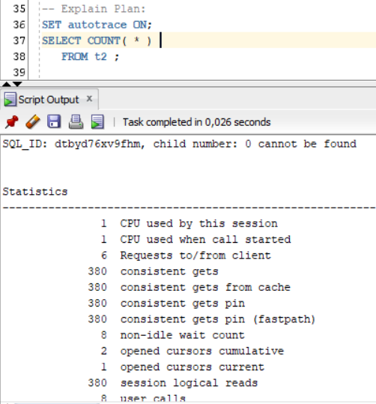

-- Step 6

INSERT INTO t2

( ID, T_PAD )

VALUES

( 1,'1' );

COMMIT;

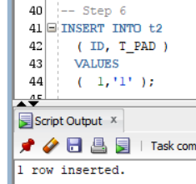

-- Step 7

-- Block count:

select blocks from user_segments where segment_name = 'T2';

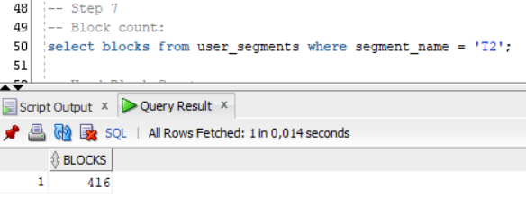

-- Used Block Count:

select count(distinct (dbms_rowid.rowid_block_number(rowid))) block_ct from t2 ;

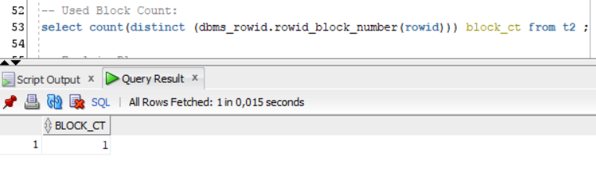

-- Explain Plan:

SET autotrace ON;

SELECT COUNT( * )

FROM t2 ;

-- Step 8

TRUNCATE TABLE t2;

-- Step 9

-- Block count:

select blocks from user_segments where segment_name = 'T2';

-- Used Block Count:

select count(distinct (dbms_rowid.rowid_block_number(rowid))) block_ct from t2 ;

-- Explain Plan:

SET autotrace ON;

SELECT COUNT( * )

FROM t2 ;

Summary table with all result and text description of analyses this results.

|  |  |  |  |  |  |
| --- | --- | --- | --- | --- | --- |
| № | Count of Blocks | Count of Used Blocks | Count of Rows | Consistent gets | Description |
| Step3 | 416 | 376 | 99999 | 380 |  |
| Step5 | 416 | 0 | 0 | 380 |  |
| Step7 | 416 | 1 | 1 | 380 |  |
| Step9 | 6 | 0 | 0 | 1 |  |

**/*Task_2*/**

-- Step 1

CREATE TABLE t2 AS

SELECT TRUNC( rownum / 100 ) id, rpad( rownum,100 ) t_pad

FROM dual

CONNECT BY rownum < 100000;

CREATE INDEX t2_idx1 ON t2

( id );

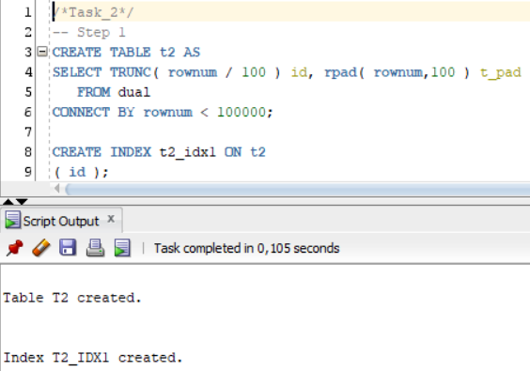

-- Step 2

CREATE TABLE t1 AS

SELECT MOD( rownum, 100 ) id, rpad( rownum,100 ) t_pad

FROM dual

CONNECT BY rownum < 100000;

-- Step 3

CREATE INDEX t1_idx1 ON t1

( id );

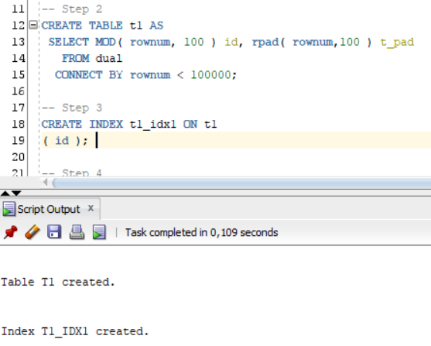

-- Step 4

EXEC dbms_stats.gather_table_stats( USER,'t1',method_opt=>'FOR ALL COLUMNS SIZE 1',CASCADE=>TRUE );

EXEC dbms_stats.gather_table_stats( USER,'t2',method_opt=>'FOR ALL COLUMNS SIZE 1',CASCADE=>TRUE );

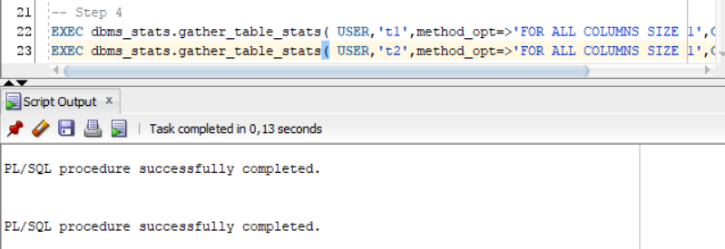

-- Step 5

SELECT t.table_name||'.'||i.index_name idx_name,

i.clustering_factor,

t.blocks,

t.num_rows

FROM user_indexes i, user_tables t

WHERE i.table_name = t.table_name

AND t.table_name IN( 'T1','T2' );

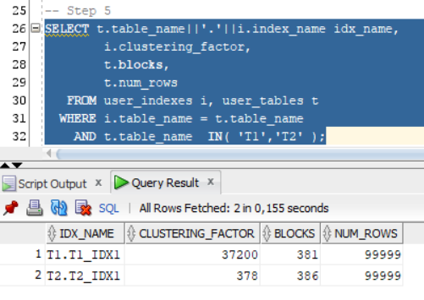

**/*Task_3*/**

-- Step 1

CREATE UNIQUE INDEX udx_t1 ON t1( t_pad );

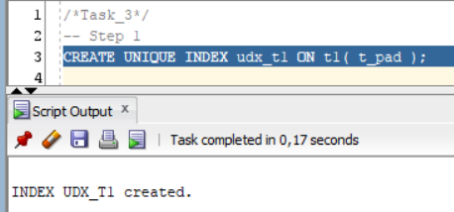

-- Step 2

SELECT t1.* FROM t1 where t1.t_pad = '1';

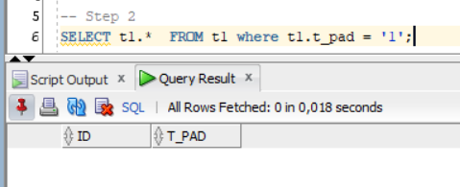

**/*Task_4*/**

-- Step 1

SELECT t2.* FROM t2 where t2.id = '1';

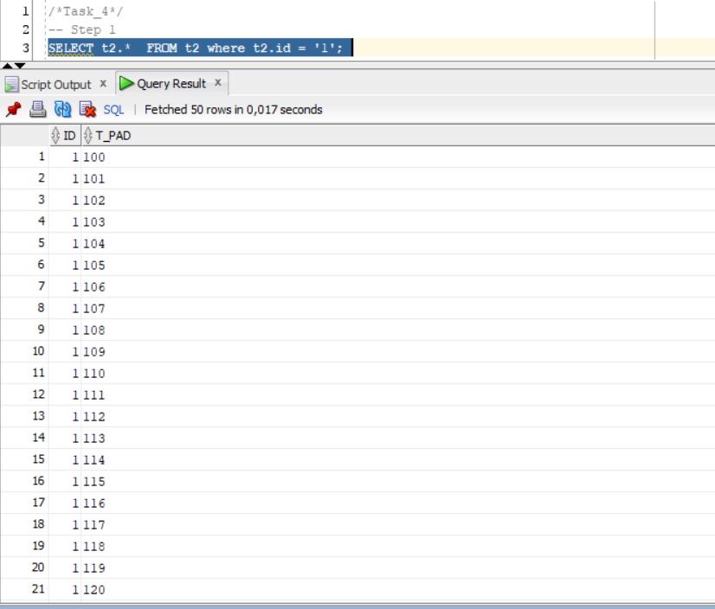

**/*Task_5*/**

-- Step 1

CREATE TABLE employees AS

SELECT *

FROM scott.emp;

-- Step 2

CREATE INDEX idx_emp01 ON employees

( empno, ename, job );

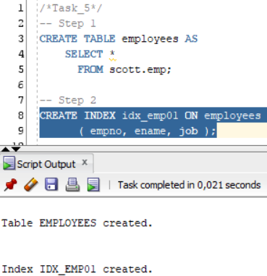

-- Step 3

SET autotrace ON;

SELECT /*+INDEX_SS(emp idx_emp01)*/ emp.* FROM employees emp where ename = 'SCOTT';

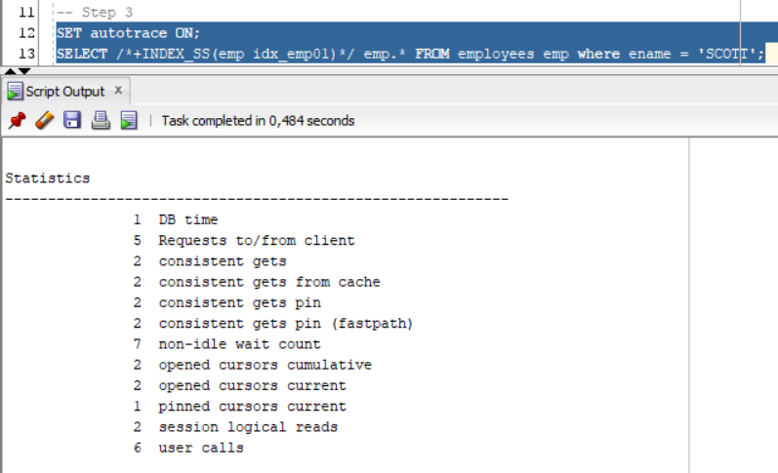

SET autotrace ON;

SELECT /*+FULL*/ emp.* FROM employees emp WHERE ename = 'SCOTT';

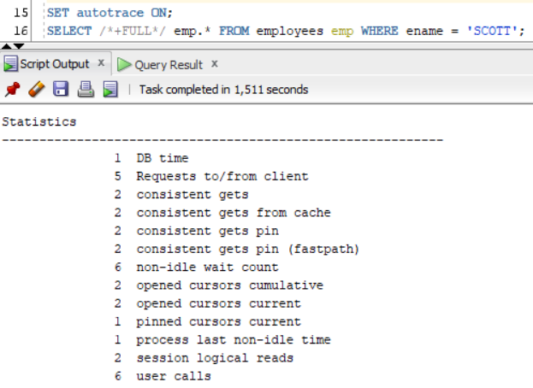

---------------------------------------

select blocks, segment_name from user_segments;

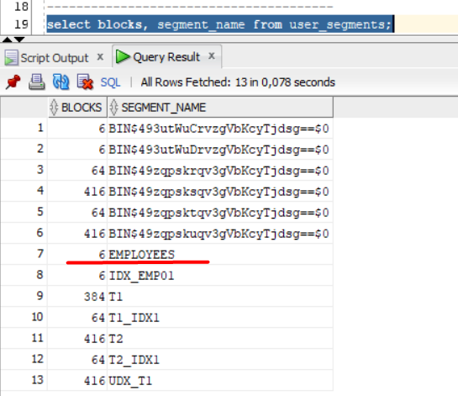

---------------------------------------

select count(distinct (dbms_rowid.rowid_block_number(rowid))) block_ct from employees ;

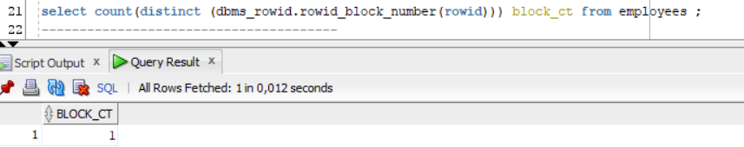

---------------------------------------

SET autotrace ON;

SELECT COUNT( * )

FROM employees ;

