**Лабораторная работа №4**

**Невейков Андрей, 2022**

**All scripts here:**

**https://github.com/AndreyNeveikov/DataMola_Labs/tree/main/Modul_2/lab4**

/*Структура хранилища*/

Лабораторная работа состоит из двух частей: на CL уровне и на DW уровне.

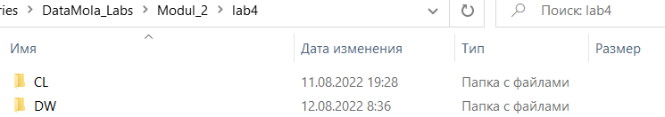

Созданы таблицы на соответствующем уровне.

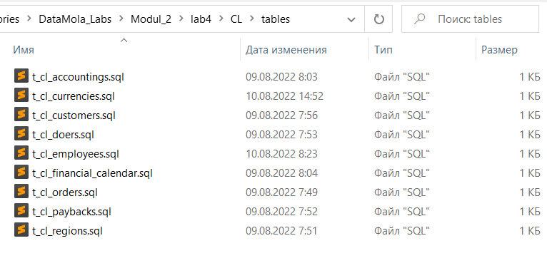

Пакеты лежат в папках, соответствующих названию таблицы.

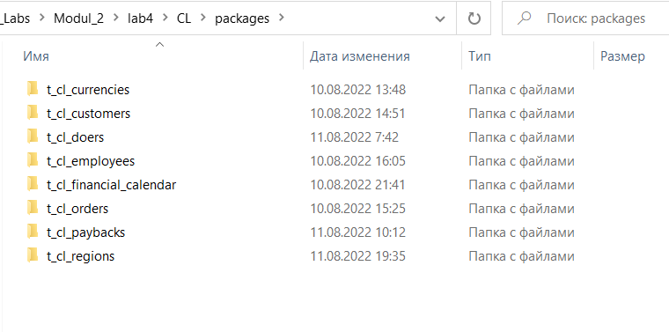

Каждый пакет состоит из def и impl частей. В def – объявление пакета, в impl – логика.

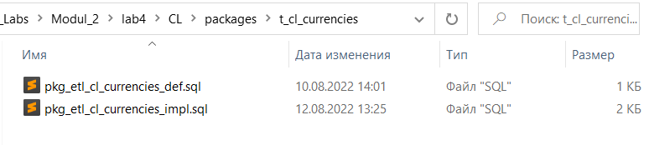

**/*Task_1*/ Соответствие заданию**

Создать объекты на DW-уровне



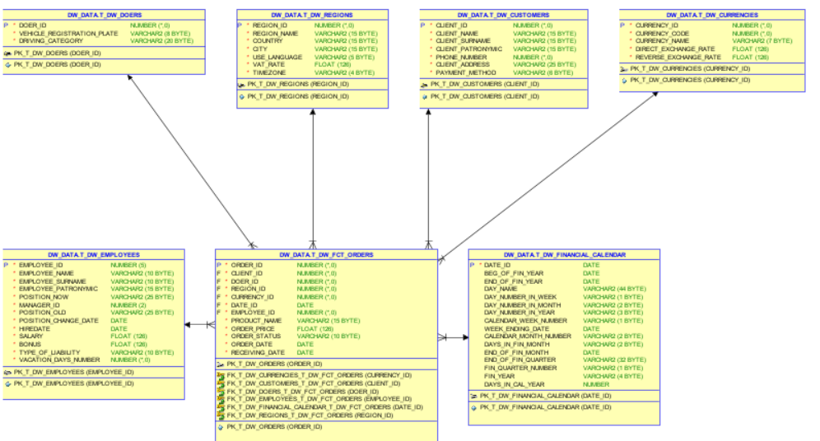

Раздать привилегии на CL уровень



Вверху каждого пакета предоставляются привилегии на уровень ниже:



Создать отдельный пакет каждому dimention:



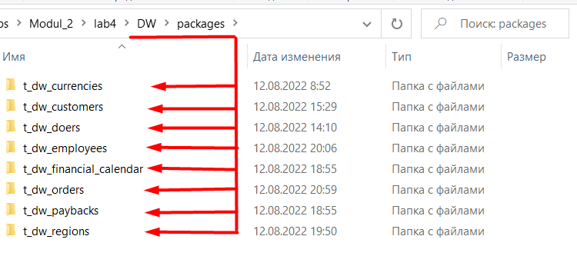

Скриншоты с данным на dimentions:

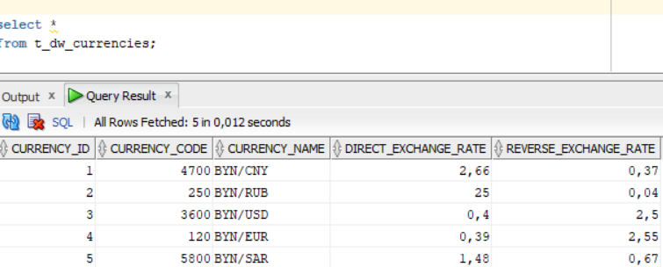

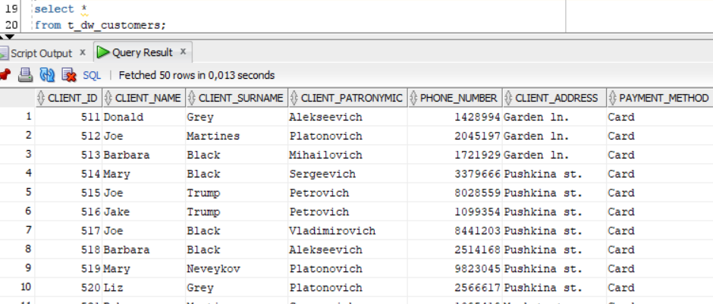

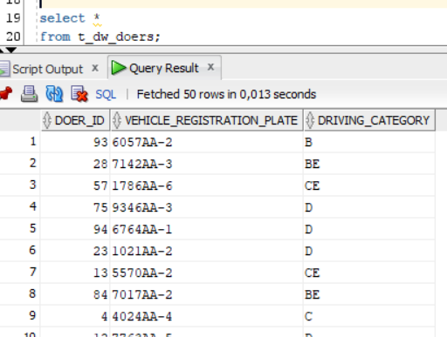

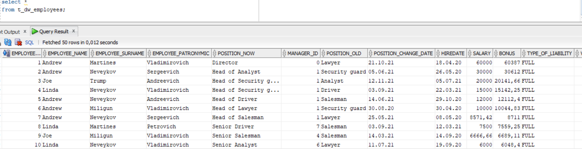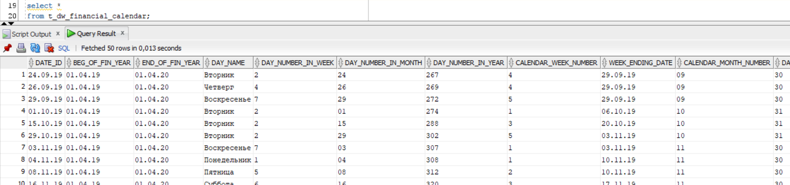

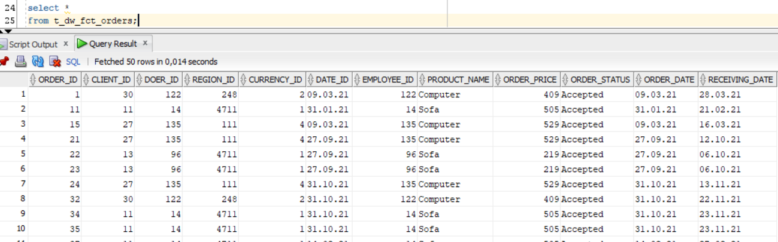

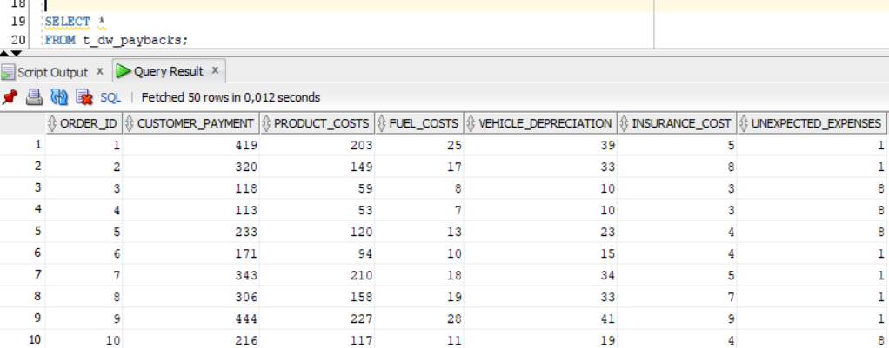

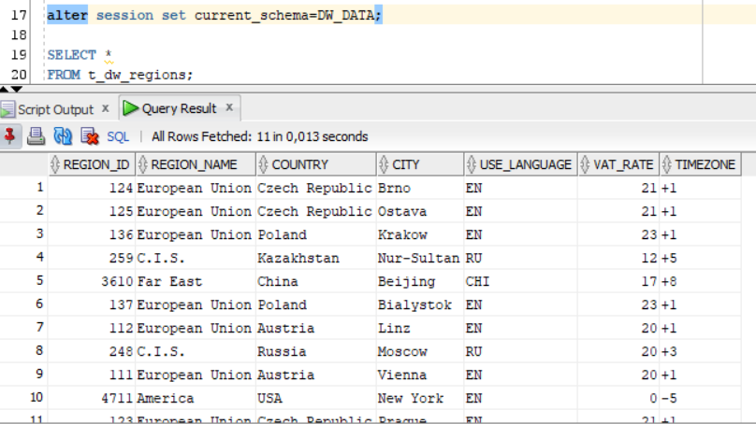

Протестировать процедуры:

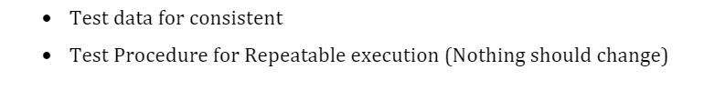

***Сделано;)***

Использовать следующие виды курсоров.

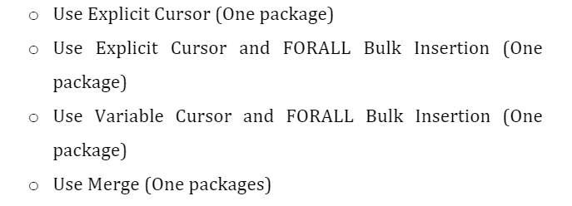

**Explicit Cursor применил в пакете для CL уровня pkg_etl_cl_employees:**

CREATE OR REPLACE PACKAGE body pkg_etl_cl_employees

AS

PROCEDURE LOAD_CLEAN_EMPLOYEES

AS

CURSOR curs_cl_employees

IS

SELECT DISTINCT

employee_id

, employee_name

, employee_surname

, employee_patronymic

, position_now

, manager_id

, position_old

, position_change_date

, hiredate

, salary

, bonus

, type_of_liability

, vacation_days_number

FROM SA_CUSTOMERS.t_sa_employees

WHERE employee_id IS NOT NULL

AND employee_name IS NOT NULL

AND employee_surname IS NOT NULL

AND employee_patronymic IS NOT NULL

AND position_now IS NOT NULL

AND manager_id IS NOT NULL

AND position_old IS NOT NULL

AND position_change_date IS NOT NULL

AND hiredate IS NOT NULL

AND salary IS NOT NULL

AND bonus IS NOT NULL

AND type_of_liability IS NOT NULL

AND vacation_days_number IS NOT NULL;

BEGIN

EXECUTE IMMEDIATE 'TRUNCATE TABLE DW_CL.t_cl_employees';

FOR i IN curs_cl_employees LOOP

INSERT INTO DW_CL.t_cl_employees(

employee_id

, employee_name

, employee_surname

, employee_patronymic

, position_now

, manager_id

, position_old

, position_change_date

, hiredate

, salary

, bonus

, type_of_liability

, vacation_days_number)

VALUES ( i.employee_id

, i.employee_name

, i.employee_surname

, i.employee_patronymic

, i.position_now

, i.manager_id

, i.position_old

, i.position_change_date

, i.hiredate

, i.salary

, i.bonus

, i.type_of_liability

, i.vacation_days_number);

EXIT WHEN curs_cl_employees%NOTFOUND;

END LOOP;

COMMIT;

END LOAD_CLEAN_EMPLOYEES;

END pkg_etl_cl_employees;

**Explicit Cursor and FOR ALL BLUNK Insertion применил в пакете для DW уровня pkg_etl_dw_currencies**

CREATE OR REPLACE PACKAGE body pkg_etl_dw_currencies

AS

PROCEDURE LOAD_DW_CURRENCY

AS

BEGIN

DECLARE

TYPE CURSOR_INT IS TABLE OF INT;

TYPE CURSOR_VARCHAR IS TABLE OF varchar2(7);

TYPE CURSOR_FLOAT IS TABLE OF FLOAT;

TYPE BIG_CURSOR IS REF CURSOR ;

ALL_INF BIG_CURSOR;

currency_code CURSOR_INT;

currency_name CURSOR_VARCHAR;

direct_exchange_rate CURSOR_FLOAT;

reverse_exchange_rate CURSOR_FLOAT;

currency_code_STAGE CURSOR_INT;

currency_id CURSOR_INT;

BEGIN

OPEN ALL_INF FOR

SELECT

source_CL.currency_code AS currency_code_source_CL,

source_CL.currency_name AS currency_name_source_CL,

source_CL.direct_exchange_rate AS direct_exchange_rate_source_CL,

source_CL.reverse_exchange_rate AS reverse_exchange_rate_source_CL,

stage.currency_code AS currency_code_stage,

stage.currency_id AS currency_id

FROM (SELECT DISTINCT * FROM DW_CL.t_cl_currencies) source_CL

LEFT JOIN DW_DATA.t_dw_currencies stage

ON (source_CL.currency_code = stage.currency_code);

FETCH ALL_INF

BULK COLLECT INTO

currency_code,

currency_name,

direct_exchange_rate,

reverse_exchange_rate,

currency_code_STAGE,

currency_id;

CLOSE ALL_INF;

FOR i IN currency_id.FIRST .. currency_id.LAST LOOP

IF ( currency_id ( i ) IS NULL ) THEN

INSERT INTO DW_DATA.t_dw_currencies (

currency_id,

currency_code,

currency_name,

direct_exchange_rate,

reverse_exchange_rate)

VALUES ( SEQ_CURRENCIES.NEXTVAL,

currency_code(i),

currency_name(i),

direct_exchange_rate(i),

reverse_exchange_rate(i));

COMMIT;

ELSE UPDATE DW_DATA.t_dw_currencies

SET

currency_code = currency_code(i),

currency_name = currency_name(i),

direct_exchange_rate = direct_exchange_rate(i),

reverse_exchange_rate = reverse_exchange_rate(i)

WHERE currency_id = currency_id(i);

COMMIT;

END IF;

END LOOP;

END;

END LOAD_DW_CURRENCY;

END pkg_etl_dw_currencies;

**Variable Cursor and FOR ALL BLUNK Insertion применил в пакете для DW уровня pkg_etl_dw_fct_orders**

alter session set current_schema=DW_CL;

GRANT SELECT ON DW_CL.t_cl_transactions TO DW_DATA;

alter session set current_schema = DW_DATA;

CREATE OR REPLACE PACKAGE body pkg_etl_dw_fct_orders

AS

PROCEDURE LOAD_DW_FCT_ORDERS

AS

BEGIN

DECLARE

TYPE CURSOR_INT IS TABLE OF int;

TYPE CURSOR_VARCHAR IS TABLE OF varchar2(15);

TYPE CURSOR_DATE IS TABLE OF date;

TYPE CURSOR_FLOAT IS TABLE OF float;

TYPE BIG_CURSOR IS REF CURSOR ;

ALL_INF BIG_CURSOR;

order_id CURSOR_INT;

client_id CURSOR_INT;

doer_id CURSOR_INT;

region_id CURSOR_INT;

currency_id CURSOR_INT;

date_id CURSOR_DATE;

employee_id CURSOR_INT;

product_name CURSOR_VARCHAR;

order_price CURSOR_FLOAT;

order_status CURSOR_VARCHAR;

order_date CURSOR_DATE;

receiving_date CURSOR_DATE;

BEGIN

OPEN ALL_INF FOR

SELECT

dw_ord.order_id

, cl.client_id

, dr.doer_id

, reg.region_id

, cur.currency_id

, calen.date_id

, emp.employee_id

, source_cl.product_name

, source_cl.order_price

, source_cl.order_status

, source_cl.order_date

, source_cl.receiving_date

FROM (SELECT DISTINCT *

FROM DW_CL.t_cl_transactions) source_cl

INNER JOIN

DW_DATA.t_dw_customers cl

ON (source_cl.client_id=cl.client_id)

INNER JOIN

DW_DATA.t_dw_doers dr

ON (source_cl.doer_id=dr.doer_id)

INNER JOIN

DW_DATA.t_dw_currencies cur

ON (source_cl.currency_code=cur.currency_code)

INNER JOIN

DW_DATA.t_dw_financial_calendar calen

ON (source_cl.date_id=calen.date_id)

INNER JOIN

DW_DATA.t_dw_regions reg

ON (source_cl.region_id=reg.region_id)

INNER JOIN

DW_DATA.t_dw_employees emp

ON (source_cl.employee_id=emp.employee_id)

LEFT JOIN

DW_DATA.t_dw_fct_orders dw_ord

ON (cl.client_id=dw_ord.client_id AND calen.date_id=dw_ord.date_id AND

cur.currency_id=dw_ord.currency_id AND dr.doer_id=dw_ord.doer_id);

FETCH ALL_INF

BULK COLLECT INTO

order_id

, client_id

, doer_id

, region_id

, currency_id

, date_id

, employee_id

, product_name

, order_price

, order_status

, order_date

, receiving_date;

CLOSE ALL_INF;

FOR i IN ORDER_ID.FIRST .. ORDER_ID.LAST LOOP

IF ( ORDER_ID ( i ) IS NULL ) THEN

INSERT INTO dw_data.t_dw_fct_orders (ORDER_ID

, client_id

, doer_id

, region_id

, currency_id

, date_id

, employee_id

, product_name

, order_price

, order_status

, order_date

, receiving_date)

VALUES ( SEQ_FCT_ORDERS.NEXTVAL

, client_id (i)

, doer_id (i)

, region_id (i)

, currency_id (i)

, date_id (i)

, employee_id (i)

, product_name (i)

, order_price (i)

, order_status (i)

, order_date (i)

, receiving_date (i));

COMMIT;

END IF;

END LOOP;

END;

END LOAD_DW_FCT_ORDERS;

END pkg_etl_dw_fct_orders;

alter session set current_schema=DW_DATA;

exec pkg_etl_dw_fct_orders.LOAD_DW_FCT_ORDERS;

select * from t_dw_fct_orders;

commit;

**Merge применил в пакете для DW уровня pkg_etl_dw_employees**

CREATE OR REPLACE PACKAGE body pkg_etl_dw_employees

AS

PROCEDURE LOAD_DW_EMPLOYEES

AS

BEGIN

MERGE INTO DW_DATA.t_dw_employees A

USING ( SELECT employee_id, employee_name, employee_surname, employee_patronymic, position_now,

manager_id, position_old, position_change_date, hiredate, salary, bonus,

type_of_liability, vacation_days_number

FROM DW_CL.t_cl_employees) B

ON (a.employee_id = b.employee_id)

WHEN MATCHED THEN

UPDATE SET a.salary = b.salary

WHEN NOT MATCHED THEN

INSERT (a.employee_id, a.employee_name, a.employee_surname, a.employee_patronymic, a.position_now,

a.manager_id, a.position_old, a.position_change_date, a.hiredate, a.salary, a.bonus,

a.type_of_liability, a.vacation_days_number)

VALUES (b.employee_id, b.employee_name, b.employee_surname, b.employee_patronymic, b.position_now,

b.manager_id, b.position_old, b.position_change_date, b.hiredate, b.salary, b.bonus,

b.type_of_liability, b.vacation_days_number);

COMMIT;

END LOAD_DW_EMPLOYEES;

END pkg_etl_dw_employees;