# Lab 4 (Deadline: 04-03-2021)

## SCENARIO

VanArsdel is a company that manufactures and sells sporting goods. The company has offices in the United States (US) and several other countries. Its sales comprise of US sales and International sales. VanArsdel’s sales come from its owned manufactured products, as well as other manufacturers’ products.

You have created reports with VanArsdel's US and International sales data using Power BI Desktop. Now it's the time to use Power BI service to display this report, create a dashboard, share it, and set a scheduled refresh for the dataset.

In this lab, you will upload a Power BI Desktop report to Power BI service. You will then pin several visualizations and create a dashboard. You will also use the natural language queries feature to create and pin new visualizations. To top it off, you will share this newly created dashboard and set a scheduled refresh so that the dashboard is always up-to-date.

Before starting this lab, you should review **Power BI Service** module in this course. Then, if you have not already done so, follow the instructions in the **Set up the Lab Environment** section of this course to set up the lab environment.

## WHAT YOU’LL NEED

* A computer with the latest version of Power BI Desktop installed on it.
* The following Power BI Desktop file:
  + The “[Lab 4 - Starting.pbix](https://github.com/MicrosoftLearning/Analyzing-Visualizing-Data-PowerBI/raw/master/Lab4/Lab%204%20-%20Starting.zip)” file
* Power BI service account (You need to have a work / business email to sign up for Power BI service)

## Exercise 1: Upload PBI Report and Pin Visualizations

First, you will upload a Power BI Desktop file to Power BI Service.

1. Start with the "[Lab 4 - Starting.pbix](https://github.com/MicrosoftLearning/Analyzing-Visualizing-Data-PowerBI/raw/master/Lab4/Lab%204%20-%20Starting.zip)" file.
2. Use the **Publish** button to publish the report. Sign in using the account you used to sign up for Power BI service.
3. Once the report is published, go to **http://www.powerbi.com** and sign in using your account.
4. If this is your first time publishing a report to Power BI service, you will notice that you now have a dataset named **Lab 4 - Starting** and a report named **Lab 4 - Starting**. You can rename both of these, but let's just leave them be for now.
5. Go to the **Lab 4 - Starting Report** and explore your published report. It looks similar to the one in Power BI Desktop file. Now you can start creating a dashboard by pinning some visualizations.
6. Go to the **Sales Report** tab and pin the chart showing **Total Sales by Category and Segment** (100% Stacked Bar Chart). Select to create a**New dashboard** and name it **VanArsdel Sales**.
7. Pin the treemap chart, the scatter chart, and the map visualization to the **VanArsdel Sales** dashboard.
8. Go to the **Yearly Trend** tab and pin the waterfall chart that shows the **Sales Var by Year**.
9. Go to the **VanArsdel Sales** dashboard and review what you have created.
10. Resize and arrange the tiles as necessary.

You should have something similar to the below:

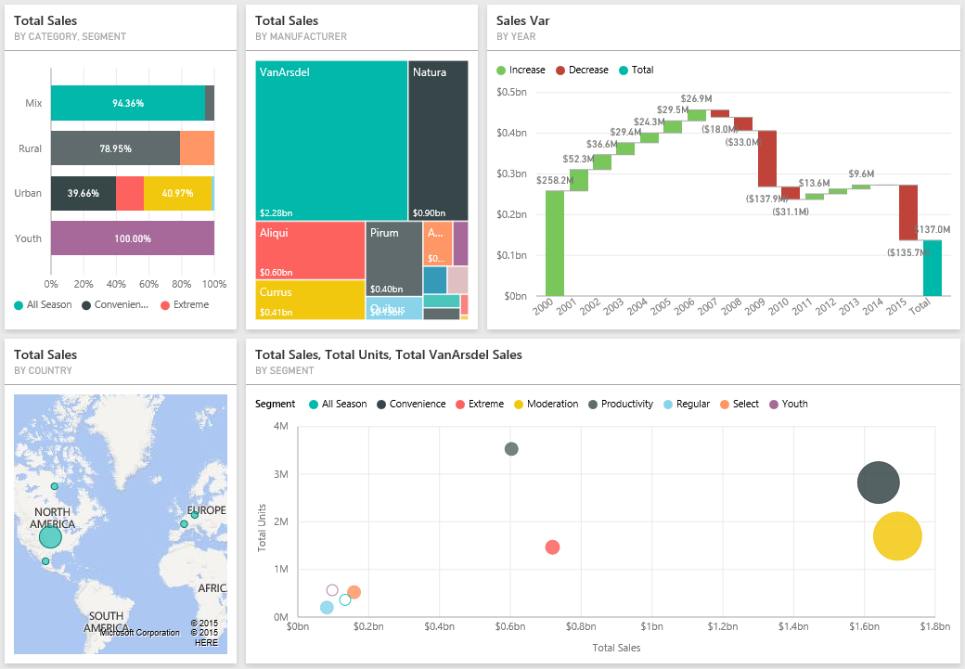

### **Question 1**

2.0/2.0 points (graded)

You want to pin existing visualizations from a report to a dashboard. What two scenarios can you do when pinning visualizations?

You can pin multiple visualizations to a dashboard but you need to do it one at a time.

You can pin two visualizations to a dashboard by pressing the CTRL key.

You can pin the whole report page to a dashboard in one attempt by pinning a live page.

You can pin three visualizations to a dashboard by pressing the CTRL key.

Let's try the natural language query feature and create a few visualizations for your dashboard.

* 1. Type the question "What is year to date sales" in the text box for Q&A.
  2. Pin the answer to **VanArsdel Sales** dashboard.
  3. Type the question "What is year to date total units"
  4. Pin the answer to **VanArsdel Sales**dashboard.
  5. Type the question "What product has the highest total sales in 2015"
  6. Expand the Fields and Visualizations pane on the right of the screen.
  7. Drag the **Total Units** field from the **Sales** table to the **Color saturation**. Notice that the bar char color saturation changes according to the **Total Units** for that product.
  8. Pin the answer to **VanArsdel Sales**dashboard.
  9. Resize and arrange the tiles as necessary.

You should have something similar to the below:

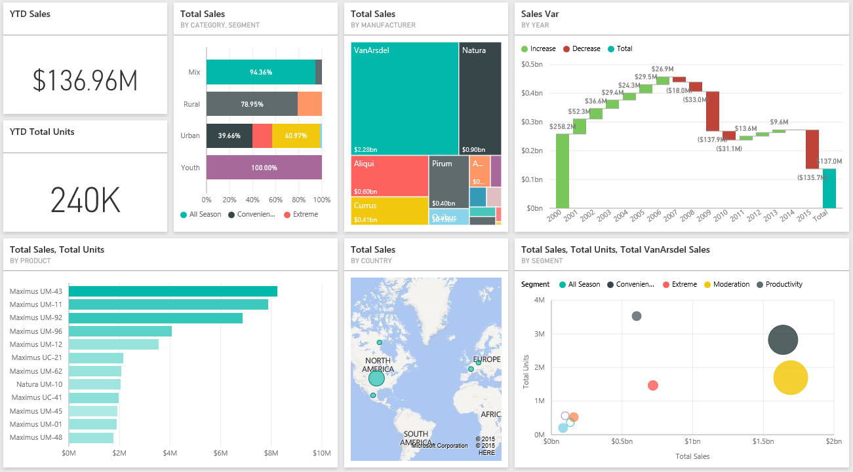

### **Question 2**

2.0/2.0 points (graded)

Now try answering the following question by using the Q&A. What is the total sales for Germany in 2014?

$4,044,962.47

$6,984,804.82

$3,681,551.21

$6,845,996.87

## Exercise 2: Share Dashboard and Update Report

Let's start sharing your newly created dashboard. For simplicity, let's share the dashboard to your own email address.

1. In the **VanArsdel Sales** dashboard, use the **Share** button to share your dashboard.
2. Enter your email address used for Power BI service and click **Share**.
3. Check your inbox to see an invite to view this dashboard.

### **Question 1**

2.0/2.0 points (graded)

Let's confirm that you received the dashboard sharing invitation email. What is the sender's name?

Microsoft Learning

Microsoft Power BI

Power BI Service

Microsoft BI

Once you've uploaded your Power BI Desktop file to Power BI service, you can still make changes to it, and re-upload the file so that your changes is reflected in Power BI service.

1. Open the "Lab 4 - Starting.pbix" file.
2. Modify the **Total Sales by Category and Segment** chart (the one displayed using "100% stacked bar chart" visualization) on the **Sales Report**tab to use **Stacked Bar chart** visualization instead.
3. Re-publish the file to Power BI service and replace the existing dataset with this one.
4. Go to Power BI service and review the **Lab 4 - Starting Report** and examine whether the change you made is reflected.

### **Question 2**

1/1 point (graded)

As you can see, when you update a Power BI Desktop file and re-publish it, the report in Power BI service (that is based on that file) will get updated. What about the Dashboard? Do pinned visualizations (tiles) get updated when the report is updated?

Yes

No

## Exercise 3: Schedule Data Refresh

So far, the report you uploaded is rather static. That means, if the data in the Access database changes, the report and dashboard are not updated. You can install Power BI Personal Gateway and schedule data refresh for on-premises data sources, such as the Access database, to keep your report and dashboard on Power BI service up-to-date.

1. Go to the **Lab 4 - Starting**Datasets in Power BI service and click **Schedule Refresh**.
2. Power BI Pro is required to setup scheduled refresh for on-premises data. If you do not have Power BI Pro subscription you can enroll for a 60 day trial.
3. Ensure that you are in the **Datasets** tab and that the **Lab 4 - Starting** dataset is selected. Click **Install now**to download and install the Power BI Personal Gateway, accept the license terms, and wait for the installation to complete.
4. Launch the Gateway, sign in using your Power BI account and click **Finish**.
5. Edit credentials for the Data sources that needs updating.
6. Now you can schedule your data source refresh.

**NOTE:** If you are using the starter file provided in the beginning of Lab 4, in order to be able to successfully refresh the data, please ensure that you have the files from previous labs under the "C:\DAT207x\" folder. This is because the files were developed with this referenced. You might use arbitrary folders in your own scenario or if you are using your own file throughout the labs.

### **Question**

2.0/2.0 points (graded)

Which two frequencies are available for scheduled refresh?

Hourly

Daily

Weekly

Monthly

Yearly