Lab: DOM Events
Problems for exercises and homework for the "JavaScript Advanced" course from the official "Applied Programmer" curriculum.
You can check your solutions here: https://judge.softuni.org/Contests/3277/DOM-Manipulation-and-Events-Lab
Environment Specifics
Please, be aware that every JS environment may behave differently when executing code. Certain things that work in the browser are not supported in Node.js, which is the environment used by Judge.
The following actions are NOT supported:
- .forEach() with NodeList (returned by querySelector() and querySelectorAll())
- .forEach() with HTMLCollection (returned by getElementsByClassName() and element.children)
- Using the spread-operator (...) to convert a NodeList into an array
- append() in Judge (use only appendChild())
- prepend()
- Always turn the collection into an JS array (forEach, forOf, et.)
If you want to perform these operations, you may use Array.from() to first convert the collection into an array.

List of Items
Write a function that read the text inside an input field and appends the specified text to a list inside an HTML page.

Examples
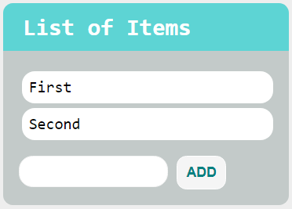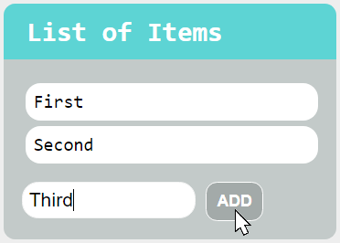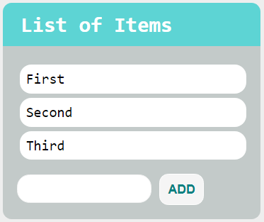

Add / Delete
Extend the previous problem to display a [Delete] link after each list item. Clicking it, should delete the item with no confirmation. You have to add href="#" to the link element.

Examples
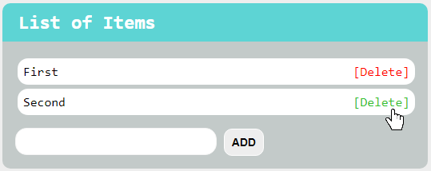
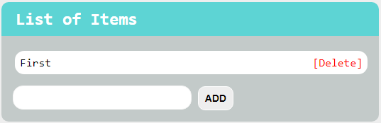

Delete from Table
Write a program that takes an e-mail from an input field and deletes the matching row from a table. The textContent in the element with id="result" must be set to "Deleted". If no entry is found, an error should be displayed in a <div> with ID "results". The error should be "Not found." Submit only the deleteByEmail() function in judge.

Input/Output
There will be no input/output, your program should instead modify the DOM of the given HTML document.

Examples
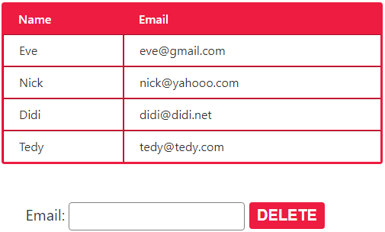
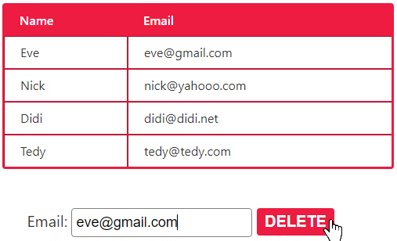
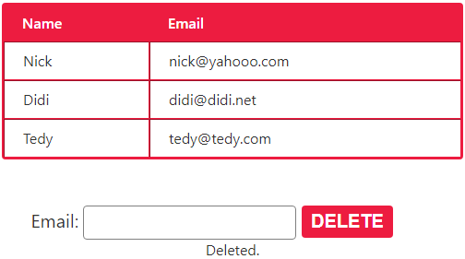

Mouse Gradient
Write a program that detects and displays how far along a gradient the user has moved their mouse. The result should be rounded down and displayed as a percentage inside the <div> with ID "result".
Submit only the attachGradientEvents() function in judge.

Input/Output
There will be no input/output, your program should instead modify the DOM of the given HTML document.

Examples

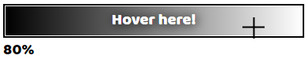
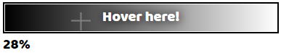

Highlight Active
Write a function that highlights the currently active section of a document. There will be multiple divs with input fields inside them. Set the class of the div that contains the currently focused input field to "focused". When focus is lost (blurred), remove the class from the element.
Submit only the focused() function in judge.

Input/Output
There will be no input/output, your program should instead modify the DOM of the given HTML document.

Example
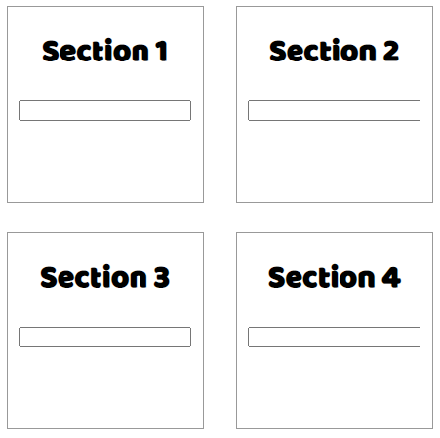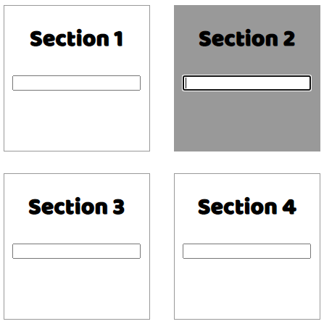

Dynamic Validation
Write a function that dynamically validates an email input field when it is changed. If the input is invalid, apply the style "error". Do not validate on every keystroke, as it is annoying for the user, consider only change events.
A valid email is considered to be in the format: <name>@<domain>.<extension>
Only lowercase Latin characters are allowed for any of the parts of the email. If the input is valid, clear the style. Submit only the validate() function in judge.

Input/Output
There will be no input/output, your program should instead modify the DOM of the given HTML document.

Example
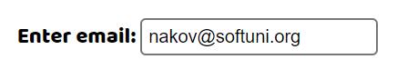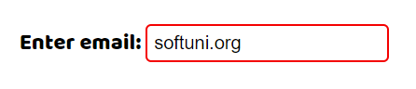

Shopping Cart
You will be given some products that you should be able to add to your cart. Each product will have a name, picture and a price.
When the "Add" button is clicked, append the current product to the textarea in the following format: "Added {name} for {money} to the cart.\n". The price must be fixed to the second digit.
When the button "Checkout" is clicked, calculate the total money that you need to pay for the products that are currently in your cart. Append the result to the textarea in the following format:
"You bought {list} for {totalPrice}."
The list should contain only the unique products, separated by ", ". The total price should be rounded to the second decimal point.
Also, after clicking over "Checkout" and every from above is done you should disable all buttons. (You can't add products or checkout again, if once checkout button is clicked)

Examples
