Exercises: ASP.NET Core Introduction
Problems for exercises and homework for the "ASP.NET MVC" course from the official "Applied Programmer" curriculum.
In this exercise we'll create simple ASP.NET Core apps – the one from the slides and one for exchanging messages.

Create Simple Pages in an ASP.NET Core App
In this task you should implement the pages from the slides' demo for an ASP.NET Core app. To do so, create a new ASP.NET Core MVC app. Open Visual Studio and choose [Create a new project]. On the next step, choose [ASP.NET Core Web App (Model-View-Controller)] as a project template. The steps are shown below:
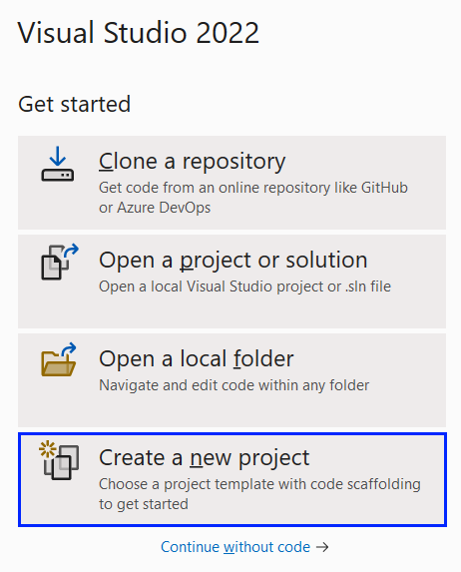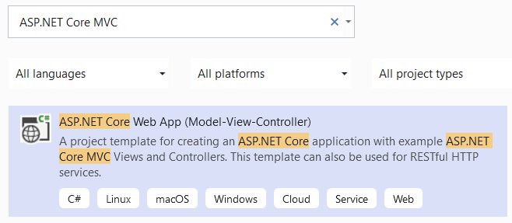
Give a name to your project and solution:
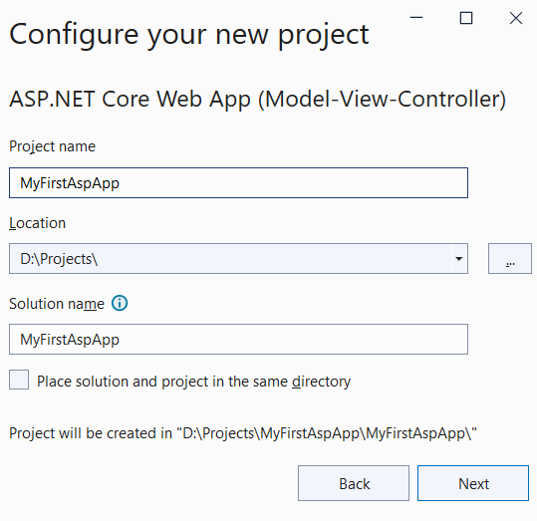
On the next step you should choose .NET 6.0 as a target framework and click on the [Create] button:
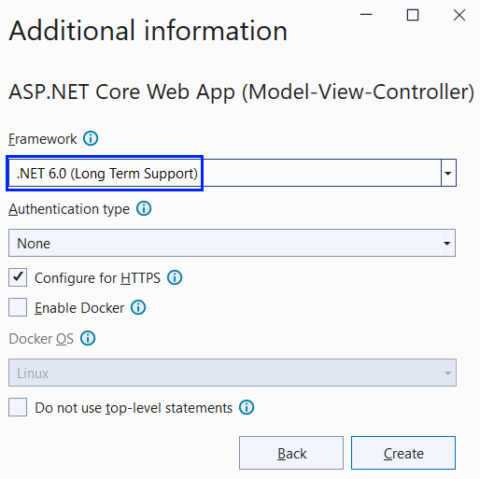
Now your app is created and looks as shown below. Note that it has folders for controllers, models and views because of the template we chose:
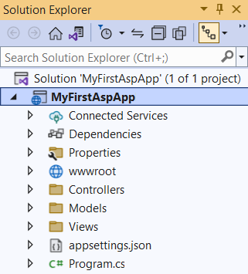
If you run the app with [Ctrl] + [F5], you will see the default "Home" page, which is served by the HomeController in the app:
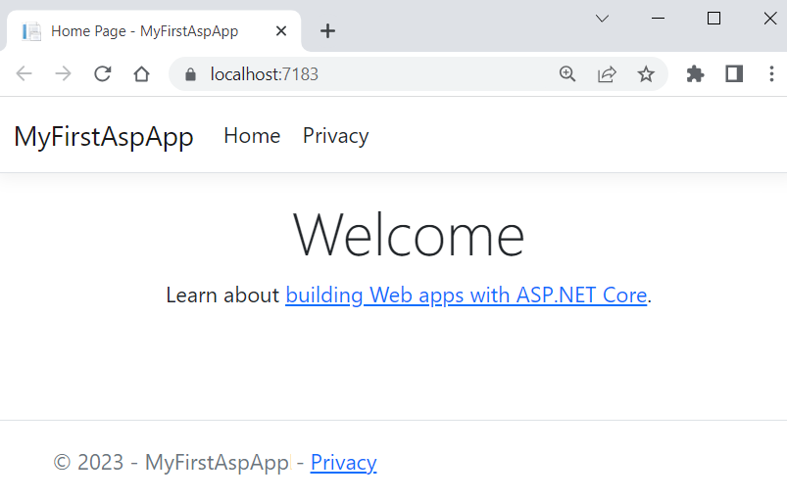

HomeController Pages

Modify the "Home" Page
Now we want to modify the "Home" page to look like this:
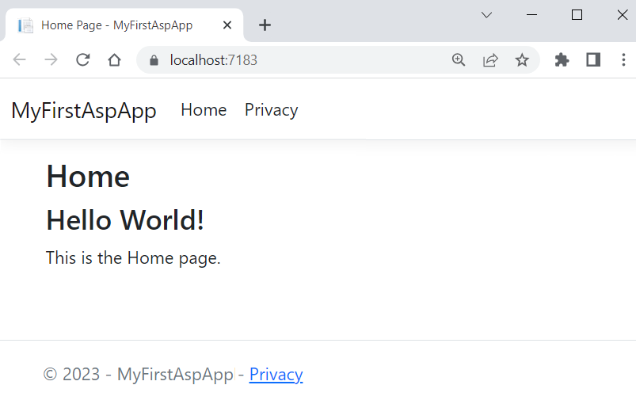
Change the Index() method of the HomeController to change the page. The controller action should return a view, as it does already, but also use the ViewBag class to create a message, which will be used in the view. Modify the method like this:
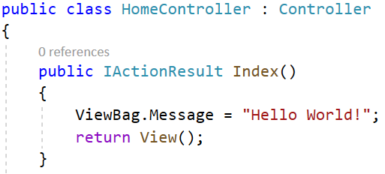
Now you should modify the Index.cshtml view in the "/Views/Home" folder to display the page differently. Use the ViewBag class to get the message from the controller. Note how the Razor views able us to use C# code inside HTML:
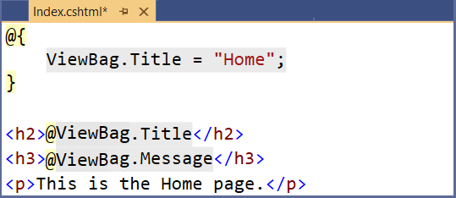
@{
ViewBag.Title = "Home";
}

<h2>@ViewBag.Title</h2>
<h3>@ViewBag.Message</h3>
<p>This is the Home page.</p>
Run the app with [Ctrl] + [F5] and make sure the "Home" page looks as shown on the screenshot above.

Create the "About" Page
Create an "About" page in the app, which should look like this:
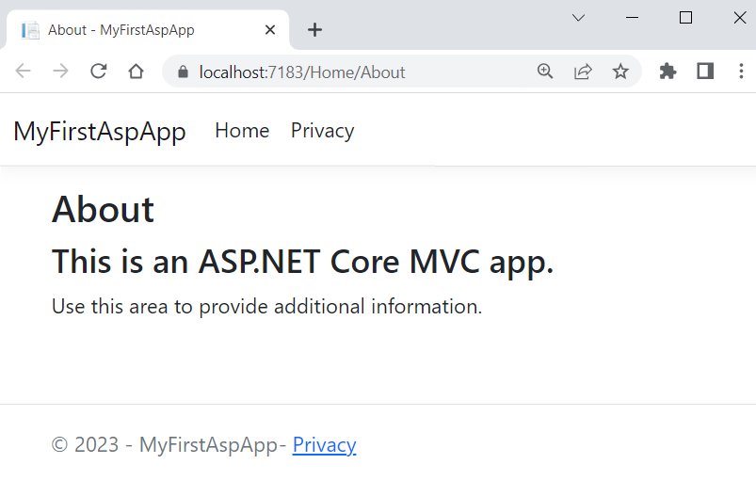
The page should be accessed on "/Home/About". Create an About() controller action in the HomeController class for the "About" page. The controller method should return a view. It should also use the ViewBag class to pass a message to the returned view. Write the method like this:
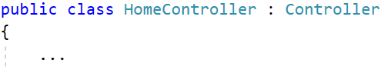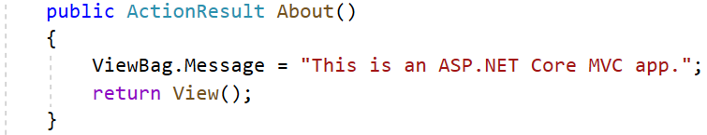
Now you should create an About.cshtml view in the "/Views/Home" folder. To do this, right-click on the folder and choose [Add] [View]:
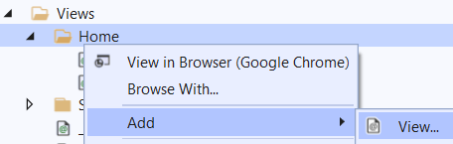
Then, choose the [Razor View – Empty] option to create an empty view and name it "About":
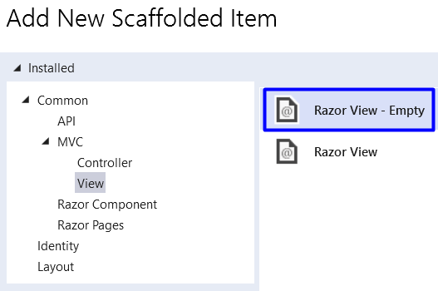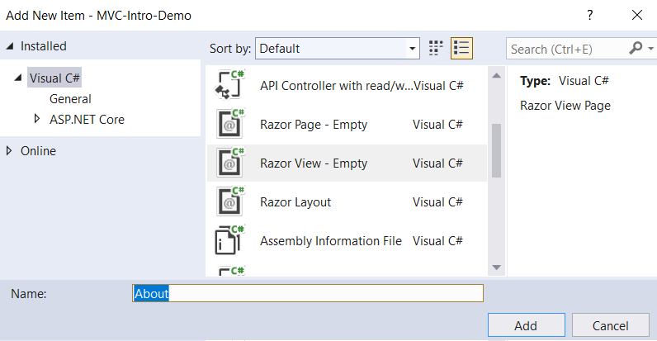
Now the About.cshtml view should be created. Write it like this:
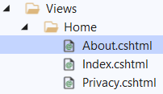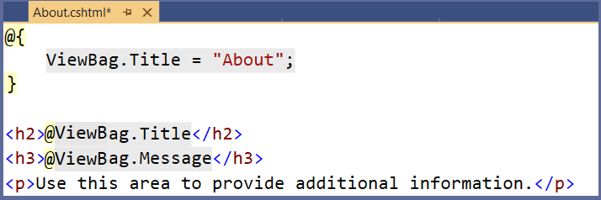
@{
ViewBag.Title = "About";
}

<h2>@ViewBag.Title</h2>
<h3>@ViewBag.Message</h3>
<p>Use this area to provide additional information.</p>
Look at the "About" page in the browser. You can access it on "/Home/About". It should look as shown above.

Create the "Numbers 1…50" Page
The "Numbers 1…50" page should display the numbers from 1 to 50. It should be accessed on "/Home/Numbers" and be the following:
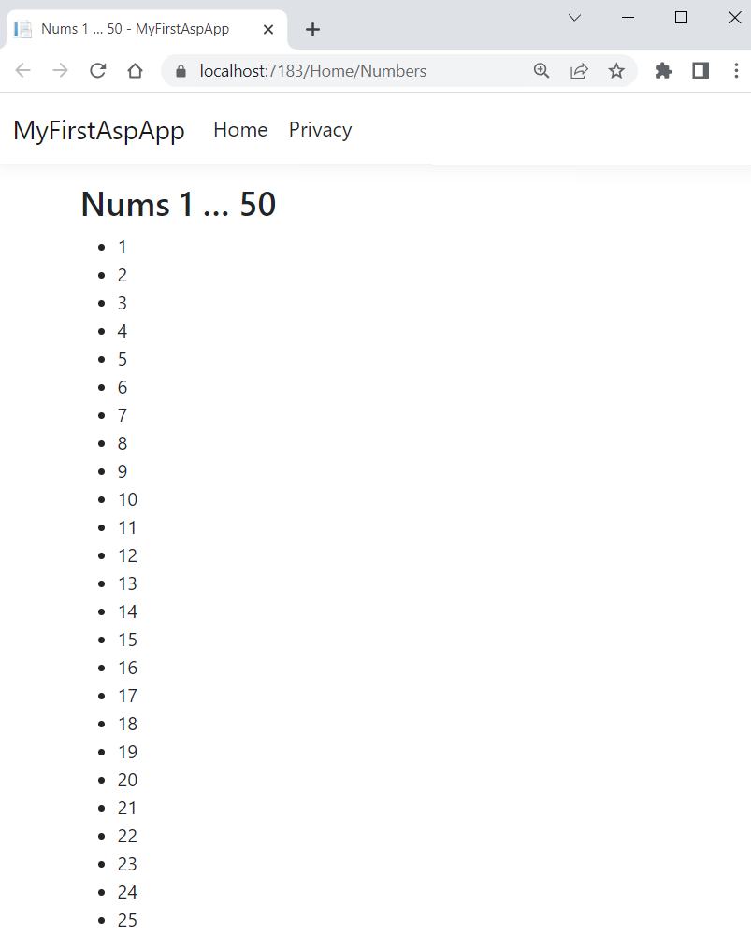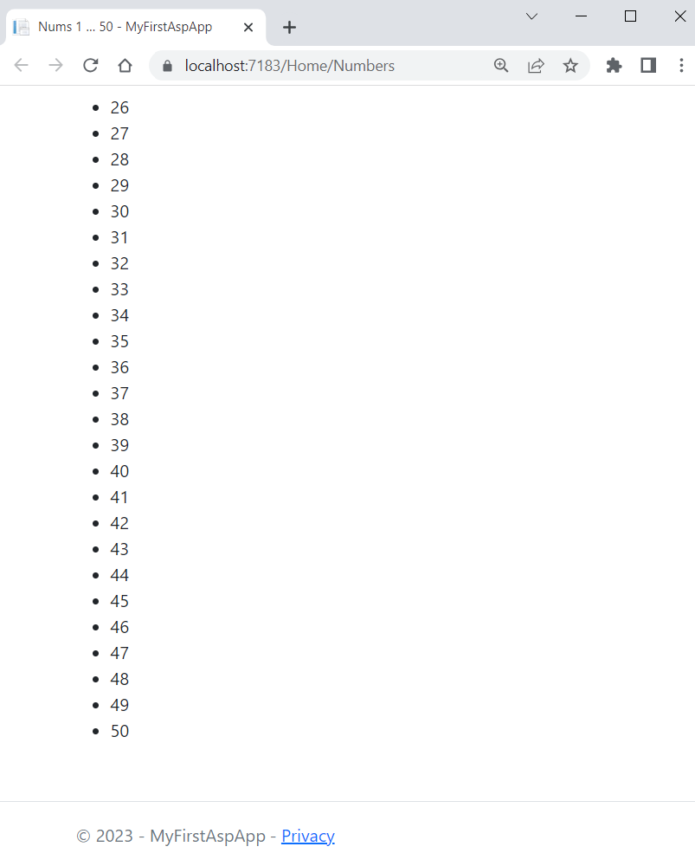
Create a Numbers() controller method in the HomeController, which should only return a view:
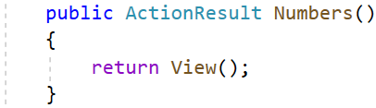
Create a Numbers.cshtml view, which should use a for loop to display each number. Write the view like this:
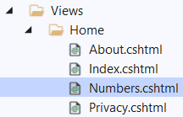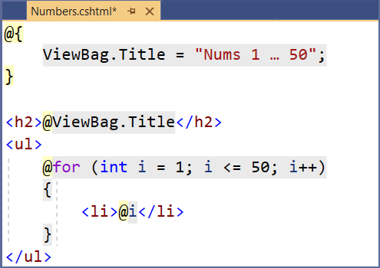
@{
ViewBag.Title = "Nums 1 … 50";
}

<h2>@ViewBag.Title</h2>

<ul>
@for (int i = 1; i <= 50; i++)
{
<li>@i</li>
}
</ul>
Make sure the numbers from 1 to 50 are displayed on the "Numbers 1…50" page on "/Home/Numbers".

Create the "Numbers 1…N" Page
This page is similar to the previous one but the user is to enter a number N. Then, only numbers from 1 to N should be displayed:
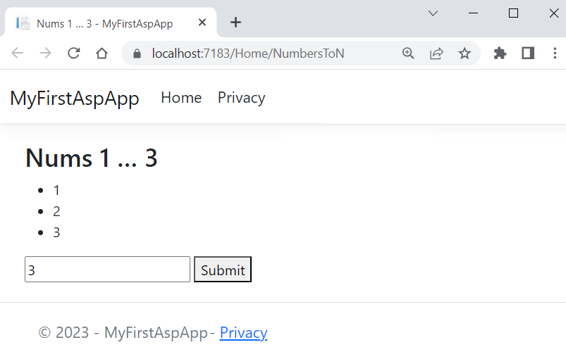
Write a NumbersToN() method in the HomeController. It should accept a count parameter from the view (with default value of the parameter 3). Then, it should add the count number to a ViewBag and return a view:
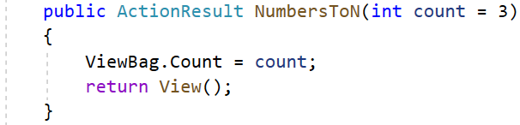
Then, the NumbersToN.cshtml view should display the numbers in a for loop and should have a form for submitting a count number. The number input field should have a "name" attribute, so that its value is passed to the controller action. Do it like this:
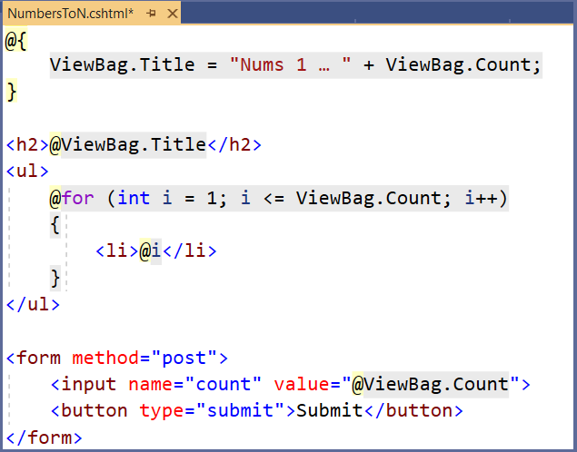
@{
ViewBag.Title =
"Nums 1 … " + ViewBag.Count;
}

<h2>@ViewBag.Title</h2>

<ul>
@for (int i = 1; i <= ViewBag.Count; i++)
{
<li>@i</li>
}
</ul>

<form method="post">
<input name="count" value="@ViewBag.Count">
<button type="submit">Submit</button>
</form>
Try out the page in the browser on "/Home/NumbersToN". It should display different numbers, depending on the count you enter in the form:
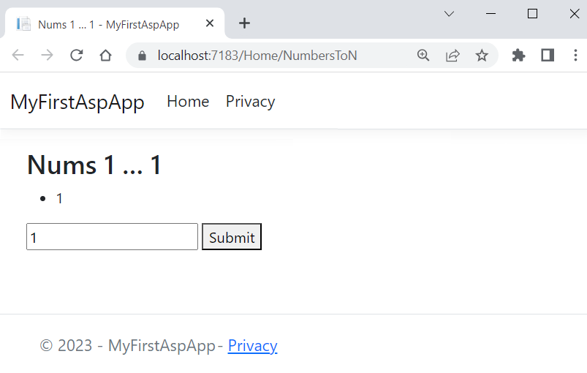

Add Navigation Links
As we have created the pages we need, let’s add links to the navigation pane to access them easier. The navigation pane should look like this:
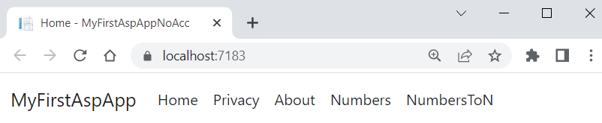
To add links, go the _Layout.cshtml partial view in the "/Views/Shared" folder, as this view is responsible for the common design of all pages. Add the following lines:
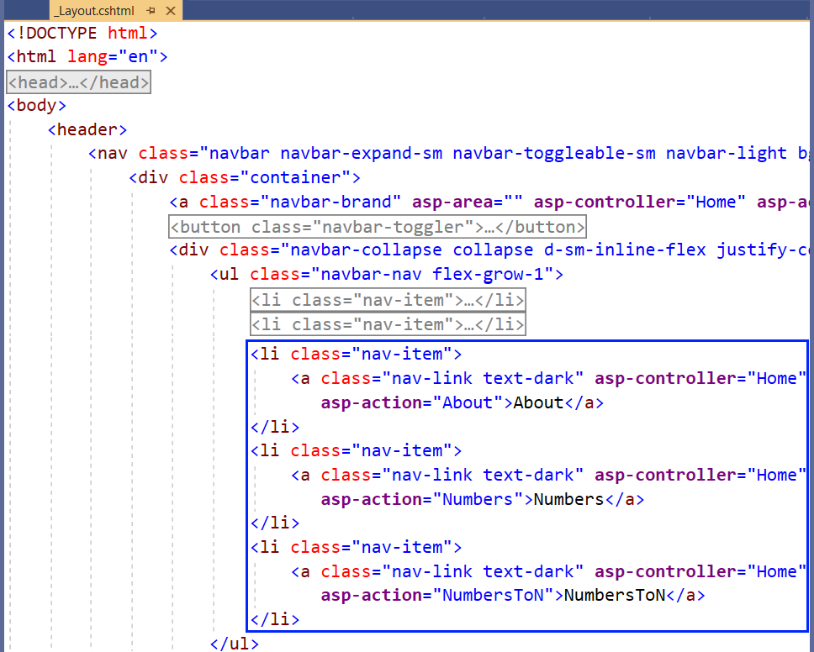
<li class="nav-item">
<a class="nav-link text-dark" asp-area="" asp-controller="Home" asp-action="About">About</a>
</li>
<li class="nav-item">
<a class="nav-link text-dark" asp-area="" asp-controller="Home" asp-action="Numbers">Numbers</a>
</li>
<li class="nav-item">
<a class="nav-link text-dark" asp-area="" asp-controller="Home" asp-action="NumbersToN">NumbersToN</a>
</li>
The asp-controller and asp-action tag helpers set the controller and action names of the page, which should be accessed.
Try out if the links work correctly and open the correct pages in the browser.

ProductsController Pages
The ProductsController will have controller actions for displaying hardcoded products on pages.
Create the ProductsController in the "Controllers" folder. To create a controller, right-click on the "Controllers" folder, click on [Add] [Controller] and choose [MVC Controller – Empty] to create an empty controller class:
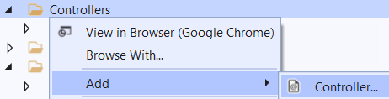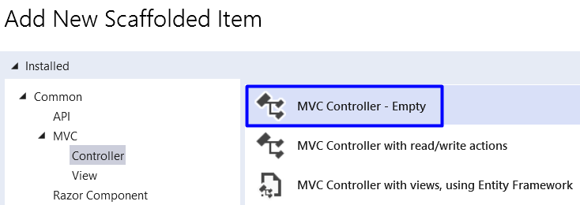
Set the controller name like this:
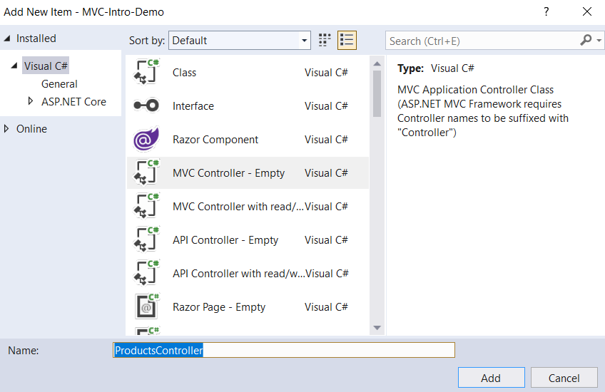
Now your controller class is created in the "Controllers" folder and inherits the Controller base class:
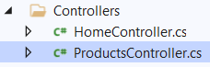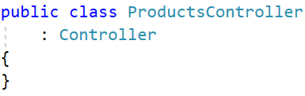
As we already know, we will display hardcoded products. First, you should create a model for these products, which should have an id, name and price. Create a ProductViewModel class in the "Models" folder with the following properties:
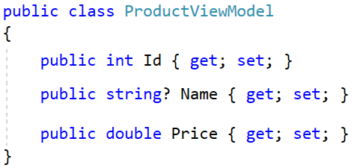
Now go back to the ProductsController and add a field with products. The field should have a collection of ProductViewModel with three products like this:
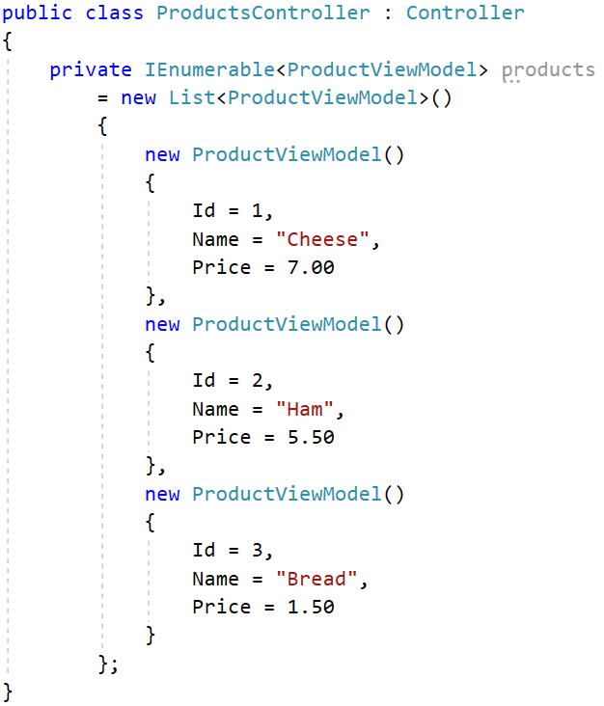
Now use these products in controller methods.

Create the "All Products" Page
The "All Products" page should display the products from the controller field like this:
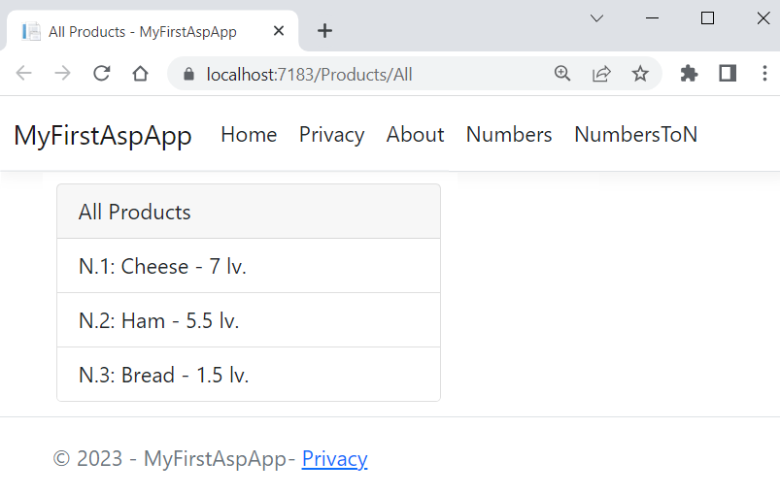
Create an All() controller method in the ProductsController, which should only return a view with the products collection:
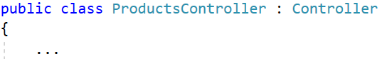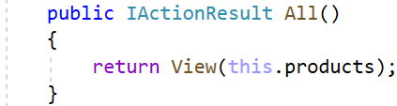
Now you should create a "Products" folder in the "Views" folder, which will have all views for the ProductsController methods. In it, add an All.cshtml view, which should accept a collection of ProductViewModel. Then, foreach the products and use the model properties to display the product data:
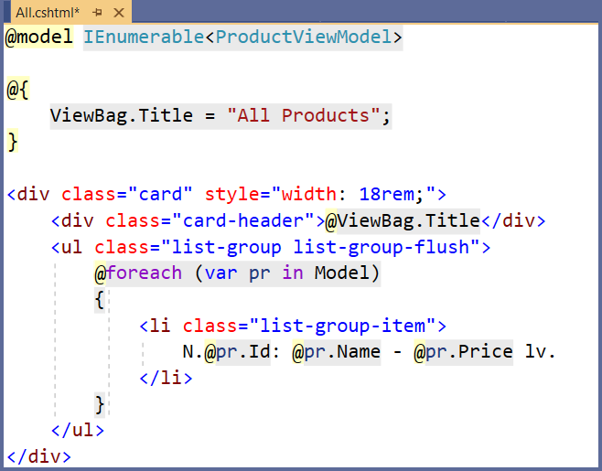
@model IEnumerable<ProductViewModel>

@{
ViewBag.Title = "All Products";
}

<div class="card" style="width: 18rem;">
<div class="card-header">@ViewBag.Title</div>

<ul class="list-group list-group-flush">
@foreach (var pr in Model)
{
<li class="list-group-item">
N.@pr.Id: @pr.Name - @pr.Price lv.
</li>
}
</ul>
</div>
Try the "All Products" page on "/Products/All" in the browser.

Create the "Product By Id" Page
The "Product By Id" page should display a product by id:
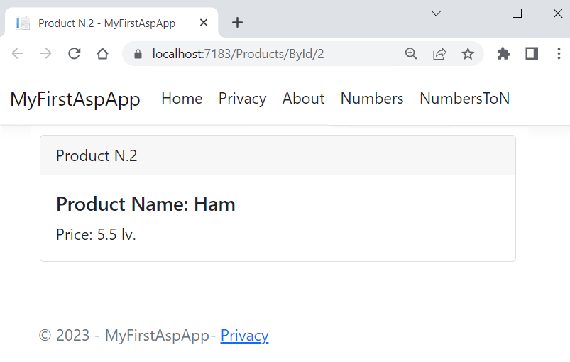
Write the ById(int id) method in the ProductsController. It should pass a product by a given id to the view, if it exists. If it does not, it should return a BadRequest:
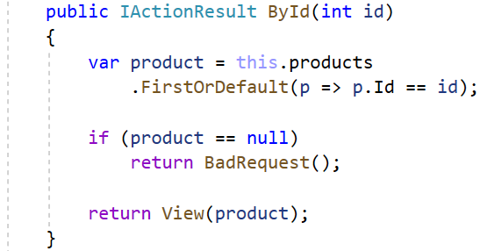
The ById.cshtml view is the following:
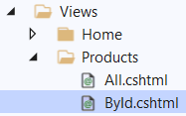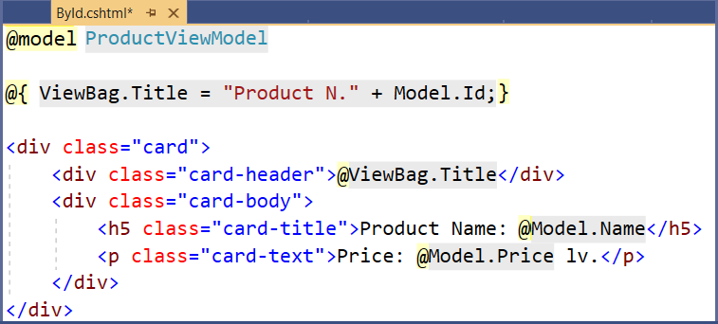
@model ProductViewModel

@{
ViewBag.Title = "Product N." + Model.Id;
}

<div class="card">
<div class="card-header">
@ViewBag.Title
</div>
<div class="card-body">
<h5 class="card-title">
Product Name: @Model.Name
</h5>
<p class="card-text">
Price: @Model.Price lv.
</p>
</div>
</div>
Go to the "Page By Id" page on "/Products/ById/{id}" with a valid and an invalid product id. When product id doesn't exist, an error page will be displayed.

Return Products as JSON
Our task now is to return the products in a JSON format when the user accesses "/Products/AllAsJson":
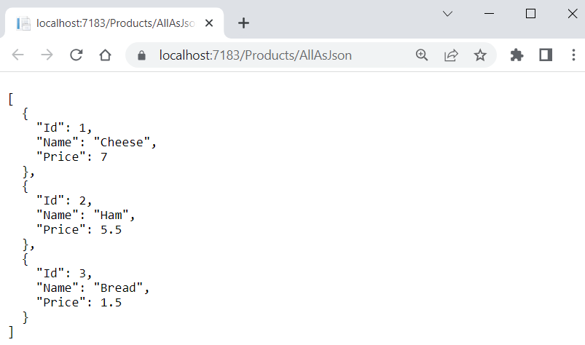
Create the AllAsJson() method in the ProductsController, which should return a JSON with the products as shown below. It should use JSON options to display the JSON indented:
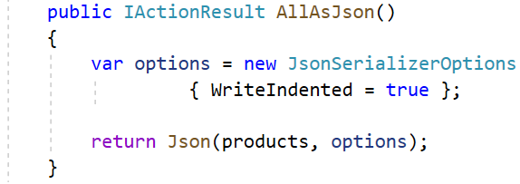
Try the page in the browser and make sure that products are displayed correctly as JSON.

Return Products as Plain Text
Now we should return the products as a plain text in a custom format when the user accesses "/Products/AllAsText":
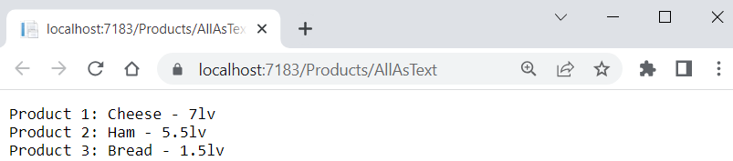
The AllAsText() method in the ProductsController should create a string of all products and return it as a plain text response:
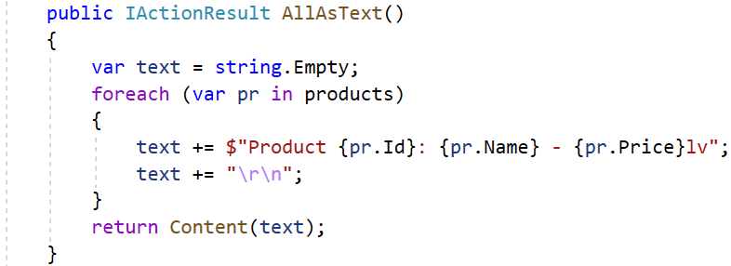
Try it in the browser.

Download Products As Text File
Now we want to download a text file with the products by accessing "/Products/AllAsTextFile":
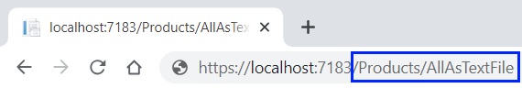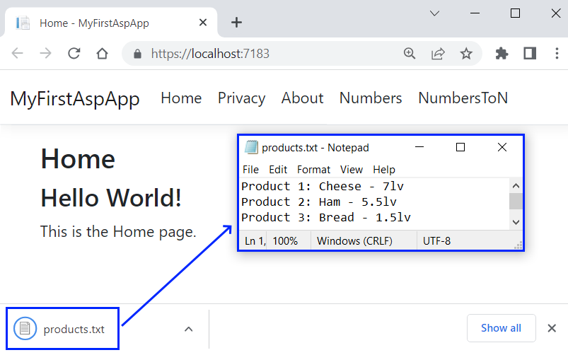
The AllAsTextFile() method in the ProductsController should form a text with the products. Then, it should add the Content-Disposition header to the Response, so that the file is downloaded as an attachment. At the end, it should return a file with the text as a byte array and the plain text type. Write it like this:
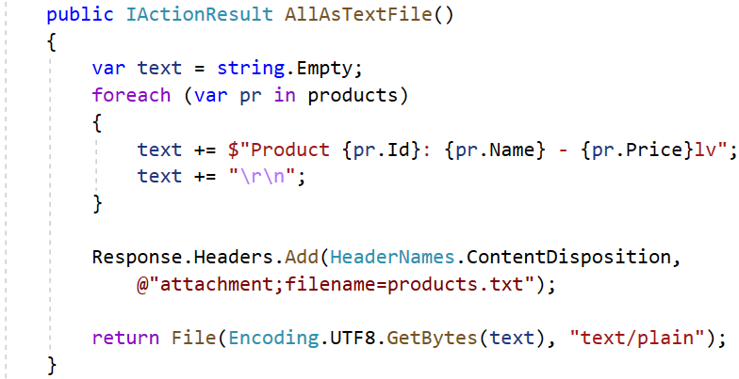

Access the "All Products" Page on Another URL
Now our task is to make the "All Products" page accessible on "/Products/My-Products":
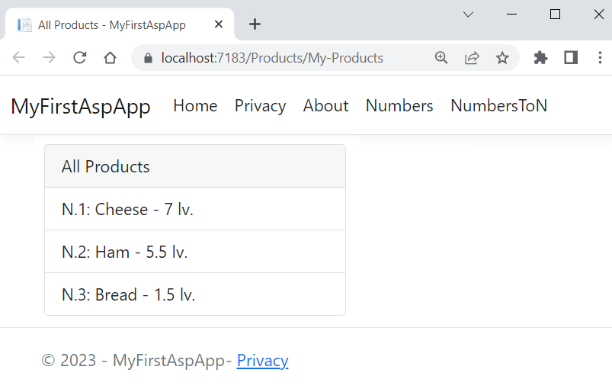
To do this, add the [Action Name] attribute over the All() method of the ProductsController. In this way, you will set an action name, different from the real one:
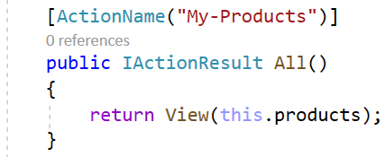
You should also change the All.cshtml view name to "My-Products.cshtml", as the view and the controller action should have the same names:
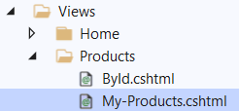
Now access the "All Products" page on "/Products/My-Products" in the browser.

Add Search to the "All Products" Page
Finally, we want to modify the "All Products" page to use a keyword in the URL to filter the displayed products like this:
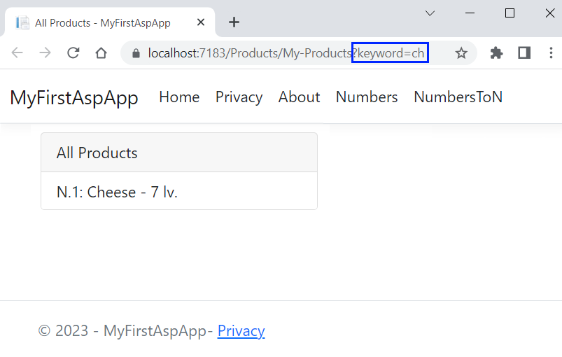
To do this, make the All() controller action accept a keyword and return only the filtered products, when there is a keyword in the URL:
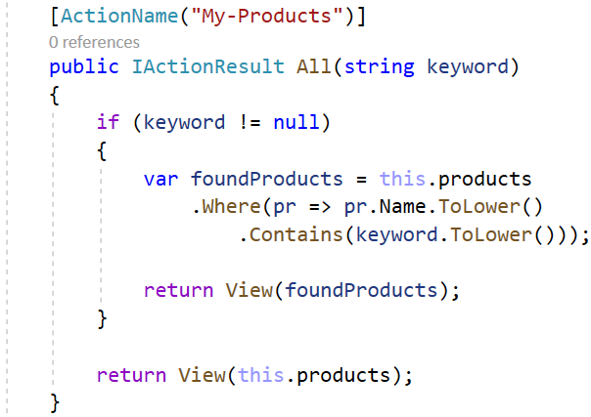
Enter different keywords on "/Products/My-Products?keyword={keyword}" in the browser and make sure that only products with the keyword in their name are shown.

Add Navigation Links
Now it is time to add links to all the pages we created in the navigation pane. They will all be in a "Products" dropdown like this:
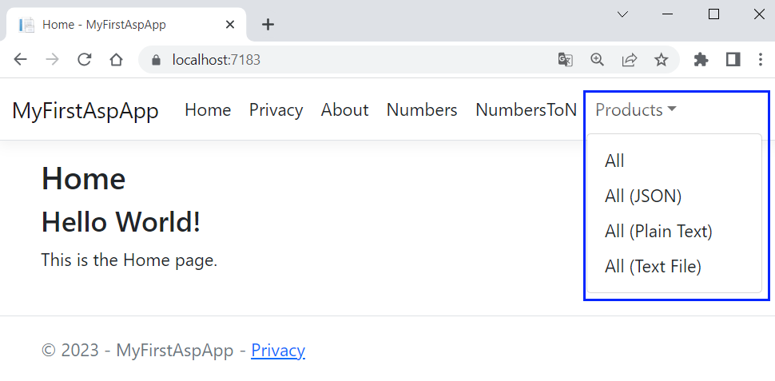
Modify the _Layout.cshtml view like this to have the above links:
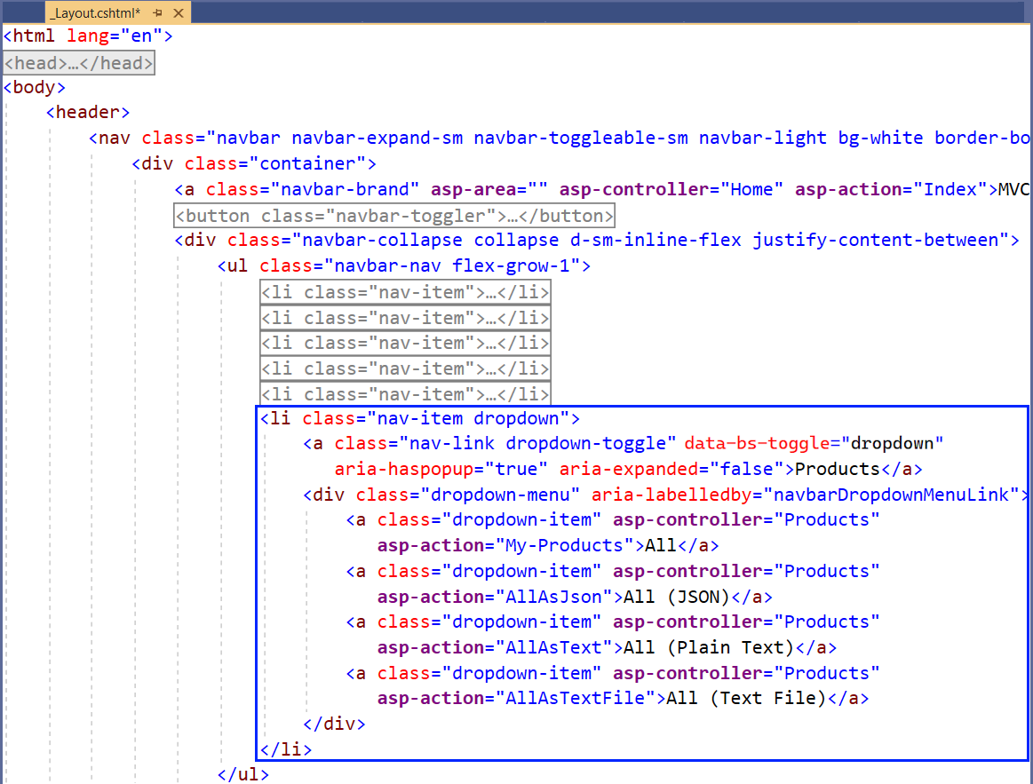
<li class="nav-item dropdown">
<a class="nav-link dropdown-toggle" data-bs-toggle="dropdown"
aria-haspopup="true" aria-expanded="false">Products</a>
<div class="dropdown-menu" aria-labelledby="navbarDropdownMenuLink">
<a class="dropdown-item" asp-controller="Products" asp-action="My-Products">All</a>
<a class="dropdown-item" asp-controller="Products" asp-action="AllAsJson">All (JSON)</a>
<a class="dropdown-item" asp-controller="Products" asp-action="AllAsText">All (Plain Text)</a>
<a class="dropdown-item" asp-controller="Products" asp-action="AllAsTextFile">All (Text File)</a>
</div>
</li>
Try out all new links in the browser. They should access the correct pages.

Simple Chat ASP.NET Core MVC App
We will begin this exercise by creating a simple ASP.NET Core MVC app called "ChatApp". Our app will have a single page for displaying and sending chat messages. It will look like this:
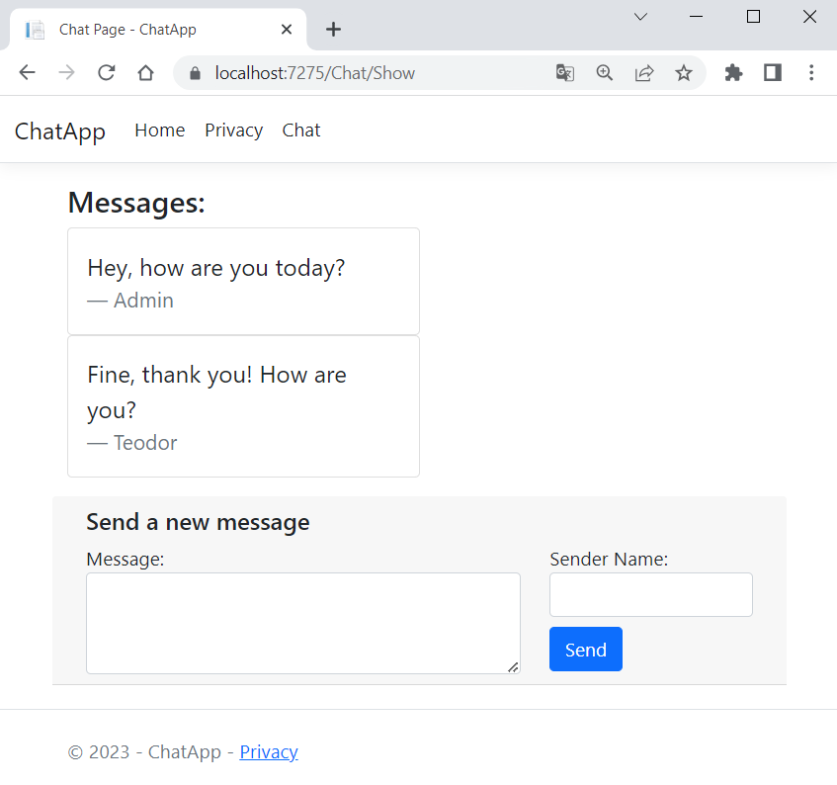

Create the Project
First, create the app and name it "ChatApp":
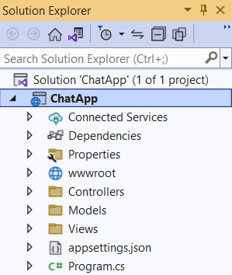

The workflow of the chat functionality in the app will be the following:
- A controller action passes the current messages (if any) to a view as a model
- The view displays the messages (if they exist). Also, the view displays a form for creating a new message and passes a model to the controller when the form is submitted
- Another controller action accepts the model and adds a new message with the model data to the other messages
- The second method invokes the first one by redirection, which again passes all messages to the view (including the new one)

Create Controller and Models
Create a ChatController controller class in the "Controllers" folder:
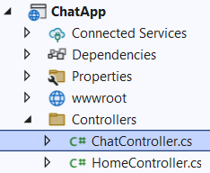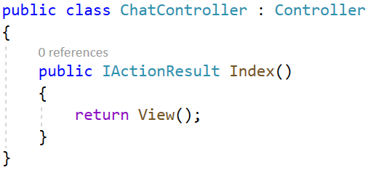
Delete the Index() method, as we will create our own actions. The ChatController should have:
- A collection of messages, which has the message sender as key and the message text as value.
- A "GET" method Show(), which return a view with model (the model may keep the messages).
- A "POST" method Send(), which accepts a model from the view and adds a message to the collection. Then, it redirects to the Show() action.
Write the above class field and methods:
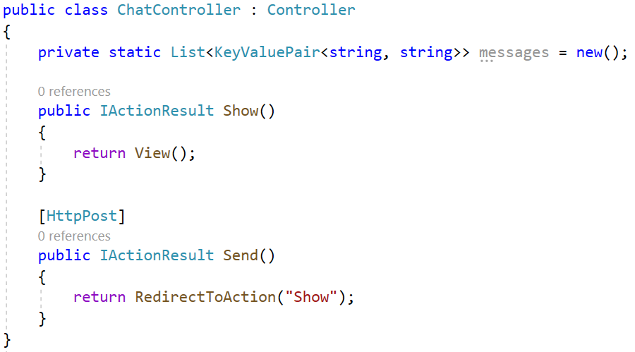
 | Warning: the above code holds the shared app data in a static field in the controller class. This is just for the example, and it is generally a bad practice! Use a database or other persistent storage to hold data, which should survive between the app requests and should be shared between all app users.
Note that the message collection is of type List<KeyValuePair<string, string>>, not Dictionary<string, string>, as it would not allow duplicate keys, but we may want to have several messages by the same sender.
Before we implement the Show() method of the ChatController, create the needed models, which will be passed to the view. In the "Models" folder, create a MessageViewModel class, which will hold properties for each message (message sender and text):
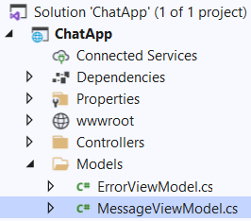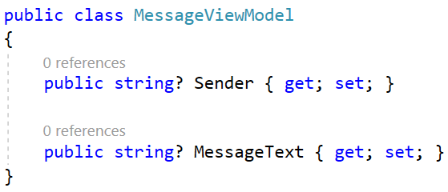
Then, create the ChatViewModel, which will be passed to the view and then returned to the controller. Write the ChatViewModel class like this:
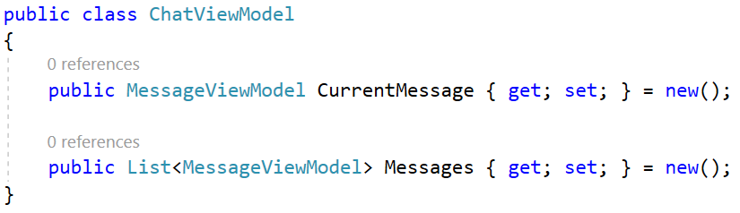
The Messages property has a collection of messages (the already created messages), which will be passed to and displayed by the view. Then, the user will submit a form for creating a new message, which will be saved to the CurrentMessage property and passed to the controller.
Now go to the ChatController and implement the above logic. Write the Show() method first. If the messages collection of the class is empty, the controller action should return a view with an empty ChatViewModel. If there are messages, a view with the non-empty ChatViewModel shall be returned. This time, however, the Messages collection of the ChatViewModel should have the messages as a collection of type MessageViewModel.
Implement the action like this:
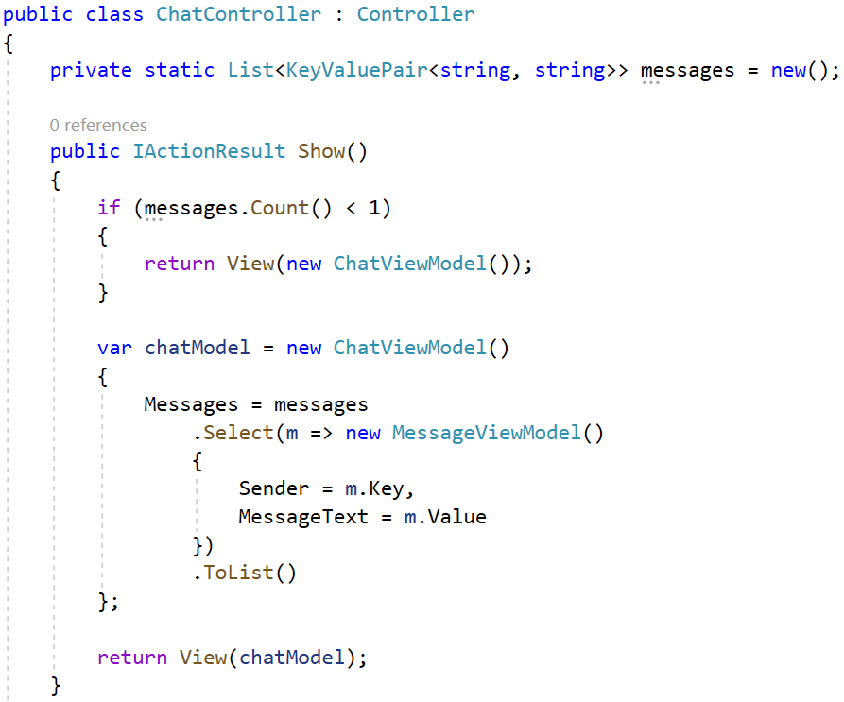

Now write the Send() method, as well. It should have the [HttpPost] attribute, which means that the action will be invoked on a "POST" request to "/Chat/Send". The method should also accept a ChatViewModel (from the view) and use its CurrentMessage property values to add a new message to the message collection. Finally, it should redirect to the Show() action. Do it like this:
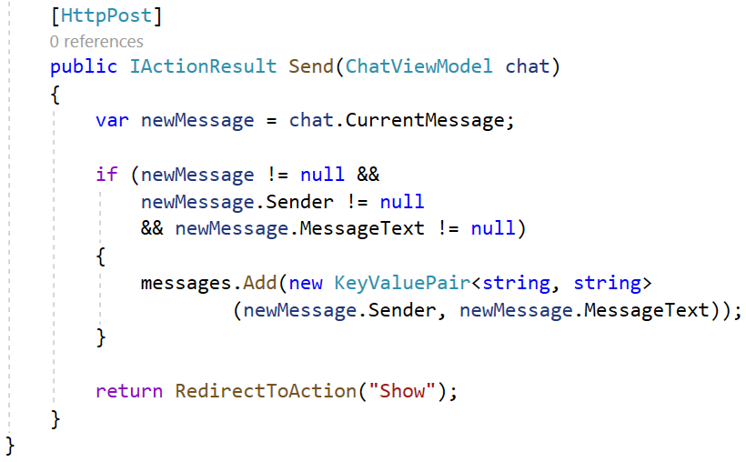

Create a View
Finally, we should create a Show.cshtml view. First, create a new folder "Chat" (the name of the controller) in the "Views" folder:
In it, create a Show.cshtml view:
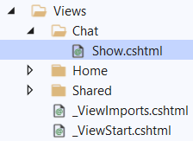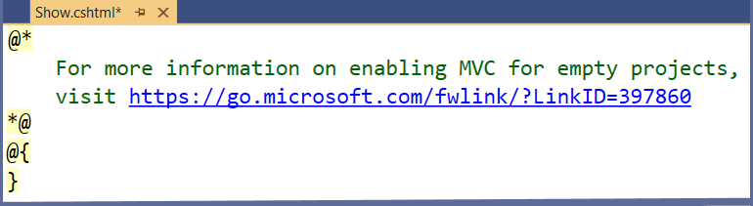
Clear the view file and let's write our own code. First, use the @model directive to make the view accept a ChatViewModel:
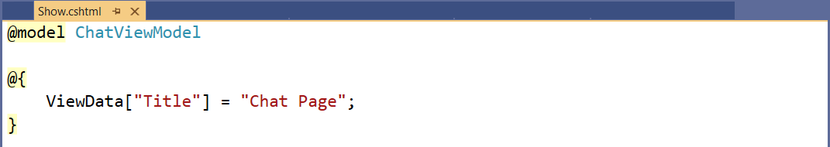
Add a heading to the view with a pure HTML like this:
Next, we want to show each message with its sender and text if the ChatView model has any. Otherwise, we should just display the "No messages yet!" message. To do this, use an if statement and a foreach loop in the Razor view. Also, use the @ symbol to switch to C# code and use the model properties. Do it like this:
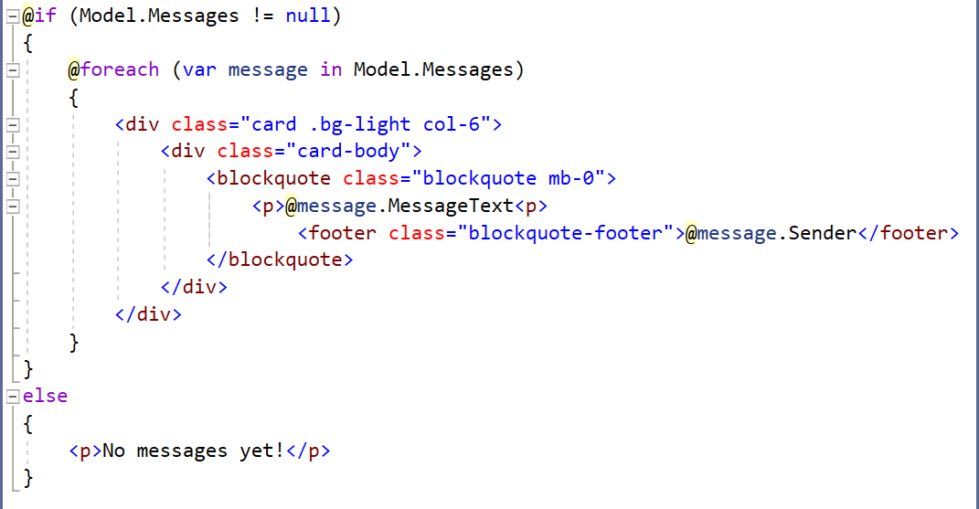
Then, create a form, which should send a "POST" request to "/Chat/Send" and fill in the CurrentMessage property of the ChatViewModel. Use different tag helpers (will be examined during the next topics) to set the controller and action and to extract the name of a specified model property into the rendered HTML. Write the rest of the view code like this:
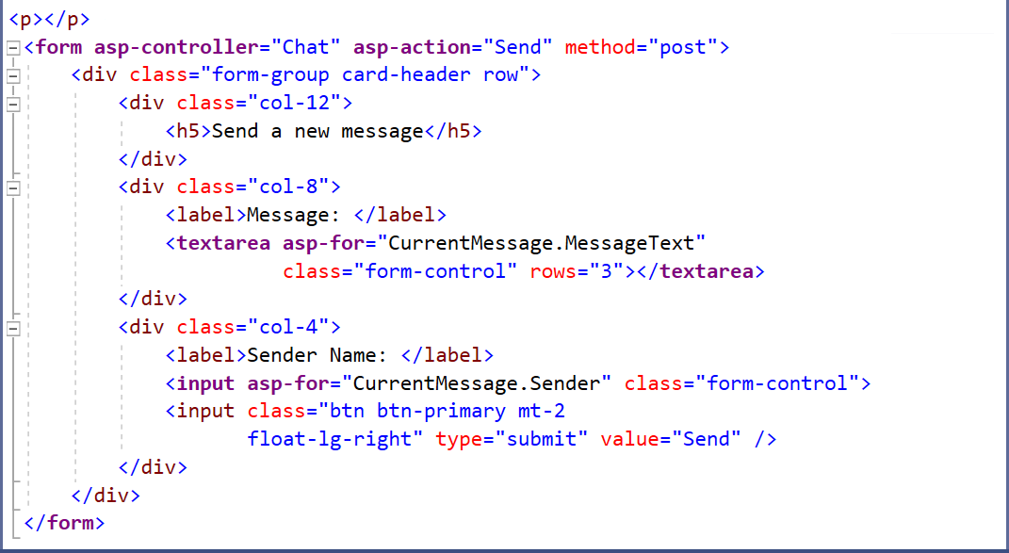

You can copy the whole view from here:
@model ChatViewModel

@{
ViewData["Title"] = "Chat Page";
}

<h3>Messages:</h3>

@if (Model.Messages != null)
{
@foreach (var message in Model.Messages)
{
<div class="card .bg-light col-6">
<div class="card-body">
<blockquote class="blockquote mb-0">
<p>@message.MessageText<p>
<footer class="blockquote-footer">@message.Sender</footer>
</blockquote>
</div>
</div>
}
}
else
{
<p>No messages yet!</p>
}

<p></p>
<form asp-controller="Chat" asp-action="Send" method="post">
<div class="form-group card-header row">
<div class="col-12">
<h5>Send a new message</h5>
</div>
<div class="col-8">
<label>Message: </label>
<textarea asp-for="CurrentMessage.MessageText"
class="form-control" rows="3"></textarea>
</div>
<div class="col-4">
<label>Sender Name: </label>
<input asp-for="CurrentMessage.Sender" class="form-control">
<input class="btn btn-primary mt-2
float-lg-right" type="submit" value="Send" />
</div>
</div>
</form>
Now if we access "/Chat/Show" we will see the Show.cshtml view.
To add a link to the page, go to the _Layout.cshtml.cshtml view in "Views/Shared" and add the following code:
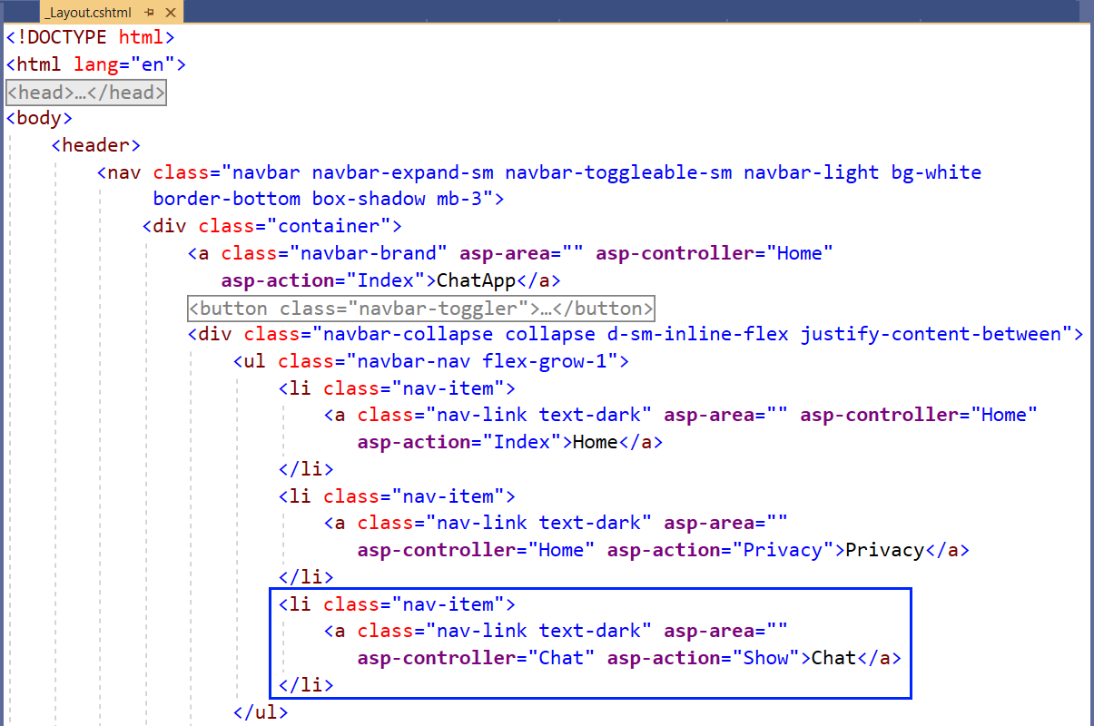

Try the App
Run the app and examine it in the browser. It should have the "Chat" navigation link, which we have just added:
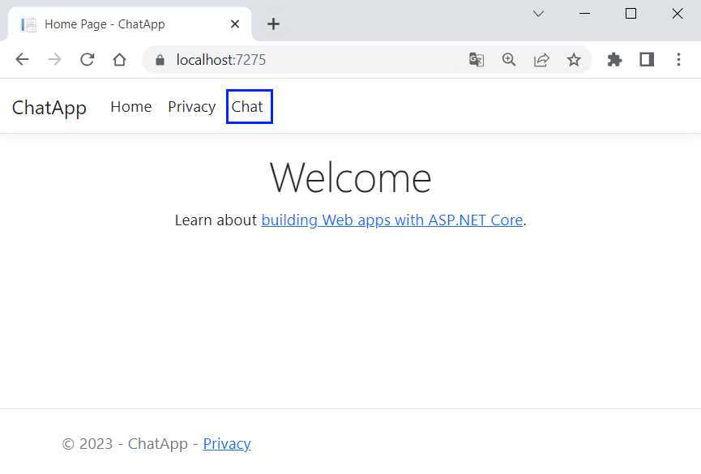
Click on the [Chat] link. You should be redirected to "/Chat/Show" and see the Show.cshtml view:
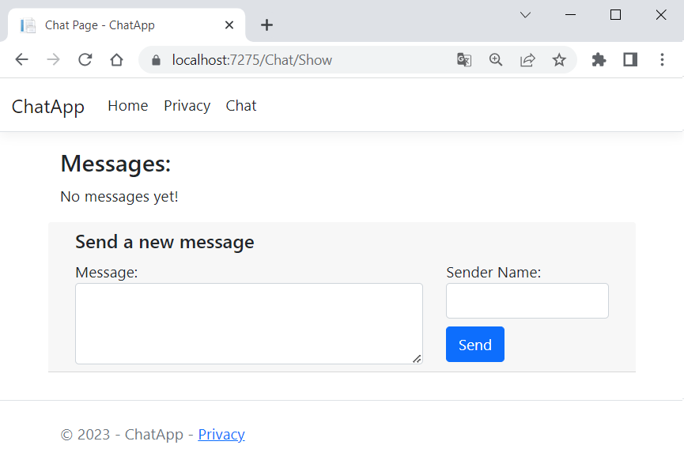
We have no messages yet, so let's add one. Fill in the form and click on the [Send] button. The new message should be displayed on the page:
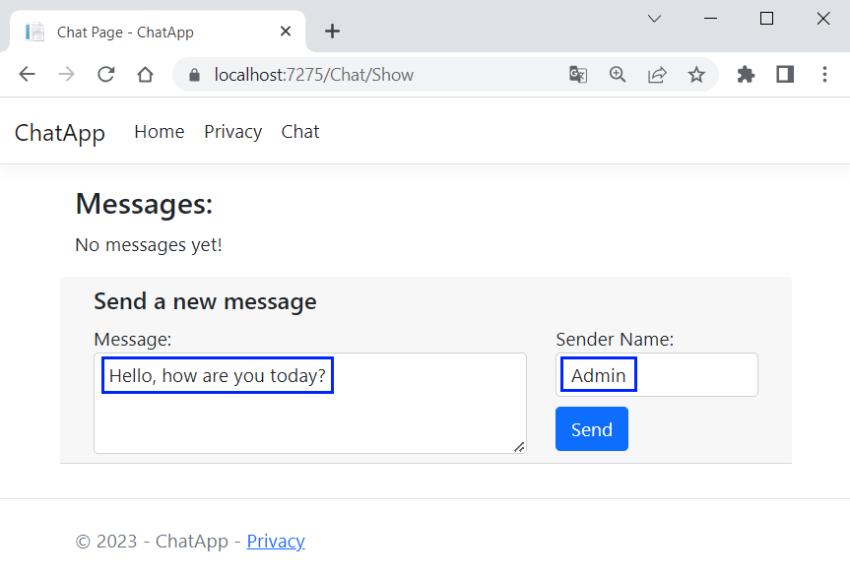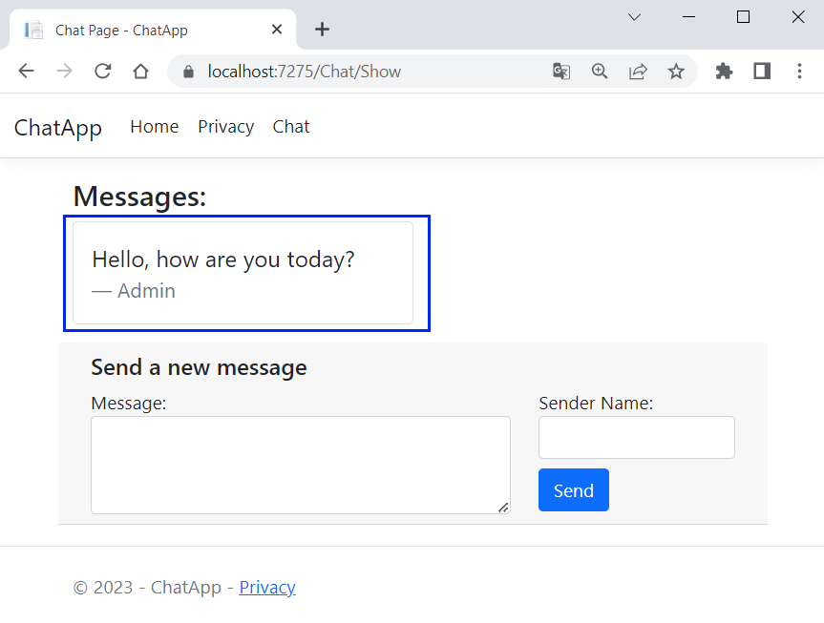
Make sure that your app works correctly. Debug the code, so that you fully understand the MVC pattern. Don't forget that messages are deleted every time you close the app because they are stored in a variable – that's why we should create databases for our apps.
Next time we will create an ASP.NET Core MVC app, which we will develop till the end of this course and it will be your project for the final exam.

