Team Exercise: Student System
(Entity Relations, DbContext, Seeding & LINQ)

1. Scenario Overview
In this exercise you will work in teams to design and implement a simple Student System database using Entity Framework Core (Code First). You will define the entities, configure the DbContext, seed initial data, and then write LINQ queries to read data from the database.
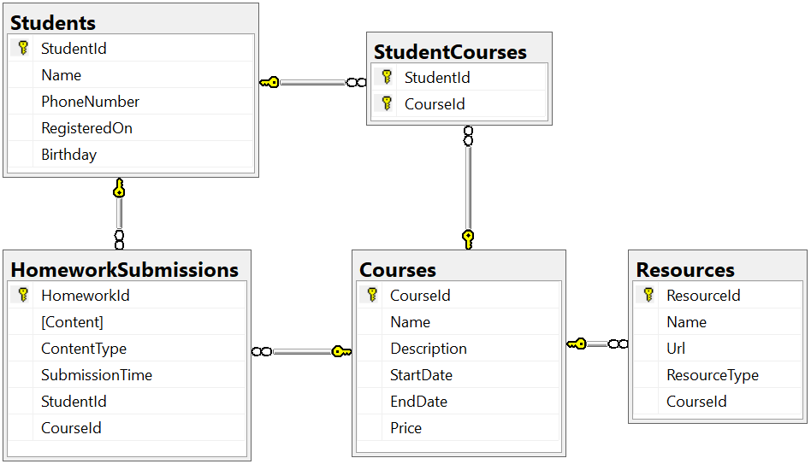

2. Team Structure
The class is divided into 4 teams of 5 students. Each team will have a Team Leader. The Team Leader is responsible for organizing the work and assigning tasks to teammates. The leader may distribute tasks such as: defining entity classes, configuring the DbContext, creating the seed data, and writing LINQ queries. However, the whole team is responsible for understanding the full solution.

3. Project Requirements
You will create a solution that models a Student System with the following layers and namespaces:
- Project for startup / console app: StudentSystem
- Data layer (DbContext): StudentSystem.Data
- Models (entities): StudentSystem.Data.Models

3.1 Entities
Define the following entities as C# classes. Use appropriate types and data annotations or Fluent API to describe the constraints.
Student:
- StudentId (primary key)
- Name (string, max length 100, Unicode)
- PhoneNumber (string, exactly 10 characters, non-Unicode, optional)
- RegisteredOn (DateTime, required)
- Birthday (DateTime?, optional)
Course:
- CourseId (primary key)
- Name (string, max length 80, Unicode)
- Description (string, Unicode, optional)
- StartDate (DateTime)
- EndDate (DateTime)
- Price (decimal)
Resource:
- ResourceId (primary key)
- Name (string, max length 50, Unicode)
- Url (string, non-Unicode)
- ResourceType (enum: Video, Presentation, Document, Other)
- CourseId (foreign key)
Homework:
- HomeworkId (primary key)
- Content (string, represents a file path or URL, non-Unicode)
- ContentType (enum: Application, Pdf, Zip)
- SubmissionTime (DateTime)
- StudentId (foreign key)
- CourseId (foreign key)
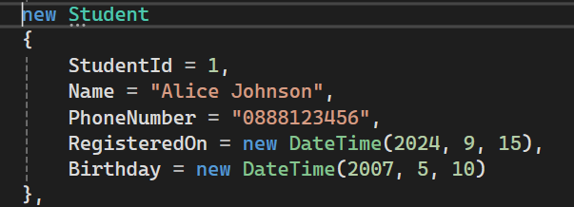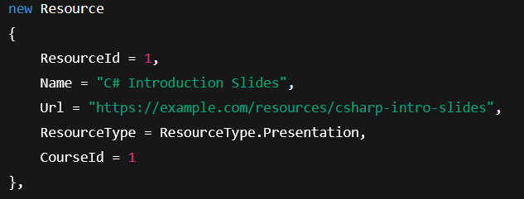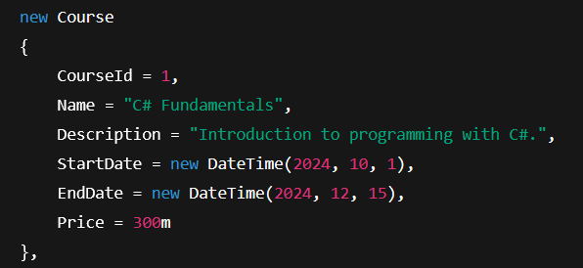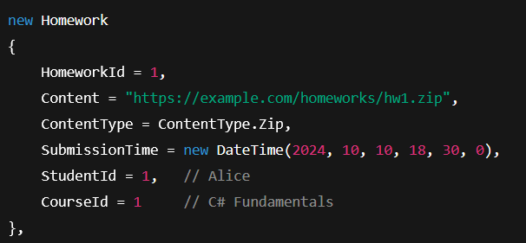

3.2 Relationships
Configure the relationships between the entities using Fluent API or data annotations:
- One Student can have many CourseEnrollments .
- One Student can have many HomeworkSubmissions.
- One Course can have many StudentsEnrolled .
- One Course can have many Resources.
- One Course can have many HomeworkSubmissions.

3.3 DbContext
Create a DbContext class named StudentSystemContext in the P01_StudentSystem.Data namespace. It should expose DbSet<TEntity> properties for all entities and configure all constraints and relationships in OnModelCreating. The context must have a constructor that accepts DbContextOptions<StudentSystemContext> so that it can be used from the judge and from dependency injection.

4. Seeding the Database
Add initial data (seed) using Fluent API in OnModelCreating or a separate configuration class. Insert a few example Students, Courses, Resources, Homeworks and StudentCourse entries so that your LINQ queries in the next section have something to work with. Aim for at least:
- 3–5 students
- 3–4 courses
- 2–3 resources per course
- 1–3 homework submissions per student
- several student–course enrollments

5. LINQ Queries
The Team Leader chooses 5 LINQ queries that the team will implement. The whole team should discuss and understand the queries, and all code must be included in the project. Examples of possible queries include (you may use these or create your own):
- List all students with their registered date and number of courses.
- List all courses with total number of resources.
- Show all homework submissions for a given student.
- Show students ordered by number of courses they are enrolled in.
- Show all courses that have at least one homework submitted after their end date.
Your team must implement 5 LINQ queries of your choice (chosen by the Team Leader), print their results in the console, and make sure they work correctly with your seeded data.
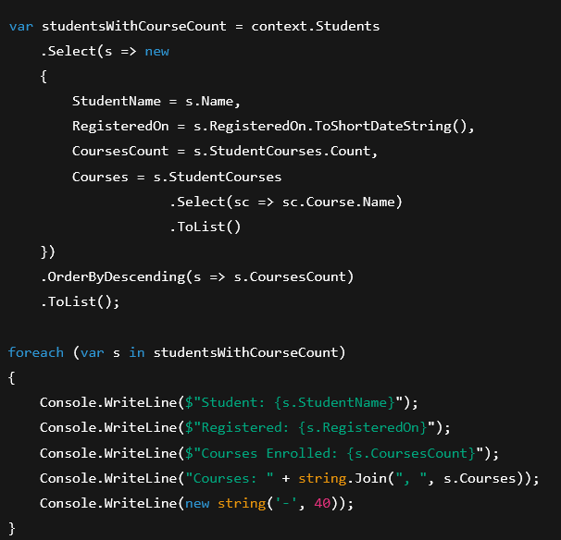

6. Deliverables
At the end of the exercise your team should have:
- A working Student System database (created from migrations).
- Correctly defined entity classes and relationships.
- Seed data that is inserted after database creation.
- At least 5 meaningful LINQ queries implemented and demonstrated.

