Лабораторная работа №3
  - Агентное моделирование
Андрей Геннадьевич Софич
Содержание
1. Цель работы 1
2. Задание 1
3. Выполнение лабораторной работы 1
4. Выводы 20

1. Цель работы
Изучить в теории и на практике возможности агентного моделирования.

2. Задание
Применить агентное моделирование на модели daisyworld.

3. Выполнение лабораторной работы
Создаем рабочий каталог и инициализируем проект в julia (рис. 1).
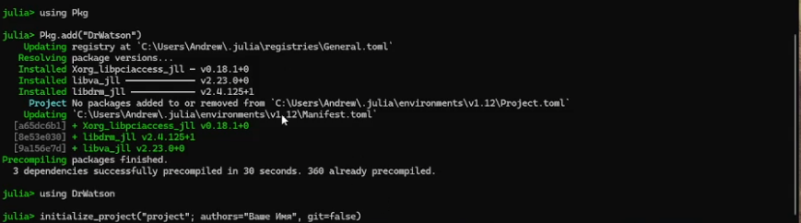
Рисунок 1: Инициализация проекта
Устанавилваем все необходимые пакеты (Agents) (рис. 2).
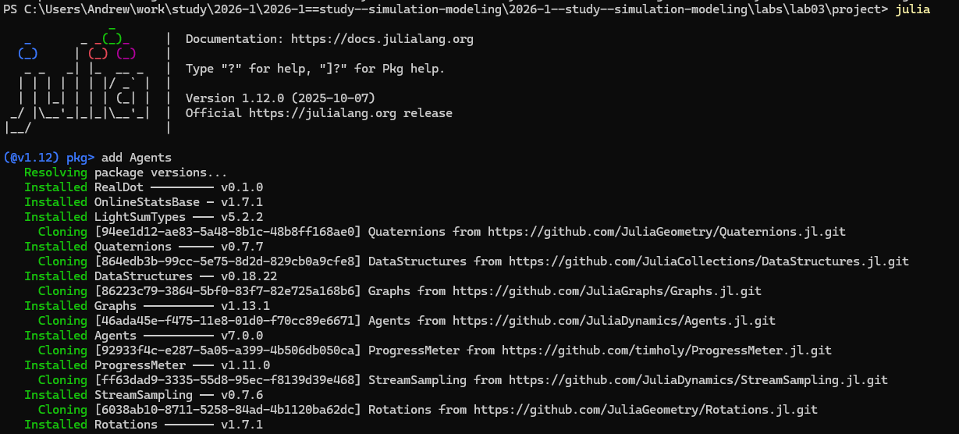
Рисунок 2: Установка пакетов Agents
Устанавливаем дополнительные пакеты для работы с агентным моделированием (рис. 3).
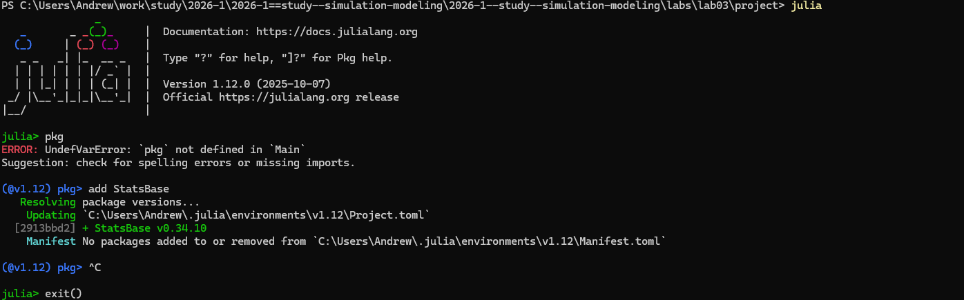
Рисунок 3: Загрузка доп. пакетов
Создаем файл в папке scr, в котором мы определим тип агента и функции шага модели (рис. 4).
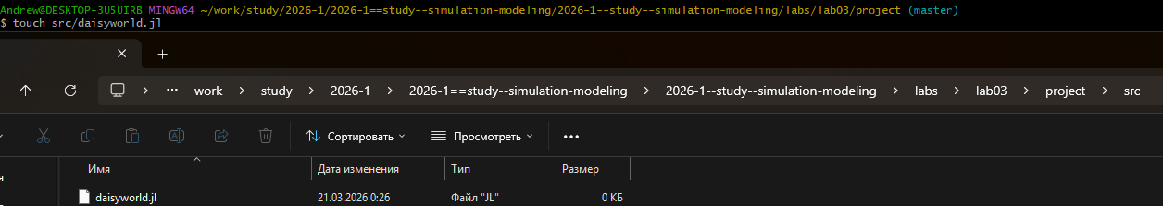
Рисунок 4: Создание файла для базовых определений
Создаем исполняемый файл в папке scripts и прописываем в нем код (рис. 5).
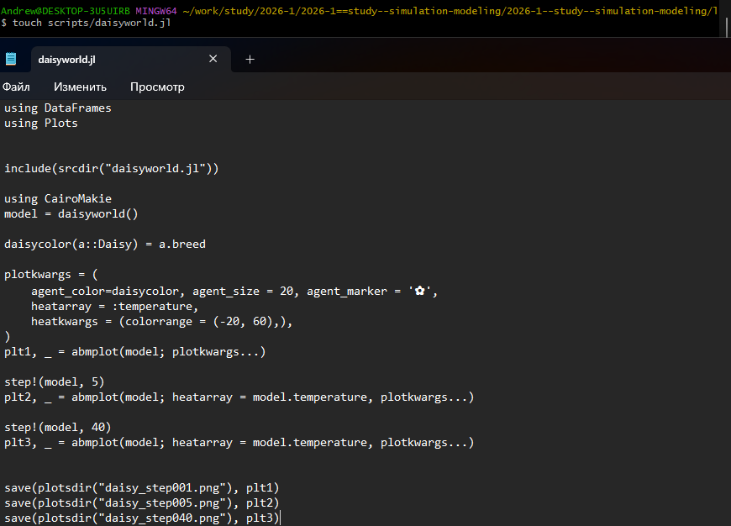
Рисунок 5: Создание исполняемого файла
Запускаем файл и анализируем тепловую карту, которая будет представлять собой температуру поверхности модели. Маргаритки будут отображаться черно-белыми в соответствии с их видом. (рис. 6).
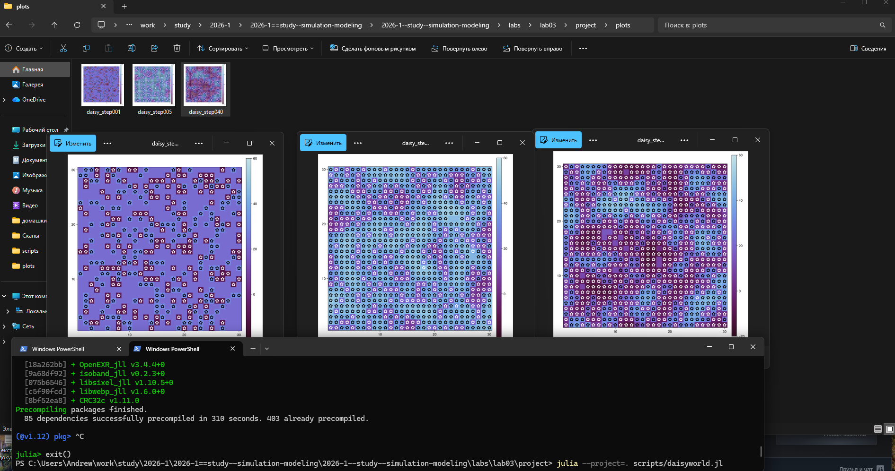
Рисунок 6: Тепловая карта - базовая визуализация
Преобразовываем код в произвольные стили, открываем jupyter файл и убеждаемся в правильной компиляции. (рис. 7).
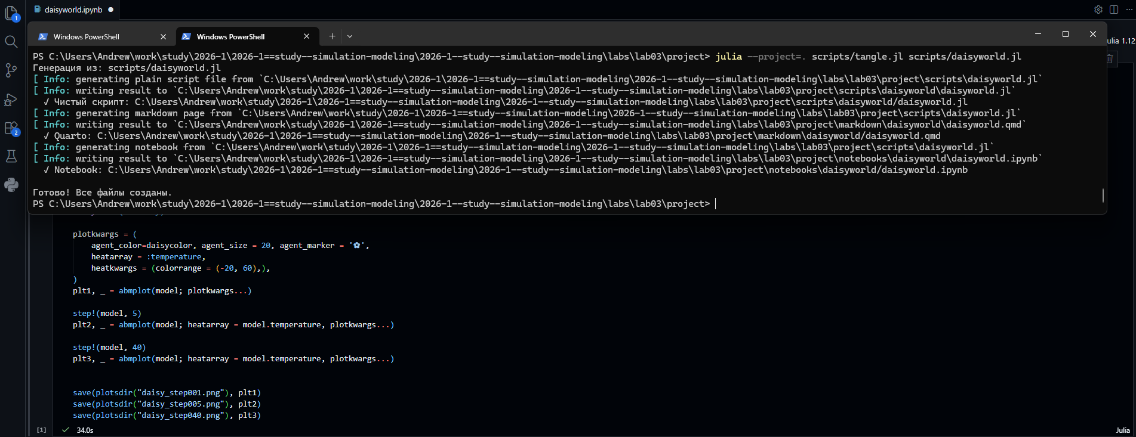
Рисунок 7: Код из jupyter notebook
Создаем файл с анимацией, прописываем в нем код и запускаем. (рис. 8).
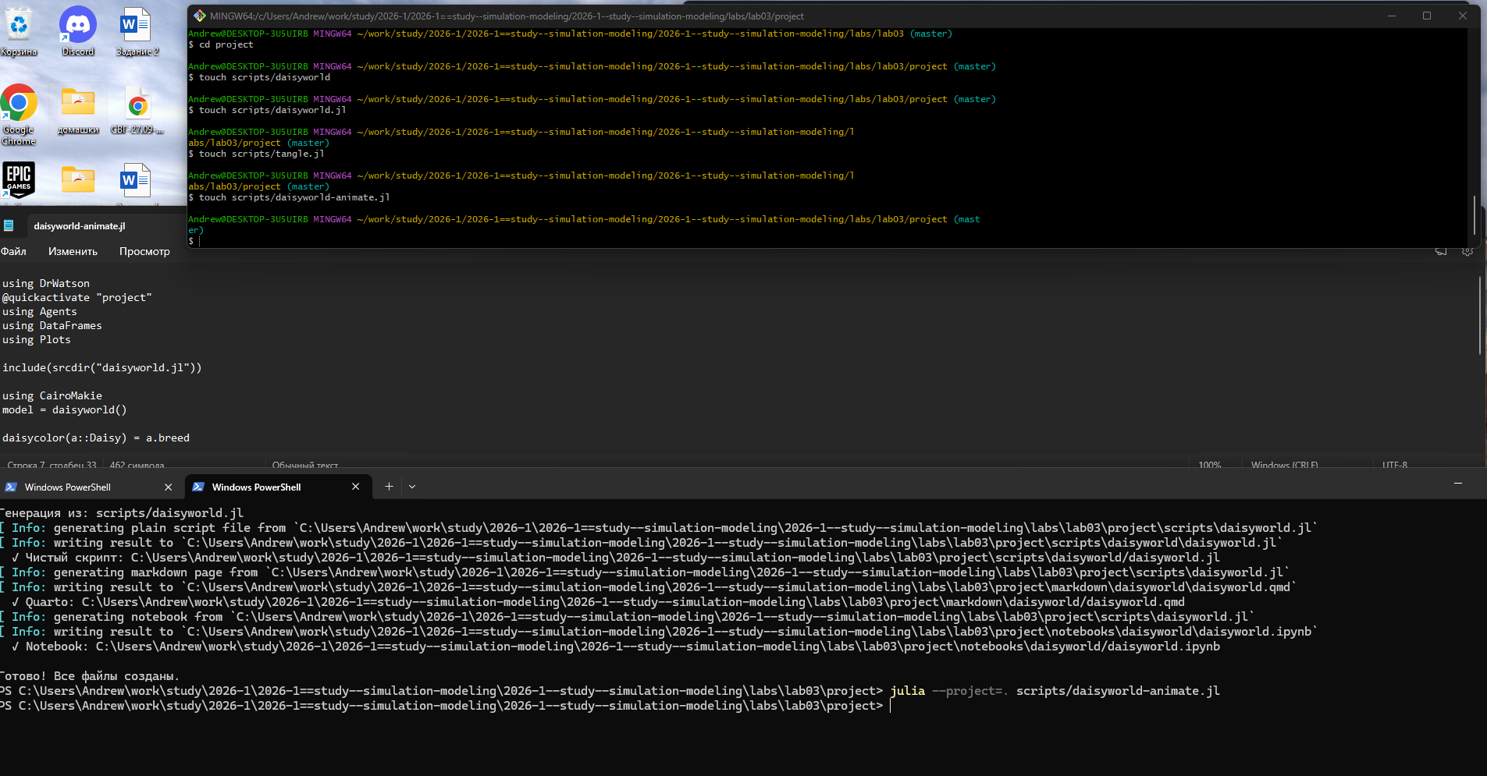
Рисунок 8: Создание и запуск анимации модели
Результат можно увидеть в папке plots или по ссылке в rutube: (рис. 9).
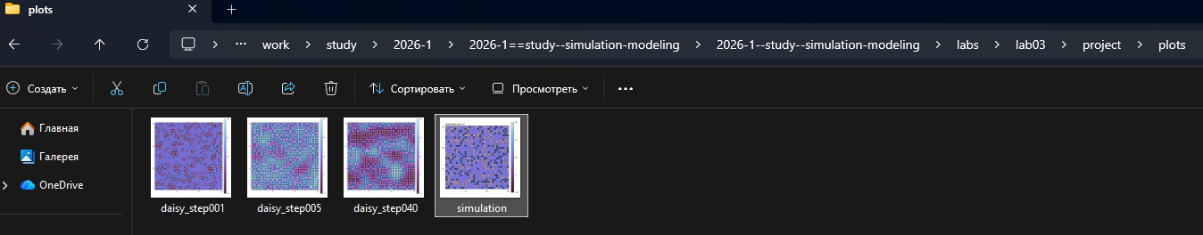
Рисунок 9: Результат
https://rutube.ru/video/fc59731ceb08176e1f6a8170228c0836/
Создаем, заполняем и запускаем файл, в котором наглядно показана динамика числа маргариток (рис. 10).
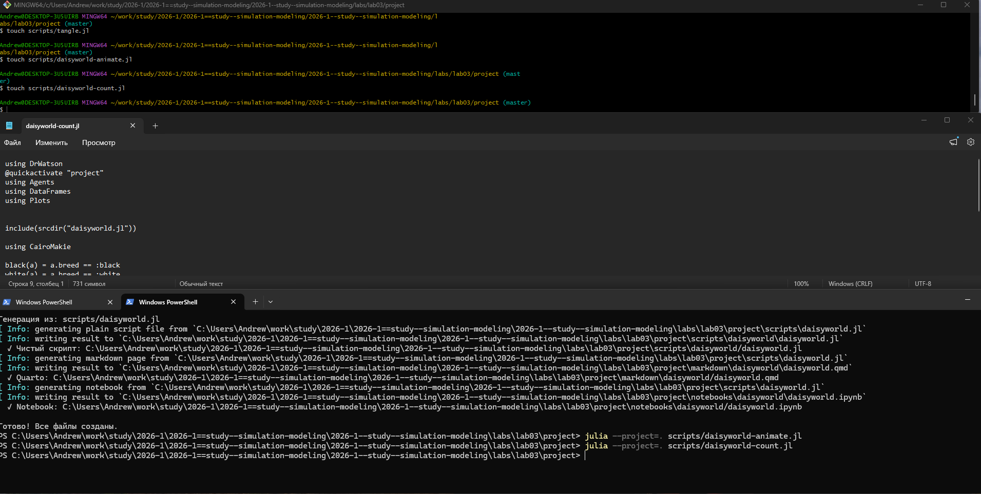
Рисунок 10: Файл с динамикой числа маргариток
Наглядно видим результат запуска файла. (рис. 11).
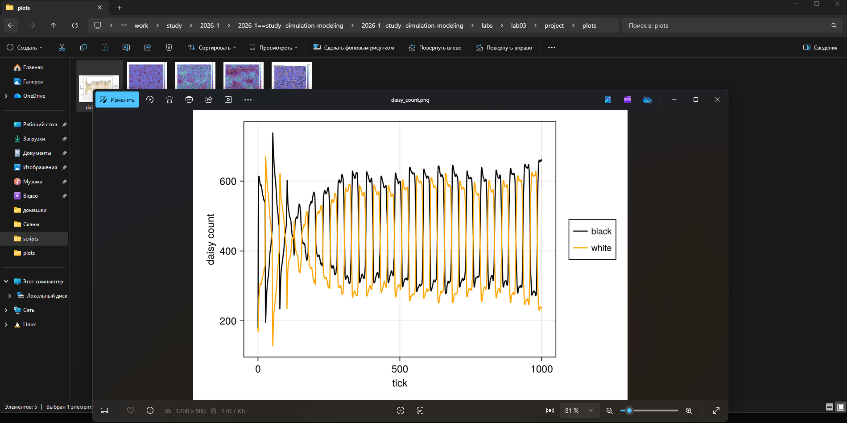
Рисунок 11: График динамики
Преобразовываем код в произвольные стили, открываем jupyter файл и убеждаемся в правильной компиляции. (рис. 12).
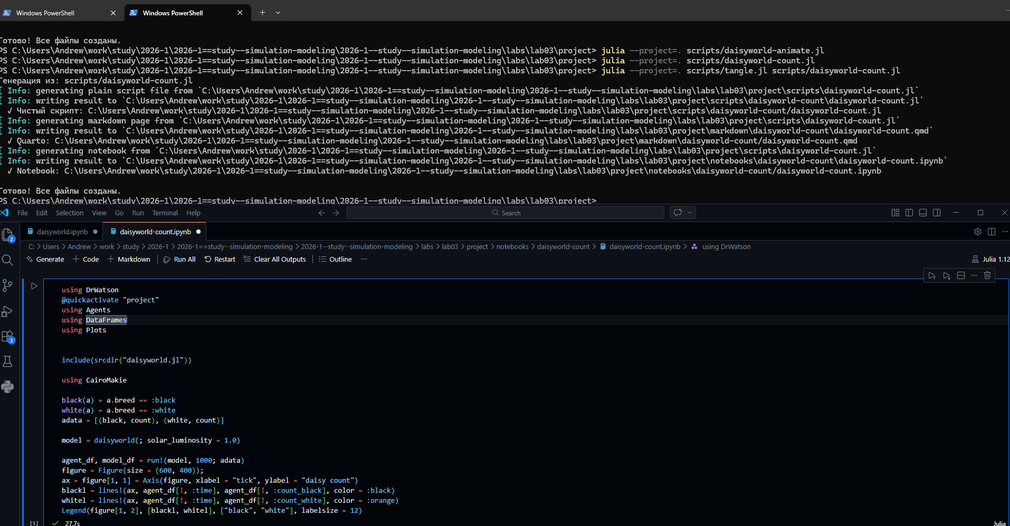
Рисунок 12: Код из jupyter notebook
Создаем, заполняем и запускаем файл, который построит комплексный график изменения числа маргариток,температуры,альбедо в зависимости от модельного времени (рис. 13).
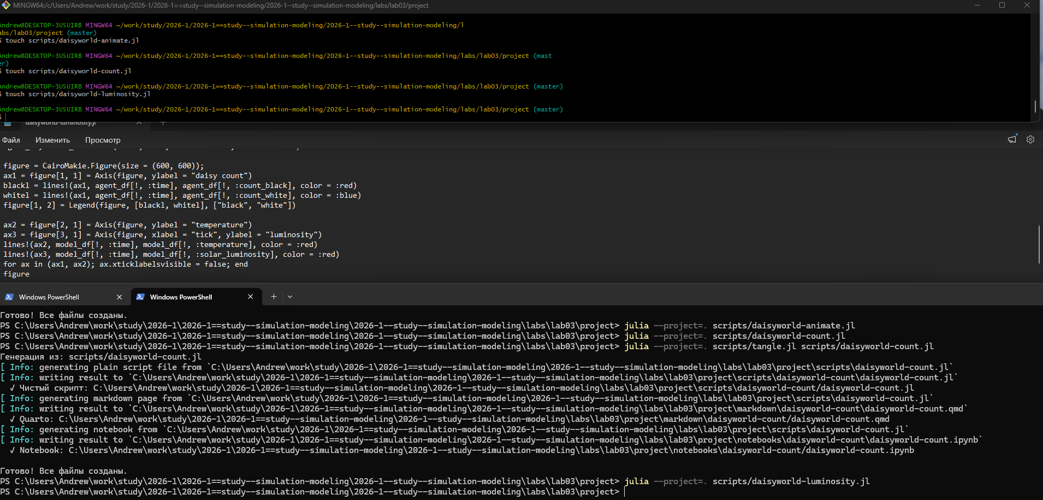
Рисунок 13: Создание файла с комплексным графиком
Заходим в папку plots и открываем наши графики, анализируем поведение модели (рис. 14).
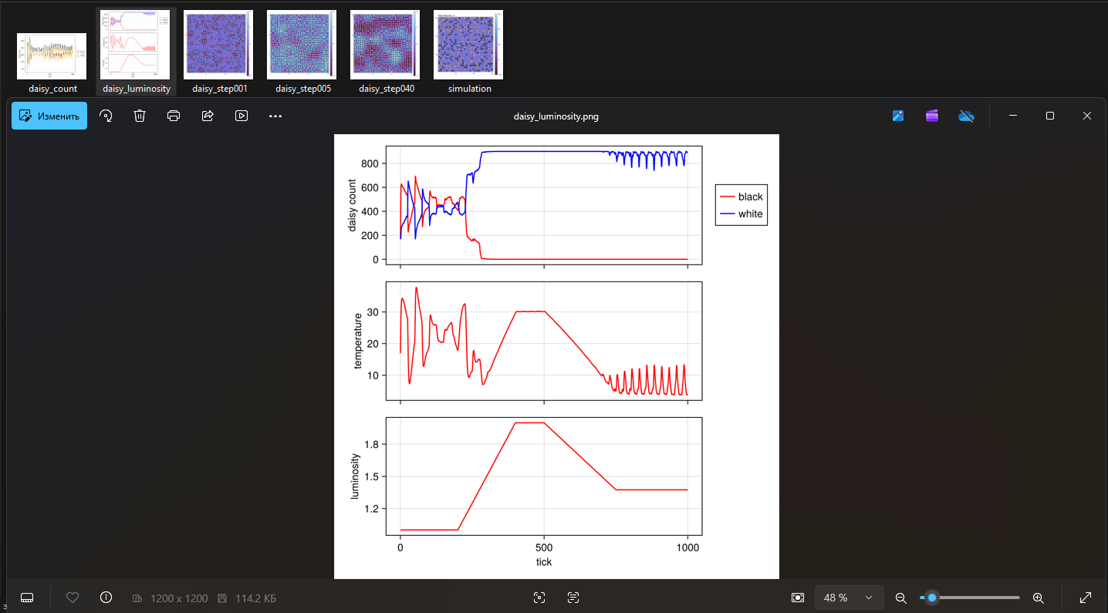
Рисунок 14: Комплексный график изменения числа маргариток
Преобразовываем код в произвольные стили, открываем jupyter файл и убеждаемся в правильной компиляции. (рис. 15).
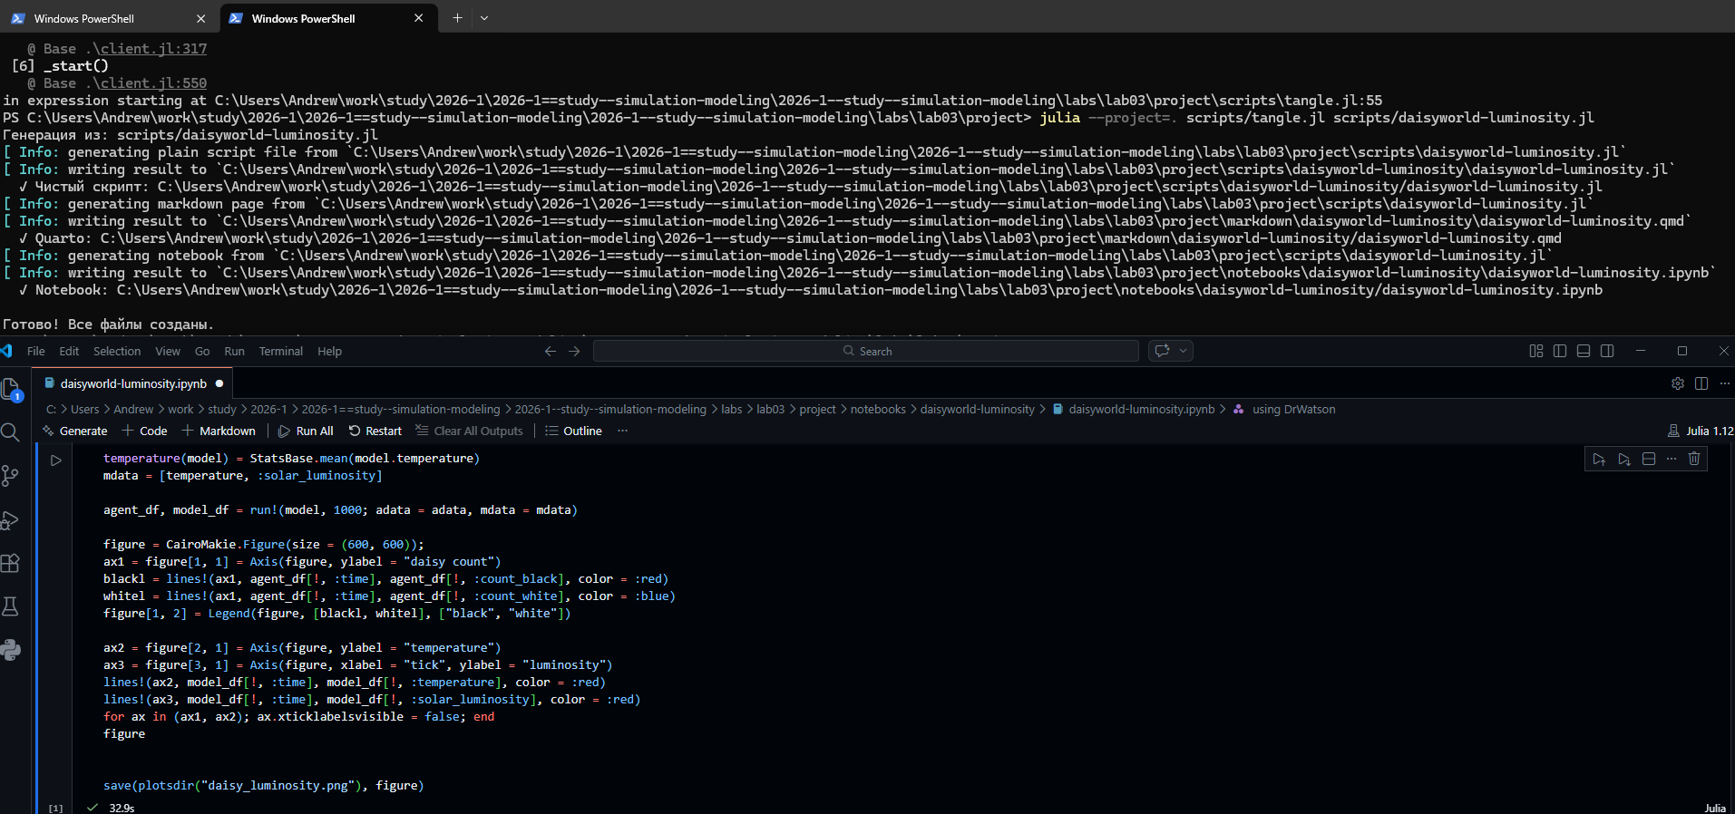
Рисунок 15: Код из jupyter notebook
Мы можем расширить базовую визуализацию за счет параметров. Для этого создаем новый файл, в котором прописываем параметры и на выходе получаем несколько троек графиков для каждого набора параметров (рис. 16).
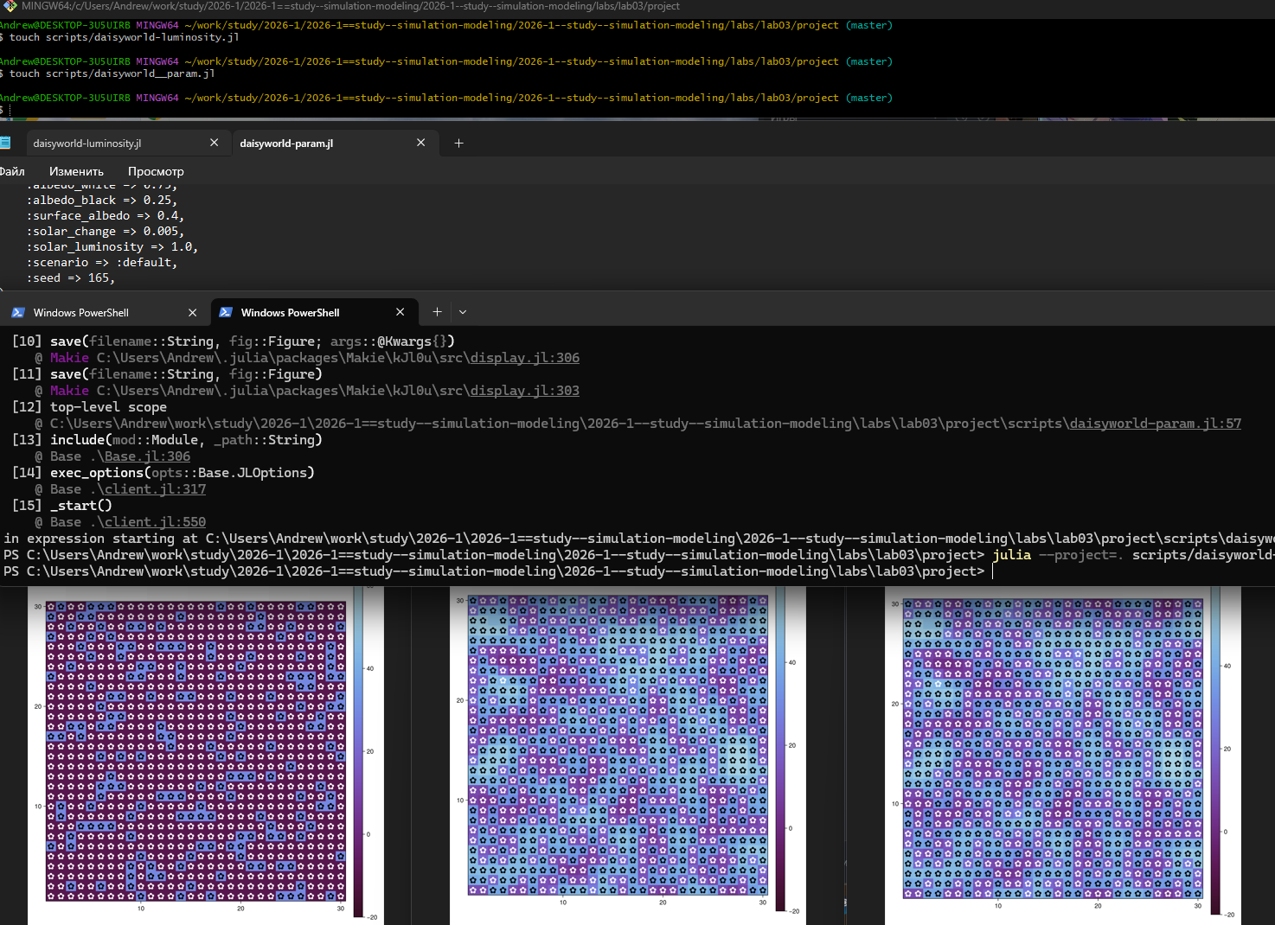
Рисунок 16: Базовая визуализация с параметрами
Преобразовываем код в произвольные стили, открываем jupyter файл и убеждаемся в правильной компиляции. (рис. 17).
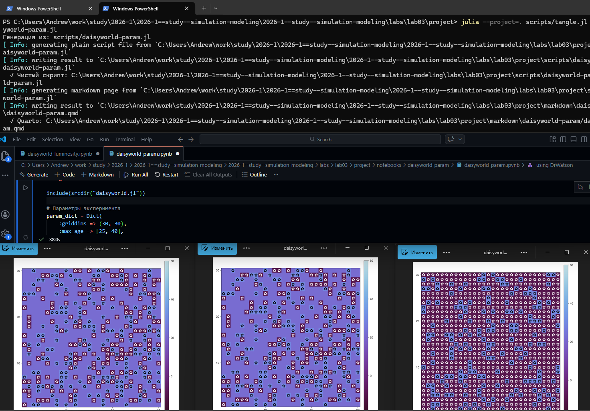
Рисунок 17: Код из jupyter notebook и еще одна тройка графиков
Создаем файл, в котором зависимо от заданого набора параметров можно построить график динамика числа маргаритов в зависимости от времени, заполняем и запускаем его (рис. 18).
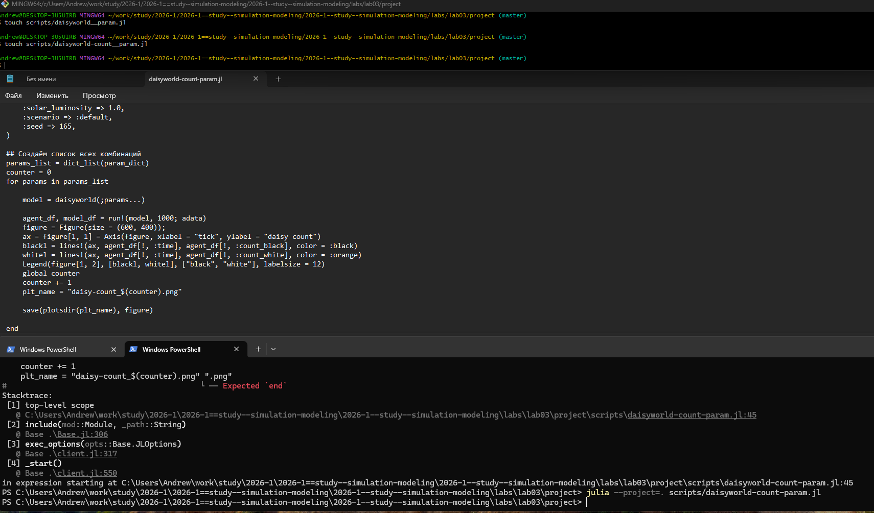
Рисунок 18: Динамика изменения числа маргариток с параметрами
Преобразовываем код в произвольные стили, открываем jupyter файл. анализируем получившиеся графики,зависящие от наших заданных параметров (рис. 19).
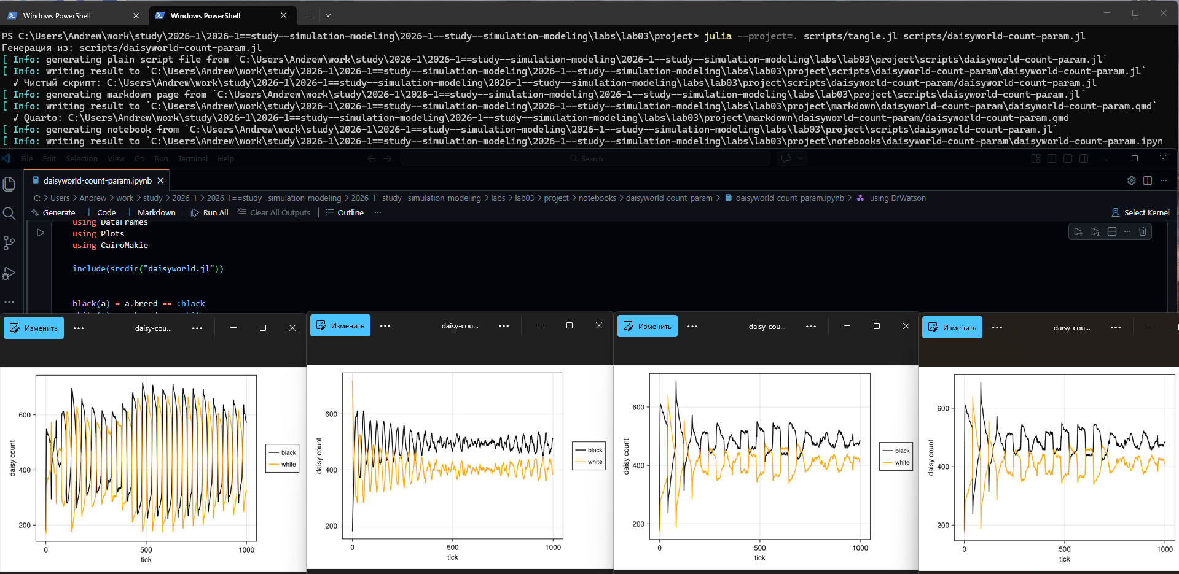
Рисунок 19: Код из jupyter notebook и графики динамики
Создаем, заполняем и запускаем файл, в котором можно построить комплексные графики, задав произвольные параметры (рис. 20).
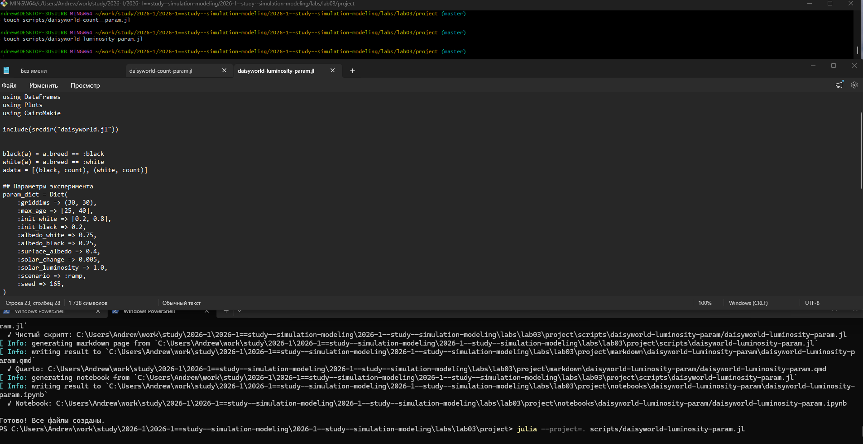
Рисунок 20: Файлы с комплексными графиками с параметрами
Преобразовываем код в произвольные стили, открываем jupyter файл. Анализируем получившиеся графики,зависящие от наших заданных параметров (рис. 21).
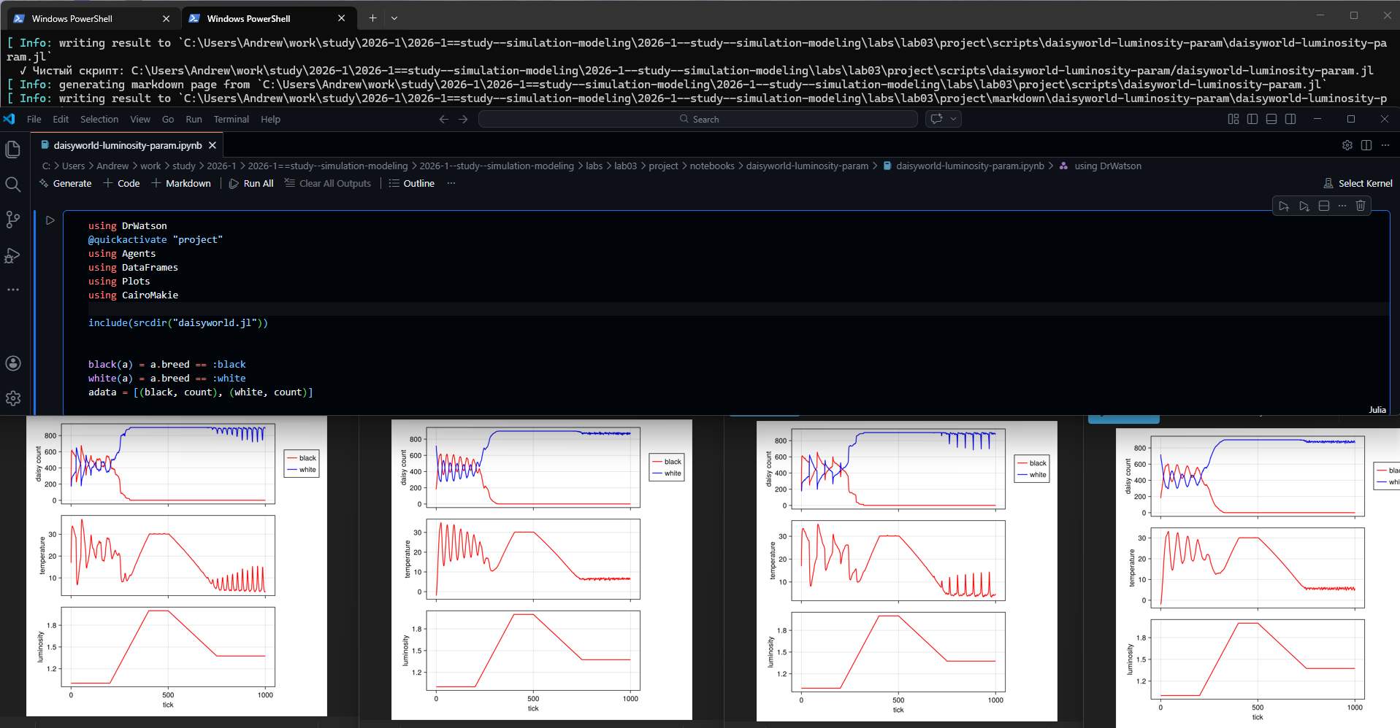
Рисунок 21: Код из jupyter notebook и комплексные графики
using DrWatson
@quickactivate "project"
using Agents
using DataFrames
using Plots
include(srcdir("daisyworld.jl"))
using CairoMakie
#Создание модели
model = daisyworld()
daisycolor(a::Daisy) = a.breed
plotkwargs = (
agent_color=daisycolor, agent_size = 20, agent_marker = '✿',
heatarray = :temperature,
heatkwargs = (colorrange = (-20, 60),),
)
#Отрисовка графиков
plt1, _ = abmplot(model; plotkwargs...)
step!(model, 5)
plt2, _ = abmplot(model; heatarray = model.temperature, plotkwargs...)
step!(model, 40)
plt3, _ = abmplot(model; heatarray = model.temperature, plotkwargs...)
#Сохранение изображений
save(plotsdir("daisy_step001.png"), plt1)
save(plotsdir("daisy_step005.png"), plt2)
save(plotsdir("daisy_step040.png"), plt3)
┌ Warning: DrWatson could not find find a project file by recursively checking given `dir` and its parents. Returning `nothing` instead.
│ (given dir: C:\Users\AESoldatov)
└ @ DrWatson C:\Users\AESoldatov\.julia\packages\DrWatson\2QF5p\src\project_setup.jl:84
┌ Warning: Using the standard Julia project.
└ @ DrWatson C:\Users\AESoldatov\.julia\packages\DrWatson\2QF5p\src\project_setup.jl:30
┌ Warning: Found `resolution` in the theme when creating a `Scene`. The `resolution` keyword for `Scene`s and `Figure`s has been deprecated. Use `Figure(; size = ...` or `Scene(; size = ...)` instead, which better reflects that this is a unitless size and not a pixel resolution. The key could also come from `set_theme!` calls or related theming functions.
└ @ Makie C:\Users\AESoldatov\.julia\packages\Makie\kJl0u\src\scenes.jl:264
┌ Warning: Found `resolution` in the theme when creating a `Scene`. The `resolution` keyword for `Scene`s and `Figure`s has been deprecated. Use `Figure(; size = ...` or `Scene(; size = ...)` instead, which better reflects that this is a unitless size and not a pixel resolution. The key could also come from `set_theme!` calls or related theming functions.
└ @ Makie C:\Users\AESoldatov\.julia\packages\Makie\kJl0u\src\scenes.jl:264
┌ Warning: Found `resolution` in the theme when creating a `Scene`. The `resolution` keyword for `Scene`s and `Figure`s has been deprecated. Use `Figure(; size = ...` or `Scene(; size = ...)` instead, which better reflects that this is a unitless size and not a pixel resolution. The key could also come from `set_theme!` calls or related theming functions.
└ @ Makie C:\Users\AESoldatov\.julia\packages\Makie\kJl0u\src\scenes.jl:264
┌ Warning: Using the standard Julia project.
└ @ DrWatson C:\Users\AESoldatov\.julia\packages\DrWatson\2QF5p\src\project_setup.jl:30
┌ Warning: Using the standard Julia project.
└ @ DrWatson C:\Users\AESoldatov\.julia\packages\DrWatson\2QF5p\src\project_setup.jl:30
┌ Warning: Using the standard Julia project.
└ @ DrWatson C:\Users\AESoldatov\.julia\packages\DrWatson\2QF5p\src\project_setup.jl:30
using DrWatson
@quickactivate "project"
using Agents
using DataFrames
using Plots
include(srcdir("daisyworld.jl"))
using CairoMakie
#Определение критериев отбора агентов
black(a) = a.breed == :black
white(a) = a.breed == :white
adata = [(black, count), (white, count)]
#Инициализация модели
model = daisyworld(; solar_luminosity = 1.0)
#Запуск симуляции и сбор данных
agent_df, model_df = run!(model, 1000; adata)
#Визуализация результатов
figure = Figure(size = (600, 400));
ax = figure[1, 1] = Axis(figure, xlabel = "tick", ylabel = "daisy count")
blackl = lines!(ax, agent_df[!, :time], agent_df[!, :count_black], color = :black)
whitel = lines!(ax, agent_df[!, :time], agent_df[!, :count_white], color = :orange)
Legend(figure[1, 2], [blackl, whitel], ["black", "white"], labelsize = 12)
#Сохранение результатов
save(plotsdir("daisy_count.png"), figure)
┌ Warning: DrWatson could not find find a project file by recursively checking given `dir` and its parents. Returning `nothing` instead.
│ (given dir: C:\Users\AESoldatov)
└ @ DrWatson C:\Users\AESoldatov\.julia\packages\DrWatson\2QF5p\src\project_setup.jl:84
┌ Warning: Using the standard Julia project.
└ @ DrWatson C:\Users\AESoldatov\.julia\packages\DrWatson\2QF5p\src\project_setup.jl:30
┌ Warning: Found `resolution` in the theme when creating a `Scene`. The `resolution` keyword for `Scene`s and `Figure`s has been deprecated. Use `Figure(; size = ...` or `Scene(; size = ...)` instead, which better reflects that this is a unitless size and not a pixel resolution. The key could also come from `set_theme!` calls or related theming functions.
└ @ Makie C:\Users\AESoldatov\.julia\packages\Makie\kJl0u\src\scenes.jl:264
┌ Warning: Using the standard Julia project.
└ @ DrWatson C:\Users\AESoldatov\.julia\packages\DrWatson\2QF5p\src\project_setup.jl:30
using DrWatson
@quickactivate "project"
using Agents
using DataFrames
using Plots
include(srcdir("daisyworld.jl"))
using CairoMakie
#Определение критериев отбора агентов
black(a) = a.breed == :black
white(a) = a.breed == :white
adata = [(black, count), (white, count)]
#Инициализация модели с расширенными параметрами
model = daisyworld(solar_luminosity = 1.0, scenario = :ramp)
#Настройка сбора данных о физических параметрах
temperature(model) = StatsBase.mean(model.temperature)
mdata = [temperature, :solar_luminosity]
#Запуск симуляции и сбор данных
agent_df, model_df = run!(model, 1000; adata = adata, mdata = mdata)
#Визуализация результатов
figure = CairoMakie.Figure(size = (600, 600));
ax1 = figure[1, 1] = Axis(figure, ylabel = "daisy count")
blackl = lines!(ax1, agent_df[!, :time], agent_df[!, :count_black], color = :red)
whitel = lines!(ax1, agent_df[!, :time], agent_df[!, :count_white], color = :blue)
figure[1, 2] = Legend(figure, [blackl, whitel], ["black", "white"])
ax2 = figure[2, 1] = Axis(figure, ylabel = "temperature")
ax3 = figure[3, 1] = Axis(figure, xlabel = "tick", ylabel = "luminosity")
lines!(ax2, model_df[!, :time], model_df[!, :temperature], color = :red)
lines!(ax3, model_df[!, :time], model_df[!, :solar_luminosity], color = :red)
for ax in (ax1, ax2); ax.xticklabelsvisible = false; end
figure
#Сохранение результатов
save(plotsdir("daisy_luminosity.png"), figure)
┌ Warning: DrWatson could not find find a project file by recursively checking given `dir` and its parents. Returning `nothing` instead.
│ (given dir: C:\Users\AESoldatov)
└ @ DrWatson C:\Users\AESoldatov\.julia\packages\DrWatson\2QF5p\src\project_setup.jl:84
┌ Warning: Using the standard Julia project.
└ @ DrWatson C:\Users\AESoldatov\.julia\packages\DrWatson\2QF5p\src\project_setup.jl:30
┌ Warning: Found `resolution` in the theme when creating a `Scene`. The `resolution` keyword for `Scene`s and `Figure`s has been deprecated. Use `Figure(; size = ...` or `Scene(; size = ...)` instead, which better reflects that this is a unitless size and not a pixel resolution. The key could also come from `set_theme!` calls or related theming functions.
└ @ Makie C:\Users\AESoldatov\.julia\packages\Makie\kJl0u\src\scenes.jl:264
┌ Warning: Using the standard Julia project.
└ @ DrWatson C:\Users\AESoldatov\.julia\packages\DrWatson\2QF5p\src\project_setup.jl:30
using DrWatson
@quickactivate "project"
using Agents
using DataFrames
using Plots
using CairoMakie
include(srcdir("daisyworld.jl"))
# Параметры эксперимента
param_dict = Dict(
:griddims => (30, 30),
:max_age => [25, 40],
:init_white => [0.2, 0.8],
:init_black => 0.2,
:albedo_white => 0.75,
:albedo_black => 0.25,
:surface_albedo => 0.4,
:solar_change => 0.005,
:solar_luminosity => 1.0,
:scenario => :default,
:seed => 165,
)
# Создаём список всех комбинаций
params_list = dict_list(param_dict)
using SHA
for params in params_list
model = daisyworld(;params...)
daisycolor(a::Daisy) = a.breed
plotkwargs = (
agent_color=daisycolor,
agent_size = 20,
agent_marker = '✿',
heatarray = :temperature,
heatkwargs = (colorrange = (-20, 60),),
)
plt1, _ = abmplot(model; plotkwargs...)
step!(model, 5)
plt2, _ = abmplot(model; heatarray = model.temperature, plotkwargs...)
step!(model, 40)
plt3, _ = abmplot(model; heatarray = model.temperature, plotkwargs...)
hash_part = bytes2hex(sha256(string(params)))[1:8]
plt1_name = "daisyworld_$(hash_part)_step01.png"
plt2_name = "daisyworld_$(hash_part)_step04.png"
plt3_name = "daisyworld_$(hash_part)_step40.png"
save(plotsdir(plt1_name), plt1)
save(plotsdir(plt2_name), plt2)
save(plotsdir(plt3_name), plt3)
end
┌ Warning: DrWatson could not find find a project file by recursively checking given `dir` and its parents. Returning `nothing` instead.
│ (given dir: C:\Users\AESoldatov)
└ @ DrWatson C:\Users\AESoldatov\.julia\packages\DrWatson\2QF5p\src\project_setup.jl:84
┌ Warning: Using the standard Julia project.
└ @ DrWatson C:\Users\AESoldatov\.julia\packages\DrWatson\2QF5p\src\project_setup.jl:30
┌ Warning: Found `resolution` in the theme when creating a `Scene`. The `resolution` keyword for `Scene`s and `Figure`s has been deprecated. Use `Figure(; size = ...` or `Scene(; size = ...)` instead, which better reflects that this is a unitless size and not a pixel resolution. The key could also come from `set_theme!` calls or related theming functions.
└ @ Makie C:\Users\AESoldatov\.julia\packages\Makie\kJl0u\src\scenes.jl:264
┌ Warning: Found `resolution` in the theme when creating a `Scene`. The `resolution` keyword for `Scene`s and `Figure`s has been deprecated. Use `Figure(; size = ...` or `Scene(; size = ...)` instead, which better reflects that this is a unitless size and not a pixel resolution. The key could also come from `set_theme!` calls or related theming functions.
└ @ Makie C:\Users\AESoldatov\.julia\packages\Makie\kJl0u\src\scenes.jl:264
┌ Warning: Found `resolution` in the theme when creating a `Scene`. The `resolution` keyword for `Scene`s and `Figure`s has been deprecated. Use `Figure(; size = ...` or `Scene(; size = ...)` instead, which better reflects that this is a unitless size and not a pixel resolution. The key could also come from `set_theme!` calls or related theming functions.
└ @ Makie C:\Users\AESoldatov\.julia\packages\Makie\kJl0u\src\scenes.jl:264
┌ Warning: Using the standard Julia project.
└ @ DrWatson C:\Users\AESoldatov\.julia\packages\DrWatson\2QF5p\src\project_setup.jl:30
┌ Warning: Using the standard Julia project.
└ @ DrWatson C:\Users\AESoldatov\.julia\packages\DrWatson\2QF5p\src\project_setup.jl:30
┌ Warning: Using the standard Julia project.
└ @ DrWatson C:\Users\AESoldatov\.julia\packages\DrWatson\2QF5p\src\project_setup.jl:30
┌ Warning: Found `resolution` in the theme when creating a `Scene`. The `resolution` keyword for `Scene`s and `Figure`s has been deprecated. Use `Figure(; size = ...` or `Scene(; size = ...)` instead, which better reflects that this is a unitless size and not a pixel resolution. The key could also come from `set_theme!` calls or related theming functions.
└ @ Makie C:\Users\AESoldatov\.julia\packages\Makie\kJl0u\src\scenes.jl:264
┌ Warning: Found `resolution` in the theme when creating a `Scene`. The `resolution` keyword for `Scene`s and `Figure`s has been deprecated. Use `Figure(; size = ...` or `Scene(; size = ...)` instead, which better reflects that this is a unitless size and not a pixel resolution. The key could also come from `set_theme!` calls or related theming functions.
└ @ Makie C:\Users\AESoldatov\.julia\packages\Makie\kJl0u\src\scenes.jl:264
┌ Warning: Found `resolution` in the theme when creating a `Scene`. The `resolution` keyword for `Scene`s and `Figure`s has been deprecated. Use `Figure(; size = ...` or `Scene(; size = ...)` instead, which better reflects that this is a unitless size and not a pixel resolution. The key could also come from `set_theme!` calls or related theming functions.
└ @ Makie C:\Users\AESoldatov\.julia\packages\Makie\kJl0u\src\scenes.jl:264
┌ Warning: Using the standard Julia project.
└ @ DrWatson C:\Users\AESoldatov\.julia\packages\DrWatson\2QF5p\src\project_setup.jl:30
┌ Warning: Using the standard Julia project.
└ @ DrWatson C:\Users\AESoldatov\.julia\packages\DrWatson\2QF5p\src\project_setup.jl:30
┌ Warning: Using the standard Julia project.
└ @ DrWatson C:\Users\AESoldatov\.julia\packages\DrWatson\2QF5p\src\project_setup.jl:30
┌ Warning: Found `resolution` in the theme when creating a `Scene`. The `resolution` keyword for `Scene`s and `Figure`s has been deprecated. Use `Figure(; size = ...` or `Scene(; size = ...)` instead, which better reflects that this is a unitless size and not a pixel resolution. The key could also come from `set_theme!` calls or related theming functions.
└ @ Makie C:\Users\AESoldatov\.julia\packages\Makie\kJl0u\src\scenes.jl:264
┌ Warning: Found `resolution` in the theme when creating a `Scene`. The `resolution` keyword for `Scene`s and `Figure`s has been deprecated. Use `Figure(; size = ...` or `Scene(; size = ...)` instead, which better reflects that this is a unitless size and not a pixel resolution. The key could also come from `set_theme!` calls or related theming functions.
└ @ Makie C:\Users\AESoldatov\.julia\packages\Makie\kJl0u\src\scenes.jl:264
┌ Warning: Found `resolution` in the theme when creating a `Scene`. The `resolution` keyword for `Scene`s and `Figure`s has been deprecated. Use `Figure(; size = ...` or `Scene(; size = ...)` instead, which better reflects that this is a unitless size and not a pixel resolution. The key could also come from `set_theme!` calls or related theming functions.
└ @ Makie C:\Users\AESoldatov\.julia\packages\Makie\kJl0u\src\scenes.jl:264
┌ Warning: Using the standard Julia project.
└ @ DrWatson C:\Users\AESoldatov\.julia\packages\DrWatson\2QF5p\src\project_setup.jl:30
┌ Warning: Using the standard Julia project.
└ @ DrWatson C:\Users\AESoldatov\.julia\packages\DrWatson\2QF5p\src\project_setup.jl:30
┌ Warning: Using the standard Julia project.
└ @ DrWatson C:\Users\AESoldatov\.julia\packages\DrWatson\2QF5p\src\project_setup.jl:30
┌ Warning: Found `resolution` in the theme when creating a `Scene`. The `resolution` keyword for `Scene`s and `Figure`s has been deprecated. Use `Figure(; size = ...` or `Scene(; size = ...)` instead, which better reflects that this is a unitless size and not a pixel resolution. The key could also come from `set_theme!` calls or related theming functions.
└ @ Makie C:\Users\AESoldatov\.julia\packages\Makie\kJl0u\src\scenes.jl:264
┌ Warning: Found `resolution` in the theme when creating a `Scene`. The `resolution` keyword for `Scene`s and `Figure`s has been deprecated. Use `Figure(; size = ...` or `Scene(; size = ...)` instead, which better reflects that this is a unitless size and not a pixel resolution. The key could also come from `set_theme!` calls or related theming functions.
└ @ Makie C:\Users\AESoldatov\.julia\packages\Makie\kJl0u\src\scenes.jl:264
┌ Warning: Found `resolution` in the theme when creating a `Scene`. The `resolution` keyword for `Scene`s and `Figure`s has been deprecated. Use `Figure(; size = ...` or `Scene(; size = ...)` instead, which better reflects that this is a unitless size and not a pixel resolution. The key could also come from `set_theme!` calls or related theming functions.
└ @ Makie C:\Users\AESoldatov\.julia\packages\Makie\kJl0u\src\scenes.jl:264
┌ Warning: Using the standard Julia project.
└ @ DrWatson C:\Users\AESoldatov\.julia\packages\DrWatson\2QF5p\src\project_setup.jl:30
┌ Warning: Using the standard Julia project.
└ @ DrWatson C:\Users\AESoldatov\.julia\packages\DrWatson\2QF5p\src\project_setup.jl:30
┌ Warning: Using the standard Julia project.
└ @ DrWatson C:\Users\AESoldatov\.julia\packages\DrWatson\2QF5p\src\project_setup.jl:30
using DrWatson
@quickactivate "project"
using Agents
using DataFrames
using Plots
using CairoMakie
include(srcdir("daisyworld.jl"))
black(a) = a.breed == :black
white(a) = a.breed == :white
adata = [(black, count), (white, count)]
# Параметры эксперимента
param_dict = Dict(
:griddims => (30, 30),
:max_age => [25, 40],
:init_white => [0.2, 0.8],
:init_black => 0.2,
:albedo_white => 0.75,
:albedo_black => 0.25,
:surface_albedo => 0.4,
:solar_change => 0.005,
:solar_luminosity => 1.0,
:scenario => :default,
:seed => 165,
)
# Создаём список всех комбинаций
params_list = dict_list(param_dict)
using SHA
for params in params_list
model = daisyworld(;params...)
agent_df, model_df = run!(model, 1000; adata)
figure = Figure(size = (600, 400));
ax = figure[1, 1] = Axis(figure, xlabel = "tick", ylabel = "daisy count")
blackl = lines!(ax, agent_df[!, :time], agent_df[!, :count_black], color = :black)
whitel = lines!(ax, agent_df[!, :time], agent_df[!, :count_white], color = :orange)
Legend(figure[1, 2], [blackl, whitel], ["black", "white"], labelsize = 12)
hash_part = bytes2hex(sha256(string(params)))[1:8]
plt_name = "daisy-count_$(hash_part).png"
save(plotsdir(plt_name), figure)
end
┌ Warning: DrWatson could not find find a project file by recursively checking given `dir` and its parents. Returning `nothing` instead.
│ (given dir: C:\Users\AESoldatov)
└ @ DrWatson C:\Users\AESoldatov\.julia\packages\DrWatson\2QF5p\src\project_setup.jl:84
┌ Warning: Using the standard Julia project.
└ @ DrWatson C:\Users\AESoldatov\.julia\packages\DrWatson\2QF5p\src\project_setup.jl:30
┌ Warning: Found `resolution` in the theme when creating a `Scene`. The `resolution` keyword for `Scene`s and `Figure`s has been deprecated. Use `Figure(; size = ...` or `Scene(; size = ...)` instead, which better reflects that this is a unitless size and not a pixel resolution. The key could also come from `set_theme!` calls or related theming functions.
└ @ Makie C:\Users\AESoldatov\.julia\packages\Makie\kJl0u\src\scenes.jl:264
┌ Warning: Using the standard Julia project.
└ @ DrWatson C:\Users\AESoldatov\.julia\packages\DrWatson\2QF5p\src\project_setup.jl:30
┌ Warning: Found `resolution` in the theme when creating a `Scene`. The `resolution` keyword for `Scene`s and `Figure`s has been deprecated. Use `Figure(; size = ...` or `Scene(; size = ...)` instead, which better reflects that this is a unitless size and not a pixel resolution. The key could also come from `set_theme!` calls or related theming functions.
└ @ Makie C:\Users\AESoldatov\.julia\packages\Makie\kJl0u\src\scenes.jl:264
┌ Warning: Using the standard Julia project.
└ @ DrWatson C:\Users\AESoldatov\.julia\packages\DrWatson\2QF5p\src\project_setup.jl:30
┌ Warning: Found `resolution` in the theme when creating a `Scene`. The `resolution` keyword for `Scene`s and `Figure`s has been deprecated. Use `Figure(; size = ...` or `Scene(; size = ...)` instead, which better reflects that this is a unitless size and not a pixel resolution. The key could also come from `set_theme!` calls or related theming functions.
└ @ Makie C:\Users\AESoldatov\.julia\packages\Makie\kJl0u\src\scenes.jl:264
┌ Warning: Using the standard Julia project.
└ @ DrWatson C:\Users\AESoldatov\.julia\packages\DrWatson\2QF5p\src\project_setup.jl:30
┌ Warning: Found `resolution` in the theme when creating a `Scene`. The `resolution` keyword for `Scene`s and `Figure`s has been deprecated. Use `Figure(; size = ...` or `Scene(; size = ...)` instead, which better reflects that this is a unitless size and not a pixel resolution. The key could also come from `set_theme!` calls or related theming functions.
└ @ Makie C:\Users\AESoldatov\.julia\packages\Makie\kJl0u\src\scenes.jl:264
┌ Warning: Using the standard Julia project.
└ @ DrWatson C:\Users\AESoldatov\.julia\packages\DrWatson\2QF5p\src\project_setup.jl:30
using DrWatson
@quickactivate "project"
using Agents
using DataFrames
using Plots
using CairoMakie
include(srcdir("daisyworld.jl"))
black(a) = a.breed == :black
white(a) = a.breed == :white
adata = [(black, count), (white, count)]
# Параметры эксперимента
param_dict = Dict(
:griddims => (30, 30),
:max_age => [25, 40],
:init_white => [0.2, 0.8],
:init_black => 0.2,
:albedo_white => 0.75,
:albedo_black => 0.25,
:surface_albedo => 0.4,
:solar_change => 0.005,
:solar_luminosity => 1.0,
:scenario => :ramp,
:seed => 165,
)
# Создаём список всех комбинаций
params_list = dict_list(param_dict)
using SHA
for params in params_list
model = daisyworld(;params...)
temperature(model) = StatsBase.mean(model.temperature)
mdata = [temperature, :solar_luminosity]
agent_df, model_df = run!(model, 1000; adata = adata, mdata = mdata)
figure = CairoMakie.Figure(size = (600, 600));
ax1 = figure[1, 1] = Axis(figure, ylabel = "daisy count")
blackl = lines!(ax1, agent_df[!, :time], agent_df[!, :count_black], color = :red)
whitel = lines!(ax1, agent_df[!, :time], agent_df[!, :count_white], color = :blue)
figure[1, 2] = Legend(figure, [blackl, whitel], ["black", "white"])
ax2 = figure[2, 1] = Axis(figure, ylabel = "temperature")
ax3 = figure[3, 1] = Axis(figure, xlabel = "tick", ylabel = "luminosity")
lines!(ax2, model_df[!, :time], model_df[!, :temperature], color = :red)
lines!(ax3, model_df[!, :time], model_df[!, :solar_luminosity], color = :red)
for ax in (ax1, ax2); ax.xticklabelsvisible = false; end
hash_part = bytes2hex(sha256(string(params)))[1:8]
plt_name = "daisy-luminosity_$(hash_part).png"
save(plotsdir(plt_name), figure)
end
┌ Warning: DrWatson could not find find a project file by recursively checking given `dir` and its parents. Returning `nothing` instead.
│ (given dir: C:\Users\AESoldatov)
└ @ DrWatson C:\Users\AESoldatov\.julia\packages\DrWatson\2QF5p\src\project_setup.jl:84
┌ Warning: Using the standard Julia project.
└ @ DrWatson C:\Users\AESoldatov\.julia\packages\DrWatson\2QF5p\src\project_setup.jl:30
┌ Warning: Found `resolution` in the theme when creating a `Scene`. The `resolution` keyword for `Scene`s and `Figure`s has been deprecated. Use `Figure(; size = ...` or `Scene(; size = ...)` instead, which better reflects that this is a unitless size and not a pixel resolution. The key could also come from `set_theme!` calls or related theming functions.
└ @ Makie C:\Users\AESoldatov\.julia\packages\Makie\kJl0u\src\scenes.jl:264
┌ Warning: Using the standard Julia project.
└ @ DrWatson C:\Users\AESoldatov\.julia\packages\DrWatson\2QF5p\src\project_setup.jl:30
┌ Warning: Found `resolution` in the theme when creating a `Scene`. The `resolution` keyword for `Scene`s and `Figure`s has been deprecated. Use `Figure(; size = ...` or `Scene(; size = ...)` instead, which better reflects that this is a unitless size and not a pixel resolution. The key could also come from `set_theme!` calls or related theming functions.
└ @ Makie C:\Users\AESoldatov\.julia\packages\Makie\kJl0u\src\scenes.jl:264
┌ Warning: Using the standard Julia project.
└ @ DrWatson C:\Users\AESoldatov\.julia\packages\DrWatson\2QF5p\src\project_setup.jl:30
┌ Warning: Found `resolution` in the theme when creating a `Scene`. The `resolution` keyword for `Scene`s and `Figure`s has been deprecated. Use `Figure(; size = ...` or `Scene(; size = ...)` instead, which better reflects that this is a unitless size and not a pixel resolution. The key could also come from `set_theme!` calls or related theming functions.
└ @ Makie C:\Users\AESoldatov\.julia\packages\Makie\kJl0u\src\scenes.jl:264
┌ Warning: Using the standard Julia project.
└ @ DrWatson C:\Users\AESoldatov\.julia\packages\DrWatson\2QF5p\src\project_setup.jl:30
┌ Warning: Found `resolution` in the theme when creating a `Scene`. The `resolution` keyword for `Scene`s and `Figure`s has been deprecated. Use `Figure(; size = ...` or `Scene(; size = ...)` instead, which better reflects that this is a unitless size and not a pixel resolution. The key could also come from `set_theme!` calls or related theming functions.
└ @ Makie C:\Users\AESoldatov\.julia\packages\Makie\kJl0u\src\scenes.jl:264
┌ Warning: Using the standard Julia project.
└ @ DrWatson C:\Users\AESoldatov\.julia\packages\DrWatson\2QF5p\src\project_setup.jl:30

4. Выводы
В данной работе мы разобрались с агентным моделированием и реализовали его на практике.

