НАЦІОНАЛЬНИЙ ТЕХНІЧНИЙ УНІВЕРСИТЕТ УКРАЇНИ

«КИЇВСЬКИЙ ПОЛІТЕХНІЧНИЙ ІНСТИТУТ»

ФАКУЛЬТЕТ ІНФОРМАТИКИ І ОБЧИСЛЮВАЛЬНОЇ ТЕХНІКИ

КАФЕДРА ОБЧИСЛЮВАЛЬНОЇ ТЕХНІКИ

**Лабораторна робота №5**

з дисципліни **«**Архітектура комп’ютерів 2**»**

Виконав:

студент 3 курсу

групи ІВ-82

Сорока Андрій

Перевірив:

Нікольський С. С.

Київ 2020 р.

**Лістинг програми:**

**hello.c**

/*

* Copyright (c) 2017, GlobalLogic Ukraine LLC

* All rights reserved.

*

* Redistribution and use in source and binary forms, with or without

* modification, are permitted provided that the following conditions are met:

* 1. Redistributions of source code must retain the above copyright

* notice, this list of conditions and the following disclaimer.

* 2. Redistributions in binary form must reproduce the above copyright

* notice, this list of conditions and the following disclaimer in the

* documentation and/or other materials provided with the distribution.

* 3. All advertising materials mentioning features or use of this software

* must display the following acknowledgement:

* This product includes software developed by the GlobalLogic.

* 4. Neither the name of the GlobalLogic nor the

* names of its contributors may be used to endorse or promote products

* derived from this software without specific prior written permission.

*

* THIS SOFTWARE IS PROVIDED BY GLOBALLOGIC UKRAINE LLC `AS IS` AND ANY

* EXPRESS OR IMPLIED WARRANTIES, INCLUDING, BUT NOT LIMITED TO, THE IMPLIED

* WARRANTIES OF MERCHANTABILITY AND FITNESS FOR A PARTICULAR PURPOSE ARE

* DISCLAIMED. IN NO EVENT SHALL GLOBALLOGIC UKRAINE LLC BE LIABLE FOR ANY

* DIRECT, INDIRECT, INCIDENTAL, SPECIAL, EXEMPLARY, OR CONSEQUENTIAL DAMAGES

* (INCLUDING, BUT NOT LIMITED TO, PROCUREMENT OF SUBSTITUTE GOODS OR SERVICES;

* LOSS OF USE, DATA, OR PROFITS; OR BUSINESS INTERRUPTION) HOWEVER CAUSED AND

* ON ANY THEORY OF LIABILITY, WHETHER IN CONTRACT, STRICT LIABILITY, OR TORT

* (INCLUDING NEGLIGENCE OR OTHERWISE) ARISING IN ANY WAY OUT OF THE USE OF THIS

* SOFTWARE, EVEN IF ADVISED OF THE POSSIBILITY OF SUCH DAMAGE.

*/

#include <linux/init.h>

#include <linux/module.h>

#include <linux/printk.h>

MODULE_AUTHOR("Soroka Andrey");

MODULE_DESCRIPTION("Lab5_hello_world_output");

MODULE_LICENSE("Dual BSD/GPL");

static uint count = 1;

module_param(count,uint,S_IRUGO);

MODULE_PARM_DESC(count, "variable for quantity of hello world output");

static int __init hello(void)

{

uint i = 0;

printk(KERN_INFO "count: %d\n", count);

if(count == 0) {

pr_warning("Parameter=0");

}else if(count >=5 && count <= 10) {

pr_warning("Parameter is between 5 and 10");

} else if(count > 10) {

pr_err(KERN_ERR "Parameter>10");

return -EINVAL;

}

for(i = 0; i < count; i++){

pr_info(KERN_INFO "Hello, world!\n");

}

return 0;

}

static void __exit hello_exit(void)

{

/* Do nothing here right now */

}

module_init(hello);

module_exit(hello_exit);

**MakeFile**

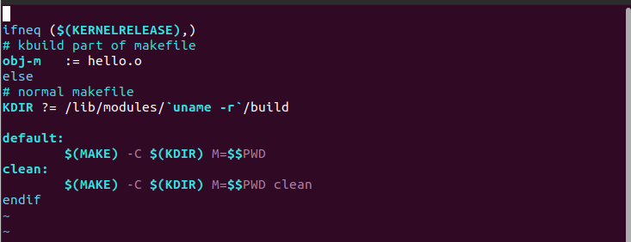

**Посилання на репозиторій:**

<https://github.com/AndreySoroka/Lab5>

**Результати виконання роботи:**

Приклад №1



Приклад №2

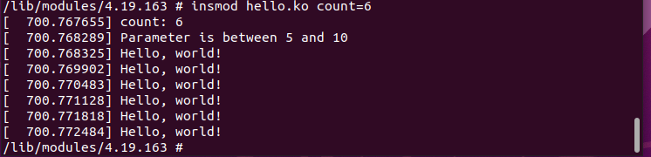

Приклад №3



Приклад №4

