НАЦІОНАЛЬНИЙ ТЕХНІЧНИЙ УНІВЕРСИТЕТ УКРАЇНИ

«КИЇВСЬКИЙ ПОЛІТЕХНІЧНИЙ ІНСТИТУТ»

ФАКУЛЬТЕТ ІНФОРМАТИКИ І ОБЧИСЛЮВАЛЬНОЇ ТЕХНІКИ

КАФЕДРА ОБЧИСЛЮВАЛЬНОЇ ТЕХНІКИ

**Лабораторна робота №7**

з дисципліни **«**Архітектура комп’ютерів 2**»**

Виконав:

студент 3 курсу

групи ІВ-82

Сорока Андрій

Перевірив:

Нікольський С. С.

Київ 2020 р.

**Лістинг програми:**

**hello.c**

/*

* Copyright (c) 2017, GlobalLogic Ukraine LLC

* All rights reserved.

*

* Redistribution and use in source and binary forms, with or without

* modification, are permitted provided that the following conditions are met:

* 1. Redistributions of source code must retain the above copyright

* notice, this list of conditions and the following disclaimer.

* 2. Redistributions in binary form must reproduce the above copyright

* notice, this list of conditions and the following disclaimer in the

* documentation and/or other materials provided with the distribution.

* 3. All advertising materials mentioning features or use of this software

* must display the following acknowledgement:

* This product includes software developed by the GlobalLogic.

* 4. Neither the name of the GlobalLogic nor the

* names of its contributors may be used to endorse or promote products

* derived from this software without specific prior written permission.

*

* THIS SOFTWARE IS PROVIDED BY GLOBALLOGIC UKRAINE LLC `AS IS` AND ANY

* EXPRESS OR IMPLIED WARRANTIES, INCLUDING, BUT NOT LIMITED TO, THE IMPLIED

* WARRANTIES OF MERCHANTABILITY AND FITNESS FOR A PARTICULAR PURPOSE ARE

* DISCLAIMED. IN NO EVENT SHALL GLOBALLOGIC UKRAINE LLC BE LIABLE FOR ANY

* DIRECT, INDIRECT, INCIDENTAL, SPECIAL, EXEMPLARY, OR CONSEQUENTIAL DAMAGES

* (INCLUDING, BUT NOT LIMITED TO, PROCUREMENT OF SUBSTITUTE GOODS OR SERVICES;

* LOSS OF USE, DATA, OR PROFITS; OR BUSINESS INTERRUPTION) HOWEVER CAUSED AND

* ON ANY THEORY OF LIABILITY, WHETHER IN CONTRACT, STRICT LIABILITY, OR TORT

* (INCLUDING NEGLIGENCE OR OTHERWISE) ARISING IN ANY WAY OUT OF THE USE OF THIS

* SOFTWARE, EVEN IF ADVISED OF THE POSSIBILITY OF SUCH DAMAGE.

*/

#include <linux/init.h>

#include <linux/module.h>

#include <linux/moduleparam.h>

#include <linux/printk.h>

#include <linux/types.h>

#include <linux/slab.h>

#include <linux/ktime.h>

struct head_list {

struct head_list *next;

ktime_t time;

};

MODULE_AUTHOR("Soroka Andrey");

MODULE_DESCRIPTION("Lab7_hello_world_output");

MODULE_LICENSE("Dual BSD/GPL");

static struct head_list *head;

static uint count = 1;

module_param(count,uint,S_IRUGO);

MODULE_PARM_DESC(count, "variable for quantity of hello world output");

static int __init init(void)

{

uint i = 0;

struct head_list *var_1, *var_2, *m, *var;

head = kmalloc(sizeof(struct head_list *), GFP_KERNEL);

var_1 = head;

if(count == 0) {

pr_warn("Parametr=0");

}else if(count >=5 && count <= 10) {

pr_warn("Parametr is between 5 and 10");

}

BUG_ON(count>10);

for(i = 0; i < count; i++){

m = kmalloc(sizeof(struct head_list), GFP_KERNEL);

if (i == 7){

m = NULL;

}

if (ZERO_OR_NULL_PTR(m)){

pr_err("No memory available");

while (head != NULL && count != 0) {

var = head;

head = var->next;

kfree(var);

}

BUG_ON(!m);

return -ENOMEM;

}

var_1->time = ktime_get();

pr_info("Hello, world!\n");

var_2 = var_1;

var_1 = m;

}

if (count != 0) {

kfree(var_2->next);

var_2->next = NULL;

}

pr_info("count: %d\n", count);

return 0;

}

static void __exit exit(void)

{

struct head_list *var;

while (head != NULL && count != 0) {

var = head;

pr_info("Time: %lld", var->time);

head = var->next;

kfree(var);

}

pr_info("");

}

module_init(init);

module_exit(exit);

**MakeFile**

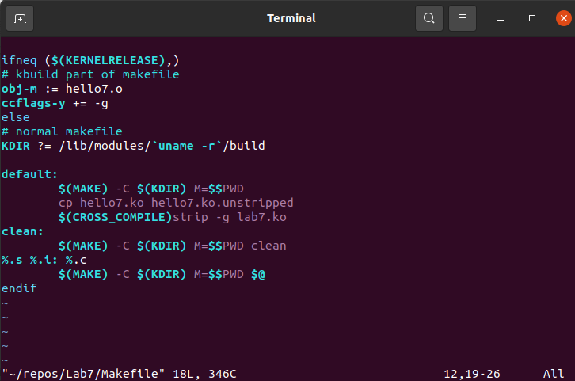

**Посилання на репозиторій:**

https://github.com/AndreySoroka/Lab7

**Результати виконання роботи:**

**Repeat=12**

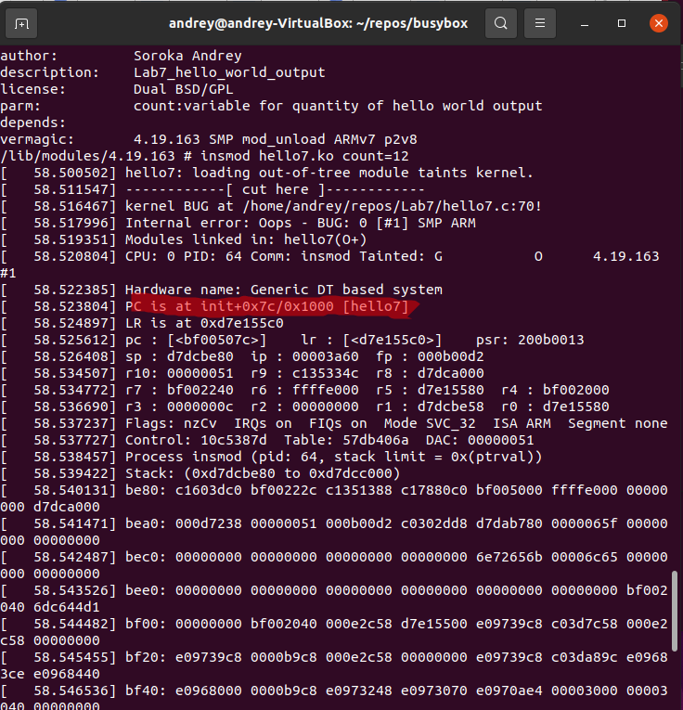

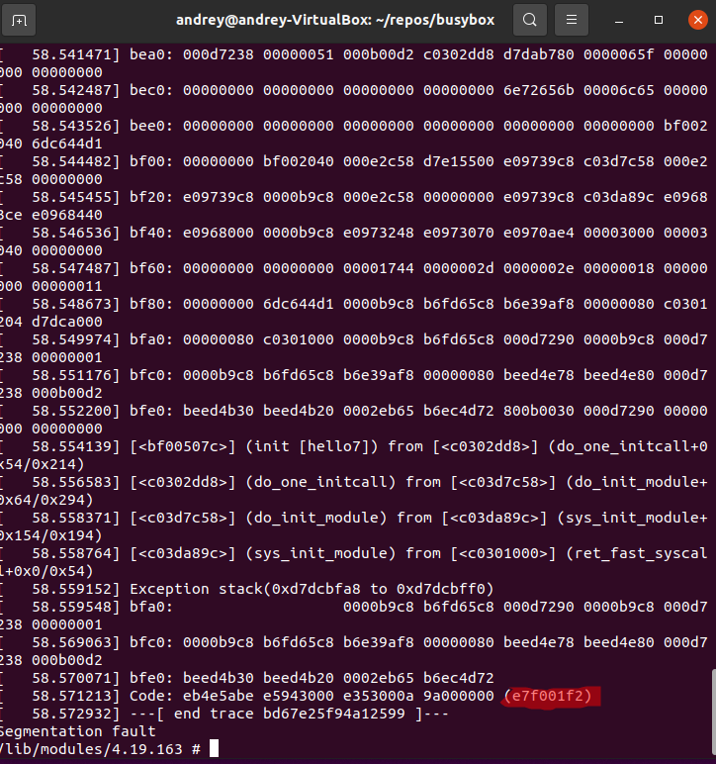

**Пошук місця аварії**

