3) Подготовить DDL скрипты и создать свою базу в СУБД.

**create** **schema** **if** **not** **exists** pm

**create** **table** **if** **not** **exists** pm.project (

project_id **integer** **not** **null** **primary** **key**,

project_name **varchar**(128) **not** **null**,

project_priority **integer** **not** **null**,

project_status **integer** **not** **null**

)

**create** **table** **if** **not** **exists** pm.users_team (

cmd_id **integer** **primary** **key**,

cmd_name **varchar**(128),

project_id **integer**,

**foreign** **key** (project_id) **references** pm.project (project_id),

team_lid **varchar**(128) **not** **null**,

users_cnt **integer** **not** **null**

)

**create** **table** **if** **not** **exists** pm.**user** (

user_id **integer** **not** **null** **primary** **key**,

user_name **varchar**(128) **not** **null**,

cmd_id **integer**,

**foreign** **key** (cmd_id) **references** pm.users_team (cmd_id)

)

**create** **table** **if** **not** **exists** pm.project_user (

user_id **integer** **primary** **key**,

**foreign** **key** (user_id) **references** pm.**user** (user_id),

project_id **integer**,

**foreign** **key** (project_id) **references** pm.project (project_id)

)

**create** **table** **if** **not** **exists** pm.project_materials (

project_id **integer** **primary** **key**,

**foreign** **key** (project_id) **references** pm.project (project_id),

project_disc **varchar**(512) **not** **null**,

project_doc **varchar**(512) **not** **null**

)

**create** **table** **if** **not** **exists** pm.project_changes (

project_id **integer** **primary** **key**,

**foreign** **key** (project_id) **references** pm.project (project_id),

user_id **integer**,

**foreign** **key** (user_id) **references** pm.**user** (user_id),

last_chng_time **date** **not** **null**

)

**create** **table** **if** **not** **exists** pm.project_deadlines (

project_id **integer** **primary** **key**,

**foreign** **key** (project_id) **references** pm.project (project_id),

start_date **date** **not** **null**,

deadline_date **date**

)

**create** **table** **if** **not** **exists** pm.used_systems (

project_id **integer** **primary** **key**,

**foreign** **key** (project_id) **references** pm.project (project_id),

main_language **varchar**(128) **not** **null**,

add_language **varchar**(128),

add_systems **varchar**(128)

)

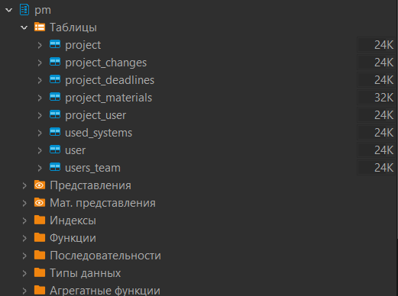

4) Наполнить созданную базу данными, ~10 записей в каждой таблице. По крайней мере по 1 строке в каждой таблице должно быть добавлено с использованием INSERT.

**insert** **into** pm.project (project_id, project_name, project_priority, project_status)

**values**

(0, '"Квантория"', 5, 0),

(1, '"Цифровой переворот"', 4, 0),

(2, '"Интеллектуальный прорыв"', 2, 1),

(3, '"Оптимизация техпроцессов"', 9, 3),

(4, '"Платформа инноваций"', 1, 1),

(5, '"Кибербезопасность+"', 0, 2),

(6, '"Интегральные решения"', 6, 1),

(7, '"Приложения будущего"', 7, 0),

(8, '"Автоматизированные системы"', 8, 2),

(9, '"Нейронные сети для анализа данных"', 3, 0)

**insert** **into** pm.users_team (cmd_id, cmd_name, project_id, team_lid, users_cnt) **values**

(0, 'ПКЛПО', 9, 'Екатерина Иванова', 3),

(1, **null**, 3, 'Александр Федоров', 2)

**insert** **into** pm.**user** (user_id, user_name, cmd_id) **values**

(0, 'Андрей Беляков', **null**),

(1, 'Екатерина Иванова', 0),

(2, 'Владимир Смирнов', 0),

(3, 'Ольга Ковалева', 0),

(4, 'Денис Петров', **null**),

(5, 'Марина Сергеева', **null**),

(6, 'Игорь Морозов', 1),

(7, 'Татьяна Павлова', **null**),

(8, 'Александр Федоров', 1),

(9, 'Наталья Шестакова', **null**)

**insert** **into** pm.project_user (user_id, project_id) **values**

(0, 2),

(1, 9),

(2, 9),

(3, 9),

(4, 4),

(5, 1),

(6, 3),

(7, 3),

(8, 3),

(9, 4)

**insert** **into** pm.project_materials (project_id, project_disc, project_doc) **values**

(0, 'https://jija.com/project0', 'https://docs.google.com/project0'),

(1, 'https://jija.com/project0', 'https://docs.google.com/project1'),

(2, 'https://jija.com/project2', 'https://docs.google.com/project2'),

(3, 'https://jija.com/project3', 'https://docs.google.com/project3'),

(4, 'https://jija.com/project4', 'https://docs.google.com/project4'),

(5, 'https://jija.com/project5', 'https://docs.google.com/project5'),

(6, 'https://jija.com/project6', 'https://docs.google.com/project6'),

(7, 'https://jija.com/project7', 'https://docs.google.com/project7'),

(8, 'https://jija.com/project8', 'https://docs.google.com/project8'),

(9, 'https://jija.com/project9', 'https://docs.google.com/project9')

**insert** **into** pm.project_changes (project_id, user_id, last_chng_time) **values**

(0, 2, '2023-01-01'),

(1, 5, '2023-02-01'),

(2, 0, '2023-01-11'),

(3, 7, '2023-03-03'),

(4, 9, '2022-11-01'),

(5, 5, '2023-01-23'),

(6, 5, '2023-02-28'),

(7, 4, '2023-04-03'),

(8, 1, '2023-04-11'),

(9, 3, '2023-05-24')

**insert** **into** pm.project_deadlines (project_id, start_date, deadline_date) **values**

(0, '2022-01-01', '2024-01-01'),

(2, '2022-02-01', **null**),

(3, '2022-03-01', **null**),

(4, '2022-04-01', **null**),

(5, '2022-05-01', '2023-12-01'),

(6, '2022-06-01', '2024-12-01'),

(7, '2022-07-01', '2024-04-01'),

(8, '2022-08-01', '2024-06-06'),

(9, '2022-09-01', '2023-07-01')

**insert** **into** pm.used_systems (project_id, main_language, add_language, add_systems)

**values**

(0, 'C#', 'C++', 'Azure'),

(1, 'C++', **null**, 'GitLab'),

(2, 'C++', **null**, **null**),

(3, 'Python', **null**, **null**),

(4, 'GO', 'Pyhon', **null**),

(5, 'Rock', 'C++', 'Aboba'),

(6, 'Ruby', 'Java', 'GitLab'),

(7, 'C++', 'C#', 'Azure'),

(8, 'C#', **null**, 'GitLab'),

(9, 'C#', **null**, **null**)

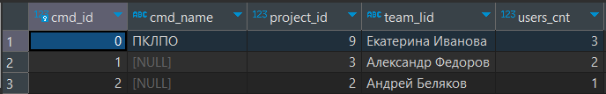

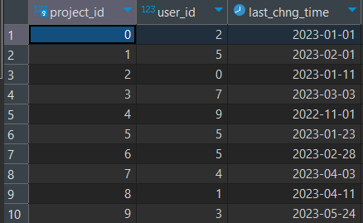

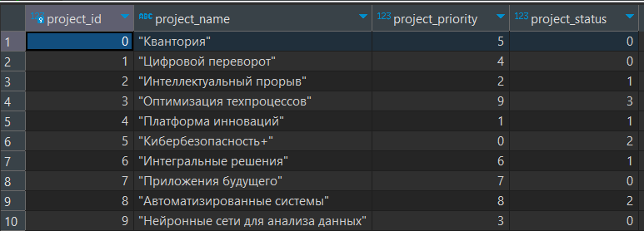

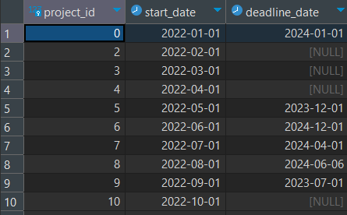

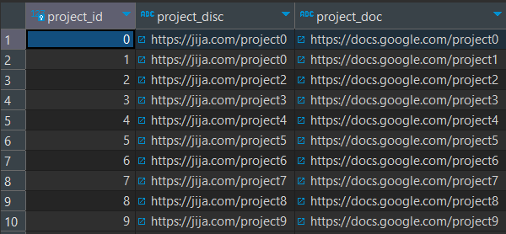

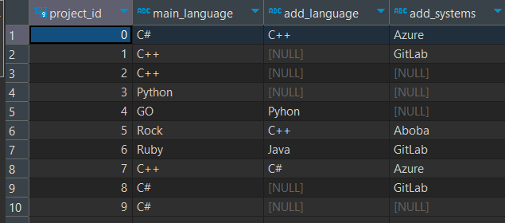

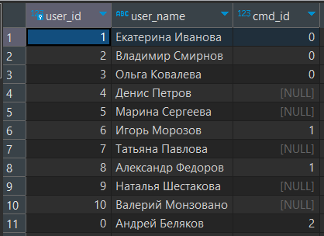

5) Написать не менее 10 INSERT, SELECT, UPDATE, DELETE запросов. Загуглить, что такое CRUD-запросы. Найти соответствие

**select** * **from** pm.**user**

**select** * **from** pm.project_changes

**order** **by** pm.project_changes.last_chng_time

**insert** **into** pm.**user** (user_id, user_name, cmd_id) **values**

(10, 'Валерий Монзовано', **null**)

**insert** **into** pm.project_user (user_id, project_id) **values**

(10, 4)

**delete** **from** pm.project

**where** pm.project.project_status = 4

**update** pm.**user**

**set** cmd_id = 2

**where** user_id = 0

**insert** **into** pm.users_team (cmd_id, cmd_name, project_id, team_lid, users_cnt) **values**

(2, **null**, (**select** project_id **from** pm.project_user **where** pm.project_user.user_id = 0),

(**select** user_name **from** pm.**user** **where** pm.**user**.user_id = 0), 1)

**update** pm.project_user

**set** project_id = 0

**where** project_id = 4

**select** user_name **from** pm.**user**

**where** cmd_id **notnull**

**select** cmd_name **from** pm.users_team

**where** cmd_name **notnull**

6) Написать осмысленные SELECT запросы

**select** project_name **as** **name**, project_status **as** status **from** pm.project p

**group** **by** project_status, project_name **having** project_status >= 1

**select** user_name **as** **name**,

(**select** cmd_name **from** users_team ut

**where** ut.cmd_id = u.cmd_id) **as** command_name **from** pm.**user** u

**where** cmd_id **notnull**

**select** (**select** user_name **from** pm.**user** u **where** u.user_id = pc.user_id) **as** **name** ,

last_chng_time **as** change_time, **row_number**() **over**() **as** **numeric** **from** pm.project_changes pc

**select** (**select** project_name **from** pm.project p **where** p.project_id = pc.project_id) **as** name_of_project,

(**select** user_name **from** pm.**user** u **where** u.user_id = pc.user_id) **as** name_of_last_editor,

**lag**(user_id) **over**() **as** id_of_previous_editor **from** pm.project_changes pc

**order** **by** id_of_previous_editor **desc**

