Mazes 3D

Your Game Logo

Here

***‘Big brain game can you handle’*** - you

This page: Table of Contents and Team Member Listing

|  |  |  |
| --- | --- | --- |
| Table of Contents  [1 Game Overview](https://n-xovwktmtjsnaxyc2mwes2xu7pohqedmdm6zjw5q-2lu-script.googleusercontent.com/userCodeAppPanel)  [2 High Concept](https://n-xovwktmtjsnaxyc2mwes2xu7pohqedmdm6zjw5q-2lu-script.googleusercontent.com/userCodeAppPanel) / Genre  [3 Unique Selling Points](https://n-xovwktmtjsnaxyc2mwes2xu7pohqedmdm6zjw5q-2lu-script.googleusercontent.com/userCodeAppPanel)  [4 Platform Minimum Requirements](https://n-xovwktmtjsnaxyc2mwes2xu7pohqedmdm6zjw5q-2lu-script.googleusercontent.com/userCodeAppPanel)  [5 Competitors / Similar Titles](https://n-xovwktmtjsnaxyc2mwes2xu7pohqedmdm6zjw5q-2lu-script.googleusercontent.com/userCodeAppPanel)  [6 Synopsis](https://n-xovwktmtjsnaxyc2mwes2xu7pohqedmdm6zjw5q-2lu-script.googleusercontent.com/userCodeAppPanel)  [7 Game Objectives](https://n-xovwktmtjsnaxyc2mwes2xu7pohqedmdm6zjw5q-2lu-script.googleusercontent.com/userCodeAppPanel)  [8 Game Rules](https://n-xovwktmtjsnaxyc2mwes2xu7pohqedmdm6zjw5q-2lu-script.googleusercontent.com/userCodeAppPanel)  [9 Game Structure](https://n-xovwktmtjsnaxyc2mwes2xu7pohqedmdm6zjw5q-2lu-script.googleusercontent.com/userCodeAppPanel)  [10 Game Play](https://n-xovwktmtjsnaxyc2mwes2xu7pohqedmdm6zjw5q-2lu-script.googleusercontent.com/userCodeAppPanel)  [10.1 Game Controls](https://n-xovwktmtjsnaxyc2mwes2xu7pohqedmdm6zjw5q-2lu-script.googleusercontent.com/userCodeAppPanel)  [10.2 Game Camera](https://n-xovwktmtjsnaxyc2mwes2xu7pohqedmdm6zjw5q-2lu-script.googleusercontent.com/userCodeAppPanel)  [10.2.1 HUD](https://n-xovwktmtjsnaxyc2mwes2xu7pohqedmdm6zjw5q-2lu-script.googleusercontent.com/userCodeAppPanel)  [10.2.2 Maps](https://n-xovwktmtjsnaxyc2mwes2xu7pohqedmdm6zjw5q-2lu-script.googleusercontent.com/userCodeAppPanel)  [11 Players](https://n-xovwktmtjsnaxyc2mwes2xu7pohqedmdm6zjw5q-2lu-script.googleusercontent.com/userCodeAppPanel)  [11.1 Characters](https://n-xovwktmtjsnaxyc2mwes2xu7pohqedmdm6zjw5q-2lu-script.googleusercontent.com/userCodeAppPanel)  [11.2 Metrics](https://n-xovwktmtjsnaxyc2mwes2xu7pohqedmdm6zjw5q-2lu-script.googleusercontent.com/userCodeAppPanel)  [11.3 States](https://n-xovwktmtjsnaxyc2mwes2xu7pohqedmdm6zjw5q-2lu-script.googleusercontent.com/userCodeAppPanel)  [11.4 Weapons](https://n-xovwktmtjsnaxyc2mwes2xu7pohqedmdm6zjw5q-2lu-script.googleusercontent.com/userCodeAppPanel)  [12 Player Line-up](https://n-xovwktmtjsnaxyc2mwes2xu7pohqedmdm6zjw5q-2lu-script.googleusercontent.com/userCodeAppPanel)  [13 Art](https://n-xovwktmtjsnaxyc2mwes2xu7pohqedmdm6zjw5q-2lu-script.googleusercontent.com/userCodeAppPanel)  [13.1 Setting](https://n-xovwktmtjsnaxyc2mwes2xu7pohqedmdm6zjw5q-2lu-script.googleusercontent.com/userCodeAppPanel)  [13.2 Level Design](https://n-xovwktmtjsnaxyc2mwes2xu7pohqedmdm6zjw5q-2lu-script.googleusercontent.com/userCodeAppPanel)  [13.3 Audio](https://n-xovwktmtjsnaxyc2mwes2xu7pohqedmdm6zjw5q-2lu-script.googleusercontent.com/userCodeAppPanel)  [14 Wish List](https://n-xovwktmtjsnaxyc2mwes2xu7pohqedmdm6zjw5q-2lu-script.googleusercontent.com/userCodeAppPanel)  15 Bibliography   |  | | --- | |  | | Game Development Team Members    PRODUCER  Andrick Mercado, Majd Alkuree    PRODUCTION MANAGER  Andrick Mercado    PRODUCTION COORDINATOR  Andrick Mercado  GAME DESIGNERS  Andrick Mercado, Majd Alkuree  SYSTEMS/IT COORDINATOR  Andrick Mercado, Majd Alkuree  PROGRAMMERS  Andrick Mercado, Majd Alkuree, Wissam Kashat  TECHNICAL ARTISTS  Majd Alkuree  AUDIO ENGINEERS  Andrick Mercado, Wissam Kashat  UX TESTERS  Andrick Mercado, Majd Alkuree |

|  |
| --- |
|  |

# **1 Game Overview**

Title: Mazes 3D

Platform: PC Standalone,

Genre: Maze Game

Rating: (Everyone) ESRB

Target: Casual gamer (aging from 3- 14) that enjoys puzzles

Release date: December 2021

Publisher: Group 8

Description: In this 3D maze game, you are attempting to solve a maze without being able to look ahead like other maze games, so you will have to test every route and memorize them in order to exit the maze and win the game. The main objective is to finish the maze in a given period of time depending on difficulty, it would be the same maze but less time given to the player.

# 2 High Concept / Genre

Mazes 3D attempts to engage its users with mazes that look engaging and allows to look ahead into the maze depending on what difficulty the user selects, why are you attempting to finish the maze you may ask, well you want to get home and sadly you have to pass the maze in order to go back home, while your main objective is to achieve this in the less time possible.

# 3 Unique Selling Points

* B engaged by the music and sound effects
* Try to beat your previous times in maze you’ve never done
* Customization for your name and timer color

# 4 Platform Minimum Requirements

PC, MAC, and LINUX STANDALONE

Any modern computer should work perfectly fine

# 5 Competitors / Similar Titles

There’s many similar 3D maze games, however they don’t have a 3rd point of view and our games does as well as better movement.

# 6 Synopsis

One day you wake up in a mysterious grassy area and have to pass through a maze in order to reach your destination which is your house in this case, help him move through the maze in order to go back home in the fastest time possible.

# 7 Game Objectives

The objective of this game is to escape the maze in the fastest time possible because you are trying to get home in the fastest time possible.

# 8 Game Rules

When you press play you have to make your own character settings, which in this case are the name and color as well as the difficulty level which is illustrated by the mazes, this game has regular wasd controls and camera move according to that movement.

# 9 Game Structure

# 10 Game Play

## 10.1 Game Controls

Game uses regular wasd controls for character movement as well as for the camera

## 10.2 Game Camera

Camera moves to where the character is looking at

### 10.2.1 HUD

Timer that display current time including microseconds

### 10.2.2 Maps

Easy Maze

Medium Maze

Hard Maze

# 11 Players

## 11.1 Characters

You’re an ordinary human that is lost

## 11.2 Metrics

Speed: Slow only walks

Max Health: N/A

Attack Damage: N/A

Time to Attack: N/A

## 11.3 States

Idle: Moves his shoulders and body to simulate idle movement

Forward: Walking forward animation

Backwards: walking backwards animation

Rotating Left: rotates feet to the left

Rotating Right: rotates feet to the right

## 11.4 Weapons

N/A

# 12 Player Line-up

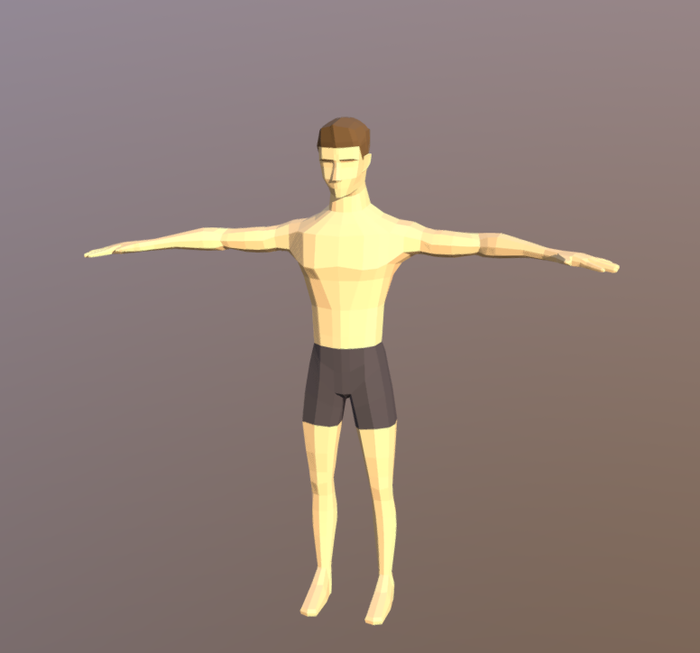

# 14 Art

## 14.1 Setting

Emptiness just a sky with clouds

## 14.2 Level Design

Each Level will consist of different sceneries as well as new maze design that difficulty depends on user desired difficulty

## 14.3 Audio

|  |  |  |
| --- | --- | --- |
| Name | Category | Description |
| Character_Maker_Music | FX | For char maker scene |
| Level_1_Music (easy/medium/hard) | FX | Music for level 1 |
| Win_music | FX | Music when player wins |
| Menu_Music | FX | Menu music |

# 16 Wish List

Better Art

The art made by our group could had been better as well as the materials used in the maze

More Levels

We only implemented 1 level for each difficulty so clearly more levels would had been needed

Better Camera Movement

Our current camera doesn’t quite move as smoothly as we wanted to, since we just attached the camera to the character it moves to sharp

Made Own Character

Current character was taken from the internet, so we wanted to learn to use blnder and make our own character

Better Scaling

Better scaling of objects to different scenes

## 17 Bibliography

Grass.jpg

https://pixabay.com/photos/grass-lawn-field-meadow-grassy-84622/

Maze_Blueprint.png

https://thenounproject.com/legal/creator-terms/icons/

source: https://thenounproject.com/term/maze/

BrickWall.jpg

https://besthqwallpapers.com/textures/decorative-stone-texture-green-brickwall-macro-green-bricks-bricks-textures-103692

Panels for Winning made by Andrick Mercado using adobe fresco

Character from this website, free to use

https://sketchfab.com/3d-models/low-poly-male-character-free-download-634469944b1f4778940da77b72deb439

animations were made with mixamo.com

Background Designs were created in Paint by Majd Alkuree

Menu ideas captured from my old projects (Majd Alkuree)

All audio was taken from pixabay.com which states all files are free to use for any usage

Scripts by Andrick Mercado

FinishLine: Implements code for when player reaches the finish line in this case the end of the maze

Timer: Implements the timer script for the user reference

AnimationStateController: determines what animation is shown based on user input

Scripts by Majd Alburee

MainMenu: holds properties for the menu screen

Menu_char: holds properties for character selection scene

Pause_menu: holds properties for pause menus

SettingsMenu: Holds properties for the settings part of the menu

Scripts by Wissam Kashat

AudioManager: holds properties for controlling the audio of each scene

Sound: holds properties for each audio clip volume, pitch, loop