**Task 1**

**Using relay recreate blink program using high voltage bulb as output.**

void setup()

{

pinMode(13, OUTPUT);

}

void loop()

{

digitalWrite(13, HIGH);

delay(1000);

digitalWrite(13, LOW);

delay(1000);

}

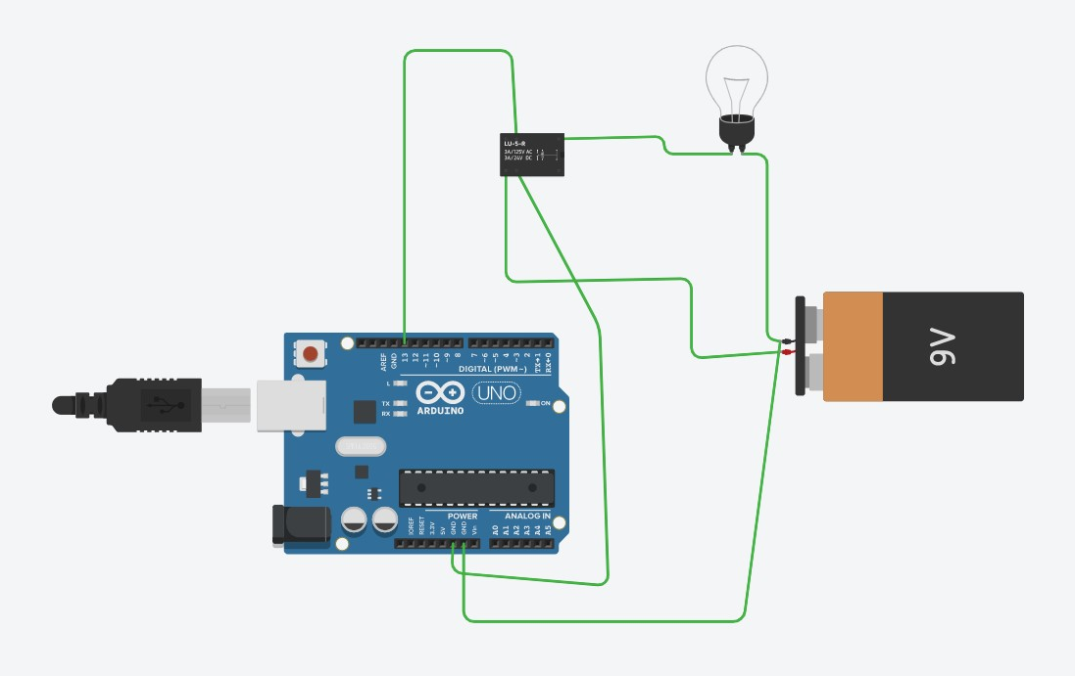

**Task 2**

**Create the same circuit like above but using transistor key instead of relay**

void setup()

{

pinMode(13, OUTPUT);

}

void loop()

{

digitalWrite(13, HIGH);

delay(1000);

digitalWrite(13, LOW);

delay(1000);

}

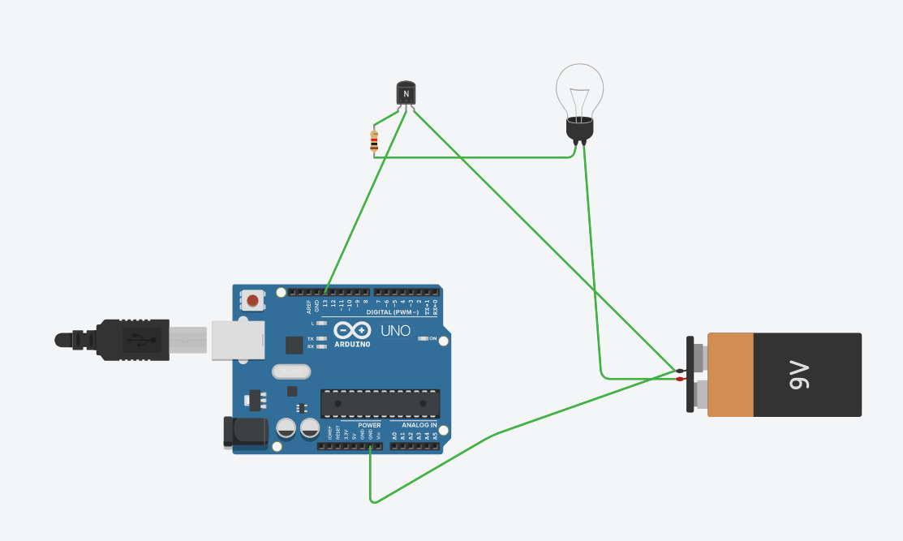

**Task 3**

**Create circuit analog to the one from LAB 7 but using DC motor with encoder. Please use**

**interrupts to read encoder in your code.**

