Appointments

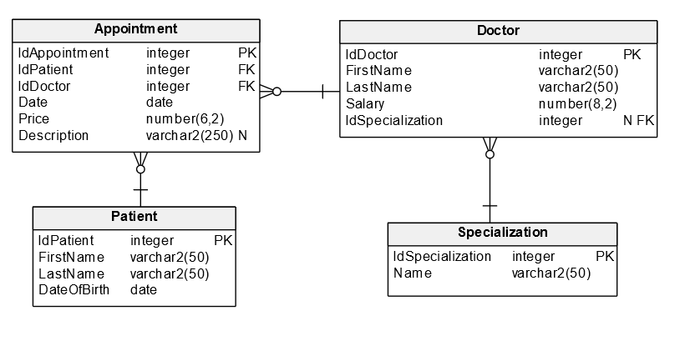

## Prepare SQL statements for the following tasks:

1. For each patient, calculate how much he spent on visits with doctors with the "internist" specialization. Display the name of the patient.
2. Display the most expensive visit for each doctor. Show doctor's name and surname. Exclude doctors who had less than three appointments.
3. List first names and last names (without repetitions) of doctors who worked with patient Kowalski (LastName).
4. For each patient, show his last name and date of the first appointment that has no desctiption.
5. Find the total costs of appointments in 2012 for each specialization. Include the name of the specialization in results.
6. Remove from the database patients who have never had a visit.
7. List the data doctors with salary lower than 3 000, with specializations beginning with the letter "P". The result should have the following form: first and last name of the doctor in one field, labeled with the heading "Doctor".
8. List all doctors, who had more visits than the average in their specialization.
9. Display the total amount spent by patient Kowalski. Show his last name and number of appointments.
10. List all patients (first name, last name, date of birth) who meet both requirements:

* Had at least 5 appointments with dentists (specialization)
* Paid at least 1000 for appointments with orthopedists.