Explanatory Note to the Detailed Design (TRP)

Teams Call Records Integration (TCRI) — Unified Engineering Specification
Revision: TRP-1.5.1 for Owner Approval · 21 October 2026. Platform: .NET 8 / C# 12 / EF Core 8 / SQLite. Repository: teams-call-records-integration. Normative basis: approved Technical Requirements Specification (TRS) v1.0 and Preliminary Design (PD) v1.1.
Status: DRAFT FOR OWNER APPROVAL; NOT APPROVED BY THE OWNER. Code presented in this document is not deemed implemented; automated test results are expected outcomes, not actual results. The Digital Polygraph production environment is not modified.

Provenance and Precedence Rules
- Sections 3.1–3.8 are based on Part 1 of the independently reviewed detailed-design draft and incorporate agreed amendments to the file tree and SQL queue. Golden samples G01–G11 are retained with all JSON documents.
- Sections 3.9–3.21 have been checked against the authentic Infrastructure v0.2 Markdown (e9425fc7…), adopted as a normative source. Later integration changes are marked [P-26]/[P-27] and listed in Appendix I. RV-01 concerning source availability has been closed; exact byte-for-byte equivalence of the sections is not claimed because registered changes were made.
- Sections 3.22 onward, including Host, security, deployment, diagrams, and end-to-end tests, were developed independently as proposed design decisions. Until approved, they do not have the status of decisions made by the owner.
- If sections of this document conflict, the order of precedence is: approved TRS → approved PD → the more detailed normative contract of this TRP. Any discrepancies identified before implementation are entered in the design decision register (appendix).

Completeness and Provenance Control (TRP-1.5.1)
Authentic baseline sources: approved TRS v1.0 and PD v1.1; Part 1 of TRP v0.1 after review; authentic Part 2 Infrastructure v0.2, SHA-256 e9425fc7aae50113be4ecdf46eaf8c8393b5a734f328e9e925739d14d33cb8d3, received in full and compared section by section with v1.4. Verbatim equivalence of passages changed after v0.2 is not asserted; the complete list appears in Appendix I.
Integration design proposals: the inbox index conflict model; clarification of NeedsFetch(force); logging of rejected hashes; handling malformed Graph JSON; revised S14/S15 golden samples; Host configuration; and the test plan. These decisions are submitted for approval; they do not supersede the approved TRS or PD and have not been verified by running C# code.
Register of blocking checks before approval (taking the TRP-1.1 review into account): RV-01 — documentary comparison with authentic v0.2 completed; RV-02 — run restore/build/test for the target .NET 8 solution; RV-03 — perform tenant-contract checks for Microsoft Graph and the Teams app manifest; RV-04 — check transactions and concurrent retries against actual SQLite; RV-05 — settle outstanding owner decisions (P-13, P-14, P-20, P-22, hosting site, tenant). Until these checks have been completed, the document remains a candidate for approval only.

Review Finding Closure Control for TRP-1.2 (TRP-1.5 Revision)
Independent Review Finding | TRP-1.5 Change | Acceptance Check
Figures 11–24 Without Arrows | New exporter reads actual Mermaid ->> / -->> and renders messages and branches | Check ≥1 arrow and messages in every PNG/PDF page
Figures 4–10 Missing from MD / Old Versions in PDF | Seven updated Mermaid diagrams added to the relevant §§3.12–3.17 | 24 graphic blocks in MD; 24 images in DOCX, all re-rendered
Missing .dockerignore | Full normative file in §3.34; paths included in register | Exclude .env, SQLite, and bin/obj from Docker context
GetStatsAsync Inconsistency | tenantId in interface, Host, diagram, and parameterized SQLite query | SQLite COUNT(DISTINCT call_id) with tenant_id filter
Obsolete D04 in §3.28 | One original G01 v3, only session end is missing | S05(b), §3.33, and D04 JSON are consistent
Undefined Bot/Teams SDK | Microsoft.Teams.Apps 2.1.1 (net8.0) and AzureAd schema | restore/build + JWT tests are mandatory and not claimed executed
Webhook mixed batch / unknown subscription | Per-item behaviour defined, 503 for temporarily unknown subscription | K12 plus regression tests
Graph Reprocess Inside HTTP | Durable 202 job, background execution, ≤7-day period, and lease renewal | /api/reprocess regression tests
Incomplete CI Script List | Normative contents/verification rules in §3.34.9a | Artifact scripts checked in CI
Infrastructure v0.2 Source Comparison | RV-01 closed by SHA and section-by-section comparison | Registered deviations in Appendix I
Evidence boundary: this document is a specification. Schema checks, the test register, and visual inspection of the PDF/DOCX build do not establish that .NET builds or Graph/Teams tests have run. [P-25] (DR-16) reproduces the original v0.2 rule and does not require a new decision; proposals [P-26]–[P-28] remain subject to approval. No code has been implemented in production.

Contents and Scope
- 3.1–3.8: Core F6, data schema, G01–G11, Core tests.
- 3.9–3.21: Infrastructure, Graph, inbox/outbox, source state, recovery, tests.
- 3.22–3.31: consolidated file register, Host and routes, authentication, bot, lifecycle, states, sequences.
- 3.32–3.37: operations, security, interfaces, proposed CI, K1–K15 test protocol, decision register.
- 4–5: technical and economic indicators and primary sources.
Readiness rule: after approval, implementation must not change public contracts or the schema without a registered TRP change request; external Microsoft Graph restrictions requiring a live tenant are checked using previously defined procedures.

1. Introduction
TCRI is a standalone Microsoft Teams/Graph application that receives notifications, reads callRecord data, produces one CDR per session, stores versions, and supports REST/bot queries and notifications. It was developed independently of DP (Digital Polygraph). This explanatory note follows the five principal sections of GOST 19.404-79; additional design sections appear in Section 3 and the appendices.

2. Purpose and Scope
A unified specification for building and testing a software product using Microsoft Entra ID app-only authentication and the minimum necessary Microsoft Graph/RSC permissions. The product does not sell call data, does not record call media, and does not use proprietary Nokia/ZTE/Ericsson CDRs.

3. Technical Characteristics

3.0. Approved Architecture and Processing-Flow Diagrams
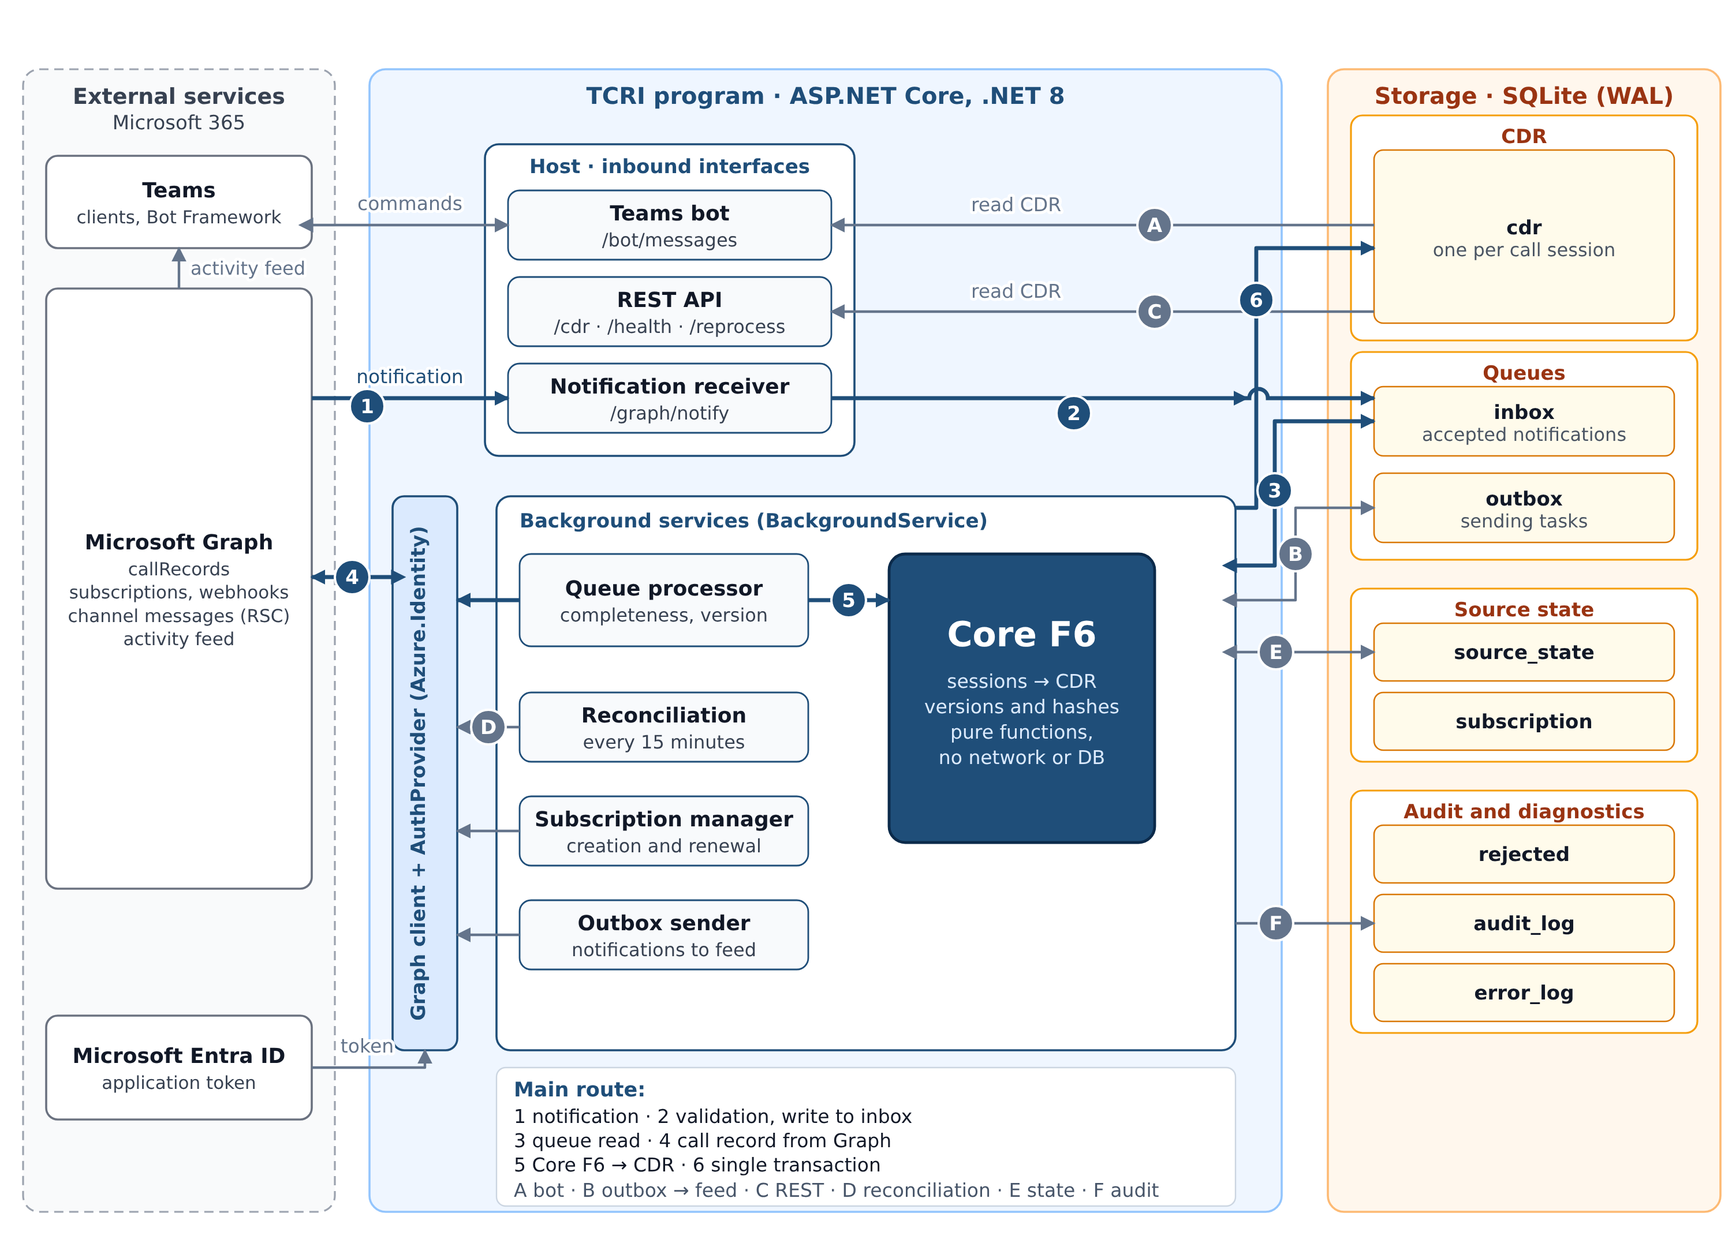
Figure 1. TCRI structural architecture. Original diagram from approved Preliminary Design v1.1: Microsoft 365/Graph/Entra ID → Webhook/Graph Client/Core F6/Bot/REST → SQLite (cdr, source_state, inbox, outbox, audit/diagnostics). The Word/PDF document embeds the image from the approved explanatory note; the same components are represented below in machine-readable form.
Figure 2. Converting a Teams notification into a CDR and a notification. Adopted principle: completeness and version checks precede any CDR update; pending does not delete previously accepted CDRs. Updated Infrastructure clarifications are reflected in the sequences in §§3.12–3.31.
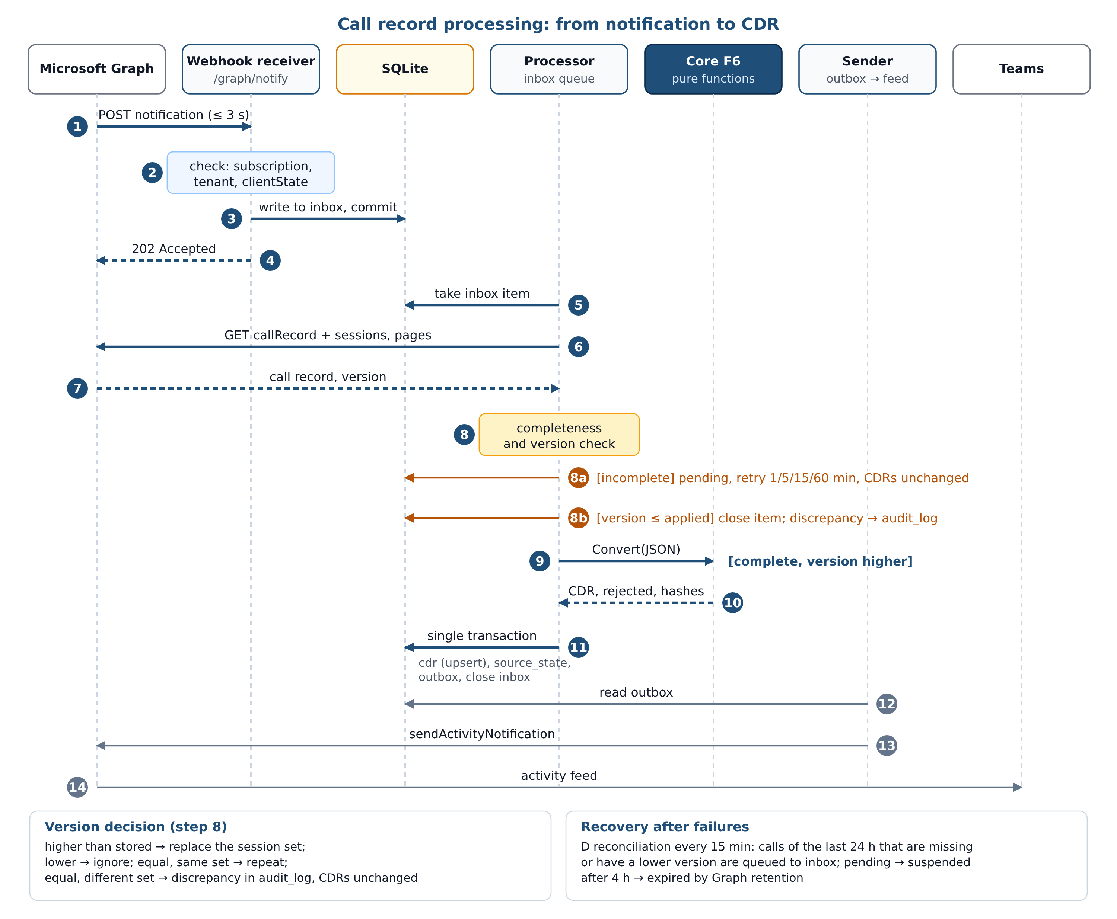

3.1. Conventions and Entity Register
Naming conventions [P]:
Scope | Rule | Example
Root Namespace | TeamsCallRecords + project name | TeamsCallRecords.Core
C# File | File name matches the primary public type | CallRecordConverter.cs
Exception | Models.cs contains several small model types | Cdr, PartyRef, Rejection
Interfaces | I prefix | IGraphClient
SQLite Tables and Columns | snake_case; names fixed in 3.5 | source_state
Database Row Properties | Column name converted to PascalCase | SourceVersion ↔ source_version
Contract JSON | snake_case | duration_s
Setting Keys | PascalCase, : separator | Inbox:MaxPending
Test Files | <Type>Tests.cs; methods Condition_Expectation | Duration_RoundsHalfUp
Time in Database Text and JSON | ISO 8601 UTC, 7 fractional digits, Z suffix | 2026-10-20T09:00:00.5000000Z
Project register.
Code | Project | Namespace | Part
PRJ-CORE | src/TeamsCallRecords.Core | TeamsCallRecords.Core | 1
PRJ-INF | src/TeamsCallRecords.Infrastructure | TeamsCallRecords.Infrastructure | 2
PRJ-HOST | src/TeamsCallRecords.Host | TeamsCallRecords.Host | 3
PRJ-CORE-T | tests/TeamsCallRecords.Core.Tests | TeamsCallRecords.Core.Tests | 1
PRJ-INF-T | tests/TeamsCallRecords.Infrastructure.Tests | TeamsCallRecords.Infrastructure.Tests | 2
PRJ-HOST-T | tests/TeamsCallRecords.Host.Tests | TeamsCallRecords.Host.Tests | 3
SQLite table register (details in 3.5): cdr, source_state, inbox, rejected, audit_log, outbox, subscription, error_log.
Rejection code register (RejectionCodes; rejected.code table):
Constant | Value | Scope
BadJson | CALLRECORD_BAD_JSON | record
NoCallId | CALLRECORD_NO_ID | record
NoVersion | CALLRECORD_NO_VERSION | record
SessionNoId | SESSION_NO_ID | session
SessionBadDate | SESSION_BAD_DATE | session
SessionEndBeforeStart | SESSION_END_BEFORE_START | session
SessionDuplicateId | SESSION_DUPLICATE_ID | session, new code [P]
Incomplete-reason register (IncompleteReasons; ConversionResult.IncompleteReasons):
Constant | Value | Class
NoSessions | NO_SESSIONS | transient
SessionDatesMissing | SESSION_DATES_MISSING | transient
SessionInvalid | SESSION_INVALID | permanent for this version
For Bad results (record-level errors), IncompleteReasons receives the rejection code from the register above; the classification is permanent.

3.2. Repository Tree
Complete repository inventory. Column “Part” identifies the part of the detailed design that fully describes the file. The file contents of Parts 2–4 are not repeated here, but their names and purposes are fixed here and must not be changed.
Path | Purpose | Part
TeamsCallRecords.sln | decision | 1
global.json | pins SDK 8.0.x, rollForward: latestFeature | 4
Directory.Build.props | common properties: TargetFramework=net8.0, Nullable, ImplicitUsings, TreatWarningsAsErrors=true, LangVersion=12 | 4
Directory.Packages.props | central package versions | 4
.editorconfig | formatting rules | 4
.gitignore | exceptions | 4
LICENSE | MIT license [P-06] | 4
README.md | deployment and test scenario | 4
HANDOFF.md | handover between implementers | 4
.dockerignore | exclude secrets and temporary files from Docker build context | 4
Dockerfile | application image | 4
docker-compose.yml | launch the application and Caddy | 4
Caddyfile | reverse proxy, TLS | 4
.env.example | example environment variables with placeholders | 4
.github/workflows/ci.yml | build and test on .NET 8 | 4
teams-app/manifest.json | Teams application manifest with RSC | 4
teams-app/color.png | color icon | 4
teams-app/outline.png | outline icon | 4
docs/explanatory-note-ru.docx | explanatory note (Preliminary Design v1.1, RU) | 4
docs/explanatory-note-en.docx | the same, EN | 4
docs/figures/fig1.svg | diagram 1 source | 4
docs/figures/fig2.svg | diagram 2 source | 4
docs/figures/fig3.svg | diagram 3 source (CallRecordConverter.Convert sequence) | 4
docs/test-protocol.md | test protocol | 4
docs/permissions.md | Graph and RSC permissions register | 4
src/TeamsCallRecords.Core/TeamsCallRecords.Core.csproj | project with no external packages | 1
src/TeamsCallRecords.Core/Models.cs | CallType, CdrStatus, AggregationStatus, PartyRef, Cdr, Rejection, RejectionCodes, IncompleteReasons, ConversionResult | 1
src/TeamsCallRecords.Core/Canonical.cs | Canonical: canonical JSON and hashes | 1
src/TeamsCallRecords.Core/VersionRules.cs | VersionAction, VersionRules: version decision, rounding | 1
src/TeamsCallRecords.Core/CallRecordConverter.cs | CallRecordConverter.Convert | 1
src/TeamsCallRecords.Core/CdrJson.cs | CdrJson: JSON representation of CDR and result | 1
src/TeamsCallRecords.Infrastructure/TeamsCallRecords.Infrastructure.csproj | project | 2
src/TeamsCallRecords.Infrastructure/InfrastructureRegistration.cs | Infrastructure DI registration | 2
src/TeamsCallRecords.Infrastructure/Data/TcriDbContext.cs | TcriDbContext | 2
src/TeamsCallRecords.Infrastructure/Data/IWriteGate.cs | write-gate contract | 2
src/TeamsCallRecords.Infrastructure/Data/WriteGate.cs | WriteGate: serialized writes | 2
src/TeamsCallRecords.Infrastructure/Data/SqlitePragmaInterceptor.cs | SqlitePragmaInterceptor: PRAGMA upon connection open | 2
src/TeamsCallRecords.Infrastructure/Data/UtcText.cs | UtcText: database timestamp format | 1
src/TeamsCallRecords.Infrastructure/Data/Cursor.cs | REST cursor encoding and decoding | 2
src/TeamsCallRecords.Infrastructure/Data/CdrMapping.cs | CdrMapping: Cdr ↔ CdrRow | 1
src/TeamsCallRecords.Infrastructure/Data/Entities/States.cs | state constants | 2
src/TeamsCallRecords.Infrastructure/Data/Entities/CdrRow.cs | cdr row | 1
src/TeamsCallRecords.Infrastructure/Data/Entities/SourceStateRow.cs | rows for other tables | 1
src/TeamsCallRecords.Infrastructure/Data/Entities/InboxRow.cs | rows for other tables | 1
src/TeamsCallRecords.Infrastructure/Data/Entities/RejectedRow.cs | rows for other tables | 1
src/TeamsCallRecords.Infrastructure/Data/Entities/AuditLogRow.cs | rows for other tables | 1
src/TeamsCallRecords.Infrastructure/Data/Entities/OutboxRow.cs | rows for other tables | 1
src/TeamsCallRecords.Infrastructure/Data/Entities/SubscriptionRow.cs | rows for other tables | 1
src/TeamsCallRecords.Infrastructure/Data/Entities/ErrorLogRow.cs | rows for other tables | 1
src/TeamsCallRecords.Infrastructure/Data/Migrations/20261021000000_InitialCreate.cs | schema migration from 3.5 | 2
src/TeamsCallRecords.Infrastructure/Data/Migrations/20261021000000_InitialCreate.Designer.cs | schema migration from 3.5 | 2
src/TeamsCallRecords.Infrastructure/Data/Migrations/TcriDbContextModelSnapshot.cs | schema migration from 3.5 | 2
src/TeamsCallRecords.Infrastructure/Data/Migrations/InitialCreate.sql | normative DDL from 3.5 | 2
src/TeamsCallRecords.Infrastructure/Queue/QueueModels.cs | DTO inbox | 2
src/TeamsCallRecords.Infrastructure/Queue/InboxTransitions.cs | atomic transitions | 2
src/TeamsCallRecords.Infrastructure/Queue/IInboxStore.cs | incoming queue | 2
src/TeamsCallRecords.Infrastructure/Queue/InboxStore.cs | incoming queue | 2
src/TeamsCallRecords.Infrastructure/Processing/ProcessingModels.cs | processing outcomes | 2
src/TeamsCallRecords.Infrastructure/Processing/IReconciler.cs | reconciliation contract | 2
src/TeamsCallRecords.Infrastructure/Processing/Reconciler.cs | reconciliation and recovery | 2
src/TeamsCallRecords.Infrastructure/Processing/ISourceStateStore.cs | call state, replacement transaction, item processing | 2
src/TeamsCallRecords.Infrastructure/Processing/SourceStateStore.cs | call state, replacement transaction, item processing | 2
src/TeamsCallRecords.Infrastructure/Processing/ICdrApplier.cs | call state, replacement transaction, item processing | 2
src/TeamsCallRecords.Infrastructure/Processing/CdrApplier.cs | call state, replacement transaction, item processing | 2
src/TeamsCallRecords.Infrastructure/Processing/ICallProcessor.cs | call state, replacement transaction, item processing | 2
src/TeamsCallRecords.Infrastructure/Processing/CallProcessor.cs | call state, replacement transaction, item processing | 2
src/TeamsCallRecords.Infrastructure/Outbox/IOutboxSender.cs | sender contract | 2
src/TeamsCallRecords.Infrastructure/Outbox/OutboxSender.cs | sender | 2
src/TeamsCallRecords.Infrastructure/Outbox/OutboxModels.cs | DTO outbox | 2
src/TeamsCallRecords.Infrastructure/Outbox/IOutboxStore.cs | outgoing notifications | 2
src/TeamsCallRecords.Infrastructure/Outbox/OutboxStore.cs | outgoing notifications | 2
src/TeamsCallRecords.Infrastructure/Graph/GraphModels.cs | Graph DTOs and errors | 2
src/TeamsCallRecords.Infrastructure/Graph/GraphException.cs | Graph exceptions | 2
src/TeamsCallRecords.Infrastructure/Graph/IGraphClient.cs | Graph client | 2
src/TeamsCallRecords.Infrastructure/Graph/GraphClient.cs | Graph client | 2
src/TeamsCallRecords.Infrastructure/Graph/GraphOptions.cs | Graph client | 2
src/TeamsCallRecords.Infrastructure/Subscriptions/SubscriptionOptions.cs | subscription options | 2
src/TeamsCallRecords.Infrastructure/Subscriptions/ISubscriptionStore.cs | subscriptions | 2
src/TeamsCallRecords.Infrastructure/Subscriptions/SubscriptionStore.cs | subscriptions | 2
src/TeamsCallRecords.Infrastructure/Subscriptions/SubscriptionService.cs | subscriptions | 2
src/TeamsCallRecords.Infrastructure/Diagnostics/IErrorLog.cs | database error log | 2
src/TeamsCallRecords.Infrastructure/Diagnostics/ErrorLog.cs | database error log | 2
src/TeamsCallRecords.Host/TeamsCallRecords.Host.csproj | Host project | 3
src/TeamsCallRecords.Host/Program.cs | startup, service registration | 3
src/TeamsCallRecords.Host/appsettings.json | default settings | 3
src/TeamsCallRecords.Host/appsettings.example.json | example settings with secret placeholders | 3
src/TeamsCallRecords.Infrastructure/Config/InboxOptions.cs | InboxOptions | 3
src/TeamsCallRecords.Infrastructure/Config/ProcessingOptions.cs | ProcessingOptions | 3
src/TeamsCallRecords.Infrastructure/Config/ReconcileOptions.cs | ReconcileOptions | 3
src/TeamsCallRecords.Infrastructure/Config/OutboxOptions.cs | OutboxOptions | 3
src/TeamsCallRecords.Host/Config/BotOptions.cs | BotOptions | 3
src/TeamsCallRecords.Host/Config/ApiOptions.cs | ApiOptions | 3
src/TeamsCallRecords.Host/Config/WebhookOptions.cs | WebhookOptions | 3
src/TeamsCallRecords.Infrastructure/Config/StorageOptions.cs | StorageOptions | 3
src/TeamsCallRecords.Host/Web/GraphNotifyEndpoint.cs | HTTP | 3
src/TeamsCallRecords.Host/Web/CdrEndpoints.cs | HTTP | 3
src/TeamsCallRecords.Host/Web/HealthEndpoint.cs | HTTP | 3
src/TeamsCallRecords.Host/Web/ReprocessEndpoint.cs | HTTP | 3
src/TeamsCallRecords.Host/Web/ApiKeyFilter.cs | HTTP | 3
src/TeamsCallRecords.Host/Bot/TcriBot.cs | Teams bot | 3
src/TeamsCallRecords.Host/Bot/BotCommands.cs | Teams bot | 3
src/TeamsCallRecords.Host/Workers/InboxWorker.cs | background services | 3
src/TeamsCallRecords.Host/Workers/OutboxWorker.cs | background services | 3
src/TeamsCallRecords.Host/Workers/ReconcileWorker.cs | background services | 3
src/TeamsCallRecords.Host/Workers/SubscriptionWorker.cs | background services | 3
tests/TeamsCallRecords.Core.Tests/TeamsCallRecords.Core.Tests.csproj | test project (xunit 2.9.3) | 1
tests/TeamsCallRecords.Core.Tests/Samples.cs | synthetic record builder | 1
tests/TeamsCallRecords.Core.Tests/ConverterTests.cs | Core tests | 1
tests/TeamsCallRecords.Core.Tests/RulesTests.cs | Core tests | 1
tests/TeamsCallRecords.Core.Tests/HashTests.cs | Core tests | 1
tests/TeamsCallRecords.Core.Tests/DuplicateSessionTests.cs | Core tests | 1
tests/TeamsCallRecords.Core.Tests/IncompleteReasonsTests.cs | Core tests | 1
tests/TeamsCallRecords.Core.Tests/CdrJsonTests.cs | Core tests | 1
tests/TeamsCallRecords.Core.Tests/GoldenTests.cs | Core tests | 1
tests/TeamsCallRecords.Core.Tests/TestData/Golden/in/G01_one_to_one_single_session.json | Golden input G01 | 1
tests/TeamsCallRecords.Core.Tests/TestData/Golden/in/G02_group_two_sessions.json | Golden input G02 | 1
tests/TeamsCallRecords.Core.Tests/TestData/Golden/in/G03_overlapping_segments.json | Golden input G03 | 1
tests/TeamsCallRecords.Core.Tests/TestData/Golden/in/G04_failure_info.json | Golden input G04 | 1
tests/TeamsCallRecords.Core.Tests/TestData/Golden/in/G05_no_caller_no_callee.json | Golden input G05 | 1
tests/TeamsCallRecords.Core.Tests/TestData/Golden/in/G06_phone_and_unknown_party.json | Golden input G06 | 1
tests/TeamsCallRecords.Core.Tests/TestData/Golden/in/G07_no_sessions.json | Golden input G07 | 1
tests/TeamsCallRecords.Core.Tests/TestData/Golden/in/G08_session_end_missing.json | Golden input G08 | 1
tests/TeamsCallRecords.Core.Tests/TestData/Golden/in/G09_invalid_and_valid_session.json | Golden input G09 | 1
tests/TeamsCallRecords.Core.Tests/TestData/Golden/in/G10_utc_offset_and_half_second.json | Golden input G10 | 1
tests/TeamsCallRecords.Core.Tests/TestData/Golden/in/G11_version_higher_content_changed.json | Golden input G11 | 1
tests/TeamsCallRecords.Core.Tests/TestData/Golden/out/G01_one_to_one_single_session.json | Golden expected result G01 | 1
tests/TeamsCallRecords.Core.Tests/TestData/Golden/out/G02_group_two_sessions.json | Golden expected result G02 | 1
tests/TeamsCallRecords.Core.Tests/TestData/Golden/out/G03_overlapping_segments.json | Golden expected result G03 | 1
tests/TeamsCallRecords.Core.Tests/TestData/Golden/out/G04_failure_info.json | Golden expected result G04 | 1
tests/TeamsCallRecords.Core.Tests/TestData/Golden/out/G05_no_caller_no_callee.json | Golden expected result G05 | 1
tests/TeamsCallRecords.Core.Tests/TestData/Golden/out/G06_phone_and_unknown_party.json | Golden expected result G06 | 1
tests/TeamsCallRecords.Core.Tests/TestData/Golden/out/G07_no_sessions.json | Golden expected result G07 | 1
tests/TeamsCallRecords.Core.Tests/TestData/Golden/out/G08_session_end_missing.json | Golden expected result G08 | 1
tests/TeamsCallRecords.Core.Tests/TestData/Golden/out/G09_invalid_and_valid_session.json | Golden expected result G09 | 1
tests/TeamsCallRecords.Core.Tests/TestData/Golden/out/G10_utc_offset_and_half_second.json | Golden expected result G10 | 1
tests/TeamsCallRecords.Core.Tests/TestData/Golden/out/G11_version_higher_content_changed.json | Golden expected result G11 | 1
tests/TeamsCallRecords.Infrastructure.Tests/ (directory) | Part 2 tests: file inventory and test project specified in Part 2 | 2
tests/TeamsCallRecords.Host.Tests/ (directory) | Part 3 tests: file inventory and test project specified in Part 3 | 3

3.3. Core: Data Types
All types are public and immutable (record or static class) in namespace TeamsCallRecords.Core, in Models.cs unless otherwise stated.
Enumerations.
Type | Values | String in JSON and Database
CallType | Unknown, OneToOne, Group | unknown, oneToOne, group
CdrStatus | Completed, Failed, Unknown | completed, failed, unknown
AggregationStatus | Complete, Incomplete | complete, incomplete
Only CdrJson (for JSON) and CdrMapping (for the database) convert enumerations to strings; no other code performs this conversion.
PartyRef(string Type, string Id) — a normalized call party. Type ∈ {user, application, phone, service, unknown}. For service and unknown, Id is an empty string. The guest type is not distinguished in v1 [P, Appendix A: P-01].
Cdr — one CDR record per session.
Property | C# Type | JSON Field | cdr Column | Required
SchemaVersion | int, default 1 | schema_version | schema_version | yes
EventType | string, default "call" | event_type | event_type | yes
TenantId | string | tenant_id | tenant_id | yes
CallId | string | call_id | call_id | yes
SessionId | string | session_id | session_id | yes
SourceVersion | long | source_version | source_version | yes
CallType | CallType | call_type | call_type | yes
Caller | PartyRef? | caller ({type,id} or null) | caller_type, caller_id | no
Callee | PartyRef? | callee | callee_type, callee_id | no
StartUtc | DateTimeOffset (zero offset) | start_utc | start_utc | yes
EndUtc | DateTimeOffset (zero offset) | end_utc | end_utc | yes
DurationSeconds | long | duration_s | duration_s | yes
Modalities | IReadOnlyList<string> | modalities | modalities (JSON array) | yes
Status | CdrStatus | status | status | yes
TerminationReason | string? | termination_reason | termination_reason | no
SegmentCount | int | segment_count | segment_count | yes
AggregationStatus | AggregationStatus | aggregation_status | aggregation_status | yes
SourceHash | string (64 lowercase hex characters) | source_hash | source_hash | yes
ExtensionsJson | string? | extensions (object or null) | extensions | no
cdr_seq is not a member of Cdr: the database assigns it; the REST JSON representation adds it as the first field (CdrJson.ToJson(cdr, cdrSeq)).
Rejection(string? CallId, string? SessionId, string Code, string Message) — rejection reason; Code is drawn from RejectionCodes; Message is an English log message and test cases do not assert its exact text.
ConversionResult
Property | Type | Meaning
CallId | string? | call identifier; null if it could not be extracted
SourceVersion | long? | record version; null if not extracted
Cdrs | IReadOnlyList<Cdr> | CDRs for valid sessions
Rejections | IReadOnlyList<Rejection> | rejections
IsComplete | bool | true only if the session set is complete and all sessions are valid; only such a result may replace stored CDRs
IncompleteReasons | IReadOnlyList<string> | distinct incomplete reasons (register 3.1)
SessionSetHash | string? | session set hash; null for Bad results
RejectionCodes and IncompleteReasons are static classes of string constants from the register in 3.1. Additionally, IncompleteReasons.IsTransient(string reason) returns true for NO_SESSIONS and SESSION_DATES_MISSING, otherwise false.

3.4. Core: Specifications

3.4.1. Canonical (Canonical.cs)
Member | Signature | Purpose
ExcludedSuffixes | IReadOnlyList<string>: @odata.context, @odata.nextLink, @odata.count | suffixes identifying excluded transport annotation names
ToCanonicalJson | string ToCanonicalJson(JsonElement element) | canonical JSON
Sha256Hex | string Sha256Hex(string text) | SHA-256 of UTF-8 bytes; 64 lowercase characters
HashOf | string HashOf(JsonElement element) | Sha256Hex(ToCanonicalJson(element))
SessionSetHash | string SessionSetHash(IEnumerable<(string Id, string Hash)> sessions) | session set hash
ToCanonicalJson. Precondition: element was obtained from a JsonDocument that has not yet been disposed. Serialization rules: for an object, omit properties whose names end (StringComparison.Ordinal) in any suffix from ExcludedSuffixes; write all other properties in StringComparer.Ordinal order by name. For an array, retain the original element order. Write strings as JSON values using UnsafeRelaxedJsonEscaping. For numbers, write their original lexical representation (GetRawText), so 1.10 and 1.1 are different. Write true/false/null unchanged; write no whitespace. Preserve @odata.type as substantive content. Postcondition: the output does not depend on property order or whitespace in the source JSON.
SessionSetHash. Precondition: identifiers are non-null. Algorithm: sort pairs by Id (Ordinal); append <Id length in characters>:<Id>=<Hash>\n to the buffer for each pair; return Sha256Hex(buffer). Postcondition: input pair order does not matter; changing the identifier set or any hash changes the result; empty input produces the hash of an empty string.

3.4.2. VersionRules (VersionRules.cs)
enum VersionAction { Apply, IgnoreLower, DuplicateSame, Discrepancy }.
VersionAction Decide(long? appliedVersion, string? appliedSetHash, long incomingVersion, string incomingSetHash). Pure function. Decision table:
Condition | Result
appliedVersion = null | Apply
incomingVersion < appliedVersion | IgnoreLower
incomingVersion > appliedVersion | Apply
versions equal and appliedSetHash equals incomingSetHash (Ordinal) | DuplicateSame
versions equal, hashes differ | Discrepancy
Only this function makes the decision; Host and Infrastructure do not independently compare versions.
long RoundDurationSeconds(DateTimeOffset start, DateTimeOffset end). Precondition: end >= start (for end < start the function would produce a negative value using the same rule, but Core rejects such sessions before calling it). Integer-tick algorithm: ticks = (end − start).Ticks; second = TimeSpan.TicksPerSecond; for ticks >= 0 return (ticks + second/2) / second (integer division); for negative ticks use the symmetric signed calculation. Floating-point arithmetic is prohibited.

3.4.3. CallRecordConverter.Convert (CallRecordConverter.cs)
Signature: public static ConversionResult Convert(string callRecordJson, string tenantId).
Preconditions. Neither argument may be null (violation raises ArgumentNullException: a programmer error, not a data error [P, P-02]). An empty or malformed JSON string is not a precondition violation: return BadJson.
Postconditions. Does not throw exceptions due to JSON content; never accesses the network or database; deterministic (identical input yields identical results, including hashes).
Helper rules (private methods; fixed names):
Method | Rule
Str(obj, name) | property value if present and of string type; otherwise null
Strings(obj, name) | string elements of the array; empty list if not an array
ReadDate(obj, name, out value) | missing property, null, or empty string → Missing; non-string value or a value that cannot be parsed using DateTimeOffset.TryParse(text, InvariantCulture, AssumeUniversal | AdjustToUniversal) → Bad; otherwise Ok with the UTC value (a string without offset is interpreted as UTC)
FailureOf(obj) | no failureInfo object → null; otherwise "<stage>:<reason>"; absent components become unknown
Party(session, name) | no caller/callee object → null; search identity in order user, application, phone; the first object with a nonempty id string becomes PartyRef(kind, id); otherwise, if @odata.type contains serviceEndpoint (case-insensitive), return PartyRef("service", ""); otherwise PartyRef("unknown", "")
SegmentsJson(segments) | no segments → null; otherwise JSON {"segments":[{"id","start","end","failure"}…]}: id, start, end are source segment strings (null when absent); failure = FailureOf(segment); retain source segment order
Bad(callId, code, message) | result: one Rejection entry, IsComplete=false, IncompleteReasons=[code], no CDRs, SessionSetHash=null
Algorithm.
- Parse callRecordJson as JsonDocument. Parse failure → Bad(null, BadJson). Non-object root → Bad(null, BadJson).
- callId = Str(root,"id"); empty value → Bad(null, NoCallId).
- version must be a numeric property that fits Int64; otherwise → Bad(callId, NoVersion).
- callType: type = peerToPeer → OneToOne; groupCall → Group; otherwise Unknown. recordModalities = Strings(root,"modalities").
- If sessions is absent, is not an array, or is empty → reason NoSessions; proceed to step 11 (no CDRs).
- For each session in source order, compute Id = Str(session,"id") and Hash = Canonical.HashOf(session); collect nonempty Id/Hash pairs for SessionSetHash.
- Identify nonempty identifiers that occur more than once. These are duplicate identifiers [P, P-03].
- For each session in order:
  - If Id is empty → Rejection(callId, null, SessionNoId), reason SessionInvalid; then proceed to the next session;
  - If Id is duplicated → Rejection(callId, Id, SessionDuplicateId) (one per session with this identifier), reason SessionInvalid;
  - ReadDate for startDateTime and endDateTime: if either is Bad → Rejection(callId, Id, SessionBadDate), reason SessionInvalid;
  - Otherwise, if either is Missing → no rejection, reason SessionDatesMissing;
  - Otherwise, if end < start → Rejection(callId, Id, SessionEndBeforeStart), reason SessionInvalid;
  - Otherwise, build Cdr: TenantId=tenantId; CallId, SessionId, SourceVersion, CallType; Caller, Callee — from Party; StartUtc, EndUtc — UTC; DurationSeconds = RoundDurationSeconds; Modalities — Strings(session,"modalities"), falling back to recordModalities if empty; Segments — elements of the session segments array (zero segments if no array); failure = FailureOf(session), or, if null, the first nonempty FailureOf(segment). Set Status = Failed and TerminationReason = failure if failure is not null; otherwise Status = Completed and TerminationReason = null. SegmentCount = number of segments; SourceHash = Hash; ExtensionsJson = SegmentsJson(segments); set AggregationStatus temporarily to Complete.
- The v1 Core does not assign status unknown: a session with a start and end and no failureInfo is completed; one with failureInfo is failed; a session without an end produces no CDR [P, P-04].
- IsComplete = (the reason list is empty).
- Construct ConversionResult: Cdrs — the generated CDRs, each with AggregationStatus = Complete when IsComplete, otherwise Incomplete; Rejections; IncompleteReasons — distinct reasons in order of occurrence; SessionSetHash = Canonical.SessionSetHash(pairs from step 6).
Errors and handling. All data errors become Rejection entries or incomplete reasons; parse exceptions are caught in step 1. Core has no queues, retries, or transactions.
Host contract (Parts 2–3): if IsComplete=false, the result does not replace stored CDRs; IsTransient=true reasons lead to pending; all other reasons result in rejection entries and rejected_version.

3.4.4. CdrJson (CdrJson.cs, new file)
The only point at which Cdr and ConversionResult are serialized as JSON. Uses System.Text.Json.Nodes.
Member | Signature | Result
FormatTime | string FormatTime(DateTimeOffset value) | value.UtcDateTime.ToString("yyyy-MM-dd'T'HH:mm:ss.fffffff'Z'", InvariantCulture)
ToJson(Cdr) | JsonObject ToJson(Cdr cdr) | properties in Table 3.3 order, excluding cdr_seq
ToJson(Cdr, long) | JsonObject ToJson(Cdr cdr, long cdrSeq) | the same, with cdr_seq as the first property
ToJson(ConversionResult) | JsonObject ToJson(ConversionResult result) | golden-sample object: call_id, source_version, is_complete, incomplete_reasons, session_set_hash, cdrs, rejections
Serialize | string Serialize(JsonNode node) | 2-space indentation, UnsafeRelaxedJsonEscaping
Rules: caller and callee are { "type", "id" } objects or null; extensions is the parsed ExtensionsJson object or null; modalities is an array of strings; termination_reason is a string or null; each rejections item contains call_id, session_id, code, and message. Golden samples are compared structurally in tests (JsonNode.DeepEquals), not textually.

3.4.5. Call Sequence
Figure 3. Core F6: Converting a Record into CDRs.
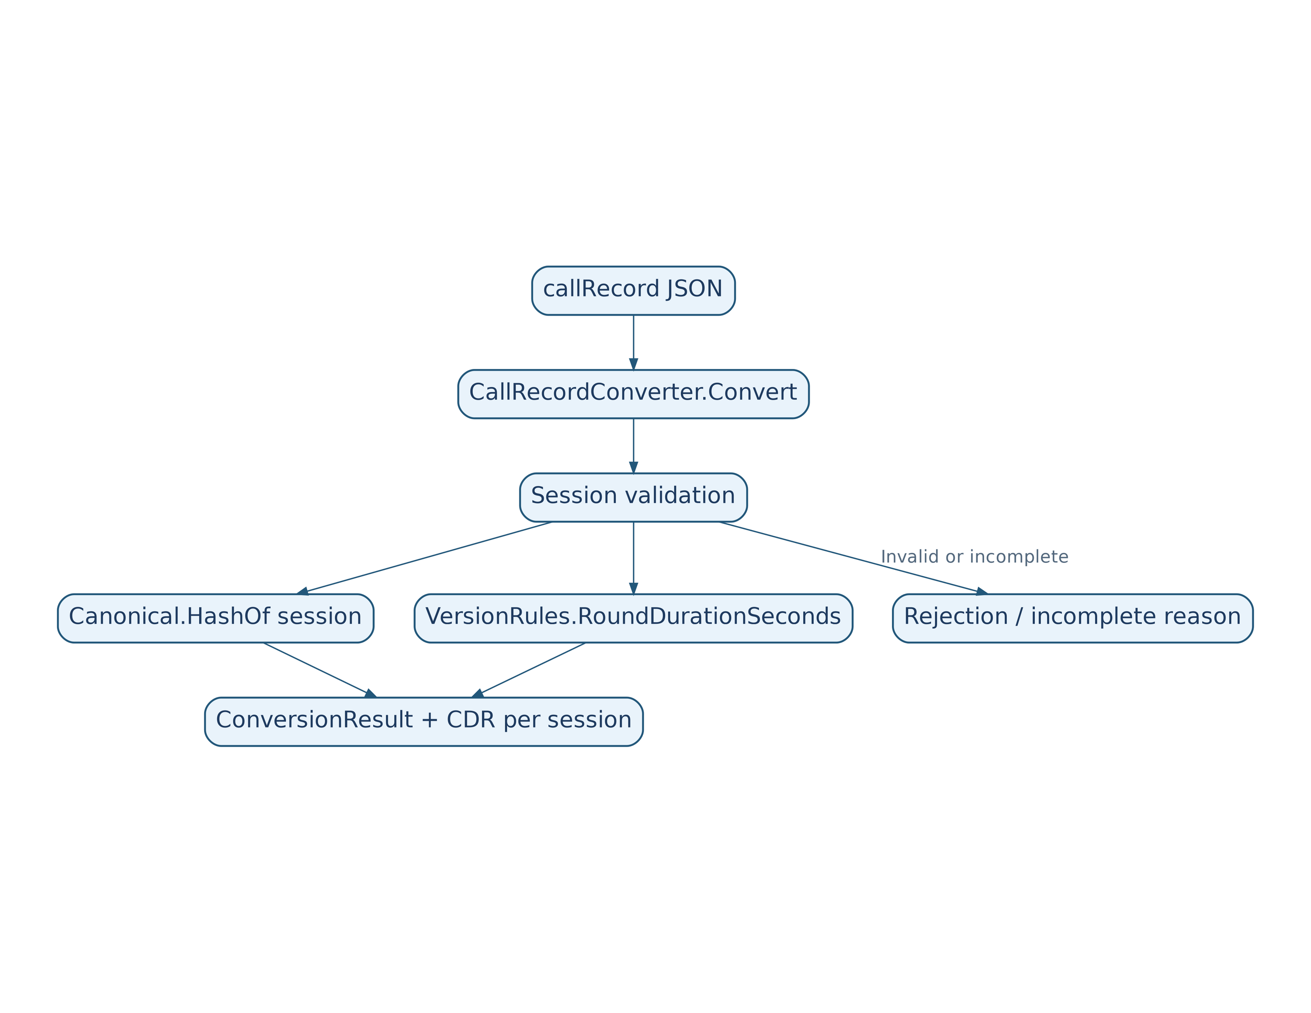

3.4.6. Mapping F6 Rules to Core Methods
F6 Rule (TRS, Section 2) | Implemented in Core
1. One CDR per Session | Convert, step 8f
2. Segments: segment_count, extensions, not summed | step 8f, SegmentsJson
3. Duration | RoundDurationSeconds
4. Version and Hash | Decide, Canonical.HashOf, SessionSetHash
5. Parties | Party
6. Statuses | steps 8f, 11
7. Idempotency | Decide (Core); keys and replacement — Part 2
8. Source Traceability | CallId, SourceVersion, SourceHash fields
9. Rejection | steps 1–3, 8a–8e, RejectionCodes
10. No Participant-Level Records | not generated
11. Incomplete Data | steps 5, 8d, 11, IncompleteReasons
12. Missed Notifications | not part of Core (Part 2: reconciliation)

3.4.7. Rejected Source Material Hash [Proposed Addition]
Canonical.RejectionHash(string rawJson) — SHA-256 of canonical JSON for a successfully parsed document, or SHA-256 of the original UTF-8 text if JSON is malformed. For an individual session error, compute Canonical.HashOf(session) for that session if available; for a whole-record error, compute RejectionHash(rawJson). This hashes the specific rejected material, not session_set_hash. An identical rejection is identified by (tenant_id, call_id, session_id, code, source_hash); registering the same tuple again does not add a row. An empty hash is not permitted when raw data is present. Tests: HashTests.RejectionHash_*, SourceStateStoreTests.Rejection_*.

3.5. SQLite Model
General rules. The tcri.db database file is located in Storage:DataDirectory. Migration 20261021000000_InitialCreate creates the schema; the migration must produce a schema equivalent to the SQL below (names of tables, columns, constraints and indexes). Upon opening every connection, SqlitePragmaInterceptor executes PRAGMA journal_mode=WAL; PRAGMA synchronous=FULL; PRAGMA foreign_keys=ON; PRAGMA busy_timeout=5000; (Part 2). synchronous=FULL was selected because Graph notification acknowledgment 202 is sent only after the inbox insert is committed; with NORMAL under WAL, even a committed transaction can be lost on a power failure or operating-system crash [P-08]. The notification-processing load test and disk-volume reliability requirements are described in Part 2. Tables have no foreign keys between them: relationships are logical, by (tenant_id, call_id).
-- TeamsCallRecords: SQLite schema, schema version 1 (migration 20261021000000_InitialCreate)
-- Time: TEXT, ISO 8601 UTC, exactly 7 fractional digits and Z suffix: 2026-10-20T09:00:00.5000000Z
CREATE TABLE cdr (
cdr_seq INTEGER PRIMARY KEY AUTOINCREMENT,
schema_version INTEGER NOT NULL,
event_type TEXT NOT NULL,
tenant_id TEXT NOT NULL,
call_id TEXT NOT NULL,
session_id TEXT NOT NULL,
source_version INTEGER NOT NULL,
call_type TEXT NOT NULL CHECK (call_type IN ('oneToOne','group','unknown')),
caller_type TEXT NULL,
caller_id TEXT NULL,
callee_type TEXT NULL,
callee_id TEXT NULL,
start_utc TEXT NOT NULL,
end_utc TEXT NOT NULL,
duration_s INTEGER NOT NULL CHECK (duration_s >= 0),
modalities TEXT NOT NULL,
status TEXT NOT NULL CHECK (status IN ('completed','failed','unknown')),
termination_reason TEXT NULL,
segment_count INTEGER NOT NULL CHECK (segment_count >= 0),
aggregation_status TEXT NOT NULL CHECK (aggregation_status IN ('complete','incomplete')),
source_hash TEXT NOT NULL,
extensions TEXT NULL,
created_utc TEXT NOT NULL,
updated_utc TEXT NOT NULL,
CONSTRAINT uq_cdr_key UNIQUE (tenant_id, call_id, session_id)
);
CREATE INDEX ix_cdr_start ON cdr (start_utc, cdr_seq);
CREATE INDEX ix_cdr_call ON cdr (tenant_id, call_id);
CREATE TABLE source_state (
tenant_id TEXT NOT NULL,
call_id TEXT NOT NULL,
applied_version INTEGER NULL,
rejected_version INTEGER NULL,
session_set_hash TEXT NULL,
state TEXT NOT NULL CHECK (state IN ('pending','done','suspended','expired')),
attempts INTEGER NOT NULL DEFAULT 0,
next_attempt_utc TEXT NULL,
first_seen_utc TEXT NOT NULL,
last_error TEXT NULL,
updated_utc TEXT NOT NULL,
PRIMARY KEY (tenant_id, call_id)
);
CREATE INDEX ix_source_state_due ON source_state (state, next_attempt_utc);
CREATE TABLE inbox (
id INTEGER PRIMARY KEY AUTOINCREMENT,
element_hash TEXT NOT NULL,
kind TEXT NOT NULL CHECK (kind IN ('callRecord','channelMessage','reconcile')),
tenant_id TEXT NOT NULL,
call_id TEXT NULL,
raw TEXT NOT NULL,
state TEXT NOT NULL CHECK (state IN ('new','processing','done','failed')),
attempts INTEGER NOT NULL DEFAULT 0,
next_attempt_utc TEXT NOT NULL,
locked_until_utc TEXT NULL,
received_utc TEXT NOT NULL,
done_utc TEXT NULL,
last_error TEXT NULL
);
CREATE UNIQUE INDEX uq_inbox_new_hash ON inbox (element_hash) WHERE state = 'new';
CREATE INDEX ix_inbox_hash ON inbox (element_hash);
CREATE INDEX ix_inbox_call ON inbox (tenant_id, call_id, state);
CREATE INDEX ix_inbox_due ON inbox (state, next_attempt_utc);
CREATE TABLE rejected (
id INTEGER PRIMARY KEY AUTOINCREMENT,
tenant_id TEXT NOT NULL,
call_id TEXT NULL,
session_id TEXT NULL,
code TEXT NOT NULL,
message TEXT NOT NULL,
source_hash TEXT NULL,
created_utc TEXT NOT NULL
);
CREATE INDEX ix_rejected_created ON rejected (created_utc);
CREATE TABLE audit_log (
id INTEGER PRIMARY KEY AUTOINCREMENT,
ts TEXT NOT NULL,
tenant_id TEXT NOT NULL,
call_id TEXT NOT NULL,
kind TEXT NOT NULL CHECK (kind IN ('version_discrepancy')),
detail TEXT NOT NULL
);
CREATE TABLE outbox (
id INTEGER PRIMARY KEY AUTOINCREMENT,
kind TEXT NOT NULL CHECK (kind IN ('activity')),
tenant_id TEXT NOT NULL,
call_id TEXT NOT NULL,
session_id TEXT NOT NULL,
recipient TEXT NOT NULL,
payload TEXT NOT NULL,
state TEXT NOT NULL CHECK (state IN ('new','sending','sent','failed')),
attempts INTEGER NOT NULL DEFAULT 0,
next_attempt_utc TEXT NOT NULL,
locked_until_utc TEXT NULL,
created_utc TEXT NOT NULL,
sent_utc TEXT NULL,
last_error TEXT NULL,
CONSTRAINT uq_outbox_key UNIQUE (kind, tenant_id, call_id, session_id, recipient)
);
CREATE INDEX ix_outbox_due ON outbox (state, next_attempt_utc);
CREATE TABLE subscription (
id TEXT PRIMARY KEY,
kind TEXT NOT NULL CHECK (kind IN ('callRecords','channelMessages')),
resource TEXT NOT NULL,
notification_url TEXT NOT NULL,
expires_utc TEXT NOT NULL,
client_state_hash TEXT NOT NULL,
status TEXT NOT NULL CHECK (status IN ('active','renewing','failed')),
created_utc TEXT NOT NULL,
renewed_utc TEXT NULL
);
CREATE TABLE error_log (
id INTEGER PRIMARY KEY AUTOINCREMENT,
ts TEXT NOT NULL,
component TEXT NOT NULL,
message TEXT NOT NULL,
details TEXT NULL
);
CREATE INDEX ix_error_log_ts ON error_log (ts);
Row classes (Data/Entities). Each table maps to one <Name>Row class: CdrRow, SourceStateRow, InboxRow, RejectedRow, AuditLogRow, OutboxRow, SubscriptionRow, ErrorLogRow. Property names are column names converted to PascalCase (source_version → SourceVersion). Types: TEXT → string, INTEGER → long (cdr_seq and id use long; counters attempts, segment_count and schema_version use int); columns allowing NULL use nullable types (?). Timestamps are stored as strings in UtcText format.
UtcText (Data/UtcText.cs): string Format(DateTimeOffset value) — a format compatible with CdrJson.FormatTime; DateTimeOffset Parse(string text) — parses using DateTimeStyles.RoundtripKind; string Now(TimeProvider clock) — current time in this format. Lexicographic ordering of timestamps in this format equals chronological ordering.
CdrMapping (Data/CdrMapping.cs):
Method | Purpose
CdrRow ToRow(Cdr cdr, string nowText) | Cdr → row; call_type, status, aggregation_status are strings from 3.3; caller_type/caller_id are both NULL if Caller=null; modalities is a JSON array; start_utc, end_utc use UtcText.Format; created_utc=updated_utc=nowText; cdr_seq is not populated
Cdr ToCdr(CdrRow row) | reverse conversion; ToCdr(ToRow(c)) equals c for all properties
void CopyOnUpdate(CdrRow target, CdrRow source, string nowText) | on replacement copies every column except cdr_seq and created_utc; updated_utc=nowText
Fractional timestamp preservation. Values with tick precision (…ffffff7) are written and read without loss; CdrMappingTests (Part 2) verifies round-trip conversion.

3.6. Core Golden Sample Catalog
The golden samples are synthetic records based on the public Microsoft Graph callRecord resource structure; they contain no real data and must not be presented as genuine Graph records. Tenant identifier: 11111111-1111-4111-8111-111111111111. Expected results were obtained by executing the prepared I1 module and checked against the rules in 3.4.3; in the implementation they are stored as files and compared automatically (GoldenTests, 3.7). The files reside in tests/TeamsCallRecords.Core.Tests/TestData/Golden/in and out. This document includes the summary table and all eleven complete input–expected-result pairs.
№ | Scenario | Version | CDR | duration_s | status | aggregation | IsComplete | Incomplete Reasons | Rejections
G01 | one_to_one_single_session | 4 | 1 | 61 | completed | complete | yes | — | —
G02 | group_two_sessions | 7 | 2 | 600,450 | completed,completed | complete | yes | — | —
G03 | overlapping_segments | 3 | 1 | 300 | completed | complete | yes | — | —
G04 | failure_info | 2 | 1 | 4 | failed | complete | yes | — | —
G05 | no_caller_no_callee | 1 | 1 | 120 | completed | complete | yes | — | —
G06 | phone_and_unknown_party | 5 | 1 | 45 | completed | complete | yes | — | —
G07 | no_sessions | 1 | 0 | — | — | — | no | NO_SESSIONS | —
G08 | session_end_missing | 2 | 0 | — | — | — | no | SESSION_DATES_MISSING | —
G09 | invalid_and_valid_session | 6 | 1 | 300 | completed | incomplete | no | SESSION_INVALID | SESSION_END_BEFORE_START
G10 | utc_offset_and_half_second | 1 | 1 | 31 | completed | complete | yes | — | —
G11 | version_higher_content_changed | 5 | 1 | 61 | completed | complete | yes | — | —
Scenarios: G01 — one-to-one, one session, duration 60.5 s → 61 (half-up); G02 — group call, two sessions, video and audio, fractional seconds (449.876 s → 450); G03 — two overlapping segments (segment_count=2, durations are not summed); G04 — failureInfo → failed; G05 — missing caller and callee → null; G06 — telephone and party with no identity (unknown); G07 — no sessions; G08 — missing session end; G09 — one valid and one invalid session; G10 — offset +03:00 converted to UTC, 30.5 s → 31; G11 — G01 record with version 5 and modified session content (different source_hash and session_set_hash).
Golden sample G01 (one-to-one, one session):
Input (G01_one_to_one_single_session.json):
{
"@odata.context": "https://graph.microsoft.com/v1.0/$metadata#communications/callRecords/$entity",
"id": "cccccccc-0000-4000-8000-000000000001",
"version": 4,
"type": "peerToPeer",
"modalities": [
"audio"
],
"startDateTime": "2026-10-20T09:00:00.0000000Z",
"endDateTime": "2026-10-20T09:05:00.0000000Z",
"sessions": [
{
"id": "dddddddd-0000-4000-8000-000000000001",
"modalities": [
"audio"
],
"startDateTime": "2026-10-20T09:00:00.0000000Z",
"endDateTime": "2026-10-20T09:01:00.5000000Z",
"caller": {
"@odata.type": "#microsoft.graph.callRecords.participantEndpoint",
"identity": {
"user": {
"id": "aaaaaaaa-0000-4000-8000-000000000001",
"displayName": "User A"
}
},
"userAgent": {
"@odata.type": "#microsoft.graph.callRecords.clientUserAgent",
"platform": "windows",
"productFamily": "teams"
}
},
"callee": {
"@odata.type": "#microsoft.graph.callRecords.participantEndpoint",
"identity": {
"user": {
"id": "aaaaaaaa-0000-4000-8000-000000000002",
"displayName": "User B"
}
},
"userAgent": {
"@odata.type": "#microsoft.graph.callRecords.clientUserAgent",
"platform": "windows",
"productFamily": "teams"
}
},
"segments": [
{
"id": "seg-1",
"startDateTime": "2026-10-20T09:00:00.0000000Z",
"endDateTime": "2026-10-20T09:01:00.5000000Z",
"media": [
{
"label": "main-audio",
"streams": [
{
"streamId": "s1",
"streamDirection": "callerToCallee"
}
]
}
]
}
]
}
]
}
Expected result (G01_one_to_one_single_session.json):
{
"call_id": "cccccccc-0000-4000-8000-000000000001",
"source_version": 4,
"is_complete": true,
"incomplete_reasons": [],
"session_set_hash": "146719861efe9004a28b3e18b1b10301ee5a5dd868aaa6b3ce4ef21ea8195381",
"cdrs": [
{
"schema_version": 1,
"event_type": "call",
"tenant_id": "11111111-1111-4111-8111-111111111111",
"call_id": "cccccccc-0000-4000-8000-000000000001",
"session_id": "dddddddd-0000-4000-8000-000000000001",
"source_version": 4,
"call_type": "oneToOne",
"caller": {
"type": "user",
"id": "aaaaaaaa-0000-4000-8000-000000000001"
},
"callee": {
"type": "user",
"id": "aaaaaaaa-0000-4000-8000-000000000002"
},
"start_utc": "2026-10-20T09:00:00.0000000Z",
"end_utc": "2026-10-20T09:01:00.5000000Z",
"duration_s": 61,
"modalities": [
"audio"
],
"status": "completed",
"termination_reason": null,
"segment_count": 1,
"aggregation_status": "complete",
"source_hash": "604b888cbcb6bd1bf3351d5ca29fbe489d11bb936aa1a1eda53071ed7593dcb3",
"extensions": {
"segments": [
{
"id": "seg-1",
"start": "2026-10-20T09:00:00.0000000Z",
"end": "2026-10-20T09:01:00.5000000Z",
"failure": null
}
]
}
}
],
"rejections": []
}
Golden sample G02 (group call, two sessions, fractional seconds):
Input (G02_group_two_sessions.json):
{
"@odata.context": "https://graph.microsoft.com/v1.0/$metadata#communications/callRecords/$entity",
"id": "cccccccc-0000-4000-8000-000000000002",
"version": 7,
"type": "groupCall",
"modalities": [
"audio",
"video"
],
"startDateTime": "2026-10-20T10:00:00.0000000Z",
"endDateTime": "2026-10-20T10:10:00.0000000Z",
"sessions": [
{
"id": "dddddddd-0000-4000-8000-000000000001",
"modalities": [
"audio",
"video"
],
"startDateTime": "2026-10-20T10:00:00.0000000Z",
"endDateTime": "2026-10-20T10:10:00.0000000Z",
"caller": {
"@odata.type": "#microsoft.graph.callRecords.participantEndpoint",
"identity": {
"user": {
"id": "aaaaaaaa-0000-4000-8000-000000000001",
"displayName": "User A"
}
},
"userAgent": {
"@odata.type": "#microsoft.graph.callRecords.clientUserAgent",
"platform": "windows",
"productFamily": "teams"
}
},
"callee": {
"@odata.type": "#microsoft.graph.callRecords.participantEndpoint",
"identity": {
"user": {
"id": "aaaaaaaa-0000-4000-8000-000000000003",
"displayName": "User C"
}
},
"userAgent": {
"@odata.type": "#microsoft.graph.callRecords.clientUserAgent",
"platform": "windows",
"productFamily": "teams"
}
},
"segments": [
{
"id": "seg-1",
"startDateTime": "2026-10-20T10:00:00.0000000Z",
"endDateTime": "2026-10-20T10:10:00.0000000Z",
"media": [
{
"label": "main-audio",
"streams": [
{
"streamId": "s1",
"streamDirection": "callerToCallee"
}
]
}
]
}
]
},
{
"id": "dddddddd-0000-4000-8000-000000000002",
"modalities": [
"audio"
],
"startDateTime": "2026-10-20T10:02:30.1230000Z",
"endDateTime": "2026-10-20T10:09:59.9990000Z",
"caller": {
"@odata.type": "#microsoft.graph.callRecords.participantEndpoint",
"identity": {
"user": {
"id": "aaaaaaaa-0000-4000-8000-000000000002",
"displayName": "User B"
}
},
"userAgent": {
"@odata.type": "#microsoft.graph.callRecords.clientUserAgent",
"platform": "windows",
"productFamily": "teams"
}
},
"callee": {
"@odata.type": "#microsoft.graph.callRecords.participantEndpoint",
"identity": {
"user": {
"id": "aaaaaaaa-0000-4000-8000-000000000003",
"displayName": "User C"
}
},
"userAgent": {
"@odata.type": "#microsoft.graph.callRecords.clientUserAgent",
"platform": "windows",
"productFamily": "teams"
}
},
"segments": [
{
"id": "seg-1",
"startDateTime": "2026-10-20T10:02:30.1230000Z",
"endDateTime": "2026-10-20T10:09:59.9990000Z",
"media": [
{
"label": "main-audio",
"streams": [
{
"streamId": "s1",
"streamDirection": "callerToCallee"
}
]
}
]
}
]
}
]
}
Expected result (G02_group_two_sessions.json):
{
"call_id": "cccccccc-0000-4000-8000-000000000002",
"source_version": 7,
"is_complete": true,
"incomplete_reasons": [],
"session_set_hash": "5522cff43718258e6bcfc7c90c92e6d51e68cfb160deec4e30920749e23e98cf",
"cdrs": [
{
"schema_version": 1,
"event_type": "call",
"tenant_id": "11111111-1111-4111-8111-111111111111",
"call_id": "cccccccc-0000-4000-8000-000000000002",
"session_id": "dddddddd-0000-4000-8000-000000000001",
"source_version": 7,
"call_type": "group",
"caller": {
"type": "user",
"id": "aaaaaaaa-0000-4000-8000-000000000001"
},
"callee": {
"type": "user",
"id": "aaaaaaaa-0000-4000-8000-000000000003"
},
"start_utc": "2026-10-20T10:00:00.0000000Z",
"end_utc": "2026-10-20T10:10:00.0000000Z",
"duration_s": 600,
"modalities": [
"audio",
"video"
],
"status": "completed",
"termination_reason": null,
"segment_count": 1,
"aggregation_status": "complete",
"source_hash": "c1d4d9ba424314df4c9e0442dfab4d8d37c9e3993c4e3df9a42002cff31fb95b",
"extensions": {
"segments": [
{
"id": "seg-1",
"start": "2026-10-20T10:00:00.0000000Z",
"end": "2026-10-20T10:10:00.0000000Z",
"failure": null
}
]
}
},
{
"schema_version": 1,
"event_type": "call",
"tenant_id": "11111111-1111-4111-8111-111111111111",
"call_id": "cccccccc-0000-4000-8000-000000000002",
"session_id": "dddddddd-0000-4000-8000-000000000002",
"source_version": 7,
"call_type": "group",
"caller": {
"type": "user",
"id": "aaaaaaaa-0000-4000-8000-000000000002"
},
"callee": {
"type": "user",
"id": "aaaaaaaa-0000-4000-8000-000000000003"
},
"start_utc": "2026-10-20T10:02:30.1230000Z",
"end_utc": "2026-10-20T10:09:59.9990000Z",
"duration_s": 450,
"modalities": [
"audio"
],
"status": "completed",
"termination_reason": null,
"segment_count": 1,
"aggregation_status": "complete",
"source_hash": "bbab6a67cc35652b2185bcf345a5a1e89370aceadbd0f300d2be04fda6b21b0f",
"extensions": {
"segments": [
{
"id": "seg-1",
"start": "2026-10-20T10:02:30.1230000Z",
"end": "2026-10-20T10:09:59.9990000Z",
"failure": null
}
]
}
}
],
"rejections": []
}
Golden sample G03 (overlapping segments):
Input (G03_overlapping_segments.json):
{
"@odata.context": "https://graph.microsoft.com/v1.0/$metadata#communications/callRecords/$entity",
"id": "cccccccc-0000-4000-8000-000000000003",
"version": 3,
"type": "peerToPeer",
"modalities": [
"audio"
],
"startDateTime": "2026-10-20T11:00:00.0000000Z",
"endDateTime": "2026-10-20T11:05:00.0000000Z",
"sessions": [
{
"id": "dddddddd-0000-4000-8000-000000000001",
"modalities": [
"audio"
],
"startDateTime": "2026-10-20T11:00:00.0000000Z",
"endDateTime": "2026-10-20T11:05:00.0000000Z",
"caller": {
"@odata.type": "#microsoft.graph.callRecords.participantEndpoint",
"identity": {
"user": {
"id": "aaaaaaaa-0000-4000-8000-000000000001",
"displayName": "User A"
}
},
"userAgent": {
"@odata.type": "#microsoft.graph.callRecords.clientUserAgent",
"platform": "windows",
"productFamily": "teams"
}
},
"callee": {
"@odata.type": "#microsoft.graph.callRecords.participantEndpoint",
"identity": {
"user": {
"id": "aaaaaaaa-0000-4000-8000-000000000002",
"displayName": "User B"
}
},
"userAgent": {
"@odata.type": "#microsoft.graph.callRecords.clientUserAgent",
"platform": "windows",
"productFamily": "teams"
}
},
"segments": [
{
"id": "seg-1",
"startDateTime": "2026-10-20T11:00:00.0000000Z",
"endDateTime": "2026-10-20T11:03:00.0000000Z",
"media": [
{
"label": "main-audio",
"streams": [
{
"streamId": "s1",
"streamDirection": "callerToCallee"
}
]
}
]
},
{
"id": "seg-2",
"startDateTime": "2026-10-20T11:02:00.0000000Z",
"endDateTime": "2026-10-20T11:05:00.0000000Z",
"media": [
{
"label": "main-audio",
"streams": [
{
"streamId": "s1",
"streamDirection": "callerToCallee"
}
]
}
]
}
]
}
]
}
Expected result (G03_overlapping_segments.json):
{
"call_id": "cccccccc-0000-4000-8000-000000000003",
"source_version": 3,
"is_complete": true,
"incomplete_reasons": [],
"session_set_hash": "c7b955b9b62d40f403f7377f366b5b967661350e7c70e4e06d82cac7a77de0fd",
"cdrs": [
{
"schema_version": 1,
"event_type": "call",
"tenant_id": "11111111-1111-4111-8111-111111111111",
"call_id": "cccccccc-0000-4000-8000-000000000003",
"session_id": "dddddddd-0000-4000-8000-000000000001",
"source_version": 3,
"call_type": "oneToOne",
"caller": {
"type": "user",
"id": "aaaaaaaa-0000-4000-8000-000000000001"
},
"callee": {
"type": "user",
"id": "aaaaaaaa-0000-4000-8000-000000000002"
},
"start_utc": "2026-10-20T11:00:00.0000000Z",
"end_utc": "2026-10-20T11:05:00.0000000Z",
"duration_s": 300,
"modalities": [
"audio"
],
"status": "completed",
"termination_reason": null,
"segment_count": 2,
"aggregation_status": "complete",
"source_hash": "caf53e440ba8932ef8390a0f4cfbbab62b7c82acdfa7564070288d38a77fb00a",
"extensions": {
"segments": [
{
"id": "seg-1",
"start": "2026-10-20T11:00:00.0000000Z",
"end": "2026-10-20T11:03:00.0000000Z",
"failure": null
},
{
"id": "seg-2",
"start": "2026-10-20T11:02:00.0000000Z",
"end": "2026-10-20T11:05:00.0000000Z",
"failure": null
}
]
}
}
],
"rejections": []
}
Golden sample G04 (failure information):
Input (G04_failure_info.json):
{
"@odata.context": "https://graph.microsoft.com/v1.0/$metadata#communications/callRecords/$entity",
"id": "cccccccc-0000-4000-8000-000000000004",
"version": 2,
"type": "peerToPeer",
"modalities": [
"audio"
],
"startDateTime": "2026-10-20T12:00:00.0000000Z",
"endDateTime": "2026-10-20T12:00:04.0000000Z",
"sessions": [
{
"id": "dddddddd-0000-4000-8000-000000000001",
"modalities": [
"audio"
],
"startDateTime": "2026-10-20T12:00:00.0000000Z",
"endDateTime": "2026-10-20T12:00:04.0000000Z",
"caller": {
"@odata.type": "#microsoft.graph.callRecords.participantEndpoint",
"identity": {
"user": {
"id": "aaaaaaaa-0000-4000-8000-000000000001",
"displayName": "User A"
}
},
"userAgent": {
"@odata.type": "#microsoft.graph.callRecords.clientUserAgent",
"platform": "windows",
"productFamily": "teams"
}
},
"callee": {
"@odata.type": "#microsoft.graph.callRecords.participantEndpoint",
"identity": {
"user": {
"id": "aaaaaaaa-0000-4000-8000-000000000002",
"displayName": "User B"
}
},
"userAgent": {
"@odata.type": "#microsoft.graph.callRecords.clientUserAgent",
"platform": "windows",
"productFamily": "teams"
}
},
"segments": [
{
"id": "seg-1",
"startDateTime": "2026-10-20T12:00:00.0000000Z",
"endDateTime": "2026-10-20T12:00:04.0000000Z",
"media": [
{
"label": "main-audio",
"streams": [
{
"streamId": "s1",
"streamDirection": "callerToCallee"
}
]
}
],
"failureInfo": {
"@odata.type": "#microsoft.graph.callRecords.failureInfo",
"stage": "callSetup",
"reason": "networkError"
}
}
]
}
]
}
Expected result (G04_failure_info.json):
{
"call_id": "cccccccc-0000-4000-8000-000000000004",
"source_version": 2,
"is_complete": true,
"incomplete_reasons": [],
"session_set_hash": "bdafe61873c8079c03e7363494082c42932ddb2ed0cc401f66fc6adf0a449979",
"cdrs": [
{
"schema_version": 1,
"event_type": "call",
"tenant_id": "11111111-1111-4111-8111-111111111111",
"call_id": "cccccccc-0000-4000-8000-000000000004",
"session_id": "dddddddd-0000-4000-8000-000000000001",
"source_version": 2,
"call_type": "oneToOne",
"caller": {
"type": "user",
"id": "aaaaaaaa-0000-4000-8000-000000000001"
},
"callee": {
"type": "user",
"id": "aaaaaaaa-0000-4000-8000-000000000002"
},
"start_utc": "2026-10-20T12:00:00.0000000Z",
"end_utc": "2026-10-20T12:00:04.0000000Z",
"duration_s": 4,
"modalities": [
"audio"
],
"status": "failed",
"termination_reason": "callSetup:networkError",
"segment_count": 1,
"aggregation_status": "complete",
"source_hash": "459f5a417571bc67b15d9b161d8439bf4a5d1b8a2d5a2cde3c6f58e367e8eab4",
"extensions": {
"segments": [
{
"id": "seg-1",
"start": "2026-10-20T12:00:00.0000000Z",
"end": "2026-10-20T12:00:04.0000000Z",
"failure": "callSetup:networkError"
}
]
}
}
],
"rejections": []
}
Golden sample G05 (no caller or callee):
Input (G05_no_caller_no_callee.json):
{
"@odata.context": "https://graph.microsoft.com/v1.0/$metadata#communications/callRecords/$entity",
"id": "cccccccc-0000-4000-8000-000000000005",
"version": 1,
"type": "groupCall",
"modalities": [
"audio"
],
"startDateTime": "2026-10-20T13:00:00.0000000Z",
"endDateTime": "2026-10-20T13:02:00.0000000Z",
"sessions": [
{
"id": "dddddddd-0000-4000-8000-000000000001",
"modalities": [
"audio"
],
"startDateTime": "2026-10-20T13:00:00.0000000Z",
"endDateTime": "2026-10-20T13:02:00.0000000Z",
"segments": [
{
"id": "seg-1",
"startDateTime": "2026-10-20T13:00:00.0000000Z",
"endDateTime": "2026-10-20T13:02:00.0000000Z",
"media": [
{
"label": "main-audio",
"streams": [
{
"streamId": "s1",
"streamDirection": "callerToCallee"
}
]
}
]
}
]
}
]
}
Expected result (G05_no_caller_no_callee.json):
{
"call_id": "cccccccc-0000-4000-8000-000000000005",
"source_version": 1,
"is_complete": true,
"incomplete_reasons": [],
"session_set_hash": "7490850e79c54194ee8cb0524b1913a597a8fca4a40bc846877da69c99c97dd9",
"cdrs": [
{
"schema_version": 1,
"event_type": "call",
"tenant_id": "11111111-1111-4111-8111-111111111111",
"call_id": "cccccccc-0000-4000-8000-000000000005",
"session_id": "dddddddd-0000-4000-8000-000000000001",
"source_version": 1,
"call_type": "group",
"caller": null,
"callee": null,
"start_utc": "2026-10-20T13:00:00.0000000Z",
"end_utc": "2026-10-20T13:02:00.0000000Z",
"duration_s": 120,
"modalities": [
"audio"
],
"status": "completed",
"termination_reason": null,
"segment_count": 1,
"aggregation_status": "complete",
"source_hash": "ea52317e0c8770c225cb77101d528779987890c11b54dac2855a2c5ed3c5b98f",
"extensions": {
"segments": [
{
"id": "seg-1",
"start": "2026-10-20T13:00:00.0000000Z",
"end": "2026-10-20T13:02:00.0000000Z",
"failure": null
}
]
}
}
],
"rejections": []
}
Golden sample G06 (telephone and unidentified party):
Input (G06_phone_and_unknown_party.json):
{
"@odata.context": "https://graph.microsoft.com/v1.0/$metadata#communications/callRecords/$entity",
"id": "cccccccc-0000-4000-8000-000000000006",
"version": 5,
"type": "peerToPeer",
"modalities": [
"audio"
],
"startDateTime": "2026-10-20T14:00:00.0000000Z",
"endDateTime": "2026-10-20T14:00:45.0000000Z",
"sessions": [
{
"id": "dddddddd-0000-4000-8000-000000000001",
"modalities": [
"audio"
],
"startDateTime": "2026-10-20T14:00:00.0000000Z",
"endDateTime": "2026-10-20T14:00:45.0000000Z",
"caller": {
"@odata.type": "#microsoft.graph.callRecords.participantEndpoint",
"identity": {
"phone": {
"id": "+10000000001",
"displayName": "Test number"
}
}
},
"callee": {
"@odata.type": "#microsoft.graph.callRecords.participantEndpoint"
},
"segments": []
}
]
}
Expected result (G06_phone_and_unknown_party.json):
{
"call_id": "cccccccc-0000-4000-8000-000000000006",
"source_version": 5,
"is_complete": true,
"incomplete_reasons": [],
"session_set_hash": "5532aef65d20f55018ac857ae27f2b38956634eacaf20b6b02b066aa9b75c561",
"cdrs": [
{
"schema_version": 1,
"event_type": "call",
"tenant_id": "11111111-1111-4111-8111-111111111111",
"call_id": "cccccccc-0000-4000-8000-000000000006",
"session_id": "dddddddd-0000-4000-8000-000000000001",
"source_version": 5,
"call_type": "oneToOne",
"caller": {
"type": "phone",
"id": "+10000000001"
},
"callee": {
"type": "unknown",
"id": ""
},
"start_utc": "2026-10-20T14:00:00.0000000Z",
"end_utc": "2026-10-20T14:00:45.0000000Z",
"duration_s": 45,
"modalities": [
"audio"
],
"status": "completed",
"termination_reason": null,
"segment_count": 0,
"aggregation_status": "complete",
"source_hash": "f857e23ac8e3762d3ac785a053f951765722125e8bac742f9c74756e2a2c654b",
"extensions": null
}
],
"rejections": []
}
Golden sample G07 (no sessions; result is unsuitable for replacement):
Input (G07_no_sessions.json):
{
"@odata.context": "https://graph.microsoft.com/v1.0/$metadata#communications/callRecords/$entity",
"id": "cccccccc-0000-4000-8000-000000000007",
"version": 1,
"type": "peerToPeer",
"modalities": [
"audio"
],
"startDateTime": "2026-10-20T09:00:00.0000000Z",
"endDateTime": "2026-10-20T09:05:00.0000000Z"
}
Expected result (G07_no_sessions.json):
{
"call_id": "cccccccc-0000-4000-8000-000000000007",
"source_version": 1,
"is_complete": false,
"incomplete_reasons": [
"NO_SESSIONS"
],
"session_set_hash": "e3b0c44298fc1c149afbf4c8996fb92427ae41e4649b934ca495991b7852b855",
"cdrs": [],
"rejections": []
}
Golden sample G08 (missing session end; result is unsuitable for replacement):
Input (G08_session_end_missing.json):
{
"@odata.context": "https://graph.microsoft.com/v1.0/$metadata#communications/callRecords/$entity",
"id": "cccccccc-0000-4000-8000-000000000008",
"version": 2,
"type": "peerToPeer",
"modalities": [
"audio"
],
"startDateTime": "2026-10-20T15:00:00.0000000Z",
"endDateTime": "2026-10-20T15:05:00.0000000Z",
"sessions": [
{
"id": "dddddddd-0000-4000-8000-000000000001",
"modalities": [
"audio"
],
"startDateTime": "2026-10-20T15:00:00.0000000Z",
"caller": {
"@odata.type": "#microsoft.graph.callRecords.participantEndpoint",
"identity": {
"user": {
"id": "aaaaaaaa-0000-4000-8000-000000000001",
"displayName": "User A"
}
},
"userAgent": {
"@odata.type": "#microsoft.graph.callRecords.clientUserAgent",
"platform": "windows",
"productFamily": "teams"
}
},
"callee": {
"@odata.type": "#microsoft.graph.callRecords.participantEndpoint",
"identity": {
"user": {
"id": "aaaaaaaa-0000-4000-8000-000000000002",
"displayName": "User B"
}
},
"userAgent": {
"@odata.type": "#microsoft.graph.callRecords.clientUserAgent",
"platform": "windows",
"productFamily": "teams"
}
},
"segments": [
{
"id": "seg-1",
"startDateTime": "2026-10-20T15:00:00.0000000Z",
"endDateTime": null,
"media": [
{
"label": "main-audio",
"streams": [
{
"streamId": "s1",
"streamDirection": "callerToCallee"
}
]
}
]
}
]
}
]
}
Expected result (G08_session_end_missing.json):
{
"call_id": "cccccccc-0000-4000-8000-000000000008",
"source_version": 2,
"is_complete": false,
"incomplete_reasons": [
"SESSION_DATES_MISSING"
],
"session_set_hash": "2fd1450529819450a1d643ef5e3d3e82bda92ce173a1edd81f69662d4a838053",
"cdrs": [],
"rejections": []
}
Golden sample G09 (valid and invalid sessions; result is unsuitable for replacement):
Input (G09_invalid_and_valid_session.json):
{
"@odata.context": "https://graph.microsoft.com/v1.0/$metadata#communications/callRecords/$entity",
"id": "cccccccc-0000-4000-8000-000000000009",
"version": 6,
"type": "groupCall",
"modalities": [
"audio"
],
"startDateTime": "2026-10-20T16:00:00.0000000Z",
"endDateTime": "2026-10-20T16:10:00.0000000Z",
"sessions": [
{
"id": "dddddddd-0000-4000-8000-000000000001",
"modalities": [
"audio"
],
"startDateTime": "2026-10-20T16:00:00.0000000Z",
"endDateTime": "2026-10-20T16:05:00.0000000Z",
"caller": {
"@odata.type": "#microsoft.graph.callRecords.participantEndpoint",
"identity": {
"user": {
"id": "aaaaaaaa-0000-4000-8000-000000000001",
"displayName": "User A"
}
},
"userAgent": {
"@odata.type": "#microsoft.graph.callRecords.clientUserAgent",
"platform": "windows",
"productFamily": "teams"
}
},
"callee": {
"@odata.type": "#microsoft.graph.callRecords.participantEndpoint",
"identity": {
"user": {
"id": "aaaaaaaa-0000-4000-8000-000000000002",
"displayName": "User B"
}
},
"userAgent": {
"@odata.type": "#microsoft.graph.callRecords.clientUserAgent",
"platform": "windows",
"productFamily": "teams"
}
},
"segments": [
{
"id": "seg-1",
"startDateTime": "2026-10-20T16:00:00.0000000Z",
"endDateTime": "2026-10-20T16:05:00.0000000Z",
"media": [
{
"label": "main-audio",
"streams": [
{
"streamId": "s1",
"streamDirection": "callerToCallee"
}
]
}
]
}
]
},
{
"id": "dddddddd-0000-4000-8000-000000000002",
"modalities": [
"audio"
],
"startDateTime": "2026-10-20T16:10:00.0000000Z",
"endDateTime": "2026-10-20T16:09:00.0000000Z",
"caller": {
"@odata.type": "#microsoft.graph.callRecords.participantEndpoint",
"identity": {
"user": {
"id": "aaaaaaaa-0000-4000-8000-000000000003",
"displayName": "User C"
}
},
"userAgent": {
"@odata.type": "#microsoft.graph.callRecords.clientUserAgent",
"platform": "windows",
"productFamily": "teams"
}
},
"callee": {
"@odata.type": "#microsoft.graph.callRecords.participantEndpoint",
"identity": {
"user": {
"id": "aaaaaaaa-0000-4000-8000-000000000002",
"displayName": "User B"
}
},
"userAgent": {
"@odata.type": "#microsoft.graph.callRecords.clientUserAgent",
"platform": "windows",
"productFamily": "teams"
}
},
"segments": []
}
]
}
Expected result (G09_invalid_and_valid_session.json):
{
"call_id": "cccccccc-0000-4000-8000-000000000009",
"source_version": 6,
"is_complete": false,
"incomplete_reasons": [
"SESSION_INVALID"
],
"session_set_hash": "740b55f6623a6accc0629a2856934c9ba64456afdd38e3ccc34e15066c4d98dc",
"cdrs": [
{
"schema_version": 1,
"event_type": "call",
"tenant_id": "11111111-1111-4111-8111-111111111111",
"call_id": "cccccccc-0000-4000-8000-000000000009",
"session_id": "dddddddd-0000-4000-8000-000000000001",
"source_version": 6,
"call_type": "group",
"caller": {
"type": "user",
"id": "aaaaaaaa-0000-4000-8000-000000000001"
},
"callee": {
"type": "user",
"id": "aaaaaaaa-0000-4000-8000-000000000002"
},
"start_utc": "2026-10-20T16:00:00.0000000Z",
"end_utc": "2026-10-20T16:05:00.0000000Z",
"duration_s": 300,
"modalities": [
"audio"
],
"status": "completed",
"termination_reason": null,
"segment_count": 1,
"aggregation_status": "incomplete",
"source_hash": "7a435bc6b09149a2e4b7932a195690fc587ff12270c1b5da94b64b713ffc66e0",
"extensions": {
"segments": [
{
"id": "seg-1",
"start": "2026-10-20T16:00:00.0000000Z",
"end": "2026-10-20T16:05:00.0000000Z",
"failure": null
}
]
}
}
],
"rejections": [
{
"call_id": "cccccccc-0000-4000-8000-000000000009",
"session_id": "dddddddd-0000-4000-8000-000000000002",
"code": "SESSION_END_BEFORE_START",
"message": "Session ends before it starts."
}
]
}
Golden sample G10 (+03:00 offset and a half-second):
Input (G10_utc_offset_and_half_second.json):
{
"@odata.context": "https://graph.microsoft.com/v1.0/$metadata#communications/callRecords/$entity",
"id": "cccccccc-0000-4000-8000-000000000010",
"version": 1,
"type": "peerToPeer",
"modalities": [
"audio"
],
"startDateTime": "2026-10-20T09:00:00.0000000Z",
"endDateTime": "2026-10-20T09:05:00.0000000Z",
"sessions": [
{
"id": "dddddddd-0000-4000-8000-000000000001",
"modalities": [
"audio"
],
"startDateTime": "2026-10-20T12:00:00.0000000+03:00",
"endDateTime": "2026-10-20T12:00:30.5000000+03:00",
"caller": {
"@odata.type": "#microsoft.graph.callRecords.participantEndpoint",
"identity": {
"user": {
"id": "aaaaaaaa-0000-4000-8000-000000000001",
"displayName": "User A"
}
},
"userAgent": {
"@odata.type": "#microsoft.graph.callRecords.clientUserAgent",
"platform": "windows",
"productFamily": "teams"
}
},
"callee": {
"@odata.type": "#microsoft.graph.callRecords.participantEndpoint",
"identity": {
"user": {
"id": "aaaaaaaa-0000-4000-8000-000000000002",
"displayName": "User B"
}
},
"userAgent": {
"@odata.type": "#microsoft.graph.callRecords.clientUserAgent",
"platform": "windows",
"productFamily": "teams"
}
},
"segments": [
{
"id": "seg-1",
"startDateTime": "2026-10-20T12:00:00.0000000+03:00",
"endDateTime": "2026-10-20T12:00:30.5000000+03:00",
"media": [
{
"label": "main-audio",
"streams": [
{
"streamId": "s1",
"streamDirection": "callerToCallee"
}
]
}
]
}
]
}
]
}
Expected result (G10_utc_offset_and_half_second.json):
{
"call_id": "cccccccc-0000-4000-8000-000000000010",
"source_version": 1,
"is_complete": true,
"incomplete_reasons": [],
"session_set_hash": "052271b811f340d180eb2de4f314003490e99772a41dd067a1fe8a05213ecd6b",
"cdrs": [
{
"schema_version": 1,
"event_type": "call",
"tenant_id": "11111111-1111-4111-8111-111111111111",
"call_id": "cccccccc-0000-4000-8000-000000000010",
"session_id": "dddddddd-0000-4000-8000-000000000001",
"source_version": 1,
"call_type": "oneToOne",
"caller": {
"type": "user",
"id": "aaaaaaaa-0000-4000-8000-000000000001"
},
"callee": {
"type": "user",
"id": "aaaaaaaa-0000-4000-8000-000000000002"
},
"start_utc": "2026-10-20T09:00:00.0000000Z",
"end_utc": "2026-10-20T09:00:30.5000000Z",
"duration_s": 31,
"modalities": [
"audio"
],
"status": "completed",
"termination_reason": null,
"segment_count": 1,
"aggregation_status": "complete",
"source_hash": "30024d86434689e9d64499e37e2db461af77763074d0b8468ade2973ab0479c5",
"extensions": {
"segments": [
{
"id": "seg-1",
"start": "2026-10-20T12:00:00.0000000+03:00",
"end": "2026-10-20T12:00:30.5000000+03:00",
"failure": null
}
]
}
}
],
"rejections": []
}
Golden sample G11 (G01 record with version 5 and changed content):
Input (G11_version_higher_content_changed.json):
{
"@odata.context": "https://graph.microsoft.com/v1.0/$metadata#communications/callRecords/$entity",
"id": "cccccccc-0000-4000-8000-000000000001",
"version": 5,
"type": "peerToPeer",
"modalities": [
"audio"
],
"startDateTime": "2026-10-20T09:00:00.0000000Z",
"endDateTime": "2026-10-20T09:05:00.0000000Z",
"sessions": [
{
"id": "dddddddd-0000-4000-8000-000000000001",
"modalities": [
"audio"
],
"startDateTime": "2026-10-20T09:00:00.0000000Z",
"endDateTime": "2026-10-20T09:01:00.5000000Z",
"caller": {
"@odata.type": "#microsoft.graph.callRecords.participantEndpoint",
"identity": {
"user": {
"id": "aaaaaaaa-0000-4000-8000-000000000001",
"displayName": "User A"
}
},
"userAgent": {
"@odata.type": "#microsoft.graph.callRecords.clientUserAgent",
"platform": "windows",
"productFamily": "teams"
}
},
"callee": {
"@odata.type": "#microsoft.graph.callRecords.participantEndpoint",
"identity": {
"user": {
"id": "aaaaaaaa-0000-4000-8000-000000000002",
"displayName": "User B"
}
},
"userAgent": {
"@odata.type": "#microsoft.graph.callRecords.clientUserAgent",
"platform": "windows",
"productFamily": "teams"
}
},
"segments": [
{
"id": "seg-1",
"startDateTime": "2026-10-20T09:00:00.0000000Z",
"endDateTime": "2026-10-20T09:01:00.5000000Z",
"media": [
{
"label": "main-audio-2",
"streams": [
{
"streamId": "s1",
"streamDirection": "callerToCallee"
}
]
}
]
}
]
}
]
}
Expected result (G11_version_higher_content_changed.json):
{
"call_id": "cccccccc-0000-4000-8000-000000000001",
"source_version": 5,
"is_complete": true,
"incomplete_reasons": [],
"session_set_hash": "3d0a0015d9fc1618734c1022f0c4ccb513b4f1e6b2a6aa45816edb18a4581360",
"cdrs": [
{
"schema_version": 1,
"event_type": "call",
"tenant_id": "11111111-1111-4111-8111-111111111111",
"call_id": "cccccccc-0000-4000-8000-000000000001",
"session_id": "dddddddd-0000-4000-8000-000000000001",
"source_version": 5,
"call_type": "oneToOne",
"caller": {
"type": "user",
"id": "aaaaaaaa-0000-4000-8000-000000000001"
},
"callee": {
"type": "user",
"id": "aaaaaaaa-0000-4000-8000-000000000002"
},
"start_utc": "2026-10-20T09:00:00.0000000Z",
"end_utc": "2026-10-20T09:01:00.5000000Z",
"duration_s": 61,
"modalities": [
"audio"
],
"status": "completed",
"termination_reason": null,
"segment_count": 1,
"aggregation_status": "complete",
"source_hash": "2acda2272c8fe133b6fb51a37b2b9f26c7f64b0555d8bdd81a83f13ab8c61175",
"extensions": {
"segments": [
{
"id": "seg-1",
"start": "2026-10-20T09:00:00.0000000Z",
"end": "2026-10-20T09:01:00.5000000Z",
"failure": null
}
]
}
}
],
"rejections": []
}

3.7. Core Automated Tests
Test infrastructure. Project TeamsCallRecords.Core.Tests, net8.0; packages: xunit 2.9.3, xunit.runner.visualstudio 3.1.4, Microsoft.NET.Test.Sdk 17.14.1, coverlet.collector 6.0.4; implicit Using Xunit. Execute: dotnet test TeamsCallRecords.sln -c Release. Tests do not access the network, clock, or file system except for reading golden samples from TestData/Golden (files are copied to the output directory: <None Update="TestData\Golden\**\*.json" CopyToOutputDirectory="PreserveNewest" />).
Samples (Samples.cs, internal static): constant Tenant = "tenant-test"; Session(id, start = "2026-01-01T10:00:00Z", end = "2026-01-01T10:01:00Z", caller = "user-a", callee = "user-b", failure = null, segments = "") — session JSON (failure as stage:reason; an empty caller/callee string omits that party; end = null produces null); Segment(id, start, end) — segment JSON with a single callerToCallee stream; Record(sessions, version = 3, type = "peerToPeer", id = "call-1") — call record JSON. The builder belongs to the test project and is not included in production code.
Legend. “Input” denotes Samples arguments; “Expected” denotes assertions; K denotes a TRS acceptance criterion.

3.7.1. ConverterTests (ConverterTests.cs, 18 tests from I1)
Method | Input | Expected | K
OneToOne_SingleSession_ProducesOneCdr | Record(Session("s1")) | IsComplete; 1 CDR; CallId="call-1", SessionId="s1", TenantId=Tenant, SourceVersion=3, CallType=OneToOne, Caller=(user,user-a), Callee=user-b, DurationSeconds=60, Completed, Complete, SegmentCount=1, SourceHash length 64 | K8
OneToOne_CanHaveSeveralSessions_CountFollowsData | two sessions, peerToPeer | 2 CDR | K8
GroupCall_OneCdrPerSession | three sessions, groupCall | 3 CDR, CallType=Group | K8
OverlappingSegments_DoNotChangeDuration_AndAreCounted | segments 10:00:00–10:00:40 and 10:00:20–10:01:00 | 1 CDR; SegmentCount=2; DurationSeconds=60; ExtensionsJson contains "segments" | K8
MissingCallerAndCallee_AreNotRejected | caller="", callee="", groupCall | IsComplete; 1 CDR; Caller=null, Callee=null | K8
FailureInfo_GivesFailedWithReason | failure="callSetup:busy" | Failed; TerminationReason="callSetup:busy" | K8
ShortCallWithoutFailureInfo_IsNotFailed | end 2 seconds after start, no failure | Completed; TerminationReason=null | K8
NoSessions_IsIncomplete_AndCreatesNoCdr | {"id":"call-1","version":2,"type":"peerToPeer"} | not IsComplete; 0 CDR; reason NO_SESSIONS | K8
EmptySessionsArray_IsIncomplete | Record("") | not IsComplete; 0 CDR | K8
MissingEndDate_IsIncomplete_NoZeroDurationInvented | end=null | not IsComplete; 0 CDR; 0 rejections; reason SESSION_DATES_MISSING | K8
IncompleteSet_MarksProducedCdrsIncomplete | s1 is valid, s2 has no end | not IsComplete; 1 CDR marked Incomplete | K8
EndBeforeStart_IsRejected | end precedes start | 1 SESSION_END_BEFORE_START rejection; not IsComplete | K14
UnparsableDate_IsRejected | start="not-a-date" | SESSION_BAD_DATE | K14
SessionWithoutId_IsRejected | session without id | SESSION_NO_ID | K14
BrokenJson_ReturnsRejection_NoException | { this is not json | CALLRECORD_BAD_JSON; 0 CDR; no exception | K14
MissingVersion_IsRejected | {"id":"call-1","sessions":[]} | CALLRECORD_NO_VERSION | K14
ValidSessionSurvives_WhenAnotherIsInvalid | s1 valid, s2 has start="bad" | 1 CDR; 1 rejection; not IsComplete | K14
Time_ZoneOffsets_AreNormalizedToUtc | 12:00:00+02:00 | StartUtc = 10:00:00Z, offset 0 | K13

3.7.2. RulesTests (RulesTests.cs, 14 tests from I1)
Method | Input | Expected | K
Duration_RoundsHalfUp (7 InlineData rows) | ticks: 0; 4 990 000; 5 000 000; 5 010 000; 14 999 999; 15 000 000; 600 000 000 | seconds: 0; 0; 1; 1; 1; 2; 60 | K13
Timestamps_KeepSourcePrecision | start 10:00:00.1234567Z, end 10:00:01.6234567Z | StartUtc = T0 + 1 234 567 ticks; DurationSeconds=2 | K13
FirstTime_Applies | Decide(null,null,1,"h") | Apply | K11
HigherVersion_Applies | Decide(2,"h1",3,"h2") | Apply | K11
LowerVersion_IsIgnored | Decide(3,"h1",2,"h2") | IgnoreLower | K11
SameVersion_SameHash_IsDuplicate | Decide(3,"h1",3,"h1") | DuplicateSame | K11
SameVersion_OtherHash_IsDiscrepancy | Decide(3,"h1",3,"h2") | Discrepancy | K11
ReprocessingSameRecord_GivesIdenticalResult | one two-session record converted twice | same SessionSetHash and SourceHash; Decide over both results = DuplicateSame | K11

3.7.3. HashTests (HashTests.cs, 10 tests; in I1 this class is in RulesTests.cs and is moved to a separate file)
Method | Expected
PropertyOrder_DoesNotChangeHash | {"a":1,"b":{"x":1,"y":2}} and {"b":{"y":2,"x":1},"a":1} produce the same hash
Whitespace_DoesNotChangeHash | whitespace and line breaks do not affect the hash
ArrayOrder_ChangesHash | [1,2] and [2,1] are different
TransportAnnotations_AreExcluded | @odata.context, segments@odata.context, b@odata.nextLink do not affect the hash
ODataType_IsContent_AndChangesHash | adding @odata.type changes the hash
MediaChange_ChangesSessionHash | changing callerToCallee to calleeToCaller changes SourceHash
FailureInfoChange_ChangesSessionHash | callSetup:busy and callSetup:noAnswer are different
NumberPrecision_IsKept | 1.10 and 1.1 are different
SessionSetHash_CoversIds | sets {s1} and {s1,s2} are different
SessionSetHash_IgnoresSessionOrder | session order does not affect the result

3.7.4. New Tests (Bring I1 into Conformance with the Design)
GoldenTests.cs (11 cases):
Method | Input | Expected | K
Convert_MatchesGolden(string name), [Theory] + [MemberData] over in/G01…G11 files | contents of in/<name>.json; tenant 11111111-1111-4111-8111-111111111111 | CdrJson.ToJson(result) structurally equals out/<name>.json (JsonNode.DeepEquals) | K8, K13, K14
Golden_Reprocessing_IsIdempotent | in/G01 twice | Decide(4, set_hash, 4, set_hash) = DuplicateSame | K11
Golden_HigherVersion_Applies_AndHashesDiffer | in/G01 (version 4) and in/G11 (version 5) | Decide(4, hashG01, 5, hashG11) = Apply; source_hash and session_set_hash differ | K11
Golden_LowerVersion_IsIgnored | the same | Decide(5, hashG11, 4, hashG01) = IgnoreLower | K11
Golden_SameVersion_OtherContent_IsDiscrepancy | in/G01 and a copy with version 4 and a changed stream | Discrepancy | K11
DuplicateSessionTests.cs (2 tests):
Method | Input | Expected | K
DuplicateSessionId_RejectsAllOccurrences | Record(Session("s1") + "," + Session("s1") + "," + Session("s2")) | 2 SESSION_DUPLICATE_ID rejections with SessionId="s1"; 1 CDR (s2); not IsComplete; reason SESSION_INVALID | K14
DuplicateSessionId_DoesNotAffectOtherCall | record without duplicates | 0 rejections | K14
IncompleteReasonsTests.cs (2 tests): Transient_ReasonsAreNoSessionsAndDatesMissing — IsTransient is true for NO_SESSIONS and SESSION_DATES_MISSING; Permanent_ReasonsAreNotTransient — false for SESSION_INVALID and all RejectionCodes values.
CdrJsonTests.cs (3 tests): FormatTime_HasSevenFractionDigitsAndZ — FormatTime(2026-10-20T09:00:00.5Z) = 2026-10-20T09:00:00.5000000Z; ToJson_NullParties_AreJsonNull — in G05, caller and callee are JsonValueKind.Null; ToJsonWithSeq_PutsCdrSeqFirst — cdr_seq is the first object property.
Total Core tests: 18 + 14 + 10 + 11 + 4 + 2 + 2 + 3 = 64 (42 from I1, 22 new). Counting test methods while accounting for InlineData and MemberData cases: expected result on execution is 64 passed, 0 skipped.

3.7.5. Requirements Coverage
Requirement | Tests
K8 | ConverterTests (1–11), GoldenTests G01–G03, G05, G06
K11 | RulesTests (versions), GoldenTests.Golden_*; Part 2: database replacement
K13 | RulesTests.Duration_RoundsHalfUp, Timestamps_KeepSourcePrecision, Time_ZoneOffsets_AreNormalizedToUtc, G10
K14 | ConverterTests (12–17), DuplicateSessionTests, G07–G09; Part 2: rejected-record register
F6-4 (hashes) | HashTests

3.8. Aligning the Prepared I1 Module with the Design
The prepared I1 module is used as a preliminary basis for implementing Core. Its 42 tests were run only on .NET 10. Those results do not demonstrate that the target application works on .NET 8. Mandatory tests are run on .NET 8 after implementation. To align with the design, the following changes, and only these changes, are made:
№ | File | Change
1 | Models.cs | add RejectionCodes.SessionDuplicateId; add IncompleteReasons class (constants and IsTransient)
2 | CallRecordConverter.cs | ArgumentNullException.ThrowIfNull for both arguments; replace literal reason strings with IncompleteReasons constants; add steps 7 and 8b (duplicate session identifiers)
3 | CdrJson.cs | new file per 3.4.4
4 | Core.Tests | move HashTests into HashTests.cs; add GoldenTests.cs, DuplicateSessionTests.cs, IncompleteReasonsTests.cs, CdrJsonTests.cs, TestData/Golden directory from 3.6; configure sample copying in .csproj
5 | .github/workflows/ci.yml | dotnet-version: 8.0.x instead of 10.0.x
6 | root | add global.json, Directory.Build.props, Directory.Packages.props (Part 4)
The remainder of the I1 code is unchanged. After these changes, the expected test outcome is 64 passed; this may only be confirmed by running dotnet test with the .NET 8 SDK after implementation, and that run is mandatory. Implementation may start only after the author approves the detailed design.

3.9. Changes to the Part 1 Register
Infrastructure design identified an inconsistency in the Part 1 file tree (3.2): option classes InboxOptions, ProcessingOptions, ReconcileOptions, OutboxOptions, and StorageOptions were placed in Host, although they are used by Infrastructure services; Infrastructure cannot reference Host (dependency direction: Host → Infrastructure → Core). Correction [P-10]:
№ | Change | Rationale
1 | Remove src/TeamsCallRecords.Host/Config/InboxOptions.cs, ProcessingOptions.cs, ReconcileOptions.cs, OutboxOptions.cs, StorageOptions.cs from Host and create them under src/TeamsCallRecords.Infrastructure/Config/ | dependency direction
2 | Only BotOptions.cs, ApiOptions.cs, and WebhookOptions.cs stay in Host/Config | used only by Host
3 | Reconcile:Interval and Reconcile:Lookback keys from TRP v0.1 become Reconcile:IntervalMinutes and Reconcile:LookbackHours | units encoded in key names
4 | Add SubscriptionOptions (Subscriptions:*), IWriteGate, IReconciler, Reconciler, IOutboxSender, OutboxSender, ICdrReader, CdrReader, model files, and others as listed below | Algorithms in 3.11–3.17 need separate modules; reconciliation, sending, and CDR reading must be testable without Host
5 | Processing:Workers key and defaults remain as in TRP v0.1; Processing:MaxAttempts is added | see 3.13.3
Amendment A1 to Part 1 DDL (3.5). The Part 2 review found that making element_hash unique across the entire inbox table prevents a repeated notification from causing a fresh Graph read after an earlier item reaches done (3.12.3). The rule changes: only an item in state new counts as a duplicate [P-22]. Only the inbox table is affected; all other tables, Core, and golden samples G01–G11 remain unchanged. The original Part 1 fragment (before amendment):
last_error TEXT NULL,
CONSTRAINT uq_inbox_hash UNIQUE (element_hash)
);
CREATE INDEX ix_inbox_due ON inbox (state, next_attempt_utc);
Fragment after the amendment (final inbox table lines and indexes; all other table columns and constraints remain as in Part 1):
last_error TEXT NULL
);
CREATE UNIQUE INDEX uq_inbox_new_hash ON inbox (element_hash) WHERE state = 'new';
CREATE INDEX ix_inbox_hash ON inbox (element_hash);
CREATE INDEX ix_inbox_call ON inbox (tenant_id, call_id, state);
CREATE INDEX ix_inbox_due ON inbox (state, next_attempt_utc);
The amendment is applied to InitialCreate.sql before the first deployment, so no separate migration is needed. Part 1 amendments consist of A1 and lines 1–5 of the table above; there are no other Part 1 changes. Changes to Part 2 itself relative to v0.1 are listed in Appendix D.
Complete file inventory for Parts 1–2 covering Infrastructure and its tests. Each file occupies one row with its repository-relative path. Column “Origin”: “from Part 1” means that the name and purpose were fixed in Part 1, 3.2, with contents specified here; “moved from Host” means the file previously belonged to Host; “new” means added in Part 2.
Path | Purpose | Origin
src/TeamsCallRecords.Infrastructure/TeamsCallRecords.Infrastructure.csproj | Infrastructure project: Core reference and packages in 3.10 | from Part 1
src/TeamsCallRecords.Infrastructure/InfrastructureRegistration.cs | InfrastructureRegistration: service registration, option validation, startup migration (3.18) | new
src/TeamsCallRecords.Infrastructure/Config/StorageOptions.cs | StorageOptions (Storage:*) | moved from Host
src/TeamsCallRecords.Infrastructure/Config/InboxOptions.cs | InboxOptions (Inbox:*) | moved from Host
src/TeamsCallRecords.Infrastructure/Config/ProcessingOptions.cs | ProcessingOptions (Processing:*) | moved from Host
src/TeamsCallRecords.Infrastructure/Config/ReconcileOptions.cs | ReconcileOptions (Reconcile:*) | moved from Host
src/TeamsCallRecords.Infrastructure/Config/OutboxOptions.cs | OutboxOptions (Outbox:*) | moved from Host
src/TeamsCallRecords.Infrastructure/Data/TcriDbContext.cs | TcriDbContext: table mapping | from Part 1
src/TeamsCallRecords.Infrastructure/Data/TcriDbContextFactory.cs | TcriDbContextFactory: design-time factory for dotnet ef | new
src/TeamsCallRecords.Infrastructure/Data/IWriteGate.cs | IWriteGate: write serialization contract | new
src/TeamsCallRecords.Infrastructure/Data/WriteGate.cs | WriteGate: implementation | from Part 1
src/TeamsCallRecords.Infrastructure/Data/SqlitePragmaInterceptor.cs | SqlitePragmaInterceptor | from Part 1
src/TeamsCallRecords.Infrastructure/Data/UtcText.cs | UtcText | from Part 1
src/TeamsCallRecords.Infrastructure/Data/CdrMapping.cs | CdrMapping | from Part 1
src/TeamsCallRecords.Infrastructure/Data/ICdrReader.cs | ICdrReader, CdrItem, CdrPage, DailyStats | new
src/TeamsCallRecords.Infrastructure/Data/CdrReader.cs | CdrReader: reading CDRs for REST and bot | new
src/TeamsCallRecords.Infrastructure/Data/Cursor.cs | Cursor: page cursor encoding and decoding | new
src/TeamsCallRecords.Infrastructure/Data/Entities/States.cs | state/kind value constants: InboxKinds, InboxStates, SourceStates, OutboxStates, SubscriptionKinds, SubscriptionStatuses, AuditKinds, Components | new
src/TeamsCallRecords.Infrastructure/Data/Entities/CdrRow.cs | cdr row | from Part 1
src/TeamsCallRecords.Infrastructure/Data/Entities/SourceStateRow.cs | source_state row | from Part 1
src/TeamsCallRecords.Infrastructure/Data/Entities/InboxRow.cs | inbox row | from Part 1
src/TeamsCallRecords.Infrastructure/Data/Entities/RejectedRow.cs | rejected row | from Part 1
src/TeamsCallRecords.Infrastructure/Data/Entities/AuditLogRow.cs | audit_log row | from Part 1
src/TeamsCallRecords.Infrastructure/Data/Entities/OutboxRow.cs | outbox row | from Part 1
src/TeamsCallRecords.Infrastructure/Data/Entities/SubscriptionRow.cs | subscription row | from Part 1
src/TeamsCallRecords.Infrastructure/Data/Entities/ErrorLogRow.cs | error_log row | from Part 1
src/TeamsCallRecords.Infrastructure/Data/Migrations/InitialCreate.sql | schema text from 3.5 as embedded resource | new
src/TeamsCallRecords.Infrastructure/Data/Migrations/20261021000000_InitialCreate.cs | migration executes InitialCreate.sql | from Part 1
src/TeamsCallRecords.Infrastructure/Data/Migrations/20261021000000_InitialCreate.Designer.cs | generated by dotnet ef (3.11.6) | from Part 1
src/TeamsCallRecords.Infrastructure/Data/Migrations/TcriDbContextModelSnapshot.cs | generated by dotnet ef (3.11.6) | from Part 1
src/TeamsCallRecords.Infrastructure/Queue/IInboxStore.cs | IInboxStore | from Part 1
src/TeamsCallRecords.Infrastructure/Queue/InboxStore.cs | InboxStore | from Part 1
src/TeamsCallRecords.Infrastructure/Queue/QueueModels.cs | InboxNewItem, InboxEnqueueResult, InboxItem, InboxStats | new
src/TeamsCallRecords.Infrastructure/Queue/InboxTransitions.cs | internal inbox item transitions within a transaction | new
src/TeamsCallRecords.Infrastructure/Processing/ISourceStateStore.cs | ISourceStateStore | from Part 1
src/TeamsCallRecords.Infrastructure/Processing/SourceStateStore.cs | SourceStateStore | from Part 1
src/TeamsCallRecords.Infrastructure/Processing/ICdrApplier.cs | ICdrApplier | from Part 1
src/TeamsCallRecords.Infrastructure/Processing/CdrApplier.cs | CdrApplier | from Part 1
src/TeamsCallRecords.Infrastructure/Processing/ICallProcessor.cs | ICallProcessor | from Part 1
src/TeamsCallRecords.Infrastructure/Processing/CallProcessor.cs | CallProcessor | from Part 1
src/TeamsCallRecords.Infrastructure/Processing/IReconciler.cs | IReconciler | new
src/TeamsCallRecords.Infrastructure/Processing/Reconciler.cs | Reconciler: reconciliation and rechecking suspended calls | new
src/TeamsCallRecords.Infrastructure/Processing/ProcessingModels.cs | ProcessOutcome, ApplyRequest, ApplyStatus, ApplyResult, PendingResult, SourceStateCounts | new
src/TeamsCallRecords.Infrastructure/Outbox/IOutboxStore.cs | IOutboxStore | from Part 1
src/TeamsCallRecords.Infrastructure/Outbox/OutboxStore.cs | OutboxStore | from Part 1
src/TeamsCallRecords.Infrastructure/Outbox/IOutboxSender.cs | IOutboxSender | new
src/TeamsCallRecords.Infrastructure/Outbox/OutboxSender.cs | OutboxSender | new
src/TeamsCallRecords.Infrastructure/Outbox/OutboxModels.cs | OutboxItem, OutboxStats, ActivityPayload | new
src/TeamsCallRecords.Infrastructure/Graph/IGraphClient.cs | IGraphClient | from Part 1
src/TeamsCallRecords.Infrastructure/Graph/GraphClient.cs | GraphClient | from Part 1
src/TeamsCallRecords.Infrastructure/Graph/GraphOptions.cs | GraphOptions (Graph:*) | from Part 1
src/TeamsCallRecords.Infrastructure/Graph/GraphModels.cs | GraphFetchStatus, GraphFetchResult, GraphCallRecordRef, GraphSubscriptionRequest, GraphSubscription, ActivityNotification | new
src/TeamsCallRecords.Infrastructure/Graph/GraphException.cs | GraphException | new
src/TeamsCallRecords.Infrastructure/Subscriptions/ISubscriptionStore.cs | ISubscriptionStore | from Part 1
src/TeamsCallRecords.Infrastructure/Subscriptions/SubscriptionStore.cs | SubscriptionStore | from Part 1
src/TeamsCallRecords.Infrastructure/Subscriptions/SubscriptionService.cs | SubscriptionService | from Part 1
src/TeamsCallRecords.Infrastructure/Subscriptions/SubscriptionOptions.cs | SubscriptionOptions (Subscriptions:*) | new
src/TeamsCallRecords.Infrastructure/Diagnostics/IErrorLog.cs | IErrorLog | from Part 1
src/TeamsCallRecords.Infrastructure/Diagnostics/ErrorLog.cs | ErrorLog | from Part 1
tests/TeamsCallRecords.Infrastructure.Tests/TeamsCallRecords.Infrastructure.Tests.csproj | test project | new
tests/TeamsCallRecords.Infrastructure.Tests/Support/TestDb.cs | TestDb: temporary database, factory, WriteGate, clock | new
tests/TeamsCallRecords.Infrastructure.Tests/Support/FakeGraphClient.cs | FakeGraphClient: programmable IGraphClient fake | new
tests/TeamsCallRecords.Infrastructure.Tests/Support/FakeCredential.cs | FakeCredential: offline token | new
tests/TeamsCallRecords.Infrastructure.Tests/Support/FakeReconciler.cs | FakeReconciler: IReconciler substitute for CallProcessorTests | new
tests/TeamsCallRecords.Infrastructure.Tests/Support/FakeCdrApplier.cs | FakeCdrApplier: ICdrApplier substitute with predefined results | new
tests/TeamsCallRecords.Infrastructure.Tests/Support/StubHandler.cs | StubHandler: scripted HTTP responses | new
tests/TeamsCallRecords.Infrastructure.Tests/Support/Golden.cs | Golden: reads G01–G11 and derived samples | new
tests/TeamsCallRecords.Infrastructure.Tests/Support/Builders.cs | builders for options, queue items, and records | new
tests/TeamsCallRecords.Infrastructure.Tests/SchemaTests.cs | schema and connection | new
tests/TeamsCallRecords.Infrastructure.Tests/CdrMappingTests.cs | mapping | new
tests/TeamsCallRecords.Infrastructure.Tests/UtcTextTests.cs | timestamp format | new
tests/TeamsCallRecords.Infrastructure.Tests/WriteGateTests.cs | serialized writes | new
tests/TeamsCallRecords.Infrastructure.Tests/InboxStoreTests.cs | inbox queue | new
tests/TeamsCallRecords.Infrastructure.Tests/SourceStateStoreTests.cs | call state | new
tests/TeamsCallRecords.Infrastructure.Tests/CdrApplierTests.cs | replacement transaction | new
tests/TeamsCallRecords.Infrastructure.Tests/CallProcessorTests.cs | item processing | new
tests/TeamsCallRecords.Infrastructure.Tests/ReconcilerTests.cs | reconciliation | new
tests/TeamsCallRecords.Infrastructure.Tests/OutboxStoreTests.cs | outbox queue | new
tests/TeamsCallRecords.Infrastructure.Tests/OutboxSenderTests.cs | sending | new
tests/TeamsCallRecords.Infrastructure.Tests/GraphClientTests.cs | Graph client | new
tests/TeamsCallRecords.Infrastructure.Tests/GraphResilienceTests.cs | retries and circuit breaker | new
tests/TeamsCallRecords.Infrastructure.Tests/SubscriptionStoreTests.cs | subscription store | new
tests/TeamsCallRecords.Infrastructure.Tests/SubscriptionServiceTests.cs | subscriptions | new
tests/TeamsCallRecords.Infrastructure.Tests/CdrReaderTests.cs | CDR reading | new
tests/TeamsCallRecords.Infrastructure.Tests/CursorTests.cs | page cursor | new
tests/TeamsCallRecords.Infrastructure.Tests/ErrorLogTests.cs | error log | new
tests/TeamsCallRecords.Infrastructure.Tests/OptionsTests.cs | options | new
tests/TeamsCallRecords.Infrastructure.Tests/ScenarioTests.cs | S01–S15 scenarios (3.19) | new
tests/TeamsCallRecords.Infrastructure.Tests/TestData/Derived/in/D01_same_version_other_content.json | derived golden sample (input), Appendix B | new
tests/TeamsCallRecords.Infrastructure.Tests/TestData/Derived/out/D01_same_version_other_content.json | derived golden sample (expected Core output), Appendix B | new
tests/TeamsCallRecords.Infrastructure.Tests/TestData/Derived/in/D02_group_one_session_v8.json | derived golden sample (input), Appendix B | new
tests/TeamsCallRecords.Infrastructure.Tests/TestData/Derived/out/D02_group_one_session_v8.json | derived golden sample (expected Core output), Appendix B | new
tests/TeamsCallRecords.Infrastructure.Tests/TestData/Derived/in/D03_session_end_arrived_v3.json | derived golden sample (input), Appendix B | new
tests/TeamsCallRecords.Infrastructure.Tests/TestData/Derived/out/D03_session_end_arrived_v3.json | derived golden sample (expected Core output), Appendix B | new
tests/TeamsCallRecords.Infrastructure.Tests/TestData/Derived/in/D04_older_version_incomplete.json | derived golden sample (input), Appendix B | new
tests/TeamsCallRecords.Infrastructure.Tests/TestData/Derived/out/D04_older_version_incomplete.json | derived golden sample (expected Core output), Appendix B | new
Infrastructure test fixtures are not duplicated: the test project includes tests/TeamsCallRecords.Core.Tests/TestData/Golden/in/*.json and out/*.json by linked files (<None Include="..\TeamsCallRecords.Core.Tests\TestData\Golden\**\*.json" Link="TestData\Golden\%(RecursiveDir)%(Filename)%(Extension)" CopyToOutputDirectory="PreserveNewest" />), so the fixtures have one storage location.

3.10. General Infrastructure Provisions
3.10.1. Project and Packages. TeamsCallRecords.Infrastructure.csproj: Sdk="Microsoft.NET.Sdk", net8.0, reference to the Core project. Packages (package identifier — version line; exact versions are pinned in Directory.Packages.props, Part 4):
Package | Version Line | Purpose
Microsoft.EntityFrameworkCore.Sqlite | 8.0.* | SQLite access
Microsoft.EntityFrameworkCore.Design | 8.0.*, PrivateAssets=all | dotnet ef
Azure.Identity | 1.* | ClientSecretCredential (F1)
Microsoft.Extensions.Http.Resilience | 8.* | retries and circuit breaker
Microsoft.Extensions.Options.ConfigurationExtensions | 8.0.* | options binding
Microsoft.Extensions.Hosting.Abstractions | 8.0.* | registration interfaces
Test project TeamsCallRecords.Infrastructure.Tests.csproj: net8.0, references to Core and Infrastructure; packages xunit 2.9.3, xunit.runner.visualstudio 3.1.4, Microsoft.NET.Test.Sdk 17.14.1, coverlet.collector 6.0.4, Microsoft.Extensions.TimeProvider.Testing 8., Microsoft.Extensions.Diagnostics.Testing 8. (FakeLogger).
3.10.2. Rules Common to All Classes.
Rule | Contents
Time | TimeProvider is the sole time source (constructor-injected); DateTimeOffset.UtcNow and DateTime.Now are prohibited; time is stored in tables as UtcText.Format(...) strings; time comparisons are performed in SQL query text (FromSqlInterpolated) because string ordering matches UTC chronology
Asynchrony | all database and network operations return Task and take CancellationToken ct as the final argument; blocking .Result/.Wait() calls are prohibited
Writes | all database writes execute within IWriteGate.RunAsync; reads use a separate IDbContextFactory<TcriDbContext> context with AsNoTracking()
Cancellation | OperationCanceledException is neither caught nor written to error_log
Errors | A “record-level error” (exception while processing one item) is caught in CallProcessor/OutboxSender, written to error_log and ILogger, and the service continues (F9, K9); a “process-level error” (database inaccessible at startup) is an exception from InfrastructureRegistration.MigrateAsync, and the process stops.
Logging | ILogger<T>; BeginScope includes component, tenant_id, call_id, session_id, inbox_id wherever known; never log secrets (ClientSecret, ClientState, Api:Key, tokens), call record bodies, or notification bodies in ILogger or error_log
Strings | Identifiers are compared using StringComparison.Ordinal; tenant_id and call_id are stored unchanged from the source
Message Size | Truncate error_log.message and rejected.message to 1000 characters, error_log.details and last_error to 4000
3.10.3. Dependencies Between Units (Arrow Means “Uses”).
CallProcessor -> IGraphClient, IInboxStore, ISourceStateStore, ICdrApplier, IReconciler, IErrorLog, CallRecordConverter (Core), VersionRules (Core)
CdrApplier -> IWriteGate, CdrMapping, InboxTransitions, VersionRules (Core)
SourceStateStore -> IWriteGate, IDbContextFactory, InboxTransitions, ProcessingOptions
Reconciler -> IGraphClient, ISourceStateStore, IInboxStore, GraphOptions, ReconcileOptions
OutboxSender -> IOutboxStore, IGraphClient, IErrorLog
SubscriptionService -> IGraphClient, ISubscriptionStore, IInboxStore, IErrorLog
InboxStore, OutboxStore, SubscriptionStore, ErrorLog, CdrReader -> IWriteGate / IDbContextFactory
GraphClient -> HttpClient, TokenCredential, GraphOptions
There are no circular dependencies; CallProcessor and Reconciler have a one-way relationship (the processor invokes reconciliation for an item of kind reconcile without call_id; the reconciler does not invoke the processor).

3.11. Data: Context, Connection, Writing, Migration, and Reading

3.11.1. State Constants (Data/Entities/States.cs)
Static classes of string constants; their values match the CHECK constraints in 3.5. String literals for these values are prohibited elsewhere.
Class | Constant = Value
InboxKinds | CallRecord = "callRecord", ChannelMessage = "channelMessage", Reconcile = "reconcile"
InboxStates | New = "new", Processing = "processing", Done = "done", Failed = "failed"
SourceStates | Pending = "pending", Done = "done", Suspended = "suspended", Expired = "expired"
OutboxStates | New = "new", Sending = "sending", Sent = "sent", Failed = "failed"
OutboxKinds | Activity = "activity"
SubscriptionKinds | CallRecords = "callRecords", ChannelMessages = "channelMessages"
SubscriptionStatuses | Active = "active", Renewing = "renewing", Failed = "failed"
AuditKinds | VersionDiscrepancy = "version_discrepancy"
Components | Inbox = "inbox", Processor = "processor", Reconciler = "reconciler", Outbox = "outbox", Subscriptions = "subscriptions", Graph = "graph", Startup = "startup"
CdrRow.CallType, Status, and AggregationStatus values are assigned by CdrMapping (Part 1, 3.5).

3.11.2. TcriDbContext (Data/TcriDbContext.cs)
public sealed class TcriDbContext : DbContext, constructor TcriDbContext(DbContextOptions<TcriDbContext> options).
Property | Type | Table
Cdrs | DbSet<CdrRow> | cdr
SourceStates | DbSet<SourceStateRow> | source_state
InboxItems | DbSet<InboxRow> | inbox
RejectedItems | DbSet<RejectedRow> | rejected
AuditLog | DbSet<AuditLogRow> | audit_log
OutboxItems | DbSet<OutboxRow> | outbox
Subscriptions | DbSet<SubscriptionRow> | subscription
ErrorLog | DbSet<ErrorLogRow> | error_log
OnModelCreating(ModelBuilder b) — deterministic mapping without attributes on row classes:
- For each entity type, the table name is derived by removing the Row suffix from the class name and converting to snake_case (SourceStateRow → source_state); each column name is the corresponding property name in snake_case (SourceVersion → source_version). The snake_case rule inserts _ before each uppercase letter except the first and lowercases everything; property names do not use abbreviations.
- Primary keys: CdrRow.CdrSeq, InboxRow.Id, RejectedRow.Id, AuditLogRow.Id, OutboxRow.Id, ErrorLogRow.Id — ValueGeneratedOnAdd; SourceStateRow — composite (TenantId, CallId); SubscriptionRow.Id — a string without generation.
- Indexes and unique constraints use the DDL names: uq_cdr_key (TenantId, CallId, SessionId), ix_cdr_start (StartUtc, CdrSeq), ix_cdr_call (TenantId, CallId), ix_source_state_due (State, NextAttemptUtc), uq_inbox_new_hash (ElementHash, unique, filtered on state = 'new': HasFilter("state = 'new'")), ix_inbox_hash (ElementHash), ix_inbox_call (TenantId, CallId, State), ix_inbox_due (State, NextAttemptUtc), ix_rejected_created (CreatedUtc), uq_outbox_key (Kind, TenantId, CallId, SessionId, Recipient), ix_outbox_due (State, NextAttemptUtc), ix_error_log_ts (Ts).
- CHECK constraints are not configured in the model: only InitialCreate.sql creates them.
- Properties permitting NULL are declared string? / long? / int?; all other properties do not permit NULL.
Postcondition: the schema created by migration and the model mapping are consistent; SchemaTests (3.20) verifies this.

3.11.3. SqlitePragmaInterceptor (Data/SqlitePragmaInterceptor.cs)
public sealed class SqlitePragmaInterceptor : DbConnectionInterceptor. Overrides: ConnectionOpened(DbConnection, ConnectionEndEventData) and ConnectionOpenedAsync(DbConnection, ConnectionEndEventData, CancellationToken). Action: execute the following command on the open connection:
PRAGMA journal_mode=WAL; PRAGMA synchronous=FULL; PRAGMA foreign_keys=ON; PRAGMA busy_timeout=5000;
ExecuteNonQuery; ignore the result. Precondition: the SQLite connection is open. Postcondition: the connection operates in WAL mode with synchronous=FULL [P-08]. Execution errors propagate as exceptions (the connection fails to open). The interceptor is a singleton registered in AddDbContextFactory (3.18).

3.11.4. IWriteGate and WriteGate (Data/IWriteGate.cs, Data/WriteGate.cs)
public interface IWriteGate
{
Task<T> RunAsync<T>(Func<TcriDbContext, CancellationToken, Task<T>> work, CancellationToken ct);
Task RunAsync(Func<TcriDbContext, CancellationToken, Task> work, CancellationToken ct);
}
public sealed class WriteGate : IWriteGate, constructor WriteGate(IDbContextFactory<TcriDbContext> factory); singleton.
RunAsync algorithm (single transaction):
- await _semaphore.WaitAsync(ct) (SemaphoreSlim(1, 1)). Cancellation while waiting raises OperationCanceledException and changes nothing.
- await using var db = await factory.CreateDbContextAsync(ct).
- await using var tx = await db.Database.BeginTransactionAsync(ct).
- var result = await work(db, ct). The caller invokes db.SaveChangesAsync(ct) itself one or more times; SaveChanges inside the gate participates in the enclosing transaction and does not commit it.
- await tx.CommitAsync(ct); return result.
- Any exception during steps 4–5: await tx.RollbackAsync(CancellationToken.None), then rethrow the original exception unchanged.
- finally: _semaphore.Release() — always, including on cancellation and failure.
Invariants: at most one writing transaction executes in the process at a time; one transaction uses one context; work must not reenter the gate (calling RunAsync recursively from work would deadlock and is prohibited and checked in review). Readers using IDbContextFactory without the gate run concurrently thanks to WAL mode. The gate enforces exclusive writing, so a regular transaction is used instead of BEGIN IMMEDIATE: the process is the only writer and no second writing connection exists [P-09].

3.11.5. TcriDbContextFactory (Data/TcriDbContextFactory.cs)
public sealed class TcriDbContextFactory : IDesignTimeDbContextFactory<TcriDbContext>; CreateDbContext(string[] args) creates a context using UseSqlite("Data Source=design-time.db") without runtime configuration.

3.11.6. InitialCreate Migration
Data/Migrations/InitialCreate.sql contains the Part 1, 3.5 DDL as amended by A1 in 3.9 (the inbox table without uq_inbox_hash, with partial unique index uq_inbox_new_hash and indexes ix_inbox_hash, ix_inbox_call); everything else is unchanged. The .csproj marks it as <EmbeddedResource Include="Data\Migrations\InitialCreate.sql" />; logical resource name TeamsCallRecords.Infrastructure.Data.Migrations.InitialCreate.sql.
InitialCreate : Migration class ([Migration("20261021000000_InitialCreate")], [DbContext(typeof(TcriDbContext))]):
Method | Action
Up(MigrationBuilder) | Read the embedded resource as UTF-8 and call migrationBuilder.Sql(text)
Down(MigrationBuilder) | DROP TABLE for error_log, subscription, outbox, audit_log, rejected, inbox, source_state, cdr, in that order
Generate the supporting files from the repository root by running:
dotnet tool install --global dotnet-ef --version 8.*
dotnet ef migrations add InitialCreate --project src/TeamsCallRecords.Infrastructure --startup-project src/TeamsCallRecords.Infrastructure --output-dir Data/Migrations
The tool generates <stamp>_InitialCreate.cs, <stamp>_InitialCreate.Designer.cs, and TcriDbContextModelSnapshot.cs. The implementer replaces the stamp in file names and the [Migration] attribute with 20261021000000, and the Up and Down bodies with those specified above. The .Designer.cs files and snapshot are not edited manually.

3.11.7. ICdrReader and CdrReader (Data/ICdrReader.cs, Data/CdrReader.cs)
public sealed record CdrItem(long CdrSeq, Cdr Cdr);
public sealed record CdrPage(IReadOnlyList<CdrItem> Items, string? Next);
public sealed record DailyStats(int Calls, long TotalDurationSeconds, int Cdrs);
public interface ICdrReader
{
Task<CdrPage> QueryAsync(DateTimeOffset fromUtc, DateTimeOffset toUtc, int limit, string? cursor, CancellationToken ct);
Task<DailyStats> GetStatsAsync(string tenantId, DateTimeOffset fromUtc, DateTimeOffset toUtc, CancellationToken ct);
}
CdrReader(IDbContextFactory<TcriDbContext> factory); singleton; read-only.
QueryAsync. Preconditions: limit between 1 and 1000 (otherwise ArgumentOutOfRangeException); fromUtc <= toUtc (otherwise ArgumentException). Algorithm:
- from = UtcText.Format(fromUtc), to = UtcText.Format(toUtc).
- If cursor is nonempty, (cs, cq) = Cursor.Decode(cursor) (3.11.8); malformed cursor raises ArgumentException("cursor").
- Without a cursor: SELECT * FROM cdr WHERE tenant_id = {tenantId} AND start_utc >= {from} AND start_utc < {to}; with a cursor append AND (start_utc > {cs} OR (start_utc = {cs} AND cdr_seq > {cq})).
- ORDER BY start_utc, cdr_seq LIMIT {limit + 1}, AsNoTracking.
- If the query produces more than limit rows, discard the last extra row and set Next = Cursor.Encode(start_utc and cdr_seq of the last returned row); otherwise Next = null.
- Rows are converted by CdrMapping.ToCdr; CdrItem.CdrSeq is assigned the cdr_seq value.
Postcondition: pages have no omissions or duplicates under concurrent insertion of rows with greater (start_utc, cdr_seq); use the half-open interval [from, to).
GetStatsAsync. SELECT COUNT(DISTINCT call_id), COALESCE(SUM(duration_s), 0), COUNT(*) FROM cdr WHERE tenant_id = {tenantId} AND start_utc >= {from} AND start_utc < {to} (half-open interval); returns DailyStats(Calls, TotalDurationSeconds, Cdrs). “Calls” is the count of distinct call_id values, and “total duration” is the sum of duration_s over CDRs [P-13, open detailed design question, Appendix B].
Integration clarification [P-26]. Statistics are strictly scoped to tenantId: SQL SELECT COUNT(DISTINCT call_id) ... FROM cdr WHERE tenant_id = @tenantId AND start_utc >= @fromUtc AND start_utc < @toUtc. SQLite-invalid COUNT(DISTINCT (tenant_id,call_id)) is prohibited. Host calls GetStatsAsync(Graph:TenantId, fromUtc, toUtc, ct).

3.11.8. Cursor (Data/Cursor.cs)
public static class Cursor — an opaque page cursor for CdrReader.QueryAsync and the REST API (Part 3). Two methods; no internal state.
Method | Contract
string Encode(string startUtc, long cdrSeq) | Preconditions: startUtc must be canonical UtcText (i.e. UtcText.Format(UtcText.Parse(startUtc)) == startUtc), and cdrSeq >= 1; otherwise ArgumentException. Result: UTF-8 bytes of text <startUtc>|<cdrSeq> (cdrSeq is a decimal number with CultureInfo.InvariantCulture) encoded as URL-safe Base64, with + replaced by -, / by _, and = removed. Example: Encode("2026-10-20T09:00:00.0000000Z",17) encodes the text 2026-10-20T09:00:00.0000000Z|17.
(string StartUtc, long CdrSeq) Decode(string cursor) | Reverse transformation: restore = padding until length is divisible by four, replace - with + and _ with /, decode Base64 and UTF-8 (invalid bytes cause an error), split the text on the single |. Requirements: exactly two parts; the first is a canonical UtcText timestamp; the second consists only of digits with a value from 1 through long.MaxValue. Every violation (empty input, invalid Base64 characters, missing delimiter, extra parts, noncanonical timestamp, nonnumeric or nonpositive value) throws ArgumentException("cursor is malformed", "cursor"). The method throws no other exception types.
Property: Decode(Encode(t, n)) = (t, n) for any valid t and n; Encode produces no +, /, or = characters. The cursor is neither secured nor signed: it only identifies a position, and tampering merely selects another page of the same data.

3.12. Queue: Incoming Inbox

3.12.1. Types (Queue/QueueModels.cs)
public sealed record InboxNewItem(string Kind, string TenantId, string? CallId, string Raw);
public sealed record InboxEnqueueResult(int Added, int Duplicates, bool Overloaded);
public sealed record InboxItem(long Id, string Kind, string TenantId, string? CallId, string Raw, int Attempts, DateTimeOffset ReceivedUtc);
public sealed record InboxStats(int Pending, long OldestPendingAgeSeconds, int Failed);
InboxNewItem.Kind — one of InboxKinds; Raw — the item's JSON (for callRecord, a notification element without clientState; for reconcile, an object per 3.13.6). CallId is required for callRecord and per-call reconcile, null for channelMessage and general reconciliation.

3.12.2. InboxTransitions (Queue/InboxTransitions.cs)
internal static class InboxTransitions — item transitions within an existing write transaction; used by InboxStore, CdrApplier, and SourceStateStore so closing the inbox item is committed atomically with the data change.
Method | Action on InboxRow with identifier id
MarkDone(TcriDbContext db, long id, string nowText) | state='done', done_utc=nowText, locked_until_utc=NULL, last_error=NULL
Reschedule(TcriDbContext db, long id, string nextText, string? error, bool resetAttempts) | state='new', next_attempt_utc=nextText, locked_until_utc=NULL, last_error=error; when resetAttempts, set attempts=0
MarkFailed(TcriDbContext db, long id, string nowText, string error) | state='failed', done_utc=nowText, locked_until_utc=NULL, last_error=error
If no row is found for id, throw InvalidOperationException (a programming error, not a data error). The caller invokes SaveChanges.

3.12.3. IInboxStore and InboxStore (Queue/IInboxStore.cs, Queue/InboxStore.cs)
InboxStore(IWriteGate gate, IDbContextFactory<TcriDbContext> factory, IOptions<InboxOptions> inbox, IOptions<ProcessingOptions> processing, TimeProvider clock); singleton.
Member | Signature | Description
Enqueue | Task<InboxEnqueueResult> EnqueueAsync(IReadOnlyList<InboxNewItem> items, CancellationToken ct) | Enqueue a batch in one transaction (algorithm below)
RenewLease | Task<DateTimeOffset?> RenewLeaseAsync(long id, DateTimeOffset expectedLockedUntilUtc, CancellationToken ct) | CAS renewal of an active processing lease only: UPDATE inbox SET locked_until_utc=@next WHERE id=@id AND state='processing' AND locked_until_utc=@expected AND locked_until_utc>@now; return null if 0 rows are updated. The new expiry is now+LeaseSeconds; the operation runs under IWriteGate.
ClaimNext | Task<InboxItem?> ClaimNextAsync(CancellationToken ct) | Claim one ready item (algorithm below)
Complete | Task CompleteAsync(long id, CancellationToken ct) | InboxTransitions.MarkDone in its own transaction
Reschedule | Task RescheduleAsync(long id, DateTimeOffset nextAttemptUtc, string? error, bool resetAttempts, CancellationToken ct) | InboxTransitions.Reschedule
Fail | Task FailAsync(long id, string error, CancellationToken ct) | InboxTransitions.MarkFailed
GetStats | Task<InboxStats> GetStatsAsync(CancellationToken ct) | Read statistics: Pending is the count of new and processing rows; OldestPendingAgeSeconds is integer seconds between the oldest such row's received_utc and now (0 if none); Failed is the count of failed rows
ElementHash | public static string ElementHash(string kind, string tenantId, string raw) | See below
ElementHash. Sha256Hex(kind + "\n" + tenantId + "\n" + Canonical.HashOf(JsonDocument.Parse(raw).RootElement)), where Sha256Hex is the Core method (Canonical.Sha256Hex); returns 64 lowercase characters. If raw is not JSON, throw ArgumentException. A repeated notification with the same content produces the same hash [P-15].
EnqueueAsync algorithm (one gate transaction):
- If items is empty, return (0,0,false).
- pending = number of inbox rows in states new and processing. If pending >= Inbox:MaxPending, write nothing and return (0,0,true).
- For each item: hash = ElementHash(...); find the row with this element_hash in state new (the query uses partial unique index uq_inbox_new_hash).
  - If no such row exists, insert: state='new', attempts=0, next_attempt_utc=now, received_utc=now; Added++. This also applies when an earlier row with the same hash is already done, failed, or processing: a repeated notification may indicate changed source data and must trigger another Graph read [P-22];
  - If a new row with the same hash already exists, it has not yet fetched Graph and will read the latest data; do not change it; Duplicates++. Items with identical hashes in the same batch count as one (the second increments Duplicates).
- SaveChanges, then commit.
Postcondition: when Overloaded=false is returned, every batch item has an inbox row in state new with its hash (added now or already present); rows in done, failed, or processing are not changed and do not block repeat notifications; Host responds 202 only in this case. A write error throws (Host responds 5xx and Graph retries notification).
ClaimNextAsync algorithm (one gate transaction):
- now = UtcText.Now(clock).
- Select using FromSqlInterpolated: SELECT * FROM inbox WHERE next_attempt_utc <= {now} AND (state = 'new' OR (state = 'processing' AND locked_until_utc < {now})) AND (call_id IS NULL OR NOT EXISTS (SELECT 1 FROM inbox p WHERE p.call_id = inbox.call_id AND p.tenant_id = inbox.tenant_id AND p.id <> inbox.id AND p.state = 'processing' AND p.locked_until_utc >= {now})), then OrderBy(NextAttemptUtc).ThenBy(Id).Take(1) with change tracking.
- If no row exists, return null.
- Set state='processing', locked_until_utc = now + Processing:LeaseSeconds, attempts += 1; SaveChanges.
- Return InboxItem (Attempts reflects the incremented value).
Properties: two concurrent claims cannot take the same item (gate); items from the same call are processed serially — while another item of that call has an active lease, the claim skips this row and takes the next one [P-22]; a repeat notification arriving during processing is queued as a new item and fetches Graph after the current operation completes; an expired processing lease following a failure is reclaimed automatically with attempts incremented; the stored raw body is not changed.
Claim, retry, and crash recovery sequence — Figure 4.
Figure 4. Inbox: Claim, Retries, and Recovery. Mermaid text diagram; steps and numbering match the diagram embedded in the PDF and DOCX.
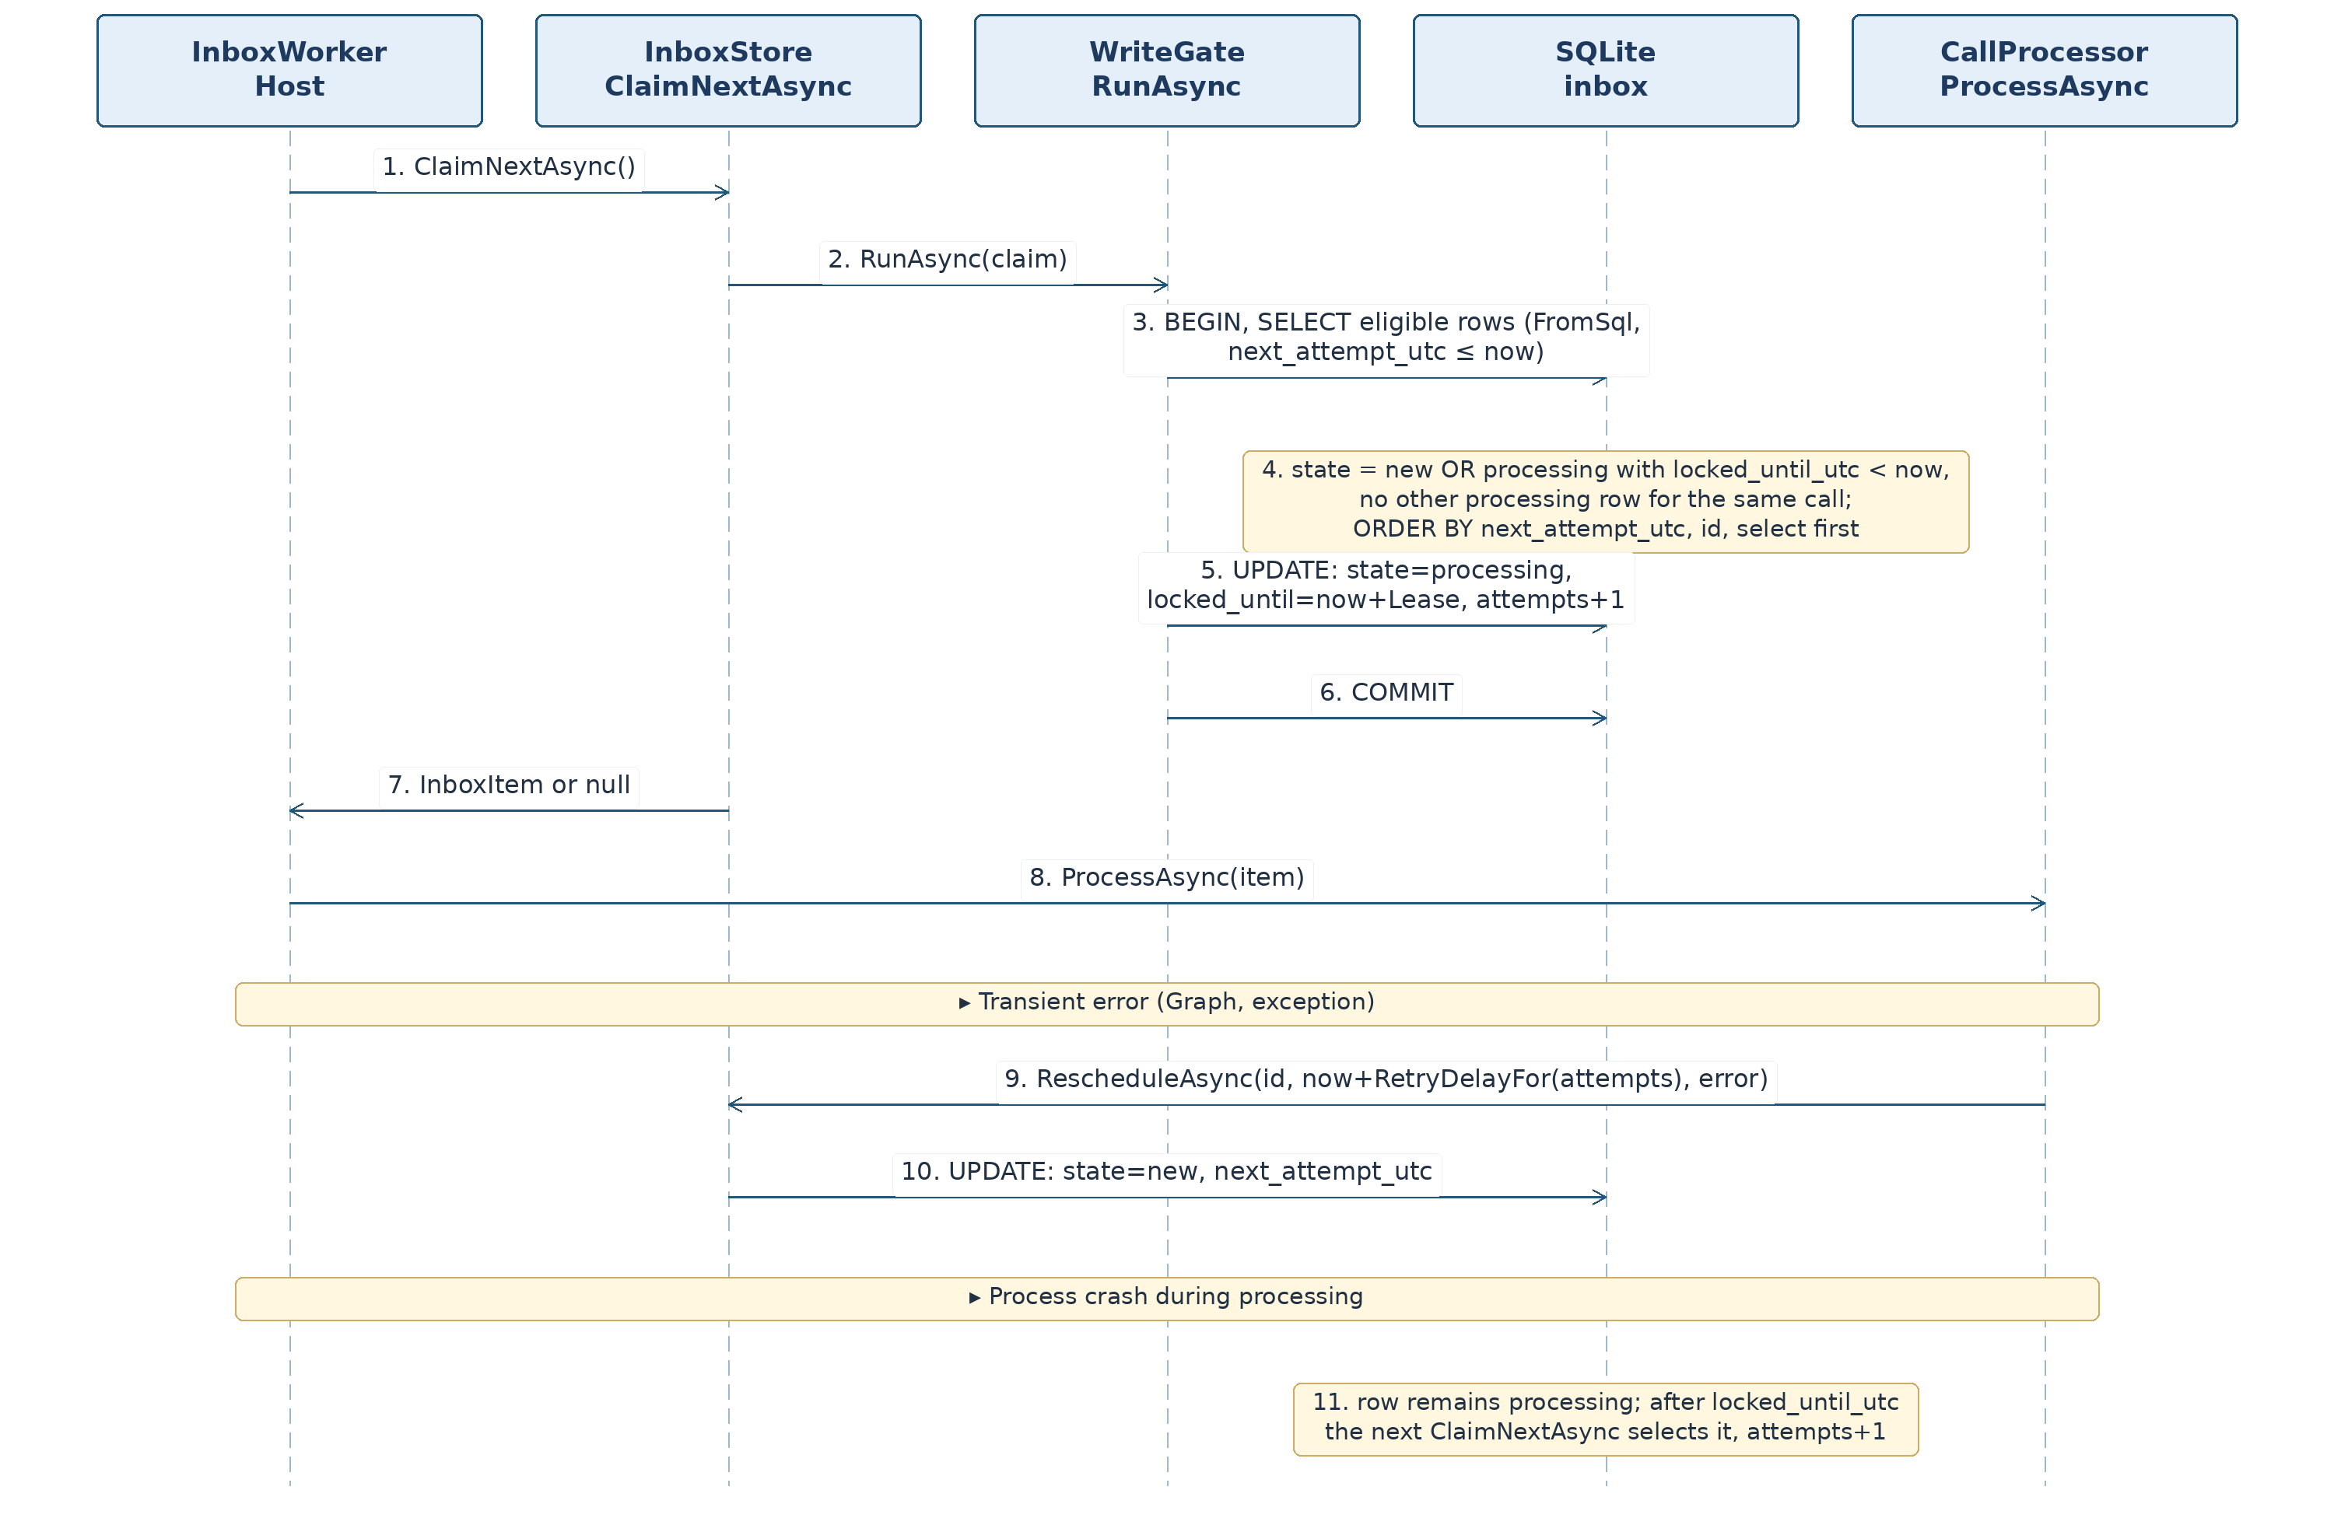
Errors. All methods propagate database exceptions; the store does not retry internally (the caller schedules retries according to 3.13.2).
Lease and retry addition [P-27]. InboxWorker renews its lease every LeaseSeconds/3 using RenewLeaseAsync, supplying the last obtained expectedLockedUntilUtc value. If null is returned or a database error occurs, the associated Graph processing is cancelled, and the stale worker must not complete the item. The CAS check prevents lease renewal after another worker has reclaimed it. For long-running ReconcileAsync, the heartbeat runs concurrently with Graph page fetching; the server does not treat the work as complete if the lease is lost.
Partial unique-index concurrency conflict [P-22, P-27]. When RescheduleAsync moves an already processing item A to new, another item B with the same element_hash may already be in new state. All changes occur in one write transaction: if B exists, A is marked done as superseded by the repeat, B remains new with a schedule no later than required for A; neither the call state nor the scheduled retry is lost. If B does not exist, A receives state=new and its own next_attempt_utc. The stale A does not change the CDR. This prevents a uq_inbox_new_hash exception and ensures reprocessing. Test: Reschedule_WhenDuplicateNew_MergesWithoutLostRetry, already included in the registry.

3.13. Processing: Item Handling, Call State, CDR Replacement, Reconciliation

3.13.1. Types (Processing/ProcessingModels.cs)
public enum ProcessOutcome { Applied, IgnoredLower, Duplicate, Discrepancy, Rejected, Pending, Suspended, Expired, Retry, Failed, Logged, ReconcileRun }
public sealed record ApplyRequest(string TenantId, ConversionResult Result, long InboxId);
public enum ApplyStatus { Applied, DecisionChanged }
public sealed record ApplyResult(ApplyStatus Status, VersionAction? ChangedAction, int Inserted, int Updated, int Deleted, int OutboxCreated);
public sealed record PendingResult(string State, DateTimeOffset? NextAttemptUtc);
public sealed record SourceStateCounts(int Pending, int Suspended, int Expired);
Final inbox item state based on processing outcome:
ProcessOutcome | Inbox Item | Data Changed
Applied | done | CDR, source_state, outbox — in one transaction
IgnoredLower | done | nothing (event in log)
Duplicate | done | nothing
Discrepancy | done | audit_log row
Rejected | done | rejected rows, source_state.rejected_version
Pending | new, attempts=0, next_attempt_utc according to schedule | source_state (pending)
Suspended | done | source_state (suspended)
Expired | done | source_state (expired), error_log row
Retry | new, attempts preserved, next_attempt_utc according to schedule | —
Failed | failed | error_log row
Logged | done | —
ReconcileRun | done | reconcile items for calls enqueued in inbox

3.13.2. Retry Schedule (Config/ProcessingOptions.cs)
ProcessingOptions: int Workers = 2, int LeaseSeconds = 120, string RetrySchedule = "1,5,15,60", int PendingLimitHours = 4, int SuspendedRecheckHours = 24, int MaxAttempts = 10 [P-11].
Method | Description
IReadOnlyList<int> RetryScheduleMinutes() | Parse RetrySchedule as positive comma-separated integers; spaces allowed
TimeSpan RetryDelayFor(int attempt) | attempt >= 1; minutes at index min(attempt − 1, n − 1), repeating the last interval; attempt < 1 → ArgumentOutOfRangeException
IEnumerable<string> Validate() | configuration errors (3.18)
Example for 1,5,15,60 schedule: attempt 1 → 1 min; 2 → 5; 3 → 15; 4 → 60; 5 onward → 60.

3.13.3. ICallProcessor and CallProcessor (Processing/ICallProcessor.cs, Processing/CallProcessor.cs)
public interface ICallProcessor { Task<ProcessOutcome> ProcessAsync(InboxItem item, CancellationToken ct); }
CallProcessor(IGraphClient graph, IInboxStore inbox, ISourceStateStore states, ICdrApplier applier, IReconciler reconciler, IErrorLog errors, IOptions<ProcessingOptions> options, TimeProvider clock, ILogger<CallProcessor> log); singleton, thread-safe (stateless).
Precondition: item was returned by IInboxStore.ClaimNextAsync and is in state processing. Postcondition: the item is transitioned to a state from Table 3.13.1 or, upon cancellation or an error inside exception handling, remains processing until the lease expires and is reclaimed. The method throws no exceptions except OperationCanceledException [K9].
ProcessAsync algorithm (A2). Diagram — Figure 5.
- Logging scope: component=processor, tenant_id, call_id, inbox_id.
- By item.Kind:
  - channelMessage — log a “channel message received” event (without message text), inbox.CompleteAsync, return Logged;
  - reconcile with CallId = null: first parse item.Raw as JSON and determine the work type [P-27]. If any of from_utc, to_utc, or force is present, the item requests manual interval reconciliation; both UTC fields are strictly required; force must be Boolean and true; from_utc < to_utc and the interval must not exceed 7 days. Only when all checks succeed call reconciler.ReconcileAsync(fromUtc,toUtc,force:true,ct). On incomplete, damaged, or invalid input, call inbox.FailAsync(id,"RECONCILE_BAD_RANGE",ct), write safe diagnostics, and return Failed without calling ReconcileAsync or ReconcileLookbackAsync. If all three fields are absent, perform normal reconciler.ReconcileLookbackAsync(ct). On success, inbox.CompleteAsync and return ReconcileRun; a GraphException from reconciliation follows step 12; other errors follow step 13. The job is executed by a background service; the HTTP handler only enqueues it;
  - callRecord or reconcile with CallId ≠ null — step 3; callRecord without CallId — inbox.FailAsync(id,"INBOX_NO_CALL_ID"), errors.WriteAsync(Components.Processor,"inbox item without call_id","inbox_id=<id>"), return Failed.
- GraphFetchResult r = await graph.GetCallRecordAsync(item.CallId, ct). On GraphException ex, go to step 12.
- state = await states.GetAsync(item.TenantId, item.CallId, ct) (one read; the following decisions are based on it, and CdrApplier rechecks it within the transaction).
- Switch on r.Status:
  - NotFound or PagesIncomplete: if state?.AppliedVersion is set, the call has already been applied, and its state must not be degraded: log, inbox.CompleteAsync, return Duplicate. Otherwise proceed to step 11 with reason GRAPH_NOT_FOUND or GRAPH_PAGES_INCOMPLETE, respectively;
  - Malformed — the source returned a response that could not be parsed as JSON; its text is in r.Json; proceed to step 6 (the converter returns CALLRECORD_BAD_JSON) [P-24];
  - Ok — step 6.
- result = CallRecordConverter.Convert(r.Json, item.TenantId).
- If result.Rejections contains a record-level rejection (BadJson, NoCallId, NoVersion): sourceHash = RejectedSourceHash(r.Json); call states.RecordRejectionAsync(item.TenantId, result.CallId ?? item.CallId, result.SourceVersion, result.Rejections, sourceHash, item.Id, ct); return Rejected.
- version = result.SourceVersion; action = VersionRules.Decide(state?.AppliedVersion, state?.SessionSetHash, version, result.SessionSetHash). If state?.RejectedVersion > version, treat the action as IgnoreLower. The version decision is made before any attempt to apply a result.
- If action is not Apply:
  - IgnoreLower — log, inbox.CompleteAsync, return IgnoredLower;
  - DuplicateSame — log, inbox.CompleteAsync, return Duplicate;
  - Discrepancy — call states.RecordDiscrepancyAsync(...), return Discrepancy. These branches also apply when result is incomplete: an obsolete or duplicate incomplete version must not change the source_state of a completed call.
- If action = Apply:
- Transient reasons (result.IncompleteReasons contains NO_SESSIONS or SESSION_DATES_MISSING) — step 11 with a comma-separated list of transient reasons; session-level rejections are not recorded at this stage, as they will be recorded when a higher-quality source version becomes available;
- Only permanent reasons (result.IsComplete = false and invalid sessions remain): if state?.RejectedVersion >= version, call inbox.CompleteAsync and return Duplicate; otherwise call states.RecordRejectionAsync(..., RejectedSourceHash(r.Json), ...), return Rejected;
- Complete result — applier.ApplyAsync(new ApplyRequest(...), ct); if Applied, return Applied; if DecisionChanged, return to step 4 (no more than three consecutive attempts; after the third, proceed to step 13 with InvalidOperationException("decision changed"));
- Incomplete data: PendingResult p = await states.RegisterIncompleteAsync(item.TenantId, item.CallId, reason, item.Id, ct); return Pending, Suspended, or Expired according to p.State.
- Graph error ex: if ex.IsTransient and item.Attempts < MaxAttempts, call inbox.RescheduleAsync(id, now + RetryDelayFor(item.Attempts), message, resetAttempts: false) and return Retry; otherwise call inbox.FailAsync(id, message), errors.WriteAsync(Components.Graph, "graph request failed", "tenant_id=<…>; call_id=<…>; status=<code or none>; attempts=<count>") and return Failed. Errors 401 and 403 are permanent [P-11]. Reading (GetCallRecordAsync) is safe to retry, so the uncertain outcome in 3.14.4 is not distinguished here.
- Any other exception (except cancellation): log its type and message; within an exception handler protected by its own try/catch, call errors.WriteAsync(Components.Processor, "unexpected processing error", "tenant_id=<…>; call_id=<…>; exception=<exception type>"). Then, if item.Attempts < MaxAttempts, call inbox.RescheduleAsync(id, now + RetryDelayFor(item.Attempts), ex.GetType().Name + ": " + ex.Message, false) and return Retry; otherwise call inbox.FailAsync and return Failed. If the exception handler itself throws, the error is written only to ILogger; the item remains processing until its lease expires.
RejectedSourceHash(string json) (internal static, CallProcessor): if json can be parsed as JSON, use Canonical.HashOf(root) (the same canonical hash as source_hash in a CDR: independent of whitespace and property order, with transport annotations excluded). If parsing fails (JsonException, empty text), use Canonical.Sha256Hex(json) over the UTF-8 response text. Store this value in rejected.source_hash for every rejection of that record [P-23].
Idempotency: reprocessing one item (reclaim after lease expiry) is safe — version decisions and unique keys prevent duplicates.
Figure 5. CallProcessor: Processing a Graph Record. Mermaid text diagram; steps and numbering match the PDF/DOCX image.
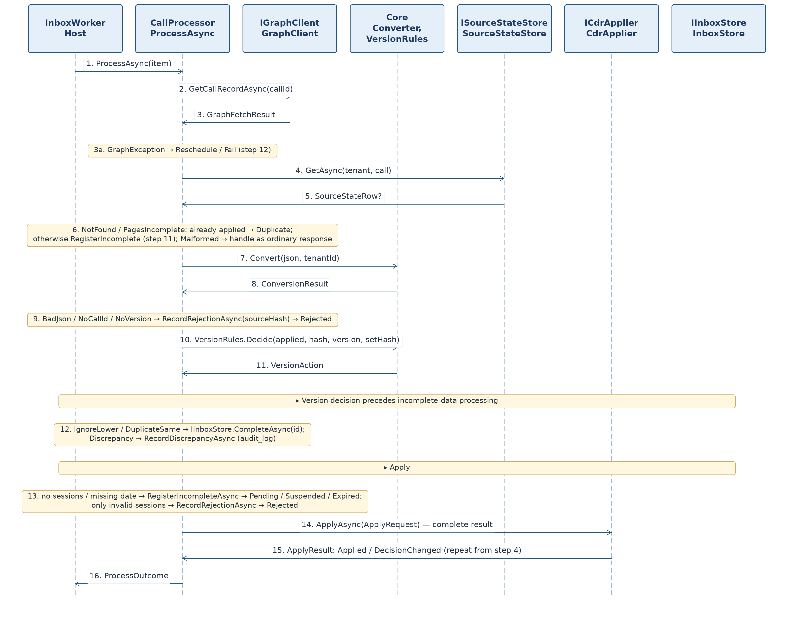

3.13.4. ISourceStateStore and SourceStateStore (Processing/ISourceStateStore.cs, Processing/SourceStateStore.cs)
SourceStateStore(IWriteGate gate, IDbContextFactory<TcriDbContext> factory, IOptions<ProcessingOptions> processing, IOptions<GraphOptions> graph, TimeProvider clock); singleton.
Member | Signature
Get | Task<SourceStateRow?> GetAsync(string tenantId, string callId, CancellationToken ct)
GetMany | Task<IReadOnlyDictionary<string, SourceStateRow>> GetManyAsync(string tenantId, IReadOnlyCollection<string> callIds, CancellationToken ct) — dictionary key is call_id; queries in batches of 500 identifiers
GetCounts | Task<SourceStateCounts> GetCountsAsync(CancellationToken ct)
ListSuspendedDue | Task<IReadOnlyList<SourceStateRow>> ListSuspendedDueAsync(int limit, CancellationToken ct) — state='suspended' and next_attempt_utc <= now, sorted ascending by next_attempt_utc, at most limit items
RegisterIncomplete | Task<PendingResult> RegisterIncompleteAsync(string tenantId, string callId, string reason, long inboxId, CancellationToken ct)
RecordRejection | Task RecordRejectionAsync(string tenantId, string? callId, long? version, IReadOnlyList<Rejection> rejections, string sourceHash, long inboxId, CancellationToken ct)
RecordDiscrepancy | Task RecordDiscrepancyAsync(string tenantId, string callId, long version, string? appliedSetHash, string incomingSetHash, long inboxId, CancellationToken ct)
All three writing methods execute in a single gate transaction, including the inbox item transition.
RegisterIncompleteAsync (now is the current time; age = now − first_seen_utc):
- Find source_state row. If no row exists or state = 'done', create or enter a new episode: state='pending', first_seen_utc = now, attempts = 1; preserve applied_version, rejected_version, and session_set_hash. Otherwise increment attempts.
- last_error = reason, updated_utc = now.
- By state:
  - pending (including just created): if age >= PendingLimitHours hours, set state='suspended', next_attempt_utc = now + SuspendedRecheckHours, MarkDone the item, and return ("suspended", next). Otherwise compute next = now + RetryDelayFor(attempts); set next_attempt_utc = next; Reschedule(next, reason, resetAttempts: false); return ("pending", next).
  - suspended (recheck): if age > GraphOptions.RetentionDays days, set state='expired', next_attempt_utc = NULL, create an error_log row (component='processor', message="source_state expired", details="tenant_id=<…>; call_id=<…>"), MarkDone the item and return ("expired", null). Otherwise set next_attempt_utc = now + SuspendedRecheckHours, MarkDone the item and return ("suspended", next).
  - expired — leave the state unchanged, MarkDone item, return ("expired", null).
- SaveChanges, then commit.
RecordRejectionAsync:
- For each Rejection r, insert a RejectedRow (tenant_id, call_id=r.CallId ?? callId, session_id=r.SessionId, code, message truncated to 1000 characters, source_hash=sourceHash, created_utc=now). Do not add the row if rejected already contains the same tenant_id, call_id, session_id (including NULL), code and source_hash: repeatedly reading the same damaged record must not multiply the rejected list.
- If callId and version are known: look up source_state; if no row exists, create one (state='done', applied_version=NULL, rejected_version=version, attempts=0, first_seen_utc=now). If a row exists, set rejected_version=max(current, version), and if state is pending or suspended, set state='done', attempts=0, next_attempt_utc=NULL.
- MarkDone the item. SaveChanges, then commit.
RecordDiscrepancyAsync: insert AuditLogRow (ts=now, tenant_id, call_id, kind='version_discrepancy', detail is JSON {"version":<version>,"applied_set_hash":"<…>","incoming_set_hash":"<…>"}; represent a null hash as JSON null); MarkDone the item. Neither source_state nor cdr is changed.

3.13.5. ICdrApplier and CdrApplier (Processing/ICdrApplier.cs, Processing/CdrApplier.cs)
public interface ICdrApplier { Task<ApplyResult> ApplyAsync(ApplyRequest request, CancellationToken ct); }
CdrApplier(IWriteGate gate, IOptions<OutboxOptions> outbox, TimeProvider clock); singleton.
Preconditions: request.Result.IsComplete = true; request.Result.Cdrs is nonempty; every CDR has the same CallId and TenantId = request.TenantId; request.InboxId refers to an item in state processing.
ApplyAsync algorithm (one gate transaction; Figure 6):
- now; state = db.SourceStates.Find(tenant, call) (with tracking).
- Reevaluate the decision: VersionRules.Decide(state?.AppliedVersion, state?.SessionSetHash, version, setHash); if state?.RejectedVersion > version, IgnoreLower. If the result is not Apply, return ApplyResult(DecisionChanged, action, 0,0,0,0) without changing data.
- existing = db.Cdrs.Where(TenantId == tenant && CallId == call).ToList() (with tracking); oldSessions is the set of SessionId values from existing.
- For each Cdr c in request.Result.Cdrs: row = CdrMapping.ToRow(c, now). If existing contains a row with the same SessionId, call CdrMapping.CopyOnUpdate(existingRow, row, now) (preserve cdr_seq and created_utc), Updated++; otherwise db.Cdrs.Add(row), Inserted++.
- For each row in existing whose SessionId is absent from the new set, call db.Cdrs.Remove and increment Deleted.
- Outbound notifications: for every Cdr c whose SessionId is not in oldSessions, provided c.EndUtc >= now − Outbox:MaxAgeHours hours, recipients are the distinct nonempty Id values of c.Caller and c.Callee with Type="user" [P-14]. For each recipient, if no row with key (activity, tenant, call, session, recipient) exists in outbox (checked by query in this same transaction), insert OutboxRow (kind='activity', payload=ActivityPayload.Create(c).ToJson(), state='new', attempts=0, next_attempt_utc=now, created_utc=now); increment OutboxCreated.
- source_state: if missing, create (first_seen_utc = now); applied_version = version, session_set_hash = setHash, state='done', attempts=0, next_attempt_utc=NULL, last_error=NULL, updated_utc=now; rejected_version is unchanged.
- InboxTransitions.MarkDone(db, request.InboxId, now).
- await db.SaveChangesAsync(ct); gate commits. Errors cause a gate rollback and propagate to CallProcessor step 13.
Postconditions when Applied: the call's cdr rows correspond exactly to the result's session set; cdr_seq values of surviving sessions do not change; source_state.applied_version = version, state='done'; inbox item is done; outbox rows are created for new sessions (not updated sessions), subject to recipient rules.
Figure 6. CdrApplier: Atomic CDR Replacement. Mermaid text diagram; steps and numbering match the PDF/DOCX image.
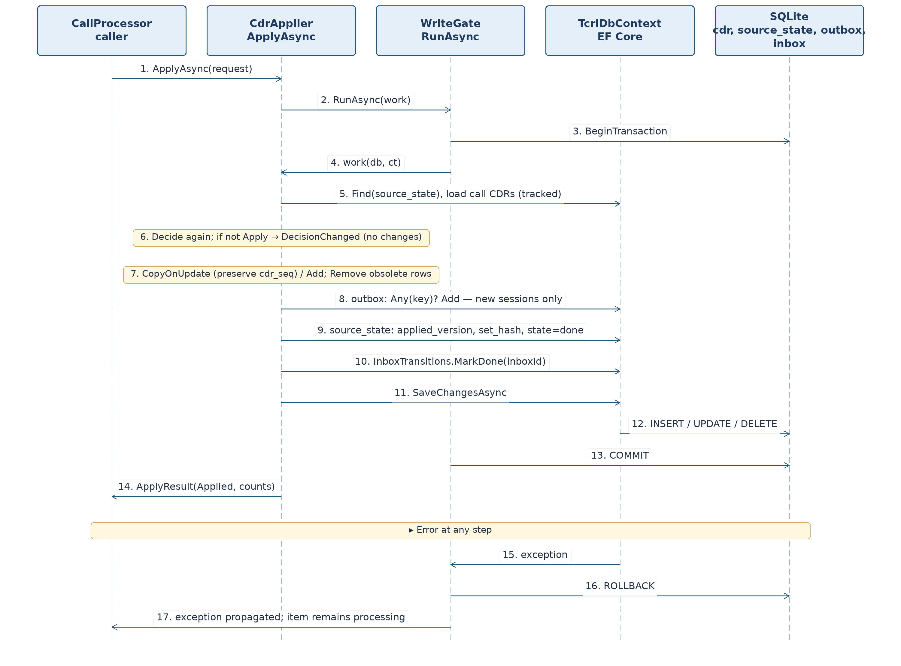

3.13.6. IReconciler and Reconciler (Processing/IReconciler.cs, Processing/Reconciler.cs)
public interface IReconciler
{
DateTimeOffset? LastRunUtc { get; }
Task<int> ReconcileAsync(DateTimeOffset fromUtc, DateTimeOffset toUtc, bool force, CancellationToken ct);
Task<int> ReconcileLookbackAsync(CancellationToken ct);
Task<int> RecheckSuspendedAsync(CancellationToken ct);
}
Reconciler(IGraphClient graph, ISourceStateStore states, IInboxStore inbox, IOptions<GraphOptions> graphOptions, IOptions<ReconcileOptions> options, TimeProvider clock, ILogger<Reconciler> log); singleton. ReconcileOptions: int IntervalMinutes = 15, int LookbackHours = 24.
Method | Algorithm
ReconcileAsync(from, to, force) | 1. refs = graph.ListCallRecordsAsync(from, to). 2. known = states.GetManyAsync(tenant, refs.Id). 3. For each reference r: evaluate NeedsFetch(known.GetValueOrDefault(r.Id), r, force); if true, create InboxNewItem(Reconcile, tenant, r.Id, raw), with raw JSON {"call_id":"<id>","version":<number or null>}. 4. Call inbox.EnqueueAsync(items). 5. If Overloaded = true, write a warning to the log and return 0. 6. Return Added. Propagate any GraphException to the caller.
ReconcileLookbackAsync() | ReconcileAsync(now − LookbackHours, now, force: false); after successful completion, LastRunUtc = now (stored only in process memory, null again after restart [P-17])
RecheckSuspendedAsync() | rows=states.ListSuspendedDueAsync(200); for each row create InboxNewItem(Reconcile, tenant, row.CallId, raw), where raw={"call_id":"<id>","recheck_at":"<row.next_attempt_utc>"}. The recheck_at value distinguishes scheduled rechecks of the same call; as long as a new row with that hash remains unprocessed, a repeated call does not duplicate it. Call inbox.EnqueueAsync; return Added.
NeedsFetch(SourceStateRow? s, GraphCallRecordRef r, bool force) — conditions are checked from top to bottom; the first match determines the result:
№ | Condition | Result
1 | s = null | yes
2 | force = true (manual /reprocess) | yes, in every state, including pending, suspended, expired, and done at the same version
3 | s.State ∈ {pending, suspended} | no (retries and daily checks are handled by item processing)
4 | s.State = expired | no (source retention has expired; only a manual force can retry it)
5 | s.State = done and r.Version = null | yes (version is unknown and cannot be compared; refetch is safe but occurs at every reconciliation, limited by the LookbackHours window [P-21])
6 | s.State = done and r.Version > max(s.applied_version ?? −1, s.rejected_version ?? −1) | yes
7 | otherwise | no
Postcondition: after execution, for each call in the period which needs a read according to the NeedsFetch table, inbox contains a new row with that call's hash. A repeat run without new versions and without force does not add items while the new rows have not been processed; once processed it does not add any at all. /reprocess (Part 3) invokes ReconcileAsync(from,to,force:true): every call in the period is reread regardless of state. Repetition is safe because the version decision (3.13.3, step 8) prevents duplicates.
Reconciliation sequence — Figure 7.
Figure 7. Reconciler: Reconciliation with Microsoft Graph. Mermaid text diagram; steps and numbering match the PDF/DOCX image.
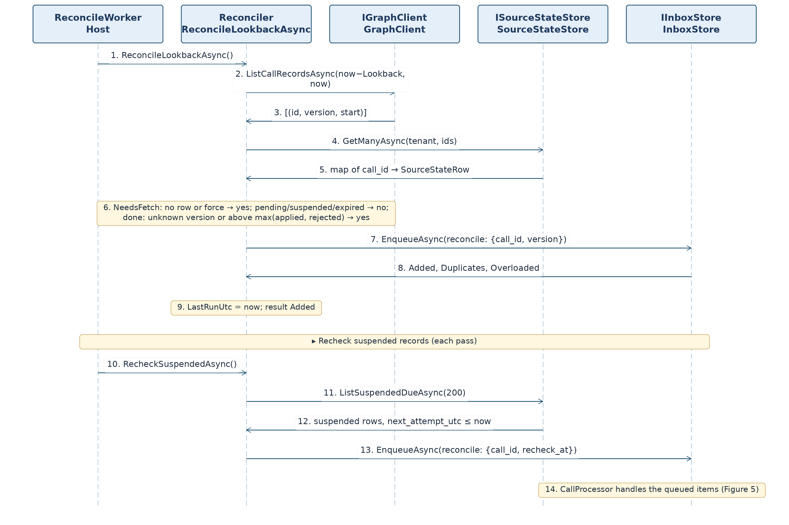
Comparison with authentic v0.2 [RV-01]. Under normal NeedsFetch(force:false), pending and suspended states return false: their next retry is determined by next_attempt_utc using the standard mechanisms. With force:true, the requested period is checked independently of next_attempt_utc.

3.14. Graph: Microsoft Graph Client

3.14.1. Types (Graph/GraphModels.cs, Graph/GraphException.cs)
public enum GraphFetchStatus { Ok, NotFound, PagesIncomplete, Malformed }
public sealed record GraphFetchResult(GraphFetchStatus Status, string? Json);
public sealed record GraphCallRecordRef(string Id, long? Version, DateTimeOffset? StartUtc);
public sealed record GraphSubscriptionRequest(string Kind, string Resource, string NotificationUrl, DateTimeOffset ExpiresUtc, string ClientState);
public sealed record GraphSubscription(string Id, string Resource, DateTimeOffset ExpiresUtc);
public sealed record GraphSubscriptionInfo(string Id, string Resource, string NotificationUrl, DateTimeOffset ExpiresUtc);
public sealed record ActivityNotification(string RecipientUserId, string ActivityType, string TopicText, string PreviewText, IReadOnlyDictionary<string, string> TemplateParameters);
public sealed class GraphException : Exception
{
public GraphException(string message, int? statusCode, bool isTransient, Exception? inner = null, bool outcomeUnknown = false);
public int? StatusCode { get; }
public bool IsTransient { get; }
public bool OutcomeUnknown { get; }
}
GraphFetchResult.Json is nonempty when Ok; for PagesIncomplete, it holds the portion already read but is not used by the processor; for Malformed, it contains the response text that could not be parsed as JSON (used to record the rejection and compute source_hash, 3.13.3 steps 5 and 7).
GraphException.OutcomeUnknown means an uncertain outcome: the server may have performed a side-effecting operation even though no response was received or a server error was received. Set this flag only for POST methods (CreateSubscriptionAsync, SendActivityNotificationAsync); it is always false for reads, PATCH and DELETE, because their retries are safe.
Error classification:
Situation | StatusCode | IsTransient | OutcomeUnknown
network unavailable or request timeout | null | yes | true for POST, false otherwise
open circuit breaker (BrokenCircuitException; request was not sent) | null | yes | no
429 after retries exhausted | 429 | yes | no (the server rejected without performing the request)
408 and 5xx after retries exhausted | status code | yes | true for POST, false otherwise
400, 401, 403, all other 4xx except 404 | status code | no | no
404 for GetCallRecordAsync | — | not an exception: GraphFetchStatus.NotFound | —
404 for other operations | 404 | no | no
2xx response body cannot be parsed as JSON: GetCallRecordAsync | — | not an exception: GraphFetchStatus.Malformed | —
the same for other operations | null | no | no
Exception messages include the method, path without query string, and status code; the response body and token are excluded.

3.14.2. GraphOptions Settings (Graph/GraphOptions.cs)
Property | Key | Default
TenantId | Graph:TenantId | —
ClientId | Graph:ClientId | —
ClientSecret | Graph:ClientSecret | — (environment)
NotificationUrl | Graph:NotificationUrl | —
ClientState | Graph:ClientState | — (environment)
RetentionDays | Graph:RetentionDays | 30
BaseUrl | Graph:BaseUrl | https://graph.microsoft.com/v1.0
Scope | Graph:Scope | https://graph.microsoft.com/.default
RequestTimeoutSeconds | Graph:RequestTimeoutSeconds | 30
TotalTimeoutSeconds | Graph:TotalTimeoutSeconds | 120
RetryMaxAttempts | Graph:RetryMaxAttempts | 3
RetryBaseDelayMilliseconds | Graph:RetryBaseDelayMilliseconds | 500
MaxPages | Graph:MaxPages | 100
ActivityTopicWebUrl | Graph:ActivityTopicWebUrl | https://teams.microsoft.com/
Validate() rules: TenantId, ClientId, ClientSecret, NotificationUrl and ClientState must be nonempty; NotificationUrl and BaseUrl must be absolute HTTPS addresses; RetentionDays 1–365; RequestTimeoutSeconds 1–300; TotalTimeoutSeconds >= RequestTimeoutSeconds; RetryMaxAttempts 0–10; MaxPages 1–1000.

3.14.3. IGraphClient and GraphClient
public interface IGraphClient
{
Task<GraphFetchResult> GetCallRecordAsync(string callId, CancellationToken ct);
Task<IReadOnlyList<GraphCallRecordRef>> ListCallRecordsAsync(DateTimeOffset fromUtc, DateTimeOffset toUtc, CancellationToken ct);
Task<IReadOnlyList<GraphSubscriptionInfo>> ListSubscriptionsAsync(CancellationToken ct);
Task<GraphSubscription> CreateSubscriptionAsync(GraphSubscriptionRequest request, CancellationToken ct);
Task<GraphSubscription> RenewSubscriptionAsync(string subscriptionId, DateTimeOffset newExpiresUtc, CancellationToken ct);
Task DeleteSubscriptionAsync(string subscriptionId, CancellationToken ct);
Task SendActivityNotificationAsync(ActivityNotification notification, CancellationToken ct);
}
GraphClient(HttpClient http, TokenCredential credential, IOptions<GraphOptions> options, ILogger<GraphClient> log); registered as a typed client (3.14.5). http.BaseAddress is GraphOptions.BaseUrl with a trailing /.
General request rules:
- Token: credential.GetTokenAsync(new TokenRequestContext(new[] { Scope }), ct); Authorization: Bearer <token> header. Token caching and refresh are handled by ClientSecretCredential. Token acquisition failure (AuthenticationFailedException) becomes GraphException(isTransient: false, statusCode: null), with message "token acquisition failed".
- Add the token only to requests whose address has the same host as BaseUrl; a continuation link with a different host throws GraphException(isTransient: false).
- GET requests have no side effects; POST requests with uncertain outcomes are not blindly retried.
- A 2xx response is parsed; all other responses are classified according to the table. HttpRequestException and TaskCanceledException without caller cancellation (ct.IsCancellationRequested = false) become GraphException(isTransient: true), with outcomeUnknown: true additionally for POST methods. BrokenCircuitException becomes GraphException(isTransient: true) (request was not sent).
Method | Request | Algorithm and Result
GetCallRecordAsync(callId) | GET communications/callRecords/{Uri.EscapeDataString(callId)}?$expand=sessions($expand=segments) | 1. HTTP 404 → (NotFound,null). 2. Parse body into JsonNode root; if this or any later page is not JSON, return (Malformed,text of that body) without throwing. 3. Session pages: while root contains sessions@odata.nextLink, if MaxPages pages have already been read, return (PagesIncomplete,root.ToJsonString()); otherwise GET that link (validating its host), append its value elements to root["sessions"], replace the link with the page's @odata.nextLink or remove it. 4. Segment pages: for each session, likewise follow segments@odata.nextLink within that session's segments array; MaxPages applies separately to each collection. 5. Remove sessions@odata.nextLink from root and segments@odata.nextLink from sessions. 6. Return (Ok,root.ToJsonString()).
ListCallRecordsAsync(from, to) | GET communications/callRecords?$filter=startDateTime ge {from} and startDateTime lt {to} (values use UtcText.Format; URI query is encoded by Uri.EscapeDataString for each component) | Follow @odata.nextLink until absent or MaxPages exceeded (then GraphException(isTransient: false)); from each value item obtain id (required; otherwise skip with warning), version (number or null), startDateTime (time), and required metadata
CreateSubscriptionAsync(request) | POST subscriptions | body from table below; result is id, resource, expirationDateTime from response
RenewSubscriptionAsync(id, newExpires) | PATCH subscriptions/{id} | body {"expirationDateTime":"<UtcText.Format(newExpires)>"}; result is id, resource, expirationDateTime from response (use empty string if resource absent)
DeleteSubscriptionAsync(id) | DELETE subscriptions/{id} | HTTP 204 or 404 — success (subscription already absent)
SendActivityNotificationAsync(n) | POST users/{n.RecipientUserId}/teamwork/sendActivityNotification | body from table below; HTTP 204 indicates success
ListSubscriptionsAsync() | GET subscriptions | Follow @odata.nextLink pages up to MaxPages (if exceeded, throw GraphException(isTransient:false)); from each value item extract id, resource, notificationUrl and expirationDateTime (skip with warning when any field is missing or expiration time cannot be parsed); return IReadOnlyList<GraphSubscriptionInfo>. This finds subscriptions created when an earlier request had an unknown outcome.
POST subscriptions body [P-proposed]:
Field | Value
changeType | "created"
notificationUrl | request.NotificationUrl
lifecycleNotificationUrl | the same address
resource | request.Resource
expirationDateTime | UtcText.Format(request.ExpiresUtc)
clientState | request.ClientState
sendActivityNotification body [P-proposed, P-19]:
{
"topic": { "source": "text", "value": "<n.TopicText>", "webUrl": "<GraphOptions.ActivityTopicWebUrl>" },
"activityType": "<n.ActivityType>",
"previewText": { "content": "<n.PreviewText>" },
"templateParameters": [ { "name": "<key>", "value": "<value>" } ]
}
templateParameters entries are pairs from n.TemplateParameters in enumeration order. The callCompleted activity type is declared in the Teams app manifest (Part 4).

3.14.4. Resilience
Registration (AddTcriGraphClient, 3.18) adds AddResilienceHandler to HttpClient with policies configured by GraphOptions [P-18]:
Policy | Parameters
Total Timeout | TotalTimeoutSeconds
Retry | MaxRetryAttempts=RetryMaxAttempts; BackoffType=Exponential; UseJitter=true; Delay=RetryBaseDelayMilliseconds; ShouldRetryAfterHeader=true (honor Retry-After). ShouldHandle depends on the request method (args.Outcome.Result.RequestMessage.Method): for GET, PATCH and DELETE, retry 408, 429, 5xx and network exceptions; for POST, retry only 429 (the server refused without executing the request). Retrying a POST after timeout, network fault or 5xx is prohibited: the request may have succeeded and repeating could create a second subscription or notification [P-20].
Attempt Timeout | RequestTimeoutSeconds
Circuit Breaker | MinimumThroughput = 5, FailureRatio = 0.5, SamplingDuration = 60 s, BreakDuration = 30 s
After retries are exhausted, the last status (429/5xx) is returned for GraphClient to classify according to Table 3.14.1 (with OutcomeUnknown set for POST).
Delivery guarantees [P-20]. Reading, renewing, and deleting a subscription use “at least once” (retry is safe). Subscription creation uses “at most once” at request level; possible duplicates after an unknown outcome are detected and removed by SubscriptionService using ListSubscriptionsAsync (3.15.3). Activity feed notification is “at most once” on an unknown outcome (the outbox item is closed as failed with OUTCOME_UNKNOWN and is not automatically resent), and “at least once” only after a definite 429 refusal where no delivery occurred. The owner may manually resend while accepting the duplicate risk.

3.14.5. Diagram Reference
The multi-page call-record request sequence appears in Figure 8.
Figure 8. GraphClient: Paginated callRecord Retrieval. Mermaid text diagram; steps and numbering match the PDF/DOCX image.
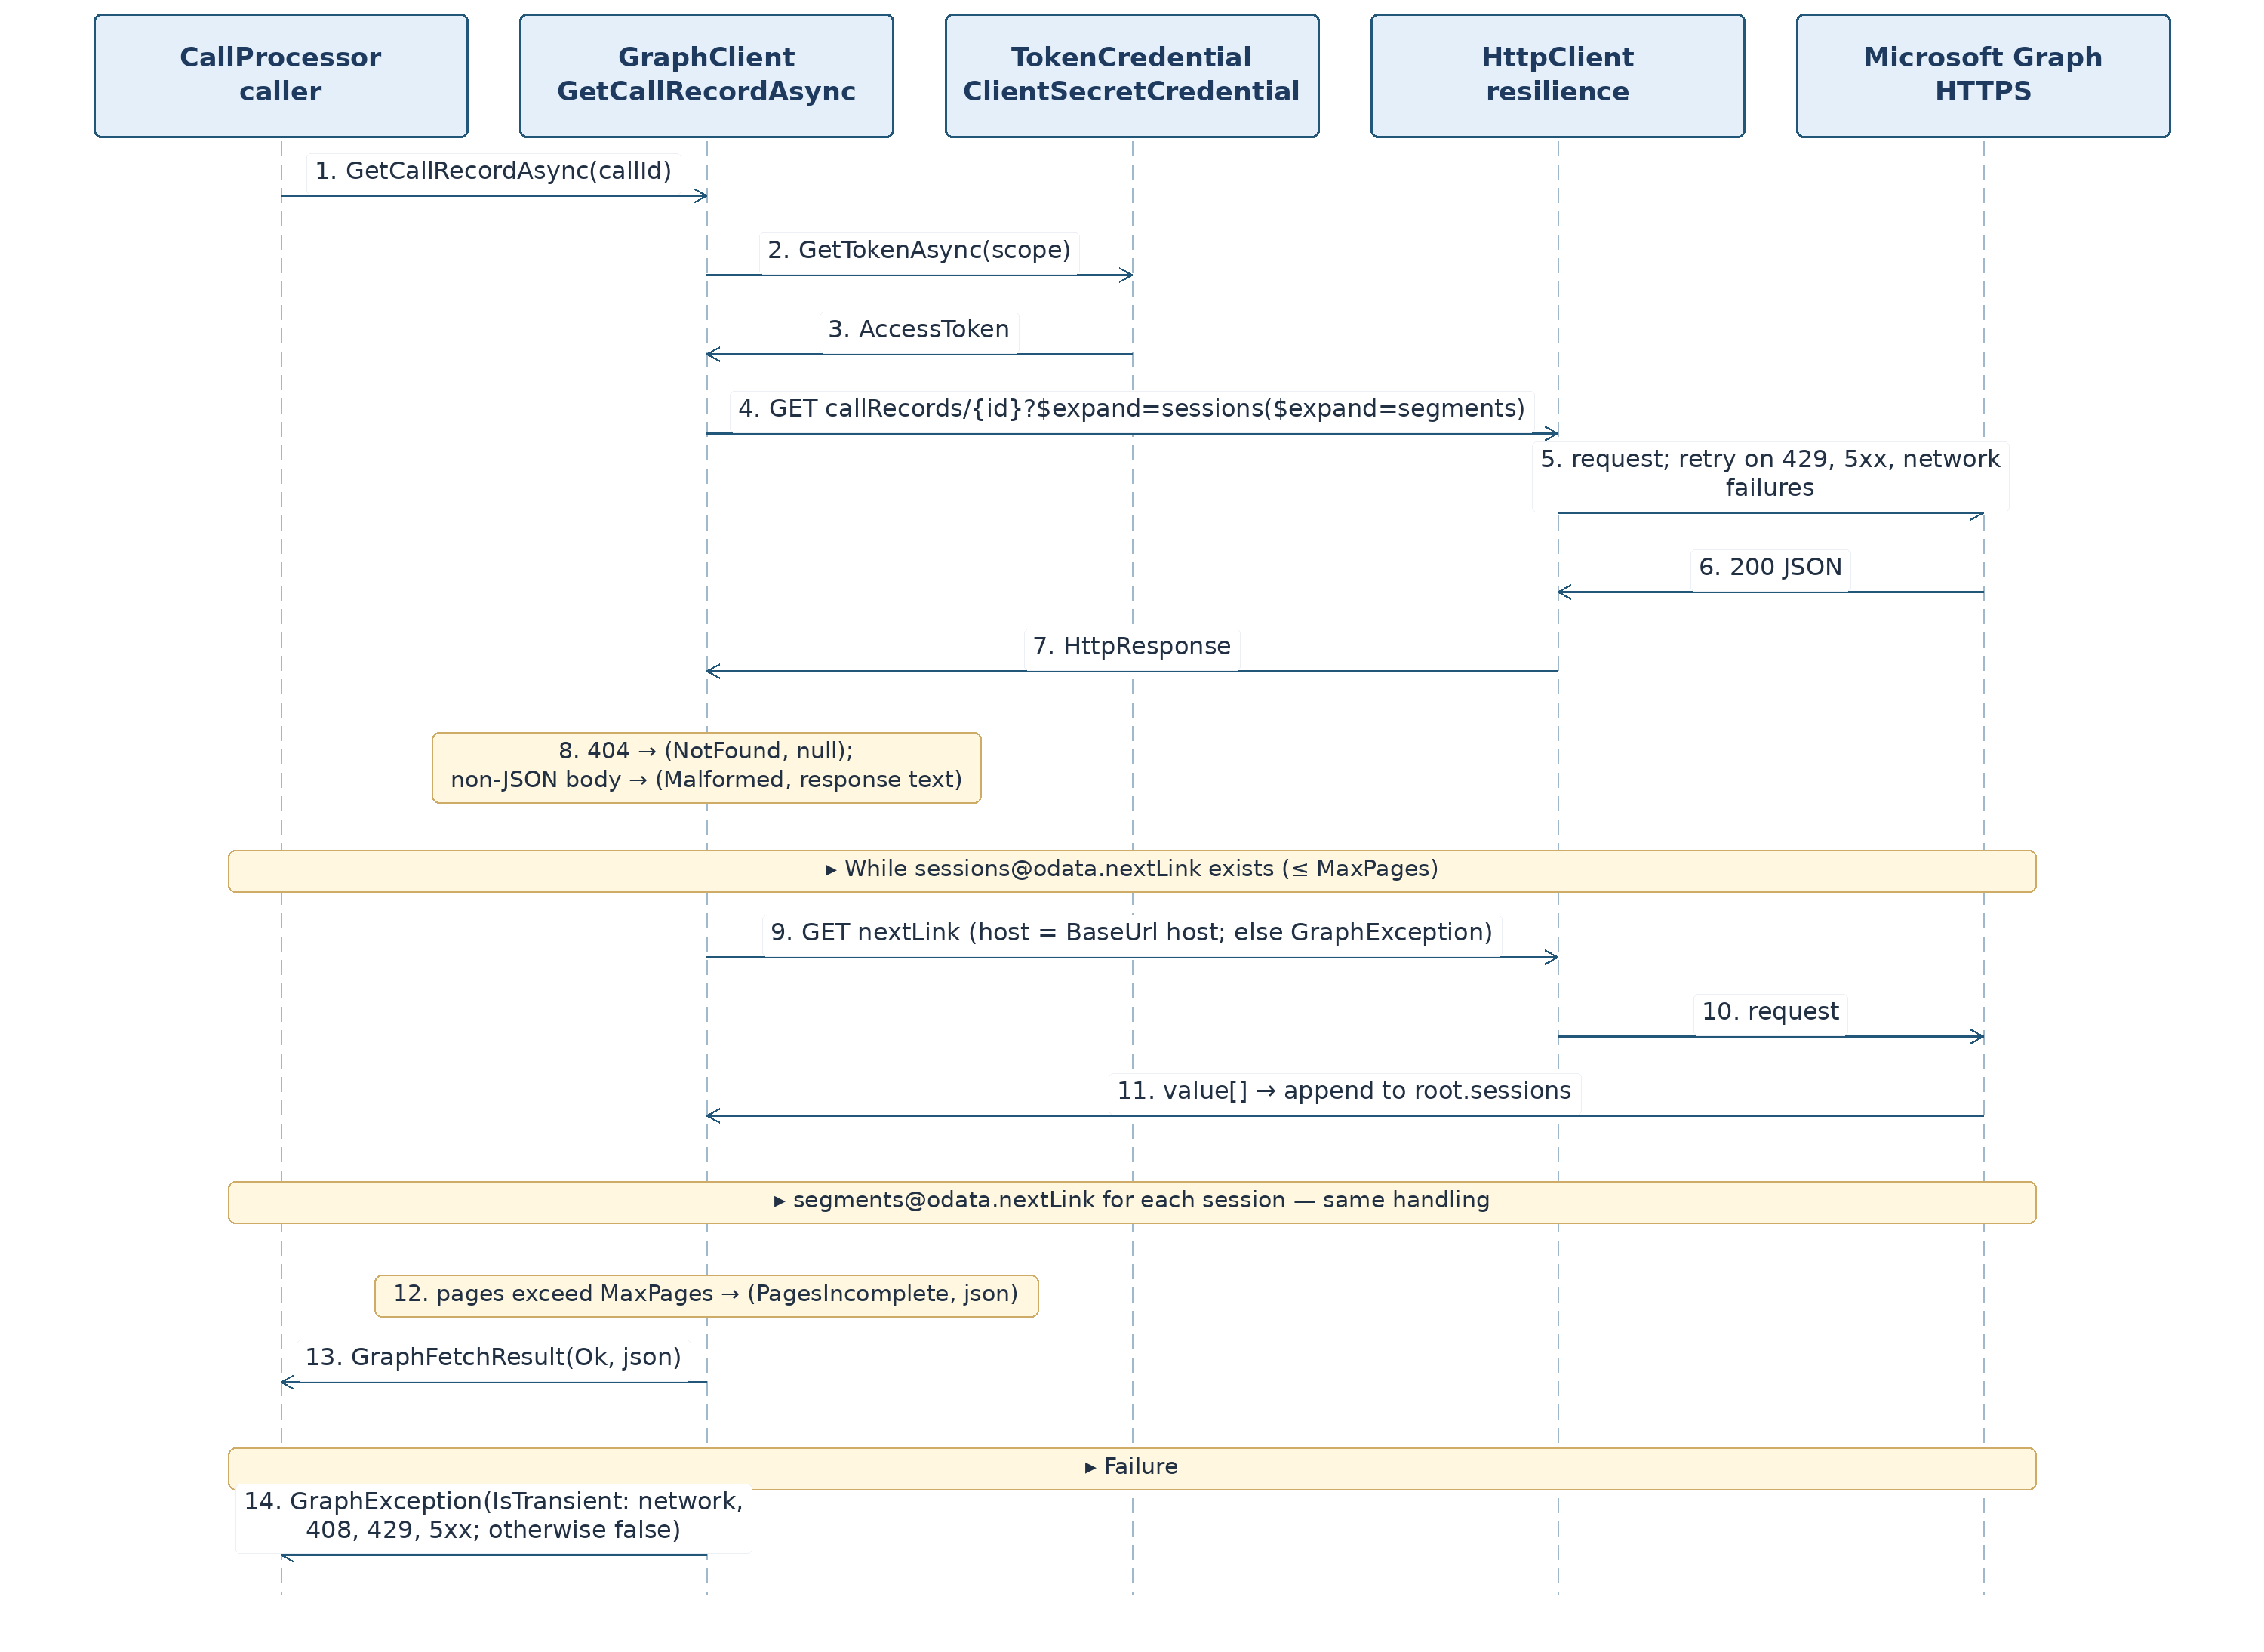

3.15. Subscriptions: Graph Subscriptions

3.15.1. SubscriptionOptions (Subscriptions/SubscriptionOptions.cs)
Property | Key | Default | Purpose
CallRecordsLifetimeMinutes | Subscriptions:CallRecordsLifetimeMinutes | 4230 | call record subscription lifetime [P-as: Graph limit must be tested in tenant] [P-16]
ChannelMessagesLifetimeMinutes | Subscriptions:ChannelMessagesLifetimeMinutes | 60 | channel message subscription lifetime [P-as]
TeamId | Subscriptions:TeamId | empty | team for F3
ChannelId | Subscriptions:ChannelId | empty | channel for F3; create message subscription only when both values are specified
RenewCheckMinutes | Subscriptions:RenewCheckMinutes | 5 | check interval (used by Host service)
Validation rules: lifetime between 10 and 43,200 minutes; RenewCheckMinutes between 1 and 60; TeamId and ChannelId must both be specified or both empty.

3.15.2. ISubscriptionStore and SubscriptionStore
SubscriptionStore(IWriteGate gate, IDbContextFactory<TcriDbContext> factory); singleton.
Member | Signature | Description
List | Task<IReadOnlyList<SubscriptionRow>> ListAsync(CancellationToken ct) | all rows, sorted by created_utc
Get | Task<SubscriptionRow?> GetAsync(string id, CancellationToken ct) | row or null
Upsert | Task UpsertAsync(SubscriptionRow row, CancellationToken ct) | insert or replace all columns by id
SetStatus | Task SetStatusAsync(string id, string status, CancellationToken ct) | change status; do nothing if row absent
Delete | Task DeleteAsync(string id, CancellationToken ct) | delete row; do nothing if absent
HashClientState | public static string HashClientState(string clientState) | SHA-256 of UTF-8 text, lowercase hex, 64 characters
Matches | public static bool Matches(string storedHash, string clientState) | constant-time comparison of storedHash and HashClientState(clientState) (CryptographicOperations.FixedTimeEquals on UTF-8 bytes; false on different lengths)
ClientState is not stored in the database: only a hash is written to client_state_hash.

3.15.3. SubscriptionService (Subscriptions/SubscriptionService.cs)
SubscriptionService(IGraphClient graph, ISubscriptionStore store, IInboxStore inbox, IErrorLog errors, IOptions<GraphOptions> graphOptions, IOptions<SubscriptionOptions> options, TimeProvider clock, ILogger<SubscriptionService> log); class is stateless and thread-safe.
Member | Signature
Ensure | Task<bool> EnsureAsync(CancellationToken ct)
HandleLifecycle | Task HandleLifecycleAsync(string subscriptionId, string lifecycleEvent, CancellationToken ct)
Desired subscriptions desired: (1) kind callRecords, resource communications/callRecords, lifetime CallRecordsLifetimeMinutes; (2) when TeamId and ChannelId are provided, kind channelMessages, resource teams/{TeamId}/channels/{ChannelId}/messages, lifetime ChannelMessagesLifetimeMinutes.
EnsureAsync algorithm (invoked at startup and every RenewCheckMinutes; Figure 9). Return true when an active row exists for each desired subscription:
- rows = store.ListAsync; allOk = true.
- For each d in desired:
  - mine — rows of the same kind; best — the row among mine with state active or renewing, matching resource and expires_utc > now, with the greatest expires_utc.
  - For all other rows of kind d.Kind except best, call graph.DeleteSubscriptionAsync (ignore errors but log them), then store.DeleteAsync.
  - Inside try: if best = null, Create(d); otherwise, if best.expires_utc − now < lifetime/2, RenewOrReplace(best, d).
  - GraphException ex — errors.WriteAsync(Components.Subscriptions, ...), allOk = false.
- Rows of kinds absent from desired are not deleted by the service (the kind is disabled by configuration; its row expires naturally).
Create(d) (create with duplicate protection after an uncertain outcome [P-20]):
- known = graph.ListSubscriptionsAsync; found — known items with Resource = d.Resource, NotificationUrl = GraphOptions.NotificationUrl, and ExpiresUtc > now.
- If found is nonempty, a subscription already exists in Graph (previously created but the response or saved row was lost): choose keep with the greatest ExpiresUtc; delete the others using DeleteSubscriptionAsync (log errors); call store.UpsertAsync for keep (client_state_hash=HashClientState(ClientState), status='active', other fields as below, created_utc=now); create no new subscription; finish. Limitation: a subscription is considered ours based on its resource and notification URL [P-as].
- Otherwise call graph.CreateSubscriptionAsync(new(d.Kind, d.Resource, GraphOptions.NotificationUrl, now + lifetime, GraphOptions.ClientState)); upon GraphException with OutcomeUnknown, write error_log (subscription create outcome unknown), set allOk=false, and do not retry in this pass: the next EnsureAsync starts with steps 1–2 and discovers the created subscription. Then call store.UpsertAsync for a row: id and expires_utc from the Graph response, resource=d.Resource, notification_url=GraphOptions.NotificationUrl, client_state_hash=HashClientState(ClientState), status='active', created_utc=now, renewed_utc=NULL.
RenewOrReplace(row,d): newExp=now + lifetime; call graph.RenewSubscriptionAsync(row.Id,newExp); on success, call store.UpsertAsync on the same row with expires_utc from the response, status='active', renewed_utc=now. On any GraphException: call errors.WriteAsync(Components.Subscriptions, "subscription renewal failed", ...), store.SetStatusAsync(row.Id,failed), Create(d), then graph.DeleteSubscriptionAsync(row.Id) (ignore errors) and store.DeleteAsync(row.Id). If Create fails again, the old row remains failed, the exception is handled under step 2.4, and the next pass retries Create (a failed row is not considered best).
HandleLifecycleAsync(id, event) algorithm:
- row = store.GetAsync(id); if no row exists, log and return.
- Switch on lifecycleEvent:
  - reauthorizationRequired — immediately RenewOrReplace(row, d) (d is the desired subscription of row.Kind; if this kind is not desired, only log);
  - subscriptionRemoved — store.SetStatusAsync(id, failed), Create(d), store.DeleteAsync(id); errors during Create are handled as in EnsureAsync step 2.4;
  - missed — inbox.EnqueueAsync([ InboxNewItem(Reconcile, GraphOptions.TenantId, null, raw) ]), with raw = {"reason":"missed","subscription_id":"<id>","at":"<UtcText.Format(now)>"}; the queue worker runs a general reconciliation (3.13.3, step 2);
  - Any other value — log a warning.
Figure 9. SubscriptionService: Creation, Renewal, and Unknown POST Outcome. Mermaid text diagram; steps and numbering match the PDF/DOCX image.
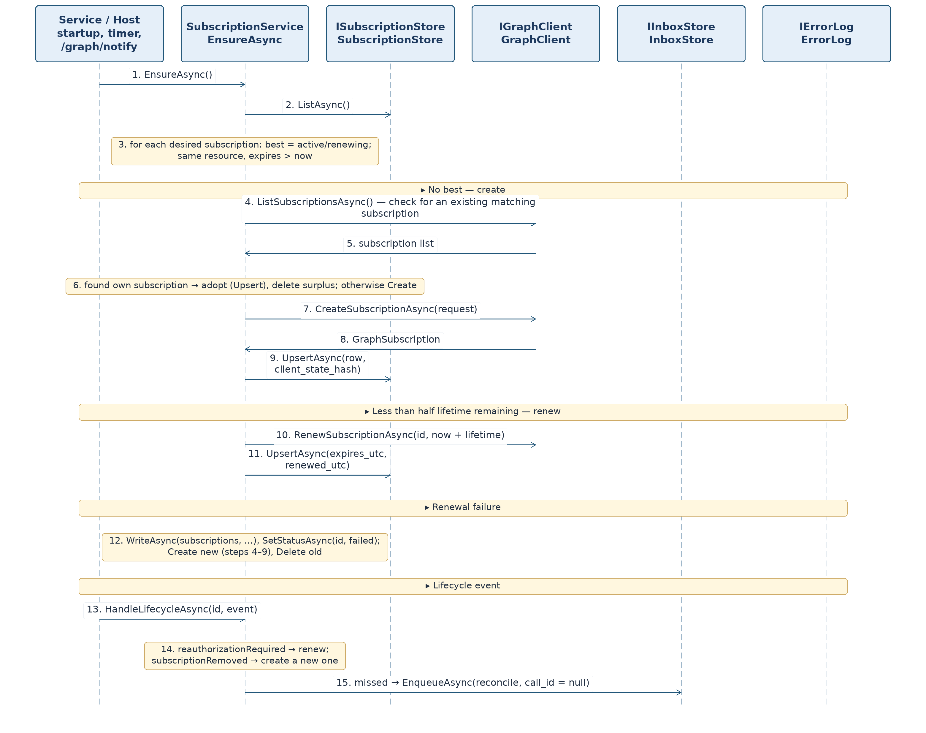
Graph errors inside the method are caught and written to error_log; they are not rethrown. Known limitation: if the process stops between creating a Graph subscription and saving the row, the subscription remains unknown to the database until the next discovery pass.

3.16. Outbox: Outbound Notifications

3.16.1. Types (Outbox/OutboxModels.cs) and Settings (Config/OutboxOptions.cs)
public sealed record OutboxItem(long Id, string TenantId, string CallId, string SessionId, string Recipient, string Payload, int Attempts);
public sealed record OutboxStats(int Pending, int Failed);
public sealed record ActivityPayload(string ActivityType, string CallType, string Status, long DurationSeconds, string StartUtc)
{
public const string CallCompleted = "callCompleted";
public static ActivityPayload Create(Cdr cdr); // ActivityType=CallCompleted; CallType/Status are values from CdrMapping; StartUtc is UtcText.Format(cdr.StartUtc)
public string ToJson(); // {"activity_type":…,"call_type":…,"status":…,"duration_s":…,"start_utc":…}, with fixed property order
public static ActivityPayload Parse(string json);// FormatException for invalid JSON or missing field
}
OutboxStats.Pending counts new and sending rows.
OutboxOptions: int MaxAttempts = 8, int LeaseSeconds = 120, string BackoffSeconds = "30,120,600,1800,3600", int MaxAgeHours = 24 [P-14]. Methods: IReadOnlyList<int> BackoffScheduleSeconds(), TimeSpan BackoffFor(int attempt) (index min(attempt − 1, n − 1); attempt < 1 throws ArgumentOutOfRangeException), IEnumerable<string> Validate().

3.16.2. IOutboxStore and OutboxStore
OutboxStore(IWriteGate gate, IDbContextFactory<TcriDbContext> factory, IOptions<OutboxOptions> options, TimeProvider clock); singleton. CdrApplier creates outbox rows (3.13.5); the store operates on existing rows.
Member | Signature | Description
ClaimNext | Task<OutboxItem?> ClaimNextAsync(CancellationToken ct) | One gate transaction. 1) Rows state='sending' AND locked_until_utc < now are moved to failed (last_error="OUTCOME_UNKNOWN: lease expired", locked_until_utc=NULL); log a warning through ILogger [P-20]. 2) Select the next row state='new' AND next_attempt_utc <= now ordered by next_attempt_utc,id; set state='sending', locked_until_utc=now + LeaseSeconds, attempts+=1.
MarkSent | Task MarkSentAsync(long id, CancellationToken ct) | state='sent', sent_utc = now, locked_until_utc = NULL, last_error = NULL
Reschedule | Task<bool> RescheduleAsync(long id, string error, CancellationToken ct) | If attempts >= MaxAttempts, set state='failed', last_error=error, locked_until_utc=NULL, return false; otherwise state='new', next_attempt_utc=now+BackoffFor(attempts), last_error=error, return true
Fail | Task FailAsync(long id, string error, CancellationToken ct) | state='failed', last_error = error
GetStats | Task<OutboxStats> GetStatsAsync(CancellationToken ct) | Read

3.16.3. IOutboxSender and OutboxSender
public interface IOutboxSender { Task<bool> RunOnceAsync(CancellationToken ct); }
OutboxSender(IOutboxStore store, IGraphClient graph, IErrorLog errors, TimeProvider clock, ILogger<OutboxSender> log); singleton. Returns true if an item was claimed (Host calls the service again without delay after true; after false it waits for the configured interval).
RunOnceAsync algorithm (Figure 10):
- item = store.ClaimNextAsync; if null, return false.
- ActivityPayload.Parse(item.Payload); on FormatException, call store.FailAsync(id, "bad payload"), errors.WriteAsync(Components.Outbox, "outbox item failed", "id=<id>; call_id=<…>; session_id=<…>; attempts=<number>"), return true.
- Construct ActivityNotification: RecipientUserId = item.Recipient; ActivityType = payload.ActivityType; TopicText = "Teams call"; PreviewText = "Call " + payload.CallType + ", " + payload.DurationSeconds + " s, " + payload.Status; TemplateParameters in this order: callType, status, duration (seconds as a string), startUtc [P-19].
- await graph.SendActivityNotificationAsync(n, ct); on success, store.MarkSentAsync and return true.
- GraphException ex [P-20]:
  - ex.OutcomeUnknown (timeout, network failure, or 5xx: the server may have delivered the notification) — do not automatically retry: store.FailAsync(id, "OUTCOME_UNKNOWN: " + message), errors.WriteAsync(Components.Outbox, "outbox item failed", "id=<id>; call_id=<…>; session_id=<…>; attempts=<number>"), return true;
  - Otherwise, if ex.IsTransient (429 or an open circuit breaker: delivery definitely did not occur), ok = store.RescheduleAsync(id, message); if ok=false, call errors.WriteAsync(Components.Outbox, "outbox item failed", "id=<id>; call_id=<…>; session_id=<…>; attempts=<number>"); return true;
  - Otherwise (permanent error, such as 403 or recipient 404), call store.FailAsync(id, message) and errors.WriteAsync with the same message and details; return true.
- Any other exception (except cancellation) is handled as an unknown outcome (step 5, first branch, using OUTCOME_UNKNOWN: <exception type>); return true.
Figure 10. Outbox: Sending Policy and Unknown Outcome. Mermaid text diagram; steps and numbering match the PDF/DOCX image.
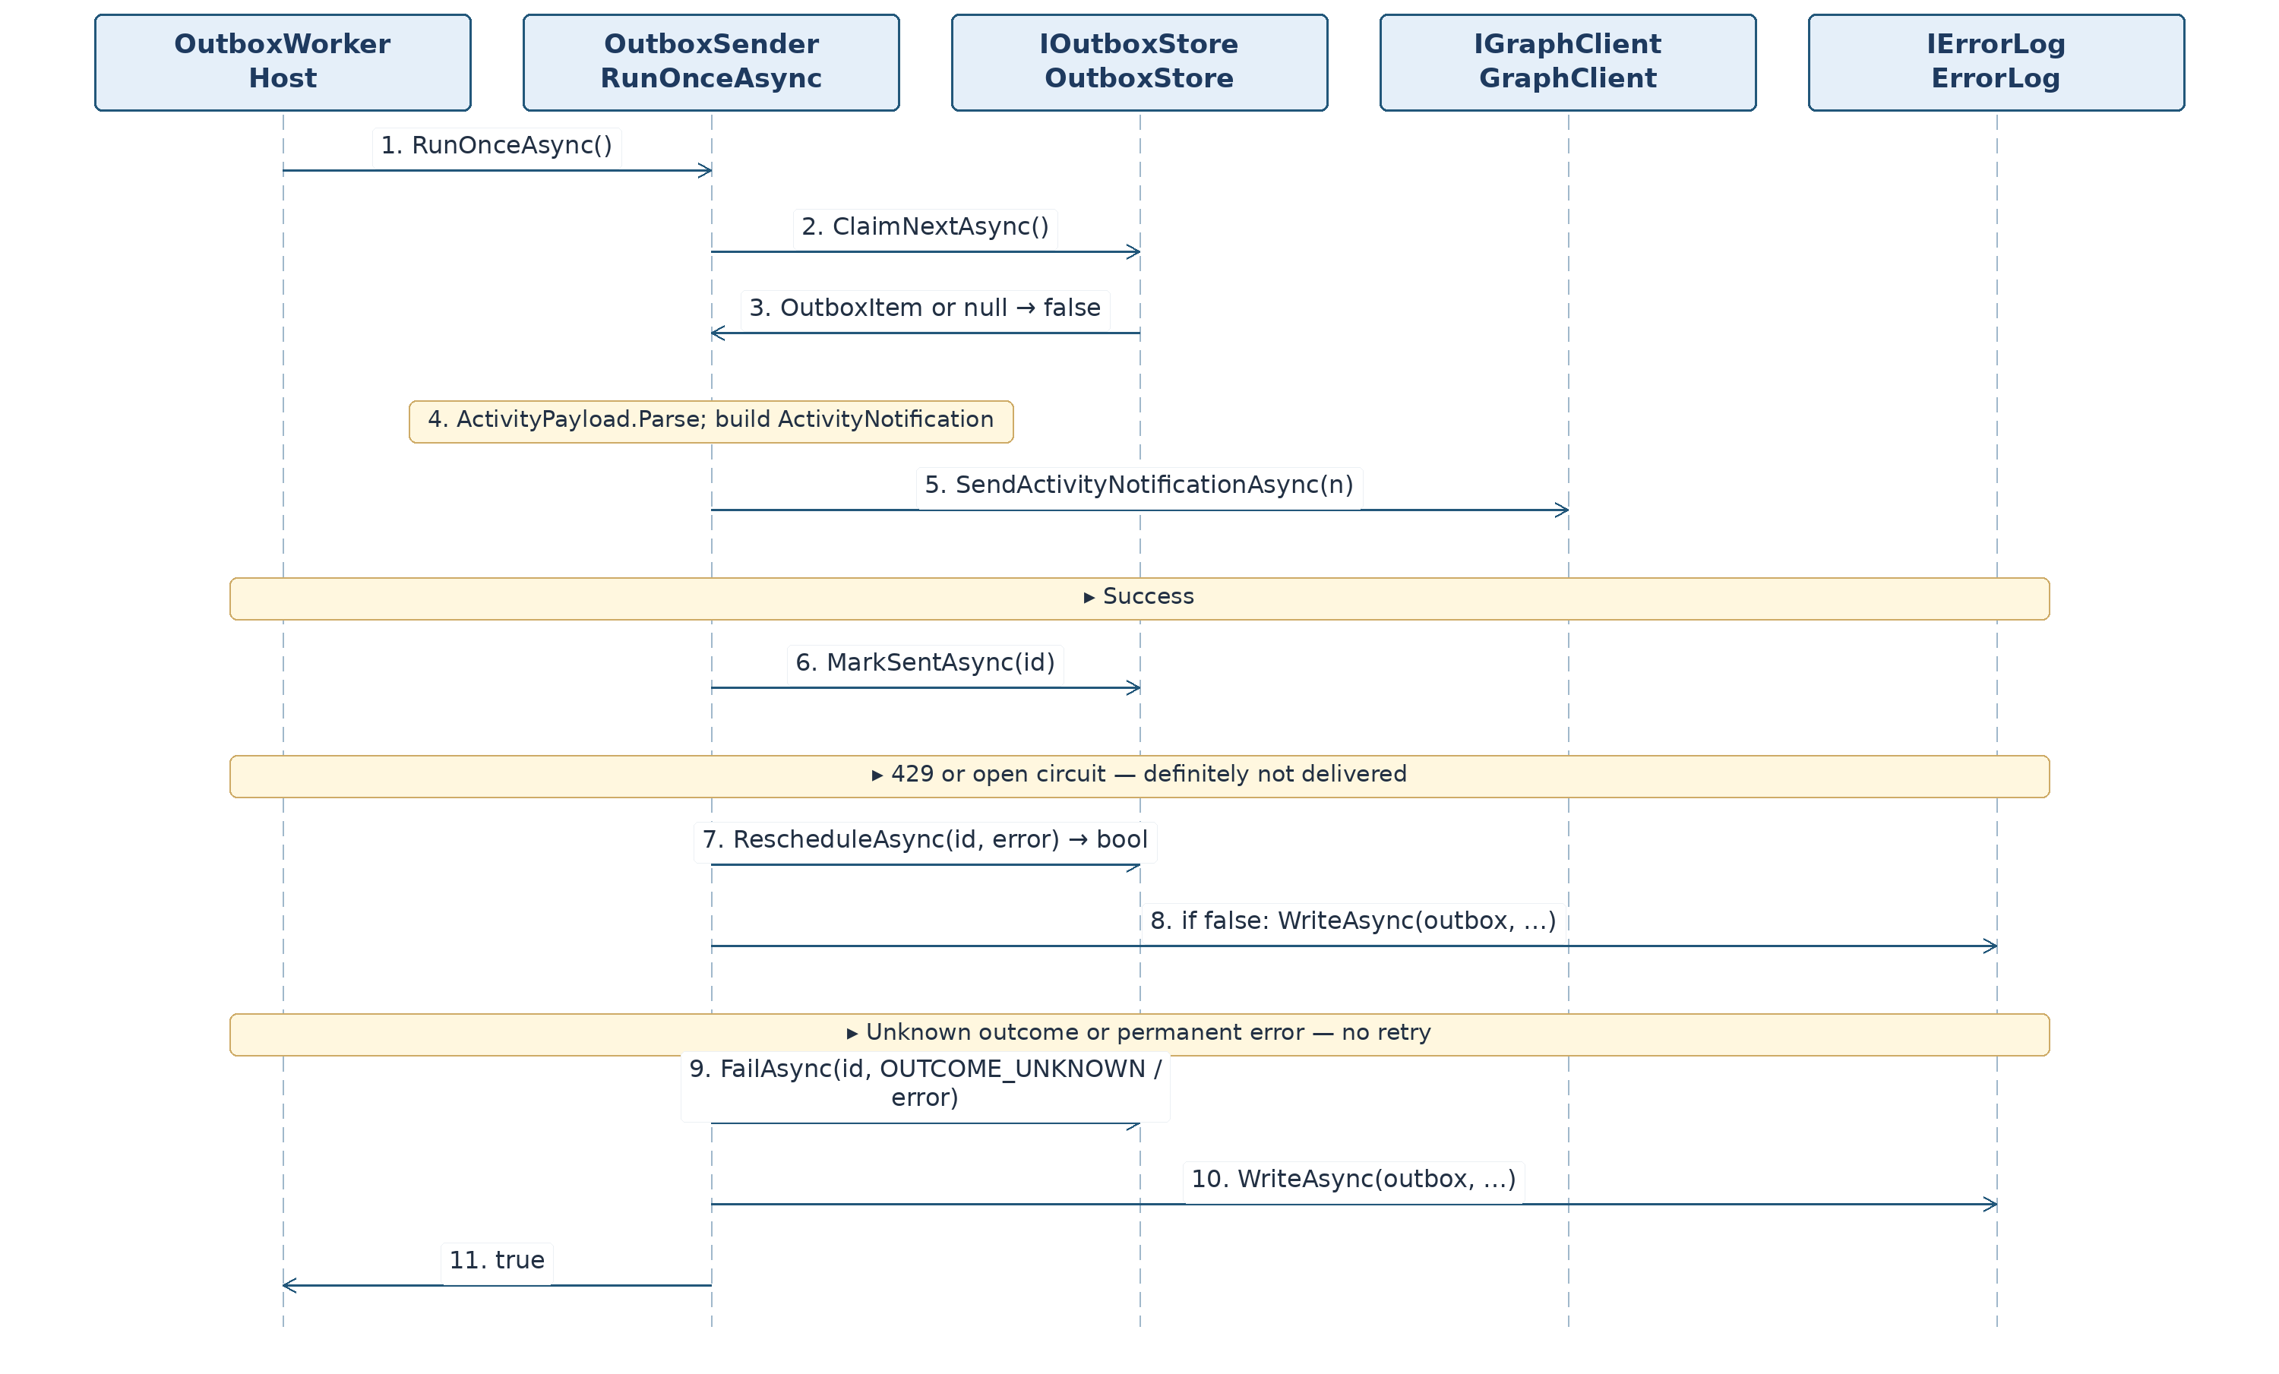
Properties: send failure does not modify cdr, source_state, or inbox; repeat sending to one recipient for one session is prevented by uq_outbox_key and sent state. After a process crash, a sending item with expired lease is not automatically resent (outcome unknown): ClaimNextAsync closes it as failed with last_error="OUTCOME_UNKNOWN: lease expired". Adopted property: “at most once” on an uncertain outcome and “at least once” on definite refusal (429) [P-20].

3.17. Diagnostics: Error Log
IErrorLog: Task WriteAsync(string component, string message, string? details, CancellationToken ct). ErrorLog(IWriteGate gate, TimeProvider clock, ILogger<ErrorLog> log); singleton.
Algorithm: truncate message to 1000 characters and details to 4000; insert an ErrorLogRow (ts=now, component, message, details) inside a gate transaction. Catch every exception except OperationCanceledException and report only to ILogger (the error logger must not itself cause new errors). component is a constant from Components. Never pass secrets or source-record bodies into message or details (verified through review and ErrorLogTests).
Exception: when SourceStateStore.RegisterIncompleteAsync changes a call to expired, it writes error_log directly in the same transaction (one commit with the state transition).

3.18. Registration, Settings, and Startup

3.18.1. InfrastructureRegistration (InfrastructureRegistration.cs)
public static class InfrastructureRegistration:
Method | Description
IServiceCollection AddTcriInfrastructure(this IServiceCollection services, IConfiguration configuration) | Registration per table below
IHttpClientBuilder AddTcriGraphClient(this IServiceCollection services) | Typed IGraphClient → GraphClient; BaseAddress from GraphOptions.BaseUrl; resilience handler from 3.14.4
Task MigrateAsync(this IServiceProvider services, CancellationToken ct) | Create Storage:DataDirectory; call Database.MigrateAsync through context factory; then PRAGMA journal_mode must return wal, otherwise InvalidOperationException; log applied migration version
AddTcriInfrastructure registrations:
Service | Implementation | Lifetime
TimeProvider | TimeProvider.System (TryAddSingleton) | singleton
SqlitePragmaInterceptor | — | singleton
IDbContextFactory<TcriDbContext> | AddDbContextFactory: UseSqlite("Data Source=<DataDirectory>/<DatabaseFileName>;Mode=ReadWriteCreate;Pooling=True"), AddInterceptors(SqlitePragmaInterceptor) | singleton
IWriteGate | WriteGate | singleton
IInboxStore, IOutboxStore, ISourceStateStore, ISubscriptionStore, IErrorLog, ICdrReader | InboxStore, OutboxStore, SourceStateStore, SubscriptionStore, ErrorLog, CdrReader | singleton
ICdrApplier, ICallProcessor, IReconciler, IOutboxSender | CdrApplier, CallProcessor, Reconciler, OutboxSender | singleton
SubscriptionService | — | singleton
TokenCredential | new ClientSecretCredential(TenantId, ClientId, ClientSecret) (TryAddSingleton) | singleton
IGraphClient | GraphClient through AddTcriGraphClient | typed client
Bind settings sections Storage, Inbox, Processing, Reconcile, Outbox, Graph, Subscriptions; register IValidateOptions<T> for each class, calling Validate(); ValidateOnStart() aborts startup on invalid settings.

3.18.2. Settings Validation Rules
Class | Validate() Rules
StorageOptions (DataDirectory = "./data", DatabaseFileName = "tcri.db") | both values must be nonempty; file name must not contain path separators
InboxOptions (MaxPending = 10000) | 1 to 1,000,000
ProcessingOptions | Workers 1–16; LeaseSeconds 10–3600; RetrySchedule must be a nonempty list of positive integers; PendingLimitHours 1–72; SuspendedRecheckHours 1–168; MaxAttempts 1–100
ReconcileOptions | IntervalMinutes 1–1440; LookbackHours 1–720
OutboxOptions | MaxAttempts 1–100; LeaseSeconds 10–3600; BackoffSeconds must be a nonempty list of positive integers; MaxAgeHours 1–720
GraphOptions, SubscriptionOptions | See 3.14.2 and 3.15.1

3.18.3. Infrastructure Startup Order
Settings (validation) → MigrateAsync → SubscriptionService.EnsureAsync → inbox workers → sender → reconciliation. After a restart, expired processing leases on inbox and outbox items are reclaimable; committed notifications are retained across restarts.

3.19. Golden Database State Scenarios
Scenarios specify expected table states after processing. They are run by ScenarioTests (3.20) and serve as worked validation examples for the implementer.
Common conditions. Clean database after migration; FakeTimeProvider initial time T0=2026-10-20T18:00:00.0000000Z; tenant 11111111-1111-4111-8111-111111111111; configuration uses defaults from 3.18 (Processing:LeaseSeconds=120, RetrySchedule=1,5,15,60, PendingLimitHours=4, SuspendedRecheckHours=24, MaxAttempts=10; Outbox:MaxAttempts=8, BackoffSeconds=30,120,600,1800,3600, MaxAgeHours=24; Graph:RetentionDays=30). FakeGraphClient returns the named fixture as GraphFetchResult(Ok,<file>) or the configured error. Times on 2026-10-20 appear as HH:MM:SS in scenario tables; in the database they have the complete form 2026-10-20T12:00:00.0000000Z. Hashes are displayed using their first 12 characters; full values are in golden files from 3.6 and Appendix B. cdr_seq starts at 1. Processing time (T0=18:00) is later than the end of all fixture calls (latest is G09 at 16:05), so no scenario processes a record before its call ends. Scenarios S01–S05 run in sequence using one database; the others use a fresh database each, unless specified otherwise.
Inbox element for callRecord: {"subscriptionId":"11111111-aaaa-4aaa-8aaa-111111111111","changeType":"created","resource":"communications/callRecords/<call_id>","resourceData":{"id":"<call_id>"},"tenantId":"11111111-1111-4111-8111-111111111111"}; for reconcile: {"call_id":"<call_id>","version":<version>}. Column element_hash equals InboxStore.ElementHash(kind, tenant, raw) and is omitted from the scenario tables.

S01. First Application of Record G01
Initial state. Database is empty. Inbox item 1 is queued (callRecord, call_id = cccccccc-0000-4000-8000-000000000001). Graph returns G01 (version 4).
Action. At T0, ClaimNextAsync() → ProcessAsync(item).
Expected. ProcessOutcome.Applied; ApplyResult(Applied, ChangedAction=null, Inserted=1, Updated=0, Deleted=0, OutboxCreated=2).
cdr table:
cdr_seq | session (…) | source_version | duration_s | status | source_hash | created_utc | updated_utc
1 | 01 | 4 | 61 | completed | 604b888cbcb6… | 18:00:00 | 18:00:00
First row in full: schema_version=1, event_type='call', tenant_id, call_id and session_id as in the golden sample, call_type='oneToOne', caller_type='user', caller_id='aaaaaaaa-0000-4000-8000-000000000001', callee_type='user', callee_id='aaaaaaaa-0000-4000-8000-000000000002', start_utc='2026-10-20T09:00:00.0000000Z', end_utc='2026-10-20T09:01:00.5000000Z', modalities='["audio"]', termination_reason=NULL, segment_count=1, aggregation_status='complete', extensions — the JSON extensions property from the golden sample ({"segments":[{"id":"seg-1",…}]}); all other values are as in out/G01_one_to_one_single_session.json.
source_state table:
call_id | applied_version | rejected_version | session_set_hash | state | attempts | next_attempt_utc | first_seen_utc
…0001 | 4 | NULL | 146719861efe… | done | 0 | NULL | 18:00:00
outbox table (recipients are parties of type user, in caller-then-callee order):
id | recipient | state | attempts | next_attempt_utc | payload
1 | aaaaaaaa-…0001 | new | 0 | 18:00:00 | {"activity_type":"callCompleted","call_type":"oneToOne","status":"completed","duration_s":61,"start_utc":"2026-10-20T09:00:00.0000000Z"}
2 | aaaaaaaa-…0002 | new | 0 | 18:00:00 | the same
inbox table: row 1 — state='done', attempts=1, done_utc=18:00:00, locked_until_utc=NULL. The rejected, audit_log, and error_log tables are empty.

S02. Repeat of the Same Version (Continuation of S01)
Action. At 18:05:00, inbox item 2 is queued (reconcile, call_id = cccccccc-0000-4000-8000-000000000001, version = 4); Graph returns G01; ClaimNextAsync() → ProcessAsync.
Expected. ProcessOutcome.Duplicate; cdr still has one row (updated_utc=18:00:00), outbox has two rows, source_state is unchanged; inbox row 2 — done, done_utc=18:05:00.

S03. Same Version with Different Content (Continuation of S02)
Action. At 18:10:00, item 3 (reconcile, version 4); Graph returns D01 (version 4, stream direction changed in the first session; Appendix B).
Expected. ProcessOutcome.Discrepancy. audit_log table:
id | ts | call_id | kind | detail
1 | 18:10:00 | …0001 | version_discrepancy | {"version":4,"applied_set_hash":"146719861efe9004a28b3e18b1b10301ee5a5dd868aaa6b3ce4ef21ea8195381","incoming_set_hash":"27fdd2c1c47948bf811635d4b2e0118da39b64facf4637d46e0618f7acdcc8d4"}
cdr, source_state, and outbox are unchanged; item 3 — done.

S04. Higher Version Replaces CDR (Continuation of S03)
Action. At 18:15:00, item 4 (reconcile, version 5); Graph returns G11.
Expected. ProcessOutcome.Applied; ApplyResult(Applied, null, Inserted=0, Updated=1, Deleted=0, OutboxCreated=0).
cdr_seq | session (…) | source_version | duration_s | status | source_hash | created_utc | updated_utc
1 | 01 | 5 | 61 | completed | 2acda2272c8f… | 18:00:00 | 18:15:00
cdr_seq and created_utc are preserved. source_state: applied_version=5, session_set_hash=3d0a0015d9fc…, state='done'. outbox still has two rows (no new notification is created for a session that already existed). Item 4 — done.

S05. Lower Version Is Ignored (Continuation of S04)
Action. At 18:20:00, item 5 (reconcile, version 4); Graph returns G01.
Expected. ProcessOutcome.IgnoredLower; cdr, source_state, outbox, and audit_log unchanged; item 5 — done, done_utc=18:20:00.
Continuation (b): obsolete incomplete version. At 18:25:00, item 6 (reconcile, version 3); Graph returns D04 (version 3, missing session end: SESSION_DATES_MISSING; Appendix B). The version decision precedes the completeness check (3.13.3, steps 8–9): version 3 is lower than applied version 5.
Expected (b). ProcessOutcome.IgnoredLower; source_state remains state='done', applied_version=5, attempts=0, next_attempt_utc=NULL (not moved to pending); cdr, outbox, and audit_log unchanged; item 6 — done, done_utc=18:25:00.

S06. Replacing the Set and Removing a Session (Clean Database)
Action. (1) At T0, a callRecord item for cccccccc-0000-4000-8000-000000000002 is processed; Graph returns G02 (version 7, two sessions). (2) At 18:10:00, reconcile item (version 8) is processed; Graph returns D02 (version 8, only the first session remains).
Expected after (1). Applied, Inserted=2, OutboxCreated=4. cdr table:
cdr_seq | session (…) | source_version | duration_s | status | source_hash | updated_utc
1 | 01 | 7 | 600 | completed | c1d4d9ba4243… | 18:00:00
2 | 02 | 7 | 450 | completed | bbab6a67cc35… | 18:00:00
outbox table: rows 1–2 — session …01 (recipients aaaaaaaa-…0001, aaaaaaaa-…0003); rows 3–4 — session …02 (recipients aaaaaaaa-…0002, aaaaaaaa-…0003); all state='new'.
Expected after (2). Applied, Inserted=0, Updated=1, Deleted=1, OutboxCreated=0. cdr table:
cdr_seq | session (…) | source_version | duration_s | source_hash | updated_utc
1 | 01 | 8 | 600 | c1d4d9ba4243… | 18:10:00
Session …02 row (cdr_seq=2) was deleted; source_state.applied_version=8, session_set_hash=3bc4de956866…. All four outbox rows remain (notification history).

S07. Incomplete Data: Pending, Suspended (Clean Database)
Initial state. Item 1 (callRecord, call_id = cccccccc-0000-4000-8000-000000000007); Graph returns G07 (no sessions, NO_SESSIONS) on every attempt. Each attempt occurs when the item's next_attempt_utc is due; processing is instantaneous.
Expected after each attempt.
attempt | time | source_state.attempts | source_state.state | next_attempt_utc | inbox: state | inbox.next_attempt_utc
1 | 18:00:00 | 1 | pending | 18:01:00 | new, attempts=0 | 18:01:00
2 | 18:01:00 | 2 | pending | 18:06:00 | new, attempts=0 | 18:06:00
3 | 18:06:00 | 3 | pending | 18:21:00 | new, attempts=0 | 18:21:00
4 | 18:21:00 | 4 | pending | 19:21:00 | new, attempts=0 | 19:21:00
5 | 19:21:00 | 5 | pending | 20:21:00 | new, attempts=0 | 20:21:00
6 | 20:21:00 | 6 | pending | 21:21:00 | new, attempts=0 | 21:21:00
7 | 21:21:00 | 7 | pending | 22:21:00 | new, attempts=0 | 22:21:00
8 | 22:21:00 | 8 | suspended | 2026-10-21 22:21:00 | done | —
first_seen_utc=18:00:00; last_error='NO_SESSIONS'. At attempt 7, age is 3 h 21 min, below PendingLimitHours; at attempt 8 (22:21:00), age is 4 h 21 min, so state='suspended', next_attempt_utc=2026-10-21 22:21:00 and the item is closed (done). Final ProcessOutcome for attempts 1–7 is Pending; for attempt 8 it is Suspended. cdr, outbox, and rejected are empty.

S08. Invalid Session (Clean Database)
Action. Item 1 (callRecord, call_id = cccccccc-0000-4000-8000-000000000009); Graph returns G09 (version 6; session …02 ends before it starts).
Expected. ProcessOutcome.Rejected. rejected table:
id | call_id | session_id | code | message | source_hash | created_utc
1 | …0009 | dddddddd-…0002 | SESSION_END_BEFORE_START | Session ends before it starts. | 199e254b3e80… | 18:00:00
source_state: applied_version=NULL, rejected_version=6, session_set_hash=NULL, state='done', attempts=0, first_seen_utc=18:00:00. cdr and outbox tables are empty (no replacement was performed; valid session …01 was not stored); item 1 — done.
The rejected source_hash is the canonical hash of the entire G09 record (RejectedSourceHash, 3.13.3): 199e254b3e80b676c852b2bc8a03dd6d8af198a8750d94c51b6c79aad94c460a. It is insensitive to whitespace and property ordering.
Repeat. At 18:05:00, item 2 (reconcile, version 6); Graph returns G09 again → ProcessOutcome.Duplicate; rejected still contains one row.
Malformed record (b). Clean database; item 1 (callRecord, call_id = cccccccc-0000-4000-8000-0000000000b1); FakeGraphClient returns GraphFetchResult(Malformed, "{ not json"). Expected: ProcessOutcome.Rejected; one rejected row: call_id='cccccccc-0000-4000-8000-0000000000b1', session_id=NULL, code='CALLRECORD_BAD_JSON', source_hash='0228f717792ffbc02f7fa058c934c10d7e91d0de743e365ebd78bfebf019254e' (SHA-256 of the UTF-8 text { not json because the JSON is not parseable); source_state is not created (version unknown); item done. Reading the same malformed record again at 18:05:00 (item 2) adds no rejected row (same call_id, code, and source_hash).

S09. Transient Graph Error: Retries and Failure (Clean Database)
Initial state. Item 1 (callRecord, call_id = cccccccc-0000-4000-8000-000000000001); FakeGraphClient throws GraphException("HTTP 503", 503, isTransient: true) on every GetCallRecordAsync call.
Expected after each attempt (attempts is the count after claim and is retained on reschedule):
attempt | time | inbox.attempts | inbox.state | next_attempt_utc | last_error
1 | 18:00:00 | 1 | new | 18:01:00 | HTTP 503
2 | 18:01:00 | 2 | new | 18:06:00 | HTTP 503
3 | 18:06:00 | 3 | new | 18:21:00 | HTTP 503
4 | 18:21:00 | 4 | new | 19:21:00 | HTTP 503
5 | 19:21:00 | 5 | new | 20:21:00 | HTTP 503
6 | 20:21:00 | 6 | new | 21:21:00 | HTTP 503
7 | 21:21:00 | 7 | new | 22:21:00 | HTTP 503
8 | 22:21:00 | 8 | new | 23:21:00 | HTTP 503
9 | 23:21:00 | 9 | new | 2026-10-21 00:21:00 | HTTP 503
10 | 2026-10-21 00:21:00 | 10 | failed | — | HTTP 503
Attempts 1–9 yield ProcessOutcome.Retry; attempt 10 (attempts = MaxAttempts) yields Failed: done_utc=2026-10-21 00:21:00; one error_log row (component='graph', message='graph request failed', details='tenant_id=11111111-1111-4111-8111-111111111111; call_id=cccccccc-0000-4000-8000-000000000001; status=503; attempts=10'). No cdr or source_state data is created.

S10. Recovery After Process Crash (Clean Database)
Action. Item 1 (callRecord) is claimed at T0 (attempts=1, locked_until_utc=18:02:00) and processing is not completed. (1) At 18:01:59, ClaimNextAsync() returns null. (2) At 18:02:01, ClaimNextAsync() returns the same item with attempts=2, locked_until_utc=18:04:01, state='processing'; ProcessAsync then completes it normally.

S11. Source Data Completed in a Later Version (Clean Database)
Action. (1) At T0, Graph returns G08 (version 2, missing session end, SESSION_DATES_MISSING). (2) At 18:01:00, Graph returns D03 (version 3, session ends at 21:05:00).
Expected after (1). Pending; source_state: state='pending', attempts=1, next_attempt_utc=18:01:00, first_seen_utc=18:00:00, applied_version=NULL; cdr is empty; item returns to new (next_attempt_utc=18:01:00, attempts=0).
Expected after (2). Applied, Inserted=1, OutboxCreated=2; cdr has row cdr_seq=1 (duration_s=300, source_version=3, source_hash 99fc67b0658f…); source_state: state='done', applied_version=3, session_set_hash 8ba282b50823…, attempts=0, next_attempt_utc=NULL, first_seen_utc=18:00:00; item — done.

S12. Notification Delivery: Retries and Failure (Clean Database)
Initial state. One outbox row 1 (state='new', attempts=0, next_attempt_utc=18:00:00); FakeGraphClient.SendActivityNotificationAsync always throws GraphException("HTTP 429", 429, isTransient: true) (failure without execution: delivery definitely did not occur). Each RunOnceAsync() is invoked at the due next_attempt_utc.
attempt | time | outbox.attempts | outbox.state | next_attempt_utc
1 | 18:00:00 | 1 | new | 18:00:30
2 | 18:00:30 | 2 | new | 18:02:30
3 | 18:02:30 | 3 | new | 18:12:30
4 | 18:12:30 | 4 | new | 18:42:30
5 | 18:42:30 | 5 | new | 19:42:30
6 | 19:42:30 | 6 | new | 20:42:30
7 | 20:42:30 | 7 | new | 21:42:30
8 | 21:42:30 | 8 | failed | —
RunOnceAsync() returns true on each attempt. After the eighth attempt, last_error='HTTP 429'; one error_log row (component='outbox', message='outbox item failed', details='id=1; call_id=<…>; session_id=<…>; attempts=8'). cdr, source_state, and inbox are untouched.
Continuation (b): uncertain outcome. Clean database with outbox row 1 as above; SendActivityNotificationAsync throws GraphException("timeout", null, isTransient: true, outcomeUnknown: true). Expected after one RunOnceAsync(): return true; state='failed', attempts=1, last_error='OUTCOME_UNKNOWN: timeout', next_attempt_utc unchanged; one error_log row (component='outbox', message='outbox item failed', details='id=1; call_id=<…>; session_id=<…>; attempts=1; outcome=unknown'); no retries. If the process stops between claiming and receiving a response, on the next ClaimNextAsync() a sending row with an expired lease becomes failed with last_error='OUTCOME_UNKNOWN: lease expired' and is not sent.

S13. Suspended Call Expires (Continuation of S07)
Initial state. After S07, source_state (cccccccc-0000-4000-8000-000000000007) has state='suspended', attempts=8, first_seen_utc=18:00:00, next_attempt_utc=2026-10-21 22:21:00. Clock advances to 2026-11-20T22:21:00Z; Graph returns G07.
Action. Reconciler.RecheckSuspendedAsync() returns 1 and enqueues an item (reconcile, raw={"call_id":"cccccccc-0000-4000-8000-000000000007","recheck_at":"2026-10-21T22:21:00.0000000Z"}); ClaimNextAsync() → ProcessAsync.
Expected. Age from 2026-10-20 18:00:00 to 2026-11-20 22:21:00 is 31 days 4 h 21 min > Graph:RetentionDays (30 days): ProcessOutcome.Expired; source_state: state='expired', attempts=9, next_attempt_utc=NULL; one error_log row (component='processor', message='source_state expired', details='tenant_id=11111111-1111-4111-8111-111111111111; call_id=cccccccc-0000-4000-8000-000000000007'); item done.

S14. Repeated Webhook After Done and Collision During Processing
Initial state: in a clean database, event A with element_hash=H, kind=callRecord, tenant_id=T, call_id=C, received_utc=T0. SQLite assigns all IDs. Process A to done, then accept the identical JSON as B at T0 + 1 min. Verify every state transition in sequence.
Check | inbox.id | element_hash | state | attempts | last_error | Expected
A after completion | 1 | H | done | 1 | NULL | G01 applied, one CDR
B after receiving the same notification | 2 | H | new | 0 | NULL | Added=1, not a duplicate; a subsequent Graph GET is mandatory
B claimed | 2 | H | processing | 1 | NULL | Graph GET executed again; unchanged version yields Duplicate
Collision: in a separate clean database, A(id=1, processing, attempts=1) exists and B(id=2, new, attempts=0) arrives with H. A receives a transient error and calls RescheduleAsync for T0+5 minutes.
id | state | attempts | next_attempt_utc | last_error
1 | done | 1 | as before | MERGED_INTO:2
2 | new | 1 | 2026-10-20T18:01:00.0000000Z (B's earlier scheduled due time) | GRAPH_TRANSIENT
Strict postcondition: SELECT count(*) FROM inbox WHERE state='new' AND element_hash=H returns 1; the transaction does not violate uq_inbox_new_hash; subsequent processing of B invokes Graph. A later callRecord version may be present upon repeated notification. Tests: InboxStoreTests.Reschedule_Collision_MergesAtomically, ScenarioTests.S14_RepeatedWebhookRechecksGraph.

S15. Manual Forced Period Reconciliation (K12)
Initial state: source_state has four rows for tenant=T and distinct call_id C1–C4, with states done, pending, suspended, and expired. C1 has applied version 4; Graph list returns Version=null for all four. cdr contains only the previously accepted C1 CDR (cdr_seq=1). Time is T0.
call_id | state before | source_state.applied_version before | GraphCallRecordRef.Version | NeedsFetch(..., force:true) | New inbox
C1 | done | 4 | NULL | true | id=1, kind=reconcile, call_id=C1, state=new
C2 | pending | NULL | NULL | true | id=2, kind=reconcile, call_id=C2, state=new
C3 | suspended | NULL | NULL | true | id=3, kind=reconcile, call_id=C3, state=new
C4 | expired | NULL | NULL | true | id=4, kind=reconcile, call_id=C4, state=new
ReconcileAsync(from,to,force:true) returns 4 if no matching new notifications exist already. source_state and cdr remain unchanged until GET/Convert/Apply actually occurs. For force:false and Version=null, the rule also requires GET; with a proven older version and done it may ignore. Any failed fetch preserves the old C1 CDR. Out-of-range calls are not enqueued.
A second call before claiming: if all four items remain new, EnqueueAsync returns Added=0, Duplicates=4; the original IDs remain. A write failure propagates and the manual API must not report success. Tests: ReconcilerTests.Force_AllStatesEnqueued, ScenarioTests.S15_ForceRechecksAllStates.

3.20. Infrastructure Automated Tests
Project tests/TeamsCallRecords.Infrastructure.Tests, net8.0; packages per 3.10.1. Run dotnet test TeamsCallRecords.sln -c Release (together with Core tests). Tests do not contact the network or a real tenant: FakeGraphClient substitutes for Graph, and StubHandler supplies HTTP responses for GraphClient. The database is actual SQLite in a temporary directory (not :memory:) because WAL, CHECK constraints, and restart behaviour are tested. FakeTimeProvider controls time.
Common conditions. Initial test time T0 = 2026-10-20T18:00:00.0000000Z; tenant 11111111-1111-4111-8111-111111111111; configuration defaults unless a test row states otherwise. Each test creates its own database and is independent of execution order; test classes may run in parallel. Column “K/F” refers to TRS acceptance criterion (K) or TRS feature (F) covered; P denotes a proposal in Appendix A. “State as S0x” means checking all tables and rows specified by scenario 3.19.
Support Classes.
Class | Components and Behaviour
TestDb | static TestDb Create(DateTimeOffset? start=null): creates directory Path.Combine(Path.GetTempPath(),"tcri-tests",Guid.NewGuid().ToString("N")), file tcri.db, FakeTimeProvider initialized to start ?? T0, and IDbContextFactory<TcriDbContext> using SqlitePragmaInterceptor; applies Database.MigrateAsync. Members: Factory, Gate (WriteGate), Clock (FakeTimeProvider), DbPath, Task<T> ReadAsync<T>(Func<TcriDbContext,Task<T>> read) (reader without gate), TestDb Reopen() (new instance using same file after closing the prior one), Dispose() (SqliteConnection.ClearAllPools() and delete directory).
FakeGraphClient | Implements IGraphClient; has per-method response queues: EnqueueFetch(GraphFetchResult), EnqueueGolden(string name) (reads in/<name> as GraphFetchResult(Ok,text)), EnqueueThrow(GraphException), EnqueueList(IReadOnlyList<GraphCallRecordRef>). When a queue becomes empty, the last response is repeated (to model "every call throws"). Includes Calls log (method and arguments) and lists CreatedSubscriptions, RenewedSubscriptions, DeletedSubscriptions, SentNotifications.
FakeCredential | TokenCredential: returns test-token valid for +1 hour; Scopes is the list of requested scopes; ThrowNext(Exception)
StubHandler | HttpMessageHandler: Enqueue(HttpStatusCode, string? body, params (string, string)[] headers), Respond(Func<HttpRequestMessage, HttpResponseMessage>); records Requests (method, URI, headers, body); supports response delay through TimeProvider
FakeReconciler | IReconciler: call counters for ReconcileLookbackAsync, RecheckSuspendedAsync, ReconcileAsync
FakeCdrApplier | ICdrApplier: returns the configured sequence of ApplyResult values
Golden | const string Tenant; string Input(string name) and string Expected(string name) read from TestData/Golden or TestData/Derived; ConversionResult Convert(string name) calls CallRecordConverter.Convert(Input(name), Tenant); call IDs are taken from fixture content
Builders | Options builders for each class (with per-field overrides), InboxNewItem (CallRecord, Reconcile, ChannelMessage), Cdr with configured party/time/duration, and GraphException (Transient(code), Permanent(code))
Golden samples. G01–G11 inputs and expected results are linked from the Core test project (3.9); derived D01–D04 reside in TestData/Derived (Appendix B). All files are copied to the build output directory.
Test count. 285 methods in 20 classes (one Theory counts as one method; Theory data sets are excluded). All counts are design expectations; the tests have not been executed.

3.20.1. SchemaTests (SchemaTests.cs, 8 tests): Schema, Connection, Restart
Method | Input | Expected | K/F
Migration_CreatesEightTables | TestDb.Create() (runs MigrateAsync) | sqlite_master contains exactly cdr, source_state, inbox, rejected, audit_log, outbox, subscription, error_log (and internal __EFMigrationsHistory) | F7
Migration_CreatesNamedIndexesAndKeys | the same | Indexes present: uq_cdr_key, ix_cdr_start, ix_cdr_call, ix_source_state_due, uq_inbox_new_hash, ix_inbox_hash, ix_inbox_call, ix_inbox_due, ix_rejected_created, uq_outbox_key, ix_outbox_due, ix_error_log_ts; uq_inbox_hash absent | F7
Migration_IsIdempotent | MigrateAsync invoked a second time | no exception; schema and __EFMigrationsHistory unchanged (one 20261021000000_InitialCreate entry) | F7
Connection_UsesWalFullForeignKeysBusyTimeout | new context-factory connection opened | PRAGMA journal_mode=wal; PRAGMA synchronous=2; PRAGMA foreign_keys=1; PRAGMA busy_timeout=5000 | F7, P-08
CheckConstraint_RejectsUnknownState | INSERT INTO inbox with state='bogus' through raw SQL | SqliteException (CHECK violation); row not inserted | F7
Inbox_UniqueIndexIsPartial | three direct-SQL inserts sharing element_hash: (new, new); (done, new); (done, done) | first pair raises SqliteException (uq_inbox_new_hash violation); second and third succeed | K12, P-22
Model_ColumnsMatchMigratedTables | Compare all *Row properties with PRAGMA table_info | column names equal property snake_case; NOT NULL matches nonnullable properties; no extra or missing columns | F7
Data_SurvivesRestart | write error_log row; close TestDb; open another TestDb over the same file | row is read with the same values | F7, K7

3.20.2. CdrMappingTests (CdrMappingTests.cs, 6 tests): Cdr ↔ CdrRow Mapping
Method | Input | Expected | K/F
RoundTrip_AllGoldenCdrs (Theory, files G01–G06, G09, G10, G11, D02, D03) | for each golden Cdr: ToRow → save → read → ToCdr | obtained Cdr equals source in all fields, including ExtensionsJson, Modalities, SourceHash | K8, K13
Ticks_ArePreservedWithoutLoss | StartUtc = 2026-10-20T09:00:00.1234567Z | database text 2026-10-20T09:00:00.1234567Z; ticks match on reading | K13
NullCaller_WritesBothColumnsNull | G05 (Caller=null, Callee=null) | caller_type, caller_id, callee_type, callee_id are NULL; readback produces null | K8
Modalities_AreJsonArray | Modalities = [audio, video] | modalities = ["audio","video"]; readback returns the same values in the same order | K8
CopyOnUpdate_KeepsSeqAndCreated | existing row (cdr_seq=1, created_utc=18:00:00) and a new row with different fields | result: cdr_seq=1, created_utc=18:00:00, other fields updated, updated_utc equals supplied time | K11
ToRow_SetsCreatedAndUpdated | ToRow(cdr, "…18:00:00") | created_utc = updated_utc = supplied value | K11

3.20.3. UtcTextTests (UtcTextTests.cs, 5 tests): Database Time Format
Method | Input | Expected | K/F
Format_SevenDigitsAndZ | 2026-10-20T12:00:00Z | 2026-10-20T12:00:00.0000000Z | K13, P-05
Format_ConvertsOffsetToUtc | 2026-10-20T12:00:00+02:00 | 2026-10-20T10:00:00.0000000Z | K13
Parse_RoundTripKeepsTicks | Format → Parse for a seven-fractional-digit value | original ticks preserved, Offset = 0 | K13
Format_OrderEqualsLexicographicOrder | five timestamps in arbitrary order | sorting strings with string.CompareOrdinal yields chronological order | P-05
Now_UsesInjectedClock | FakeTimeProvider at 18:00:00; then advance +90 s | 2026-10-20T18:00:00.0000000Z, then 2026-10-20T18:01:30.0000000Z | P-05

3.20.4. WriteGateTests (WriteGateTests.cs, 7 tests): Write Gate
Method | Input | Expected | K/F
Run_Commits | add an ErrorLogRow within RunAsync | after return, the row is visible to the reader | F7
Run_ReturnsValue | RunAsync<int> returns 42 | result is 42 | F7
Run_RollsBackOnException | work inserts a row and throws InvalidOperationException | exception propagates; table has 0 rows | K9
Run_ReleasesGateAfterException | a successful call follows a failed call | second call completes (gate is not blocked) | K9
Run_ExecutesOneAtATime | 20 parallel calls, each increments the concurrent-inside counter, waits 5 ms, and decrements it | maximum concurrent-inside value is 1; all 20 calls complete | K12, F7
Run_CancelledBeforeEntry | cancellation token was cancelled before the call | OperationCanceledException; work was not called | K9
Readers_DoNotWaitForGate | gate held by long-running work; reader requests COUNT(*) through the factory | read completes without waiting for the gate (WAL) | F7

3.20.5. InboxStoreTests (InboxStoreTests.cs, 27 tests): Incoming Queue
Method | Input | Expected | K/F
Enqueue_Empty_ReturnsZeros | empty list | (0,0,false); table empty | K12
Enqueue_NewItem_IsAdded | one callRecord; time 18:00:00 | (Added=1); row: state=new, attempts=0, next_attempt_utc=received_utc=18:00:00, raw unchanged | K12
Enqueue_SameContent_IsDuplicate | two calls with identical raw; first row still new | second: Duplicates=1; table has one row | K12
Enqueue_PropertyOrderDoesNotMatter | {"a":1,"b":2} and {"b":2,"a":1} | hashes equal; second enqueue — Duplicates=1 | K12
Enqueue_SameBatchDuplicates | batch of two identical items | Added=1, Duplicates=1 | K12
Enqueue_AfterFailed_AddsNewItem | row with this hash has state failed, attempts=10 | Added=1; previous row unchanged; a new row added with state=new, attempts=0 | K12, P-22
Enqueue_AfterDone_AddsNewItem | row with this hash has state done (another notification about the same call) | Added=1, Duplicates=0; previous row unchanged; new row added with state=new (S14a) | K11, K12, P-22
Enqueue_WhileProcessing_AddsNewItem | row with this hash has state processing | Added=1; new row has state new (S14b) | K11, K12, P-22
Enqueue_Overloaded_WritesNothing | Inbox:MaxPending=2, queue has 2 new rows | (0,0,true); row count remains 2 | K12
ElementHash_Is64LowerHex | any valid raw | 64 characters [0-9a-f] | K12, P-15
ElementHash_DependsOnKindAndTenant | one raw; different kind, then different tenantId | four hashes are pairwise distinct | K12
ElementHash_BadJson_Throws | raw = "{ not json" | ArgumentException | K12
ClaimNext_ReturnsOldestDue | two new rows (next_attempt_utc 17:59:00 and 17:58:00); time 18:00:00 | returns row at 17:58:00; state=processing, locked_until_utc=18:02:00, Attempts=1 | K12
ClaimNext_SameTimeOrderedById | two rows with equal timestamps | returns row with smaller id | K12
ClaimNext_SameCallInProcessing_IsSkipped | A (processing, active lease, call X), B (new, call X, earlier due time), C (new, call Y) | first call returns C, not B; after CompleteAsync(A), next returns B; rows with call_id=NULL do not block | K11, K12, P-22
ClaimNext_SameCallExpiredLease_DoesNotBlock | A (processing, expired lease, call X), B (new, call X) | returns row with earlier next_attempt_utc, id; no blocking | K12, P-22
ClaimNext_NothingDue_ReturnsNull | next_attempt_utc = 18:00:01, current time 18:00:00 | null; row unchanged | K12
ClaimNext_SkipsLockedProcessing | processing, locked_until_utc=18:02:00, time 18:01:59 | null | K12
ClaimNext_RecoversExpiredLease | same, time 18:02:01 | same row returned: Attempts=2, locked_until_utc=18:04:01 (scenario S10) | K12
ClaimNext_ParallelCallers_NoDuplicates | 5 ready rows, 12 concurrent calls | each row is returned to exactly one caller; 5 non-null results, 7 null | K12
Complete_SetsDone | claimed item | state=done, done_utc=now, locked_until_utc=NULL, last_error=NULL | K12
Reschedule_ResetAttemptsFlag | two calls: resetAttempts=true and false | state=new, next_attempt_utc=specified, last_error=text; attempts=0 / previous value | K12
Fail_SetsFailed | item being processed | state=failed, done_utc=now, last_error=text | K9
Transition_MissingId_Throws | CompleteAsync(999) | InvalidOperationException | K9
GetStats_CountsPendingOldestAndFailed | rows: 2 new (received at 17:50:00 and 17:55:00), 1 processing, 1 failed, 1 done; time 18:00:00 | Pending=3, OldestPendingAgeSeconds=600, Failed=1; without rows — 0 | K12
RenewLease_ExtendsOnlyProcessing | processing, expected locked_until_utc; lease still valid | returns new deadline; row updated atomically using CAS; for new, done, failed returns null | K9, K12, P-27
RenewLease_AfterReclaim_Fails | A claimed row; lease expired; B claimed it; A attempts to renew with stale deadline | null; B's deadline and state remain unchanged; A cancels work | K9, K12, P-27

3.20.6. SourceStateStoreTests (SourceStateStoreTests.cs, 22 tests): Call State
Method | Input | Expected | K/F
RegisterIncomplete_First_SetsPending | new row, reason NO_SESSIONS; time 18:00:00 | ("pending", 18:01:00); source_state: pending, attempts=1, first_seen_utc=18:00:00, last_error=NO_SESSIONS; new item with next_attempt_utc=18:01:00, attempts=0 | K8
RegisterIncomplete_Schedule_1_5_15_60_60 | 7 sequential calls advancing to next_attempt_utc | next after 1, 5, 15, 60, 60, 60, 60 minutes (table S07) | K8
RegisterIncomplete_BecomesSuspendedAtLimit | first_seen_utc=18:00:00, attempts=7, time 22:00:00 (age exactly 4 h) | ("suspended", 2026-10-21T22:00:00Z); item done | K8
RegisterIncomplete_BelowLimit_StaysPending | age 3 h 59 min 59 s | pending | K8
RegisterIncomplete_SuspendedRecheck_Reschedules | suspended, age 5 days | suspended, next_attempt_utc=now + 24 h; item done; error_log empty | K8
RegisterIncomplete_BecomesExpiredAfterRetention | suspended, age 30 days 1 min, RetentionDays=30 | expired, next_attempt_utc=NULL; one error_log row (processor, source_state expired, tenant_id=…; call_id=…) in same commit | K8, F9
RegisterIncomplete_AtExactRetention_NotExpired | age exactly 30 days | suspended (strict condition: age > RetentionDays) | K8
RegisterIncomplete_Expired_StaysExpired | expired | state unchanged; item done | K8
RegisterIncomplete_NewEpisodeAfterDone | done, applied_version=4 | pending, attempts=1, first_seen_utc=now, applied_version=4 preserved | K8, K11
RegisterIncomplete_MissingInbox_RollsBack | nonexistent inboxId | InvalidOperationException; source_state not created | K9
RecordRejection_G09_WritesRejectedAndState | G09 rejections; version 6; sourceHash = RejectedSourceHash(G09) | one rejected row (SESSION_END_BEFORE_START, dddddddd-…0002, source_hash=199e254b3e80b676c852b2bc8a03dd6d8af198a8750d94c51b6c79aad94c460a); source_state: done, applied_version=NULL, rejected_version=6; item done | K14, P-23
RecordRejection_KeepsMaxRejectedVersion | existing rejected_version=7; version 6 arrives | rejected_version=7 | K14
RecordRejection_SameRowTwice_NotDuplicated | two calls with identical call_id, session_id, code, source_hash | one rejected row | K14, P-23
RecordRejection_OtherHash_AddsRow | same call_id and code, different source_hash | two rows | K14, P-23
RecordRejection_ClosesPendingEpisode | pending, attempts=3 | done, attempts=0, next_attempt_utc=NULL | K14
RecordRejection_WithoutCallId_WritesOnlyRejected | callId=null, rejection CALLRECORD_BAD_JSON, sourceHash=SHA-256 of text { not json | rejected row with source_hash=0228f717792ffbc02f7fa058c934c10d7e91d0de743e365ebd78bfebf019254e; source_state not created | K14, P-23
RecordRejection_MessageTruncatedTo1000 | message of 1500 characters | 1000 characters stored | K14
RecordDiscrepancy_WritesAuditRow | version 4, hashes from D01/G01 | audit_log row as in S03; cdr and source_state unchanged; item done | K11
RecordDiscrepancy_NullAppliedHash_WritesJsonNull | appliedSetHash=null | detail contains "applied_set_hash":null | K11
GetMany_ChunksOf500 | 1200 rows, request for 1200 identifiers | dictionary with 1200 entries (querying in batches of 500 loses none) | K12
ListSuspendedDue_OrdersAndLimits | three suspended rows with next_attempt_utc 18:03, 18:01, 18:09; time 18:05; limit=1 | one row at 18:01; with limit=10, two rows (18:01, 18:03) | K8
GetCounts_GroupsByState | rows pending×2, suspended×1, expired×1, done×3 | corresponding counts in SourceStateCounts | F9

3.20.7. CdrApplierTests (CdrApplierTests.cs, 20 tests): CDR Replacement Transaction
Method | Input | Expected | K/F
Apply_G01_InsertsCdrStateOutbox | ApplyRequest from G01; item processing | ApplyResult(Applied, null, 1,0,0,2); table contents as in S01 | K7, K8, K11
Apply_G02_TwoSessions_FourOutboxRows | G02 | Inserted=2, OutboxCreated=4; cdr_seq 1 and 2 | K8
Apply_G03_OverlappingSegments_OneCdr | G03 | Inserted=1; segment_count=2; duration_s as in out/G03… | K8, K13
Apply_G04_Failed_StoresReason | G04 | status=failed, termination_reason as in golden fixture | K8
Apply_G05_NoParties_NoOutbox | G05 | Inserted=1, OutboxCreated=0; caller_* and callee_* are NULL | K8
Apply_G06_PhoneAndUnknown_NoOutbox | G06 (phone and unknown parties) | OutboxCreated=0 | K8
Apply_G10_KeepsSubSecondTime | G10 | start_utc and end_utc in database equal golden fixture values (7 digits) | K13
Apply_HigherVersion_UpdatesInPlace | after S01 — G11 | Updated=1; cdr_seq and created_utc unchanged; updated_utc new; outbox — 2 rows (scenario S04) | K11
Apply_ReplaceSet_DeletesMissingSession | G02, then D02 | Updated=1, Deleted=1; cdr has one row; outbox — 4 rows (S06) | K11
Apply_ExistingSession_NoNewOutbox | repeated replacement with same session set, higher version | OutboxCreated=0 | K11
Apply_OldEndedCall_NoOutbox | end_utc 25 h earlier than now; Outbox:MaxAgeHours=24 | OutboxCreated=0; CDR persisted | F5
Apply_OutboxBoundary_ExactlyMaxAge | end_utc exactly 24 h before now | OutboxCreated equals recipient count (condition >=) | F5
Apply_SameCaller_AndCallee_OneRecipient | Caller.Id = Callee.Id, type user | one outbox row | F5
Apply_OnlyUserParties_AreRecipients | Caller type application, Callee type user | one outbox row — for callee | F5, P-14
Apply_DecisionChanged_ChangesNothing | source_state.applied_version=5; request version 4 | ApplyResult(DecisionChanged, IgnoreLower, 0,0,0,0); tables unchanged | K11
Apply_SameVersionTwice_SecondIsDecisionChanged | two successive calls with same result | second: DecisionChanged (DuplicateSame); no duplicate CDR or outbox | K11
Apply_Failure_RollsBackEverything | CDR with DurationSeconds=-1 (CHECK violation) as second item in set | exception; no cdr, outbox, source_state data; item remains processing | K9
Apply_ClosesInboxInSameTransaction | normal apply | inbox.state=done, done_utc=now; on rollback (previous test) — processing | K12
Apply_PreservesRejectedVersion | source_state.rejected_version=3, apply version 5 | rejected_version=3, applied_version=5 | K14
Payload_Format_IsExact | G01 | outbox.payload equals {"activity_type":"callCompleted","call_type":"oneToOne","status":"completed","duration_s":61,"start_utc":"2026-10-20T09:00:00.0000000Z"} | F5

3.20.8. CallProcessorTests (CallProcessorTests.cs, 35 tests): Queue Item Processing
Method | Input | Expected | K/F
ChannelMessage_IsLoggedAndCompleted | channelMessage item | Logged; item done; message body absent from log | F3
ReconcileWithoutCallId_RunsLookback | reconcile item without call_id | ReconcileLookbackAsync called once; ReconcileRun; item done | K12
CallRecordWithoutCallId_Fails | callRecord with call_id=NULL | Failed; last_error=INBOX_NO_CALL_ID; error_log row "inbox item without call_id" | K9
G01_Applied | S01 | Applied; table states as in S01 | K7, K8
SameVersion_Duplicate | S02 | Duplicate; tables unchanged | K11
SameVersionOtherContent_Discrepancy | S03 (D01) | Discrepancy; audit_log row as in S03 | K11
HigherVersion_ReplacesCdr | S04 (G11) | Applied, Updated=1 | K11
LowerVersion_Ignored | S05 | IgnoredLower; tables unchanged | K11
OlderIncompleteVersion_DoesNotReopenDone | after S04 (applied_version=5): Graph returns D04 (version 3, no session end) | IgnoredLower; source_state remains done, attempts=0; pending not created (S05b) | K8, K11, P-23
SameVersionIncomplete_AfterApplied_Discrepancy | applied_version=4; Graph returns version 4 with a different session set and incomplete record | Discrepancy (version decision precedes completeness check); source_state unchanged | K11, P-23
G07_NoSessions_Pending | G07 | Pending; source_state.pending; cdr empty | K8
G08_SessionEndMissing_Pending | G08 | Pending, reason SESSION_DATES_MISSING; session rejections not stored | K8, K14
G08_ThenD03_Applied | S11 | after D03 — Applied; Inserted=1, duration_s=300 | K8
G09_InvalidSession_Rejected | S08 | Rejected; rejected and source_state as S08; cdr empty | K14
G09_Repeat_Duplicate | S08, repeated | Duplicate; still one rejected row | K14
G09_SourceHash_IsCanonical | G09 in original and compact representation (no whitespace, different property order) | both have source_hash=199e254b3e80b676c852b2bc8a03dd6d8af198a8750d94c51b6c79aad94c460a | K14, P-23
G09_NewerVersionValid_Applies | after S08, version 7 with corrected session | Applied; rejected_version=6 preserved | K14
BadJson_Malformed_RejectedWithRawHash | FakeGraphClient returns GraphFetchResult(Malformed, "{ not json") | Rejected, CALLRECORD_BAD_JSON, source_hash=0228f717792ffbc02f7fa058c934c10d7e91d0de743e365ebd78bfebf019254e; source_state not created; item done; service continues (S08b) | K14, K9, P-23, P-24
BadJson_Repeated_NoSecondRejectedRow | repeat same read (reconcile item) | Rejected; still one rejected row | K14, P-23
BadJson_FromGraphClientStub_IsRejectedNotFailed | StubHandler responds 200 with body { bad; real GraphClient | Rejected (not Failed); error_log empty | K14, K9, P-24
GraphNotFound_RegistersIncomplete | GraphFetchStatus.NotFound, no call state | Pending, reason GRAPH_NOT_FOUND | K12
GraphPagesIncomplete_RegistersIncomplete | PagesIncomplete | Pending, reason GRAPH_PAGES_INCOMPLETE; CDR not created | K8
GraphNotFoundOrIncomplete_AlreadyApplied_Duplicate (Theory, 2 data sets) | source_state: done, applied_version=4; Graph returns NotFound or PagesIncomplete | Duplicate; source_state unchanged (done, not pending); cdr unchanged; item done | K8, K11, P-23
TransientGraphError_Reschedules | GraphException(503, transient), attempt 1 | Retry; next_attempt_utc=+1 min; attempts not reset (S09) | K9
TransientGraphError_RetryScheduleTable | 10 successive attempts | delays 1, 5, 15, 60, 60, 60, 60, 60, 60 min; 10th — Failed (S09) | K9
TransientError_ExhaustedAttempts_Fails | attempts=MaxAttempts | Failed; one error_log row "graph request failed" with status=503; attempts=10 | K9, F9
PermanentGraphError_FailsImmediately | GraphException(403, permanent), attempt 1 | Failed; error_log: status=403; attempts=1 | K9
UnexpectedException_Reschedules | FakeGraphClient throws InvalidOperationException | Retry; error_log "unexpected processing error"; service does not crash | K9
Cancellation_PropagatesAndKeepsProcessing | token cancelled during request | OperationCanceledException; item remains processing | K9
DecisionChangedRepeatedly_ThreeTimes_Fails | FakeCdrApplier returns DecisionChanged three times | InvalidOperationException("decision changed repeatedly") handled at step 12 → Retry | K9
SessionLevelRejectionsNotWrittenWhileTemporaryReasonsPresent | record: one session without end, another invalid | Pending; no rejected rows (P-12) | K14
SuspendedRecheck_ExpiresAfterRetention | S13 | Expired; error_log as in S13 | K8, F9
ReprocessSameElement_AfterLeaseLoss_IsIdempotent | processing performed twice in succession for one item (simulating lease loss) | CDR and outbox have no duplicates | K12
ReconcileWithRange_UsesRawPeriod | reconcile, CallId=null, raw from_utc/to_utc/force:true within 7 days | one ReconcileAsync(from,to,true) call, 0 ReconcileLookbackAsync calls, inbox done on success | K12, F2, P-27
ReconcileBadRange_FailsNoLookback | reconcile, CallId=null; cases: missing endpoint, interval >7 days, or force!=true | inbox failed; last_error=RECONCILE_BAD_RANGE; 0 ReconcileAsync and ReconcileLookbackAsync calls; one Theory method, 3 data sets | K9, K12, F2, P-27

3.20.9. ReconcilerTests (ReconcilerTests.cs, 15 tests): Graph Reconciliation
Method | Input | Expected | K/F
Reconcile_UnknownCall_IsEnqueued | Graph: one call version 3; source_state empty | Added=1; raw={"call_id":"<id>","version":3}; result 1 | K12, F2
Reconcile_KnownSameVersion_NotEnqueued | done, applied_version=3, Graph version 3 | 0 | K11, F2
Reconcile_KnownHigherVersion_IsEnqueued | done, applied_version=3, Graph version 4 | 1 | K11, F2
Reconcile_VersionLowerThanRejected_NotEnqueued | rejected_version=6, Graph version 6 | 0 | K14, F2
Reconcile_VersionNull_DoneState_IsEnqueued | Graph version null, state done | 1 (NeedsFetch #5); repeat after processing item — again 1; repeat before processing — 0 (existing new row) | K11, P-21, F2
Reconcile_PendingSuspendedExpired_NotEnqueued | states pending, suspended, expired | 0 (NeedsFetch table) | K8, F2
Reconcile_Force_EnqueuesEveryState (Theory, 5 data sets) | force=true; states: absent row, done with same version, pending, suspended, expired | 1 in each case (NeedsFetch #1–2); raw={"call_id":"<id>","version":<version>} (S15) | K11, F8, P-21, F2
Reconcile_ForceFalse_SameVersionDone_NotEnqueued | force=false, done, version equals applied | 0 (S15, action 1) | K11, P-21, F2
Reconcile_SecondRun_AddsNothing | two consecutive runs with unchanged Graph | second: 0 | K12, F2
Reconcile_AfterFailedItem_AddsNewItem | item with same hash is failed | 1; new row inserted; previous unchanged | K12, P-22, F2
Reconcile_Overloaded_ReturnsZero | Inbox:MaxPending exhausted | 0; log warning; no exception | K12, F2
Reconcile_GraphError_Propagates | GraphException | exception propagates; no items inserted | K9, F2
Lookback_UsesNowMinusLookback_AndSetsLastRun | time 18:00:00; LookbackHours=24 | ListCallRecordsAsync(2026-10-19T18:00:00Z, 2026-10-20T18:00:00Z); call ReconcileAsync(..., force=false); LastRunUtc=18:00:00; on error LastRunUtc unchanged | K12, F2
RecheckSuspended_EnqueuesDueRows | two suspended items: one past due, one future due | result 1; raw={"call_id":"<id>","recheck_at":"<next_attempt_utc>"} | K8, F2
RecheckSuspended_SameRowTwice_NotDuplicated | two calls without next_attempt_utc change | second: 0 (same hash) | K12, F2

3.20.10. OutboxStoreTests (OutboxStoreTests.cs, 11 tests): Outgoing Queue
Method | Input | Expected | K/F
ClaimNext_ReturnsDueNew | new row, due | state=sending, locked_until_utc=+120 s, attempts=1 | F5
ClaimNext_SkipsFutureAndSent | rows new in future, sent, failed | null | F5
ClaimNext_ExpiredSending_BecomesFailedUnknown | sending, lease expired | row becomes failed, last_error="OUTCOME_UNKNOWN: lease expired", locked_until_utc=NULL; is not returned again; next new row (if any) returned | F5, K12, P-20
ClaimNext_Parallel_NoDuplicates | 3 rows, 8 parallel calls | each row returned to one call | F5
MarkSent_SetsSentUtc | claimed row | state=sent, sent_utc=now, last_error=NULL | F5
Reschedule_BackoffTable | row with attempts 1…7 and HTTP 503 error | next_attempt_utc=+30, +120, +600, +1800, +3600, +3600, +3600 s | F5
Reschedule_AtMaxAttempts_Fails | attempts=8 | state=failed, result false, locked_until_utc=NULL | F5
Fail_SetsFailedWithoutBackoff | FailAsync | state=failed, last_error=text | F5
UniqueKey_PreventsSecondRowForSameRecipient | two inserts with same key (kind, tenant, call, session, recipient) | second — DbUpdateException | F5, K12
GetStats_CountsByState | rows in all states | corresponding counts | F9
BackoffFor_IndexIsClamped | attempt = 1, 5, 6, 100 | 30, 3600, 3600, 3600 s; attempt=0 — ArgumentOutOfRangeException | F5

3.20.11. OutboxSenderTests (OutboxSenderTests.cs, 10 tests): Notification Delivery
Method | Input | Expected | K/F
RunOnce_NoItems_ReturnsFalse | empty queue | false; no Graph calls | F5
RunOnce_Success_MarksSent | row from S01; FakeGraphClient successful | true; state=sent; exactly one ActivityNotification received: recipient, callCompleted, TopicText="Teams call", PreviewText="Call oneToOne, 61 s, completed", parameters in this order: callType=oneToOne, status=completed, duration=61, startUtc=2026-10-20T09:00:00.0000000Z. | F5, K6
RunOnce_TransientError_Reschedules | GraphException(429, transient) | true; state=new; due in +30 s; error_log empty | F5
RunOnce_TransientError_EightAttempts_Fails | S12 | 8 calls with 429 response; 8th failed with error_log "outbox item failed"; all calls return true | F5, F9
RunOnce_PermanentError_FailsImmediately | GraphException(403, permanent) | state=failed, attempts=1; one error_log row | F5
RunOnce_OutcomeUnknown_FailsWithoutRetry | GraphException("timeout", null, true, outcomeUnknown: true) | true; state=failed, attempts=1, last_error="OUTCOME_UNKNOWN: timeout"; error_log: …; attempts=1; outcome=unknown; no retries (S12b) | F5, K9, P-20
RunOnce_UnexpectedException_TreatedAsOutcomeUnknown | FakeGraphClient throws InvalidOperationException | state=failed, last_error="OUTCOME_UNKNOWN: InvalidOperationException" | F5, K9, P-20
RunOnce_BadPayload_Fails | payload="{ bad" | state=failed, last_error="bad payload"; error_log written; no Graph call | F5, K9
RunOnce_SendFailure_DoesNotTouchCdr | any send error | cdr, source_state, inbox unchanged | K9
RunOnce_Cancellation_KeepsSending | token cancelled during send | OperationCanceledException; row remains sending | K9

3.20.12. GraphClientTests (GraphClientTests.cs, 31 tests): Graph Client (StubHandler Supplies HTTP Responses)
Method | Input | Expected | K/F
GetCallRecord_Ok_ReturnsJson | response 200 containing G01 body (input) | (Ok, json); request GET {BaseUrl}/communications/callRecords/<id>?$expand=sessions($expand=segments); headers Authorization: Bearer test-token, Accept: application/json | K2, F2
GetCallRecord_404_ReturnsNotFound | response 404 | (NotFound, null); no exception | K2, F2
GetCallRecord_EscapesCallId | call_id = a/b c | path contains a%2Fb%20c | K2, F2
GetCallRecord_MergesSessionPages | first page has sessions@odata.nextLink, second has one session and no link | result contains all sessions in original order; no sessions@odata.nextLink key | K8, F2
GetCallRecord_MergesSegmentPages | session has segments@odata.nextLink | segments merged; segments@odata.nextLink removed | K8, F2
GetCallRecord_PageLimit_ReturnsPagesIncomplete | endless page chain, MaxPages=3 | PagesIncomplete; exactly 3 page fetches | K8, F2
GetCallRecord_NextLinkOtherHost_Throws | @odata.nextLink points to different host | GraphException(isTransient=false); token not sent to foreign host | K10, F2
GetCallRecord_BadJson_ReturnsMalformed | 200 body { bad | (Malformed, "{ bad"); no exception | K14, P-24, F2
GetCallRecord_BadJsonOnNextPage_ReturnsMalformed | first page valid, second { bad | (Malformed, "{ bad") | K14, P-24, F2
ListCallRecords_BadJson_Throws | 200 body { bad | GraphException(isTransient=false, statusCode=null) | K9, F2
Error_Classification | codes 400, 401, 403, 404 (not for GetCallRecord), 408, 429, 500, 503 | permanent: 400, 401, 403, 404; transient: 408, 429, 500, 503 (after retries exhausted) | K9, F2
Error_Network_IsTransient | HttpRequestException | GraphException(isTransient=true, statusCode=null) | K9, F2
Error_Post_OutcomeUnknown (Theory, 6 data sets) | POST: network error, timeout, 408, 500, 503, 504 | IsTransient=true, OutcomeUnknown=true | K9, P-20, F2
Error_Post_DefiniteRefusal_NotUnknown (Theory, 3 data sets) | POST: 429 (after retries), 403, BrokenCircuitException | OutcomeUnknown=false; for 429 and open circuit IsTransient=true, for 403 — false | K9, P-20, F2
Error_NonPost_NeverUnknown | GET, PATCH, DELETE with network fault and 503 | OutcomeUnknown=false | K9, P-20, F2
Error_Timeout_IsTransient | TaskCanceledException with ct not cancelled | isTransient=true | K9, F2
Error_CallerCancellation_Propagates | ct cancelled | OperationCanceledException without wrapper | K9, F2
Error_TokenFailure_IsPermanent | FakeCredential throws AuthenticationFailedException | GraphException(isTransient=false, statusCode=null), message "token acquisition failed" | K1, F2, F1
Error_Message_HasNoSecretsOrBody | 500 response with "secret-body"; token "test-token" | message contains method, path without query, and status; not "secret-body" or "test-token" | K10, F2
Token_RequestedWithGraphScope | any call | FakeCredential received scope https://graph.microsoft.com/.default | K1, F2, F1
ListCallRecords_ParsesPages | two pages of 2 items each | 4 links in fetched order; Version is number or null; StartUtc is time or null | K2, F2
ListCallRecords_Filter | from, to | request includes $filter=startDateTime ge 2026-10-19T18:00:00.0000000Z and startDateTime lt 2026-10-20T18:00:00.0000000Z encoded | K2, F2
ListCallRecords_SkipsItemWithoutId | item missing id | skipped; other items returned | K12, F2
ListCallRecords_PageLimit_Throws | chain exceeds MaxPages | GraphException(isTransient=false) | K9, F2
ListSubscriptions_ParsesPages | two pages, 3 subscriptions | 3 GraphSubscriptionInfo items (Id, Resource, NotificationUrl, ExpiresUtc); GET subscriptions request | K3, P-20, F2
ListSubscriptions_SkipsIncompleteItems | item without id and item with invalid expirationDateTime | skipped with warning; others returned | K3, P-20, F2
CreateSubscription_Body | call subscription request | POST subscriptions; body: changeType=created, notificationUrl, lifecycleNotificationUrl=same URL, resource=communications/callRecords, expirationDateTime in UtcText format, clientState; response parsed | K3, F2
RenewSubscription_Body | renewal | PATCH subscriptions/<id>; body {"expirationDateTime":"…"}; if resource absent from response, empty string | K3, F2
DeleteSubscription_404And204_AreSuccess | responses 204 and 404 | no exception in either case | K3, F2
SendActivityNotification_Body | notification from OutboxSenderTests | POST users/<id>/teamwork/sendActivityNotification; body: topic{source=text, value="Teams call", webUrl}, activityType, previewText.content, templateParameters in listed order; response 204 — success | K6, F2
SendActivityNotification_403_IsPermanent | response 403 | GraphException(403, isTransient=false) | K6, F2

3.20.13. GraphResilienceTests (GraphResilienceTests.cs, 12 tests): Retries, Delays, and Circuit Breaker (Registered Pipeline, FakeTimeProvider Clock)
Method | Input | Expected | K/F
Retry_503_ThenOk_Succeeds | responses 503, 503, 200 | success; 3 requests total | K9, F2
Retry_Exhausted_Returns5xx_AsTransient | 503 on each request, RetryMaxAttempts=3 | 4 requests; GraphException(503, isTransient=true) | K9, F2
Retry_429_HonorsRetryAfter | 429 response with Retry-After: 7, then 200 | delay before retry no less than 7 s (FakeTimeProvider) | K9, F2
Retry_400_NotRetried | response 400 | one request | K9, F2
Retry_Post_503_NotRetried | 503 response to POST subscriptions | one request; GraphException(503, IsTransient=true, OutcomeUnknown=true) | K3, P-20, F2
Retry_Post_Timeout_NotRetried | handler does not respond longer than RequestTimeoutSeconds on POST | one request; OutcomeUnknown=true | K3, P-20, F2
Retry_Post_429_IsRetried | POST: 429 (Retry-After: 2), then 201 | success; 2 requests; delay at least 2 s | K3, P-20, F2
Retry_Patch_503_IsRetried | PATCH: 503, then 200 | success; 2 requests | K3, P-20, F2
Retry_Delete_503_IsRetried | DELETE: 503, then 204 | success; 2 requests | K3, P-20, F2
Retry_BackoffGrowsExponentially | 503 on every request with RetryMaxAttempts=4, RetryBaseDelayMilliseconds=500 | total delay of last two retries greater than first two (growth regardless of jitter) | K9, F2
Timeout_Attempt_IsTransient | handler takes longer than RequestTimeoutSeconds | GraphException(isTransient=true) | K9, F2
CircuitBreaker_OpensAfterFailures | 10 consecutive 503 responses (MinimumThroughput=5, FailureRatio=0.5) | after circuit opens, request ends with GraphException(isTransient=true, statusCode=null) without calling handler; after 30 s (clock +30 s) it passes again | K9, F2

3.20.14. SubscriptionStoreTests (SubscriptionStoreTests.cs, 8 tests): Subscription Store
Method | Input | Expected | K/F
Upsert_InsertsAndReplaces | two records with same id | one row with latest values | K3, F2
List_OrderedByCreated | three rows in arbitrary order | ordered by created_utc | K3, F2
Get_Missing_ReturnsNull | nonexistent id | null | K3, F2
SetStatus_Changes_AndMissingIgnored | existing and nonexistent id | status changed; nonexistent id does not throw | K3, F2
Delete_RemovesRow_AndMissingIgnored | the same | row deleted; no error | K3, F2
HashClientState_IsSha256Lower64 | "secret-state" | 64 lowercase characters; equals SHA-256 UTF-8 (expected value independently calculated in test) | K12, F2
Matches_ConstantTimeSemantics | valid, invalid, empty, different length | true, false, false, false | K12, F2
ClientState_IsNeverStored | Upsert through service | no plaintext ClientState value in database (search all text columns) | K10, K12, F2

3.20.15. SubscriptionServiceTests (SubscriptionServiceTests.cs, 17 tests): Creation, Renewal, Lifecycle Events
Method | Input | Expected | K/F
Ensure_NoRows_CreatesCallRecordsSubscription | empty table; TeamId empty | true; first ListSubscriptionsAsync (no subscriptions), then CreateSubscriptionAsync (resource communications/callRecords, duration 4230 min); row active, nonempty client_state_hash, expires_utc from response | K3, F2
Ensure_CreateOutcomeUnknown_NextEnsureAdoptsExisting | first EnsureAsync: CreateSubscriptionAsync throws GraphException(…, outcomeUnknown: true); Graph actually created subscription; second EnsureAsync | first: false, error_log row "subscription create outcome unknown"; second: ListSubscriptionsAsync finds subscription, CreateSubscriptionAsync not called, subscription row recorded (active); true | K3, P-20, F2
Ensure_DuplicatesInGraph_KeepsLatestDeletesOthers | two Graph subscriptions with our resource and URL (different expiry), database empty | keep one with greatest ExpiresUtc; second deleted (DeleteSubscriptionAsync); no creation | K3, P-20, F2
Ensure_ForeignNotificationUrl_IsNotAdopted | Graph subscription with same resource but different NotificationUrl | not adopted or deleted; new subscription created | K3, P-20, F2
Ensure_WithTeamAndChannel_CreatesBoth | TeamId and ChannelId specified | two subscriptions created, second — teams/{TeamId}/channels/{ChannelId}/messages, duration 60 min | K4, F2
Ensure_ActiveFarFromExpiry_DoesNothing | more than half duration remains | no Graph calls; true | K3, F2
Ensure_LessThanHalfLeft_Renews | less than half duration remains | RenewSubscriptionAsync with new expiration; expires_utc updated, renewed_utc=now | K3, F2
Ensure_RenewFails_CreatesNewAndDeletesOld | renewal — GraphException | old row marked failed → new created → old deleted; error_log entry "subscription renewal failed" | K3, F9, F2
Ensure_ExpiredRow_IsReplaced | expires_utc in the past | new subscription created; old deleted (DeleteSubscriptionAsync called) | K3, F2
Ensure_CreateFails_ReturnsFalse_AndLogs | Create — GraphException | false; error_log entry; no exception | K9, F9, F2
Ensure_ExtraRowsOfKind_AreRemoved | two active rows of same kind | one with latest expires_utc remains; other deleted from Graph and database | K3, F2
Lifecycle_ReauthorizationRequired_Renews | reauthorizationRequired event | immediate renewal; status active | K3, F2
Lifecycle_SubscriptionRemoved_Recreates | subscriptionRemoved event | row failed → new subscription → old removed | K3, F2
Lifecycle_Missed_EnqueuesFullReconcile | missed event | inbox reconcile item without call_id, raw={"reason":"missed","subscription_id":"<id>","at":"<time>"} | K12, F2
Lifecycle_UnknownSubscription_OnlyLogs | unknown id | tables unchanged; log entry | K12, F2
Lifecycle_UnknownEvent_OnlyLogs | other event | no changes; warning | K12, F2
Lifecycle_GraphError_IsLoggedNotThrown | renewal fails | method finishes; error_log row | K9, F2

3.20.16. CdrReaderTests (CdrReaderTests.cs, 12 tests): CDR Reading for REST API and Bot
Method | Input | Expected | K/F
Query_Interval_IsHalfOpen | CDR with start_utc exactly from, inside range, exactly to | first and middle returned; last (equal to to) excluded | K7, F8
Query_OrderedByStartThenSeq | three rows with identical start_utc | ordered by cdr_seq | K7, F8
Query_Paging_NoGapsNoRepeats | 25 rows, limit=10 | pages of 10, 10, 5; Next nonempty for first two and null for last; combined equal to all 25 without repeats | K7, F8
Query_Paging_StableUnderInsert | row with greater (start_utc, cdr_seq) inserted between pages | no skips or duplicates on second page | K7, F8
Query_LimitOutOfRange_Throws | limit=0 and limit=1001 | ArgumentOutOfRangeException | K7, F8
Query_FromAfterTo_Throws | from > to | ArgumentException | K7, F8
Query_BadCursor_Throws | cursor="###" | ArgumentException("cursor") | K7, F8
Query_NextCursor_IsDecodable | last row of first page | Next decodes using Cursor.Decode into this row's (start_utc, cdr_seq) | K7, F8, F8
Query_ReturnsCdrSeq | any row | CdrItem.CdrSeq equals cdr_seq | K7, F8
GetStats_CountsDistinctCallsAndSumsDuration | G02 (2 CDRs, 600 and 450 s) and G01 (61 s) in window | Calls=2, TotalDurationSeconds=1111, Cdrs=3 | F4, K5, F8
GetStats_EmptyWindow_ReturnsZeros | window with no CDRs | DailyStats(0,0,0) | F4, K5, F8
GetStats_HalfOpenWindow | CDR exactly on to boundary | not counted | F4, F8

3.20.17. ErrorLogTests (ErrorLogTests.cs, 5 tests): Error Log
Method | Input | Expected | K/F
Write_AddsRow | component graph, message, details; time 18:00:00 | row with these values, ts=18:00:00 | F9, K9
Write_TruncatesMessageAndDetails | message 1500 characters, details 5000 characters | 1000 and 4000 characters | F9
Write_DatabaseFailure_DoesNotThrow | database unavailable (file deleted/error context) | method completes; ILogger entry (checked using FakeLogger) | K9
Write_Cancellation_Propagates | token cancelled | OperationCanceledException | K9
Write_NullDetails_Allowed | details=null | row with NULL | F9

3.20.18. OptionsTests (OptionsTests.cs, 8 tests): Settings and Registration
Method | Input | Expected | K/F
Defaults_MatchSpecification | creation of all options classes | defaults as in 3.14.2, 3.15.1, 3.16.1, 3.18.2 | F9
RetryDelayFor_Table | RetrySchedule="1,5,15,60", attempts 1–6 | 1, 5, 15, 60, 60, 60 min; attempt 0 — ArgumentOutOfRangeException | K8
BackoffFor_Table | BackoffSeconds="30,120,600,1800,3600" | see OutboxStoreTests.BackoffFor_IndexIsClamped | F5
Validate_InvalidValues (Theory, 21 data sets) | one violation per data set: empty TenantId; NotificationUrl using http; RetentionDays=0 and 366; TotalTimeoutSeconds<RequestTimeoutSeconds; MaxPages=0; Workers=0 and 17; RetrySchedule="" and "1,0"; LeaseSeconds=9; PendingLimitHours=0; MaxAttempts=0 and 101; Reconcile:IntervalMinutes=0; Outbox:BackoffSeconds="a"; Inbox:MaxPending=0; Storage:DatabaseFileName="a/b.db"; TeamId without ChannelId; subscription lifetime 9 and 43201. | Validate() returns nonempty list of violations with option key names | F9
ValidateOnStart_ListsViolations_WithoutValues | host with ClientSecret="" and RetentionDays=0 | OptionsValidationException lists key names; no option values in message | K10
AddTcriInfrastructure_ResolvesAllServices | valid configuration | all services of table 3.18.1 can be resolved; IGraphClient is typed client | F9
MigrateAsync_CreatesDirectory_AndWal | DataDirectory does not exist | directory created; journal_mode=wal; migration number logged | F7
Registration_UsesFakeTokenCredential | TokenCredential override before AddTcriInfrastructure | ClientSecretCredential not created (TryAdd) | K1, F1

3.20.19. ScenarioTests (ScenarioTests.cs, 16 tests): Entire Section 3.19 Scenarios
Method | Input | Expected | K/F
S01_FirstApply | S01 | table state as in 3.19 | K7, K8
S02_Duplicate | S01 → S02 | as in 3.19 | K11
S03_Discrepancy | S01 → S03 | as in 3.19 | K11
S04_HigherVersionReplaces | S01 → S04 | as in 3.19 | K11
S05_LowerVersionIgnored | S01 → S05 (including continuation "b" with D04) | as in 3.19 | K11
S06_ReplaceWithDeletion | S06 | as in 3.19 | K8, K11
S07_PendingThenSuspended | S07 (8 attempts) | attempt table 3.19 | K8
S08_InvalidSession_Rejected | S08 (including malformed record "b") | as in 3.19 | K14
S09_TransientErrors_ThenFailed | S09 (10 attempts) | attempt table 3.19 | K9
S10_LeaseRecovery | S10 | as in 3.19 | K12
S11_DataCompleted_Later | S11 | as in 3.19 | K8
S12_OutboxFailure | S12 (8 attempts, 429) and continuation "b" (unknown outcome) | attempt table 3.19 | F5, K9
S13_SuspendedExpires | S07 → S13 | as in 3.19 | K8
S14_RepeatedNotification_RefetchesGraph | S01 → S14 (a) and (b) | as in 3.19 | K11, K12
S15_ReprocessForce | S01, S07 → S15 (1)–(4) | as in 3.19 | K11, F8
Restart_BetweenSteps_KeepsState | S01, then new TestDb against same file, then S02 | S02 result identical; data preserved | K7, K12

3.20.20. CursorTests (CursorTests.cs, 10 tests): Page Cursor (Cursor, 3.11.8)
Method | Input | Expected | K/F
Encode_Decode_RoundTrip | (2026-10-20T09:00:00.0000000Z, 17) and 100 other pairs with different times and cdr_seq from 1 to long.MaxValue | Decode(Encode(t, n)) = (t, n) | K7, F8, F8
Encode_KnownValue | Encode("2026-10-20T09:00:00.0000000Z", 17) | MjAyNi0xMC0yMFQwOTowMDowMC4wMDAwMDAwWnwxNw | K7, F8, F8
Encode_IsUrlSafe_NoPadding | 1000 pairs with varying value lengths | result contains none of +, /, = | K7, F8, F8
Encode_InvalidArguments_Throw | time not canonical (2026-10-20T09:00:00Z); cdrSeq=0; cdrSeq=-5 | ArgumentException | K7, F8
Decode_EmptyOrWhitespace_Throws | "", " " | ArgumentException (cursor parameter) | K7, F8
Decode_InvalidBase64_Throws | "###", "abc!" | ArgumentException | K7, F8
Decode_NoSeparatorOrExtraParts_Throws | encoded texts 2026-10-20T09:00:00.0000000Z17 and 2026-10-20T09:00:00.0000000Z|17|1 | ArgumentException | K7, F8
Decode_NonCanonicalTime_Throws | encoded text 2026-10-20T09:00:00Z|17 | ArgumentException | K7, F8
Decode_BadSequence_Throws (Theory, 5 data sets) | encoded texts with cdr_seq=abc, 0, -1, 1e3, 5 | ArgumentException | K7, F8
Decode_InvalidUtf8_Throws | base64 of FF FE bytes | ArgumentException | K7, F8

3.21. Mapping TRS Requirements to Infrastructure Automated Tests
TRP-1.5 recount method. Results shown are from a programmatic count of 285 unique methods in Tables 3.20.1–3.20.20 by the K/F column (one Theory is one method). This is a proposed-test matrix, not an execution report. The original v0.2 matrix profile is preserved in the RV-01 protocol (Appendix I).

3.21.1. Acceptance Criteria K1–K15
Criterion | Number of methods | Test classes (method count) | External verification
K1 | 3 | GraphClientTests (2), OptionsTests (1) | live-tenant verification required
K2 | 5 | GraphClientTests (5) | live-tenant verification required
K3 | 26 | GraphClientTests (5), GraphResilienceTests (5), SubscriptionServiceTests (11), SubscriptionStoreTests (5) | live-tenant verification required
K4 | 1 | SubscriptionServiceTests (1) | live-tenant verification required
K5 | 2 | CdrReaderTests (2) | live-tenant verification required
K6 | 3 | GraphClientTests (2), OutboxSenderTests (1) | live-tenant verification required
K7 | 24 | CallProcessorTests (1), CdrApplierTests (1), CdrReaderTests (9), CursorTests (10), ScenarioTests (2), SchemaTests (1) | Host / CI / acceptance tests
K8 | 38 | CallProcessorTests (8), CdrApplierTests (6), CdrMappingTests (3), GraphClientTests (3), OptionsTests (1), ReconcilerTests (2), ScenarioTests (5), SourceStateStoreTests (10) | Host / CI / acceptance tests
K9 | 49 | CallProcessorTests (11), CdrApplierTests (1), ErrorLogTests (3), GraphClientTests (9), GraphResilienceTests (7), InboxStoreTests (4), OutboxSenderTests (5), ReconcilerTests (1), ScenarioTests (2), SourceStateStoreTests (1), SubscriptionServiceTests (2), WriteGateTests (3) | Host / CI / acceptance tests
K10 | 4 | GraphClientTests (2), OptionsTests (1), SubscriptionStoreTests (1) | Host / CI / acceptance tests
K11 | 33 | CallProcessorTests (7), CdrApplierTests (6), CdrMappingTests (2), InboxStoreTests (3), ReconcilerTests (5), ScenarioTests (7), SourceStateStoreTests (3) | Host / CI / acceptance tests
K12 | 52 | CallProcessorTests (5), CdrApplierTests (1), GraphClientTests (1), InboxStoreTests (25), OutboxStoreTests (2), ReconcilerTests (6), ScenarioTests (3), SchemaTests (1), SourceStateStoreTests (1), SubscriptionServiceTests (3), SubscriptionStoreTests (3), WriteGateTests (1) | Host / CI / acceptance tests
K13 | 7 | CdrApplierTests (2), CdrMappingTests (2), UtcTextTests (3) | Host / CI / acceptance tests
K14 | 21 | CallProcessorTests (9), CdrApplierTests (1), GraphClientTests (2), ReconcilerTests (1), ScenarioTests (1), SourceStateStoreTests (7) | Host / CI / acceptance tests
K15 | 0 | — | live-tenant verification required

3.21.2. Features F1–F9
Function | Methods | Test classes (method count)
F1 | 3 | GraphClientTests (2), OptionsTests (1)
F2 | 85 | CallProcessorTests (2), GraphClientTests (31), GraphResilienceTests (12), ReconcilerTests (15), SubscriptionServiceTests (17), SubscriptionStoreTests (8)
F3 | 1 | CallProcessorTests (1)
F4 | 3 | CdrReaderTests (3)
F5 | 25 | CdrApplierTests (5), OptionsTests (1), OutboxSenderTests (8), OutboxStoreTests (10), ScenarioTests (1)
F6 | 0 | —
F7 | 12 | OptionsTests (1), SchemaTests (7), WriteGateTests (4)
F8 | 24 | CdrReaderTests (12), CursorTests (10), ReconcilerTests (1), ScenarioTests (1)
F9 | 14 | CallProcessorTests (2), ErrorLogTests (3), OptionsTests (3), OutboxSenderTests (1), OutboxStoreTests (1), SourceStateStoreTests (2), SubscriptionServiceTests (2)
Limitation: K15 cannot be considered met without real calls. Host test results (3.29) and Core test results are counted separately.

3.22. Normative Register of Host Contracts and Project Files
Build dependency graph: TeamsCallRecords.Core has no project dependencies; TeamsCallRecords.Infrastructure → TeamsCallRecords.Core; TeamsCallRecords.Host → TeamsCallRecords.Infrastructure + TeamsCallRecords.Core. Test projects reference only the required production projects. Infrastructure does not use the Host namespace. Service registration lives in InfrastructureRegistration; the Host assembly invokes it from Program.cs.
Host structure: final proposed inventory. Each row gives a physical path relative to the repository root and one primary type. Auxiliary internal nested types, where present, are described in that file's specification; hidden files are prohibited.
File path | Public types / contents | Dependencies | Criteria
src/TeamsCallRecords.Host/TeamsCallRecords.Host.csproj | Web SDK, net8.0, references to Core/Infrastructure, Microsoft.Teams.Apps 2.1.1 package for .NET 8; command class separated from SDK (DR-13) | Core, Infrastructure | K1–K14
src/TeamsCallRecords.Host/Program.cs | composition root: DI, middleware, routes, configuration, hosted services | all registered services | K1, K7, K9, K10
src/TeamsCallRecords.Host/Config/BotOptions.cs | BotOptions: TimeZoneId; bot credentials in AzureAd:* per Teams SDK 2.1 | MicrosoftBotConnection | K5
src/TeamsCallRecords.Host/Config/ApiOptions.cs | ApiOptions: Key, MaxPageSize, AllowedOrigins; secret only in env | Http pipeline | K7, K10
src/TeamsCallRecords.Host/Config/WebhookOptions.cs | WebhookOptions: MaxBodyBytes=1048576, MaxBatchItems=100, ValidationTimeoutSeconds=10, SubscriptionCreationGraceSeconds=120 (allowed 1..300) | Http pipeline | K3, K12
src/TeamsCallRecords.Host/Config/HostOptionsValidator.cs | HostOptionsValidator: validate Bot/Api/Webhook, diagnostic startup failure | IOptions | K9, K10
src/TeamsCallRecords.Host/Web/GraphNotifyEndpoint.cs | GraphNotifyEndpoint.Map(IEndpointRouteBuilder); ValidateAsync, NotifyAsync, LifecycleAsync | IInboxStore, ISubscriptionStore, GraphOptions | K3, K4, K12
src/TeamsCallRecords.Host/Web/GraphNotificationParser.cs | GraphNotificationParser.Parse(ReadOnlyMemory<byte>), notification DTOs; strict validation of size, fields, and tenant | System.Text.Json | K12
src/TeamsCallRecords.Host/Web/GraphNotificationValidator.cs | GraphNotificationValidator.ValidateAsync; explicit classification valid, temporarilyUnknownSubscription, permanentlyInvalid | ISubscriptionStore, PendingSubscriptionRegistry, GraphOptions | K12
src/TeamsCallRecords.Host/Web/PendingSubscriptionRegistry.cs | PendingSubscriptionRegistry: local in-flight IDs of subscriptions successfully created through Graph, TTL, tenant/resource/hash; no secrets | TimeProvider, WebhookOptions | K10, K12
src/TeamsCallRecords.Host/Web/CdrEndpoints.cs | CdrEndpoints.Map(IEndpointRouteBuilder); GET /api/cdr | ICdrReader, ApiKeyFilter | K7
src/TeamsCallRecords.Host/Web/HealthEndpoint.cs | HealthEndpoint.Map; GET /health/live, /health/ready, /api/status | queue, source, outbox | K9
src/TeamsCallRecords.Host/Web/ReprocessEndpoint.cs | ReprocessEndpoint.Map; POST /api/reprocess only durable InboxNewItem(reconcile) | IInboxStore, ApiKeyFilter | K7, K12
src/TeamsCallRecords.Host/Web/ApiKeyFilter.cs | ApiKeyFilter: IEndpointFilter with constant-time header comparison | IOptions | K7, K10
src/TeamsCallRecords.Host/Web/ErrorContracts.cs | ApiError, ApiRequestTrace; public error JSON without tokens | ASP.NET Core | K7, K9
src/TeamsCallRecords.Host/Bot/TcriBot.cs | TcriBot.RegisterHandlers(TeamsBotApplication teams, BotCommands commands); teams.OnMessage handler | BotCommands, SDK | K5
src/TeamsCallRecords.Host/Bot/BotCommands.cs | BotCommands.ExecuteAsync, Help, CallsToday | ICdrReader, TimeProvider | K5
src/TeamsCallRecords.Host/Bot/BotAdapter.cs | BotAdapter registers AddTeamsBotApplication()/UseTeamsBotApplication() in Host and Teams SDK 2.1 JWT mechanism for /api/messages | Bot SDK | K5, K10
src/TeamsCallRecords.Host/Workers/InboxWorker.cs | InboxWorker: BackgroundService; heartbeat for long-running reconciliation, cancellation on lease loss | IInboxStore, ICallProcessor, TimeProvider | K9, K12
src/TeamsCallRecords.Host/Workers/OutboxWorker.cs | OutboxWorker : BackgroundService | IOutboxSender | K6, K9
src/TeamsCallRecords.Host/Workers/ReconcileWorker.cs | ReconcileWorker : BackgroundService | IReconciler | K11, K12
src/TeamsCallRecords.Host/Workers/SubscriptionWorker.cs | SubscriptionWorker : BackgroundService | SubscriptionService | K3, K4
src/TeamsCallRecords.Host/Workers/StartupBarrier.cs | StartupBarrier and IStartupBarrier: readiness after DB, HTTP, checks | IHealthCheck | K9
src/TeamsCallRecords.Host/Properties/launchSettings.json | local HTTP/HTTPS profiles, development only | Kestrel | K10
src/TeamsCallRecords.Host/appsettings.json | safe nonsecret default values | IOptions | K9
src/TeamsCallRecords.Host/appsettings.example.json | demonstration of all keys with placeholders | IOptions | K10
tests/TeamsCallRecords.Host.Tests/TeamsCallRecords.Host.Tests.csproj | xUnit + Microsoft.AspNetCore.Mvc.Testing + Bot test adapter | Host | K3–K12
tests/TeamsCallRecords.Host.Tests/Support/TcriWebFactory.cs | test Host factory with replaceable services and SQLite temp file | WebApplicationFactory | K3–K12
tests/TeamsCallRecords.Host.Tests/Support/FakeTeamsAdapter.cs | incoming signed test Bot activities | SDK mock | K5
tests/TeamsCallRecords.Host.Tests/Support/WebhookFixtures.cs | valid/invalid notifications, lifecycle, validationToken | fixtures | K3, K12
tests/TeamsCallRecords.Host.Tests/WebhookEndpointTests.cs | Graph callback acceptance | test host | K3, K12
tests/TeamsCallRecords.Host.Tests/WebhookSecurityTests.cs | subscription, tenant, clientState, size, HTTPS proxy | test host | K10, K12
tests/TeamsCallRecords.Host.Tests/LifecycleEndpointTests.cs | reauthorizationRequired, missed, removed events | test host | K3, K12
tests/TeamsCallRecords.Host.Tests/CdrEndpointTests.cs | API key, boundaries, cursor, errors | test host | K7
tests/TeamsCallRecords.Host.Tests/ReprocessEndpointTests.cs | durable reconcile range 202, interval ≤7 days, no Graph in HTTP | test host | K7, K12
tests/TeamsCallRecords.Host.Tests/HealthEndpointTests.cs | live/ready/status, DB failure | test host | K9
tests/TeamsCallRecords.Host.Tests/BotCommandsTests.cs | help, calls today, timezone, no data | fake clock | K5
tests/TeamsCallRecords.Host.Tests/BotAuthenticationTests.cs | invalid JWT, wrong aud/iss, expiry | Bot SDK | K5, K10
tests/TeamsCallRecords.Host.Tests/WorkerRecoveryTests.cs | graceful shutdown, reclaim lease, retry | SQLite | K9, K12
tests/TeamsCallRecords.Host.Tests/ConfigurationTests.cs | missing secret, defaults, options | host factory | K10
tests/TeamsCallRecords.Host.Tests/EndToEndSyntheticTests.cs | webhook→inbox→Graph fake→Core→CDR→REST/outbox fake | temp SQLite | K7–K14
tests/TeamsCallRecords.Host.Tests/TestData/webhook_call.json | synthetic input signal; no clientState in logs | fixture | K12
tests/TeamsCallRecords.Host.Tests/TestData/webhook_lifecycle_missed.json | missed signal | fixture | K12
tests/TeamsCallRecords.Host.Tests/TestData/bot_calls_today.json | test bot message | fixture | K5
Inventory of other files: the exact Core tree is retained in §3.2 and Infrastructure in §3.9. Section 3.22 supplements those trees; Infrastructure/Config replaces the previously listed Host/Config names rather than creating duplicates. The consolidated docs/file-inventory.tsv is generated from the unified row list in §§3.2, 3.9, and 3.22; columns are path,project,primary_type,requirement,test; CI rejects duplicate physical paths. The register also includes Data/Cursor.cs, tests/.../CursorTests.cs, D04, and deployment files detailed in §3.34.

3.23. Host Application HTTP Contracts

3.23.1. Public and Protected Routes
Method | Path | Access | Expected responses | Implementation
POST | /graph/notify?validationToken=... | public over HTTPS only for Graph challenge (text/plain) | 200 text/plain, decoded token | GraphNotifyEndpoint.ValidateAsync
POST | /graph/notify | validate clientState, subscription, tenantId | 202, 400, 403, 413, 503 | GraphNotifyEndpoint.NotifyAsync
POST | /graph/lifecycle | validate subscription, tenantId, and clientState | 202, 403, 503 | GraphNotifyEndpoint.LifecycleAsync
POST | /api/messages | Bot Framework JWT, not API key | 200/401 and SDK response body | BotAdapter
GET | /api/cdr?from=...&to=...&limit=...&cursor=... | X-TCRI-Key header | 200/400/401 | CdrEndpoints
POST | /api/reprocess | X-TCRI-Key | 202, 400, 401, 503 | ReprocessEndpoint
GET | /api/status | X-TCRI-Key | 200, 401, 503 | HealthEndpoint
GET | /health/live | public HTTP/HTTPS behind proxy | 200 with no environment leakage | HealthEndpoint
GET | /health/ready | public to infrastructure health monitor, no tenant/data in body | 200 or 503 | HealthEndpoint
Host serves exactly these paths; MapFallback returns 404. Production has no Swagger/debug UI; in development it may be enabled only on loopback with a separate flag. /api/cdr, /api/reprocess, and /api/status do not accept keys through the query string, cookies, or URL. Production startup fails when ApiOptions.Key is empty.

3.23.2. GraphNotifyEndpoint.ValidateAsync — challenge
Task<IResult> ValidateAsync(HttpContext http, CancellationToken ct).
- Read only the validationToken query parameter; if absent, return 400. ASP.NET Core query parsing performs decoding (one URL decode). Do not decode again because % may be part of the token.
- Require exactly one value with a UTF-8 length no greater than 2048 bytes; otherwise return 400.
- Return Results.Text(token, "text/plain", Encoding.UTF8, 200), without JSON quotes or HTML. Do not query Graph or wait for SQLite.
- Target response time is under 10 seconds; proposed target ≤2 s; measure with WebhookEndpointTests.Validation_UnderDeadline.

3.23.3. GraphNotificationParser.Parse and GraphNotificationValidator.ValidateAsync
Input contract: { "value": [ { "subscriptionId": "...", "tenantId": "...", "clientState": "...", "changeType": "created", "resource": "communications/callRecords/{id}" } ] }. The JSON signal is not trusted as a callRecord; after validation all data is fetched anew through IGraphClient. Only kind, tenantId, callId, and Raw enter InboxNewItem; clientState is not stored in Raw.
Algorithm:
- Check Content-Type application/json (allow charset=utf-8), Webhook:MaxBodyBytes request size, MaxBatchItems, and JSON nesting depth ≤32. On limit exceeded return 413; do not store the body in error_log.
- Check required subscriptionId, tenantId, resource, clientState (lifecycleEvent for lifecycle) and an allowed event shape. Return exactly 400 for syntactically invalid outer JSON; 413 when limits are exceeded. Valid elements in a mixed batch must not be lost: classify each element as valid, permanentlyInvalid, or temporarilyUnknownSubscription; never log secrets. Commit valid elements in one durable inbox transaction. If a temporarily unknown subscription has a verified in-flight marker owned by this process, return 503 for the batch after committing valid elements: Graph may retry; new rows are deduplicated. If there is no transient problem and at least one valid element, return 202 after COMMIT; ignore permanently invalid elements with safe diagnostics. If there are no valid elements and only a confirmed tenant/clientState mismatch, return 403. Repetition must not grant access. Under [P-28], tests separately cover mixed batches, known mismatches, and eventual consistency of a new subscriptionId.
- Deterministically classify each entry [P-28]. valid: subscription.id exists, its status allows notifications, tenantId = Graph:TenantId, resource matches, and the hash of supplied clientState matches in constant time. temporarilyUnknownSubscription: the subscription row is not yet present, but PendingSubscriptionRegistry contains that exact ID from a trusted successful CreateSubscriptionAsync response no more than 120 seconds ago; supplied tenantId/resource/clientStateHash must match the marker in constant time; return 503 after committing other valid items. permanentlyInvalid: ID is absent with no marker or an expired marker, or tenant/resource/clientState is different; return 403 if no other valid elements exist; ignore such records in mixed batches with safe diagnostics. Do not treat all unknown IDs as transient based solely on server age or a submitted timestamp: an attacker must not be able to induce endless 503 responses. Delete the marker after successful UpsertAsync. TTL is Webhook:SubscriptionCreationGraceSeconds=120 (allowed 1..300); TimeProvider controls it, and expiry is cleaned up upon read. Because the marker is in memory, a crash between remote 201 and local commit may cause 403 on retry: this is an explicit residual risk DR-19/RV-05 requiring a live test and periodic Graph adoption. Do not log clientState or its value.
- Create InboxNewItem: for callRecords, derive callId from resource only for the exact /communications/callRecords/{id} path; for channel messages, callId=null and Raw includes resource and message ID but not message text; for lifecycle missed enqueue reconcile.
- await inbox.EnqueueAsync(batch, ct); Overloaded ⇒ 503; disk/commit failure ⇒ 503; only after commit return empty-body 202. Graph target response time ≤3 seconds; overload must not produce a false 202.
In production, trust forwarded HTTPS headers only from explicitly configured proxies; prohibit UseForwardedHeaders with all hosts trusted. No debug/bypass endpoints.
Transactions: the HTTP handler never writes CDRs; durable notification acceptance is the single transaction in IInboxStore.EnqueueAsync, completed before 202 is returned.

3.23.4. CdrEndpoints.QueryAsync and ReprocessEndpoint.ReprocessAsync
GET /api/cdr requires from and to as ISO 8601 with time zone, checks from < to and a period ≤90 days (design limit), limit between 1 and Api:MaxPageSize (default 100; maximum 1000), and parses cursor only through Cursor.Decode.
200 JSON contract:
{
"items": [
{
"cdr_seq": 17,
"schema_version": 1,
"event_type": "call",
"tenant_id": "11111111-1111-4111-8111-111111111111",
"call_id": "cccccccc-0000-4000-8000-000000000001",
"session_id": "dddddddd-0000-4000-8000-000000000001",
"source_version": 1,
"call_type": "oneToOne",
"caller": null,
"callee": null,
"start_utc": "2026-10-20T09:00:00.0000000Z",
"end_utc": "2026-10-20T09:01:00.0000000Z",
"duration_s": 60,
"modalities": ["audio"],
"status": "completed",
"termination_reason": null,
"segment_count": 1,
"aggregation_status": "complete",
"source_hash": "aaaaaaaaaaaaaaaaaaaaaaaaaaaaaaaaaaaaaaaaaaaaaaaaaaaaaaaaaaaaaaaa",
"extensions": null
}
],
"next": null
}
Note: this REST JSON is a synthetic shape illustration, not G01; its source_hash made of a characters is explicitly a placeholder. REST tests use actual golden hashes from G01–G11.
POST /api/reprocess body: {"from_utc":"2026-10-20T00:00:00.0000000Z","to_utc":"2026-10-21T00:00:00.0000000Z"}. Host does not call Graph from the HTTP handler: it validates the period (from<to, maximum 7 days per job [P-27]), then durably enqueues one InboxNewItem(kind=reconcile, tenantId=Graph:TenantId, callId=null, raw={"from_utc":"...","to_utc":"...","force":true}) using IInboxStore.EnqueueAsync. Two identical requests while the first reconcile row is new yield the same canonical element_hash and are coalesced by uq_inbox_new_hash under [P-22]: repeated request returns 202 {"accepted":true,"queued":true}, Added=0, Duplicates=1; after done, repetition enqueues again. See ReprocessEndpointTests.DuplicateWhileNew_Collapsed. Return 202 {"accepted":true,"queued":true} only after commit; call count is not known and not returned. Return 503 on overload or durable commit failure, 400 for invalid period. InboxWorker/CallProcessor reads period parameters from raw and invokes IReconciler.ReconcileAsync(from,to,force:true,ct) in the background, paging through Graph; Graph errors trigger scheduled retries, so HTTP 202 is not a false confirmation that calls were processed. Caller splits periods exceeding 7 days into multiple requests; 90 days is allowed only for GET /api/cdr. A long-running reconcile item requires lease heartbeat per §3.12.3: IInboxStore.RenewLeaseAsync(long id, DateTimeOffset expectedLockedUntilUtc, CancellationToken ct) returns a new deadline or null when ownership is lost. InboxWorker runs heartbeat in parallel with Graph pagination every LeaseSeconds/3, updates the expected deadline and cancels the linked processing on null or database error; CallProcessor stops work and the old worker must not mark the lost lease done. Test both successful renewal and reclamation between two workers. Tests: ReprocessEndpointTests.EnqueuesReconcileRaw, ReprocessEndpointTests.DuplicateWhileNew_Collapsed, ReprocessEndpointTests.NoSynchronousGraph, ReprocessEndpointTests.Period_Over7Days400, ReprocessEndpointTests.CommitFailure503, WorkerRecoveryTests.Reconcile_LeaseRenewsDuringPaging, WorkerRecoveryTests.Reconcile_LeaseLossCancelsAndDoesNotComplete, CallProcessorTests.ReconcileWithRange_UsesRawPeriod. All of this is proposed decision P-27, not a claim of implemented code.
API errors use {"error":{"code":"INVALID_PERIOD","message":"..."},"trace_id":"..."}, without SQL, stack traces, or tokens.

3.24. Teams Bot and F4 Call Summary
Signature validation: /api/messages is handled by Teams SDK 2.1 (Microsoft.Teams.Apps) with built-in Authorization Bearer validation according to the documented chain: JWKS, iss, aud, time, and channel msteams. A hand-written “three-line JWT check” is prohibited. On failure, return 401 and do not call BotCommands. Do not log secrets or claim values. Validate BotOptions at startup.
UNVERIFIED SDK signatures (design pseudocode, NOT compile-ready before RV-02): AddTeamsBotApplication, UseTeamsBotApplication, teams.OnMessage, and context.SendAsync must be checked with Microsoft.Teams.Apps 2.1.1 during dotnet restore/build. Do not regard the identifiers below as confirmed API methods.
Teams SDK 2.1 integration contract [P-26; candidate DR-13]: Program.cs calls builder.Services.AddTeamsBotApplication() and, after app.Build(), TeamsBotApplication teams = app.UseTeamsBotApplication(); then TcriBot.RegisterHandlers(teams, commands). RegisterHandlers configures teams.OnMessage(async (context, ct) => { string message = context.Activity.Text ?? string.Empty; string answer = await commands.ExecuteAsync(message, clock.GetUtcNow(), configuredZone, ct); await context.SendAsync(answer, ct); });. TcriBot does not derive from the deprecated ActivityHandler; /api/messages is created and authenticated by the SDK. AzureAd:TenantId, AzureAd:ClientId, AzureAd:ClientCredentials[0].SourceType=ClientSecret, and AzureAd:ClientCredentials[0].ClientSecret are bot settings separate from Graph:*. AzureAd:DangerouslyAllowUnauthenticatedRequests is absent or false in production; unauthenticated mode is prohibited. Exact method signatures are verified by compiling against net8.0 (RV-02); current status remains proposed, not restore-verified.
BotCommands.ExecuteAsync(string text, DateTimeOffset nowUtc, TimeZoneInfo timeZone, CancellationToken ct) contract: returns Task<string>; normalizes text using Trim() and case-insensitive invariant comparison; accepts help and calls today; all other commands return Unknown command. Type help. Responses are consistently in English for the Bliscore demo.
help → Commands: help; calls today.
calls today: localNow = TimeZoneInfo.ConvertTime(nowUtc, timeZone); obtain local startOfDay and startOfNextDay and convert these boundaries to UTC with TimeZoneInfo.ConvertTimeToUtc(DateTime.SpecifyKind(localMidnight, Unspecified), zone), checking ambiguous/nonexistent local times. For midnight affected by a DST gap/overlap, define the fallback in advance as “the first valid instant of the day” and test it separately. Call ICdrReader.GetStatsAsync(_graphOptions.TenantId,fromUtc,toUtc,ct).
Decision P-13: call count = COUNT(DISTINCT call_id) after mandatory WHERE tenant_id = @tenantId filtering within the period; total duration = SUM(duration_s) over CDR sessions. This is the sum of session durations, not the elapsed time of a multi-party call; the bot labels it Total session duration. Coding a different interpretation requires changing the TRP.
With data: Today (Europe/Kyiv): 3 calls, total session duration 00:12:30.; with no data: Today (Europe/Kyiv): no calls recorded.. Time zone comes from Bot:TimeZoneId, default Europe/Kyiv for the demo; Windows mapping uses TimeZoneInfo.FindSystemTimeZoneById with a supported identifier. Startup fails if the zone cannot be resolved. Time comes from TimeProvider, not DateTime.Now.
Contract consistency: Host always passes Graph:TenantId to GetStatsAsync(tenantId,fromUtc,toUtc,ct), and SQL filters by tenant_id = @tenantId. The method belongs to Infrastructure, and its interface change is reflected in Figure 18, CdrReaderTests, and the contract table. Cross-tenant mixing is prevented. Only the public Infrastructure interface changes; Core is unchanged.

3.25. Background Services and Application Lifecycle
Service | Period and loop | What it processes | Readiness condition | Failure
InboxWorker | loop; when no item, Task.Delay(1s) through TimeProvider; heartbeat each LeaseSeconds/3 | ClaimNextAsync → ICallProcessor.ProcessAsync + CAS RenewLeaseAsync during Graph pagination | migration applied | log error, delay, continue
OutboxWorker | loop; when no item, 2s | IOutboxSender.RunOnceAsync | migration applied | log error, delay, continue
ReconcileWorker | every Reconcile:IntervalMinutes (15) | ReconcileLookbackAsync(false) + RecheckSuspendedAsync() | Graph configured | errors/health without stopping others
SubscriptionWorker | Subscriptions:RenewCheckMinutes (5) | SubscriptionService.EnsureAsync | token available | retries only after remote list, not blind POST
InboxWorker.ExecuteAsync starts Processing:Workers parallel loops; one IWriteGate serializes writes. All BackgroundService instances honor CancellationToken. After SIGTERM no new ClaimNext begins; the current operation has a bounded 30-second grace period for transaction commit. If the process dies during a transaction, SQLite rolls it back; the lease is reclaimed later. On shutdown, do not return 202 to a webhook before the actual commit.
StartupBarrier: (1) validate configuration and secrets; (2) create the data directory with appropriate permissions; (3) apply migration and inspect the journal; (4) enable /health/ready; (5) start background workers. Missing Graph token does not prevent /health/live, but readiness may be degraded under the chosen policy; if the database is unavailable, /health/ready must not falsely return HTTP 200.
One application / one process per SQLite database: do not scale to replicas>1 against one database; a second instance is prohibited until a shared coordination mechanism is introduced. Docker restart policy: unless-stopped; state persists in a volume.

3.26. Normative Sequence Diagrams
Markdown contains Mermaid sources; DOCX/PDF must contain corresponding diagrams with legible captions. Every arrow corresponds to a method in §§3.11–3.25, and failure logic appears under alt/opt. These are proposed diagrams, not records of actual code execution traces.
Figure 11. Graph: validationToken and Webhook Verification.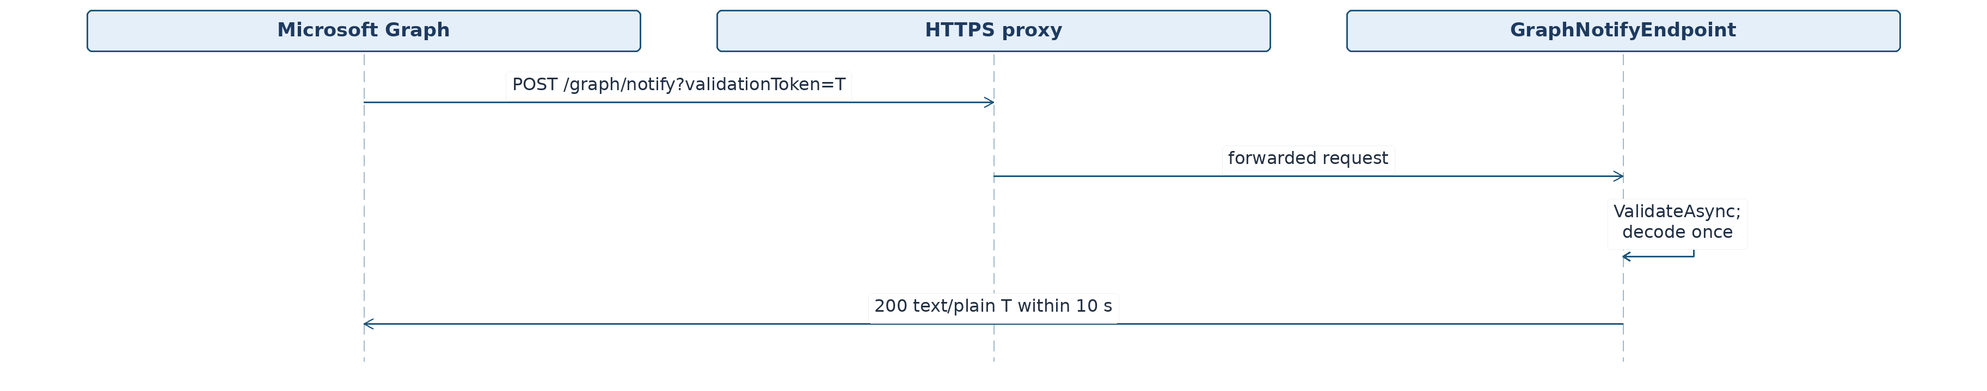
Figure 12. Webhook: Durable Inbox → Core → Outbox.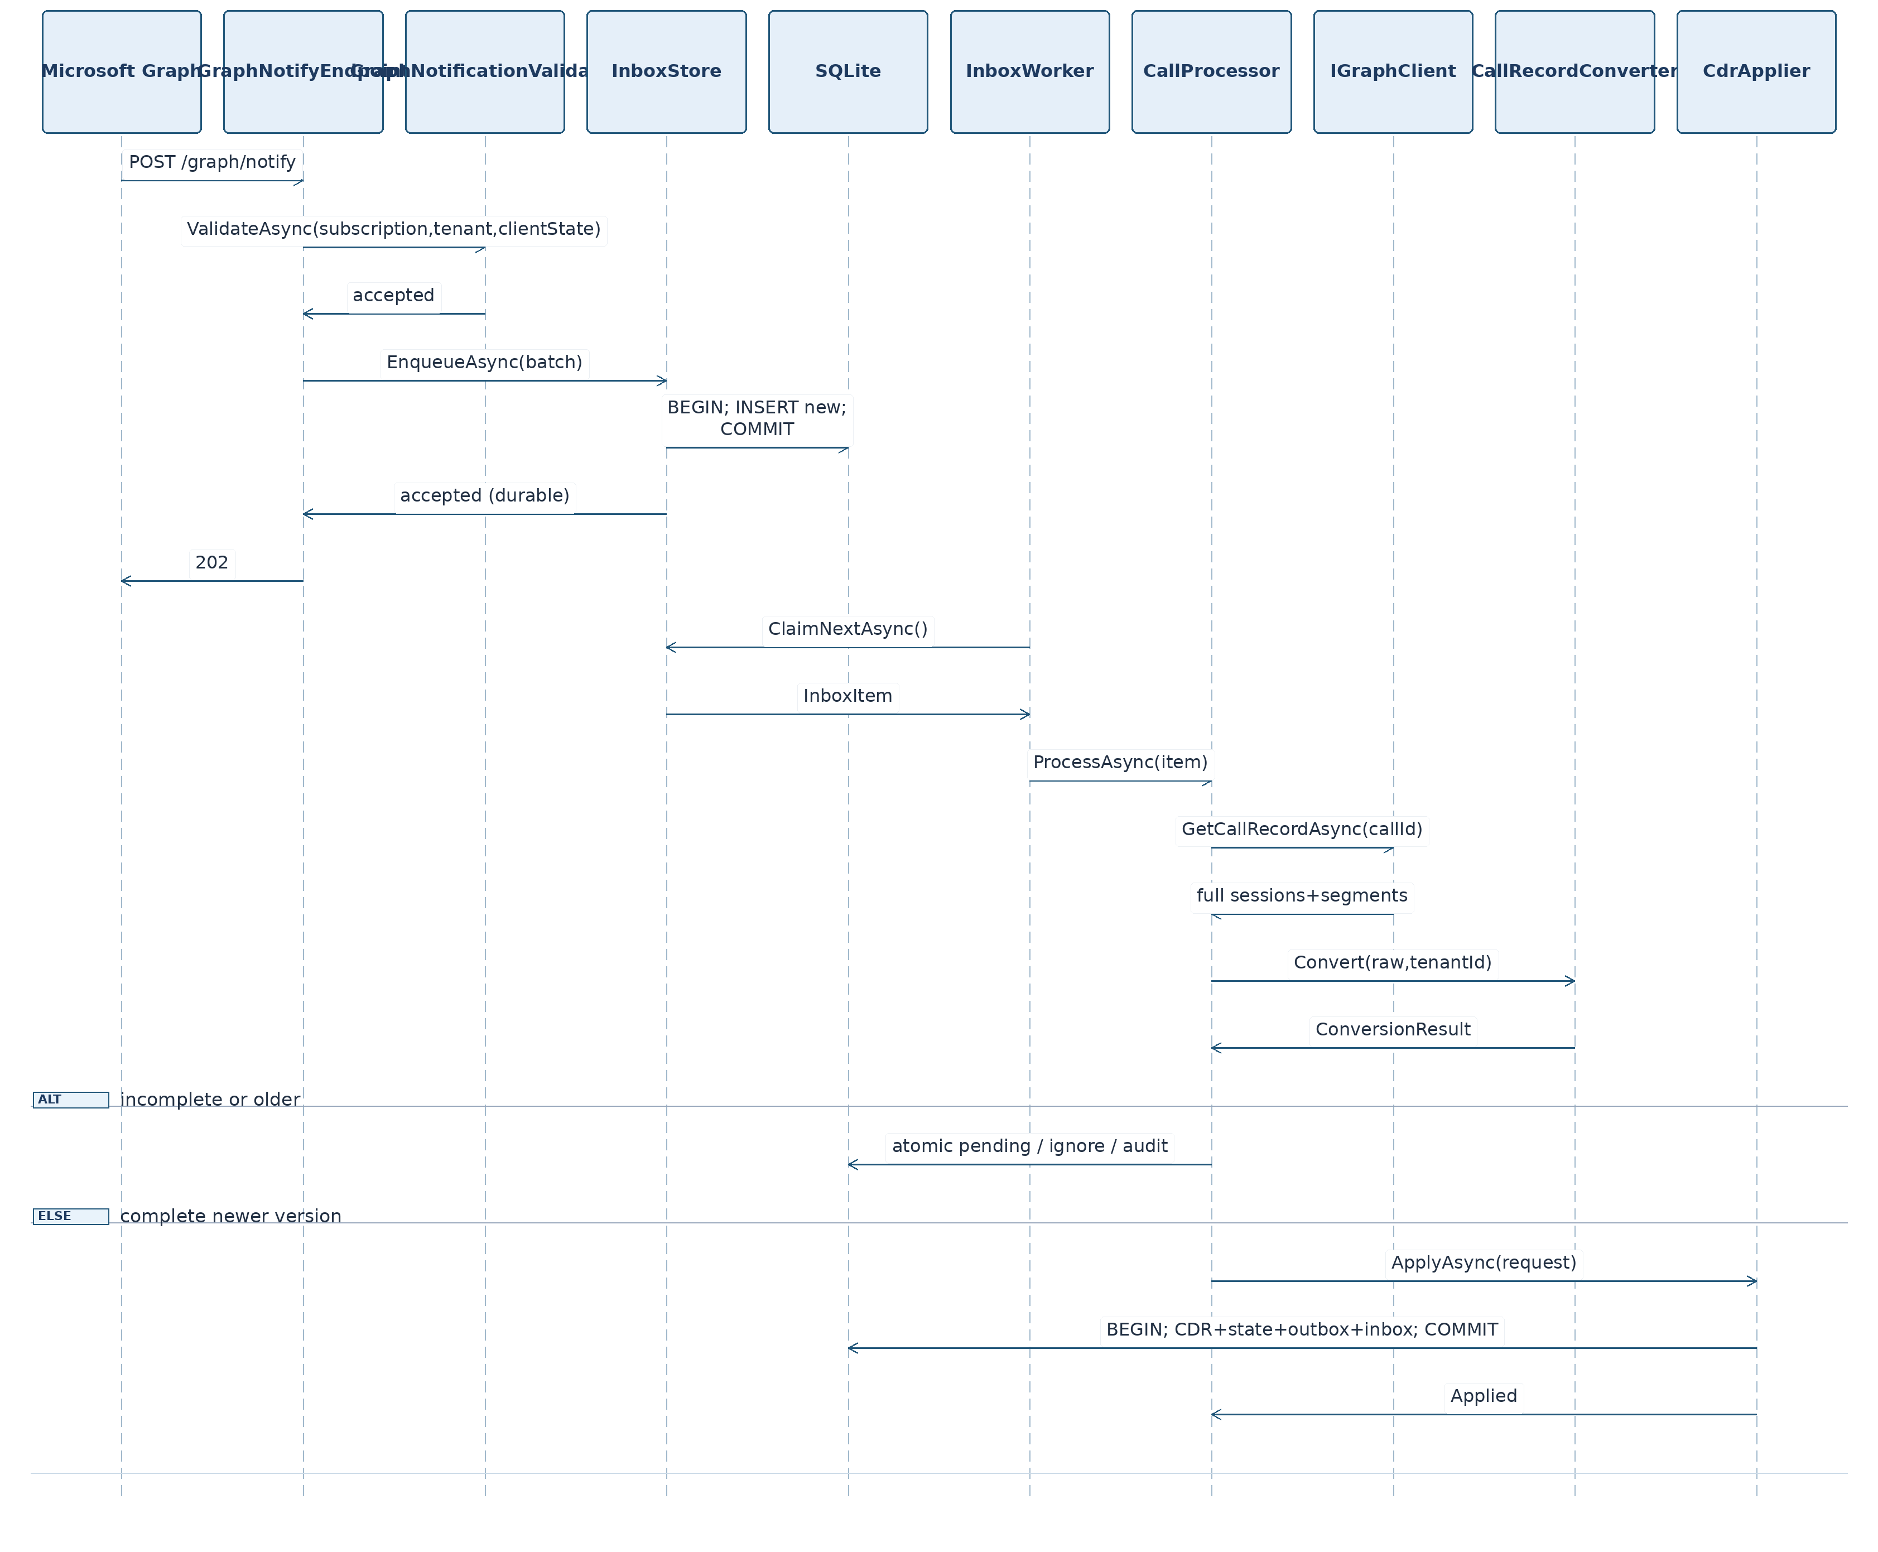
Figure 13. Repeated Webhook During Processing.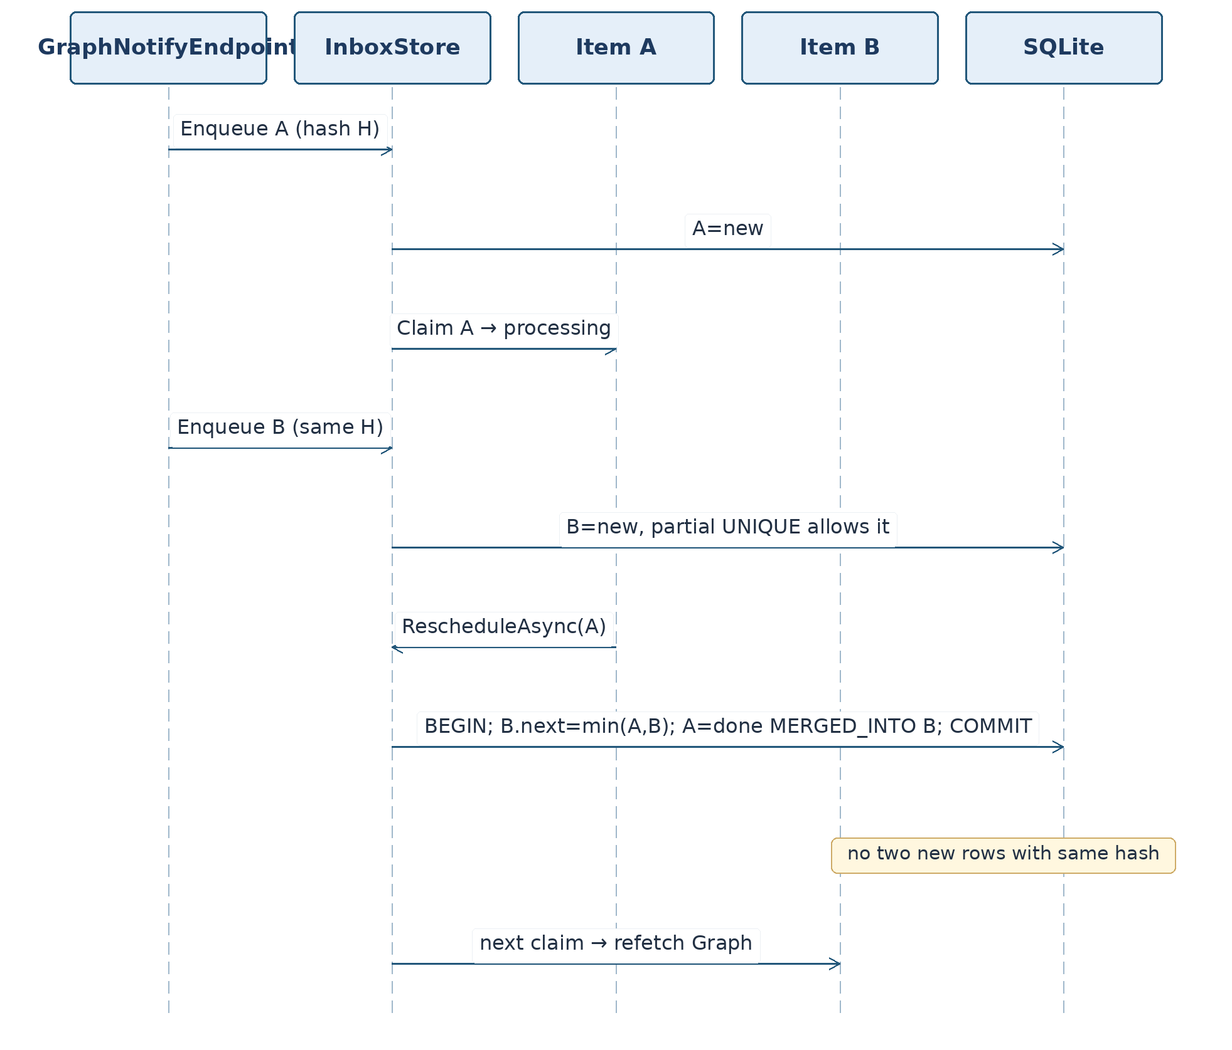
Figure 14. Manual /api/reprocess Reconciliation: Queue and Lease Heartbeat.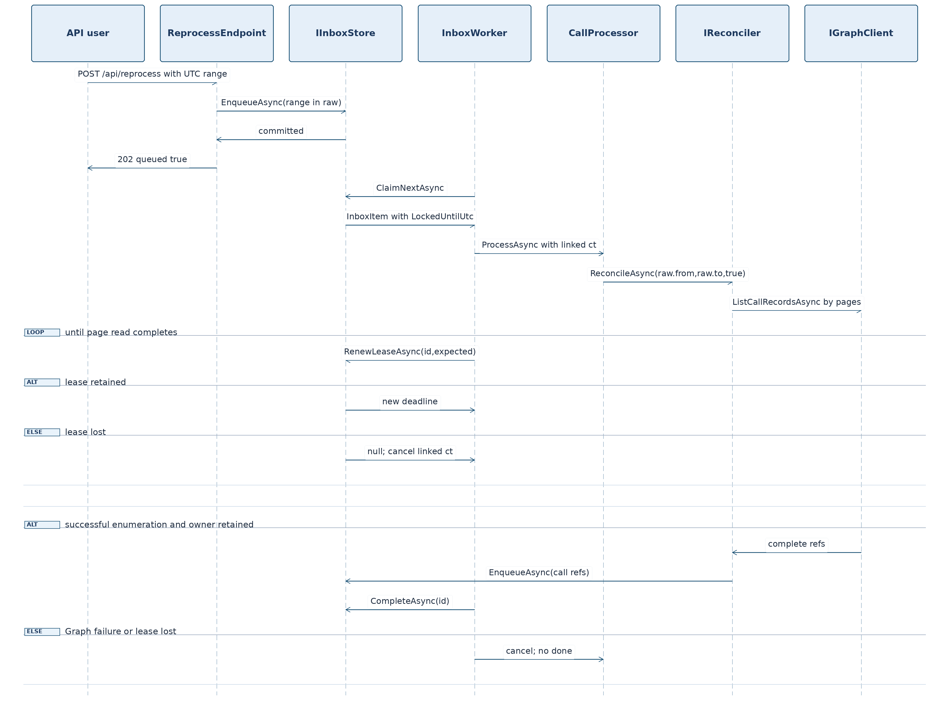
Figure 15. Graph Subscription: Safe Recovery After POST.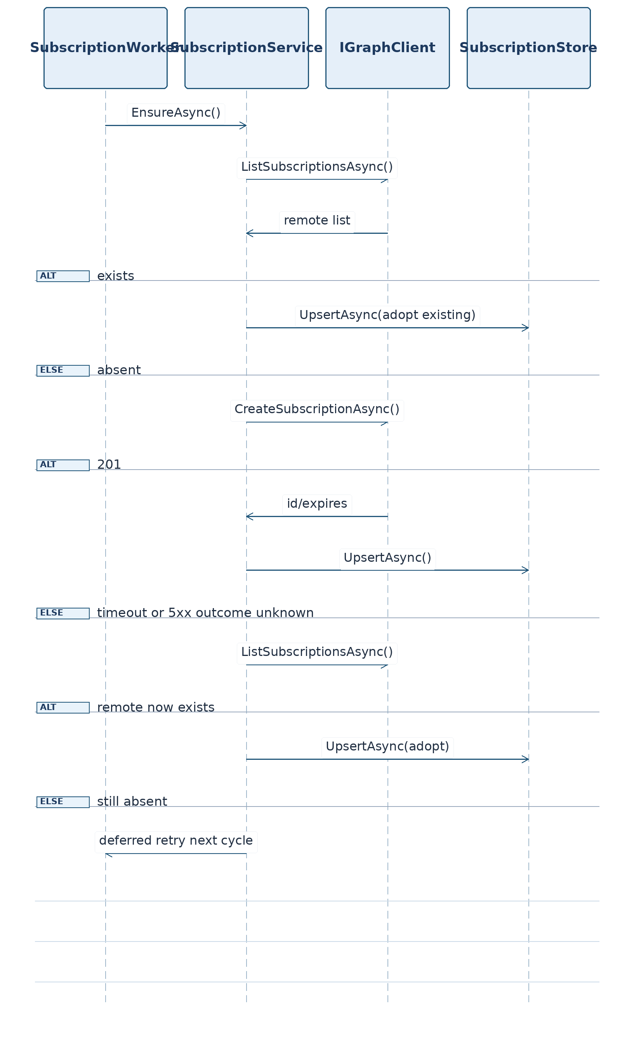
Figure 16. Activity Feed: At-Most-Once Policy.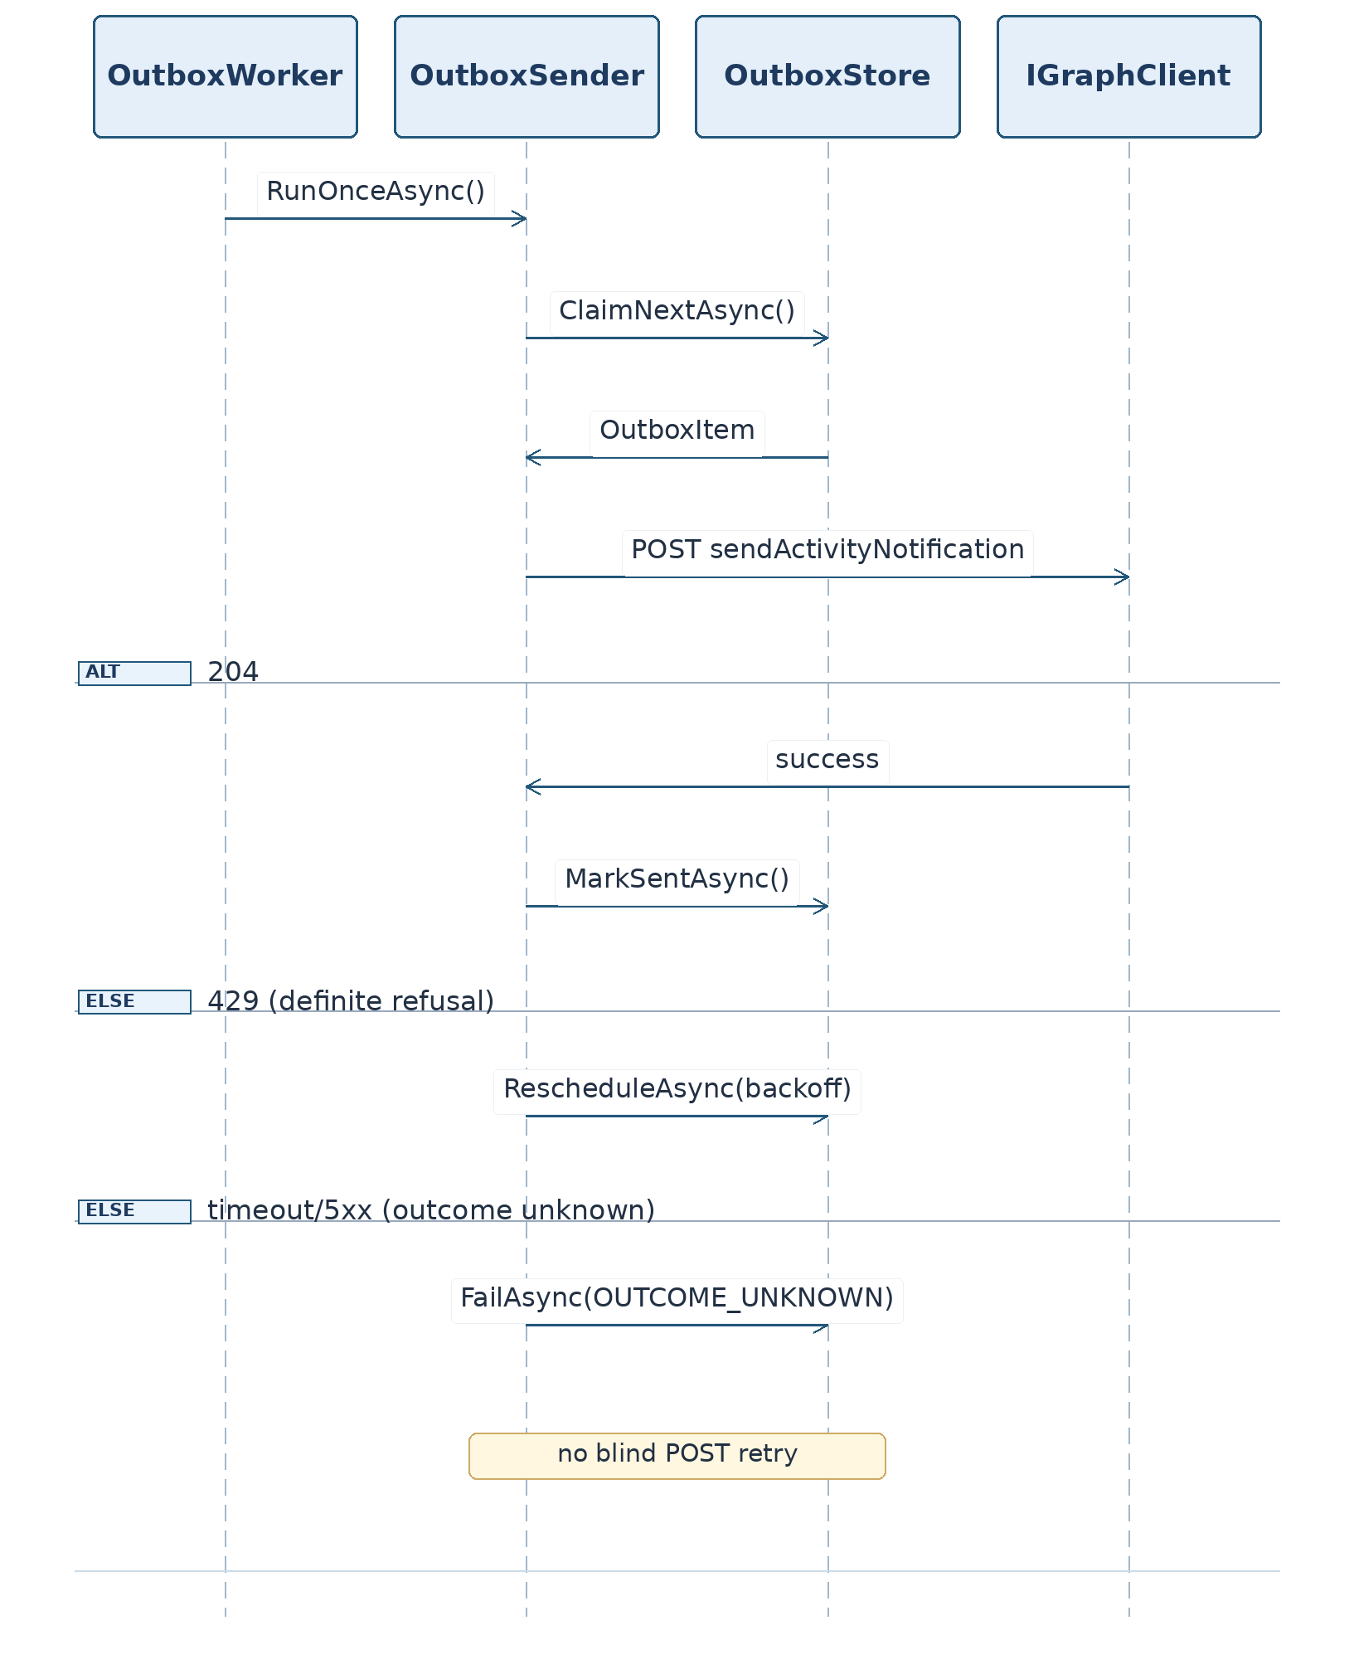
Figure 17. Teams Bot: Authentication and calls today.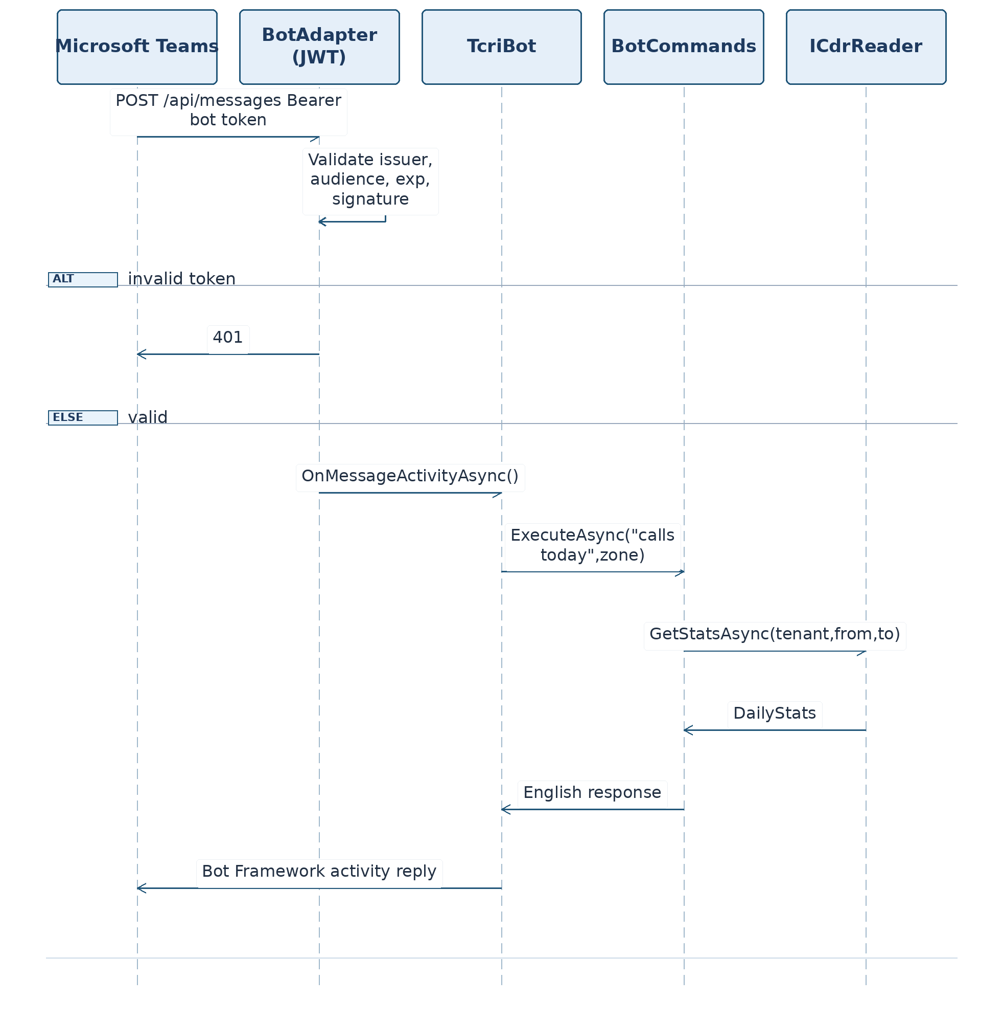
Figure 18. Application Startup and Recovery.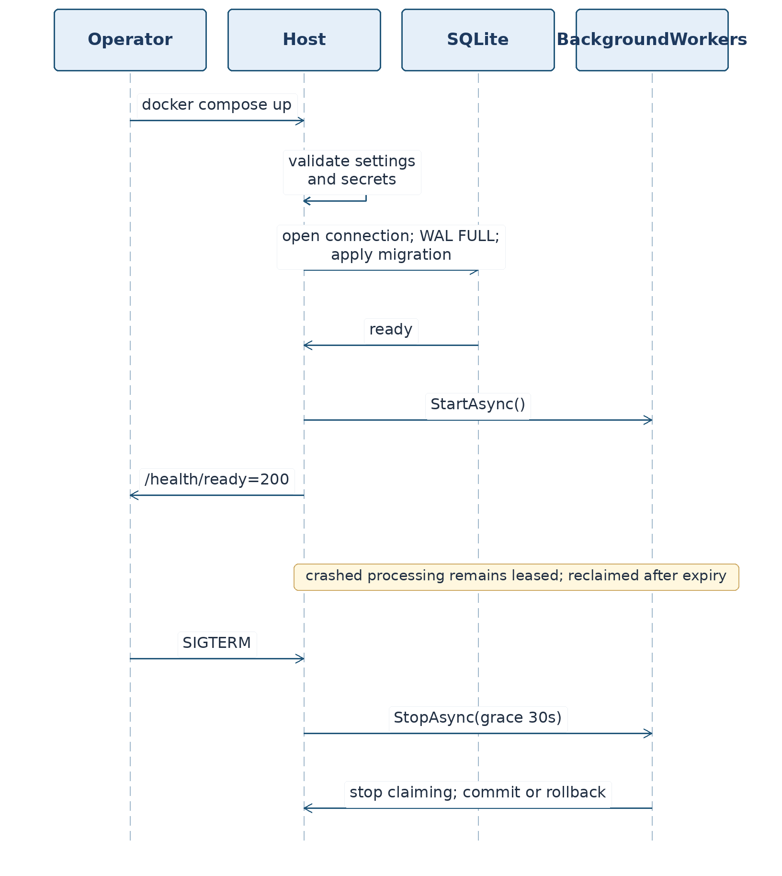

3.27. Complete State Model and Cross-Module Invariants
Object | State | Allowed transitions | On abnormal termination
inbox | new | processing; on duplicate remains new | durable
inbox | processing | done, failed, new (retry), merged into another new | lease timeout → reclaim
inbox | done | terminal for physical item | new webhook = new row
source_state | pending | done, suspended, expired | retry due date preserved
source_state | suspended | done, expired, suspended | periodic recheck
source_state | expired | done only via manual force with actual complete data | audit/diagnostics; previous CDR preserved
outbox | new | sending | eligible for sending
outbox | sending | sent (204), new (429), failed (unknown) | after lease → failed unknown; no blind retry
subscription | active | renewing, failed, active (adopt) | GET/list reconciliation
System invariants (mandatory in SQL and tests):
I-01. UNIQUE(cdr.tenant_id,cdr.call_id,cdr.session_id) always holds; cdr_seq remains stable when updating a session.
I-02. No incomplete callRecord may advance source_state.applied_version or delete an existing CDR.
I-03. A lower version changes neither pending/done nor a CDR. Same version with a different hash → audit only.
I-04. HTTP 202 is not returned before committing inbox. 503 on overload or database unavailability allows Graph to retry notification delivery.
I-05. There cannot be two inbox rows with state='new' and identical element_hash, but there may be one processing and one new with the same hash. A→new collisions are merged atomically.
I-06. Outbox does not change the CDR record; under the chosen policy an uncertain POST outcome is not automatically retried.
I-07. Secrets, access tokens, clientState, and actual Graph payload bodies are neither logged nor published in the repository.
I-08. Moving from one version to the next is transactional: cdr + source_state + inbox + outbox are all written together or remain unchanged.
I-09. RSC is not replaced by tenant-wide protected API access and is not expanded without another owner decision.
I-10. Infrastructure does not depend on Host, and no project code affects the Digital Polygraph production system.

3.28. Reference Integration JSON Contracts
Graph notification (synthetic transport signal).
{
"value": [
{
"subscriptionId": "00000000-1111-4222-8333-444444444444",
"tenantId": "11111111-1111-4111-8111-111111111111",
"clientState": "REPLACE_IN_TEST_WITH_FIXED_FAKE_STATE",
"changeType": "updated",
"resource": "communications/callRecords/cccccccc-0000-4000-8000-000000000001"
}
]
}
CDR: the canonical output for all G01–G11 derived events is in §3.6 and remains the sole Core golden set; REST JSON in §3.23.4 illustrates the shape but does not override G01–G11 hashes. Additional D04 is derived strictly from G01: retain call ID cccccccc-0000-4000-8000-000000000001 and session ID dddddddd-0000-4000-8000-000000000001; change version=4 to 3; delete sessions[0].endDateTime only, leaving root endDateTime intact. This is the input to S05(b), in which complete G01 version 4 was already applied: the outcome is IgnoredLower, with no CDR change, no pending transition, and no new rejected rows. The standalone Core output (when invoked for diagnostic comparison) has IsComplete=false with SESSION_DATES_MISSING. Complete JSON appears in Appendix B.
Outbox payload:
{"activity_type":"callCompleted","call_type":"oneToOne","status":"completed","duration_s":60,"start_utc":"2026-10-20T09:00:00.0000000Z"}
API error:
{"error":{"code":"UNAUTHORIZED","message":"API key required"},"trace_id":"synthetic-trace-001"}
Diagnostics (key-protected response, available only after the API key):
{
"status":"degraded",
"database":"ready",
"queues":{"inbox_pending":2,"inbox_failed":0,"outbox_pending":1,"outbox_failed":1},
"sources":{"pending":1,"suspended":1,"expired":0},
"last_reconcile_utc":null,
"reason_codes":["OUTBOX_OUTCOME_UNKNOWN"]
}
Teams SDK signatures not verified by compilation (RV-02). Names AddTeamsBotApplication, UseTeamsBotApplication, OnMessage and context.SendAsync are pseudocode for integration points. Their existence and parameters are not confirmed by dotnet restore/build for Microsoft.Teams.Apps 2.1.1. Before implementation, a minimal compile probe against the installed package is required. Do not transfer these names into C# as a proven API.
Error contract — no false precision: without a tenant, Graph health may be degraded; this does not mean integration succeeded. The example CDRs in this document are synthetic, not data from a real tenant.

3.29. Host Automated Test Plan
Planned environment: .NET SDK 8.0.x, xUnit 2.9.3, ASP.NET Core WebApplicationFactory, SQLite in a temporary directory, FakeTimeProvider, StubHttpMessageHandler, fake Graph, and a dedicated Bot test adapter if needed. Expected HTTP responses are given directly in test names/descriptions; counts are planned and must be verified after implementation.
Class/file (tests/TeamsCallRecords.Host.Tests/) | Methods — condition and expected result | Count | Criteria
WebhookEndpointTests.cs | Validation_UrlDecoded_Plain200, Validation_Missing400, Validation_DoubleEncodedPreserved, Notification_Valid202AfterCommit, Notification_Overloaded503, Notification_DatabaseError503, Notification_EmptyBatch400, Notification_TooLarge413, Notification_MixedBatch_ValidCommittedInvalidIgnored, Notification_DuplicateDoneEnqueued, Notification_MixedBatch_ValidCommittedTemporaryUnknown503, Notification_MixedBatch_AllInvalid403 | 12 | K3, K12
WebhookSecurityTests.cs | UnknownSubscription_NoPendingMarker403, WrongClientState403, WrongTenant403, WrongResource403, CorrectHashAccepted, NoClientStateInInbox, NoSecretsLogged, BadContentType415, BodyDepthRejected, TrustedForwardedHeadersOnly, UnknownSubscription_PendingMarker503, UnknownSubscription_ExpiredPendingMarker403 | 12 | K10, K12
LifecycleEndpointTests.cs | Missed_ReconcileEnqueued, Removed_EnsureTriggered, Reauthorization_Refresh, UnknownSubscription_NotPending403, DuplicateLifecycleIdempotent, UnknownSubscription_PendingMarker503 | 6 | K3, K12
CdrEndpointTests.cs | MissingKey401, WrongKey401, ValidKey200, FromMissing400, InvalidTime400, InvalidCursor400, PageSizeLimit400, CorrectPagingNoDuplicates, TenantFiltered, EmptyResult200 | 10 | K7
ReprocessEndpointTests.cs | WithoutKey401, WrongPeriod400, ForceDoneEnqueued, ForceSuspendedEnqueued, ForceExpiredEnqueued, Period_Over7Days400, EnqueuesReconcileRaw, Overloaded503, ResponseHasNoCount, DuplicateWhileNew_Collapsed, NoSynchronousGraph, CommitFailure503 | 12 | K7, K12
HealthEndpointTests.cs | LiveWithoutDb200, ReadyDatabaseUnavailable503, StatusNeedsKey, StatusCountsCorrect, StatusHidesSecrets | 5 | K9, K10
BotCommandsTests.cs | HelpListsCommands, CallsTodayEmpty, CallsTodayThreeCalls, CallsTodayTimezoneBoundary, CallsTodayDSTBoundary, UnknownCommand, CaseInsensitive, DurationIsSessionSum | 8 | K5
BotAuthenticationTests.cs | MissingBearer401, BadSignature401, WrongAudience401, Expired401, ValidSignedActivityHandled | 5 | K5, K10
WorkerRecoveryTests.cs | InboxLeaseRecover, OutboxUnknownNotRetried, ShutdownStopsClaim, RollbackPreservesInbox, SecondInstanceProhibited, NoCrashOnSingleGraphFailure, Reconcile_LeaseRenewsDuringPaging, Reconcile_LeaseLossCancelsAndDoesNotComplete | 8 | K6, K9, K12
ConfigurationTests.cs | MissingApiKeyFailsStartup, InvalidTimezoneFailsStartup, NoGraphSecretInSettingsFile, InvalidMaxPendingFails, DevConfigDoesNotBypassJwt | 5 | K9, K10
EndToEndSyntheticTests.cs | WebhookG01CreatesOneCdr, GroupG02CreatesTwo, OverlappingG03NotSummed, MalformedGraphRejected, SameVersionDiffHashAudit, NewVersionUpdates, PendingNoFakeCdr, ForcedReprocessRecovers, OutboxFailureKeepsCdr, RestartRetainsData | 10 | K7–K14
A total of 92 named proposed Host tests (sum of rows). These are not execution results. Every test includes a representative HTTP body, expected status, expected SQLite rows, and absence of forbidden side effects; a real Microsoft tenant test cannot be replaced by a fixture.

3.30. Requirements → Implementation → Test Matrix
Requirements | Layer / key file | Automated verification | Live verification
F1 / K1 | GraphClient, GraphOptions, Entra app | GraphClientTests.Token*, ConfigurationTests | App-only token through real Entra
F2 / K2 | GraphClient, SubscriptionService | GraphClientTests, SubscriptionServiceTests | users/teams/channels/callRecord in tenant
F3 / K4 | GraphNotifyEndpoint, manifest.json | WebhookEndpointTests, LifecycleEndpointTests | channel message without @mention under RSC
F4 / K5 | BotAdapter, TcriBot, BotCommands | BotCommandsTests, BotAuthenticationTests | Teams bot responds to help, calls today
F5 / K6 | OutboxSender, GraphClient | OutboxSenderTests, EndToEndSyntheticTests | activity feed notification
F6 / K8,K11,K13,K15 | CallRecordConverter, VersionRules, CdrApplier | Golden G01–G11, D01–D04, ScenarioTests | real callRecord, manual time comparison
F7 / K7 | TcriDbContext, migrations, CdrReader | SchemaTests, CdrEndpointTests | restart preserves CDR
F8 / K7,K12 | CdrEndpoints, ReprocessEndpoint, Reconciler | ReprocessEndpointTests | reprocess for selected period
F9 / K9,K10,K14 | Diagnostics, error_log, rejected, logs | WebhookSecurityTests, HealthEndpointTests | failure of one record, secret masking
K3 | GraphNotifyEndpoint, SubscriptionWorker | WebhookEndpointTests | Graph validationToken challenge
K12 | GraphNotificationValidator, InboxStore | WebhookSecurityTests, InboxStoreTests | foreign clientState rejected
Final acceptance criteria: automated tests verify the implemented properties, but K8, K11, K13, and K15 require processing records from an actual tenant. Synthetic-only demonstrations are allowed with the explicit statement “live F6 acceptance is not complete.”

3.31. Atlas of Additional Sequences and Signatures
Scenario | Calls / components | Main branches | Figure
Token F1 | GraphClient → ClientSecretCredential.GetTokenAsync | token cache, expired, 401/403 | R19
Read callRecord | GraphClient.GetCallRecordAsync → sessions/segments page loaders | @odata.nextLink, MaxPages, malformed, retry | R20
Version transition | CallProcessor → VersionRules.Decide → CdrApplier | lower, equal/same, equal/different, higher | R21
CDR replacement | CdrApplier → IWriteGate → SQLite | update/insert/delete/rollback | R22
Subscription renew | SubscriptionService → IGraphClient → ISubscriptionStore | 204, unknown outcome/list, missed | R23
Channel message RSC | Graph → Endpoint → Inbox → CallProcessor | validate team/channel; never use protected tenant-wide API | R24
Figure 19. Entra ID Token for Graph.
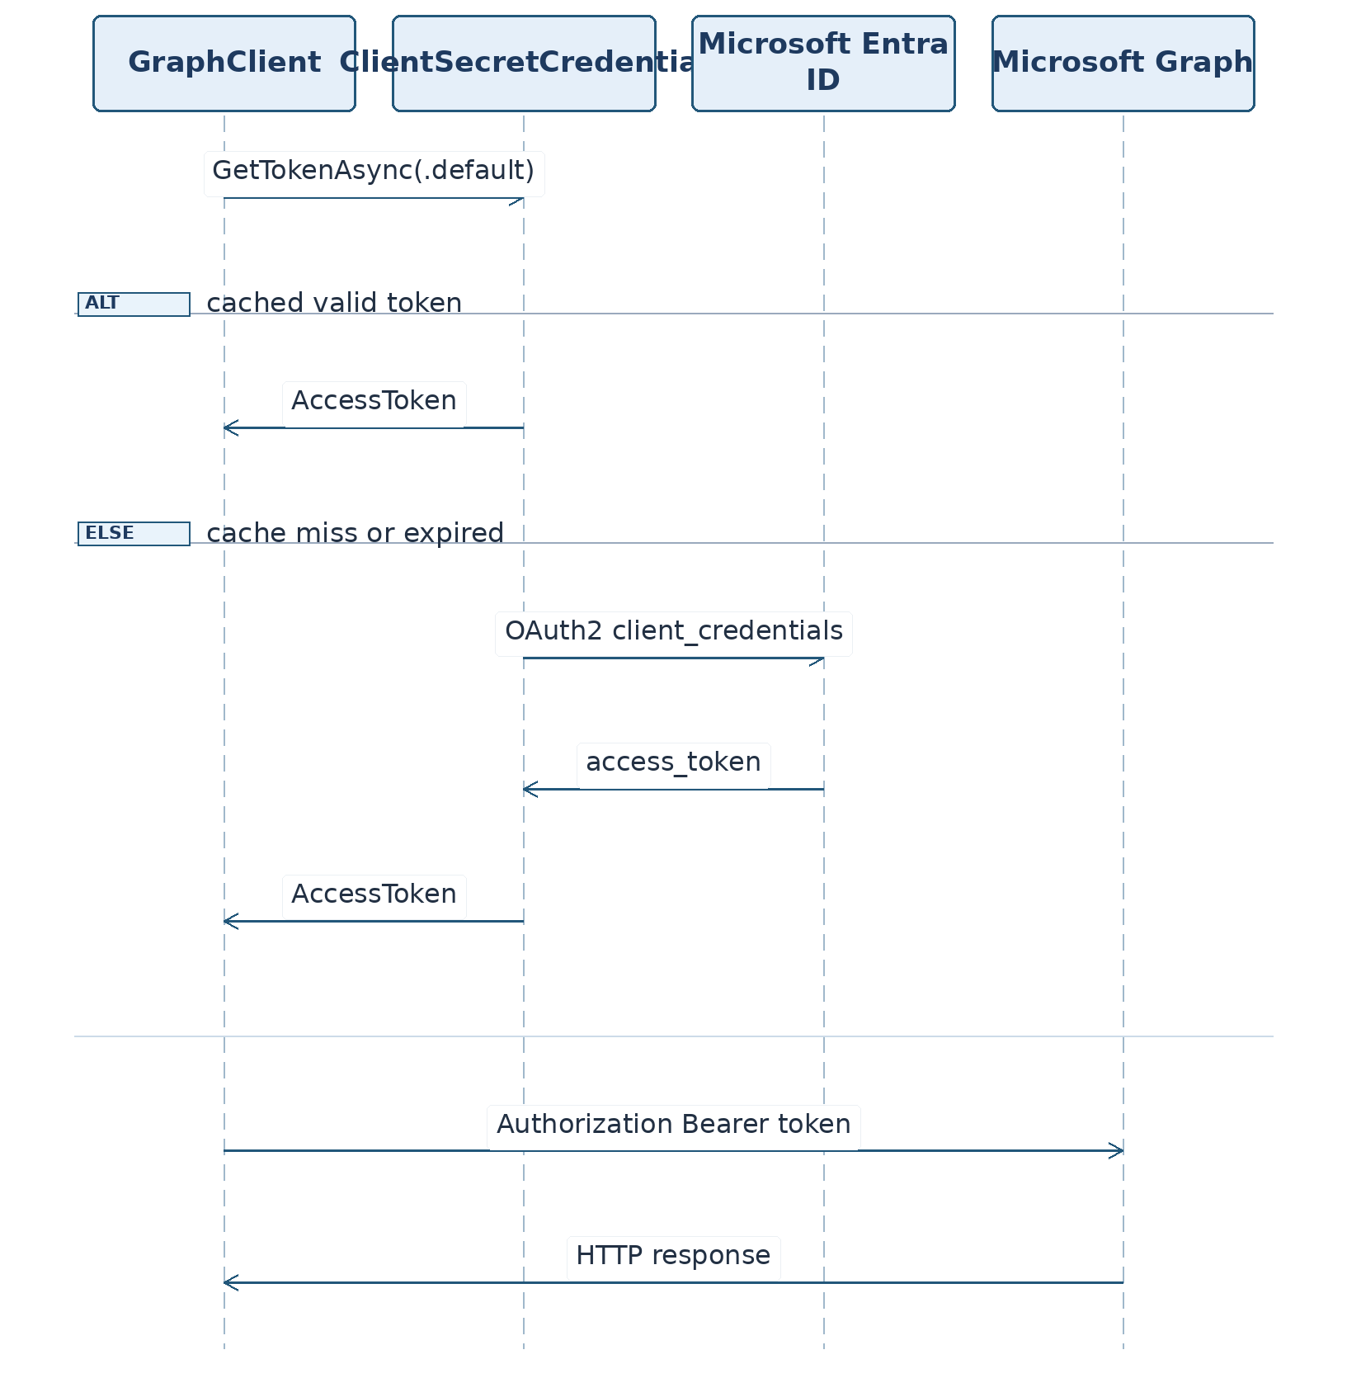
Figure 20. Loading callRecord Pages.
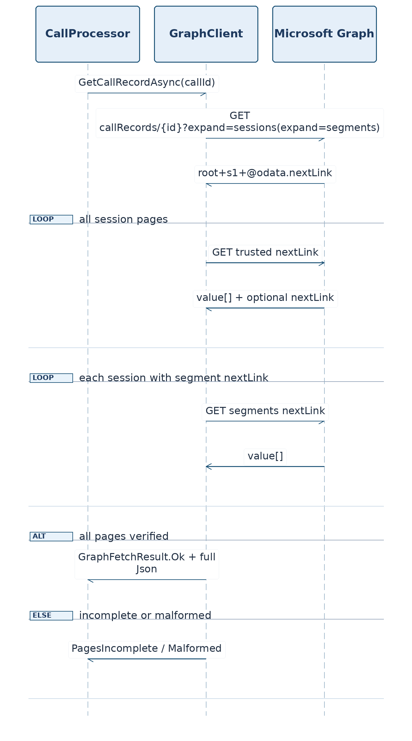
Figure 21. Version and State Check.
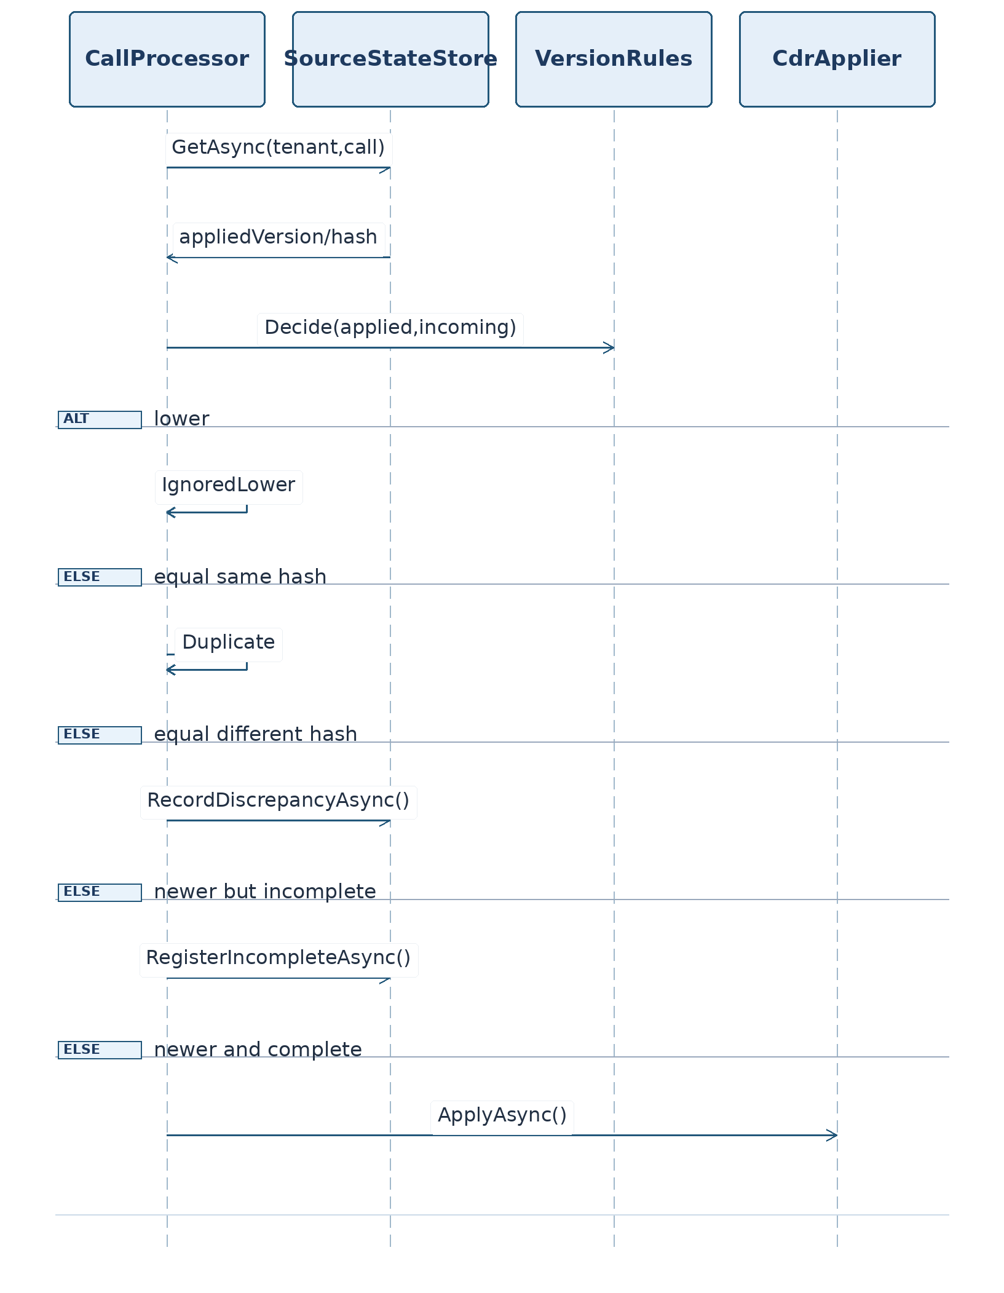
Figure 22. Atomic Update of the CDR Set.
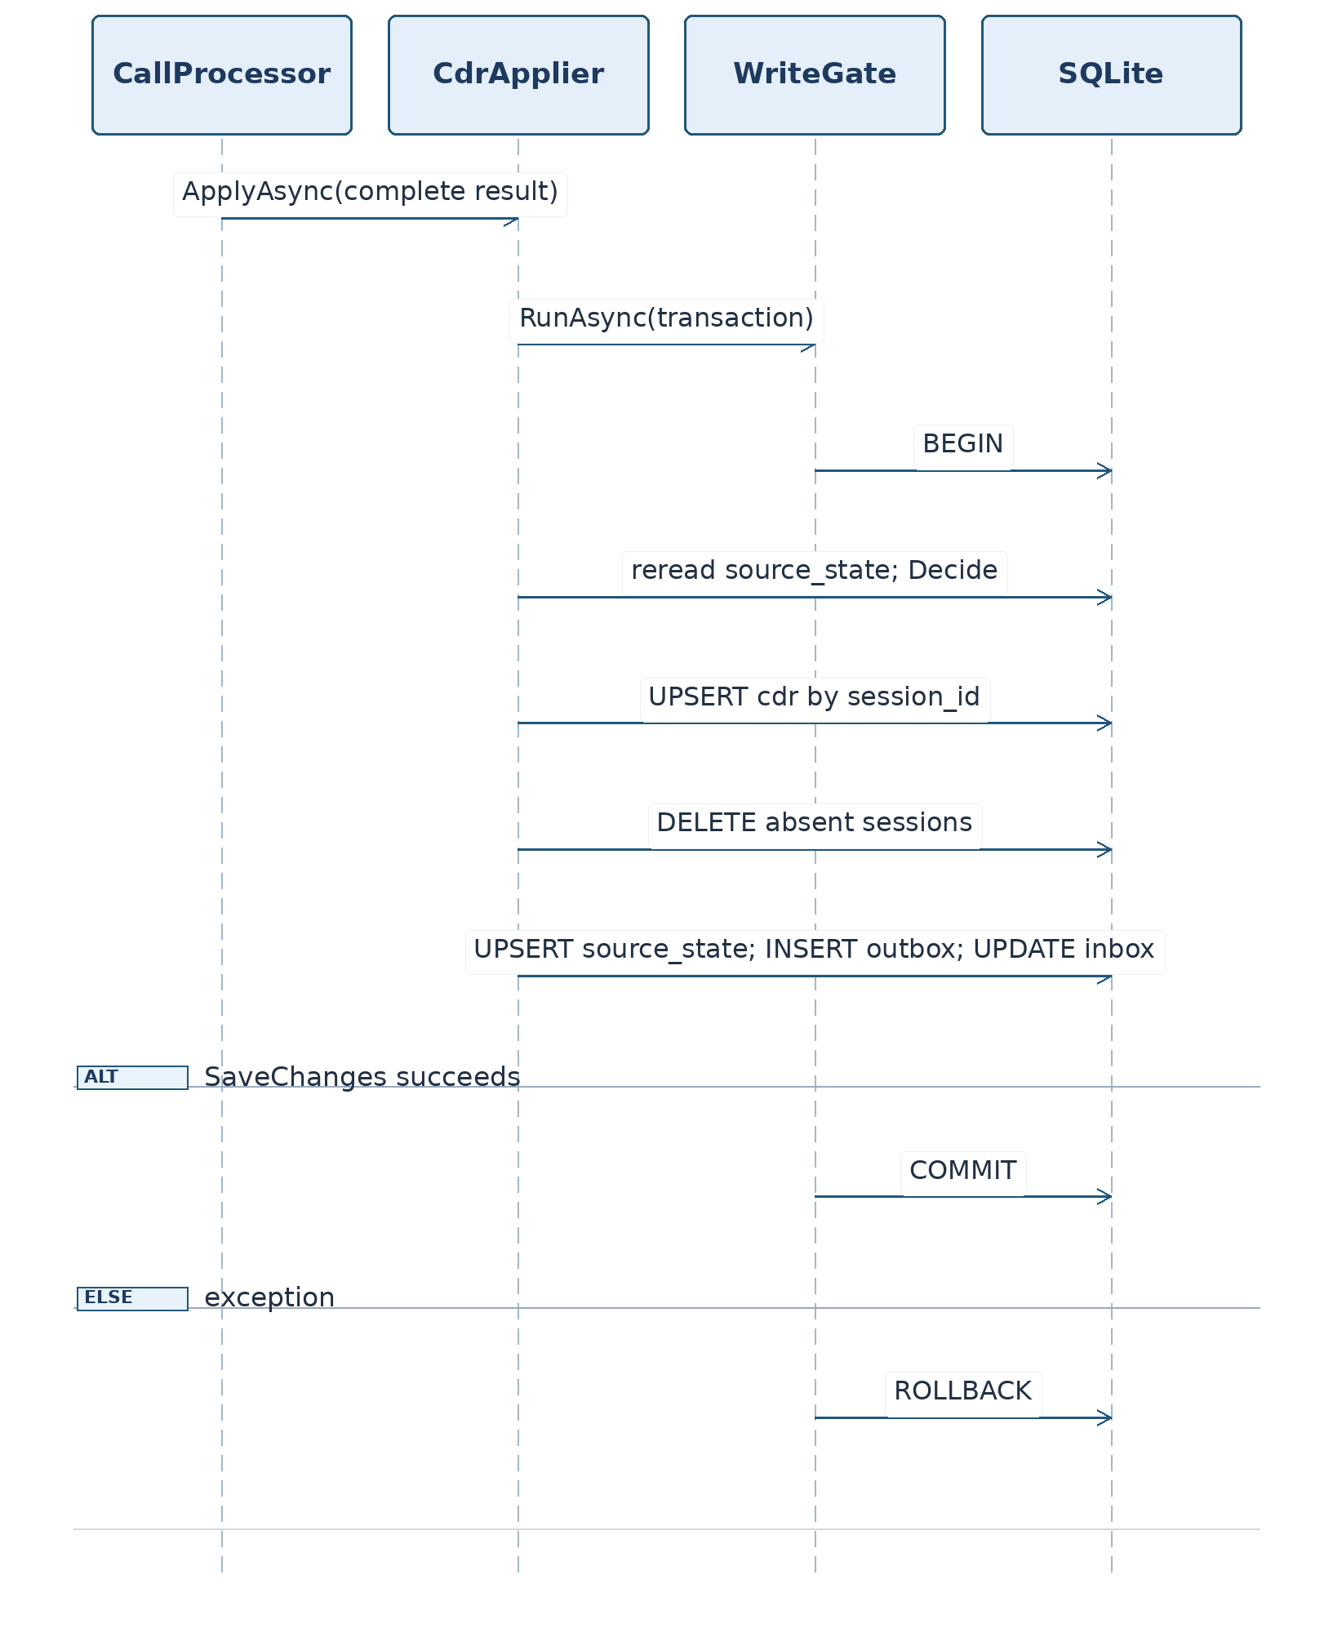
Figure 23. Renewing a Graph Subscription.
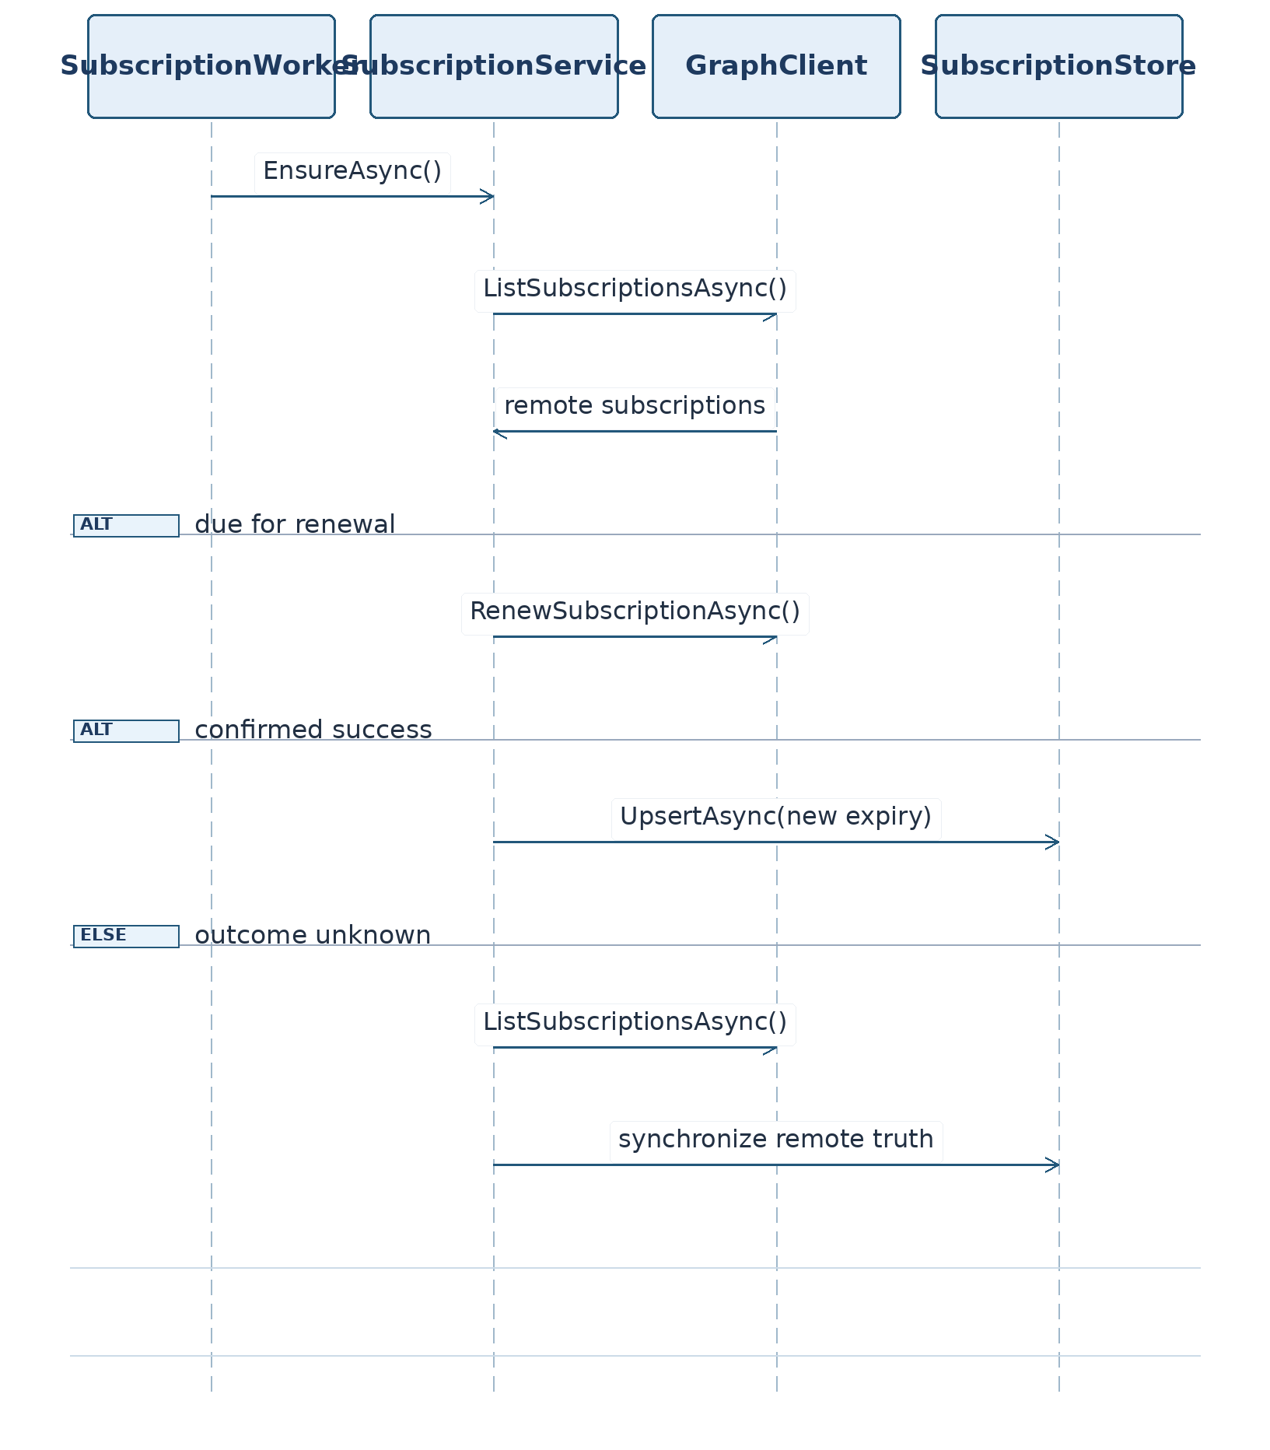
Figure 24. Channel Message Without @mention.
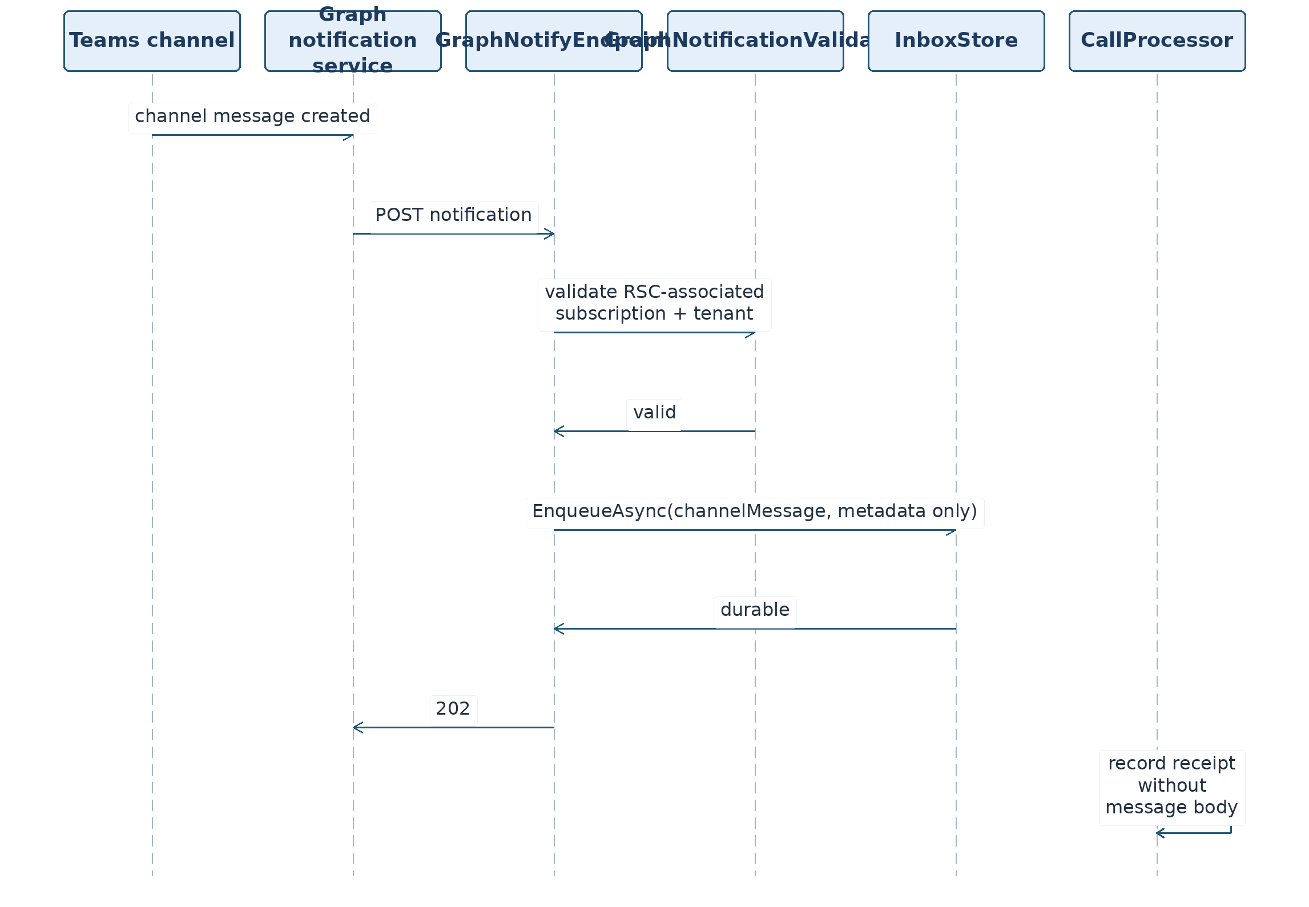

3.32. Preliminary Verification of Contracts and .NET 8 Compatibility
global.json pins the .NET 8 SDK and does not require any change to the Digital Polygraph runtime. TeamsCallRecords.sln is used rather than .slnx. Directory.Build.props sets TargetFramework=net8.0, LangVersion=12, Nullable=enable, ImplicitUsings=enable, TreatWarningsAsErrors=true, deterministic build, and ContinuousIntegrationBuild in CI.
Compatibility must be verified by compiling under .NET 8 and running all tests (Core + Infrastructure + Host), not by choosing a version by inspection. No .NET 10-only code is used. IHostedService, TimeProvider, HttpClient, IOptions, and EF Core 8 are available in the target release. NuGet package versions must be pinned centrally in Directory.Packages.props; unverified versions are not represented as restore-tested.
The design does not assert perfect idempotency of Microsoft Graph POST. Uncertain operation outcomes are treated as a separate state, using remote reads where possible.

3.33. D04 Golden Sample and Its Links to S05(b), S14, and S15
D04 is G01 v3 with the session end time missing. This is a synthetic golden sample, not one retrieved from Microsoft Graph. Original G01 has source_version=4, call_id=...0001, session_id=...0001. D04 sets the lower version 3 and removes only sessions[0].endDateTime. The root callRecord.endDateTime remains: it is not the session end timestamp and does not justify generating a CDR.
D04/in — complete JSON:
{
"@odata.context": "https://graph.microsoft.com/v1.0/$metadata#communications/callRecords/$entity",
"id": "cccccccc-0000-4000-8000-000000000001",
"version": 3,
"type": "peerToPeer",
"modalities": [
"audio"
],
"startDateTime": "2026-10-20T09:00:00.0000000Z",
"endDateTime": "2026-10-20T09:05:00.0000000Z",
"sessions": [
{
"id": "dddddddd-0000-4000-8000-000000000001",
"modalities": [
"audio"
],
"startDateTime": "2026-10-20T09:00:00.0000000Z",
"caller": {
"@odata.type": "#microsoft.graph.callRecords.participantEndpoint",
"identity": {
"user": {
"id": "aaaaaaaa-0000-4000-8000-000000000001",
"displayName": "User A"
}
},
"userAgent": {
"@odata.type": "#microsoft.graph.callRecords.clientUserAgent",
"platform": "windows",
"productFamily": "teams"
}
},
"callee": {
"@odata.type": "#microsoft.graph.callRecords.participantEndpoint",
"identity": {
"user": {
"id": "aaaaaaaa-0000-4000-8000-000000000002",
"displayName": "User B"
}
},
"userAgent": {
"@odata.type": "#microsoft.graph.callRecords.clientUserAgent",
"platform": "windows",
"productFamily": "teams"
}
},
"segments": [
{
"id": "seg-1",
"startDateTime": "2026-10-20T09:00:00.0000000Z",
"endDateTime": "2026-10-20T09:01:00.5000000Z",
"media": [
{
"label": "main-audio",
"streams": [
{
"streamId": "s1",
"streamDirection": "callerToCallee"
}
]
}
]
}
]
}
]
}
D04/out — complete expected Core JSON (exact hashes per §3.4.1):
{
"call_id": "cccccccc-0000-4000-8000-000000000001",
"source_version": 3,
"is_complete": false,
"incomplete_reasons": [
"SESSION_DATES_MISSING"
],
"session_set_hash": "b76cf8e6d4dc200613dad12fe14fca9280c08f968aa7961e9ca9026291dfc2b4",
"cdrs": [],
"rejections": []
}
Computed Canonical.HashOf(session) = 18f5ecee18c3e04be1c6256840a4422753573c5133caf5895fd9d63896de785f; Canonical.SessionSetHash = b76cf8e6d4dc200613dad12fe14fca9280c08f968aa7961e9ca9026291dfc2b4. The expected CallRecordConverter.Convert(D04) result is incomplete (SESSION_DATES_MISSING), but Infrastructure classifies it as an older version and ignores it before moving to pending. Therefore S05(b)'s main assertion is checked after applying G01 version 4 with the same call_id.
Specific states and numeric expectations for S14 appear in §3.19; S15's forced reconciliation of four states is described there too. Appendix B duplicates D04 in the D01–D04 catalog because the standalone golden sample is required both in the file tree and in the TRP text.

3.34. Exact Build and Deployment Files (Normative Set)
The design includes the following additional files and directories at exact paths: global.json, Directory.Build.props, Directory.Packages.props, NuGet.Config, .editorconfig, .gitignore, .dockerignore, .env.example, Dockerfile, docker-compose.yml, Caddyfile, .github/workflows/ci.yml, teams-app/manifest.json, teams-app/color.png, teams-app/outline.png, README.md, HANDOFF.md, LICENSE, docs/file-inventory.tsv, docs/test-protocol.md, docs/permissions.md, docs/diagrams/sequence-04.mmd … sequence-24.mmd, scripts/check-artifacts.py, scripts/check-secrets.sh, scripts/verify-schema.py. Every ellipsis in this row denotes a range of numbers: the physical register contains one docs/diagrams/sequence-N.mmd file for each N=04,…,24; inventory generation expands this range explicitly. Additional details remain as specified in the file register.
All texts below are given in full or have exactly one specifically marked item to be checked after an owner decision. Loading secrets from .env, local dev tunnels, and public TLS do not require installation of a different .NET SDK on the DP server. Reading this TRP does not run commands on the owner's computer.

3.34.1. global.json
{
"sdk": {
"version": "8.0.100",
"rollForward": "latestFeature",
"allowPrerelease": false
}
}
Use a .sln solution (not .slnx). A later installed SDK in the same version-8 line is allowed with rollForward=latestFeature; .NET 10 need not be installed.

3.34.2. Directory.Build.props
<Project>
<PropertyGroup>
<TargetFramework>net8.0</TargetFramework>
<LangVersion>12</LangVersion>
<Nullable>enable</Nullable>
<ImplicitUsings>enable</ImplicitUsings>
<TreatWarningsAsErrors>true</TreatWarningsAsErrors>
<Deterministic>true</Deterministic>
<EnableNETAnalyzers>true</EnableNETAnalyzers>
</PropertyGroup>
</Project>

3.34.3. Directory.Packages.props
The following file consolidates proposed NuGet version lines and versions. Some are inherited from the reviewed source documents; others require verification by actual dotnet restore --locked-mode with the target SDK. Until verified, it is a proposed input, not a proven restorable lockfile.
<Project>
<PropertyGroup>
<ManagePackageVersionsCentrally>true</ManagePackageVersionsCentrally>
</PropertyGroup>
<ItemGroup>
<PackageVersion Include="Microsoft.EntityFrameworkCore.Sqlite" Version="8.0.11" />
<PackageVersion Include="Microsoft.EntityFrameworkCore.Design" Version="8.0.11" />
<PackageVersion Include="Azure.Identity" Version="1.13.2" />
<PackageVersion Include="Microsoft.Extensions.Http.Resilience" Version="8.10.0" />
<PackageVersion Include="Microsoft.Extensions.Options.ConfigurationExtensions" Version="8.0.0" />
<PackageVersion Include="Microsoft.Extensions.Hosting.Abstractions" Version="8.0.0" />
<PackageVersion Include="Microsoft.Extensions.TimeProvider.Testing" Version="8.10.0" />
<PackageVersion Include="Microsoft.Extensions.Diagnostics.Testing" Version="8.10.0" />
<PackageVersion Include="xunit" Version="2.9.3" />
<PackageVersion Include="xunit.runner.visualstudio" Version="3.1.4" />
<PackageVersion Include="Microsoft.NET.Test.Sdk" Version="17.14.1" />
<PackageVersion Include="coverlet.collector" Version="6.0.4" />
<PackageVersion Include="Microsoft.AspNetCore.Mvc.Testing" Version="8.0.11" />
<PackageVersion Include="Microsoft.Teams.Apps" Version="2.1.1" />
</ItemGroup>
</Project>
Explicit Host dependency for DR-13: TeamsCallRecords.Host.csproj contains <PackageReference Include="Microsoft.Teams.Apps" /> (without Version, because CPM is enabled). Directory.Packages.props specifies Microsoft.Teams.Apps 2.1.1 (NuGet, supports net8.0). The bot implements TeamsBotApplication.OnMessage, not deprecated ActivityHandler. Route /api/messages must use SDK JWT validation without skipAuth. Verify the class/method signatures and MSAL subpackages using dotnet restore, dotnet build, and BotAuthenticationTests under .NET 8; executing these commands is not claimed. Microsoft documentation: https://microsoft.github.io/teams-sdk/csharp/getting-started/quickstart/ ; https://microsoft.github.io/teams-sdk/csharp/migrations/v2-dotnet/ . If the API or packages differ, update DR-13 and the corresponding tests before approval; do not silently switch to legacy Bot Framework 4.x.

3.34.4. src/TeamsCallRecords.Host/appsettings.example.json
{
"Graph": {
"TenantId": "REPLACE_WITH_TENANT_GUID",
"ClientId": "REPLACE_WITH_ENTRA_APP_GUID",
"ClientSecret": "",
"ClientState": "",
"BaseUrl": "https://graph.microsoft.com/v1.0/",
"Scope": "https://graph.microsoft.com/.default",
"NotificationUrl": "https://tcri.example.org/graph/notify",
"RetentionDays": 30,
"RequestTimeoutSeconds": 30,
"TotalTimeoutSeconds": 120,
"RetryMaxAttempts": 3,
"MaxPages": 100
},
"Storage": {"DataDirectory": "/var/lib/tcri"},
"Inbox": {"MaxPending": 10000},
"Processing": {"Workers": 2, "LeaseSeconds": 120, "RetrySchedule": "1,5,15,60", "PendingLimitHours": 4, "SuspendedRecheckHours": 24, "MaxAttempts": 10},
"Reconcile": {"IntervalMinutes": 15, "LookbackHours": 24},
"Outbox": {"MaxAttempts": 8, "LeaseSeconds": 120, "BackoffSeconds": "30,120,600,1800,3600", "MaxAgeHours": 24},
"Subscriptions": {"TeamId": "", "ChannelId": "", "CallRecordsLifetimeMinutes": 4230, "ChannelMessagesLifetimeMinutes": 60, "RenewCheckMinutes": 5},
"Bot": {"TimeZoneId": "Europe/Kyiv"},
"AzureAd": {"TenantId": "REPLACE_WITH_TENANT_GUID", "ClientId": "REPLACE_WITH_BOT_APP_GUID", "ClientCredentials": [{"SourceType":"ClientSecret","ClientSecret":""}]},
"Api": {"Key": "", "MaxPageSize": 100, "AllowedOrigins": []},
"Webhook": {"MaxBodyBytes": 1048576, "MaxBatchItems": 100, "ValidationTimeoutSeconds": 10},
"AllowedHosts": "tcri.example.org"
}
appsettings.json contains only nonsecret parts of this structure. Graph:ClientSecret, Graph:ClientState, AzureAd:ClientCredentials:0:ClientSecret, and Api:Key are supplied through Graph__ClientSecret, Graph__ClientState, AzureAd__ClientCredentials__0__ClientSecret, and Api__Key environment variables; no file containing actual values is committed.

3.34.5. .env.example
# Copy to .env on isolated TCRI host (never commit a populated file).
TCRI_HOSTNAME=tcri.example.org
GRAPH_TENANT_ID=REPLACE_WITH_TENANT_GUID
GRAPH_CLIENT_ID=REPLACE_WITH_APP_GUID
GRAPH_CLIENT_SECRET=
GRAPH_CLIENT_STATE=
BOT_APP_ID=REPLACE_WITH_BOT_GUID
BOT_APP_PASSWORD=
API_KEY=
Name mapping: Compose passes GRAPH_TENANT_ID into Graph__TenantId and so on. ASP.NET Core's configuration binder directly reads keys containing double underscores.

3.34.5a. .dockerignore — Required File [K10]
Dockerfile uses COPY . ., so Docker build context must exclude the local .env containing Graph/Bot/API secrets, SQLite files, and build directories. Run scripts/check-secrets.sh before docker compose build; do not create .env inside the image or use ARG for secrets.
.git
.env
.env.*
!.env.example
**/bin/
**/obj/
**/TestResults/
**/.vs/
**/.vscode/
**/*.db
**/*.db-wal
**/*.db-shm
**/*.sqlite
**/*.sqlite-wal
**/*.sqlite-shm
coverage/
_tcri_master_work/
Dockerfile reads only files present in build context. DockerBuild_EnvIsAbsentFromContext puts a unique test string in .env, builds from a temporary copy of the tree, checks that the string is absent from the image and its layers (without publishing the string in CI), and separately checks that .env.example remains available. CI does not depend on an .env file in the repository.

3.34.6. Dockerfile
FROM mcr.microsoft.com/dotnet/sdk:8.0-bookworm-slim AS build
WORKDIR /src
COPY . .
RUN dotnet restore TeamsCallRecords.sln
RUN dotnet publish src/TeamsCallRecords.Host/TeamsCallRecords.Host.csproj \
-c Release -o /out --no-restore
FROM mcr.microsoft.com/dotnet/aspnet:8.0-bookworm-slim AS runtime
WORKDIR /app
RUN addgroup --system tcri && adduser --system --ingroup tcri tcri \
&& mkdir -p /var/lib/tcri && chown -R tcri:tcri /var/lib/tcri
COPY --from=build /out/ .
USER tcri
ENV ASPNETCORE_URLS=http://+:8080
EXPOSE 8080
ENTRYPOINT ["dotnet", "TeamsCallRecords.Host.dll"]
Exact image digests must be pinned during release preparation. A Debian Bookworm-derived 8.0-bookworm-slim base image provides the system time zone database for Europe/Kyiv (do not use Alpine without installing tzdata separately); pin its digest on release. The net8 base image includes the application runtime and does not modify existing hosts or DP.

3.34.7. docker-compose.yml
services:
tcri:
build: .
restart: unless-stopped
init: true
environment:
ASPNETCORE_ENVIRONMENT: Production
Graph__TenantId: ${GRAPH_TENANT_ID}
Graph__ClientId: ${GRAPH_CLIENT_ID}
Graph__ClientSecret: ${GRAPH_CLIENT_SECRET}
Graph__ClientState: ${GRAPH_CLIENT_STATE}
Graph__NotificationUrl: https://${TCRI_HOSTNAME}/graph/notify
AzureAd__TenantId: ${GRAPH_TENANT_ID}
AzureAd__ClientId: ${BOT_APP_ID}
AzureAd__ClientCredentials__0__SourceType: ClientSecret
AzureAd__ClientCredentials__0__ClientSecret: ${BOT_APP_PASSWORD}
Api__Key: ${API_KEY}
Storage__DataDirectory: /var/lib/tcri
volumes:
- tcri-data:/var/lib/tcri
networks: [private]
read_only: true
tmpfs:
- /tmp
security_opt:
- no-new-privileges:true
proxy:
image: caddy:2
restart: unless-stopped
ports:
- "80:80"
- "443:443"
environment:
TCRI_HOSTNAME: ${TCRI_HOSTNAME}
volumes:
- ./Caddyfile:/etc/caddy/Caddyfile:ro
- caddy-data:/data
- caddy-config:/config
depends_on: [tcri]
networks: [private]
networks:
private:
volumes:
tcri-data:
caddy-data:
caddy-config:
TCRI does not expose port 8080 publicly; Caddy publishes only 80/443. The volume holds SQLite WAL/SHM and is writable by the container user with the UID that owns it. Some Docker hosts need a one-time secure volume ownership initialization (document the exact UID/GID in deployment instructions; never chmod 777). With read_only, only /var/lib/tcri and /tmp are writable.

3.34.8. Caddyfile
{$TCRI_HOSTNAME} {
encode zstd gzip
reverse_proxy tcri:8080
header {
X-Content-Type-Options nosniff
Referrer-Policy no-referrer
-Server
}
log {
output stdout
format json
}
}
Host configures KnownProxies with Caddy's internal address and rejects X-Forwarded-Proto from untrusted clients. Proxy and TCRI communicate over a private bridge; API access requires a separate key, and bot access requires a validated JWT. Caddy manages certificates using ACME, which requires public DNS and accessible ports 80/443.

3.34.9. .github/workflows/ci.yml
name: tcri-ci
on:
push:
pull_request:
jobs:
build-test:
runs-on: ubuntu-latest
permissions:
contents: read
steps:
- uses: actions/checkout@v4
- uses: actions/setup-dotnet@v4
with:
dotnet-version: '8.0.x'
- name: Restore
run: dotnet restore TeamsCallRecords.sln
- name: Build
run: dotnet build TeamsCallRecords.sln -c Release --no-restore
- name: Tests
run: dotnet test TeamsCallRecords.sln -c Release --no-build --logger 'trx;LogFileName=tcri.trx'
- name: Check repository
run: |
python3 scripts/check-artifacts.py
bash scripts/check-secrets.sh
- uses: actions/upload-artifact@v4
if: always()
with:
name: tcri-test-results
path: '**/TestResults/*.trx'
CI does not use real client secrets or access other people's tenants. Publication readiness requires a separate manual procedure in §3.36.

3.34.9a. Normative Contents of CI Checks in scripts/*
scripts/check-secrets.sh (POSIX bash, set -euo pipefail; examines only git-tracked files, does not print contents of the local .env, exits with code 1 upon match):
#!/usr/bin/env bash
set -euo pipefail
if git ls-files -z | grep -azE '(^|/)\.env($|\.)' | grep -avzE '(^|/)\.env\.example$' >/dev/null; then
echo 'FAIL: tracked .env file' >&2; exit 1
fi
if git grep -IlE '-----BEGIN (RSA |EC |OPENSSH )?PRIVATE KEY-----|("?(ClientSecret|Api__Key|Bot__AppPassword)"?[[:space:]]*[:=][[:space:]]*"[^" ]{12,}")' -- ':!*.md' ':!*.pdf' 2>/dev/null | grep -q .; then
echo 'FAIL: potential committed credential; inspect locally' >&2; exit 1
fi
printf 'tracked secrets scan: no matches (heuristic; manual review required)\n'
Neither file contents nor secret values are printed. Regular expressions provide an additional heuristic, not a substitute for manual K10 checks; CI also checks that sensitive artifacts are absent from Docker context.
scripts/check-artifacts.py — a static design check, not represented as dotnet test:
from pathlib import Path
import csv,sys
root=Path(__file__).resolve().parent.parent
with (root/'docs/file-inventory.tsv').open(encoding='utf-8', newline='') as f:
rows=list(csv.DictReader(f, delimiter='\t'))
paths=[r['path'] for r in rows]
if len(paths)!=len(set(paths)):
sys.exit('FAIL: duplicate physical path')
missing=[p for p in paths if not (root/p).is_file()]
if missing:
sys.exit('FAIL: missing files: '+', '.join(missing[:15]))
required={'.dockerignore','Dockerfile','Directory.Packages.props','NuGet.Config',
'scripts/check-secrets.sh','scripts/check-artifacts.py','scripts/verify-schema.py'}
if required-set(paths):
sys.exit('FAIL: required files absent in inventory')
print(f'checked {len(paths)} declared files')
scripts/verify-schema.py reads src/TeamsCallRecords.Infrastructure/Data/Migrations/InitialCreate.sql, opens sqlite3.connect(':memory:'), runs executescript, compares the exact set of eight expected tables against sqlite_master, checks index names uq_inbox_new_hash, ix_inbox_hash, ix_inbox_call, ix_inbox_due and the WHERE state='new' SQL filter (normalizing whitespace and quotes), and exits 1 on discrepancies. It then inserts two records with the same element_hash in done and new (must succeed) and a second new record with the same hash (must raise sqlite3.IntegrityError). Only the Python 3 standard library is used, with no Graph or secrets. Mandatory inbox column values come directly from the §3.5 DDL without fictitious tenant data. Passing CI cannot be claimed without executing it.

3.34.10. teams-app/manifest.json — Proposed Template Requiring Schema Validation
{
"$schema": "https://developer.microsoft.com/json-schemas/teams/v1.16/MicrosoftTeams.schema.json",
"manifestVersion": "1.16",
"version": "1.0.0",
"id": "REPLACE_WITH_TEAMS_APP_GUID",
"packageName": "org.example.tcri",
"developer": {
"name": "TCRI",
"websiteUrl": "https://tcri.example.org",
"privacyUrl": "https://tcri.example.org/privacy",
"termsOfUseUrl": "https://tcri.example.org/terms"
},
"name": {"short": "TCRI", "full": "Teams Call Records Integration"},
"description": {"short": "Call records", "full": "Teams call record summaries and notifications."},
"icons": {"outline": "outline.png", "color": "color.png"},
"accentColor": "#1456A0",
"bots": [{
"botId": "REPLACE_WITH_BOT_APP_GUID",
"scopes": ["personal", "team"],
"isNotificationOnly": false,
"supportsFiles": false
}],
"permissions": ["identity"],
"validDomains": ["tcri.example.org"],
"webApplicationInfo": {"id": "REPLACE_WITH_ENTRA_APP_GUID", "resource": "api://tcri.example.org/REPLACE_WITH_ENTRA_APP_GUID"},
"authorization": {"permissions": {"resourceSpecific": [
{"name": "ChannelMessage.Read.Group", "type": "Application"}
]}},
"activities": {"activityTypes": [{
"type": "callCompleted",
"description": "New Teams call recorded",
"templateText": "Call {callType}: {status}, {duration} seconds at {startUtc}"
}]}
}
External checks: manifestVersion, schema URL, permission shape, activityTypes, and webApplicationInfo.resource are proposed assumptions. Run the official Teams manifest validator before packaging. Microsoft documentation requires the Teams app to be installed for the activity notification recipient and its app ID included in webApplicationInfo. HTTPS privacy/terms URLs require real public pages before public deployment, unless a subsequent owner decision changes the addresses; these URLs are placeholders, not claims that pages exist.

3.35. Operating and Recovery Procedures
New tenant / installation. First obtain an authorized Microsoft 365 tenant, App Registration, and Bot registration. Assign app-only CallRecords.Read.All for Graph callRecord, minimum actual API permissions to read users/teams/channels, and RSC ChannelMessage.Read.Group for the relevant team to receive channel messages. Activity feed needs the permission for the chosen app mechanism (TeamsActivity.Send.User with RSC, or broader permission only upon separate decision). Install the Teams app for users/team and grant required consent. Do not replace RSC with tenant-wide protected getAllMessages API access.
Preparing an independent host: (1) separate machine/container host, not DP; (2) public subdomain DNS; (3) access to ports 80/443; (4) secrets in .env mode 0600 outside git; (5) Docker Compose; (6) readiness; (7) Graph webhook challenge; (8) subscription check; (9) synthetic unit/integration tests; (10) test Teams call and subsequent callRecord retrieval.
Backup: under WAL use SQLite Online Backup API (Microsoft.Data.Sqlite backup), or stop TCRI and atomically copy all tcri.db, -wal, and -shm files; copying only tcri.db during active WAL is prohibited. Plan: daily backups in separate protected storage, retention of seven daily copies, weekly restore test. Secrets are stored separately from the database. When restoring a volume into a new environment, update webhook URLs and recreate subscriptions through remote reconciliation.
Graph failure: does not delete CDRs; recorded in error_log and health. Database failure: readiness 503, webhook 503 (not 202). Power loss: WAL+FULL; after restart, run integrity checks and recover leases; durability depends on the storage volume's actual fsync semantics. External POST failures: audit uncertain outcomes and never promise “exactly once” without Graph confirmation. Tenant change: never reuse SQLite with another tenant's secrets; plan migration separately.
Cleanup: remove inbox done/failed items older than 30 days and outbox sent/failed items older than 30 days using a maintenance command while intake is closed or under a single WriteGate; do not automatically purge CDR and audit_log. Changes to retention are governed by the public privacy policy and project owner. Do not enable regular rejected/error_log cleanup without a separate decision.

3.36. Acceptance Tests and K1–K15 Protocol
Criterion | Procedure | Evidence | Status before execution
K1 | register app, execute client credentials flow | HTTP 200 token metadata without exposing token itself | not performed
K2 | GET users/teams/channels/callRecord in authorized tenant | request, status code, and duration recorded without PII | not performed
K3 | create subscription, accept validationToken, renew subscription | HTTP challenge traces, masked id/expires | not performed
K4 | post channel message without @mention under RSC | evidence of inbox event without channel text | not performed
K5 | bot commands help and calls today | response screenshots without PII | not performed
K6 | create new CDR and deliver activity feed notification | masked timestamp/recipient, 204 from Graph | not performed
K7 | read CDR with key; expect 401 without key | REST / JSON responses | not performed
K8 | compare session count with saved CDR count on live callRecord | N↔N table | not performed
K9 | corrupt one JSON; verify service continues | rejected/error_log, health, next record processed | not performed
K10 | audit repository for secrets, tokens, real CDRs | machine scan, manual audit | not performed
K11 | repeated and higher version, same/different hash | SQLite snapshots and audit log | not performed
K12 | foreign tenant/clientState, repeated webhook, crash, recovery | HTTP 403/503/202, evidence SQLite | not performed
K13 | 7 fractional digits, round half seconds up, do not sum segments | G03/G10/live examples, timestamp differences | not performed
K14 | invalid record in rejected with time, code and SHA-256 | row dump without PII | not performed
K15 | real tenant calls and manual time verification within requirements tolerance | live test call protocol | not performed
Two readiness levels: Synthetic verified (unit/integration tests and G01–G11 passed) and Live verified (Graph app-only, subscriptions, RSC, bot, feed, real CDRs, K8/K11/K13/K15). Documentation and README must not claim complete production acceptance on synthetic-only evidence.
Test protocol docs/test-protocol.md has fixed columns: criterion_id,run_utc,environment,commit_sha,SDK_version,result,artifact_path,reviewer,note. Publication must attach actual execution results, not proposed test-count figures.

3.37. Design Decision Register and Remaining Dependencies
ID | Technical decision | Status at drafting | Before implementation
DR-01 | .NET 8 / C# 12 / .sln, no changes to DP | fixed by owner | do not change
DR-02 | One CDR per session; segments not summed | fixed by requirements | do not change
DR-03 | WAL + synchronous=FULL, 8 tables | proposed design specification | approve/reject upon TRP approval
DR-04 | inbox UNIQUE(element_hash) WHERE state='new' and merge collision | proposed design specification, amendment A1 [P-22] | approve/reject
DR-05 | one processing per call, VersionRules before incompleteness | proposed design specification | approve/reject
DR-06 | force=true for manual reprocess regardless of source_state | follows requirements; technical solution proposed | approve/reject
DR-07 | Unknown POST outcome → no automatic feed retry [P-20] | owner decision required | accept risk of a missed notification or specify another contract
DR-08 | bot sums duration_s (not call elapsed time) [P-13] | owner decision required | approve label "total session duration"
DR-09 | Activity recipient caller/callee user + installed app [P-14] | owner decision required | determine recipient for test activity feed
DR-10 | Keep last reconciliation time in memory [P-17] | proposed design specification | approve/reject
DR-11 | Hosted separately from DP; one app/one SQLite | protection of DP fixed; hosting location open | specify physical host/DNS
DR-12 | Tenant, consent, app manifest URL, actual Microsoft schema validation | external dependency | verify in live tenant and update document upon differences
DR-13 | specific Bot/Teams SDK NuGet and JWT adapter | external dependency and compilation verification | pin version after .NET 8 restore
DR-14 | Public demonstration deadline 22 Oct 2026 | previously set by owner; not guaranteed by this document | report actual readiness honestly
DR-15 | Maximum API interval 90 days, MaxPageSize=100 | design choice | verify / approve
DR-16 | [P-25] pending/suspended retries determined by next_attempt_utc due time; force unrestricted | confirmation of original Infrastructure v0.2 rule | no new owner decision needed; rule in §3.13.6 already active
DR-17 | [P-26] Teams SDK 2.1.1 / AzureAd / OnMessage instead of deprecated Bot Builder 4.x | external Microsoft specification; design choice | .NET 8 restore/build and JWT test mandatory
DR-18 | [P-27] /api/reprocess durable enqueue 202, maximum 7 days, worker + lease renewal | proposed Host amendment | approve SLA and range bounds
DR-19 | [P-28] Mixed Graph batch: 503 only for trusted in-flight marker (≤120 s), otherwise 403 for unknown ID | proposed Host amendment; crash window remains RV-05 | verify on real Graph callback and approve TTL threshold
TRP approval criterion: the owner approves the entire specification and explicitly resolves DR-07–DR-13 and DR-17–DR-19. A specific parameter value may be fixed and verified in a live tenant during implementation, provided it does not leave an architectural fork unresolved. A change to Microsoft API requires a separate ADR recording traceability to the affected contract and test.

4. Expected Technical and Economic Indicators
The technology requires no dedicated database server: SQLite resides in a secured local volume, EF Core 8 provides transactions, and the container carries its own .NET 8 runtime. Additional mandatory external costs depend on actual Microsoft 365 licensing, hosting, and domain conditions; no specific prices are approved until verified. The demonstration environment imposes no costs or risks on DP production. The design uses a single-process host; horizontal scaling is outside v1 scope.
Quantitative design estimates: 8 SQLite tables; one Graph client; four background workers; one CDR per session; eleven G01–G11 golden samples plus D04; S01–S15 scenarios; and Core, Infrastructure, and Host test catalogs whose actual counts will be confirmed by xUnit discovery after implementation (estimated counts are not passing-test reports).

5. Sources Used in Development
- Approved TCRI Technical Requirements Specification v1.0 dated 20–21 October 2026 — primary list of F1–F9 and K1–K15.
- Approved TCRI Preliminary Design v1.1 in Russian and English, 21 October 2026 — system architecture and processing routes.
- TCRI Detailed Design, Part 1 v0.1, original explanatory note containing Core, G01–G11, and DDL, 21 October 2026.
- TCRI Detailed Design, Part 2 Infrastructure v0.2 — verified primary source (SHA-256 e9425fc7aae50113be4ecdf46eaf8c8393b5a734f328e9e925739d14d33cb8d3); later changes are reflected in Appendix I. Version v0.1 is used only as archival material.
- GOST 19.404-79. Unified System for Program Documentation. Explanatory Note: Requirements for Content and Presentation.
- Microsoft Learn, Get callRecord: https://learn.microsoft.com/en-us/graph/api/callrecords-callrecord-get?view=graph-rest-1.0
- Microsoft Learn, List sessions: https://learn.microsoft.com/en-us/graph/api/callrecords-callrecord-list-sessions?view=graph-rest-1.0
- Microsoft Learn, Teams change notifications: https://learn.microsoft.com/en-us/graph/teams-changenotifications-chatmessage
- Microsoft Learn, Teams resource-specific consent: https://learn.microsoft.com/en-us/microsoftteams/platform/graph-api/rsc/resource-specific-consent
- Microsoft Learn, Teams activity notifications: https://learn.microsoft.com/en-us/graph/teams-send-activityfeednotifications
- Microsoft Learn, Send user activity notification: https://learn.microsoft.com/en-us/graph/api/userteamwork-sendactivitynotification?view=graph-rest-1.0
- Microsoft Learn, Entity Framework Core / SQLite: https://learn.microsoft.com/en-us/ef/core/providers/sqlite/
- Microsoft Learn, Teams SDK 2.1 C# quickstart: https://microsoft.github.io/teams-sdk/csharp/getting-started/quickstart/
- Microsoft Learn, Teams SDK 2.1 migration/auth: https://microsoft.github.io/teams-sdk/csharp/migrations/v2-dotnet/
- NuGet, Microsoft.Teams.Apps 2.1.1: https://www.nuget.org/packages/Microsoft.Teams.Apps/2.1.1
- Microsoft Learn, .NET 8 lifecycle policy: https://dotnet.microsoft.com/en-us/platform/support/policy/dotnet-core
Normative caveat: exact Microsoft Graph schemas and limits are verified in a live tenant; discrepancies must not be concealed by automated tests using synthetic data.

End of the unified design explanatory note. This document is submitted for engineering review and an owner decision. It does not assert that C# code, a Graph tenant, or live tests already exist.
- Microsoft Learn, webhook validation uses POST: https://learn.microsoft.com/en-us/graph/change-notifications-delivery-webhooks

Appendix A. Proposal Register for Author Approval
Part 2 proposals [P] continue the numbering from Part 1 (P-01…P-08). They are not author decisions until approved.
Code | Proposal | Rationale
P-09 | Writes use ordinary EF Core transaction under WriteGate (not BEGIN IMMEDIATE) | single process; no second writing connection; gate provides exclusivity
P-10 | Options classes InboxOptions, ProcessingOptions, ReconcileOptions, OutboxOptions, StorageOptions moved from Host to Infrastructure/Config; reconciliation keys include units (Reconcile:IntervalMinutes, Reconcile:LookbackHours) | Infrastructure cannot reference Host; corrects Part 1 (3.2) and technical design v0.1
P-11 | Retry schedule 1,5,15,60 min (then 60 min), Processing:MaxAttempts=10, Processing:Workers=2; errors 401 and 403 permanent | retry without permissions change would not help; values refined during testing
P-12 | While a record has temporary incompleteness reasons (NO_SESSIONS, SESSION_DATES_MISSING), session-level rejections are not stored | otherwise each retry creates transient rejected entries; session may be corrected
P-13 | Bot "calls" means distinct call_id per day; "total duration" means sum of duration_s over all CDRs (sessions) | requirements do not define it; session sum overestimates call duration with parallel sessions — owner decides
P-14 | Notification recipients are caller/callee parties of type user; sessions ending earlier than Outbox:MaxAgeHours (24 h) create no notifications | activity feed is addressed to user; old notifications unneeded. Demonstration recipient requires owner decision
P-15 | Inbound deduplication key is SHA-256 of kind, tenant and canonical body hash | redelivery of same notification does not create second item
P-16 | Call subscription lifetime 4230 min (slightly under three days) | Graph limit checked on tenant [P-as]
P-17 | Last reconciliation time (IReconciler.LastRunUtc) kept in process memory, not database | value only used for diagnostics; reconciliation runs immediately on restart
P-18 | Graph resilience: overall timeout 120 s, attempt timeout 30 s, 3 retries with exponential backoff and jitter from 500 ms, honoring Retry-After; circuit breaker: minimum 5 requests, 50% failure, 60 s window, 30 s break | typical library settings; refine via testing
P-19 | Activity notification: type callCompleted, title "Teams call", parameters callType, status, duration, startUtc | minimum fields; template declared in manifest (Part 4)
P-20 | Graph POST requests (subscription creation and activity-feed notification) are automatically retried only after HTTP 429; after timeout, network failure, or 5xx, the outcome is uncertain and no retry occurs. Subscription creation is protected by reconciliation through ListSubscriptionsAsync; the notification is closed as failed (OUTCOME_UNKNOWN) when the outcome is uncertain. Guarantee: “at most once” for an uncertain outcome, not exactly once. | retrying after lost response could create duplicate subscription/notification; missing one feed notification is less harmful than duplication. "At least once" alternative requires owner decision
P-21 | NeedsFetch for done with unknown version in Graph listing → fetch (cost bounded by reconciliation window); manual /reprocess (force) fetches all period calls regardless of state, including pending, suspended, expired | reconciliation must not skip calls it is invoked to recover
P-22 | An inbound item is duplicate only if a new row with same hash exists; done, failed and processing do not suppress new notifications; same-call items processed sequentially (lease); unique element_hash in DDL replaced with partial index uq_inbox_new_hash; Requeued removed | repeated signal may mean source version changed (requirements); version rules prevent duplicate CDRs. Old inbox row cleanup belongs to Host (Part 3)
P-23 | Version decision precedes incompleteness check; NotFound and PagesIncomplete do not change already applied call; rejected.source_hash is canonical hash of record JSON, or SHA-256 of raw text when unparseable; duplicate rejections are suppressed | old incomplete version must not return completed call to pending; requirements mandate rejected record hash
P-24 | Graph 2xx response with non-JSON call record is rejection CALLRECORD_BAD_JSON (GraphFetchStatus.Malformed), not queue item failure | K14: malformed source record enters rejection list; transport failure (network, 5xx) remains Graph error
External-system assumptions [P-as] (to be checked in a live tenant, Part 4):
Assumption | Used in
POST subscriptions body with changeType, notificationUrl, lifecycleNotificationUrl, resource, expirationDateTime, clientState accepted as described | 3.14.3
Maximum subscription lifetime for communications/callRecords is at least 4230 min; channel messages — 60 min | 3.15.1
sendActivityNotification body (text topic, previewText, templateParameters) accepted; activity type declared in manifest | 3.14.3, 3.16.3
A guest cannot be distinguished from a user in identity | Part 1, P-01
POST response 429 means request was not executed | 3.14.4, P-20
GET subscriptions returns app subscriptions with resource, notificationUrl, expirationDateTime; subscription matching our resource and notification URL was created by this service | 3.15.3

Appendix B. Derived Golden Samples D01–D04
The fixtures were derived from G01, G02 and G08 with minimal changes and are used in the scenarios of 3.19 and tests of 3.20. Output files were computed by the Core module (as were G01–G11) and contain the expected CallRecordConverter.Convert result for tenant 11111111-1111-4111-8111-111111111111. Repository location: tests/TeamsCallRecords.Infrastructure.Tests/TestData/Derived/in/ and out/ (full paths in table 3.9).
Fixture | Derived from | Change | Purpose
D01 | G01 | in first session streamDirection changed from callerToCallee to calleeToCaller; version 4 unchanged | S03: same version, changed content (discrepancy)
D02 | G02 | second session removed, version 7 → 8 | S06: session set replacement with deletion
D03 | G08 | session gained endDateTime=2026-10-20T15:05:00.0000000Z, version 2 → 3 | S11: data completed in later version
D04 | G01 | version 4 → 3, endDateTime removed from first session | S05(b): older incomplete version does not move completed call to pending
Input (D01_same_version_other_content.json):
{
"@odata.context": "https://graph.microsoft.com/v1.0/$metadata#communications/callRecords/$entity",
"id": "cccccccc-0000-4000-8000-000000000001",
"version": 4,
"type": "peerToPeer",
"modalities": [
"audio"
],
"startDateTime": "2026-10-20T09:00:00.0000000Z",
"endDateTime": "2026-10-20T09:05:00.0000000Z",
"sessions": [
{
"id": "dddddddd-0000-4000-8000-000000000001",
"modalities": [
"audio"
],
"startDateTime": "2026-10-20T09:00:00.0000000Z",
"endDateTime": "2026-10-20T09:01:00.5000000Z",
"caller": {
"@odata.type": "#microsoft.graph.callRecords.participantEndpoint",
"identity": {
"user": {
"id": "aaaaaaaa-0000-4000-8000-000000000001",
"displayName": "User A"
}
},
"userAgent": {
"@odata.type": "#microsoft.graph.callRecords.clientUserAgent",
"platform": "windows",
"productFamily": "teams"
}
},
"callee": {
"@odata.type": "#microsoft.graph.callRecords.participantEndpoint",
"identity": {
"user": {
"id": "aaaaaaaa-0000-4000-8000-000000000002",
"displayName": "User B"
}
},
"userAgent": {
"@odata.type": "#microsoft.graph.callRecords.clientUserAgent",
"platform": "windows",
"productFamily": "teams"
}
},
"segments": [
{
"id": "seg-1",
"startDateTime": "2026-10-20T09:00:00.0000000Z",
"endDateTime": "2026-10-20T09:01:00.5000000Z",
"media": [
{
"label": "main-audio",
"streams": [
{
"streamId": "s1",
"streamDirection": "calleeToCaller"
}
]
}
]
}
]
}
]
}
Expected result (D01_same_version_other_content.json):
{
"call_id": "cccccccc-0000-4000-8000-000000000001",
"source_version": 4,
"is_complete": true,
"incomplete_reasons": [],
"session_set_hash": "27fdd2c1c47948bf811635d4b2e0118da39b64facf4637d46e0618f7acdcc8d4",
"cdrs": [
{
"schema_version": 1,
"event_type": "call",
"tenant_id": "11111111-1111-4111-8111-111111111111",
"call_id": "cccccccc-0000-4000-8000-000000000001",
"session_id": "dddddddd-0000-4000-8000-000000000001",
"source_version": 4,
"call_type": "oneToOne",
"caller": {
"type": "user",
"id": "aaaaaaaa-0000-4000-8000-000000000001"
},
"callee": {
"type": "user",
"id": "aaaaaaaa-0000-4000-8000-000000000002"
},
"start_utc": "2026-10-20T09:00:00.0000000Z",
"end_utc": "2026-10-20T09:01:00.5000000Z",
"duration_s": 61,
"modalities": [
"audio"
],
"status": "completed",
"termination_reason": null,
"segment_count": 1,
"aggregation_status": "complete",
"source_hash": "582ce756b512d7fd57c11d2250451eacf9bb07076e6dd7985e81eda4814397e3",
"extensions": {
"segments": [
{
"id": "seg-1",
"start": "2026-10-20T09:00:00.0000000Z",
"end": "2026-10-20T09:01:00.5000000Z",
"failure": null
}
]
}
}
],
"rejections": []
}
Input (D02_group_one_session_v8.json):
{
"@odata.context": "https://graph.microsoft.com/v1.0/$metadata#communications/callRecords/$entity",
"id": "cccccccc-0000-4000-8000-000000000002",
"version": 8,
"type": "groupCall",
"modalities": [
"audio",
"video"
],
"startDateTime": "2026-10-20T10:00:00.0000000Z",
"endDateTime": "2026-10-20T10:10:00.0000000Z",
"sessions": [
{
"id": "dddddddd-0000-4000-8000-000000000001",
"modalities": [
"audio",
"video"
],
"startDateTime": "2026-10-20T10:00:00.0000000Z",
"endDateTime": "2026-10-20T10:10:00.0000000Z",
"caller": {
"@odata.type": "#microsoft.graph.callRecords.participantEndpoint",
"identity": {
"user": {
"id": "aaaaaaaa-0000-4000-8000-000000000001",
"displayName": "User A"
}
},
"userAgent": {
"@odata.type": "#microsoft.graph.callRecords.clientUserAgent",
"platform": "windows",
"productFamily": "teams"
}
},
"callee": {
"@odata.type": "#microsoft.graph.callRecords.participantEndpoint",
"identity": {
"user": {
"id": "aaaaaaaa-0000-4000-8000-000000000003",
"displayName": "User C"
}
},
"userAgent": {
"@odata.type": "#microsoft.graph.callRecords.clientUserAgent",
"platform": "windows",
"productFamily": "teams"
}
},
"segments": [
{
"id": "seg-1",
"startDateTime": "2026-10-20T10:00:00.0000000Z",
"endDateTime": "2026-10-20T10:10:00.0000000Z",
"media": [
{
"label": "main-audio",
"streams": [
{
"streamId": "s1",
"streamDirection": "callerToCallee"
}
]
}
]
}
]
}
]
}
Expected result (D02_group_one_session_v8.json):
{
"call_id": "cccccccc-0000-4000-8000-000000000002",
"source_version": 8,
"is_complete": true,
"incomplete_reasons": [],
"session_set_hash": "3bc4de956866f6cd6c58d29c99700989ad92114b5486baa739b0eeb33cd50d31",
"cdrs": [
{
"schema_version": 1,
"event_type": "call",
"tenant_id": "11111111-1111-4111-8111-111111111111",
"call_id": "cccccccc-0000-4000-8000-000000000002",
"session_id": "dddddddd-0000-4000-8000-000000000001",
"source_version": 8,
"call_type": "group",
"caller": {
"type": "user",
"id": "aaaaaaaa-0000-4000-8000-000000000001"
},
"callee": {
"type": "user",
"id": "aaaaaaaa-0000-4000-8000-000000000003"
},
"start_utc": "2026-10-20T10:00:00.0000000Z",
"end_utc": "2026-10-20T10:10:00.0000000Z",
"duration_s": 600,
"modalities": [
"audio",
"video"
],
"status": "completed",
"termination_reason": null,
"segment_count": 1,
"aggregation_status": "complete",
"source_hash": "c1d4d9ba424314df4c9e0442dfab4d8d37c9e3993c4e3df9a42002cff31fb95b",
"extensions": {
"segments": [
{
"id": "seg-1",
"start": "2026-10-20T10:00:00.0000000Z",
"end": "2026-10-20T10:10:00.0000000Z",
"failure": null
}
]
}
}
],
"rejections": []
}
Input (D03_session_end_arrived_v3.json):
{
"@odata.context": "https://graph.microsoft.com/v1.0/$metadata#communications/callRecords/$entity",
"id": "cccccccc-0000-4000-8000-000000000008",
"version": 3,
"type": "peerToPeer",
"modalities": [
"audio"
],
"startDateTime": "2026-10-20T15:00:00.0000000Z",
"endDateTime": "2026-10-20T15:05:00.0000000Z",
"sessions": [
{
"id": "dddddddd-0000-4000-8000-000000000001",
"modalities": [
"audio"
],
"startDateTime": "2026-10-20T15:00:00.0000000Z",
"caller": {
"@odata.type": "#microsoft.graph.callRecords.participantEndpoint",
"identity": {
"user": {
"id": "aaaaaaaa-0000-4000-8000-000000000001",
"displayName": "User A"
}
},
"userAgent": {
"@odata.type": "#microsoft.graph.callRecords.clientUserAgent",
"platform": "windows",
"productFamily": "teams"
}
},
"callee": {
"@odata.type": "#microsoft.graph.callRecords.participantEndpoint",
"identity": {
"user": {
"id": "aaaaaaaa-0000-4000-8000-000000000002",
"displayName": "User B"
}
},
"userAgent": {
"@odata.type": "#microsoft.graph.callRecords.clientUserAgent",
"platform": "windows",
"productFamily": "teams"
}
},
"segments": [
{
"id": "seg-1",
"startDateTime": "2026-10-20T15:00:00.0000000Z",
"endDateTime": null,
"media": [
{
"label": "main-audio",
"streams": [
{
"streamId": "s1",
"streamDirection": "callerToCallee"
}
]
}
]
}
],
"endDateTime": "2026-10-20T15:05:00.0000000Z"
}
]
}
Expected result (D03_session_end_arrived_v3.json):
{
"call_id": "cccccccc-0000-4000-8000-000000000008",
"source_version": 3,
"is_complete": true,
"incomplete_reasons": [],
"session_set_hash": "8ba282b5082377cd19ba35b0df2e47863bedd5635c0038a284f146c53332a221",
"cdrs": [
{
"schema_version": 1,
"event_type": "call",
"tenant_id": "11111111-1111-4111-8111-111111111111",
"call_id": "cccccccc-0000-4000-8000-000000000008",
"session_id": "dddddddd-0000-4000-8000-000000000001",
"source_version": 3,
"call_type": "oneToOne",
"caller": {
"type": "user",
"id": "aaaaaaaa-0000-4000-8000-000000000001"
},
"callee": {
"type": "user",
"id": "aaaaaaaa-0000-4000-8000-000000000002"
},
"start_utc": "2026-10-20T15:00:00.0000000Z",
"end_utc": "2026-10-20T15:05:00.0000000Z",
"duration_s": 300,
"modalities": [
"audio"
],
"status": "completed",
"termination_reason": null,
"segment_count": 1,
"aggregation_status": "complete",
"source_hash": "99fc67b0658f03a05604111332692d02a69b38440dfa0b539aae2a7ce26ab54d",
"extensions": {
"segments": [
{
"id": "seg-1",
"start": "2026-10-20T15:00:00.0000000Z",
"end": null,
"failure": null
}
]
}
}
],
"rejections": []
}
Input (D04_older_version_incomplete.json):
{
"@odata.context": "https://graph.microsoft.com/v1.0/$metadata#communications/callRecords/$entity",
"id": "cccccccc-0000-4000-8000-000000000001",
"version": 3,
"type": "peerToPeer",
"modalities": [
"audio"
],
"startDateTime": "2026-10-20T09:00:00.0000000Z",
"endDateTime": "2026-10-20T09:05:00.0000000Z",
"sessions": [
{
"id": "dddddddd-0000-4000-8000-000000000001",
"modalities": [
"audio"
],
"startDateTime": "2026-10-20T09:00:00.0000000Z",
"endDateTime": null,
"caller": {
"@odata.type": "#microsoft.graph.callRecords.participantEndpoint",
"identity": {
"user": {
"id": "aaaaaaaa-0000-4000-8000-000000000001",
"displayName": "User A"
}
},
"userAgent": {
"@odata.type": "#microsoft.graph.callRecords.clientUserAgent",
"platform": "windows",
"productFamily": "teams"
}
},
"callee": {
"@odata.type": "#microsoft.graph.callRecords.participantEndpoint",
"identity": {
"user": {
"id": "aaaaaaaa-0000-4000-8000-000000000002",
"displayName": "User B"
}
},
"userAgent": {
"@odata.type": "#microsoft.graph.callRecords.clientUserAgent",
"platform": "windows",
"productFamily": "teams"
}
},
"segments": [
{
"id": "seg-1",
"startDateTime": "2026-10-20T09:00:00.0000000Z",
"endDateTime": "2026-10-20T09:01:00.5000000Z",
"media": [
{
"label": "main-audio",
"streams": [
{
"streamId": "s1",
"streamDirection": "callerToCallee"
}
]
}
]
}
]
}
]
}
Expected result (D04_older_version_incomplete.json):
{
"call_id": "cccccccc-0000-4000-8000-000000000001",
"source_version": 3,
"is_complete": false,
"incomplete_reasons": [
"SESSION_DATES_MISSING"
],
"session_set_hash": "4f6eb30bf13ac34cf101f8b13c3c19825a519d68d32137ea8841ea33a98d2ccf",
"cdrs": [],
"rejections": []
}

Appendix C. Next Steps
Part 3 — Host: endpoints (webhook, REST API, status), Teams bot, background services (queue workers, sender, reconciliation, subscription renewal, cleanup), Host settings, Host-level sequence diagrams, and Host automated tests. Part 4 — deployment, CI, README, Teams app manifest, end-to-end tenant verification, and consolidated [P] register.
Outstanding author decisions that do not affect Parts 2–3: hosting location (A or B), subdomain, tenant availability date, demonstration date, whether to accept prepared I1, notification recipient [P-14], and the meaning of “total duration” [P-13].
Programming has not started and is not authorized until the author approves the design.

Appendix D. List of Changes in Version 0.2 After Review of Version 0.1
№ | Review comment | Change made | Location
1 | Repeated webhook did not trigger another Graph fetch | duplicate only if item is new; done, failed, processing do not block; partial unique index (amendment A1 to Part 1 DDL); same-call items processed sequentially; Requeued removed; scenario S14 | 3.9, 3.11.2, 3.12, 3.19 S14, P-22
2 | Reconciliation skipped calls with unknown version; /reprocess did not check range | NeedsFetch with force parameter: fetch done if version unknown, force reads any state; ReconcileAsync(from,to,force); scenario S15 | 3.13.6, 3.19 S15, P-21
3 | Retrying POST is unsafe when response is lost | retry POST only for 429; OutcomeUnknown flag; subscription creation reconciled through ListSubscriptionsAsync (adopt existing); unknown notification outcome marked failed; stalled sending closed instead of resending; test Retry_PostIsRetriedToo replaced | 3.14.1, 3.14.4, 3.15.3, 3.16, 3.19 S12, P-20
4 | Cursor type undefined | Data/Cursor.cs file, Encode/Decode methods, contracts, CursorTests test class | 3.11.8, 3.20
5 | rejected.source_hash always NULL | sourceHash parameter to RecordRejectionAsync; RejectedSourceHash rule (canonical hash or SHA-256 text); S08 values calculated by Core; duplicate rejections suppressed | 3.13.3, 3.13.4, 3.19 S08, P-23
6 | Invalid Graph JSON did not enter rejected | GraphFetchStatus.Malformed; processor passes text to converter, yielding CALLRECORD_BAD_JSON; scenario S08(b) | 3.14.1, 3.13.3, P-24
7 | Completeness check preceded version check | ProcessAsync steps reordered: version before completeness; NotFound/PagesIncomplete leave already applied call unchanged; fixture D04, scenario S05(b) | 3.13.3, 3.19 S05, P-23
8 | S11 time contradicted call timestamps | base time T0 for scenarios moved to 18:00, after all fixture calls end (G09 — 16:05); S01–S15 and tests recalculated | 3.19, 3.20
9 | Markdown had figure placeholders instead of diagrams | Figures 4–10 inserted into Markdown as Mermaid diagrams built from same data as PDF/DOCX figures | 3.12–3.16

Appendix E. Consolidated Exact File Register (No Path Abbreviations)
This register combines the fixed paths in §§3.2, 3.9, 3.22, and 3.34. Each row denotes one file. Generated .Designer.cs files, Snapshot, and diagram sources are listed explicitly. Each path becomes a verifiable expectation for the future project implementation.
Full path from root | Purpose
.editorconfig | formatting rules
.env.example | example environment variables with placeholders
.github/workflows/ci.yml | build and test on .NET 8
.gitignore | exceptions
Caddyfile | reverse proxy, TLS
Directory.Build.props | common properties: TargetFramework=net8.0, Nullable, ImplicitUsings, TreatWarningsAsErrors=true, LangVersion=12
Directory.Packages.props | central package versions
.dockerignore | Exclude secrets from Docker build context; K10
Dockerfile | application image
HANDOFF.md | handover between implementers
LICENSE | MIT license [P-06]
NuGet.Config | NuGet source configuration; package origin
README.md | deployment and test scenario
TeamsCallRecords.sln | decision
docker-compose.yml | launch the application and Caddy
docs/diagrams/sequence-04.mmd | Original Infrastructure diagram 4 (Mermaid)
docs/diagrams/sequence-05.mmd | Original Infrastructure diagram 5 (Mermaid)
docs/diagrams/sequence-06.mmd | Original Infrastructure diagram 6 (Mermaid)
docs/diagrams/sequence-07.mmd | Original Infrastructure diagram 7 (Mermaid)
docs/diagrams/sequence-08.mmd | Original Infrastructure diagram 8 (Mermaid)
docs/diagrams/sequence-09.mmd | Original Infrastructure diagram 9 (Mermaid)
docs/diagrams/sequence-10.mmd | Original Infrastructure diagram 10 (Mermaid)
docs/diagrams/sequence-11.mmd | Source Mermaid for Figure 11
docs/diagrams/sequence-12.mmd | Source Mermaid for Figure 12
docs/diagrams/sequence-13.mmd | Source Mermaid for Figure 13
docs/diagrams/sequence-14.mmd | Source Mermaid for Figure 14
docs/diagrams/sequence-15.mmd | Source Mermaid for Figure 15
docs/diagrams/sequence-16.mmd | Source Mermaid for Figure 16
docs/diagrams/sequence-17.mmd | Source Mermaid for Figure 17
docs/diagrams/sequence-18.mmd | Source Mermaid for Figure 18
docs/diagrams/sequence-19.mmd | Source Mermaid for Figure 19
docs/diagrams/sequence-20.mmd | Source Mermaid for Figure 20
docs/diagrams/sequence-21.mmd | Source Mermaid for Figure 21
docs/diagrams/sequence-22.mmd | Source Mermaid for Figure 22
docs/diagrams/sequence-23.mmd | Source Mermaid for Figure 23
docs/diagrams/sequence-24.mmd | Source Mermaid for Figure 24
docs/explanatory-note-en.docx | the same, EN
docs/explanatory-note-ru.docx | explanatory note (Preliminary Design v1.1, RU)
docs/figures/fig1.svg | diagram 1 source
docs/figures/fig2.svg | diagram 2 source
docs/figures/fig3.svg | diagram 3 source (CallRecordConverter.Convert sequence)
docs/file-inventory.tsv | Canonical file registry generated from TWP
docs/permissions.md | Graph and RSC permissions register
docs/tcri-trp-master.docx | This complete technical-working specification
docs/tcri-trp-master.md | Source Markdown for this specification
docs/test-protocol.md | test protocol
global.json | pins SDK 8.0.x, rollForward: latestFeature
scripts/check-artifacts.py | Validate declared files and naming
scripts/check-secrets.sh | Check tracked source for keys and identifiers
scripts/verify-schema.py | Compare SQLite schema to normative DDL
src/TeamsCallRecords.Core/CallRecordConverter.cs | CallRecordConverter.Convert
src/TeamsCallRecords.Core/Canonical.cs | Canonical: canonical JSON and hashes
src/TeamsCallRecords.Core/CdrJson.cs | CdrJson: JSON representation of CDR and result
src/TeamsCallRecords.Core/Models.cs | CallType, CdrStatus, AggregationStatus, PartyRef, Cdr, Rejection, RejectionCodes, IncompleteReasons, ConversionResult
src/TeamsCallRecords.Core/TeamsCallRecords.Core.csproj | project with no external packages
src/TeamsCallRecords.Core/VersionRules.cs | VersionAction, VersionRules: version decision, rounding
src/TeamsCallRecords.Host/Bot/BotAdapter.cs | BotAdapter registers verified SDK JWT adapter and /api/messages endpoint
src/TeamsCallRecords.Host/Bot/BotCommands.cs | Teams bot
src/TeamsCallRecords.Host/Bot/TcriBot.cs | Teams bot
src/TeamsCallRecords.Host/Config/ApiOptions.cs | ApiOptions
src/TeamsCallRecords.Host/Config/BotOptions.cs | BotOptions
src/TeamsCallRecords.Host/Config/HostOptionsValidator.cs | HostOptionsValidator: validate Bot/Api/Webhook, diagnostic startup failure
src/TeamsCallRecords.Host/Config/WebhookOptions.cs | WebhookOptions
src/TeamsCallRecords.Host/Program.cs | startup, service registration
src/TeamsCallRecords.Host/Properties/launchSettings.json | local HTTP/HTTPS profiles, development only
src/TeamsCallRecords.Host/TeamsCallRecords.Host.csproj | Host project
src/TeamsCallRecords.Host/Web/ApiKeyFilter.cs | HTTP
src/TeamsCallRecords.Host/Web/CdrEndpoints.cs | HTTP
src/TeamsCallRecords.Host/Web/ErrorContracts.cs | ApiError, ApiRequestTrace; public error JSON without tokens
src/TeamsCallRecords.Host/Web/GraphNotificationParser.cs | GraphNotificationParser.Parse(ReadOnlyMemory), notification DTOs; strict checking of size, fields, tenant
src/TeamsCallRecords.Host/Web/GraphNotificationValidator.cs | GraphNotificationValidator.ValidateAsync; subscription, tenant, clientState validation
src/TeamsCallRecords.Host/Web/PendingSubscriptionRegistry.cs | in-flight markers from trusted Graph POST 201 with 120 s TTL
src/TeamsCallRecords.Host/Web/GraphNotifyEndpoint.cs | HTTP
src/TeamsCallRecords.Host/Web/HealthEndpoint.cs | HTTP
src/TeamsCallRecords.Host/Web/ReprocessEndpoint.cs | HTTP
src/TeamsCallRecords.Host/Workers/InboxWorker.cs | background services
src/TeamsCallRecords.Host/Workers/OutboxWorker.cs | background services
src/TeamsCallRecords.Host/Workers/ReconcileWorker.cs | background services
src/TeamsCallRecords.Host/Workers/StartupBarrier.cs | StartupBarrier and IStartupBarrier: readiness after DB, HTTP, checks
src/TeamsCallRecords.Host/Workers/SubscriptionWorker.cs | background services
src/TeamsCallRecords.Host/appsettings.example.json | example settings with secret placeholders
src/TeamsCallRecords.Host/appsettings.json | default settings
src/TeamsCallRecords.Infrastructure/Config/InboxOptions.cs | InboxOptions
src/TeamsCallRecords.Infrastructure/Config/OutboxOptions.cs | OutboxOptions
src/TeamsCallRecords.Infrastructure/Config/ProcessingOptions.cs | ProcessingOptions
src/TeamsCallRecords.Infrastructure/Config/ReconcileOptions.cs | ReconcileOptions
src/TeamsCallRecords.Infrastructure/Config/StorageOptions.cs | StorageOptions
src/TeamsCallRecords.Infrastructure/Data/CdrMapping.cs | CdrMapping: Cdr ↔ CdrRow
src/TeamsCallRecords.Infrastructure/Data/CdrReader.cs | CdrReader: reading CDRs for REST and bot
src/TeamsCallRecords.Infrastructure/Data/Cursor.cs | REST cursor encoding and decoding
src/TeamsCallRecords.Infrastructure/Data/Entities/AuditLogRow.cs | rows for other tables
src/TeamsCallRecords.Infrastructure/Data/Entities/CdrRow.cs | cdr row
src/TeamsCallRecords.Infrastructure/Data/Entities/ErrorLogRow.cs | rows for other tables
src/TeamsCallRecords.Infrastructure/Data/Entities/InboxRow.cs | rows for other tables
src/TeamsCallRecords.Infrastructure/Data/Entities/OutboxRow.cs | rows for other tables
src/TeamsCallRecords.Infrastructure/Data/Entities/RejectedRow.cs | rows for other tables
src/TeamsCallRecords.Infrastructure/Data/Entities/SourceStateRow.cs | rows for other tables
src/TeamsCallRecords.Infrastructure/Data/Entities/States.cs | state constants
src/TeamsCallRecords.Infrastructure/Data/Entities/SubscriptionRow.cs | rows for other tables
src/TeamsCallRecords.Infrastructure/Data/ICdrReader.cs | ICdrReader, CdrItem, CdrPage, DailyStats
src/TeamsCallRecords.Infrastructure/Data/IWriteGate.cs | write-gate contract
src/TeamsCallRecords.Infrastructure/Data/Migrations/20261021000000_InitialCreate.Designer.cs | schema migration from 3.5
src/TeamsCallRecords.Infrastructure/Data/Migrations/20261021000000_InitialCreate.cs | schema migration from 3.5
src/TeamsCallRecords.Infrastructure/Data/Migrations/InitialCreate.sql | normative DDL from 3.5
src/TeamsCallRecords.Infrastructure/Data/Migrations/TcriDbContextModelSnapshot.cs | schema migration from 3.5
src/TeamsCallRecords.Infrastructure/Data/SqlitePragmaInterceptor.cs | SqlitePragmaInterceptor: PRAGMA upon connection open
src/TeamsCallRecords.Infrastructure/Data/TcriDbContext.cs | TcriDbContext
src/TeamsCallRecords.Infrastructure/Data/TcriDbContextFactory.cs | TcriDbContextFactory: design-time factory for dotnet ef
src/TeamsCallRecords.Infrastructure/Data/UtcText.cs | UtcText: database timestamp format
src/TeamsCallRecords.Infrastructure/Data/WriteGate.cs | WriteGate: serialized writes
src/TeamsCallRecords.Infrastructure/Diagnostics/ErrorLog.cs | database error log
src/TeamsCallRecords.Infrastructure/Diagnostics/IErrorLog.cs | database error log
src/TeamsCallRecords.Infrastructure/Graph/GraphClient.cs | Graph client
src/TeamsCallRecords.Infrastructure/Graph/GraphException.cs | Graph exceptions
src/TeamsCallRecords.Infrastructure/Graph/GraphModels.cs | Graph DTOs and errors
src/TeamsCallRecords.Infrastructure/Graph/GraphOptions.cs | Graph client
src/TeamsCallRecords.Infrastructure/Graph/IGraphClient.cs | Graph client
src/TeamsCallRecords.Infrastructure/InfrastructureRegistration.cs | Infrastructure DI registration
src/TeamsCallRecords.Infrastructure/Outbox/IOutboxSender.cs | sender contract
src/TeamsCallRecords.Infrastructure/Outbox/IOutboxStore.cs | outgoing notifications
src/TeamsCallRecords.Infrastructure/Outbox/OutboxModels.cs | DTO outbox
src/TeamsCallRecords.Infrastructure/Outbox/OutboxSender.cs | sender
src/TeamsCallRecords.Infrastructure/Outbox/OutboxStore.cs | outgoing notifications
src/TeamsCallRecords.Infrastructure/Processing/CallProcessor.cs | call state, replacement transaction, item processing
src/TeamsCallRecords.Infrastructure/Processing/CdrApplier.cs | call state, replacement transaction, item processing
src/TeamsCallRecords.Infrastructure/Processing/ICallProcessor.cs | call state, replacement transaction, item processing
src/TeamsCallRecords.Infrastructure/Processing/ICdrApplier.cs | call state, replacement transaction, item processing
src/TeamsCallRecords.Infrastructure/Processing/IReconciler.cs | reconciliation contract
src/TeamsCallRecords.Infrastructure/Processing/ISourceStateStore.cs | call state, replacement transaction, item processing
src/TeamsCallRecords.Infrastructure/Processing/ProcessingModels.cs | processing outcomes
src/TeamsCallRecords.Infrastructure/Processing/Reconciler.cs | reconciliation and recovery
src/TeamsCallRecords.Infrastructure/Processing/SourceStateStore.cs | call state, replacement transaction, item processing
src/TeamsCallRecords.Infrastructure/Queue/IInboxStore.cs | incoming queue
src/TeamsCallRecords.Infrastructure/Queue/InboxStore.cs | incoming queue
src/TeamsCallRecords.Infrastructure/Queue/InboxTransitions.cs | atomic transitions
src/TeamsCallRecords.Infrastructure/Queue/QueueModels.cs | DTO inbox
src/TeamsCallRecords.Infrastructure/Subscriptions/ISubscriptionStore.cs | subscriptions
src/TeamsCallRecords.Infrastructure/Subscriptions/SubscriptionOptions.cs | subscription options
src/TeamsCallRecords.Infrastructure/Subscriptions/SubscriptionService.cs | subscriptions
src/TeamsCallRecords.Infrastructure/Subscriptions/SubscriptionStore.cs | subscriptions
src/TeamsCallRecords.Infrastructure/TeamsCallRecords.Infrastructure.csproj | project
teams-app/color.png | color icon
teams-app/manifest.json | Teams application manifest with RSC
teams-app/outline.png | outline icon
tests/TeamsCallRecords.Core.Tests/CdrJsonTests.cs | Core tests
tests/TeamsCallRecords.Core.Tests/ConverterTests.cs | Core tests
tests/TeamsCallRecords.Core.Tests/DuplicateSessionTests.cs | Core tests
tests/TeamsCallRecords.Core.Tests/GoldenTests.cs | Core tests
tests/TeamsCallRecords.Core.Tests/HashTests.cs | Core tests
tests/TeamsCallRecords.Core.Tests/IncompleteReasonsTests.cs | Core tests
tests/TeamsCallRecords.Core.Tests/RulesTests.cs | Core tests
tests/TeamsCallRecords.Core.Tests/Samples.cs | synthetic record builder
tests/TeamsCallRecords.Core.Tests/TeamsCallRecords.Core.Tests.csproj | test project (xunit 2.9.3)
tests/TeamsCallRecords.Core.Tests/TestData/Golden/in/G01_one_to_one_single_session.json | Golden input G01
tests/TeamsCallRecords.Core.Tests/TestData/Golden/in/G02_group_two_sessions.json | Golden input G02
tests/TeamsCallRecords.Core.Tests/TestData/Golden/in/G03_overlapping_segments.json | Golden input G03
tests/TeamsCallRecords.Core.Tests/TestData/Golden/in/G04_failure_info.json | Golden input G04
tests/TeamsCallRecords.Core.Tests/TestData/Golden/in/G05_no_caller_no_callee.json | Golden input G05
tests/TeamsCallRecords.Core.Tests/TestData/Golden/in/G06_phone_and_unknown_party.json | Golden input G06
tests/TeamsCallRecords.Core.Tests/TestData/Golden/in/G07_no_sessions.json | Golden input G07
tests/TeamsCallRecords.Core.Tests/TestData/Golden/in/G08_session_end_missing.json | Golden input G08
tests/TeamsCallRecords.Core.Tests/TestData/Golden/in/G09_invalid_and_valid_session.json | Golden input G09
tests/TeamsCallRecords.Core.Tests/TestData/Golden/in/G10_utc_offset_and_half_second.json | Golden input G10
tests/TeamsCallRecords.Core.Tests/TestData/Golden/in/G11_version_higher_content_changed.json | Golden input G11
tests/TeamsCallRecords.Core.Tests/TestData/Golden/out/G01_one_to_one_single_session.json | Golden expected result G01
tests/TeamsCallRecords.Core.Tests/TestData/Golden/out/G02_group_two_sessions.json | Golden expected result G02
tests/TeamsCallRecords.Core.Tests/TestData/Golden/out/G03_overlapping_segments.json | Golden expected result G03
tests/TeamsCallRecords.Core.Tests/TestData/Golden/out/G04_failure_info.json | Golden expected result G04
tests/TeamsCallRecords.Core.Tests/TestData/Golden/out/G05_no_caller_no_callee.json | Golden expected result G05
tests/TeamsCallRecords.Core.Tests/TestData/Golden/out/G06_phone_and_unknown_party.json | Golden expected result G06
tests/TeamsCallRecords.Core.Tests/TestData/Golden/out/G07_no_sessions.json | Golden expected result G07
tests/TeamsCallRecords.Core.Tests/TestData/Golden/out/G08_session_end_missing.json | Golden expected result G08
tests/TeamsCallRecords.Core.Tests/TestData/Golden/out/G09_invalid_and_valid_session.json | Golden expected result G09
tests/TeamsCallRecords.Core.Tests/TestData/Golden/out/G10_utc_offset_and_half_second.json | Golden expected result G10
tests/TeamsCallRecords.Core.Tests/TestData/Golden/out/G11_version_higher_content_changed.json | Golden expected result G11
tests/TeamsCallRecords.Host.Tests/BotAuthenticationTests.cs | invalid JWT, wrong aud/iss, expiry
tests/TeamsCallRecords.Host.Tests/BotCommandsTests.cs | help, calls today, timezone, no data
tests/TeamsCallRecords.Host.Tests/CdrEndpointTests.cs | API key, boundaries, cursor, errors
tests/TeamsCallRecords.Host.Tests/ConfigurationTests.cs | missing secret, defaults, options
tests/TeamsCallRecords.Host.Tests/EndToEndSyntheticTests.cs | webhook→inbox→Graph fake→Core→CDR→REST/outbox fake
tests/TeamsCallRecords.Host.Tests/HealthEndpointTests.cs | live/ready/status, DB failure
tests/TeamsCallRecords.Host.Tests/LifecycleEndpointTests.cs | reauthorizationRequired, missed, removed events
tests/TeamsCallRecords.Host.Tests/ReprocessEndpointTests.cs | durable reconcile range 202, interval ≤7 days, no Graph in HTTP
tests/TeamsCallRecords.Host.Tests/Support/FakeTeamsAdapter.cs | incoming signed test Bot activities
tests/TeamsCallRecords.Host.Tests/Support/TcriWebFactory.cs | test Host factory with replaceable services and SQLite temp file
tests/TeamsCallRecords.Host.Tests/Support/WebhookFixtures.cs | valid/invalid notifications, lifecycle, validationToken
tests/TeamsCallRecords.Host.Tests/TeamsCallRecords.Host.Tests.csproj | xUnit + Microsoft.AspNetCore.Mvc.Testing + Bot test adapter
tests/TeamsCallRecords.Host.Tests/TestData/bot_calls_today.json | test bot message
tests/TeamsCallRecords.Host.Tests/TestData/webhook_call.json | synthetic input signal; no clientState in logs
tests/TeamsCallRecords.Host.Tests/TestData/webhook_lifecycle_missed.json | missed signal
tests/TeamsCallRecords.Host.Tests/WebhookEndpointTests.cs | Graph callback acceptance
tests/TeamsCallRecords.Host.Tests/WebhookSecurityTests.cs | subscription, tenant, clientState, size, HTTPS proxy
tests/TeamsCallRecords.Host.Tests/WorkerRecoveryTests.cs | graceful shutdown, reclaim lease, retry
tests/TeamsCallRecords.Infrastructure.Tests/CallProcessorTests.cs | item processing
tests/TeamsCallRecords.Infrastructure.Tests/CdrApplierTests.cs | replacement transaction
tests/TeamsCallRecords.Infrastructure.Tests/CdrMappingTests.cs | mapping
tests/TeamsCallRecords.Infrastructure.Tests/CdrReaderTests.cs | CDR reading
tests/TeamsCallRecords.Infrastructure.Tests/CursorTests.cs | 10 cursor unit tests
tests/TeamsCallRecords.Infrastructure.Tests/ErrorLogTests.cs | error log
tests/TeamsCallRecords.Infrastructure.Tests/GraphClientTests.cs | Graph client
tests/TeamsCallRecords.Infrastructure.Tests/GraphResilienceTests.cs | retries and circuit breaker
tests/TeamsCallRecords.Infrastructure.Tests/InboxStoreTests.cs | inbox queue
tests/TeamsCallRecords.Infrastructure.Tests/OptionsTests.cs | options
tests/TeamsCallRecords.Infrastructure.Tests/OutboxSenderTests.cs | sending
tests/TeamsCallRecords.Infrastructure.Tests/OutboxStoreTests.cs | outbox queue
tests/TeamsCallRecords.Infrastructure.Tests/ReconcilerTests.cs | reconciliation
tests/TeamsCallRecords.Infrastructure.Tests/ScenarioTests.cs | S01–S15 scenarios (3.19)
tests/TeamsCallRecords.Infrastructure.Tests/SchemaTests.cs | schema and connection
tests/TeamsCallRecords.Infrastructure.Tests/SourceStateStoreTests.cs | call state
tests/TeamsCallRecords.Infrastructure.Tests/SubscriptionServiceTests.cs | subscriptions
tests/TeamsCallRecords.Infrastructure.Tests/SubscriptionStoreTests.cs | subscription store
tests/TeamsCallRecords.Infrastructure.Tests/Support/Builders.cs | builders for options, queue items, and records
tests/TeamsCallRecords.Infrastructure.Tests/Support/FakeCdrApplier.cs | FakeCdrApplier: ICdrApplier substitute with predefined results
tests/TeamsCallRecords.Infrastructure.Tests/Support/FakeCredential.cs | FakeCredential: offline token
tests/TeamsCallRecords.Infrastructure.Tests/Support/FakeGraphClient.cs | FakeGraphClient: programmable IGraphClient fake
tests/TeamsCallRecords.Infrastructure.Tests/Support/FakeReconciler.cs | FakeReconciler: IReconciler substitute for CallProcessorTests
tests/TeamsCallRecords.Infrastructure.Tests/Support/Golden.cs | Golden: reads G01–G11 and derived samples
tests/TeamsCallRecords.Infrastructure.Tests/Support/StubHandler.cs | StubHandler: scripted HTTP responses
tests/TeamsCallRecords.Infrastructure.Tests/Support/TestDb.cs | TestDb: temporary database, factory, WriteGate, clock
tests/TeamsCallRecords.Infrastructure.Tests/TeamsCallRecords.Infrastructure.Tests.csproj | test project
tests/TeamsCallRecords.Infrastructure.Tests/TestData/Derived/in/D01_same_version_other_content.json | derived golden sample (input), Appendix B
tests/TeamsCallRecords.Infrastructure.Tests/TestData/Derived/in/D02_group_one_session_v8.json | derived golden sample (input), Appendix B
tests/TeamsCallRecords.Infrastructure.Tests/TestData/Derived/in/D03_session_end_arrived_v3.json | derived golden sample (input), Appendix B
tests/TeamsCallRecords.Infrastructure.Tests/TestData/Derived/in/D04_older_incomplete_version.json | D04 synthetic test input
tests/TeamsCallRecords.Infrastructure.Tests/TestData/Derived/out/D01_same_version_other_content.json | derived golden sample (expected Core output), Appendix B
tests/TeamsCallRecords.Infrastructure.Tests/TestData/Derived/out/D02_group_one_session_v8.json | derived golden sample (expected Core output), Appendix B
tests/TeamsCallRecords.Infrastructure.Tests/TestData/Derived/out/D03_session_end_arrived_v3.json | derived golden sample (expected Core output), Appendix B
tests/TeamsCallRecords.Infrastructure.Tests/TestData/Derived/out/D04_older_incomplete_version.json | D04 expected Core conversion result
tests/TeamsCallRecords.Infrastructure.Tests/UtcTextTests.cs | timestamp format
tests/TeamsCallRecords.Infrastructure.Tests/WriteGateTests.cs | serialized writes

Appendix F. Verifiable Named Infrastructure Test Register (TRP-1.5)
Source: verbatim register of 281 Infrastructure v0.2 test methods plus four proposed P-27 extensions: RenewLease_ExtendsOnlyProcessing, RenewLease_AfterReclaim_Fails, ReconcileWithRange_UsesRawPeriod, ReconcileBadRange_FailsNoLookback. There are 285 unique named test methods in total.

F.1. Summary by 20 Classes
Class | From original v0.2 | New | Total
SchemaTests | 8 | 0 | 8
CdrMappingTests | 6 | 0 | 6
UtcTextTests | 5 | 0 | 5
WriteGateTests | 7 | 0 | 7
InboxStoreTests | 25 | 2 | 27
SourceStateStoreTests | 22 | 0 | 22
CdrApplierTests | 20 | 0 | 20
CallProcessorTests | 33 | 2 | 35
ReconcilerTests | 15 | 0 | 15
OutboxStoreTests | 11 | 0 | 11
OutboxSenderTests | 10 | 0 | 10
GraphClientTests | 31 | 0 | 31
GraphResilienceTests | 12 | 0 | 12
SubscriptionStoreTests | 8 | 0 | 8
SubscriptionServiceTests | 17 | 0 | 17
CdrReaderTests | 12 | 0 | 12
ErrorLogTests | 5 | 0 | 5
OptionsTests | 8 | 0 | 8
ScenarioTests | 16 | 0 | 16
CursorTests | 10 | 0 | 10
Overall total | 281 | 4 | 285

F.2. Named Test Register
№ | Class | Method
1 | SchemaTests | Migration_CreatesEightTables
2 | SchemaTests | Migration_CreatesNamedIndexesAndKeys
3 | SchemaTests | Migration_IsIdempotent
4 | SchemaTests | Connection_UsesWalFullForeignKeysBusyTimeout
5 | SchemaTests | CheckConstraint_RejectsUnknownState
6 | SchemaTests | Inbox_UniqueIndexIsPartial
7 | SchemaTests | Model_ColumnsMatchMigratedTables
8 | SchemaTests | Data_SurvivesRestart
9 | CdrMappingTests | RoundTrip_AllGoldenCdrs
10 | CdrMappingTests | Ticks_ArePreservedWithoutLoss
11 | CdrMappingTests | NullCaller_WritesBothColumnsNull
12 | CdrMappingTests | Modalities_AreJsonArray
13 | CdrMappingTests | CopyOnUpdate_KeepsSeqAndCreated
14 | CdrMappingTests | ToRow_SetsCreatedAndUpdated
15 | UtcTextTests | Format_SevenDigitsAndZ
16 | UtcTextTests | Format_ConvertsOffsetToUtc
17 | UtcTextTests | Parse_RoundTripKeepsTicks
18 | UtcTextTests | Format_OrderEqualsLexicographicOrder
19 | UtcTextTests | Now_UsesInjectedClock
20 | WriteGateTests | Run_Commits
21 | WriteGateTests | Run_ReturnsValue
22 | WriteGateTests | Run_RollsBackOnException
23 | WriteGateTests | Run_ReleasesGateAfterException
24 | WriteGateTests | Run_ExecutesOneAtATime
25 | WriteGateTests | Run_CancelledBeforeEntry
26 | WriteGateTests | Readers_DoNotWaitForGate
27 | InboxStoreTests | Enqueue_Empty_ReturnsZeros
28 | InboxStoreTests | Enqueue_NewItem_IsAdded
29 | InboxStoreTests | Enqueue_SameContent_IsDuplicate
30 | InboxStoreTests | Enqueue_PropertyOrderDoesNotMatter
31 | InboxStoreTests | Enqueue_SameBatchDuplicates
32 | InboxStoreTests | Enqueue_AfterFailed_AddsNewItem
33 | InboxStoreTests | Enqueue_AfterDone_AddsNewItem
34 | InboxStoreTests | Enqueue_WhileProcessing_AddsNewItem
35 | InboxStoreTests | Enqueue_Overloaded_WritesNothing
36 | InboxStoreTests | ElementHash_Is64LowerHex
37 | InboxStoreTests | ElementHash_DependsOnKindAndTenant
38 | InboxStoreTests | ElementHash_BadJson_Throws
39 | InboxStoreTests | ClaimNext_ReturnsOldestDue
40 | InboxStoreTests | ClaimNext_SameTimeOrderedById
41 | InboxStoreTests | ClaimNext_SameCallInProcessing_IsSkipped
42 | InboxStoreTests | ClaimNext_SameCallExpiredLease_DoesNotBlock
43 | InboxStoreTests | ClaimNext_NothingDue_ReturnsNull
44 | InboxStoreTests | ClaimNext_SkipsLockedProcessing
45 | InboxStoreTests | ClaimNext_RecoversExpiredLease
46 | InboxStoreTests | ClaimNext_ParallelCallers_NoDuplicates
47 | InboxStoreTests | Complete_SetsDone
48 | InboxStoreTests | Reschedule_ResetAttemptsFlag
49 | InboxStoreTests | Fail_SetsFailed
50 | InboxStoreTests | Transition_MissingId_Throws
51 | InboxStoreTests | GetStats_CountsPendingOldestAndFailed
52 | InboxStoreTests | RenewLease_ExtendsOnlyProcessing
53 | InboxStoreTests | RenewLease_AfterReclaim_Fails
54 | SourceStateStoreTests | RegisterIncomplete_First_SetsPending
55 | SourceStateStoreTests | RegisterIncomplete_Schedule_1_5_15_60_60
56 | SourceStateStoreTests | RegisterIncomplete_BecomesSuspendedAtLimit
57 | SourceStateStoreTests | RegisterIncomplete_BelowLimit_StaysPending
58 | SourceStateStoreTests | RegisterIncomplete_SuspendedRecheck_Reschedules
59 | SourceStateStoreTests | RegisterIncomplete_BecomesExpiredAfterRetention
60 | SourceStateStoreTests | RegisterIncomplete_AtExactRetention_NotExpired
61 | SourceStateStoreTests | RegisterIncomplete_Expired_StaysExpired
62 | SourceStateStoreTests | RegisterIncomplete_NewEpisodeAfterDone
63 | SourceStateStoreTests | RegisterIncomplete_MissingInbox_RollsBack
64 | SourceStateStoreTests | RecordRejection_G09_WritesRejectedAndState
65 | SourceStateStoreTests | RecordRejection_KeepsMaxRejectedVersion
66 | SourceStateStoreTests | RecordRejection_SameRowTwice_NotDuplicated
67 | SourceStateStoreTests | RecordRejection_OtherHash_AddsRow
68 | SourceStateStoreTests | RecordRejection_ClosesPendingEpisode
69 | SourceStateStoreTests | RecordRejection_WithoutCallId_WritesOnlyRejected
70 | SourceStateStoreTests | RecordRejection_MessageTruncatedTo1000
71 | SourceStateStoreTests | RecordDiscrepancy_WritesAuditRow
72 | SourceStateStoreTests | RecordDiscrepancy_NullAppliedHash_WritesJsonNull
73 | SourceStateStoreTests | GetMany_ChunksOf500
74 | SourceStateStoreTests | ListSuspendedDue_OrdersAndLimits
75 | SourceStateStoreTests | GetCounts_GroupsByState
76 | CdrApplierTests | Apply_G01_InsertsCdrStateOutbox
77 | CdrApplierTests | Apply_G02_TwoSessions_FourOutboxRows
78 | CdrApplierTests | Apply_G03_OverlappingSegments_OneCdr
79 | CdrApplierTests | Apply_G04_Failed_StoresReason
80 | CdrApplierTests | Apply_G05_NoParties_NoOutbox
81 | CdrApplierTests | Apply_G06_PhoneAndUnknown_NoOutbox
82 | CdrApplierTests | Apply_G10_KeepsSubSecondTime
83 | CdrApplierTests | Apply_HigherVersion_UpdatesInPlace
84 | CdrApplierTests | Apply_ReplaceSet_DeletesMissingSession
85 | CdrApplierTests | Apply_ExistingSession_NoNewOutbox
86 | CdrApplierTests | Apply_OldEndedCall_NoOutbox
87 | CdrApplierTests | Apply_OutboxBoundary_ExactlyMaxAge
88 | CdrApplierTests | Apply_SameCaller_AndCallee_OneRecipient
89 | CdrApplierTests | Apply_OnlyUserParties_AreRecipients
90 | CdrApplierTests | Apply_DecisionChanged_ChangesNothing
91 | CdrApplierTests | Apply_SameVersionTwice_SecondIsDecisionChanged
92 | CdrApplierTests | Apply_Failure_RollsBackEverything
93 | CdrApplierTests | Apply_ClosesInboxInSameTransaction
94 | CdrApplierTests | Apply_PreservesRejectedVersion
95 | CdrApplierTests | Payload_Format_IsExact
96 | CallProcessorTests | ChannelMessage_IsLoggedAndCompleted
97 | CallProcessorTests | ReconcileWithoutCallId_RunsLookback
98 | CallProcessorTests | CallRecordWithoutCallId_Fails
99 | CallProcessorTests | G01_Applied
100 | CallProcessorTests | SameVersion_Duplicate
101 | CallProcessorTests | SameVersionOtherContent_Discrepancy
102 | CallProcessorTests | HigherVersion_ReplacesCdr
103 | CallProcessorTests | LowerVersion_Ignored
104 | CallProcessorTests | OlderIncompleteVersion_DoesNotReopenDone
105 | CallProcessorTests | SameVersionIncomplete_AfterApplied_Discrepancy
106 | CallProcessorTests | G07_NoSessions_Pending
107 | CallProcessorTests | G08_SessionEndMissing_Pending
108 | CallProcessorTests | G08_ThenD03_Applied
109 | CallProcessorTests | G09_InvalidSession_Rejected
110 | CallProcessorTests | G09_Repeat_Duplicate
111 | CallProcessorTests | G09_SourceHash_IsCanonical
112 | CallProcessorTests | G09_NewerVersionValid_Applies
113 | CallProcessorTests | BadJson_Malformed_RejectedWithRawHash
114 | CallProcessorTests | BadJson_Repeated_NoSecondRejectedRow
115 | CallProcessorTests | BadJson_FromGraphClientStub_IsRejectedNotFailed
116 | CallProcessorTests | GraphNotFound_RegistersIncomplete
117 | CallProcessorTests | GraphPagesIncomplete_RegistersIncomplete
118 | CallProcessorTests | GraphNotFoundOrIncomplete_AlreadyApplied_Duplicate
119 | CallProcessorTests | TransientGraphError_Reschedules
120 | CallProcessorTests | TransientGraphError_RetryScheduleTable
121 | CallProcessorTests | TransientError_ExhaustedAttempts_Fails
122 | CallProcessorTests | PermanentGraphError_FailsImmediately
123 | CallProcessorTests | UnexpectedException_Reschedules
124 | CallProcessorTests | Cancellation_PropagatesAndKeepsProcessing
125 | CallProcessorTests | DecisionChangedRepeatedly_ThreeTimes_Fails
126 | CallProcessorTests | SessionLevelRejectionsNotWrittenWhileTemporaryReasonsPresent
127 | CallProcessorTests | SuspendedRecheck_ExpiresAfterRetention
128 | CallProcessorTests | ReprocessSameElement_AfterLeaseLoss_IsIdempotent
129 | CallProcessorTests | ReconcileWithRange_UsesRawPeriod
130 | CallProcessorTests | ReconcileBadRange_FailsNoLookback
131 | ReconcilerTests | Reconcile_UnknownCall_IsEnqueued
132 | ReconcilerTests | Reconcile_KnownSameVersion_NotEnqueued
133 | ReconcilerTests | Reconcile_KnownHigherVersion_IsEnqueued
134 | ReconcilerTests | Reconcile_VersionLowerThanRejected_NotEnqueued
135 | ReconcilerTests | Reconcile_VersionNull_DoneState_IsEnqueued
136 | ReconcilerTests | Reconcile_PendingSuspendedExpired_NotEnqueued
137 | ReconcilerTests | Reconcile_Force_EnqueuesEveryState
138 | ReconcilerTests | Reconcile_ForceFalse_SameVersionDone_NotEnqueued
139 | ReconcilerTests | Reconcile_SecondRun_AddsNothing
140 | ReconcilerTests | Reconcile_AfterFailedItem_AddsNewItem
141 | ReconcilerTests | Reconcile_Overloaded_ReturnsZero
142 | ReconcilerTests | Reconcile_GraphError_Propagates
143 | ReconcilerTests | Lookback_UsesNowMinusLookback_AndSetsLastRun
144 | ReconcilerTests | RecheckSuspended_EnqueuesDueRows
145 | ReconcilerTests | RecheckSuspended_SameRowTwice_NotDuplicated
146 | OutboxStoreTests | ClaimNext_ReturnsDueNew
147 | OutboxStoreTests | ClaimNext_SkipsFutureAndSent
148 | OutboxStoreTests | ClaimNext_ExpiredSending_BecomesFailedUnknown
149 | OutboxStoreTests | ClaimNext_Parallel_NoDuplicates
150 | OutboxStoreTests | MarkSent_SetsSentUtc
151 | OutboxStoreTests | Reschedule_BackoffTable
152 | OutboxStoreTests | Reschedule_AtMaxAttempts_Fails
153 | OutboxStoreTests | Fail_SetsFailedWithoutBackoff
154 | OutboxStoreTests | UniqueKey_PreventsSecondRowForSameRecipient
155 | OutboxStoreTests | GetStats_CountsByState
156 | OutboxStoreTests | BackoffFor_IndexIsClamped
157 | OutboxSenderTests | RunOnce_NoItems_ReturnsFalse
158 | OutboxSenderTests | RunOnce_Success_MarksSent
159 | OutboxSenderTests | RunOnce_TransientError_Reschedules
160 | OutboxSenderTests | RunOnce_TransientError_EightAttempts_Fails
161 | OutboxSenderTests | RunOnce_PermanentError_FailsImmediately
162 | OutboxSenderTests | RunOnce_OutcomeUnknown_FailsWithoutRetry
163 | OutboxSenderTests | RunOnce_UnexpectedException_TreatedAsOutcomeUnknown
164 | OutboxSenderTests | RunOnce_BadPayload_Fails
165 | OutboxSenderTests | RunOnce_SendFailure_DoesNotTouchCdr
166 | OutboxSenderTests | RunOnce_Cancellation_KeepsSending
167 | GraphClientTests | GetCallRecord_Ok_ReturnsJson
168 | GraphClientTests | GetCallRecord_404_ReturnsNotFound
169 | GraphClientTests | GetCallRecord_EscapesCallId
170 | GraphClientTests | GetCallRecord_MergesSessionPages
171 | GraphClientTests | GetCallRecord_MergesSegmentPages
172 | GraphClientTests | GetCallRecord_PageLimit_ReturnsPagesIncomplete
173 | GraphClientTests | GetCallRecord_NextLinkOtherHost_Throws
174 | GraphClientTests | GetCallRecord_BadJson_ReturnsMalformed
175 | GraphClientTests | GetCallRecord_BadJsonOnNextPage_ReturnsMalformed
176 | GraphClientTests | ListCallRecords_BadJson_Throws
177 | GraphClientTests | Error_Classification
178 | GraphClientTests | Error_Network_IsTransient
179 | GraphClientTests | Error_Post_OutcomeUnknown
180 | GraphClientTests | Error_Post_DefiniteRefusal_NotUnknown
181 | GraphClientTests | Error_NonPost_NeverUnknown
182 | GraphClientTests | Error_Timeout_IsTransient
183 | GraphClientTests | Error_CallerCancellation_Propagates
184 | GraphClientTests | Error_TokenFailure_IsPermanent
185 | GraphClientTests | Error_Message_HasNoSecretsOrBody
186 | GraphClientTests | Token_RequestedWithGraphScope
187 | GraphClientTests | ListCallRecords_ParsesPages
188 | GraphClientTests | ListCallRecords_Filter
189 | GraphClientTests | ListCallRecords_SkipsItemWithoutId
190 | GraphClientTests | ListCallRecords_PageLimit_Throws
191 | GraphClientTests | ListSubscriptions_ParsesPages
192 | GraphClientTests | ListSubscriptions_SkipsIncompleteItems
193 | GraphClientTests | CreateSubscription_Body
194 | GraphClientTests | RenewSubscription_Body
195 | GraphClientTests | DeleteSubscription_404And204_AreSuccess
196 | GraphClientTests | SendActivityNotification_Body
197 | GraphClientTests | SendActivityNotification_403_IsPermanent
198 | GraphResilienceTests | Retry_503_ThenOk_Succeeds
199 | GraphResilienceTests | Retry_Exhausted_Returns5xx_AsTransient
200 | GraphResilienceTests | Retry_429_HonorsRetryAfter
201 | GraphResilienceTests | Retry_400_NotRetried
202 | GraphResilienceTests | Retry_Post_503_NotRetried
203 | GraphResilienceTests | Retry_Post_Timeout_NotRetried
204 | GraphResilienceTests | Retry_Post_429_IsRetried
205 | GraphResilienceTests | Retry_Patch_503_IsRetried
206 | GraphResilienceTests | Retry_Delete_503_IsRetried
207 | GraphResilienceTests | Retry_BackoffGrowsExponentially
208 | GraphResilienceTests | Timeout_Attempt_IsTransient
209 | GraphResilienceTests | CircuitBreaker_OpensAfterFailures
210 | SubscriptionStoreTests | Upsert_InsertsAndReplaces
211 | SubscriptionStoreTests | List_OrderedByCreated
212 | SubscriptionStoreTests | Get_Missing_ReturnsNull
213 | SubscriptionStoreTests | SetStatus_Changes_AndMissingIgnored
214 | SubscriptionStoreTests | Delete_RemovesRow_AndMissingIgnored
215 | SubscriptionStoreTests | HashClientState_IsSha256Lower64
216 | SubscriptionStoreTests | Matches_ConstantTimeSemantics
217 | SubscriptionStoreTests | ClientState_IsNeverStored
218 | SubscriptionServiceTests | Ensure_NoRows_CreatesCallRecordsSubscription
219 | SubscriptionServiceTests | Ensure_CreateOutcomeUnknown_NextEnsureAdoptsExisting
220 | SubscriptionServiceTests | Ensure_DuplicatesInGraph_KeepsLatestDeletesOthers
221 | SubscriptionServiceTests | Ensure_ForeignNotificationUrl_IsNotAdopted
222 | SubscriptionServiceTests | Ensure_WithTeamAndChannel_CreatesBoth
223 | SubscriptionServiceTests | Ensure_ActiveFarFromExpiry_DoesNothing
224 | SubscriptionServiceTests | Ensure_LessThanHalfLeft_Renews
225 | SubscriptionServiceTests | Ensure_RenewFails_CreatesNewAndDeletesOld
226 | SubscriptionServiceTests | Ensure_ExpiredRow_IsReplaced
227 | SubscriptionServiceTests | Ensure_CreateFails_ReturnsFalse_AndLogs
228 | SubscriptionServiceTests | Ensure_ExtraRowsOfKind_AreRemoved
229 | SubscriptionServiceTests | Lifecycle_ReauthorizationRequired_Renews
230 | SubscriptionServiceTests | Lifecycle_SubscriptionRemoved_Recreates
231 | SubscriptionServiceTests | Lifecycle_Missed_EnqueuesFullReconcile
232 | SubscriptionServiceTests | Lifecycle_UnknownSubscription_OnlyLogs
233 | SubscriptionServiceTests | Lifecycle_UnknownEvent_OnlyLogs
234 | SubscriptionServiceTests | Lifecycle_GraphError_IsLoggedNotThrown
235 | CdrReaderTests | Query_Interval_IsHalfOpen
236 | CdrReaderTests | Query_OrderedByStartThenSeq
237 | CdrReaderTests | Query_Paging_NoGapsNoRepeats
238 | CdrReaderTests | Query_Paging_StableUnderInsert
239 | CdrReaderTests | Query_LimitOutOfRange_Throws
240 | CdrReaderTests | Query_FromAfterTo_Throws
241 | CdrReaderTests | Query_BadCursor_Throws
242 | CdrReaderTests | Query_NextCursor_IsDecodable
243 | CdrReaderTests | Query_ReturnsCdrSeq
244 | CdrReaderTests | GetStats_CountsDistinctCallsAndSumsDuration
245 | CdrReaderTests | GetStats_EmptyWindow_ReturnsZeros
246 | CdrReaderTests | GetStats_HalfOpenWindow
247 | ErrorLogTests | Write_AddsRow
248 | ErrorLogTests | Write_TruncatesMessageAndDetails
249 | ErrorLogTests | Write_DatabaseFailure_DoesNotThrow
250 | ErrorLogTests | Write_Cancellation_Propagates
251 | ErrorLogTests | Write_NullDetails_Allowed
252 | OptionsTests | Defaults_MatchSpecification
253 | OptionsTests | RetryDelayFor_Table
254 | OptionsTests | BackoffFor_Table
255 | OptionsTests | Validate_InvalidValues
256 | OptionsTests | ValidateOnStart_ListsViolations_WithoutValues
257 | OptionsTests | AddTcriInfrastructure_ResolvesAllServices
258 | OptionsTests | MigrateAsync_CreatesDirectory_AndWal
259 | OptionsTests | Registration_UsesFakeTokenCredential
260 | ScenarioTests | S01_FirstApply
261 | ScenarioTests | S02_Duplicate
262 | ScenarioTests | S03_Discrepancy
263 | ScenarioTests | S04_HigherVersionReplaces
264 | ScenarioTests | S05_LowerVersionIgnored
265 | ScenarioTests | S06_ReplaceWithDeletion
266 | ScenarioTests | S07_PendingThenSuspended
267 | ScenarioTests | S08_InvalidSession_Rejected
268 | ScenarioTests | S09_TransientErrors_ThenFailed
269 | ScenarioTests | S10_LeaseRecovery
270 | ScenarioTests | S11_DataCompleted_Later
271 | ScenarioTests | S12_OutboxFailure
272 | ScenarioTests | S13_SuspendedExpires
273 | ScenarioTests | S14_RepeatedNotification_RefetchesGraph
274 | ScenarioTests | S15_ReprocessForce
275 | ScenarioTests | Restart_BetweenSteps_KeepsState
276 | CursorTests | Encode_Decode_RoundTrip
277 | CursorTests | Encode_KnownValue
278 | CursorTests | Encode_IsUrlSafe_NoPadding
279 | CursorTests | Encode_InvalidArguments_Throw
280 | CursorTests | Decode_EmptyOrWhitespace_Throws
281 | CursorTests | Decode_InvalidBase64_Throws
282 | CursorTests | Decode_NoSeparatorOrExtraParts_Throws
283 | CursorTests | Decode_NonCanonicalTime_Throws
284 | CursorTests | Decode_BadSequence_Throws
285 | CursorTests | Decode_InvalidUtf8_Throws

Appendix G. TRP-1.4 Integration Technical Record (Historical)
ID | Check / correction | Implemented in text | Execution confirmation
I-01 | T0 for S01–S15=18:00 UTC, aligned with D03; separate unit tests may use 12:00 UTC | yes, §3.19/3.20 | awaits .NET 8 testing
I-02 | Only partial uq_inbox_new_hash, no uq_inbox_hash | yes, §§3.5/3.11/3.12 | awaits DDL/EF model comparison
I-03 | InboxEnqueueResult without Requeued; repeated notification after done/processing | yes, §§3.12/3.20 | awaits .NET 8 testing
I-04 | POST is not blindly retried without determining OutcomeUnknown | yes, §§3.14/3.20 | verify against Graph contract
I-05 | D04 uses G01 with same call_id and lower version | yes, §3.33, Appendix B | synthetic hash calculated; test required
I-06 | NeedsFetch(s,r,force), including done + Version=NULL, and manual Reprocess | yes, §3.13.7/§3.19 S15 | verify Graph list semantics on tenant
I-07 | Complete inputs/outputs D01–D04 | yes, Appendix B | verify all JSON
I-08 | S14/S15 with row-by-row states | yes, §3.19 | tests not yet executed
I-09 | Named test register rather than arithmetic promises | yes, Appendix E | xUnit discovery pending
I-10 | Synchronize original Infrastructure v0.2 | done in TRP-1.5: authentic MD v0.2 compared by SHA and sections | comparison recorded in Appendix I; Appendix D sourced from authentic v0.2
The document remains a candidate for approval. No evidence establishes that actual code fully complies with this specification; SDK 8, Graph tenant, tests, and platform have not been run or changed.

Appendix H. TRP-1.5.1 Review Finding Closure and Readiness Boundaries
Item | Change | Normative text location | Check
A | RV-01: exact original v0.2 adopted, SHA-256 e9425fc7… | §§3.9–3.21, Appendices A–D; detailed comparison in I | primary-source comparison closed; targeted deviation log maintained; no claim of byte-for-byte identity for entire integrated edition
B | Headings and test arithmetic recalculated from actual rows | §3.20, Appendix E | 281 original + 4 new=285, 20 classes
C | Invalid reconcile.raw terminates with RECONCILE_BAD_RANGE without falling back to lookback | §3.13.3, CallProcessorTests, Appendix E | ReconcileBadRange_FailsNoLookback — one Theory method, three data sets
D | Duplicate raw reprocess while first item is new | §3.23.4, §3.29 | DuplicateWhileNew_Collapsed; Host 93 methods
E | Diagrams include scenario names and no duplicated headers | §§3.0, 3.12–3.17, 3.26, 3.31 | 24 Mermaid in MD / 24 images in DOCX, selective PDF visual inspection
F | Teams SDK methods not compile-verified | §3.24, RV-02 | explicitly marked pseudocode; compilation probe required before coding
G | Authentic Appendices A–D restored | after §5 | fixtures D01–D04 and v0.2 change log included from original

H.1. TRP-1.5.1 Editorial Changes Following Independent Review
№ | Finding | Correction adopted | Where to verify
1 | PDF delivered with different SHA than message claimed | actual SHA-256 of delivered TRP-1.5 recorded: 9f87c1e2d690506c203af2e4522fe7b4c2a89510bf11e70ef80f5217c520253d; new SHAs calculated for three TRP-1.5.1 files | 1.5.1 release checksum protocol
2 | §3.21.1/3.21.2 called verbatim original but tables reworked | Appendix I marks "recalculated for 285 methods"; transformation of columns disclosed | Appendix I, §3.21.1–3.21.2 rows
3 | Table I.1 omitted removal of obsolete Requeued | registered correction to original v0.2 internal contradiction in RecheckSuspendedAsync | §3.13.6, Appendix I.1
4 | DR-16 was incorrectly referred for new owner decision | reclassified as reaffirmation of original due/force rule without separate decision | §3.37, DR-16
5 | "41 JSON blocks" did not match number of marked blocks | control refined: 10 fenced Markdown blocks labeled json (validated separately); other JSON examples inside unlabeled blocks excluded from this count | TRP-1.5.1 machine validation report
6 | Figure captions duplicated or detached; top of Fig. 4 clipped | one normative caption per figure, keep caption with figure, expanded top margin on Fig. 4 | PDF/DOCX, figure atlas 1–24
Additionally | Release-file verification found that two SQL lines in a previously delivered MD had lost tenant_id filter | restored tenant_id={tenantId} in CDR query and statistics, preventing cross-tenant reads | §3.11.7; matches already stated Host contract
Status: TRP-1.5.1 — submitted for owner approval; NOT APPROVED. This detailed design does not prove working C# code. RV-02–RV-05, [P] decisions, and live-tenant checks remain open; the project has not been compiled or integration-tested.

Appendix I. RV-01 — Comparison of Authentic Infrastructure v0.2 and TRP-1.4
Authenticity control: file TCRI_TRP_Part2_v0.2.md, size 243,510 bytes, SHA-256 e9425fc7aae50113be4ecdf46eaf8c8393b5a734f328e9e925739d14d33cb8d3. Paragraphs and tables of §§3.9–3.21 were compared against the previous revision v1.4. In v1.5 the normative basis of these sections is the authentic v0.2 original; deviations from it are itemized below, and all other provisions are taken from the primary source without reconstruction.
Section | Original v0.2 | TRP-1.4 before correction | TRP-1.5 decision
§3.9 | 124 lines; During Infrastructure design, a conflict was found in the Part 1 (3.2) tree: options classes InboxOption | text / tables differ; 104 lines | original v0.2 restored | | §3.10 | 32 lines; **3.10.1. Project and packages.**TeamsCallRecords.Infrastructure.csproj:Sdk=“Microsoft.NET.Sdk”,net8.0, references | close to original; 32 lines | original retained | | §3.11 | 1 lines; no data | close to original; 1 lines | original retained | | §3.11.1 | 13 lines; Static string-constant classes; values match CHECK constraints in §3.5. String literals | close to original; 13 lines | original retained | | §3.11.2 | 18 lines;public sealed class TcriDbContext : DbContext, constructorTcriDbContext(DbContextOptions op | text / tables differ; 19 lines | authentic v0.2 restored
§3.11.3 | 6 lines; public sealed class SqlitePragmaInterceptor : DbConnectionInterceptor. Overrides: ConnectionOpened(Db | close to original; 6 lines | original retained | | §3.11.4 | 18 lines; public interface IWriteGate | close to original; 18 lines | original retained | | §3.11.5 | 2 lines;public sealed class TcriDbContextFactory : IDesignTimeDbContextFactory;CreateDbContext(stri | close to original; 2 lines | original retained
§3.11.6 | 12 lines; Data/Migrations/InitialCreate.sql contains the Part 1 §3.5 DDL with amendment A1 from §3.9 (inbox table) | text / tables differ; 12 lines | authentic v0.2 restored
§3.11.7 | 21 lines; public sealed record CdrItem(long CdrSeq, Cdr Cdr); | editorially / algorithmically modified; 21 lines | original + traceable P-26/P-27 integration
§3.11.8 | 6 lines; public static class Cursor — opaque page pointer for CdrReader.QueryAsync and REST API (Part 3) | text / tables differ; 21 lines | authentic v0.2 restored
§3.12 | 1 line; no data | close to original; 1 line | original retained
§3.12.1 | 8 lines; public sealed record InboxNewItem(string Kind, string TenantId, string? CallId, string Raw); | text / tables differ; 8 lines | authentic v0.2 restored
§3.12.2 | 7 lines; internal static class InboxTransitions — item transitions inside an already open write transaction; used by processing components | close to original; 7 lines | original retained
§3.12.3 | 52 lines; InboxStore(IWriteGate gate, IDbContextFactory<TcriDbContext> factory, IOptions<InboxOptions> inbox, IOptions< | editorially / algorithmically changed; 11 lines | original + traceable integration P-26/P-27 | | §3.13 | 1 lines; no data | close to original; 1 lines | original retained | | §3.13.1 | 23 lines; public enum ProcessOutcome { Applied, IgnoredLower, Duplicate, Discrepancy, Rejected, Pending, Suspended, Expi | close to original; 23 lines | original retained | | §3.13.2 | 7 lines;ProcessingOptions:int Workers = 2,int LeaseSeconds = 120,string RetrySchedule = “1,5,15,60”,int P | close to original; 7 lines | original retained
§3.13.3 | 66 lines; public interface ICallProcessor { Task ProcessAsync(InboxItem item, CancellationToken ct); } | editorially / algorithmically modified; 39 lines | original + traceable P-26/P-27 integration
§3.13.4 | 24 lines; SourceStateStore(IWriteGate gate, IDbContextFactory<TcriDbContext> factory, IOptions<ProcessingOptions> proce | text / tables differ; 15 lines | original v0.2 restored | | §3.13.5 | 45 lines; public interface ICdrApplier { Task<ApplyResult> ApplyAsync(ApplyRequest request, CancellationToken ct); } | text / tables differ; 40 lines | original v0.2 restored | | §3.13.6 | 51 lines; public interface IReconciler | editorially / algorithmically changed; 16 lines | due/force rule restored from original | | §3.14 | 1 lines; no data | close to original; 1 lines | original retained | | §3.14.1 | 31 lines; public enum GraphFetchStatus { Ok, NotFound, PagesIncomplete, Malformed } | text / tables differ; 26 lines | original v0.2 restored | | §3.14.2 | 17 lines; / Property / Key / Default / | close to original; 17 lines | original retained | | §3.14.3 | 45 lines; public interface IGraphClient | text / tables differ; 44 lines | original v0.2 restored | | §3.14.4 | 9 lines; Registration (AddTcriGraphClient, 3.18) attaches toHttpClienthandlerAddResilienceHandlerwith policy | text / tables differ; 29 lines | original v0.2 restored | | §3.14.5 | 29 lines; Call-record paginated retrieval sequence — Figure 8. | text / tables differ; 3 lines | original v0.2 restored | | §3.15 | 1 lines; no data | close to original; 1 lines | original retained | | §3.15.1 | 8 lines; / Property / Key / Default / Purpose / | close to original; 8 lines | original retained | | §3.15.2 | 11 lines;SubscriptionStore(IWriteGate gate, IDbContextFactory factory); singleton. | close to original; 11 lines | original retained | | §3.15.3 | 57 lines;SubscriptionService(IGraphClient graph, ISubscriptionStore store, IInboxStore inbox, IErrorLog errors, IOptio | text / tables differ; 31 lines | authentic v0.2 restored
§3.16 | 1 line; no data | close to original; 1 line | original retained
§3.16.1 | 14 lines; public sealed record OutboxItem(long Id, string TenantId, string CallId, string SessionId, string Recipient, string Payload); | close to original; 14 lines | original retained
§3.16.2 | 8 lines; OutboxStore(IWriteGate gate, IDbContextFactory<TcriDbContext> factory, IOptions<OutboxOptions> options, TimeP | text / tables differ; 8 lines | original v0.2 restored | | §3.16.3 | 41 lines; public interface IOutboxSender { Task<bool> RunOnceAsync(CancellationToken ct); } | text / tables differ; 33 lines | original v0.2 restored | | §3.17 | 4 lines;IErrorLog:Task WriteAsync(string component, string message, string? details, CancellationToken ct).Erro | close to original; 4 lines | original retained
§3.18 | 1 line; no data | close to original; 1 line | original retained
§3.18.1 | 18 lines; public static class InfrastructureRegistration: | close to original; 18 lines | original retained
§3.18.2 | 8 lines; / Class / Validate() rules / | close to original; 8 lines | original retained
§3.18.3 | 2 lines; Options (validation) → MigrateAsync → SubscriptionService.EnsureAsync → queue workers → sender | close to original; 2 lines | original retained
§3.19 | 4 lines; scenarios specify expected database table states after processing. They are executed by ScenarioTests. | text / tables differ; 4 lines | authentic v0.2 restored
§3.20 | 15 lines; Project tests/TeamsCallRecords.Infrastructure.Tests, net8.0; packages — 3.10.1. Run: dotnet test Team | editorially / algorithmically changed; 15 lines | original + traceable integration P-26/P-27 | | §3.20.1 | 10 lines; / Method / Input / Expected / K/F / | table/test counts differed; 9 lines | original named test table restored; +4 methods in affected classes | | §3.20.2 | 8 lines; / Method / Input / Expected / K/F / | table/test counts differed; 8 lines | original named test table restored; +4 methods in affected classes | | §3.20.3 | 7 lines; / Method / Input / Expected / K/F / | table/test counts differed; 7 lines | original named test table restored; +4 methods in affected classes | | §3.20.4 | 9 lines; / Method / Input / Expected / K/F / | close to original; 9 lines | original retained | | §3.20.5 | 27 lines; / Method / Input / Expected / K/F / | table/test counts differed; 26 lines | original named test table restored; +4 methods in affected classes | | §3.20.6 | 24 lines; / Method / Input / Expected / K/F / | table/test counts differed; 22 lines | original named test table restored; +4 methods in affected classes | | §3.20.7 | 22 lines; / Method / Input / Expected / K/F / | close to original; 22 lines | original retained | | §3.20.8 | 35 lines; / Method / Input / Expected / K/F / | table/test counts differed; 30 lines | original named test table restored; +4 methods in affected classes | | §3.20.9 | 17 lines; / Method / Input / Expected / K/F / | table/test counts differed; 15 lines | original named test table restored; +4 methods in affected classes | | §3.20.10 | 13 lines; / Method / Input / Expected / K/F / | table/test counts differed; 13 lines | original named test table restored; +4 methods in affected classes | | §3.20.11 | 12 lines; / Method / Input / Expected / K/F / | table/test counts differed; 11 lines | original named test table restored; +4 methods in affected classes | | §3.20.12 | 33 lines; / Method / Input / Expected / K/F / | table/test counts differed; 26 lines | original named test table restored; +4 methods in affected classes | | §3.20.13 | 14 lines; / Method / Input / Expected / K/F / | table/test counts differed; 10 lines | original named test table restored; +4 methods in affected classes | | §3.20.14 | 10 lines; / Method / Input / Expected / K/F / | close to original; 10 lines | original retained | | §3.20.15 | 19 lines; / Method / Input / Expected / K/F / | table/test counts differed; 16 lines | original named test table restored; +4 methods in affected classes | | §3.20.16 | 14 lines; / Method / Input / Expected / K/F / | table/test counts differed; 14 lines | original named test table restored; +4 methods in affected classes | | §3.20.17 | 7 lines; / Method / Input / Expected / K/F / | table/test counts differed; 7 lines | original named test table restored; +4 methods in affected classes | | §3.20.18 | 10 lines; / Method / Input / Expected / K/F / | close to original; 10 lines | original retained | | §3.20.19 | 18 lines; / Method / Input / Expected / K/F / | table/test counts differed; 16 lines | original named test table restored; +4 methods in affected classes | | §3.20.20 | 12 lines; / Method / Input / Expected / K/F / | table/test counts differed; 13 lines | original named test table restored; +4 methods in affected classes | | §3.21 | 2 lines; Table is built from column «K/F» sections 3.20. «Tests» — number of methods, where criterion is specified. Column «Remaining | close to original; 2 lines | original retained | | §3.21.1 | 17 lines; / Criterion / Content / Tests / Classes / Remaining outside Infrastructure / | text / tables differ; 17 lines | **recalculated for 285 methods**; columns «Content» and «Remaining outside Infrastructure» converted into summary of external checks; not a verbatim original | | §3.21.2 | 12 lines; / Function / Name / Tests / Classes / Remaining outside Infrastructure / | text / tables differ; 12 lines | **recalculated for 285 methods**; columns «Name» and «Remaining outside Infrastructure» omitted in summary format; not a verbatim original | | §S01 | 16 lines; **Initial state.** Database empty. In inboxenqueued item 1 (callRecord,call_id=cccccccc-0000-4000-8000-00 | close to original; 16 lines | original retained
§S02 | 3 lines; Action. At 18:05:00 item enqueued in inbox 2 (reconcile, call_id = cccccccc-0000-4000-80 | close to original; 3 lines | original retained | | §S03 | 6 lines; **Action.** At 18:10:00 item 3 (reconcile, version 4); Graph returnsD01(version 4, in first | close to original; 6 lines | original retained | | §S04 | 6 lines; **Action.** At 18:15:00 item 4 (reconcile, version 5); Graph returnsG11. | close to original; 6 lines | original retained | | §S05 | 5 lines; **Action.** At 18:20:00 item 5 (reconcile, version 4); Graph returnsG01. | text / tables differ; 3 lines | original v0.2 restored | | §S06 | 11 lines; **Action.** (1) At T0 processedcallRecordfor callcccccccc-0000-4000-8000-000000000002; Graph | close to original; 11 lines | original retained | | §S07 | 13 lines; **Initial state.** Item 1 (callRecord,call_id=cccccccc-0000-4000-8000-000000000007); Graph for each on | close to original; 13 lines | original retained | | §S08 | 9 lines; **Action.** Item 1 (callRecord,call_id=cccccccc-0000-4000-8000-000000000009); Graph returns | text / tables differ; 7 lines | authentic v0.2 restored
§S09 | 15 lines; Initial state. Item 1 (callRecord, call_id=cccccccc-0000-4000-8000-000000000001); FakeGraphClient | text / tables differ; 15 lines | authentic v0.2 restored
§S10 | 2 lines; Action. Item 1 (callRecord) claimed at T0 (attempts=1, locked_until_utc=18:02:00); processing not completed | close to original; 2 lines | original retained
§S11 | 4 lines; Action. (1) At T0 Graph returns G08 (version 2, session has no end, SESSION_DATES_MISSING). (2) At 18:0… | text / tables differ; 4 lines | authentic v0.2 restored
§S12 | 13 lines; Initial state. Outbox has one line 1 (state='new', attempts=0, next_attempt_utc=18:00:00); FakeGraphC | text / tables differ; 12 lines | original v0.2 restored | | §S13 | 4 lines; **Initial state.** State after S07:source_state(cccccccc-0000-4000-8000-000000000007) —state=’suspended | text / tables differ; 8 lines | authentic v0.2 restored
§S14 | 4 lines; Initial state. After S01, item 1 done, applied_version=4. Graph notification for same call arrives again | editorially / algorithmically modified; 11 lines | original + traceable P-26/P-27 integration
§S15 | 3 lines; Initial state. After S01 (done, applied_version=4). FakeGraphClient.ListCallRecordsAsync returns… | editorially / algorithmically modified; 9 lines | original + traceable P-26/P-27 integration

I.1. Material Deviations Retained
Change | Reason | Status
GetStatsAsync(tenantId,from,to,ct) and tenant filter | fix SQLite error and cross-tenant count | P-26; pending approval
RenewLeaseAsync with CAS and heartbeat | prevent double processing of long-running reprocess | P-27; pending approval
reconcile.raw with interval and RECONCILE_BAD_RANGE | manual range must not silently fall back to lookback | P-27; pending approval
RecheckSuspendedAsync: returns Added without Requeued (§3.13.6) | fixes internal contradiction in original v0.2: InboxEnqueueResult no longer contains Requeued but algorithm referenced it | corrected an error in the original source draft, not a new design decision
7 days for background job; HTTP 202 after enqueue | safe asynchronous API processing | P-27; pending approval
tenant-aware ix_inbox_call | align index and multi-tenant queue | P-26; pending approval
S14/S15 row by row | scenarios verifiable after late decisions | P-22/P-27; pending approval
4 new Infrastructure tests and 1 Host test | complete test coverage of changes | proposed tests, not executed
Ordinary NeedsFetch(pending/suspended) | unchanged: original "false" restored, retry on due; force=true unrestricted | primary source, no new decision
RV-01: the provenance comparison is complete; exact correspondence to v0.2 is not claimed due to registered later design corrections.

