# Installation

The G/L Source Names Extension is installed in the Extension Management page. You can access this page by searching

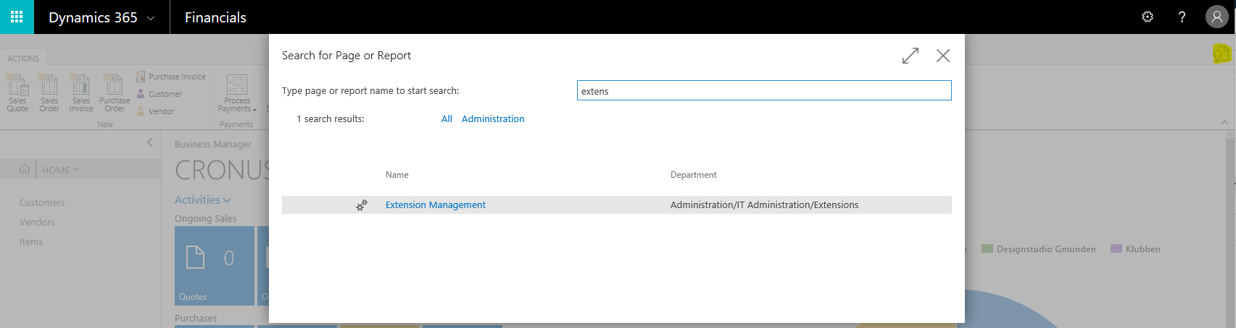

or via the Business Manager role center.

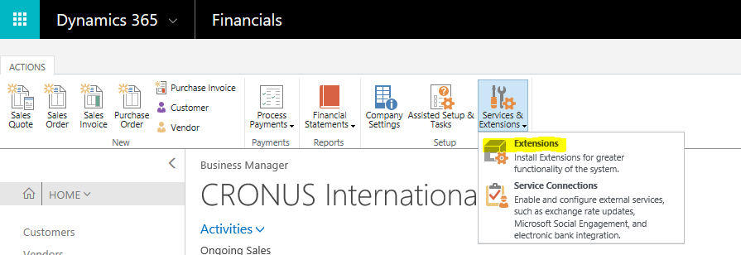

From the Extension Management page you’re able to install the G/L Source Names extension.

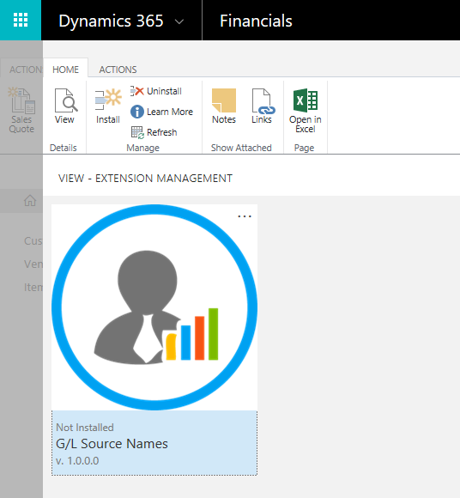

Click on the extension’s logo to start the installation.

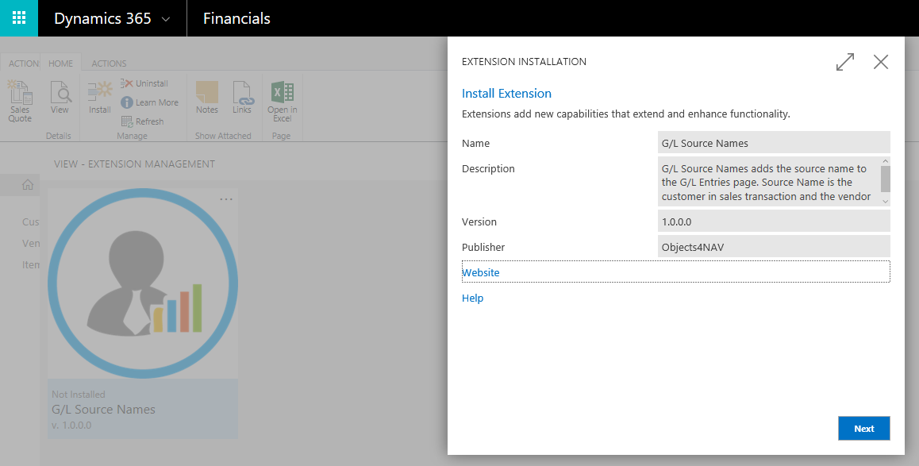

Press Next

Follow the link to [Terms and Conditions](http://objects4nav.com/terms/) before accepting and installing.

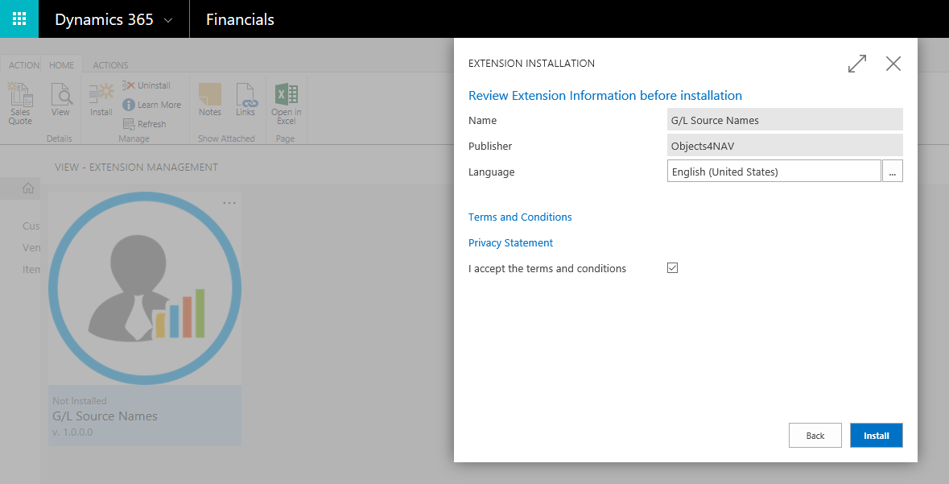

After successful installation the user must logout and login again, to activate the new extension.

# Assisted Setup

The G/L Source Names extension has an Assisted Setup Wizard. You’re able to access this wizard page by searching

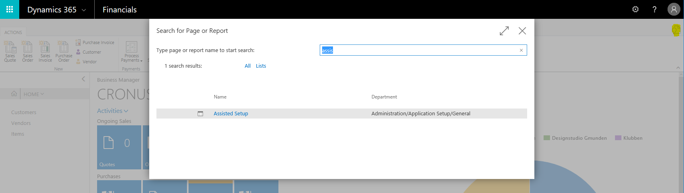

Or via the Business Manager role center

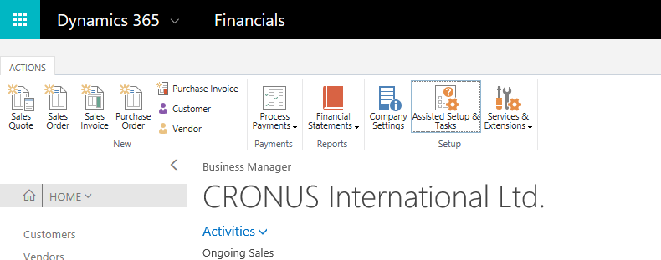

From the Assisted Setup page locate the line for “Set up G/L Source Names”.

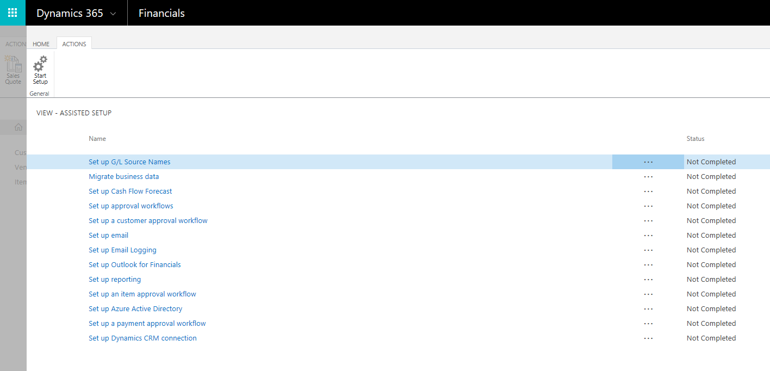

Click on the text or use the Start Setup action in the ribbon. This will start the Assisted Setup Wizard.

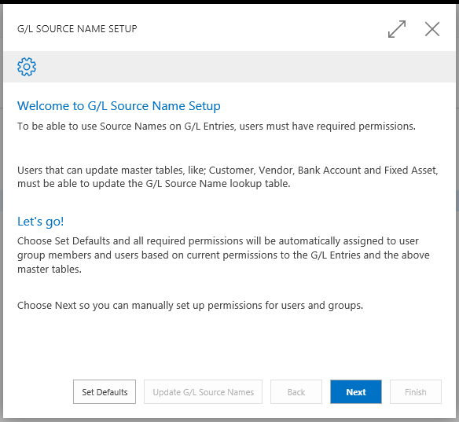

The wizard’s role is to help ensure that every user has the required permissions to use the G/L Source Names extension. As stated in the wizard’s welcome page you have the option to set defaults or to manually go through the wizard’s setup steps.

When using “Set Defaults” you will assign all required permissions to users and user groups based on their current permissions. Also, the registration e-mail address will be picked up from the Company Settings. This is the recommended way to complete the Assisted Setup Wizard. Click the Set Defaults button and the wizard will take you to the final step of the setup process.

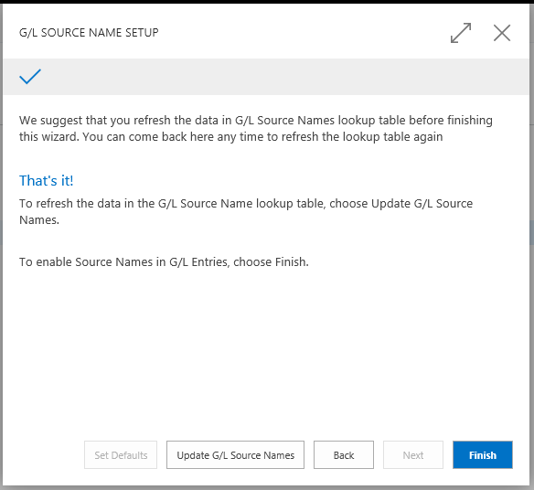

If you opt to manually register and assign permissions, then the wizard will guide you through four steps in the setup process. You will manually assign permissions (read and write) to users and user groups. The wizard will suggest that users and user groups who already have access to tables related to G/L Source Names. In the first step, you will assign read permission to user groups.

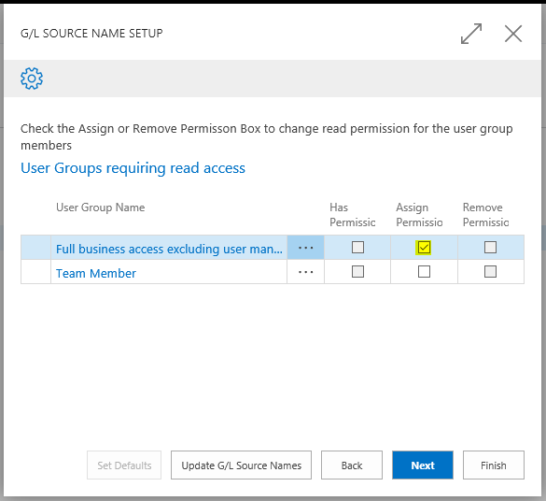

This is done by checking the box in column named “Assign Permission” for each row (User Group Name) you wish to assign this permission. If User Group already has permission, then it will show a checkmark in the box for “Has Permission”. Press Next to go to the next step and assign update access permission to user groups.

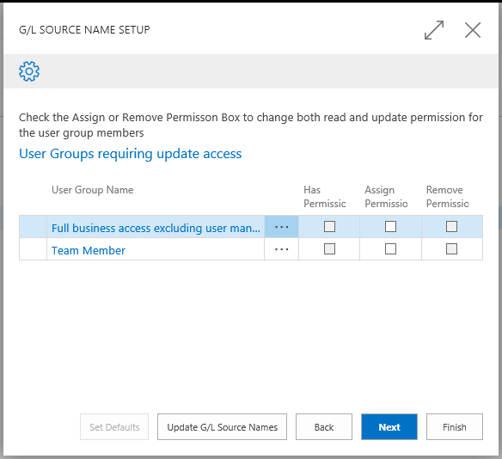

After pressing Next, the wizard will take you to the third step and display a list of users who have access to tables related to G/L Source Names. Note, some users have User Group Membership and will therefore have access even if you do not assign the permission to the user. The example provided displays two users who are both members of a user group, as you see on the following screenshot.

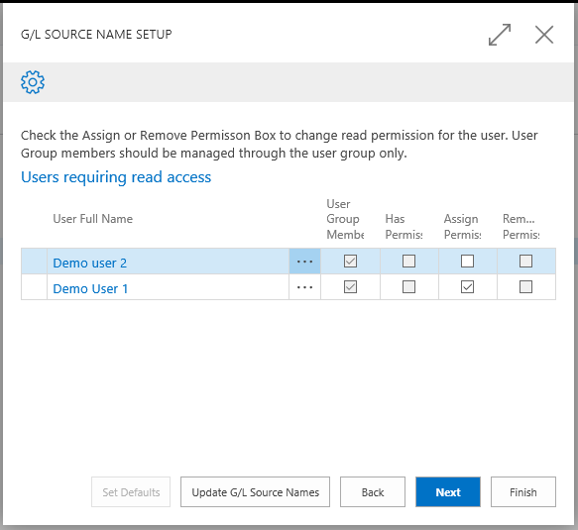

In this example the Demo user 2 is a Team Member. We did not assign permissions to the Team Member user group, but we can manually assign permission to individual user. Press Next to assign read permissions for users.

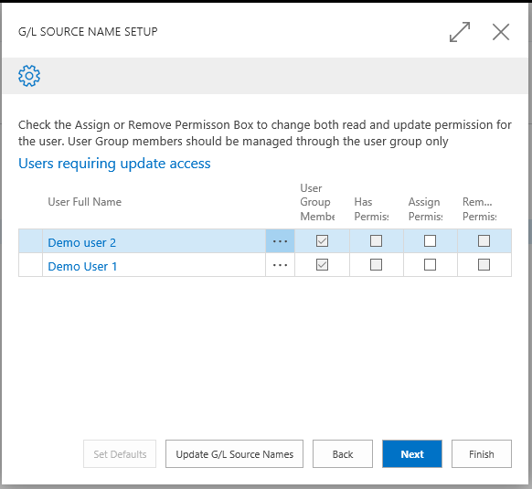

Finally, assign update access permission to individual users. This concludes the steps for permission management for the G/L Source Name extension. For the next step in the setup process, you are required to register the extension with a specific e-mail address. This e-mail address is not shared, published or used in any way outside of the G/L Source Name extension.

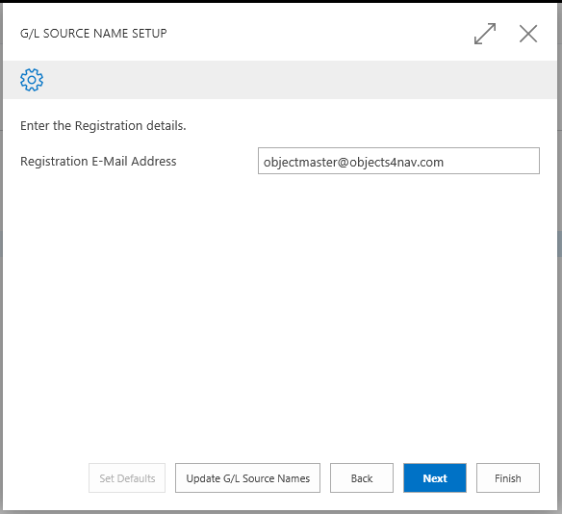

For the final step, we recommend that you select to “Update G/L Source Names” before you select to Finish and complete the setup process. The update action will update lookup tables to ensure that you’re working with the most recent data.

# Usage

G/L Source Names extension will add two fields to the General Ledger Entry page. These fields will give the user information on related master entries. This is one of the following types: Customer, Vendor, Bank Account or Fixed Asset.

To see this is action, do the following: Go to the Chart of Accounts and locate an account that you know has sales entries. In this example, we use the account no. 6110 (domestic sales).

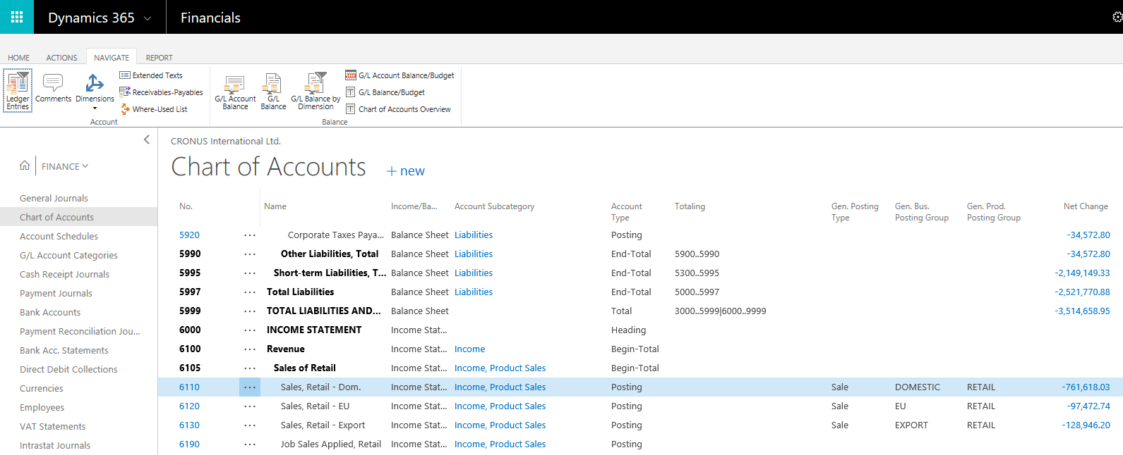

Click on the row and select “Ledger Entries” from the ribbon

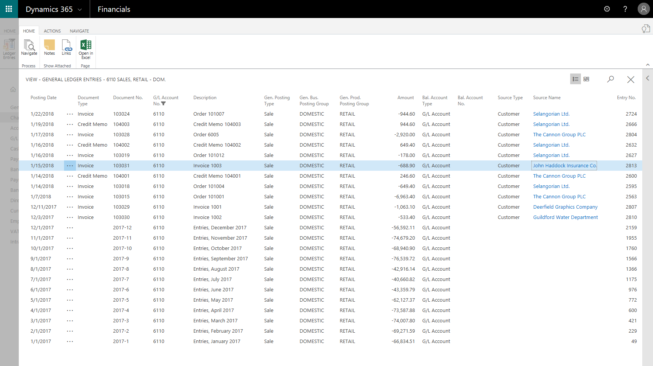

The two extra fields on this page are named “Source Type” and “Source Name”. The user can drill down from the Source Name to the Source Card by clicking on the text value in Source Name column. This new drill down action is also available from the ribbon, where the user can select to jump directly to the Source Card.

# Behind the scenes

## Master tables

G/L Source Names extension adds a new lookup table to Dynamics 365. When any of the four master tables; Customer, Vendor, Bank Account or Fixed Asset are updated, an event subscription makes sure to update the lookup table.

It is therefore vital that all users that can update any of the master tables are assigned the required permission to update the G/L Source Names lookup table as well. When a user is added to the system, please make sure to assign the correct user group and the required user permissions to that user. You can always verify that the required access is in place by going through the steps in the Assisted Setup Wizard.

## Permission sets

There are three permission sets that are included with the extension.

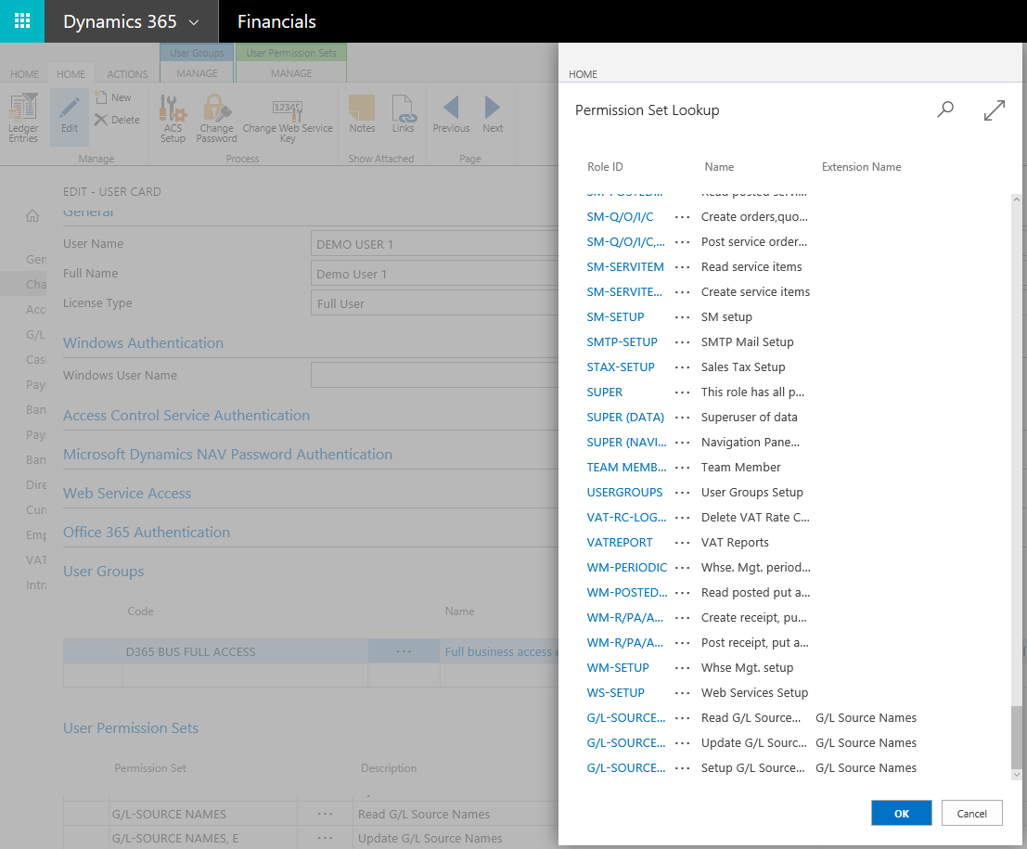

All users who have permission to read G/L Entries should be assigned the “G/L-SOURCE NAMES” permission set directly or via the user group.

All users who have permission to update any of the four master tables should be assigned the “G/L-SOURCE NAMES, E” permission set as well.

Any user who is allowed to run the Assisted Setup Wizard requires the “G/L-SOURCE NAMES, S” set.

Any user who has either the “SUPER” or “SUPER (DATA)” permission set, already has access to all tables in Dynamics 365 for Financials.