Abstraction:

The sparse Fourier transform (SFT) is derived from the traditional Fast Fourier transform.Considering the emergence of big data problem ,FFT is no longer fast enough.The sparse Fourier transform (SFT) addresses the big data setting by computing a compressed Fourier transform using only a subset of the input data, in time smaller than the data set size.The goal of this report is to give a introduction to   
theoretical framework and major technical issues and explain the details of certain theory and show the implementation of our code and simulation of our results with figures.

Introduction

The emergence of big data problem make FFT no longer fast enough and furthermore, in many applications it is hard to acquire a sufficient amount of data to compute the desired Fourier transform.So we switched our attention to signal itself and found that lots of signal are sparse which means in frequency domain most points’ value is zero except for a small fragment of points.Base on this quality of the signal, sparse Fourier transform derived.In this algorithm we only use small subset of input data.

The theoretical framework

SFT is a kind of algorithm that can sense the position of the non-zero frequency points,(the position and the value of the nonzero frequency can be found using only two samples of the signal)The key is we use certain rule (Γ(.))to project signal frequency points into a ‘bin’(total number is B).Since the frequency domain is sparse,it would be very likely for each non-zero point to stay in their own ‘bin’.We add up point in each bin to switch the N-long sequence to a short B-length sequence and do the FFT and according to the results of our computation we will ignore all the bin which do not contain the non-zero point.And we design a method to reconstruct the frequency of original N point.

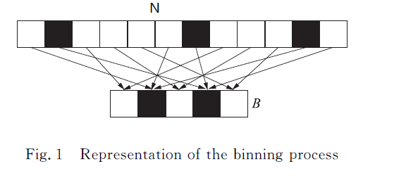

We use filter to divide ‘N’ bins to ‘B’ bins.Filter is used to do the binning. To avoid multiple non-zero points appear in the same ‘bin’.First we need to do is randomly binning the frequency so that non-zero frequencies could be separated.Then we used a filter which bandwidth is N/B to divide the frequency domain .The convolution of frequency domain can make each parts superposed .Finally we down sample the frequency domain at the frequency of N/B.Then we suppose to get all non-zero frequency .We can get all the position and value of non-zero frequency through the FFT of B.At last ,we can use simple-frequency recovery to get the original position of each non-zero frequency .

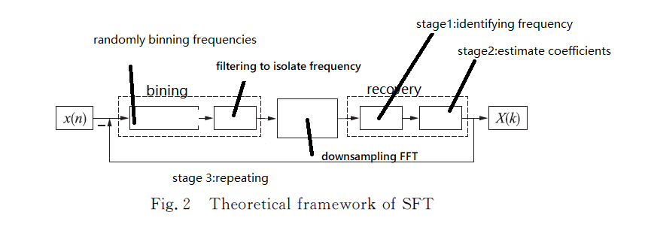

1.1 randomly binning frequencies

Just the simple use two basic properties of FFT

the scaling property, if ,then ;

The modulation property ,if ,then.

 means the number-theoretic reciprocal of modulo N.And this is the concept of Chinese remainder theorem.According to the concept of complete system of residues,still has completeness.And is the new position of original K.

1.2 filtering to isolate frequency

Since each repetitive or iterative cycle involves multiplying the filter, in order to improve the efficiency of the algorithm, the time domain and the frequency domain of the filter are required to be sparse, that is, the effective length of the time domain is only a small part, Can be ignored outside.

1. Recovery

There are three ways of recovery the complete original frequency domain and they are Phase encoding ,binary search techniques and an aliased based search.

2.1aliased based search

Suppose the length of a signal is N which could be represented by the multiplication of coprime integers.For example:N=2x5x7.

Let M be divisible by N.

(1)Randomly selected offset parameters;

(2)let 

(3)do DFT to z(n) of M points to get Z(k)

(4)The 2K maximum coordinates of Z (k) are grouped into set T.

according to this formula we know that the non-zero value coordinate will appear in new set T in the form of k mod M.Set M into different value and we will get a set of formula and we can use Chinese remainder theorem to get the position of non-zero value.

2.2 phase encoding

It is derived from the OFDM trick.Suppose the single frequency signal 

So we can easily get .But this method requires no noise in signal.

2.3 Binary search technique

For signal with containing noise,this technique has better robust comparing to phase encoding whose time complex is O(klbN NlbN/k).For example ,let us set ,let us randomly pick ,

consider when we multiply |x(n)|on both sides of both equation we can get 

Then we can know which quadrant is the frequency in .

Then we make signal 

Consider the picture below

 (1)

 (2)

If (1) is true and (2) is not true ,then belongs to the second quadrant.

Then we make :

If  is true .

Then w-5=0,and w=5.

