Ministry of Education and Science of Ukraine
National Technical University of Ukraine
"Kyiv Polytechnic Institute named after Igor Sikorsky"
Educational and Scientific Institute of Atomic and Thermal Energy
Department of Digital Technologies in Energy

Graphics work
Topic: «Operations on texture coordinates.»
from the discipline: «Visualization of graphical and geometric information»

Variant 18

Performed by:
student of the TP-52mp group
Khavkin A. D.

Kyiv – 2025

1.Task

- Reuse texture mapping from Control task.
- Implement texture scaling (texture coordinates) scaling / rotation around user specified point- odd variants implement scaling, even variants implement rotation
- It has to be possible to move the point along the surface (u,v) space using a keyboard. E.g. keys A and D move the point along u parameter and keys W and S move the point along v parameter.

2. Theoretical information

2.1 Sievert’s Surface

2.1.1 Parametric Definition of Sievert’s Surface

Sievert’s surface belongs to the class of surfaces with constant positive Gaussian curvature
$$K = const, K > 0$$
It is defined parametrically using two real parameters u and v.
The parametric equations of Sievert’s surface are given as:
$x\left(u,v\right)=r\left(u,v\right)cosφ\left(u\right)$,
$$y\left(u,v\right)=r\left(u,v\right)\sin{φ\left(u\right)},$$
$z\left(u,v\right)=\frac{\ln\left(\tan{\frac{v}{2}}\right)+a\left(u,v\right)\left(C+1\right)cosv}{\sqrt{C}}$,
where auxiliary functions are defined as:
$$φ\left(u\right)=-\frac{u}{\sqrt{C+1}}+\arctan\left(\sqrt{C+1}\tan{u}\right),$$
$$a\left(u,v\right)=\frac{2}{C+1-C \sin^{2}{v} \cos^{2}{u}},$$
$$r\left(u,v\right)=\frac{a\left(u,v\right)}{\sqrt{C}}\sqrt{\left(C+1\right)\left(1+C\sin^{2}{u}\right)}\sin{v}.$$
In the implemented model, the constant C is set to C = 1, which corresponds to the classical Sievert surface without self-intersections.
The parameters vary within the following ranges:
$$u∈\left[-1.2, 1.2\right], v∈[0.1, 3.05],$$
which are chosen to avoid singularities and logarithmic divergence near v = 0, while preserving the characteristic geometry of the surface.
The analytical parametrization is implemented directly in the function surfaceFunc(u, v) and evaluated per vertex during mesh generation.

2.1.2 Surface Normal Computation

For lighting and normal mapping, a normal vector is required at each surface point. Surface normals are computed numerically using the triangle mesh representation.
For each triangular facet, the normal vector is calculated as the cross product of two edge vectors:
$$n_{f}=\frac{(p1-p0)×(p2-p0)}{∥(p1-p0)×(p2-p0)∥}.$$
Vertex normals are obtained by averaging adjacent facet normals and performing final normalization. This approach provides smooth shading and stable normal vectors suitable for per-pixel lighting.

2.2 Texture Coordinate Transformations

2.2.1 Texture Space Representation

Each vertex of the surface mesh is assigned texture coordinates (ut,vt) ∈ [0,1]², generated linearly from the parametric grid indices:
$$ut=\frac{i}{N_{u}}, vt=\frac{j}{N_{v}},$$
where N_{u} and N_{v} are the numbers of subdivisions along the u and v parameters, respectively.
These texture coordinates are used consistently for:
- diffuse texture sampling,
- normal map sampling,
- specular map sampling.

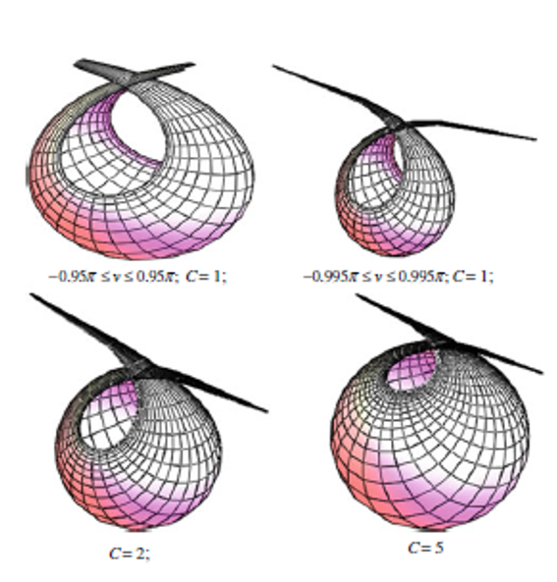

Image 2.1 - Reference shapes of Sievert’s surface

2.2.2 Texture Rotation Around an Arbitrary Center

According to the requirements of even-numbered Variant 18, texture rotation is implemented in the UV plane.
Let (u,v) be the original texture coordinates and (u₀,v₀) be the current texture center.
The rotation of texture coordinates by angle θ\thetaθ around the center point is defined as:
$$\left(u^{'},v^{'}\right)=R\left(θ\right)⋅\left(\begin{matrix}u & - & u_{0} \\ v & - & v_{0}\end{matrix}\right)+\left(\begin{matrix}u_{0} \\ v_{0}\end{matrix}\right),$$
where the rotation matrix is:
$$R\left(θ\right)=\left(\begin{matrix}\cos{θ} & -\sin{θ} \\ \sin{θ} & \cos{θ}\end{matrix}\right).$$
This transformation is evaluated in the vertex shader, ensuring that all texture channels are rotated coherently.

2.2.3 Texture Center Translation

The texture center (u₀,v₀) is modified interactively using keyboard input:
- W — increase v₀,
- S — decrease v₀,
- A — decrease u₀,
- D — increase u₀.
The center coordinates are clamped to the interval [0,1] to prevent sampling outside the texture domain.

2.3 Tangent Space and Normal Mapping

2.3.1 TBN Basis Construction (Normal Priority)

To support normal mapping, a Tangent–Bitangent–Normal (TBN) coordinate system is constructed for each vertex.
The tangent vector T is approximated numerically using neighboring vertices along the uuu-direction. The normal vector N is obtained from the averaged surface normals.
To satisfy the Variant 18 requirement, orthogonalization is performed using the Gram–Schmidt process with normal priority:
$$T^{'}=T-\left(N⋅T\right)N, T'=\frac{T'}{∥T'∥}.$$
This guarantees that the tangent vector is orthogonal to the surface normal, ensuring a stable and physically correct tangent space.

2.3.2 Normal Transformation from Texture Space

Normal map values are stored in the [0,1] range and first remapped to [−1,1]:
$$n_{t}=2n_{map}-1.$$
The final world-space normal is computed as:
$$n_{w}=normalize(TBN⋅n_{t}).$$
This normal is then used in per-pixel lighting calculations.

2.4 Lighting Model

2.4.1 Phong Illumination Model

The surface is shaded using the Phong reflection model:
$$I=I_{ambient}+I_{diffuse}+I_{specular}.$$
The individual components are defined as:
$$I_{ambient}=k_{a}I_{a},$$
$I_{diffuse}=k_{d}\left(L⋅N\right)I_{d}$,
$$I_{specular}=k_{s}{(R⋅V)}^{α}I_{s},$$
where:
- L is the light direction,
- V is the view direction,
- R is the reflection vector,
- α is the shininess coefficient.
Diffuse, normal, and specular textures are sampled per fragment.

2.5 WebGL Rendering Pipeline

2.5.1 Vertex Processing Stage

The vertex processing pipeline includes:
- Fetching vertex attributes (position, normal, texture coordinates, tangent),
- Model-view transformation,
- Projection transformation,
- Passing transformed data to the fragment shader.

2.5.2 Fragment Processing Stage
The fragment processing stage consists of:
- Rasterization,
- Per-fragment normal reconstruction via TBN,
- Phong lighting computation,
- Depth testing and final color output.

3. Algorithm Description

3.1 Overall Algorithm Structure
The rendering algorithm is organized as a real-time interactive WebGL pipeline and consists of the following main stages:
- Analytical generation of the Sievert’s surface geometry.
- Construction of vertex attributes (positions, normals, texture coordinates, tangents).
- Initialization of the WebGL rendering context and shader programs.
- Real-time transformation of texture coordinates in the vertex shader.
- Per-pixel lighting computation with normal mapping in the fragment shader.
- Interactive update of parameters and continuous rendering loop.
Each stage is executed in a strictly defined order to ensure numerical stability, visual correctness, and interactive performance.

3.2 Analytical Surface Mesh Generation

The surface mesh is generated from the analytical parametric definition of Sievert’s surface. The parameter domain (u,v) is discretized into a uniform grid defined by the user-controlled parameters N_{u} and N_{v}.

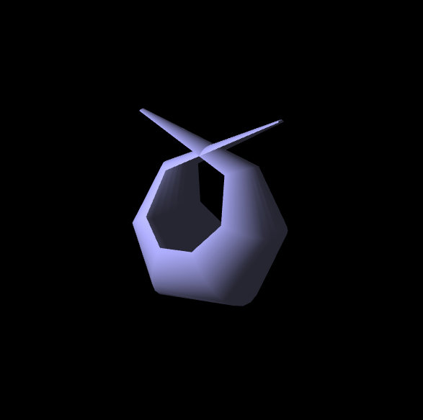

Image 3.1 - Parametric grid discretization

For each grid point (u_{i},v_{j}):
- The 3D position p(u_{i},v_{j}) is evaluated using the analytical equations implemented in surfaceFunc(u, v) (Image 3.1).
- Texture coordinates are generated linearly as:
$$u_{t}=\frac{i}{N_{u}},{uv}_{t}=\frac{j}{N_{v}}.$$
- The resulting vertex data are stored in linear buffers.
Triangle indices are generated by connecting adjacent grid cells into two triangles per cell, forming a structured triangular mesh suitable for indexed rendering.

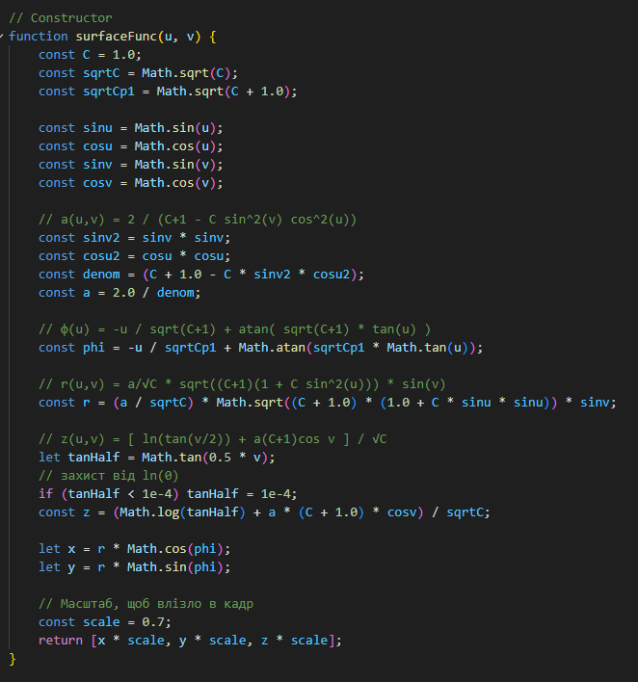
Image 3.2 - surfaceFunc(u, v).

3.3 Surface Normal Computation

Surface normals are computed using a facet-averaging approach:
- For each triangle, a face normal is calculated using the cross product of two edge vectors.
- The face normal is accumulated for all vertices belonging to the triangle.
- After accumulation, each vertex normal is normalized to unit length.
This method produces smooth shading across the surface and provides stable input for subsequent tangent-space computations.

3.4 Tangent Vector Construction with Normal Priority

To support normal mapping, a tangent vector is computed at each vertex using neighboring vertices along the parametric u-direction.
Because the surface is defined analytically but rendered as a mesh, tangents are approximated numerically:
- A preliminary tangent vector T is obtained from the difference between neighboring vertex positions.
- The surface normal N is normalized.
- Gram–Schmidt orthogonalization with normal priority is applied:
$$T'=T-(N⋅T)N.$$
- The resulting tangent vector is normalized.
This procedure guarantees that the tangent vector lies in the surface tangent plane and is orthogonal to the normal, satisfying the requirements of Variant 18.

3.5 Shader Initialization and Data Binding

After mesh generation, all vertex attributes are uploaded to the GPU:
- vertex positions,
- vertex normals,
- texture coordinates,
- tangent vectors.
Three texture samplers are initialized and bound to fixed texture units:
- diffuse texture (unit 0),
- specular texture (unit 1),
- normal map (unit 2).
Uniform variables for transformation matrices, lighting parameters, texture center, and rotation angle are also initialized.

3.6 Texture Coordinate Transformation Algorithm

Texture coordinate transformation is performed entirely in the vertex shader.
For each vertex, the following steps are executed:
- The original texture coordinates (u,v) are shifted so that the current texture center (u₀,v₀) becomes the origin.
- A rotation by angle θ is applied in the UV plane.
- The coordinates are shifted back to the original texture space.
Formally:
$$(u',v')=R(θ)⋅((u,v)-(u_{0},v_{0}))+(u_{0},v_{0}).$$
The rotation angle θ is animated over time, while the texture center (u₀,v₀) is updated interactively via keyboard input.
The same transformed texture coordinates are used consistently for diffuse, normal, and specular texture sampling.

3.7 Per-Pixel Lighting and Normal Mapping

In the fragment shader, lighting is computed per pixel using the following algorithm:
- The normal vector is reconstructed from the normal map and transformed from tangent space to world space using the TBN matrix.
- A dynamic point light position is evaluated in camera space.
- Ambient, diffuse, and specular lighting components are computed using the Phong reflection model.
- The final fragment color is obtained by combining all lighting components with texture samples.
This approach ensures that fine surface details encoded in the normal map respond correctly to both lighting and texture coordinate transformations.

3.8 Interactive Parameter Updates and Rendering Loop

User interaction affects the rendering in real time:
- Mouse input controls camera rotation via a virtual trackball.
- Keyboard input (W, A, S, D) updates the texture center coordinates.
- Slider controls dynamically modify mesh resolution.
All changes are reflected immediately in the next rendered frame through a continuous animation loop driven by requestAnimationFrame.

4. Implementation Details

4.1 Application Structure and Module Responsibilities

The application is implemented as a modular WebGL project, where each file is responsible for a clearly defined part of the rendering pipeline.
The main structural components are (Image 4.1):
- index.html — defines the user interface, canvas element, and interactive controls.
- main.js — initializes WebGL, manages the render loop, camera, lighting, and user input.
- model.js — generates the analytical Sievert’s surface mesh and all vertex attributes.
- shader.gpu — contains vertex and fragment shader source code.
- TextureHandler.js — provides asynchronous texture loading utilities.
- ui.js — handles visualization of the texture center in screen space.
This separation ensures clarity of implementation and simplifies debugging and further extension.

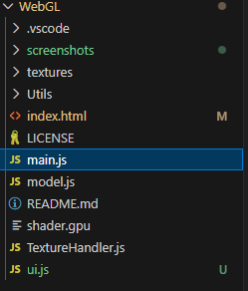
Image 4.1 - Structural components

4.2 WebGL Context Initialization

The WebGL context is created from the HTML <canvas> element using the standard getContext("webgl") call. Depth testing is enabled to ensure correct visibility of surface fragments:
gl.enable(DEPTH_TEST
A perspective projection matrix is constructed with a fixed field of view and clipping planes chosen to fully contain the Sievert’s surface within the camera frustum.
Camera rotation is implemented using a virtual trackball mechanism, allowing intuitive mouse-based interaction.

4.3 Shader Program Architecture

The rendering pipeline uses a programmable shader architecture, consisting of:
- Vertex Shader — responsible for geometric transformations and texture coordinate manipulation.
- Fragment Shader — responsible for per-pixel lighting and texture sampling.
Uniform variables are used to pass transformation matrices, lighting parameters, and texture transformation parameters from JavaScript to the GPU.

4.4 Vertex Shader Implementation

The vertex shader performs the following operations for each vertex:
- Transformation of vertex positions from model space to clip space using the Model–View–Projection matrix.
- Transformation of normals using the normal matrix (inverse-transpose of the model–view matrix).
- Construction of the TBN basis for normal mapping.
- Rotation of texture coordinates in the UV plane.
Texture rotation is implemented directly in the shader using the current texture center and rotation angle:
$$(u',v')=R(θ)⋅((u,v)-(u_{0},v_{0}))+(u_{0},v_{0})$$
This ensures that texture transformations are applied uniformly and efficiently at the GPU level.

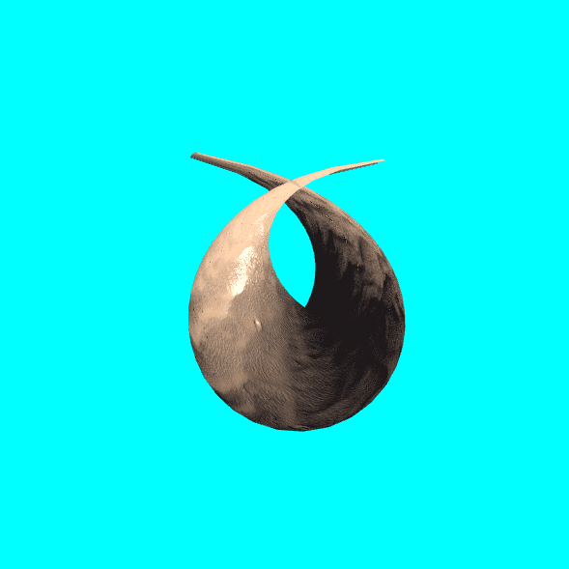

Image 4.1 - Texture rotation in UV space

4.5 Fragment Shader Implementation

The fragment shader implements a per-pixel Phong lighting model enhanced with normal mapping.
The execution sequence is as follows:
- Sample the diffuse, specular, and normal textures using transformed texture coordinates.
- Convert the normal map value from [0,1] to [−1,1].
- Transform the normal from tangent space to world space using the TBN matrix.
- Compute ambient, diffuse, and specular lighting components.
- Combine lighting contributions into the final fragment color.
This approach produces visually detailed shading that reacts correctly to dynamic texture rotation and lighting changes.

4.6 Texture Loading and Management

Textures are loaded asynchronously to avoid blocking the rendering process.
Each texture is initially created as a 1×1 placeholder pixel. Once the image is fully loaded, it replaces the placeholder data and triggers a redraw.
Three texture types are used:
- Diffuse map — defines the base color of the surface.
- Normal map — encodes fine surface detail in tangent space.
- Specular map — controls the intensity of specular highlights.
All textures are sampled using identical transformed texture coordinates, preserving visual coherence.

4.7 Texture Center Visualization

To provide visual feedback for texture transformations, the texture center is displayed as a marker overlaid on the canvas.
The marker position is computed by mapping the UV coordinates $(u_{0},v_{0})$ to screen space:
$$x=u_{0}⋅W, y=(1-v_{0})⋅H$$
where W and H are the canvas dimensions in pixels.
This visualization aids in understanding the effect of texture translation and rotation during interaction.

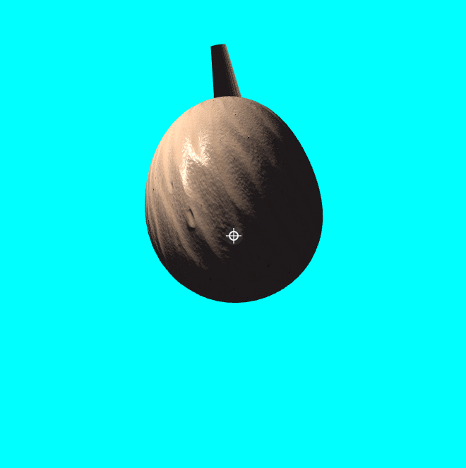

Image 4.2 - Visualization of the texture center position in UV space.

4.8 Interactive Controls Implementation

User interaction is handled through event listeners:
- Mouse input — controls camera rotation via the trackball mechanism.
- Keyboard input (W, A, S, D) — translates the texture center in UV space.
- Slider input — dynamically adjusts the number of surface subdivisions.
Texture center values are clamped to the interval [0,1] to prevent invalid texture sampling.

4.9 Dynamic Lighting Animation

The point light source moves along a circular trajectory around the surface:
$$x=\operatorname{Rcos}{t},$$
$$z=\operatorname{Rsin}{t},$$
$$y=const$$
This dynamic motion highlights surface curvature and emphasizes the effect of normal mapping and specular reflection.

4.10 Rendering Loop and Performance Considerations

Rendering is performed in a continuous loop driven by requestAnimationFrame. Only necessary parameters are updated each frame, while static data (geometry and textures) remain unchanged, ensuring stable real-time performance even at higher mesh resolutions.

5. User Interaction and Controls

5.1 Camera Control

The visualization supports interactive camera manipulation using a virtual trackball mechanism.
By dragging the mouse over the rendering canvas, the user can rotate the view around the Sievert’s surface, allowing inspection of the geometry from arbitrary angles.
This interaction is implemented independently of the surface geometry and does not affect texture transformations or lighting calculations.

5.2 Texture Center Translation

The texture center in UV space is translated interactively using keyboard input:
- W — move the texture center upward (increase v0v_0v0​),
- S — move the texture center downward (decrease v0v_0v0​),
- A — move the texture center to the left (decrease u0u_0u0​),
- D — move the texture center to the right (increase u0u_0u0​).
Each key press updates the texture center by a fixed step size.
To ensure valid texture sampling, the texture center coordinates are clamped to the interval [0,1][0,1][0,1].
The current texture center values are displayed numerically and visualized directly on the canvas using a marker overlay.

5.3 Mesh Resolution Control

The resolution of the surface mesh can be modified dynamically using slider controls:
- U segments — number of subdivisions along the uuu-parameter,
- V segments — number of subdivisions along the vvv-parameter.
Adjusting these parameters triggers a complete regeneration of the surface mesh, including vertex positions, normals, texture coordinates, and tangent vectors.
This functionality allows the user to analyze the effect of mesh density on surface smoothness and shading quality.

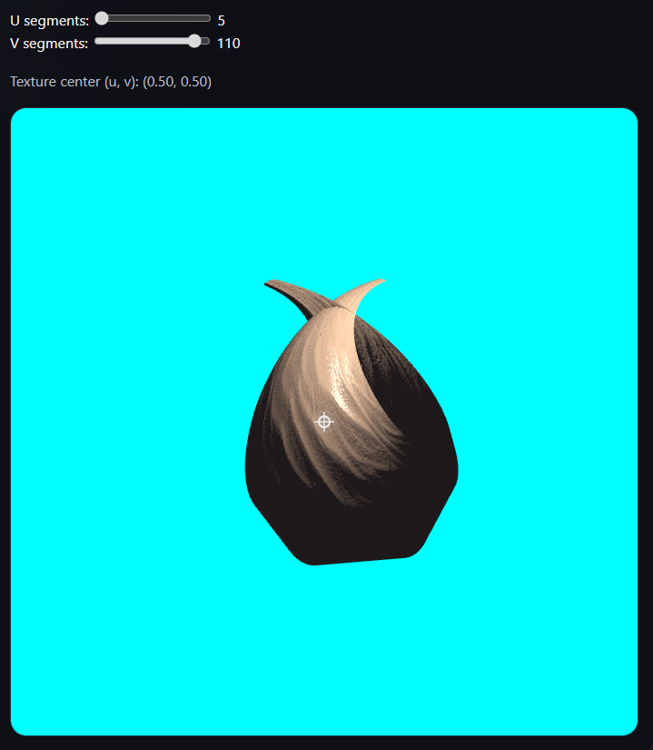

Image 5.1 -Influence of mesh resolution on surface smoothness.

5.4 Animation Control

Texture rotation is animated automatically over time by continuously increasing the rotation angle θ\thetaθ.
The animation demonstrates that texture coordinate transformations, TBN basis construction, and per-pixel lighting remain stable under dynamic conditions.

6. Results

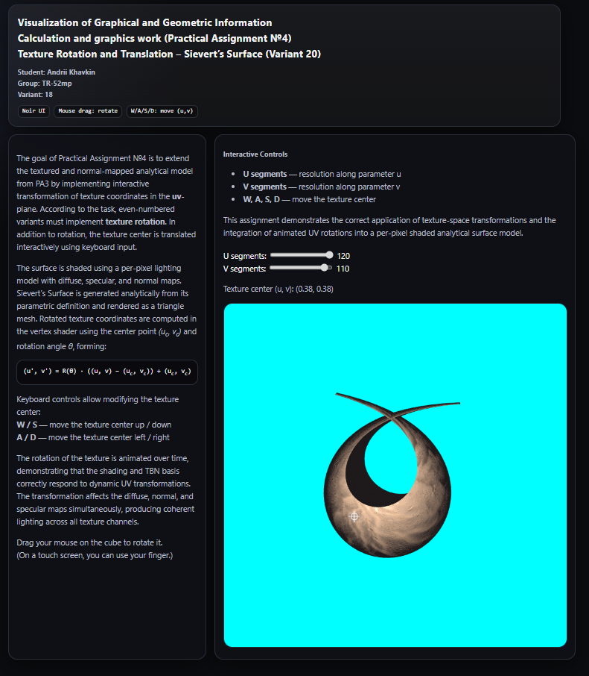

Image 6.1 - Final rendered result

As a result of the completed Calculation and graphics work, an interactive WebGL application for visualizing Sievert’s surface was successfully implemented.
The following features were achieved:
- Analytical generation of Sievert’s surface geometry (Variant 18).
- Real-time rendering of the surface as a triangular mesh.
- Per-pixel lighting using diffuse, normal, and specular maps.
- Construction of the TBN basis using Gram–Schmidt orthogonalization with normal priority.
- Interactive translation of the texture center in UV space.
- Continuous rotation of texture coordinates around an arbitrary center.
- Dynamic animated point light source.
- Interactive control of mesh resolution and camera orientation.
- Visual feedback of texture center position directly on the canvas.
The application demonstrates correct and stable behavior of texture transformations and lighting across the entire surface.

7. Conclusions

In this practical assignment, an interactive visualization system for Sievert’s surface was developed using WebGL and programmable shaders.
The work demonstrated how analytical surface definitions can be combined with modern real-time rendering techniques, including normal mapping, per-pixel lighting, and texture-space transformations.
Special attention was paid to the correct handling of texture coordinate rotation and translation, as required for even-numbered Variant 18.
The use of Gram–Schmidt orthogonalization with normal priority ensured numerical stability and visual correctness of normal mapping under dynamic texture transformations.
The completed application confirms that GPU-based texture coordinate manipulation and per-pixel shading provide an efficient and flexible approach to visualizing complex analytical surfaces in real time.

8. Source code
Link fir Github (Branch for CGW)
https://github.com/AndriiKhavkin/VGGI_PA1.git

