| Fontys University of Applied Science |
| --- |
| User Requirements Specifications |
| Media Bazaar |
| PRJ-CBo2-2  Supervisor: Brice Guayrin  Eindhoven, 08-09-2021 |

Document Change Record

| *Date* | *Version* | *Author* | *Comments* |
| --- | --- | --- | --- |
| 08-09-2021 | 0.1 |  |  |
| 15-09-2021 | 0.3 |  | Added missing use cases, fixed some grammatical problems |

**Definitions, Acronyms and Abbreviations**

| *Term* | *Description* |
| --- | --- |
| Stakeholder | A person with an interest or concern in something, especially a business. |
| G Manager | General Manager |
| HR Manager | Human Resources Manager |
| W Manager | Warehouse Manager |
| S Employee | Store Employee |
| W Employee | Warehouse Employee |

Table of Contents

Definitions, Acronyms and Abbreviations

1. Introduction
2. Background
3. Agreements with Clients
4. User Requirements  
   2.1. Functional Requirements  
   2.2. Non-Functional Requirements
5. Stakeholder and User Analysis
6. Use Cases
7. GUI

# Introduction

This document is meant to outline the user requirements and specification for the “Media Bazaar” Project. It holds the technical development acceptance criteria of the application. This document is intended to be read by all responsible for the management and development of the application.

# Background

Media Bazaar is a subsidiary of Jupiter, a franchise that has opened its first shop in Eindhoven with expectations to grow further into other cities. At the moment it sells home appliances, technology, tools, toys and games. So far Media bazaar has 4 types of employees, A Manager, Hr-Manager and finally Store and Warehouse Employees. But both the store and warehouse employees will have department managers observe and administrate their work.

Media Bazaar is getting bigger and observing their employees and stocks is becoming more difficult. So the manager from Media Bazaar “Mrs. Fransen” has informed us about their current issues and asked us to solve them before it becomes a big problem.

## Scope and Objectives

-Login/Profile Page, page to store/show all information

-Employee Page: Shows all employees and their departments

-Depart Page: Show all the various departments we have in the application CRUD

-Statistic Page: Show all the statistics of the store CRUD

-Schedule Page: Show the shift of all employees, Plan shift CRUD

The scope of this project is to allow the users with administrative rights of changing the department and assigning schedules to employees. It should also allow them to view stocks and restock shelves if they're running low. Where normal employees will have limited access to some functionalities of the application. They should be able to view the scheduling system, request a shift change In case they’re sick. A statistics page will be made available for all employees to see, but only users with administrative rights will be able to edit.

# Stakeholder and User Analysis

Our client is Mariëlle Fransen, manager of Media Bazaar and stakeholder of the current application. The users of the application will be the management team and the working employees of Media Bazaar.

**Gen. Manager**The General manager will have administrative rights in the application. They can see the employees, the stocks and statistics and the schedule of the application, although they do not have a schedule of their own. (Schedule for full-time work). They can not delete employees, that will be handled by the HR management team.

**Hr. Manager**

The Human resources manager has the same administrative right as a manager, however they will manage the application in the stead of the Gen.Manager. They are allowed to add, update and delete employees of the application. They also handle assigning/approving employee shifts and schedules. They will also handle the employee’s notification, e.g. requesting a day off or calling in sick. And employee department assigning, in case an employee is promoted or changed into another shift.

**Department Manager**

The Department manager can handle the department their employees are assigned to. They are normal employees, they don’t have the same administrative rights as a Gen/Hr manager but they are allowed to request stocks if they run low. This will be sent as a notification to the Gen/Hr. Manager. But their main role is to manage employees on sight (In the physical Media Bazaar Store).

# User Requirements

## Functional Requirements

**Sorted by priority**

Must have - Should have - Could have - Won’t have

| *ID* | *Name* | *Priority (MoSCoW)* |
| --- | --- | --- |
| FR-01 | User can log in | M |
| FR-02 | User can log out | M |
| FR-03 | User can change own user information | S |
| FR-04 | G Manager can view the statistics of sold items | C |
| FR-05 | G Manager can view all currently employed employees | S |
| FR-06 | G Manager can create notifications | C |
| FR-07 | HR Manager can create new user accounts | M |
| FR-08 | HR Manager can disable user accounts | C |
| FR-09 | HR Manager can view all user accounts | M |
| FR-10 | HR Manager can update user information | S |
| FR-11 | HR Manager can create schedule* | M |
| FR-12 | HR Manager can update schedule | S |
| FR-13 | HR Manager can check unavailability’s | W |
| FR-14 | W Manager can create new warehouse items | M |
| FR-15 | W Manager can edit warehouse items | M |
| FR-16 | W Manager can view all warehouse items | M |
| FR-17 | W Manager can remove warehouse items** | M |
| FR-18 | W Manager can approve resupply request by W Employee | S |
| FR-19 | S&W Employee can view shifts*** | W |
| FR-20 | S&W Employee can input their unavailability’s*** | W |
| FR-21 | W Employee can request resupply of warehouse items | S |

* = as long as the scheduling system is not automated  
** = adjust quantity or remove entire item  
*** = in web application

## Non-Functional Requirements

| *ID* | *Name* | *Description* |
| --- | --- | --- |
| N-FR-01 | Security | Making sure that the application is safe to use and keeps the information of the users safe. |
| N-FR-02 | Reliability | Ensuring the application does not crash otherwise shut down unintentionally. |
| N-FR-03 | Scalability | The application would be functional and easy to use with both a small number of employees and a large number of them. |

# 

# Assumptions/Constraints

**Assumptions:**

* Media Bazaar has their own computers and we do not need to provide them with it.
* We will not provide website hosting

**Constraints:**

* We have 3 weeks to provide a version of the application

# Use Case Models

| Use case | **FR-01 - Login Functionality** |
| --- | --- |
| Actor | G Manager, HR Manager, W Manager |
| Pre-condition | User must have correct credentials |
| Trigger | User must press the login button |
| Main Success scenario | 1. User types in needed credentials 2. User logs in 3. Home page oppens |
| Extension | 1.a. Incorrect credentials  1. Credentials don't match one in the database.  2. User doesn't log in  3. User gets notified about wrong credentials  4. Returns to the login page, where user can enter its credentials and try again |

| Use case | **FR-02 - Log Out** |
| --- | --- |
| Actor | User |
| Pre-condition | User must be logged in |
| Trigger | User presses the log-out button |
| Main Success scenario | 1. User is logged in the application 2. User presses log-out button and logs out off the application |
| Extensions | ------------------------------------------------------------------------------------ |

| Use case | **FR-03- User can change own user information** |
| --- | --- |
| Actor | User |
| Pre-condition | User is logged in and is on page with the personal information |
| Trigger | User presses the personal details tab |
| Main Success scenario | 1. User changes some fields with his personal details, field inputs are correct 2. User changes information about itself |
| Extensions | Ex1: **Input type not correct**   1. User intends to change personal information 2. User gets notified that some of the credentials are not correct input types 3. User gets returned to personal information page   Ex2: **Input already exists**   1. User intends to change personal information 2. User gets notified that some of the credentials already exist 3. User gets returned to personal information page |

| Use case | **FR-04 G Manager can view the statistics of sold items** |
| --- | --- |
| Actor | General manager |
| Pre-condition | User must be logged in. |
| Trigger | Click on statistics button |
| Main Success scenario | 1. Statistics of sold items are displayed |
| Extensions | ------------------------------------------------------------------------------ |

| Use case | **FR-05 G Manager can view all currently employed employees** |
| --- | --- |
| Actor | General Manager |
| Pre-condition | General manager must be logged in |
| Trigger | User presses the employee tab |
| Main Success scenario | 1. Information of employees is displayed |
| Extensions | ------------------------------------------------------------------------------ |

| Use case | **FR-06 G Manager can add a notification** |
| --- | --- |
| Actor | General manager |
| Pre-condition | General manager must be logged in |
| Trigger | User presses the Add notification button |
| Main Success scenario | 1. User enters notification information 2. User presses on the submit button 3. User receives pop up window notifying him that the notification was successfully added |
| Extensions | Ex2: **Not all or no input was detected**   1. User is notified that not all fields are entered 2. User is returned to add notification window 3. Return to main success scenario 1 |

| Use case | **FR-07 - HR Manager can create new user accounts** |
| --- | --- |
| Actor | HR Manager |
| Pre-condition | User is logged in, user has rights |
| Trigger | HR manager clicked create user account |
| Main Success scenario | 1. HR manager enters a first name, last name, email, a repeat of the email, and a phone number. 2. HR manager enters a (temporary) password 3. HR manager clicks done |
| Extensions | 1. HR manager tries to create a user account 2. User account already exist or certain unique credentials are the same as from someone in the company. |

| Use case | **FR-08 HR Manager can disable user accounts** |
| --- | --- |
| Actor | HR Manager |
| Pre-condition | HR manager must be logged in |
| Trigger | User presses the change user account |
| Main Success scenario | 1. User selects employee that wants to be disabled 2. User disables that employees user account |
| Extensions | 1. HR manager wants to disable user account 2. User account was previously marked as diasbled |

| Use case | **FR-09- HR Manager can view all user accounts** |
| --- | --- |
| Actor | HR Manager |
| Pre-condition | User is logged in, user has rights |
| Trigger | HR manager clicked view employees button |
| Main Success scenario | 1. The system returns all employees |
| Extentions | - |

| Use case | **FR-10 HR Manager can update user information** |
| --- | --- |
| Actor | HR Manager |
| Pre-condition | HR manager must be logged in |
| Trigger | User selects an employee and presses the Update button in employee tab |
| Main Success scenario | 1. User changes some fields with information 2. User confirms changes and overwrites existing information |
| Extensions | Ex1: **Fields are empty or incorrect input type**   1. User is notified that fields are empty and/or there is incorrect input type 2. User is returned to employee tab |

| Use case | **FR-11 - HR Manager can create shift** |
| --- | --- |
| Actor | HR Manager |
| Pre-condition | User is logged in, user has rights |
| Trigger | HR manager clicks on create shift |
| Main Success scenario | 1. HR Manager selects day 2. HR Manager selects user 3. HR Manager selects specific time or preset times 4. HR Manager clicks save |
| Extensions | - |

| Use case | **FR-12- HR Manager can update schedule** |
| --- | --- |
| Actor | HR Manager |
| Pre-condition | HR manager must be logged in |
| Trigger | User presses the schedule tab |
| Main Success scenario | 1. User selects schedule that should be updated 2. User updates the schedule |
| Extensions | 1. User selects schedule that should be updated 2. The schedule is not changed properly, so the update does not happen 3. User gets returned to the schedule page |

| Use case | **FR-14 - W Manager can create new warehouse items** |
| --- | --- |
| Actor | W Manager |
| Pre-condition | User is logged in, user has rights |
| Trigger | W manager clicks on add item |
| Main Success scenario | 1. Manager inputs all item information 2. Manager presses the add item button |
| Extensions | 1.1 A new item is added to the warehouse  2.1 An error message appears stating that not all information was entered correctly |

| Use case | **FR-15 - W Manager can edit warehouse items** |
| --- | --- |
| Actor | W Manager |
| Pre-condition | User is logged in, user has rights |
| Trigger | W manager clicks on edit item |
| Main Success scenario | 1. New form pops up 2. All old information shows up 3. User can edit fields 4. User clicks save |
| Extensions | 3.1: user empties fields  3.2: warning is shown  3.3: user has to confirm that the changes are correct |

| Use case | **FR-16 - W Manager can view all warehouse items** |
| --- | --- |
| Actor | W Manager |
| Pre-condition | User is logged in, user has rights |
| Trigger | User clicks view all items button |
| Main Success scenario | 1. The system returns all items from the database |
| Extensions | 1.1 the system returns an error message |

| Use case | **FR-17 - W Manager can create new warehouse items** |
| --- | --- |
| Actor | W Manager |
| Pre-condition | User is logged in, user has rights |
| Trigger | W manager clicks on add item |
| Main Success scenario | 1. Manager inputs all item information 2. Manager presses the add item button |
| Extensions | 1.1 A new item is added to the warehouse  2.1 An error message appears stating that not all information was entered correctly |

| Use case | **FR-18- W Manager can approve resupply request by W Employee** |
| --- | --- |
| Actor | Warehouse manager |
| Pre-condition | W manager must be logged in |
| Trigger | W Employee sent resupply request |
| Main Success scenario | 1. W manager selects the a particular request for approving resupply 2. W manager accepts the request from W employee, resupply approved |
| Extensions | 1. W manager sees the request for resupply made by W employee 2. W manager decides not to approve resupply 3. Resupply postponed |

| Use case | **FR-21 W Manager can request a resupply of warehouse items** |
| --- | --- |
| Actor | Warehouse manager |
| Pre-condition | W manager must be logged in |
| Trigger | W Employee presses the resupply request button |
| Main Success scenario | 1. W manager selects the right item, their amount for the resupply and submits it 2. W manager is notified of successful resupply request |
| Extensions | Ex1: **Fields are empty or incorrect input type**   1. User is notified that fields are empty and/or there is incorrect input type 2. User is returned to Warehouse tab |

# GUI

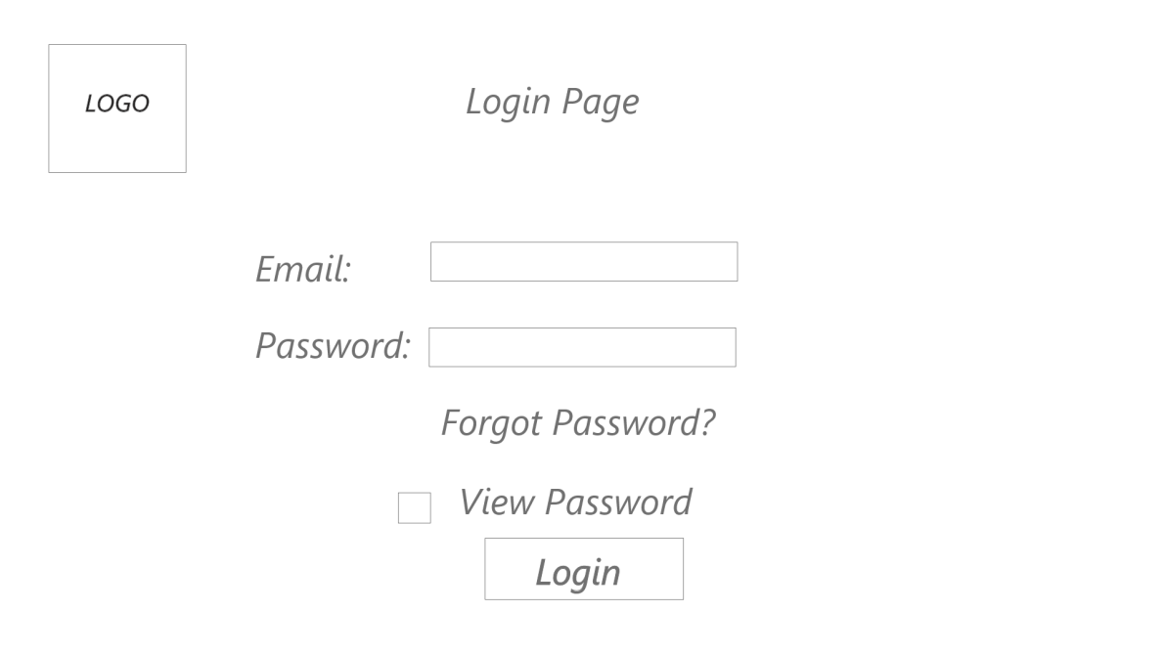

The login page is where every user has to input their information and press the login button to verify his/her identity, thus allowing access to the application.

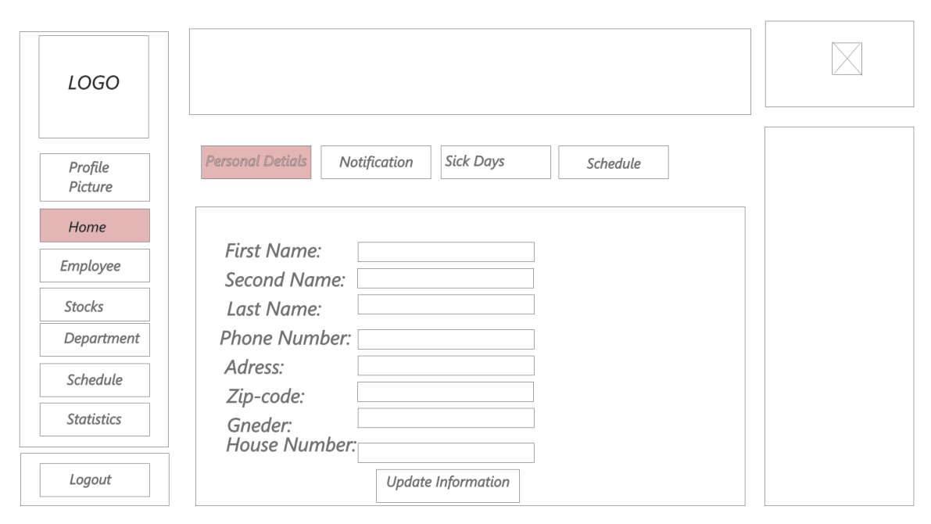

The home page where the user can access personal details and update/change them, see new notifications, review the current work schedule.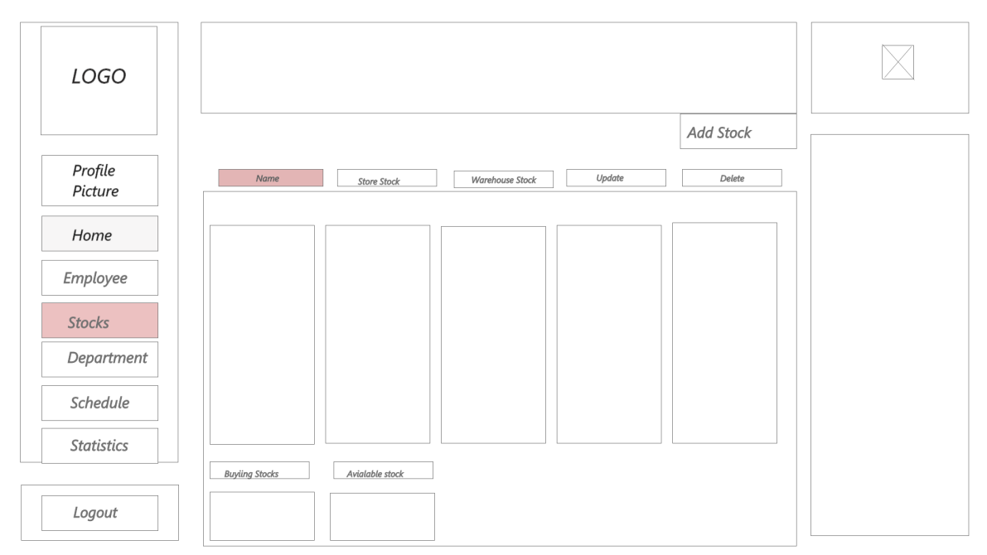

The Stocks page is where a stock employee can view existing items in the stock, add items to the stock as well as remove them.

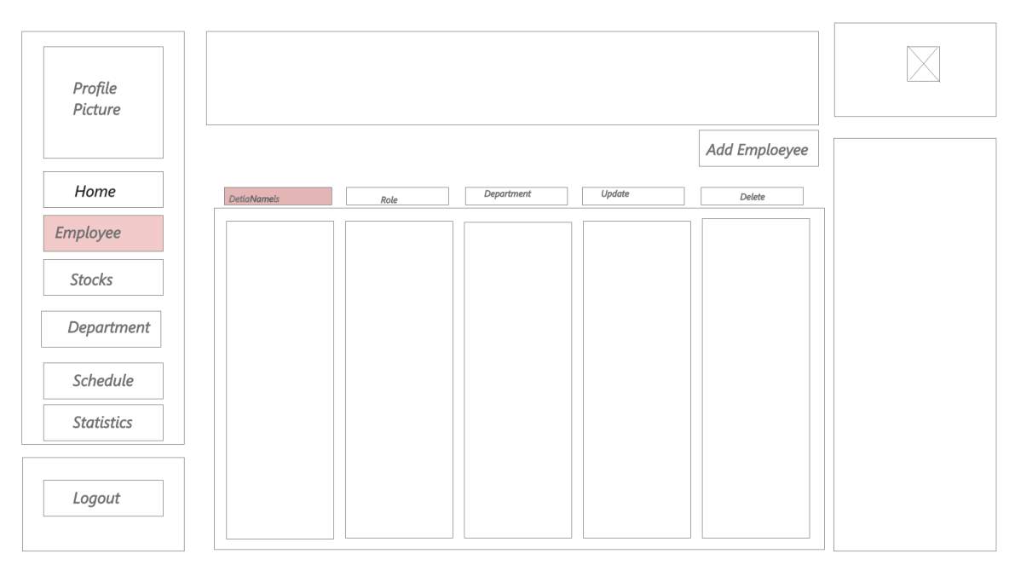

The employee page is where the Hr managers can manage existing, as well as new employees. It is possible to add new employees, view their information and remove them.

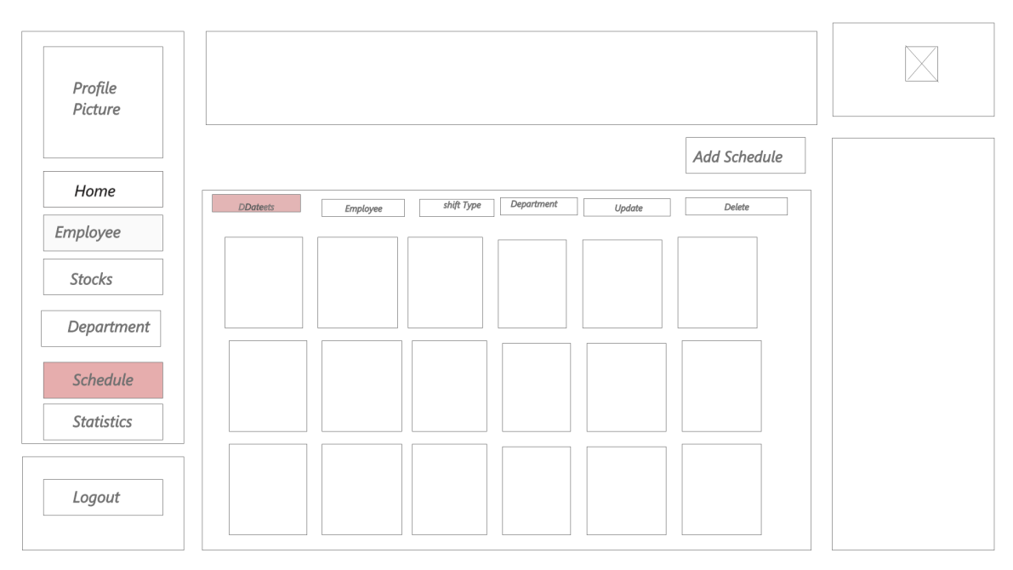

The schedule page is where all employees can check their schedule.

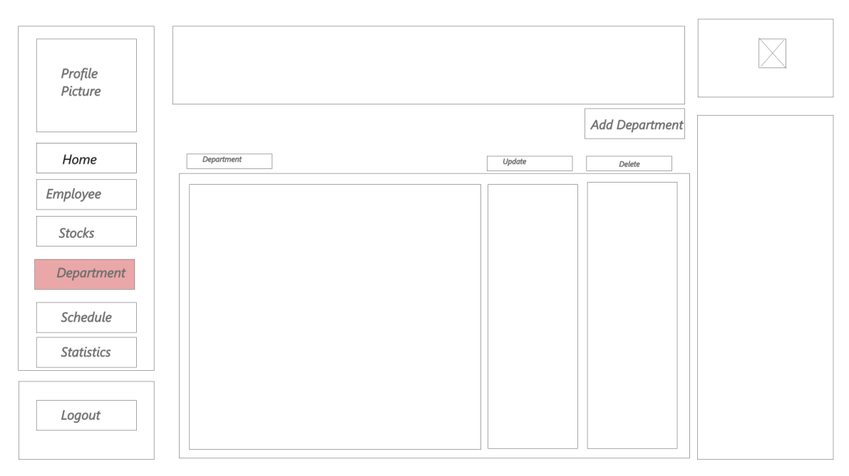

The department page will be a page for accessing Department information and the ability to change/update it. There are employees assigned to different departments.

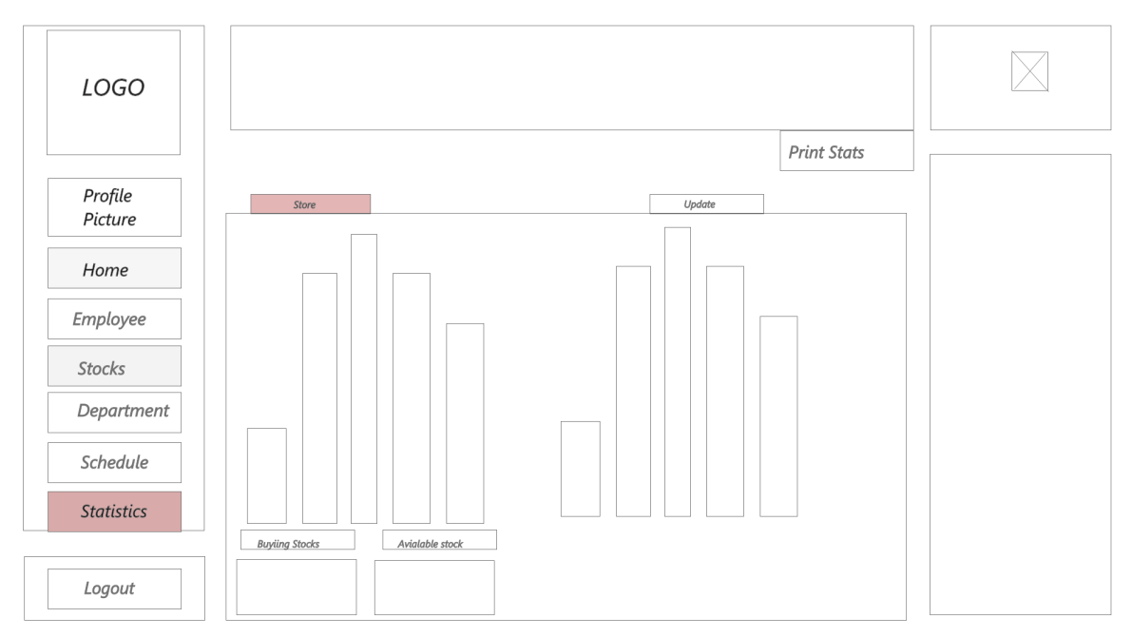

The statistics page is where it is possible to view statistics from the sales, as well as other information.