- RAG Architecture Diagram:

Raw Documents (ML Basics .txt)

Text Cleaning + Overlapping Chunking

Cleaned + Chunked texts
Embedding Generation
(OpenAI text-embedding-3)

Vectors
Vector Store (FAISS) + Metadata JSON Storage

Query

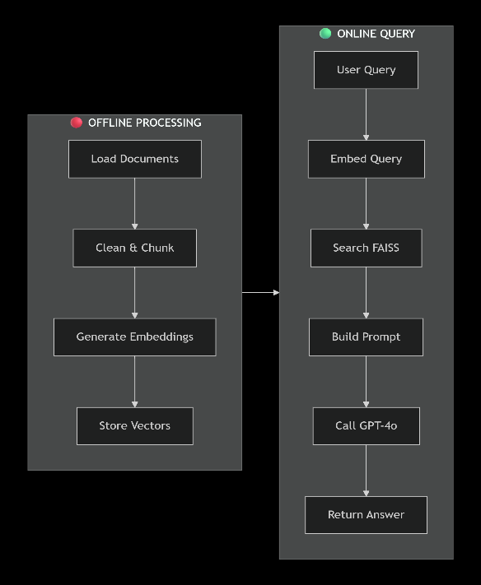
Similarity Search (FAISS)
Retrieve Top-k Chunks

Retrieved Chunks

Prompt Construction (context + system rules)

LLM Answer Generation (OpenAI gpt-4o)

Data Flow for better understanding

2. Text Extraction & Chunking Plan
Document Format
The dataset consists of multiple .txt files containing machine learning basics (supervised learning, unsupervised learning, overfitting, regularization, etc.).
Text Cleaning Applied
- Normalize newline format (\r\n → \n)
- Remove extra blank lines
- Collapse multiple spaces/tabs
- Strip leading/trailing whitespace
Chunking Strategy
Type: Word-level chunking with overlap
- Chunk size: 300 words
- Overlap: 60 words
Why This Works
- Avoids losing context across chunk boundaries
- Works well with small datasets
- Reduces LLM hallucination risk because related concepts remain grouped
- Improves retrieval recall
3. Embedding Model Choice & Justification
Model Used:
OpenAI text-embedding-3-small
Justification
- High quality embeddings suitable for semantic search
- Low cost compared to larger models
- 768-dimension vectors give good performance for RAG tasks
- Works seamlessly with FAISS
- Ideal for small-to-medium RAG projects
The chosen model strikes the best balance of:
- Cost
- Speed
- Accuracy
4. Vector Database Choice
Vector Store Used:
FAISS
Reasons for Choosing FAISS
- Very fast local similarity search
- Lightweight and easy to integrate
- Works offline
- Ideal for small datasets (no need for cloud vector DB)
- Supports multiple index types (L2, cosine, IVF, HNSW)
Structure
- faiss_index.bin - stores the vector index
- metadata.json - stores metadata for each chunk: source, chunk_id, start_word, end_word, text
5. Retrieval Strategy
Steps:
- Embedding the user query using the same embedding model.
- Using FAISS to obtain the top-k most similar chunks (default k=5).
- De-duplicate overlapping chunks by (source, chunk_id).
- Appling a similarity threshold check:
if best_score < 0.75 → return fallback message
- Building a context block including:
- chunk text
- source file
- chunk ID
- similarity score
Why This Strategy Works
- Ensures only highly relevant chunks are passed to the LLM
- Prevents hallucination from weak matches
- Keeps prompt size manageable

6. Prompt Structure
System Prompt:
Guides the LLM to answer only from the documentation:
You are an AI assistant specialized in Machine Learning Basics. You must answer only using the provided context chunks from the documentation.
If the answer is not clearly contained in the context, say:
"I do not know based on the provided documentation."
Do not invent facts or rely on outside knowledge.
Always mention which source files used in the answer.
User Prompt Template:
CONTEXT:
---------
{context_block}

---------
USER QUESTION:
{query}

Instructions:
- Use only the information from the CONTEXT.
- If the context is insufficient, say: "I do not know based on the provided documentation."
- If multiple sources conflict, say that there are conflicting descriptions.
Why This Prompting Works
- Strong grounding instructions
- Forces fallback instead of hallucinating
- Encourages citing specific source chunks
7. Failure Modes & Hallucination Prevention
Failure Modes
- Low-similarity retrieval - irrelevant results returned
- Contradictory content - LLM confusion
- Very broad queries - too many chunks retrieved
- Chunk fragmentation - missing relationships
Mitigations Implemented
- Similarity threshold (0.75)
- Overlapping chunks
- Strict system prompt
- Explicit fallback responses when context is insufficient
- Source highlighting at the end of the answer
Mitigations Planned (Bonus Section)
- Metadata filtering
- Multi-query retrieval
- Context compression
- LLM-based re-ranking
8. Evaluation Plan
Qualitative Evaluation
Run a set of representative queries covering:
- Definitions
- Differences between ML concepts
- Advantages/disadvantages
- Examples
Measure:
- Correctness
- Grounding
- Consistency across queries
Stress Testing
- Ambiguous queries
- Multi-hop reasoning
- Out-of-domain questions
- Queries with missing or contradictory content

