# Project Documentation

## Project Overview

### Group Name and Team Members

Group Name: Stillife  
Team Members: Andris Edgars Artejevs

### Description of the Chosen Website Topic

The project is a photography portfolio website designed for a team of photographers. The website showcases services, contact information, and an about section detailing the photographers' expertise.

### Target Audience and Purpose

The website targets individuals and businesses looking for professional photography services. It aims to provide an easy-to-navigate platform where potential clients can explore services, view previous work, and get in touch with the team.

## Design & Development Process

### Website Layout Structure

The website consists of the following pages:

* **Home**: Features a hero section with a background image and call-to-action buttons.
* **Services**: Lists all photography services with images and descriptions.
* **About**: Details the team's background and experience.
* **Contact**: Provides a form for users to send inquiries.

Navigation is implemented with a fixed navbar, ensuring users can move between sections smoothly.

### Explanation of Color Schemes, Typography, and Images

**Color Scheme:** A professional grayscale theme with accents of blue (#007bff) for buttons and links.  
**Typography:** System UI fonts and sans-serif fonts for readability.  
**Images:** High-quality images are used for the hero section and service listings, ensuring visual appeal.

### CSS Techniques and Layouts Used

Flexbox: Used for the navigation bar, form layouts, and service sections.  
Grid: Implemented for equal spacing of images and content alignment.  
Media Queries: Responsive design ensuring compatibility across devices.  
Hover Effects: Used on buttons and links to enhance user experience.

## Challenges & Solutions

### Technical Difficulties and Solutions

Footer Alignment Issue: Initially, the footer was misaligned and overlapping content. This was fixed by using flexbox with align-items: center and justify-content: center while ensuring the footer had a fixed height.  
  
Navigation Spacing: Menu items were too close together. Adjusted with margin-right: 40px on <li> elements.

### Code Modifications

Example Fix for Footer Alignment:

footer {  
 width: 100%;  
 background-color: #2c2c2c;  
 color: white;  
 display: flex;  
 flex-direction: column;  
 align-items: center;  
 padding: 20px 0;  
}

Example Fix for Submit Button Hover Effect:

#submit-btn:hover {  
 background-color: #064e9b;  
 transition: 0.5s ease-in-out;  
}

Home  
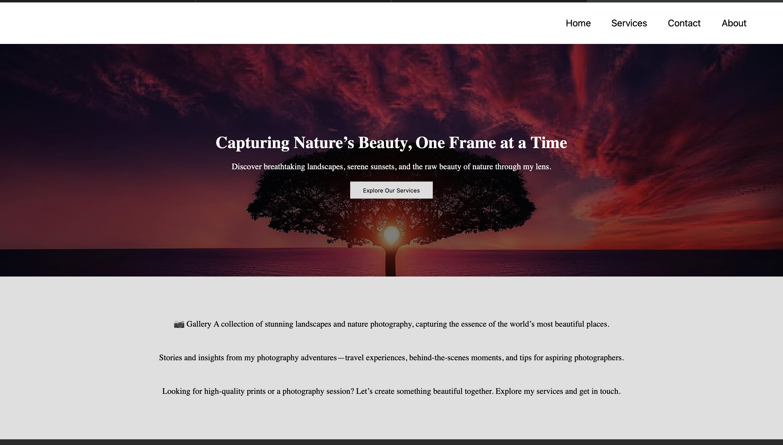

Services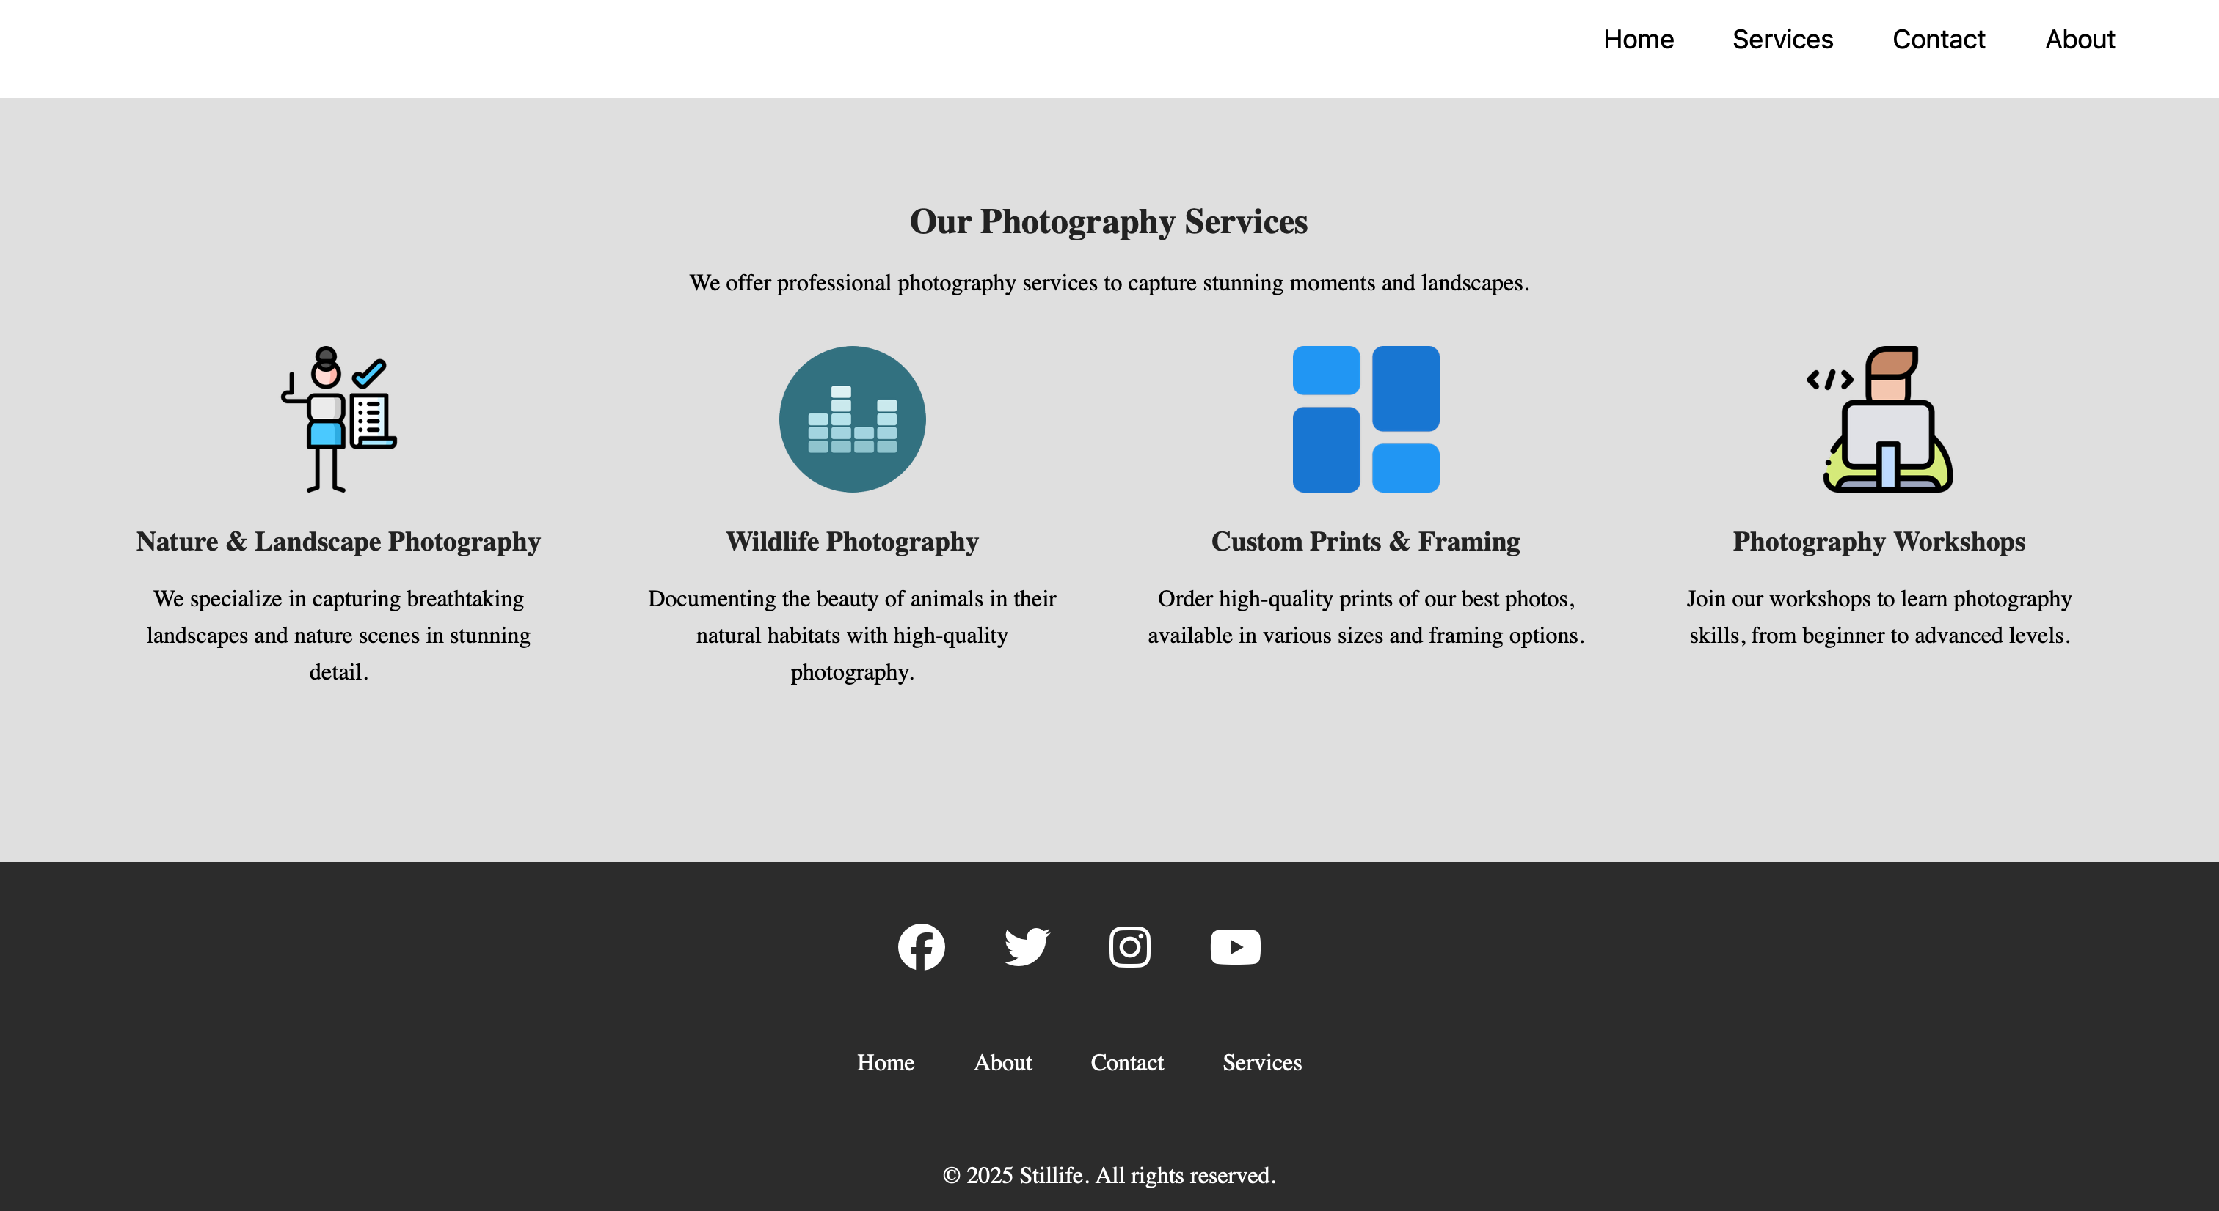

Contact

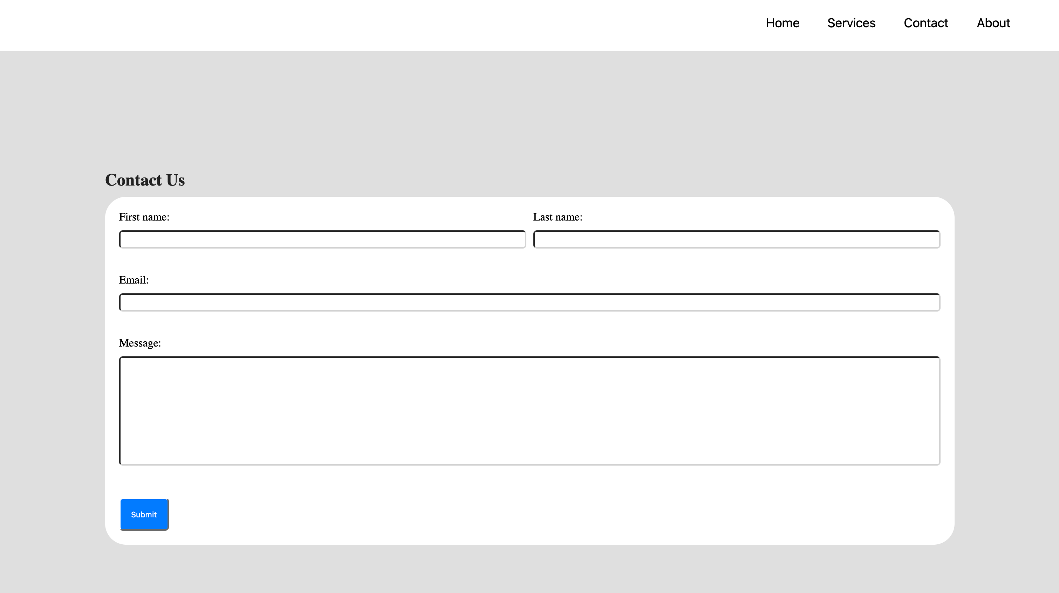

About

