When I first started using Blender in 2004, I remember feeling completely overwhelmed at the amount of keyboard shortcuts.

Worst of all though, was that after looking online, I disovered there were no helpful guides that explained which shortcuts were the most important.

So I decided to make one. I released the first edition of this guide in 2009, and I’ve revamped it and improved it, over the years to create the guide that you’re reading right now.

It’s designed to outline the most useful, most essentials shortcuts that pros use.

PS. It’s also printer friendly, so if you want, you can print it out and stick it to your wall! :)

Happy Blendering!

Andrew Price

BlenderGuru.com

# How to Print this Shortcut Guide

**Step 1:** Press Ctrl+P

**Step 2:** Select Pages 2-4

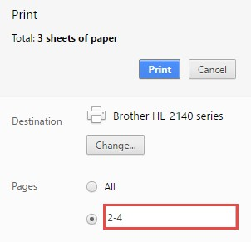

**Step 3:** Stick it to your wall! :)

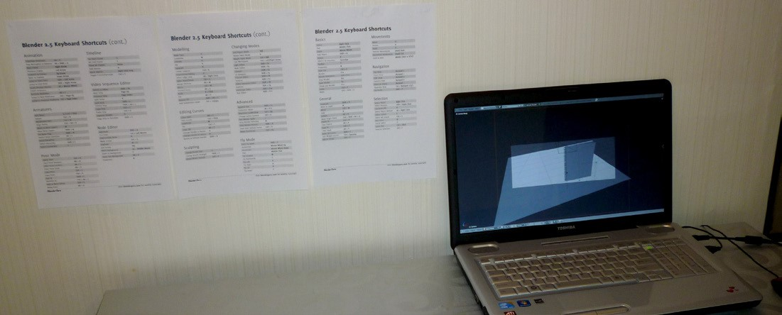

# Basic Navigation Common

|  |  |  |  |  |  |  |  |  |  |  |  |  |  |  |  |  |  |  |  |  |  |  |  |  |  |  |  |  |  |  |  |  |  |  |  |  |  |  |  |  |  |  |  |  |  |  |  |  |  |  |  |  |  |  |  |  |  |  |  |  |  |  |  |  |  |  |  |  |  |  |  |  |  |  |  |  |  |  |  |  |  |  |  |  |  |  |  |  |  |  |  |  |  |  |  |  |  |  |  |  |  |  |  |  |  |  |  |  |  |  |  |  |  |  |  |  |  |  |  |  |  |  |  |  |  |  |  |  |  |  |  |  |  |  |  |  |  |  |
| --- | --- | --- | --- | --- | --- | --- | --- | --- | --- | --- | --- | --- | --- | --- | --- | --- | --- | --- | --- | --- | --- | --- | --- | --- | --- | --- | --- | --- | --- | --- | --- | --- | --- | --- | --- | --- | --- | --- | --- | --- | --- | --- | --- | --- | --- | --- | --- | --- | --- | --- | --- | --- | --- | --- | --- | --- | --- | --- | --- | --- | --- | --- | --- | --- | --- | --- | --- | --- | --- | --- | --- | --- | --- | --- | --- | --- | --- | --- | --- | --- | --- | --- | --- | --- | --- | --- | --- | --- | --- | --- | --- | --- | --- | --- | --- | --- | --- | --- | --- | --- | --- | --- | --- | --- | --- | --- | --- | --- | --- | --- | --- | --- | --- | --- | --- | --- | --- | --- | --- | --- | --- | --- | --- | --- | --- | --- | --- | --- | --- | --- | --- | --- | --- | --- | --- | --- | --- | --- |
| |  |  |  | | --- | --- | --- | | Orbit | Middle Click | | | Pan | Shift + Middle Click | | | Zoom | Scroll | | | Top View | Numpad 7 | | | Front View | Numpad 1 | | | Side View | Numpad 3 | | | Camera View | Numpad 0 | | | Go to Selected Object | Numpad . | | | Perspective/Orthographic | Numpad 5 | | | Zoom to Show All Objects | Home | | | Fly Mode | Shift + F | | | Toolbar | T | | | Object Properties | N | | | Reset 3D cursor  **In Object Mode** | Shift + C | | | Duplicate | Shift + D | | | Duplicate Linked | Alt + D | | | Move to layer | M | | | Join/Merge Objects | Ctrl + J | | | Mirror Object | Ctrl + M | | | Hide Selected | H | | | Unhide All | Alt + H | | | Move Selected Object to Center | | Alt + G | | Snap to Cursor | | Shift + S | | Copy Attributes to New Object | | Ctrl + L | | Proportional Editing On/Off | | O | | Apply Scale/Rotation/Location | | Ctrl + A | | Add Constraint | | Ctrl + Shift + C | | Parent | | Ctrl + P | | Clear Parent | | Alt + P | | |  |  | | --- | --- | | Add Object | Shift + A | | Search | Space | | Move | G | | Scale | S | | Rotate | R | | Trackball Rotate | R, R | | Move Origin Point | Ctrl + Shift + Alt + C | | Properties Bar | P | | Toolbar | T | | Option Menu **While Moving** | W | | Precise Movement | Shift [Hold] | | Incremental Movement | Ctrl [Hold] | | Lock movement to Axis | Middle Click or X/Y/Z | | **Selection** |  | | Select | Right Click | | Select All/Deselect All | A | | Box Select | B | | Circle Select | C | | Lasso Tool | Ctrl + Click | | Select Similar | Shift + G | | Invert Selection | Ctrl + I | | **Changing View** |  | | Wireframe/Solid View | Z | | Isolated View | / | | Rendered View | Shift + Z | |

Weight Paint Mode Ctrl + TAB

# In Edit Mode Rendering

|  |  |  |  |  |  |  |  |  |  |  |  |  |  |  |  |  |  |  |  |  |  |  |  |  |  |  |  |  |  |  |  |  |  |  |  |  |  |  |  |  |  |  |  |  |  |  |  |  |  |  |  |  |  |  |  |  |  |  |  |  |  |  |  |  |  |  |  |  |  |  |  |  |  |  |  |  |  |  |  |  |  |  |  |  |  |  |  |  |  |  |  |  |  |  |  |  |  |  |  |  |  |  |  |  |  |  |  |  |  |  |  |  |  |  |  |  |  |  |  |  |  |  |  |  |  |  |  |  |  |
| --- | --- | --- | --- | --- | --- | --- | --- | --- | --- | --- | --- | --- | --- | --- | --- | --- | --- | --- | --- | --- | --- | --- | --- | --- | --- | --- | --- | --- | --- | --- | --- | --- | --- | --- | --- | --- | --- | --- | --- | --- | --- | --- | --- | --- | --- | --- | --- | --- | --- | --- | --- | --- | --- | --- | --- | --- | --- | --- | --- | --- | --- | --- | --- | --- | --- | --- | --- | --- | --- | --- | --- | --- | --- | --- | --- | --- | --- | --- | --- | --- | --- | --- | --- | --- | --- | --- | --- | --- | --- | --- | --- | --- | --- | --- | --- | --- | --- | --- | --- | --- | --- | --- | --- | --- | --- | --- | --- | --- | --- | --- | --- | --- | --- | --- | --- | --- | --- | --- | --- | --- | --- | --- | --- | --- | --- | --- | --- | --- | --- |
| |  |  | | --- | --- | | Edit/Object Mode | TAB | | Extrude | E | | Inset | i | | Fill | F | | Select Edge Loop | Alt + Click | | Select Ring | Ctrl+Alt+Click | | Create Loopcut | Ctrl + R | | Edge Slide | G, G | | Select All Connected | Ctrl + L | | Make Seam/Sharp | Ctrl + E | | Edge Crease | Shift + E | | Unwrap UVs | U | | Change Selection Mode | Ctrl + TAB | | Bevel | Ctrl + B | | Knife Tool | K | | Separate to a New Object | P | | Rip | V | | Rip Fill | Alt + V | | Split | Y | | Mirror | Ctrl + M | | Shrink/Fatten | Alt + S | | Proportional Falloff | O | | Recalculate Normals | Ctrl + Shift + N | | **Sculpting** |  | | Add/Subtract Sculpting | Ctrl [Hold] | | Smooth | Shift [Hold] | | Brush Size | F | | Brush Strength | Shift + F | | Hide Area | H | | Unhide Selection | Shift + H | | Unhide All | Alt + H | | Mask Paint Mode | M | | Subtract Mask Paint | Ctrl + Click | | Fill/Clear Mask | Ctrl + i | | Lasso Mask | Ctrl + Shift + Click | | |  |  | | --- | --- | | Render | F12 | | Show Last Render | F11 | | Save Render | F3 | | Change Render Slot | 1-8 | | Only Render Portion | Shift + B | | Reset Render Portion | Ctrl + Alt + B | | Change Active Camera | Ctrl + 0 | | **Node Editor** |  | | Jump to Node Editor | Shift + F3 | | Connect Nodes | F | | Cut Links | Ctrl + Click [Drag] | | Reroute Link | Shift + Click [Drag] | | Delete but keep connected | Ctrl + X | | Duplicate and keep connected | Ctrl + Shift + D | | Mute Selected Node | M | | Make Group | Ctrl + G | | Ungroup | Alt + G | | Edit Selected Group | TAB | | Move Background | Alt + Middle  Mouse | | Zoom in Background | V | | Zoom out Background | Alt + V | | **Editing Curves** |  | | Add new Handle | Ctrl + Click | | Change Handle Type | V | | Delete but keep connection | Ctrl + X | | Close Path | Alt + C | | Tilt | Ctrl + T | | Clear Tilt | Alt + T | | Convert Curve to Mesh | Alt + C | |

Stroke Method E

# Animation Posing Mode

|  |  |
| --- | --- |
| Clear Pose Rotation | Alt + R |
| Clear Pose Location | Alt + G |
| Clear Pose Scale | Alt + S |
| Copy Pose | Ctrl + C |
| Paste Pose | Ctrl + V |
| Add IK | Shift + I |
| Add Pose to Library | Shift + L |
| Remoke IK | Ctrl + Alt + i |
| Add to Bone Group | Ctrl + G |
| Relax Pose | Alt + E |
| Breakdowner | Shift + E |
| Rotate on Bone’s Center | R, R |
| Select Grouped | Shift + G |
| Paste X-Flipped  **Fun to Know** | Ctrl + Shift + V |
| Repeat Last Action | Shift + R |
| Play Animation in Reverse | Shift + Alt + A |
| Maximize SubWindow | Shift + Space |
| Fly Mode | Shift + F |
| Quad Mode | Ctrl + Alt + Q |
| Scroll Value | Ctrl + Scroll |
| Scroll Dropdown Values | Ctrl + Scroll |
| Grease Pencil | D + Click |
| Erase Pencil | D + Right Click |
| Copy change across objects | Alt while clicking |
| Select behind object | Alt + Click |

|  |  |  |  |
| --- | --- | --- | --- |
| Play/Stop Animation | | Alt + A | |
| Insert Keyframe | | i | |
| Remove Keyframe | | Alt + i | |
| Go to Next/Previous Frame | | ç / è | |
| Go Forward/Back 10 Frames | | Shift + é / ê | |
| Go to Next/Previous Keyframe | é / ê | | |
| Go to First/Last Frame | Shift + ç / è | | |
| **Armatures** |  | | |
| Add New Bone | Shift + A | | |
| Extrude Bone | E | | |
| Roll | Ctrl + R | | |
| Recalculate Roll | Ctrl + N | | |
| Align Bones | Ctrl + Alt + A | | |
| Move to Bones Layer | M | | |
| Set Bone Flag | Shift + W | | |
| Switch Bone Direction | Alt + F | | |
| Scroll Hierarchy | ] / [ | | |
| **Timeline** |  | | |
| Scroll through frames | Alt + Scroll | | |
| Set Start Frame | S | | |
| Set End Frame | E | | |
| Zoom to show all frames | | | Home |
| Zoom to Frame | | | Numpad 0 |
| Add Marker | | | M |
| Move Marker | | | Right Click  Drag |
| Set Preview Range | | | P |
| Clear Preview Range | | | Alt + P |

Add Subdivision Level Ctrl + 0/1/2/3/4/5

***Enjoy this PDF?***

Get helpful Blender tips, and selected community artworks by [liking us on Facebook:](https://www.facebook.com/blenderguru)

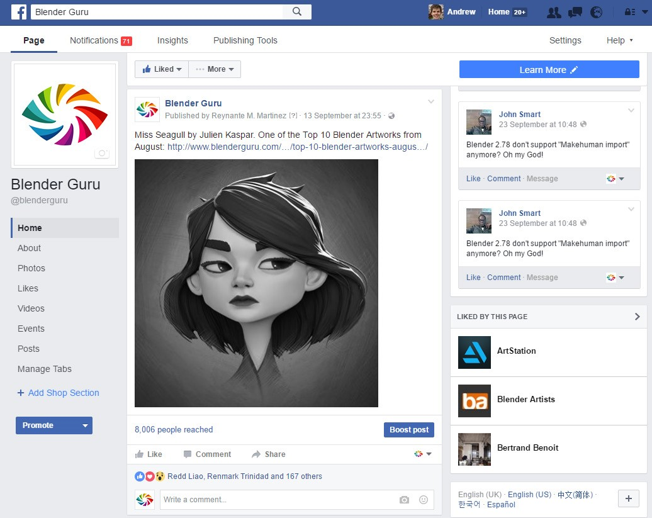

You can also follow me on [Twitter](https://twitter.com/andrewpprice), [Youtube](https://www.youtube.com/user/AndrewPPrice) or [Instagram](https://twitter.com/andrewpprice) if you wanna be a stalker :P

Enjoy the shortcut guide!

-Andrew Price

|  |  |  |
| --- | --- | --- |
| **Andris Practice**  **Extra shortcuts** |  | |
| Slide vertex | G + G | |
|  |  | |
|  |  | |
|  |  | |
|  |  | |
|  |  | |
|  |  | |
|  |  | |
|  |  | |
| **Timeline** |  | |
|  |  | |
|  |  | |
|  |  | |
|  | |  |
|  | |  |
|  | |  |
|  | |  |
|  | |  |
|  | |  |

Graph editor. 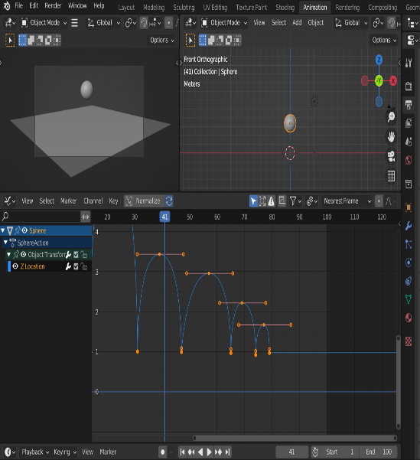Press t to change interpolation

Render animation.

