Improving Business Solutions with Microsoft® Office Professional® 2003 and Microsoft Windows® XP Professional
A Microsoft® Office Systems® 2003 White Paper

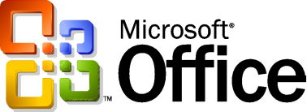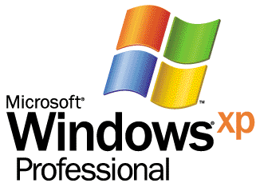

This white paper reviews how Microsoft Office Professional 2003 and Microsoft Windows XP Professional together is a winning combination by providing you with the most economical desktop system and outstanding software features to increase productivity, while also achieving lower deployment and ongoing maintenance costs.
Published: June 2004
For the latest information, please see http://office.microsoft.com/home/default.aspx
The information contained in this document represents the current view of Microsoft Corporation on the issues discussed as of the date of publication. Because Microsoft must respond to changing market conditions, it should not be interpreted to be a commitment on the part of Microsoft, and Microsoft or its respective suppliers cannot guarantee the accuracy of any information presented after the date of publication.

This white paper is for informational purposes only. MICROSOFT AND ITS RESPECTIVE SUPPLIERS MAKES NO WARRANTIES, EXPRESS OR IMPLIED, AS TO THE INFORMATION IN THIS DOCUMENT.

Complying with all applicable copyright laws is the responsibility of the user. Without limiting the rights under copyright, no part of this document may be reproduced, stored in or introduced into a retrieval system, or transmitted in any form or by any means (electronic, mechanical, photocopying, recording, or otherwise), or for any purpose, without the express written permission of Microsoft Corporation.

Microsoft may have patents, patent applications, trademarks, copyrights, or other intellectual property rights covering subject matter in this document. Except as expressly provided in any written license agreement from Microsoft, the furnishing of this document does not give you any license to these patents, trademarks, copyrights, or other intellectual property.

© 2004 Microsoft Corporation. All rights reserved.

Microsoft, Windows, Windows Server, FrontPage, PowerPoint, SharePoint, OneNote, Outlook, Visio, InfoPath, and the Office logo are either registered trademarks or trademarks of Microsoft Corporation in the United States and/or other countries.

The names of actual companies and products mentioned herein may be the trademarks of their respective owners.

Microsoft Corporation • One Microsoft Way • Redmond, WA 98052-6399 • USA
0302

Contents
Introduction 2
Microsoft Office System 2003 2
Windows XP Professional 2
Generating Value in Four Areas 2
Return on Investment 2
Benefits of Business Collaboration and Mobility 2
Working Remotely, Working Wirelessly 2
User Productivity and Downtime 2
Case Study: Building and Construction Organization 2
Other Collaboration Solutions 2
Business Value of Mobility 2
Benefits of Process Management 2
Faster Startup, Better Run-Time and Memory Performance 2
Case Study: Financial Organization 2
Other Process Management Solutions 2
Benefits of Integration and Business Intelligence 2
Windows XP Security Enhancements Protect Business Data 2
Case Study: Legal 2
Other Business Intelligence Solutions 2
Benefits of Improved Management and Administration 2
Deployment Costs 2
Case Study: Educational Organization 2
Business Value of IT Infrastructure and TCO 2
New Office System Products 2
Case Study: Management Consulting Organization 2
Business Value of Microsoft Office OneNote 2003 2
Case Study: Information Technology Organization 2
Business Value of Microsoft Live Communications Server 2003 2
Business Value of Microsoft Office Live Meeting Service 2
Conclusion 2
Resources 2
Appendix A: Microsoft Office System Products 2
Appendix B: Office 2003 Comparison Guide 2
Appendix C: Windows XP Professional Comparison Guide 2

Introduction
This white paper demonstrates that using Microsoft Windows XP Professional and Microsoft Office System 2003 as a desktop productivity platform offers businesses significantly greater financial value than previous versions of Windows client and Office software.
The IT world of today is dramatically different than it was just a decade ago. IT systems are more complex, with computers and software distributed throughout the organization and often around the world. Employees rely on laptops, mobile phones, and smart handheld devices to stay in touch with the people and information they care about. Security technologies and policies are required to keep company data safe and ensure that critical systems can run without disruption. Partners and suppliers use powerful Web services to connect their business processes and work more efficiently. Customers have come to expect real-time information about inventory, billing, and shipping delivered securely over the Web.
Our results demonstrate that deploying a desktop PC or notebook PC solution based on the Microsoft Windows XP operating system, and Microsoft Office 2003 productivity programs can contribute to improvements in operational efficiencies for both end users and the IT departments of participating organizations. Adopting these technologies can result in distinct and compelling improvements in end-user productivity that helps to drive revenue and reduce overall operating expenses.

Measure | Median | Range
Internal rate of Return | 142% | 46% - 460%
Payback Period | 8 months | 3 to 9 months
Net Present Value | $600,000 | $78,000 to $18 million
Net Present Value Per User | $4,000 | $280 to $65,000
Number of Users Impacted | 85 | 9 to 1,500
Typical Benefits Realized

Connected Productivity
People have a dependence on finding and prioritizing the information they need, whether they are in the office or working remotely. Microsoft technologies answer the individual’s need for:
- Better information management – enabling people to organize, protect, and manage their business information.
- Effective uses of notes – making it easy for people to find important information, create formal documents from their notes, and easily share them with others.
- Staying connected – ensuring that people have real-time access to the information that resides on their computers, both in the office and on the road, so they are always up-to-date.
Finding and sharing the information when working with others is an integral part of collaborating more effectively and with greater confidence. The Microsoft team environment facilitates:
- Better teamwork – making it easy to stay connected with teammates to cut project cycle times and save meeting costs; making it easier and more efficient to create and review documents; keeping teammates updated and on top of meetings and follow up.
- Easy-to-find information – using Web-based team workspaces to make it faster and easier for team members to manage, find, share, and collaborate on documents.
- Decreased dependence on IT – making it easy to set up, use, and customize tools that let team members collaborate so they can carry out their work on time.
- Keeping in control – increasing the control people have over their information by managing who has permission to access team and document workspaces.
Together, these features work together to create a work environment that can enable a large gain in productivity, and help people to reach their objectives.

Microsoft Office System 2003
Microsoft Office has changed from a suite of personal productivity products to a more comprehensive and integrated system. Building on the familiar tools that people already know, the Microsoft Office System includes programs, servers, services, and solutions designed to work together to help organizations and their workers transform information into impact. New and familiar products, features, and functionality improve how people and organizations connect to coworkers, information, and business processes.
Advances in intranet collaboration through integration with the collaboration and information-sharing portal, Microsoft Office SharePoint Portal Server 2003, enable workers to access and share information both internally and externally. Support for information rights management (IRM) and industry-standard Extensible Markup Language (XML) provide a platform on which to quickly build cost-effective solutions that have an immediate impact.

Windows XP Professional
Designed for businesses of all sizes and for home users who demand the most from their computing experience, Windows XP Professional delivers the new standard in reliability and performance. It includes all the great features and new visual design of Windows XP Home Edition, plus premier security and privacy features, advanced recovery options, improved ability to connect to large networks, and much more. Key benefits include:
Reliability –By building on the proven Windows 2000 operating system, Windows XP Professional delivers a reliable foundation you can count on to keep your computer up and running when you need it most. Not only is Windows XP more reliable, it also helps you more easily recover from system problems.
High Performance –Computers running Windows XP Professional outperform Windows 98 Second Edition, and meet the performance of Windows 2000 on commercial benchmarks. Not only will Windows XP launch applications faster, in most cases, your entire system will start up much more quickly.
Security –Security features in Windows XP Professional protect sensitive and confidential data both on your computer and while you are transmitting over a network or the Internet. With support for the latest security standards and enhanced virus protection, Windows XP also protects you from some of the more common types of Internet attacks.
Easy to Use –From its fresh, new look to its intuitive, task-based design, Windows XP Professional makes it easier than ever to use your computer. You’ll be able to get more done in less time, find items in a snap, and arrange files and folders in a way that makes sense to you. Simply put, Windows XP Professional helps you work smarter.

Generating Value in Four Areas
There are four areas where Microsoft Office System and Windows XP can enable workers to improve their productivity, thereby helping businesses address their challenges.

Area | Description | Details
Process Management | Transform Information into Impact | Help employees improve their ability to contribute to the organization’s goals in an increasingly competitive environment.
Collaboration | Collaborate More Effectively | Get teams, partners, organizations, and customers on the same page, enabling them to work together with speed and agility.
Integrate | Process Integration | Improve the organization’s ability to anticipate, manage and respond to changes in order to maximize opportunities.
Business Intelligence | Utilize Information | Provide more people within the organization better visibility into information so the can gain deeper insights, make better decisions, and take more effective action faster.

Return on Investment
The projected average ROI for implementing Windows XP Professional is 203%, with a range of 179% to 351%. The ROI calculation is based on dividing the NPV of the benefits by the present value of the investment and taking the absolute value.
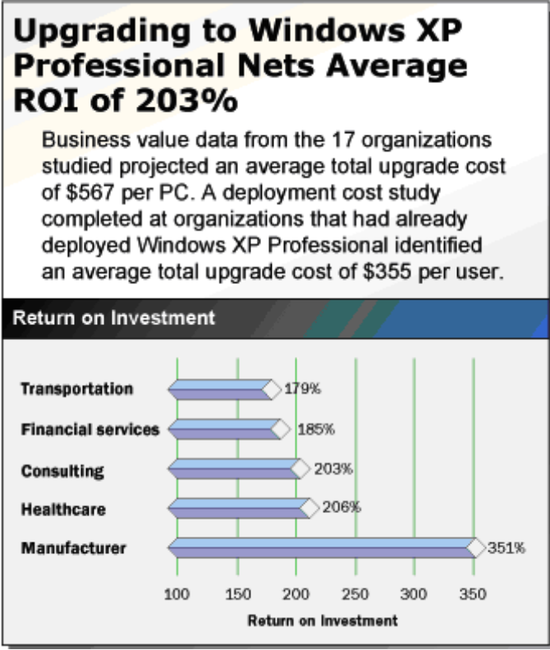
ROI

Benefits of Business Collaboration and Mobility
Microsoft Office 2003 and Windows XP Professional help businesses and their workers transform information into impact. New and familiar products, features, and functionality improve how people and organizations connect to coworkers, information, and business processes. Microsoft Office 2003 and Windows XP Professional create value by improving company responsiveness through improved collaboration.
- Meet New Business Demands
- Relive Economic Pressure
- Maximize Existing Business Investments
As mobile PC user productivity becomes an increasingly important part of maintaining competitive advantage, the business value of ensuring efficient collaboration and communication for mobile PC users increases as well. Support for remote and mobile workers includes improvements to connectivity performance, such as better caching, shared calendars, and the ability to fill out forms offline.

Working Remotely, Working Wirelessly
One of the greatest returns on investment opportunities offered by Windows XP Professional is providing mobile access to data and systems. The returns are equally significant whether notebooks are networked wirelessly or through docking stations or modems.

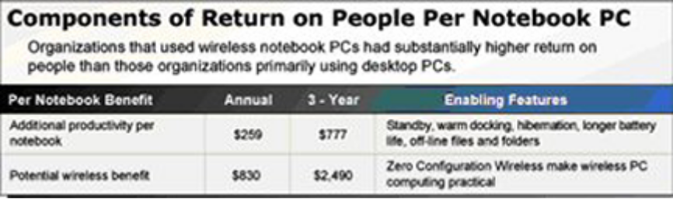
Mobile ROI

With the new operating system, wireless computing is more easily realized for the mobile user and therefore provides substantial productivity gains for employers. Although wireless networking is possible for organizations using older versions of Windows, Windows XP Professional makes it more practical and profitable by adding new features such as Zero Configuration Wireless, which allows users to leverage the technology without involving IT support staff. For many organizations, Zero Configuration Wireless is a sign that the technology had reached maturity thus prompting them to adopt wireless computing on a wide scale.

User Productivity and Downtime
Notebook as well as desktop PC users of Windows XP Professional will benefit from the increased reliability of the new operating system. Not only is the operating system intrinsically more reliable than its predecessors, it also contains tools that enable support personnel to quickly get end-users working again after a system failure.

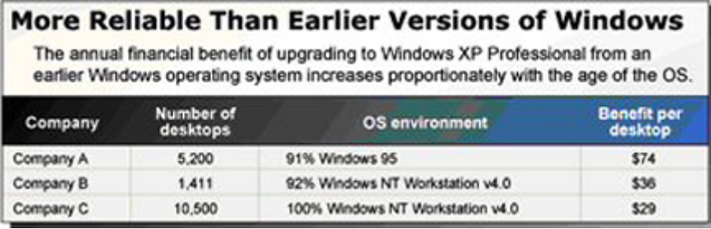
Reliability Improvement Business Value

The average annual benefit from reduced downtime was $46 per desktop resulting from reduced downtime and subsequent increases in productivity.
The annual financial benefit of upgrading to Windows XP Professional from an earlier Windows operating system increases in proportion with the age of the earlier operating system.

Case Study: Building and Construction Organization
Pinnacle Communities: Developer Expands Mobile Productivity Solution for Greater Efficiency and Sale
Pinnacle Communities is one of the premier builders of upscale homes in the New York tri-state area, in large part due to the efficiencies achieved using leading-edge technology. With a small home-office staff of 30, the company is able to efficiently and profitably build, market, and sell hundreds of new homes each year.
Pinnacle had two business problems for which it was continually seeking solutions:
- How to manage a geographically dispersed business with minimum overhead?
- How to achieve greater efficiencies in communication and collaboration to better manage messages and documents?
Pinnacle needed a solution that would facilitate universal, reliable access to information held within its Exchange data — whether a user is in the office, traveling regionally, traveling worldwide, at a field site, or at home. Hardware clients include company desktop PCs, laptop and Tablet PCs connected by wired or wireless wide-area virtual private network (VPN), and PDA/telephone devices.
Pinnacle Communities created an enhanced mobile productivity solution by upgrading to Windows XP Professional and Office 2003 (specifically: Excel, Outlook, OneNote, and Word). This resulted in the following benefits:
- Mobile productivity solution seen as a competitive advantage that generates more customers.
- Better mobile communications shortens closing time saves $500,000 a year.
- Pinnacle closes more sales with Microsoft mobile productivity solution making their business worth increase by $2 to $3 million.
View the complete case study for more information.

Other Collaboration Solutions
Microsoft Office System and Windows XP Professional solutions improve collaboration by providing teams with enhanced visibility into business information and enabling team members to locate the information they need without resorting to unnecessary meetings or travel, resulting in increased productivity and reduced costs.
These solutions also provide teams with the ability to collaborate with speed and agility. Several companies used these solutions to speed the production of sales and marketing material and shorten product development cycles.

Company | Solution | Business Metric
Accenture | Provides an environment for distance learning. | 80% - Travel  for offshore knowledge transfer engagements
Stevens Healthcare | Teams can access the site for schedule, task, and status information. | 75% - Meetings  for HIPAA (the compliance team)
Eniro | Pull information from numerous corporate databases to bring status information together. | 2% - Administrative time  for product development teams
Nordea | Meeting Workspace used to keep team members up to date. | 45% - Cycle Time  for IT projects
CommonHealth | Meeting Workspace and Document Workspace used to speed workflows. | 4% - Productivity  for medical education material project teams
Collaboration Productivity Improvement Metrics

Business Value of Mobility
Business communication is more than checking email and voice mail. For mobile users, it's immediately accessing important information; acting on that information to the benefit of the business; and collaborating efficiently with customers, partners, and colleagues. In other words, successful business communications rely on an efficient exchange between people and data, which Microsoft's mobile solutions enable.
The mobile computing improvements in Windows XP Professional build on the flexibility of Microsoft Windows® 2000 Professional. New features for mobile computing will help you accomplish as much on the road or at home as you do in the office, so you can be productive no matter where you are. Add these capabilities to the reliability, performance, and communication features in Windows XP Professional and you have a system that can do things that you always thought a system should be able to do.
In general, key findings of business value studies showed Windows XP Professional and Office 2003 resulted in the following benefits:

Benefit | Details | Annual Savings Per user
Empower mobile users to be more productive by increasing user uptime | Improved security, reliability, and power management features of Windows XP Professional helped reduce time lost to computer-related delays and work interruptions that mobile workers experience while working out of the office. | $500
Enable information workers to collaborate more efficiently and eliminate the need for face-to-face meetings and long-distance travel | Use of Microsoft SharePoint™ Team Services, Office XP authoring tools, and the Tablet PC to expedite collaborative and communications tasks. | $410
Reduce the TCO of mobile IT services | Use improved security, reliability, and help services of Windows XP Professional and Office 2003 to deliver IT services to mobile and remote users with less IT support time and effort. | $500
Key Business Value Metrics Using Windows XP Professional and Office 2003

Other Benefits
- Ubiquitous Access
- Security and Reliability
- Office System Information Rights Management
- Document Protection
- Cached Exchange Mode
- Intelligent Connectivity
- Connectivity to Exchange via HTTP
- Flexible Form Completion

Benefits of Process Management
Process management solutions look to develop and standardize company processes so that employees produce more strategic results, identify and share best practices, and deliver on present objectives. Many companies have found that employees in different parts of the organization are performing similar tasks in completely different ways. In some instances, employees are forced to repeat tasks because it is impossible to share information. Companies recognize the value of standardizing tasks around best practices and eliminating rework, and they are using Microsoft Office System and Windows XP Professional solutions to address these issues.

Process Management Benefits | Description
Automated Status Reporting | Enforcing standard work practices allows companies to automate reporting, resulting in estimated savings averaging $20,000 annually
Electronic Delivery of Files vs. Physical Delivery | Eliminating the need to deliver physical files potentially resulting in cost savings of $260,000 annually.
Automating Project Management Functions | Savings averaging $142,000 annually are expected from reducing costs and improving cycle times.
Increased Productivity | Productivity increases of 0.2% to 27% are predicted from streamlining processes, automating tasks, eliminating rework, and enforcing standards.
Process Management Benefits Using Windows XP Professional and Office 2003

Faster Startup, Better Run-Time and Memory Performance
The benefit of standardizing tasks and processes would be questionable if workers had to perform these tasks on a slow computer. Windows XP Professional manages system resources efficiently, meeting the performance standards set by Windows 2000 and exceeding those set by Windows 98 Second Edition.
Windows XP Professional is clearly superior to earlier versions in all key performance categories:
- Faster startup performance: Windows XP is on average 34% faster than Windows 2000 and 27% faster than Windows 98 SE.
- Better run-time performance: This measurement refers to the speed at which Windows XP performs tasks while your computer is running. Improvements in Windows XP runtime performance are evident in application startup and time and resource management. For example, average application startup on Windows XP is 25% faster than Windows 98 SE and equivalent to Windows 2000 Professional.
- Memory and Performance: In systems which include the recommended memory requirement of 128 megabytes of RAM, Windows XP is consistently superior to previous versions of Windows.
- Windows XP offers dramatically faster startup and resume times, highly responsive applications, and other new features such as Fast User Switching and an enhanced user interface.

Performance Measurement | Windows XP enabling feature(s) | Performance Improvement
Commercial Benchmarks  (averaged) | Overall system improvements | 36% faster than Windows 98 SE  Equivalent to Windows 2000
System Startup Time | Prefetching and elimination of unnecessary network delays | 27% faster than Windows 98 SE  34% faster than Windows 2000
Resume from Standby | Overlap device initialization; maximizing parallelism | 19% faster than Windows Me  21% faster than Windows 2000
Resume from Hibernate | Optimizations in the compression algorithms and overlapping compression with DMA (Direct Memory Access) transfers to disk | 13% faster than Windows Me  9% faster than Windows 2000
Application Startup  (averaged) | Prefetching | 25% faster than Windows 98 SE  Equivalent to Windows 2000
Windows XP Professional Performance Improvement Metrics

Case Study: Financial Organization
PGGM: Automating Data Processes and Document Handling Helps PGGM Greatly Increase Their Return on IT
Based in Zeist in the Netherlands, PGGM oversees a pension fund that focuses exclusively on employers and employees in the healthcare and social work sectors. With a total pension capital of approximately €45 billion, PGGM provides former and current employees with insurance policies as well as pensions and serves more than 1.7 million customers.
A complex mainframe-based IT infrastructure and a labor-intensive, error-prone, and paper-based document handling process used to provide subscriber services correspondence was driving up PGGM operating costs. The lack of standardized document design and content standards resulted in an explosion of more than 1,000 document types and formats, which added to document delivery cycle times. PGGM wanted to integrate their IT assets under a single architecture and reduce TCO by consolidating its suppliers and improving customer services to fund subscribers.
PGGM replaced its manual paper-based document creation and subscriber data processing with a document information system that automates document handling, updates data, and archives it electronically. XML-enabled Web services ensure tight integration between desktop applications, server products, and development tools of the Microsoft Office System (specifically: InfoPath, SharePoint Server, Word, SharePoint Services, and Web Services).
Their solution resulted in the following benefits:
- Reduced IT operating costs
- Provided collaboration with required regulatory compliance
- Reduced number of line-of-business applications running data text integration
- Dramatically reduced the number of software platforms and suppliers
- Reduced errors caused by manual data entry

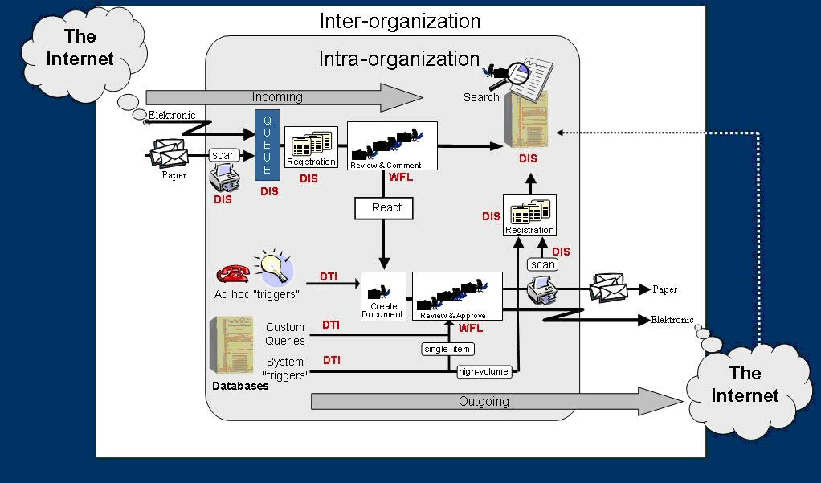
Upgrading to Windows XP Professional and Office Systems 2003 simplified IT assets and reduced TCO without creating redundant document handling systems for different line-of-business applications.
View the complete case study for more information.

Other Process Management Solutions
Process management solutions enable companies to develop processes that facilitate the flow of information to workers. Eliminating the manual task of finding information allows these workers to focus on more strategic tasks that add value to the company.
Office System 2003 integrates support for XML in a way that helps companies create new, simple, and efficient processes for everyday business functions, such as invoices, contracts, press releases, reports, presentations, customer-facing e-mails, and more. The new processes combined with the power of XML can bring all departments together and save time by eliminating the need to pass documents back and forth among departments and people.
Several companies used Microsoft solutions to increase efficiency and reduce costs through standardized workflow and business processes. The three solutions described below utilized built-in XML functionality to improve the transfer of information between people and systems.
Some companies used the integrated XML connectivity of Microsoft Office System products to improve data access to back-end systems and to improve business processes and eliminate manual activities.
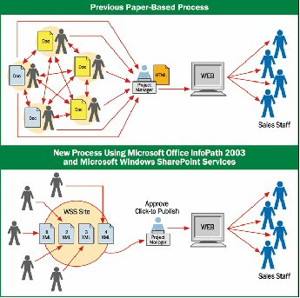
Improving Business Process With Office 2003
These solutions also provide the technology to standardize the processes that teams use when completing projects. Many of the companies developed standard templates for Windows SharePoint Services sites, thus enabling teams to utilize the same format on each project. Windows SharePoint Services alert functionality can also be used to keep processes moving without involving a project manager.
Some companies used Microsoft Office System and Windows XP Professional solutions to automate analytical reporting, making it easier for end-users to get up-to-date information whenever they need it.
Several companies used this solution to establish processes that organize teams to take advantage of business opportunities. They utilized SharePoint Products & Technologies to standardize processes across teams, making it easier to analyze and report progress, create new project teams, and increase team productivity.

Company | Solution | Business Metric
Eniro | XML-enabled aggregate information from Windows SharePoint Services sites to automatically produce status reports and run project analytics. | ⇧ 2% - Productivity  for product development teams
Franklins Solicitors LLP | Native XML capabilities link firm employees directly to Franklins' case management system increasing case management and execution efficiency. | .23% - Repeat business   5% - Case cycle time   5% - Utilization
Solutia | InfoPath forms enable trial data to be collected and saved in an off-line mode. | ⇩ 50% - Cycle Time   27% - Productivity  for clinical trials
CLE | XML capabilities of Office Word 2003 used to repurpose traditionally-published legal reference materials for Web and other media. | ⇩ 7% - Cycle Time   43% - Revenue from Web marketing
Elsevier Science | Windows SharePoint Services Meeting Workspace used to keep team members up to date. | 12% - Cycle Time  for IT Projects

Benefits of Integration and Business Intelligence
Business Intelligence enables companies to make better decisions faster than ever before by providing the right information to the right people at the right time. Employees increasingly find that they suffer from information overload and need solutions that provide the analysis to enable effective decision-making. Microsoft Office System and Windows XP Professional provide the building blocks for end-to-end business intelligence solutions that help users draw insight from business and operational data.
Business Intelligence Benefits | Description
Improved Reuse of Existing Data | Cycle time reductions averaging 39% are expected for document creation processes.
Better Decision Making | Resulting in an average estimated increase in revenues of 0.4%
Increased Productivity | Productivity increases of 0.2% to 12.3% are estimated to result from reduced rework, improved access to information, and better knowledge capture.
BI Business Value Metrics Using Windows XP Professional and Office 2003

Since different departments in a business have varying needs for consuming and reporting the same data, sharing information between departments can be difficult. Often, data output from one department is in the wrong form or file type to be opened or used by others. Critical business information is kept separate from the programs that workers know and use. This means that departments must spend extra time reworking data to fit their needs and then verifying that it remains accurate.
Through native XML capabilities, Microsoft Office System products succeed in linking critical business data directly to the user’s desktop without expensive customization. Automating information exchange reduces manual extraction that can lead to errors and increases individual productivity. Integrating data from internal and external systems shortens process cycle times and improves decision making to deliver measurable business value.

Integration Benefits | Description
Shorter Cycle Times | Users expect to be able to reduce business process cycle times between 42% and 46%.
Enhanced Revenue | Faster process cycle times, improved decision making, and improved productivity resulted in predicted revenue increases of 0.1%. Improved quality and execution of services will result in a 0.3% increase in repeat business from highly satisfied customers.
Increased Productivity | Automating manual tasks through integrating information directly into the desktop allowed two participants to estimate a direct productivity benefit from process change of 5% and 3%.
Integration Business Value Metrics

Windows XP Security Enhancements Protect Business Data
Improved security can significantly reduce costs by avoiding the productivity losses that occur when systems are damaged by viruses, worms, or hackers. Better security can also reduce lost revenue due to unplanned outages.
Windows XP Professional includes a number of features that businesses can use to protect selected files, applications, and other resources. These features include access control lists (ACLs), security groups, and Group Policy—in addition to the tools that allow businesses to configure and manage these features. Together they provide a powerful, yet flexible, access control infrastructure for business networks.
Windows XP offers thousands of security-related settings that can be implemented individually. The Windows XP operating system also includes predefined security templates, which businesses can implement without modifications or use as the basis for a more customized security configuration.
Businesses can apply these security templates when they:
- Create a resource, such as a folder or file share, and either accept the default access control list settings or implement custom access control list settings.
- Place users in the standard security groups, such as Users, Power Users, and Administrators, and accept the default ACL settings that apply to those security groups.
- Use the Basic, Compatible, Secure, and Highly Secure Group Policy templates that have been provided with the operating system.
Poorly written programs and defective device drivers are common causes of computer problems, but Windows XP Professional helps you avoid these problems by protecting important system files.
Your system files are protected by:
- Windows File Protection: Windows XP protects core system files from being overwritten when you install new programs. If a file is overwritten, Windows File Protection will restore the correct version.
- Defective Driver Blocking: Microsoft’s Windows Update Web site maintains a regularly updated database of device drivers with known issues. Visit Windows Update before you install new hardware, and the Defective Driver Blocking feature in Windows XP will prevent installation of drivers that are known to cause problems.

Case Study: Legal
Gunderson Dettmer, LLP: Law Firm Performs Conflicts of Interest Checks with 75 Percent Time Savings
Gunderson Dettmer, LLP, was founded by six partners with leading reputations in their respective practice areas, and today continues its growth by attracting lawyers of the very highest caliber. Gunderson Dettmer differentiates itself from competitors in a number of respects. By operating with relatively low overhead expenses, it is able to invest significantly more in the crucial areas of training, technology, systems, and procedures to deliver high-quality, value-added legal services on a cost-effective basis.
Gunderson Dettmer has always looked to technology to support its goals of efficiency and productivity, and its ongoing effort to streamline business processes keeps the firm in the forefront of technological innovation. With this in mind, the firm began to think about finding an automated solution to reduce the time required to perform a key business process: the conflicts of interest process.
Gunderson Dettmer implemented a Microsoft Office System and Windows XP Professional solution that streamlines its conflicts of interest process to maximum efficiency, yet yields the same reliable results as the previous system (specifically: InfoPath, Web Services, Microsoft SQL Server™ 2000 data repository, Microsoft Exchange 2000 Server, and Microsoft Internet Explorer 6
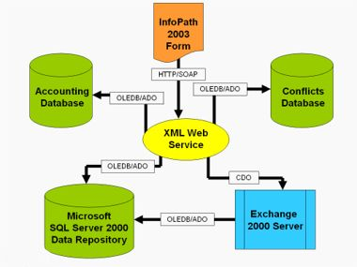
Their solution resulted in the following benefits:
- Lowered operating costs by reducing time required to do conflict checks by 75 percent for conflicts representatives, and by making it easier for attorneys to complete and review conflict-of-interest check forms and reports
- Improved system responsiveness by minimizing manual steps
- Provided framework for better reporting on new business
View the complete case study for more information.

Other Business Intelligence Solutions
Microsoft Office System and Windows XP Professional solutions provide access to information to improve decision-making and reduce inefficiencies and errors resulting from unnecessary re-creation of information. Microsoft SharePoint Products & Technologies provides improved access to files so teams can share information and avoid duplicating work. The XML capabilities of Microsoft Office System products allow information to automatically flow into analysis tools.
These solutions improve processes to transfer information throughout the company. Companies are using these solutions to develop processes to transfer knowledge between workers that have never met.
The following companies improved decision-making and work processes through better access to information. Some companies saw improvements in the reuse of existing information through increased access to files. The reuse resulted in a variety of business benefits. Some companies developed solutions to improve data analysis, providing end-users with the information they need to make better decisions.
Several companies provided better processes for transferring information which make it available on a company-wide basis.

Company | Solution | Business Metric
Hewlett-Packard | Sales Guide information saved as XML data using Word and InfoPath. Windows SharePoint Services provides access to existing materials. | ⇩ 46% - Cycle Time  for sales guide creation
BM.I | Uses InfoPath as a front-end to its SQL Server. The XML data is used by a custom coded procedure to drive work processes. | ⇧ 12% - Productivity  for administrative tasks
Wortmann | XML-enabled Excel 2003 files receive sales data from Wortmann's MBS-Navision database via XML Web services. | Improved supplier contract terms
Guidant | XML-enabled Excel 2003 spreadsheets incorporate data from company systems and perform statistical analysis. | ⇧ 3.3% - Productivity  for pricing analysts
Improved Decision-making And Work Process Metrics Using Windows XP Professional and Office 2003

Benefits of Improved Management and Administration
Improving the operational efficiency and total cost of owning their desktop environment is a great concern of IT managers. Windows XP Professional and Office System contribute to return on IT infrastructure by providing the following benefits:
- Less frequent help desk calls and lower help desk costs due to greater desktop uptime
- Less time required to deploy security patches
- Less time required to manage and avoid virus attacks
- Reduced costs of planning, deploying, and maintaining the desktop environment

Deployment Costs
Windows XP Professional was designed to drive down deployment costs and to allow organizations to standardize on a single desktop image to reduce training and support costs.

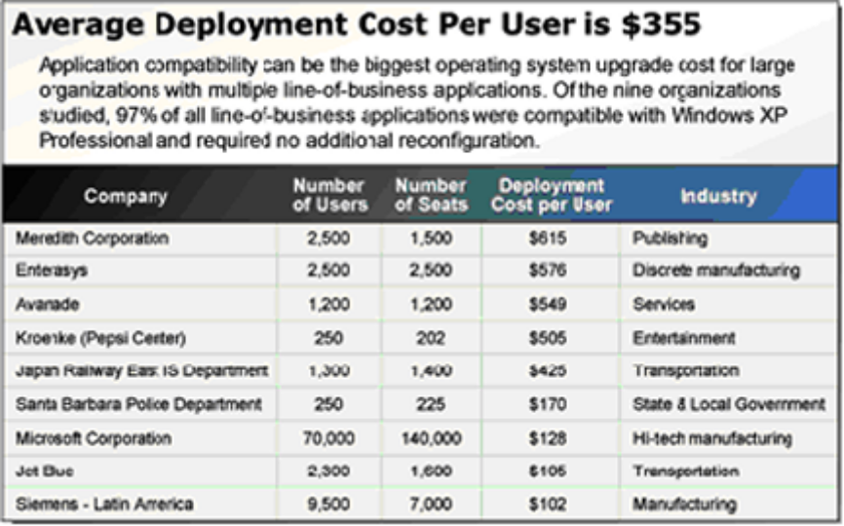
Deployment Costs

Specific administration and management features of Windows XP that helped lower total cost of ownership were:

Feature | Benefit Scenario
System Preparation tool  Microsoft's unified Help and Support Center | - Create standardized, easier-to-support desktop.  - Avoid help desk calls by putting all support services in one easily accessed place on PCs.  - Avoid costs of sending computers to repair facility.  - Reduction in support costs.
Active Directory and Group Policies  User State Migration Tool | - Use centralized client management to simplify hardware inventory process.  - Automate migration of user data and settings during maintenance tasks.  - Reduction in management costs.
Remote Assistance | - Use automated help to avoid sending IT techs to remote locations.  - Enable long-distance or peer-to-peer assistance.  - Reduction in user help desk calls.
TOC Lowering Administration And Management Features Of Windows XP Professional

Case Study: Educational Organization
Mid-America Technology Center: Large Technology School Makes Tax Dollars Go Further with Microsoft Solution
Mid-America Technology Center offers technical training to high school juniors and seniors and adults in 20 Oklahoma communities. The school has 794 students and 90 faculty and staff members.
With an IT staff of two and limited funds, Mid-America struggled to provide the latest technology. Heavy user support needs resulted in large outsourced IT costs and prevented proactive maintenance. Their main problems:
- Extended and Frequent Downtime
- High Outsourced Resource Costs
- Security Vulnerability
Although Mid-America had several compelling reasons for moving to newer technology, the school ultimately needed to simply accomplish more with better ROI of their current funding. This meant empowering their IT staff with tools to better support their user base, driver compatibility problems, and system installations. Mid-America also wanted to be able to train its students on more up-to-date technology.
Upgrading to Windows XP Professional and Office Systems 2003 resulted in the following benefits:
- Reallocated Two Full-Time IT Workers saving $69,402 annually.
- Decreased IT Consulting Costs saving $18,000.
- Decreased Time Spent on System Installations saving the equivalent of 262 full working days each year.
- Enhanced security in several areas
- Improved Experience for Administrators and Users
- Improved Driver Compatibility
- Total cost savings of $87,402 annually.
View the complete case study for more information.

Business Value of IT Infrastructure and TCO
Windows XP Professional and Office System achieved lower deployment and ongoing maintenance costs that resulted in a lower total cost of ownership than could be realized by remaining on older versions of Windows and Office software. They deliver a powerful collection of integrated programs, servers, and services that help build robust business solutions and improve productivity.

Benefits | Description
Lower support costs through quicker resolution of help desk calls | Remote Assistance and the Microsoft unified Help and Support Center help reduce the time spent providing help desk assistance by 76%.
Lower management and maintenance costs | A series of new Group Policy objects provide higher level manageability compared to Windows 2000 Professional or Windows 9x. The average annual cost saving for operating system management and maintenance was reduced by 51%.
Easier administration | Improved management tools decreased the number of desktop images an average of 74%, which enabled IT staff members to focus on other value-added activities that directly supported the business.
Lower costs for mobile and remote clients | Remote Assistance enables fewer remote user help desk calls, which reduce total calls by 25% annually.
Quicker deployment with fewer errors | Fewer desktop images decreased deployment time, and remote installation tools improved deployment efficiency, providing a $36 per-PC benefit. Those companies that deployed Office System at the same time achieved a greater economy of scale and more rapid return on investment.
Out-of-the-box compatibility | Application compatibility testing demonstrated an average 98.7% level of compatibility with packaged software applications and 97.3% of custom applications
Easier image engineering and deployment | Improved management capabilities helped reduce the number of desktop images an average 74%, which simplified deployment and enabled IT staff members to focus on value-added activities that directly support the business
TOC Metrics Using Windows XP Professional and Office 2003

Other Benefits
- Multi-language support simplifies international deployment
- Zero Touch Deployment
- Automated Security Update and Application Deployment
- Central Reporting and Administration
- More Accurate and Efficient Patch Management
- Reduction in Manual Effort to Deploy Updates

New Office System Products
With a focus on finding more business solutions that help to connect people and information in order to increase productivity and business value, and decrease expenses, Office System 2003 has added the following new programs to its product line: Microsoft Office OneNote™ 2003, Microsoft Live Communications Server™ 2003, and Microsoft Office Live Meeting Service.

Case Study: Management Consulting Organization
Cheskin: Marketing Firm Experiences Smoother Reorganization with Digital Note-Taking Program
For 55 years, the market research and consulting firm Cheskin has helped Fortune 500 clients build and refine their products and brands. With 70 employees in five cities, Cheskin collects and retains a vast amount of knowledge. Meeting notes, Web research, and client profiles were assembled on paper in file folders and in e-mail, while proposals and presentations were stored on hard drives and file servers. Accessing, finding, and reusing knowledge became progressively more difficult.
"There was a huge amount of intellectual property and experience that was collected at different times and in different forms," says Denise Klarquist, Vice President of Cheskin. "Trying to find specific information reminded me of looking into a messy, overflowing closet."
Cheskin deployed the Microsoft Office OneNote 2003 note-taking program on a combination of desktop PCs, portable computers, and Tablet PCs. Using OneNote 2003, marketing consultants easily can collect, organize, find, share, and retain ideas and information from a project's proposal stage to its completion.

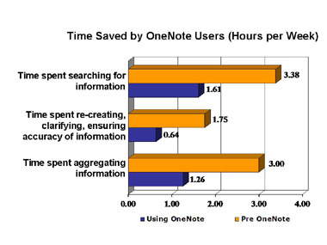
After deploying OneNote, Cheskin has realized the following benefits:
- Cost Savings with Improved Knowledge Retention and Transfer of 30% decrease in time.
- Time Savings of 50% with Increased Productivity of 15 – 30 minutes per meeting.
- Higher Employee Confidence with Improved Project Management.
- Annual productivity savings of $1,139 per user.

Cheskin projects that within four months it will recoup its investment in the OneNote deployment.
View the complete case study for more information.

Business Value of Microsoft Office OneNote 2003
OneNote is a new digital note-taking and management program that enables information workers to capture, organize, reuse, and share their notes more productively on laptops, desktops, or Tablet PCs. It enables individuals and groups to work in new and more efficient ways. OneNote strips away many of the roadblocks to information sharing and effective team collaboration, while preserving intellectual property.
Benefits | Description
Productivity | Information workers will be more productive because they will not be tied down with note-taking and note-handling logistics.
Knowledge management | Organizations can expect improvements in their knowledge management capabilities because information workers and teams will be able to communicate and collaborate more effectively and with less effort.
Decision making | Teams will have the ability to access the information they need and the advantage of having instant, up-to-date information that allows them to make more informed decisions. OneNote, especially in combination with Outlook and Windows SharePoint Services, can provide collaboration opportunities not previously available to information workers.
Opportunity costs | The opportunity costs of note-taking and note-sharing will plummet because high value information workers will no longer be bogged down with low value tasks like searching for notes and retyping them. Retrieval will be fast and sharing can be almost instantaneous. Moreover, the number of missed opportunities should also decrease because more people will have faster, more accurate and more up-to-date information.
Business Value of Microsoft Office OneNote 2003
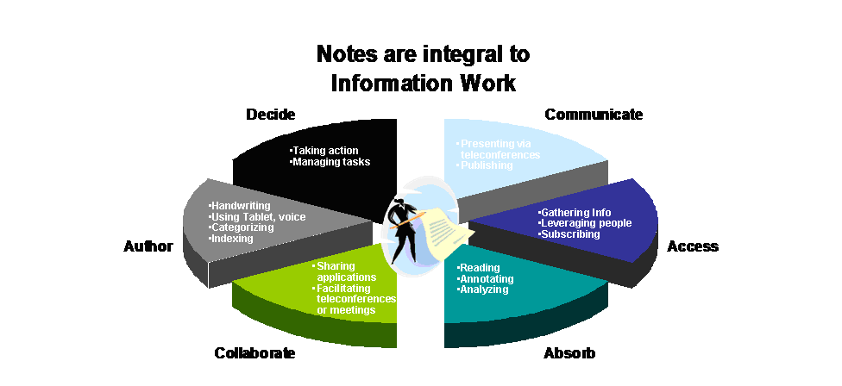

Case Study: Information Technology Organization
Neulogic:Web Conferencing Helps Slash Costs of Sales and Services by 80 Percent
Neulogic is a leading provider of Web-based communication, interaction, and branding solutions for nonprofit and other business organizations. It is the developer of neuance™, an infrastructure for Web-based communications that can be managed by nontechnical staff, which it sells in the community foundation marketplace under the name of VisionMgr.
Neulogic faced the challenges of communicating with a highly dispersed target market. Due to mounting competition and a weak economy, Neulogic needed to control its costs and price aggressively. The company also wanted to shift its product mix from custom services toward its VisionMgr self-service product—and needed a way to effectively communicate the benefits of VisionMgr to potential customers.
To address its communications needs, Neulogic uses the Microsoft Office Live Meeting 2003 conferencing service for marketing and sales, solution design and deployment, and training and support. After deploying Live Meeting, Neulogic has realized the following benefits:
- 80 Percent Reduction in Project Costs.
- 500 Percent Increase in Customer Engagement.
- Productive Meeting Environment.
- Easy Recording of Meetings for Training Purposes.
View the complete case study for more information.

Business Value of Microsoft Live Communications Server 2003
Live Communications Server 2003 provides your business with enterprise-ready instant messaging (IM), presence awareness, and an extensible platform that connects people, information, and business processes, enabling better decisions faster. Live Communications Server 2003 allows people to communicate without the constraints of geography, office location, or time zone.

Highlight | Description
Connect People and Information in Real Time | Share presence status so that everyone knows who online, offline, busy, is away, on the phone, or out to lunch.
Connect People and Information in Real Time | Use audio, video, and data collaboration features to exchange information and share applications.
Connect People and Information in Real Time | Participate in multiparty IM conversations with up to 32 people at the same time.
Designed for the Enterprise | Encrypt server-to-server IM traffic and client-to-server traffic using Transport Layer Security (TLS) or Real-Time Transfer Protocol (RTP).
Designed for the Enterprise | Manage user authentication and permissions with the Active Directory® directory service.
Designed for the Enterprise | Monitor traffic with Microsoft Operations Manager (MOM); Microsoft Management Console (MMC) snap-ins, or any management console that is compliant with Windows Management Instrumentation (WMI).
Extensible Development Platform | Add presence and other real-time capabilities—including voice and video—to asynchronous applications and collaboration tools.
Extensible Development Platform | Use server and client APIs to create custom applications and solutions.
Extensible Development Platform | Customize the user interface and integrate it into existing line-of-business applications.
Business Value of Microsoft Live Communications Server 2003

Business Value of Microsoft Office Live Meeting Service
The Live Meeting Web conferencing service helps you and your employees run and participate in interactive meetings around the world with remote teams, prospects, customers, partners, colleagues, and global audiences, in real time and at a moments notice. With everyone participating from their desktops, teams can swap ideas, share information, mark up files, collaborate with whiteboards, or negotiate deals at a fraction of the cost of travel. Live Meeting delivers organizational business value in the following ways:
- Collaborate with Groups of All Types and Sizes
- Enjoy Unsurpassed Flexibility
- Increase Productivity and Higher ROI

Highlight | Description
Two types of virtual conference rooms | Use virtual rooms designed for both larger sessions and smaller collaborative ones. Both are optimized to make it easy for you to present and for meeting attendees to have an enjoyable and productive experience.
View sharing/application sharing | Broadcast visuals, applications, Web pages, files, or software to participants in real time. Meeting attendees can see exactly what you are doing—including your mouse movements and keyboard inputs. You can also share only a portion of your screen to keep your audience focused on the key information.
Web slides | Take your audience to live Web pages. Each meeting attendee can click on links, fill out forms, or use interactive media. The preview feature allows you to see the page before you show it to meeting attendees.
Instant Polling | Receive instant feedback from meeting attendees with real-time polling. Display the results as they come in or keep them hidden from view.
Electronic whiteboards | Illustrate an idea or draw a picture for meeting attendees. All attendees can be given permission to use the whiteboard and each attendee has a different colored set of tools to use.
Send invitations | Send invites automatically to meeting attendees with Microsoft Office Outlook® or other common e-mail applications.
Secure access | Control access to meetings with meeting IDs and meeting keys, or through individual authentication with access control lists (ACLs). You can create attendee keys or require individual user IDs and passwords for each invited guest. Presenters can decide what type of access control is most appropriate.

Conclusion
The IT world of today is dramatically different than it was just a decade ago. IT systems are more complex, with computers and software distributed throughout the organization and often around the world.
Software and supporting technologies need to address the concerns and issues of those working in the information environment today. Technology can take productivity to the next level by helping employees use information better, access information away from the desk, and share information when collaborating with others.
Microsoft Office System 2003 and Windows XP Professional technologies help business leaders provide a platform that promote connected productivity for their employees and teams.
Solutions based on Microsoft Office System 2003 and Windows XP Professional demonstrate significant business value. Business value studies at 14 organizations show that Microsoft Office System applications and Windows XP Professional consistently provide a positive return on investment.
Upgrading client environments to the Windows XP Professional operating system will improve employee productivity by- increasing desktop uptime, enhancing platform security, and reducing the IT operating costs of maintaining a secure, reliable platform. In particular, organizations that upgrade from older operating systems such as Windows 9x will see greater value than organizations upgrading from Windows 2000 Professional.
Standardizing on Windows XP Professional and Office System as an enterprise desktop platform engages the best of each product. The operating system and productivity suite complement each other and help improve end-user efficiencies while decreasing IT operating expenses. These benefits can result in significant gains in revenue and operating margin.

Resources
- Windows XP Professional
- Office System 2003
- Windows XP Professional Comparison Guide
- Office 2003 Editions: Compare them to Previous Versions
- Access 2003
- Excel 2003
- FrontPage 2003
- InfoPath 2003
- Live Communications Server 2003
- Live Meeting
- OneNote 2003
- Outlook 2003
- PowerPoint 2003
- Project 2003
- Publisher 2003
- SharePoint Portal Server 2003
- SharePoint™ Services
- Visio 2003
- Word 2003
- Office System 2003 Case Studies
- Microsoft Case Studies
- Office 2003 Resource Kit
- Microsoft Office Smart Document SDK
- Microsoft Help and Support
- Deciding When to Deploy Windows SharePoint Services and SharePoint Portal Server 2003
- Using Microsoft Windows SharePoint Services with the Microsoft Office System
- Mobile Computing with Windows XP
- The Financial Benefits of Windows XP Professional
- Working Offline
- Q&A: How New Microsoft Office System Transforms Information into Business Value
- Desktop Business Value
- Empowering Business on the Desktop: Using Gartner Total Value of Opportunity

Appendix A: Microsoft Office System Products
- Access 2003 that provides a powerful set of tools that are sophisticated enough for professional developers, yet easy to learn for new users. Create or use powerful database solutions that make organizing, accessing, and sharing information easier than ever.
- Excel 2003 that enables you to turn data into information with powerful tools to analyze, communicate, and share results. It helps you work better in teams, and help protect and control access to your work. In addition, you can work with industry-standard XML data to make it easier to connect to business processes.
- FrontPage 2003 that provides the features, flexibility, and functionality to help you build better Web sites. It includes the professional design, authoring, data, and publishing tools needed to create dynamic and sophisticated Web sites.
- InfoPath 2003 that helps improve collaboration and decision-making to positively impact your business. Gather information flexibly and efficiently in rich, dynamic forms and effectively share, reuse, and repurpose information throughout your team or organization.
- Live Communications Server 2003 that provides your business with enterprise-ready instant messaging (IM), presence awareness, and an extensible platform that connects people, information, and business processes—enabling better decisions faster. With a familiar user experience integrated into Microsoft Office System programs, Live Communications Server 2003 allows people to communicate without the constraints of geography, office location, or time zone.
- Live Meeting Web conferencing service that helps businesses and their workers run and participate in interactive meetings around the world with remote teams, prospects, customers, partners, colleagues, and global audiences—in real time and at a moments notice. With everyone participating from their desktops, teams swap ideas, share information, mark up files, collaborate with whiteboards, or negotiate deals—at a fraction of the cost of travel. Communicating with people easily and quickly helps shorten sales cycles, increase productivity, and improve the bottom line.
- OneNote 2003 that combines the freedom and flexibility of paper notes with the efficiency and power of digital organizational tools. You are more productive anywhere you work with notes—in meetings, at your desk, presentations, classes, phone conferences, or brainstorming sessions. You now have one place to store all your notes and the freedom to work with them however you want. It helps you capture information in multiple ways and then organize and use it according to your needs.
- Outlook 2003 that provides an integrated solution for managing and organizing e-mail messages, schedules, tasks, notes, contacts, and other information. It delivers innovations you can use to manage your communications, organize your work, and work better with others—all from one place.
- PowerPoint 2003 that enables you to create presentations that have an impact in person or online. With user improvements and increased support for multimedia, ink markup, and smart tags, it is easier to create powerful, persuasive presentations.
- Project 2003 that lets you efficiently organize and track tasks and resources to keep your projects on time and within budget. Because of its extensive help resources and printing assistance Project is easy to learn, and you can be productive quickly. It also lets you use products like Microsoft Office PowerPoint® 2003 and Microsoft Office Visio® 2003 to present project status effectively.
- Publisher 2003 that is a complete business publishing and marketing materials solution that helps you reach out to customers. Keeping in touch and communicating with customers is essential for any business. Now it's easier than ever to design, create, and publish professional marketing and communication materials in-house.
- SharePoint Portal Server 2003 that enables enterprises to develop an intelligent portal that seamlessly connects users, teams, and knowledge. People can then take advantage of relevant information across business processes to help them work more efficiently. It provides an enterprise business solution that integrates information from various systems into one solution through single sign-on and enterprise application integration capabilities, with flexible deployment options and management tools.
- SharePoint™ Services that is a component of Microsoft Windows Server 2003 that provides tools for information sharing and document collaboration that workers and teams can use to work together with speed, security, and flexibility.
- Visio 2003 that is a diagramming program that can help you create business and technical diagrams that document and organize complex ideas, processes, and systems. Diagrams created in Visio 2003 enable you to visualize and communicate information clearly, concisely, and effectively in ways that text and numbers cannot. It also automates data visualization by synchronizing directly with data sources to provide up-to-date diagrams, and can be customized to meet the needs of your organization.
- Word 2003, the latest version of the best-selling word processor, that delivers customer-requested innovations to help you create impressive documents, control distribution of sensitive information, and work more productively with others.

Appendix B: Office 2003 Comparison Guide
The features in the table below illustrate why upgrading to the Microsoft Office System is the right choice for businesses of all sizes. Organizations that deploy Microsoft Office System solutions achieve both dramatic cost reductions and high returns by generating work process improvements in the areas of Collaboration & Portals, Work Management, Business Intelligence, Enterprise Integration, and Personal Productivity. See how it compares with previous versions of Windows.
KEY: | = Feature Included = Improved in Office 2003 Editions = New in Office 2003 Editions

Connecting People
Collaborating on Documents with Team Members
Feature | Office 97 | Office 2000 | Office System | Office 2003
Document Workspaces
Simplify the process of working with others to co-author, modify, and review files using Document Workspaces. Document Workspace are centralized sites where team members can access files, see lists of tasks, find helpful links, and collaborate. Team members can also send instant messages to each other.¹
Shared attachments
Simplify the process of working with others to co-author, edit, and review files. When you send a file as a shared attachment with Microsoft Office Outlook® 2003, you can create a Document Workspace.¹
Shared Workspace task pane
Check for updated versions of files, see if team members are online, see lists of related links and files, and view file properties. The Shared Workspace task pane is available from Microsoft Office Excel 2003 spreadsheets, Outlook 2003 e-mail messages, Microsoft Office PowerPoint® 2003 presentations, and Microsoft Office Word 2003 documents.¹
Integration with Windows SharePoint Services  Create a team intranet site and then upload files using your browser or Excel 2003, PowerPoint 2003, or Word 2003. Integration with Microsoft Windows® SharePoint™ Services enables you to use the Shared Workspace task pane, Document Workspaces, and shared attachments.¹ |  |  | Included with FrontPage 2002

Exchanging Contact Information
Feature | Office 97 | Office 2000 | Office System | Office 2003
Synchronize contacts
Using Outlook 2003 integration with Microsoft® Windows SharePoint™ Services, you can share your contacts with others to ensure that team members have the contacts they need to reach people and conduct business. Synchronize contacts on the Windows SharePoint Services site and view it from within Outlook 2003.

Organizing Meetings and Events
Feature | Office 97 | Office 2000 | Office System | Office 2003
Meeting Workspaces
Plan for and organize meetings by storing and sharing agendas, visuals, document links, attendee lists, and other documentation in a location everyone can access. Meeting Workspaces can be automatically created when you send meeting invitations from Outlook 2003.¹
Side-by-side calendars in Outlook 2003
View multiple calendars next to your own. The calendars are color-coded and labeled to help you quickly compare schedules or schedule meetings. After you open another person's calendar you can easily show or hide that person's calendar.
Events
Team members can add and store information about an event in a central location, and then export the event information directly to an Outlook calendar.
Share Outlook free/busy information
More easily schedule meetings with Outlook users who don't share a Microsoft Exchange server by providing free/busy information over the Internet.

Managing Document Changes
Feature | Office 97 | Office 2000 | Office System | Office 2003
Word 2003 editing restrictions
Lock down portions of Word documents to prevent anyone from editing sections they are not authorized to edit. Choose to allow others to make changes with revisions marks, or make the entire document read-only.
Word 2003 formatting restrictions
Lock down a document through the Protect Document task pane. Give coworkers permissions to edit content in a document, but not any of the styles that make up the document formatting.
Reviewing Toolbar
View changes by specific reviewers or by all reviewers, and then accept or reject changes one at a time or all at once.
Markup Balloons
Markups in Word 2003 and PowerPoint 2003 now appear in the right margin of the file. Balloons identify revisions and reviewer comments without obscuring the original document or presentation, or affecting its layout.

Controlling Access to Vital Business Information
Feature | Office 97 | Office 2000 | Office System | Office 2003
Information Rights Management (IRM) in Office Professional Edition 2003 files
Help reduce the risk of having confidential e-mail messages and files fall into the wrong hands, whether by accident, carelessness, or malicious intent. Specify who can receive files and set restrictions on copying, forwarding, or printing them. IRM functionality is available in Excel 2003, Outlook 2003, PowerPoint 2003, and Word 2003.²
Note Microsoft Office Professional Edition 2003 enables you to create IRM-protected content and grant other users the rights to access and modify your files or e-mail messages. With Microsoft Office Standard Edition 2003, Microsoft Office Small Business Edition 2003, and Microsoft Office Student and Teacher Edition 2003 you can read IRM-protected files and e-mail messages; with permission, you can modify them as well.
IRM document expiration dates
Give your files an expiration date, after which they cannot be viewed or shared.²
IRM organizational policy templates
Create custom templates, geared for specific use, that help protect files. For example, an organization can create a company-wide "confidential" template that helps protect sensitive documents and e-mail messages from unauthorized use.²
Digital Signatures
Use digital certificates to enable access to files or macro projects. The certificate used to create this signature confirms that the macro or file originated from the signer. The signature confirms that it has not been altered.
File password encryption  Word 2003 and Excel 2003 offer improved password security through the addition of the Microsoft CryptoAPI standard. PowerPoint 2003 now includes password encryption. |  | Simple password protection without encryption
¹ Requires Microsoft Windows Server™ 2003 running Windows SharePoint Services.
² Requires Windows Server 2003 with IRM functionality, or access to a Web service that supports IRM.

Connecting Information
Preventing E-Mail Overload
Feature | Office 97 | Office 2000 | Office System | Office 2003
E-Mail Desktop Alerts
Announcements inform you immediately of new e-mail messages coming in, no matter which program you are using. You can open or delete the e-mail message from this notification window.
E-Mail Reading Pane
Outlook 2003 makes it easier to read messages, including long ones. The Reading Pane displays twice as much content as before and reduces the need to scroll to read e-mail messages.
Enhanced privacy features
To help protect privacy and combat Web beacons, Outlook 2003 can block the download of external content from the Internet. If an e-mail message tries to connect unannounced to a Web server, Outlook blocks that connection until you decide to view the content. This feature also helps prevent you from viewing potentially offensive messages. If you're on a slow connection, it allows you to decide whether an image warrants the time required to download it.
Safe Senders/Block Senders lists
Automatically move junk e-mail messages to a folder so you can decide later whether to keep or delete the messages. The Safe Senders list tells the filters not to flag messages from senders as junk messages. The Block Senders list filters out e-mail from that sender altogether.
Improved junk mail filtering
The improved Junk E-Mail Filter can help you prevent junk e-mail messages from cluttering your Inbox. Microsoft provides updates to the filter periodically from Office Online so that it continues to be effective.

Organizing Your E-Mail Inbox
Feature | Office 97 | Office 2000 | Office System | Office 2003
Arranged By conversation
Along with grouping messages by date, size, subject, and other criteria, Outlook 2003 offers a "Conversation" option. Catch up on e-mail using a conversation-oriented view that shows only unread or marked e-mail and the specific messages that are being responded to.
Quick Flags
Tag messages by priority or time sensitivity, and then find them in whatever folder they reside. When you need to follow up on an e-mail message, flag it in one of six colors so that it's easy to find. The For Follow Up folder shows all Quick Flagged messages, regardless of the folder they are in.
Search Folders
Find e-mail messages that meet specific search criteria regardless of where the messages are stored. You no longer need to rerun common searches; instead turn your commonly used searches into Search Folders and click on them whenever you need them.¹

Saving Time with Tools
Feature | Office 97 | Office 2000 | Office System | Office 2003
Research and Reference task pane
Do research without leaving the program in which you're working. The Research task pane brings electronic dictionaries, thesauri, online research sites, and proprietary company information into Excel 2003, Outlook 2003, PowerPoint 2003, and Word 2003.²
Office Online services
Office 2003 Editions offer new and improved integration with Office Online services. More powerful, better integrated, and with an improved online interface, these services are seamlessly available in programs in Office 2003 Editions.³
Help improvements available in a task pane
Regularly updated articles and information help users accomplish their goals by making Help and useful online resources easily accessible from Assistance on Office Online in the Help task pane.
Task panes
Perform important tasks from a single location in your document. Task panes give you access to online help and templates and allow you to view open documents in that particular application, view Clipboard contents, format documents, and complete other tasks.

Application-Specific Improvements
Feature | Office 97 | Office 2000 | Office System | Office 2003
Word 2003 Reading Layout view
The Reading Layout view makes it easier to read documents online. It optimizes the document for reading on screen, including larger text, shorter lines, and pages that fit exactly on the screen.
Excel 2003 list integration with Windows SharePoint Services
Save time using Excel with Windows SharePoint Services. Select ranges of data in Excel spreadsheets to create lists in sites created with Windows SharePoint Services. If the list is linked to the Windows SharePoint Services site, any changes made to the data in the Excel worksheet are reflected in the Windows SharePoint Services site when synchronized. Excel can also be used to edit or print existing Windows SharePoint Services lists.⁴
Excel 2003 enhanced statistical functions
Excel 2003 offers enhancements in collinearity detection, calculations of sum of squared deviations, normal distributions and continuous probability distribution functions.
PowerPoint 2003 Package for CD
Package a PowerPoint presentation to a CD for broader sharing or distribution. When the recipient inserts the CD into their CD drive, the presentation automatically launches in slide-show mode using the improved PowerPoint Viewer.
PowerPoint 2003 smart tag support
Smart tags are now in PowerPoint. When a name, address, or other key phrases comes up, a smart tag icon appears that can provide additional information and options so that you can complete tasks more quickly.
PowerPoint 2003 enhanced multimedia support
PowerPoint 2003 supports additional play list formats and playback of full-screen video. Play video full screen and use playback to stop, start, rewind, or find screens from within a slide show. Supported file types include ASX, WMX, M3U, WVX, WAX, and WMA. If a media codec is not available, PowerPoint and Windows Media Player will attempt to download it.
Improved error checking in Access 2003
The new error checking feature flags common errors in forms and reports, making testing and fixing errors faster than ever. Once flagged, you can have the option to correct errors, saving more time than ever.
Field property changes in Access 2003
Field properties and all the forms or reports that have controls bound to them are updated automatically for accurate information.

Improving Performance and Administration
Feature | Office 97 | Office 2000 | Office System | Office 2003
Intelligent network detection
Local caching downloads all necessary information to your computer as it comes in—so you're not affected by network performance issues. When the mail server is unavailable due to network, maintenance, or outage conditions, you can continue to work without interruption.⁵
Outlook 2003 connectivity performance enhancements
Outlook 2003 stays connected even when you roam between network connections, making it easier to switch between working at the office or remotely. Outlook 2003 adapts for bandwidth availability. You can also choose when to download large messages, when to synchronize your Inbox and mobile device, and other ways to improve how you work in different networks.
Application and document recovery
Should an error occur, you'll have the option to save the files you're working on when the error occurs. The recovered document(s) is displayed in the Recovery task pane.
File Format Compatibility
Backward compatibility between Office 2003 Editions, Office System, Office 2000, and Office 97 (with the exception of Access 97) lets users of all four versions seamlessly share documents. Access 2003 uses the Access 2000 file format by default.

Working Mobile
Feature | Office 97 | Office 2000 | Office System | Office 2003
Inking support for the Tablet PC
If you use a Tablet PC, you can use a digital pen to annotate files in your own handwriting. Take notes, insert diagrams, or send files with comments to others.
Handwriting integration with mobile devices
Notes you take on a handheld computer can be uploaded to programs in Office 2003 Editions as text. Write directly in Word and save your work as a handwritten document or convert it to text or typed characters.
¹ Search Folders require a connection to Microsoft Exchange Server 2003.
² Some of the capabilities in the Research task pane require a connection to the Internet.
³ Office Online requires a connection to the Internet. Learn more about Office Online.
⁴ Requires Windows Server 2003 running Windows SharePoint Services.
⁵ Local caching requires Exchange Server 2003.

Connecting Business Processes
Harnessing Information from the Programs You Use Most
Feature | Office 97 | Office 2000 | Office System | Office 2003
Programmable task panes
Extensible Markup Language (XML) enables developers to create solutions that incorporate information from a variety of sources into Access 2003, Excel 2003, and Word 2003 files. Programs in Office 2003 Editions can automate virtually any task involved with creating files such as reports, spreadsheets, and forms. Using Office Professional Edition 2003, you can customize schemas and task panes to integrate with other programs or XML data sources.
XML support in Word 2003
Word 2003 supports customizable XML schemas, enabling you to open business documents that contain XML data and work with them like any other document. In addition, you can save and open XML files in Word 2003 to integrate with key business data in the organization.
Note In all Office 2003 Editions, Word 2003 documents can be saved in a native XML file format which can be manipulated and searched using any program that can process industry standard XML. With Office Professional Edition 2003, companies can also use customized XML formats—or schemas—to enable easier and more advanced information creation, capture, exchange, and reuse.
Excel 2003 Visual XML Mapping tool
Use the visual mapping tool to map a user-specified XML schema to fields in an Excel spreadsheet. The visual mapping tool makes it easy to bring XML data into a spreadsheet.
Note The Visual XML Mapping tool is available in Office Professional Edition 2003.
InfoPath 2003
Use Microsoft Office InfoPath™ 2003 to streamline and control the gathering of information that your team or organization can reuse across processes and organizations. InfoPath provides support for XML, XML Web services, and custom XML schemas. Use dynamic rich authoring and built-in validation in a WYSIWYG ("what you see is what you get") environment. InfoPath 2003 is available in Microsoft Office Professional Enterprise Edition 2003. Read the InfoPath 2003 overview.
Support for custom defined XML schemas  With extensive support for industry-standard XML, Office Professional Edition programs (Access 2003, Excel 2003, and Word 2003) can communicate with disparate back-end systems and formats. XML support in Word 2003, Excel 2003, and Access 2003 streamlines the process of accessing and capturing information between computers and back-end systems, unlocking hidden information, and enabling the creation of integrated business solutions across the organization and between business partners. |  |  | In Excel and Access | In Word, Excel, and Access

Customizing Office 2003 Editions Programs
Feature | Office 97 | Office 2000 | Office System | Office 2003
Smart tags
A set of buttons shared across Office programs, smart tags deliver a menu of context-sensitive options when and where they are needed. For example, when you paste data or make an error in an Excel formula. They provide options for completing a task quickly.
• | Context-sensitive smart tag  Automatically recognize many information types, including names, dates, addresses, telephone numbers, places, and stock symbols. Smart tags can be customized to recognize multiple types of data.
• | Paste options smart tag  When pasting data from another source, you can paste data in its original style and format, modify it to match the target document's formatting, or paste it as text only.
• | AutoCorrect options smart tag  When auto-corrections are made, you can undo or modify a correction or specify that the correction not be made again in the future.

Appendix C: Windows XP Professional Comparison Guide
The features in the table below illustrate why upgrading to the Microsoft Windows XP Professional operating system will be the right choice for businesses of all sizes. With the strengths of Windows 2000 Professional and the best business features of Windows 98, Windows XP Professional is the best desktop operating system for business. See how it compares with previous versions of Windows.
Key:
= Feature included = Feature partly supported/included = Feature not included

Dependable
Stays Up and Running
Feature | 95/98/Me | NT 4.0 | 2000 Professional | XP Professional
Built on New Windows Engine
Windows XP Professional is built on the proven code base of Windows 2000, which features a 32-bit computing architecture, and a fully protected memory model. This makes Windows XP Professional the most reliable version yet.
System Restore  The System Restore feature enables users and administrators to restore a computer to a previous state without losing data. System Restore automatically creates easily identifiable restore points, which allow you to restore the system to a previous time. | In Windows Me
Device Driver Rollback
When certain classes of new device drivers are installed, Windows XP Professional will maintain a copy of the previously installed driver, which can be reinstalled if problems occur.
Device Driver Verifier
Building on the device driver verifier found with Windows 2000, the Windows XP Professional version will provide even greater stress tests for device drivers.
Dramatically Reduced Reboot Scenarios
Eliminates most scenarios that forced users to reboot in Windows NT 4.0 and Windows 95/98/Me. Also, many software installations will not require reboots.
Scalable Memory and Processor Support
Supports up to 4 gigabytes (GB) of RAM and up to two symmetric multiprocessors.

Reduces Application Failure
Feature | 95/98/Me | NT 4.0 | 2000 Professional | XP Professional
Side-by-Side DLL Support
Provides a mechanism for multiple versions of individual Windows components to be installed and run "side by side."
Windows File Protection
Protects core system files from being overwritten by application installations. If a file is overwritten, Windows File Protection will restore the correct version.
Windows Installer
An integrated service that helps users install, configure, track, upgrade, and remove software programs correctly.

Enhances Windows Security
Feature | 95/98/Me | NT 4.0 | 2000 Professional | XP Professional
Internet Connection Firewall
A firewall client that can protect small businesses from common Internet attacks.
Encrypting File System (EFS) with Multi-user Support  Encrypts each file with a randomly generated key. The encryption and decryption processes are transparent to the user. In Windows XP Professional, EFS can allow multiple users access to an encrypted document. |  |  | No support for use with multiple users
IP Security (IPSec)
Helps protect data transmitted across a network. IPSec is an important part of providing security for virtual private networks (VPNs), which allow organizations to transmit data securely over the Internet.
Kerberos Support
Provides industry-standard and high-strength authentication with fast, single sign-on to Windows 2000-based enterprise resources. Kerberos is an Internet standard, which makes it especially effective for networks that include different operating systems, such as UNIX.
Smart Card Support
Windows XP Professional integrates smart card capabilities into the operating system, including support for smart card login to terminal server sessions.

Simplified Management and Deployment
Simplifies Desktop Deployment
Feature | 95/98/Me | NT 4.0 | 2000 Professional | XP Professional
User State Migration Tool  Helps administrators migrate a user’s data and application/operating system settings from an old computer to a new Windows XP Professional desktop computer. |  |  | As a resource kit tool with no support
Support for Latest Hardware Standards  Windows XP Professional supports the latest hardware standards. It supports UDF 2.01, the latest standard for reading DVD discs. It also supports the formatting of DVD-RAM drives with the FAT32 file system. DirectX® 8 API support will be included, and Windows XP Professional fully supports standards for Infrared Data Association (IrDA), Universal Serial Bus (USB), and the high-speed bus known as IEEE 1394. | Support for some standards listed |  | Support for some standards listed
Setup with Dynamic Update
The Windows XP Professional Setup routine ensures that the operating system files are up to date. Before any files are installed, Windows XP Professional checks the Web for critical system updates and downloads them for installation.
Unattended Installation  Provides the ability to specify a greater number of options than previous versions of Windows, and allows for a greater degree of security by encrypting passwords in the answer files. | Support for subset of options | Support for subset of options | Support for subset of options
Internet Explorer 6 Administration Kit
Internet Explorer 6 is more customizable via the Internet Explorer Administration Kit (IEAK 6), so it's easier to deploy and maintain the browser. Version 6 of the IEAK adds control over new features such as the Media bar, Auto Image Resize, and the Personal bar.
System Preparation Tool (SysPrep)  SysPrep helps administrators clone computer configurations, systems, and applications. A single image, which includes the operating system and business applications, can be restored to multiple different machine configurations. |  | Version 1.0 available as download
Setup Manager
A graphical wizard that guides administrators in designing installation scripts.
Remote OS Installation
Can be installed across the network (including SysPrep images). Note: This feature requires the Active Directory™ service.
Multilingual Support
Allows users to easily create, read, and edit documents in many languages with the English version of Windows XP Professional. The Multilanguage User Interface version lets you change the user interface language for each user.

Improves Desktop Management
Feature | 95/98/Me | NT 4.0 | 2000 Professional | XP Professional
Remote Assistance
Remote Assistance enables a user to share control of his or her computer with someone on a network or the Internet. An administrator or friend can view the user's screen, and control the pointer and keyboard to help solve a technical problem. IT departments can build custom solutions, on top of published APIs using HTML, to tailor Remote Assistance to their needs, and the feature can be centrally enabled or disabled.
Group Policy
Group Policy settings simplify the administration of users and objects by letting administrators organize them into logical units, such as departments or locations, and then assign the same settings—such as security, appearance, and management options—to all employees in that group. There are hundreds of new policies available for Windows XP Professional, in addition to those provided for Windows 2000 Professional.
Resultant Set of Policy (RSoP)
Allows administrators to see the effect of Group Policy on a targeted user or computer. With RSoP, administrators have a powerful and flexible base-level tool to plan, monitor, and troubleshoot Group Policy.
Improved Help and Support Services  The Help and Support Center combines features users are familiar with from previous versions of Windows (such as Search, Index, and Favorites) with content from the World Wide Web to give users more chances to get the help they need when they need it. If the content in the Help and Support Center doesn't answer their question, it can be used to contact a friend, a support community, or a professional to get assistance. Tools such as My Computer Information and System Restore are also available to diagnose and fix common problems. | Subset of features in Windows Me
Automatic Updates  With the user's permission, Windows XP Professional automatically downloads critical and security updates in the background when the user is connected to the Internet. These downloads are designed to minimize the impact on Internet browsing, and the update automatically resumes upon reconnection if the computer is disconnected before the download is complete. Once the update has been downloaded, the user can choose to install it. | Subset of features in Windows Me
Windows Update Improvements
As application compatibility updates, new device drivers, and other updates are released for Windows XP Professional, they become available on the Windows Update Web site. (Users can also find critical and security updates here, if they choose not to use automatic updating.) Administrators can disable user access to Windows Update. The Windows Update Catalog is provided for administrators to download updates and deploy them as appropriate in their organizations.
Microsoft Management Console (MMC)
Provides a centralized and consistent environment for management tools.
Recovery Console
Windows XP provides a command-line console for administrators to start and stop services, format drives, read and write data on a local drive, and perform many other administrative tasks.
Windows Management Instrumentation (WMI)  Provides a standard infrastructure for monitoring and managing system resources. | Subset of features |  | Subset of features
Safe Mode Startup Options
Allows Windows XP Professional to boot the system at the most basic level, using default settings and minimum device drivers.

Increases User Efficiency
Feature | 95/98/Me | NT 4.0 | 2000 Professional | XP Professional
Adaptive User Environment
Windows XP Professional adapts to the way you work. With a redesigned Start menu, the most frequently used applications are shown first. When you open multiple files in the same application, (such as multiple e-mail messages in the Outlook® messaging and collaboration client) the open windows will be consolidated under a single task bar button. To remove some of the clutter from the notification area, items that are not being used will be hidden. All of these features can be set via Group Policy.
Improved Handling of File Associations
If you are trying to open a file that is not associated with any program, Windows XP Professional can send you to a Web page from which to download or purchase the right program. Also, some file types, especially media and image files, become difficult to open because they are used with many programs and their associations change. For these files, if the associated program has been uninstalled, Windows XP Professional restores associations with default programs, such as Microsoft Image Viewer. Default programs are integrated with the operating system so the files are always easy to open.
Context Sensitive Task Menus
When a file is selected in Windows Explorer, a dynamic menu appears. This menu lists tasks that are appropriate for the type of file selected.
Integrated CD Burning
Windows XP Professional has integrated support for burning CDs on CD-R and CD-RW drives.
Easily Publish Information to the Web
Files and folders can be easily published to any Web service that uses the WebDAV protocol.
DualView
A single computer desktop can be displayed on two monitors driven off of a single display adapter. With a laptop computer, a user could run the internal LCD display as well as an external monitor. There are a variety of high-end display adapters that will support this functionality for desktops.
Troubleshooters  Help users and administrators configure, optimize, and troubleshoot numerous Windows XP Professional functions. | Partial subset of features | Partial subset of features | Partial subset of features

Built for Mobile and Remote Users
Revolutionizes the Way Remote Users Work
Feature | 95/98/Me | NT 4.0 | 2000 Professional | XP Professional
Remote Desktop
Let a user access his computer and any programs and data on it, from any computer, anywhere with network access. Using Microsoft’s Remote Desktop Protocol (RDP), a user could connect over the Internet and control the powerful computer in his office, while using a low-powered computer at an airport kiosk.
Credential Manager
A secured store for password information. It allows users to input usernames and passwords once, and then have the system automatically supply them.
Offline Files and Folders  A user can specify which network-based files and folders she needs when she disconnects from the network. Additionally, with Windows XP Professional, offline folders can now be encrypted to provide the highest level of security. |  |  | Without encryption support
ClearType
A new text display technology that triples the horizontal resolution available for rendering text through software.
Offline Viewing
Makes entire Web pages with graphics available for viewing offline.
Synchronization Manager
Lets users compare and update their offline files and folders with those on the network.
Enhanced Online Conferencing
TAPI based applications, such as NetMeeting® 3.01 conferencing software, will benefit from advances in audio and video streaming.
Improvements in audio conferencing include:
Support for new codecs to improve quality and interoperability.
Support for the DirectSound® API to reduce latency and improve mixing.
Acoustic Echo Cancellation (AEC), Acoustic Gain Control (AGC) and reduced ambient noise.
Improved jitter buffer control and silence suppression algorithms to reduce latency and improve quality.
Improvements in video conferencing include:
New codecs to improve quality and interoperability.
Support for new cameras.
Support for the DirectDraw® API to improve video performance.
Support for lip-synchronization to improve synchronization of video and voice.
Support for larger video sizes.
NetMeeting 3.01 will be able to connect with multi-point conferences hosted on Exchange 2000 Conferencing Server.

Extends Laptop Capabilities
Feature | 95/98/Me | NT 4.0 | 2000 Professional | XP Professional
Improved Power Management
By intelligently monitoring CPU state, Windows XP Professional can reduce the amount of power it is using. The operating system will provide more accurate data on the amount of power left, which will prevent the system from shutting down prematurely. Also, by allowing for the system to wake up as the battery nears a drained state, the computer can be put into hibernation, and save work in progress. Power management can now be set for each computer, or each user on a computer.
Hibernate
After a set time, or on demand, Windows XP Professional will save memory to disk, and shut the power down. When power is restored, all the applications are reopened exactly as they were left.
Hot Docking  Lets you dock or undock your notebook computer without changing hardware configuration or rebooting. |  | Support only available via 3rd party driver
Advanced Configuration and Power Interface (ACPI)  Provides the latest in power management and Plug and Play support. | Windows 98 & Windows Me

Simplifies Networking
Feature | 95/98/Me | NT 4.0 | 2000 Professional | XP Professional
Wireless Networking
Provides secured access, as well as performance improvements, for wireless networks.
Network Location Awareness
Provides an underlying service that allows the operating system and applications to determine when a machine has changed network locations.
Network Setup Wizard  Makes it easy for a small business owner to set up and manage a network. The Wizard walks through key steps, such as sharing files and printers, sharing the Internet connection, and configuring the Internet Connection Firewall. | Subset of features in Windows Me
Network Bridge  Simplifies the setup and configuration of small networks that use mixed network connections (such as Cat-5 Ethernet and wireless) by linking the different types of networks together. | Subset of features in Windows Me
Internet Connection Sharing (ICS)  Connects a small office network to the Internet, using a dial-up or broadband connection. Windows XP Professional can provide network address translation, addressing, and name resolution services for all computers on a small business network to share a single connection. | Windows 98SE and Windows Me
Easier Remote Access Configuration Wizards  Guide users through the steps for setting up remote access to a network or virtual private network (VPN). | Windows Me
Peer-to-Peer Networking Support
Enables Windows XP Professional to interoperate with earlier versions of Windows on a peer-to-peer level, allowing the sharing of all resources, such as folders, printers, and peripherals.

