Act as a Senior UI/UX Art Director. Analyze my web project and create a visual direction for its interface.
Project: "ChargeUA" - an EV charging station aggregator in Ukraine with a real-time availability map and interactive cost/time calculator.
Target Audience: EV drivers in Ukraine (both experienced owners needing fast DC ports and new owners needing cost calculation and guidance).
Brand Colors: Royal electric blue (#005EC9), dark slate-navy (#0F172A), and pure white (#FFFFFF).
Determine: 1. visual style; 2. logo style; 3. icon style; 4. hero image style; 5. lighting; 6. shapes; 7. background style; 8. typography; 9. visual consistency rules for a modern 2026 responsive website. Provide a concise visual design specification.
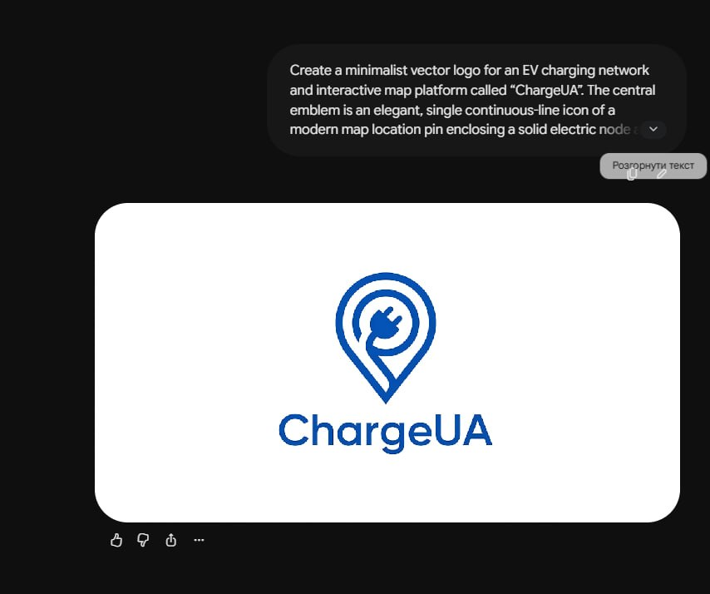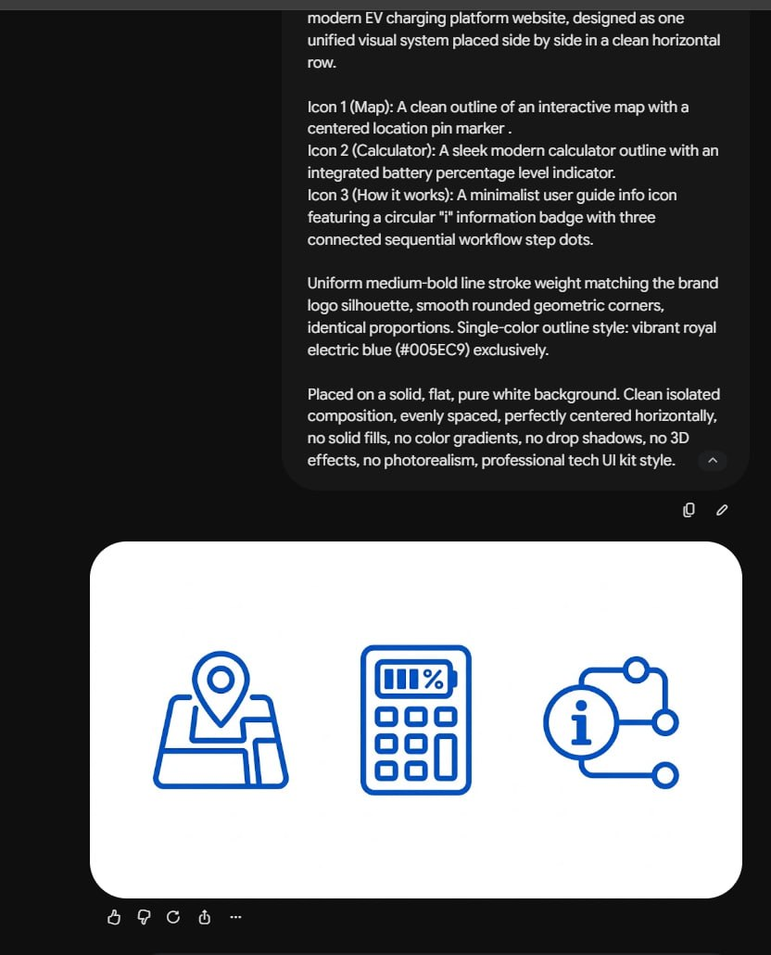A cohesive set of three minimalist vector line icons for a modern EV charging platform website, designed as one unified visual system placed side by side in a clean horizontal row.
Icon 1 (Map): A clean outline of an interactive map with a centered location pin marker .
Icon 2 (Calculator): A sleek modern calculator outline with an integrated battery percentage level indicator.
Icon 3 (How it works): A minimalist user guide info icon featuring a circular "i" information badge with three connected sequential workflow step dots.
Uniform medium-bold line stroke weight matching the brand logo silhouette, smooth rounded geometric corners, identical proportions. Single-color outline style: vibrant royal electric blue (#005EC9) exclusively.
Placed on a solid, flat, pure white background. Clean isolated composition, evenly spaced, perfectly centered horizontally, no solid fills, no color gradients, no drop shadows, no 3D effects, no photorealism, professional tech UI kit style.
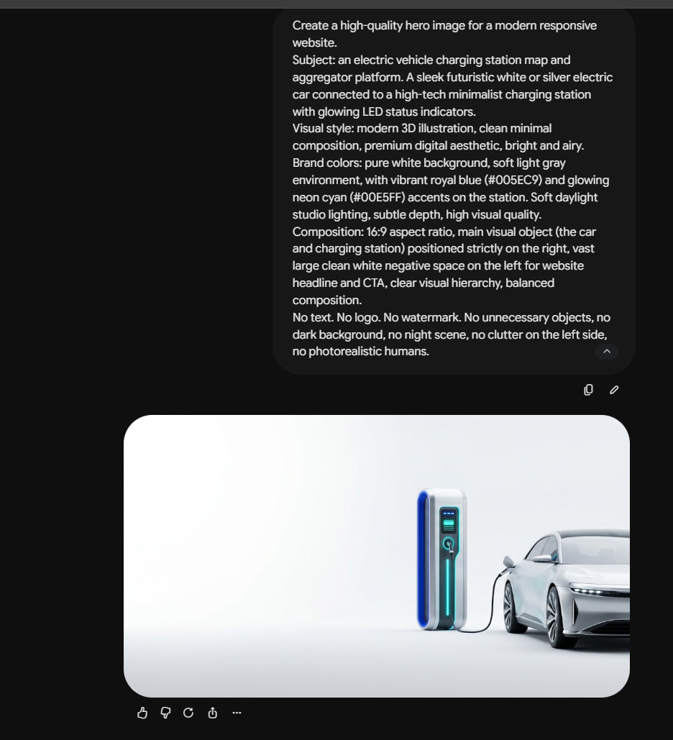Create a high-quality hero image for a modern responsive website.
Subject: an electric vehicle charging station map and aggregator platform. A sleek futuristic white or silver electric car connected to a high-tech minimalist charging station with glowing LED status indicators.
Visual style: modern 3D illustration, clean minimal composition, premium digital aesthetic, bright and airy. Brand colors: pure white background, soft light gray environment, with vibrant royal blue (#005EC9) and glowing neon cyan (#00E5FF) accents on the station. Soft daylight studio lighting, subtle depth, high visual quality.
Composition: 16:9 aspect ratio, main visual object (the car and charging station) positioned strictly on the right, vast large clean white negative space on the left for website headline and CTA, clear visual hierarchy, balanced composition.
No text. No logo. No watermark. No unnecessary objects, no dark background, no night scene, no clutter on the left side, no photorealistic humans
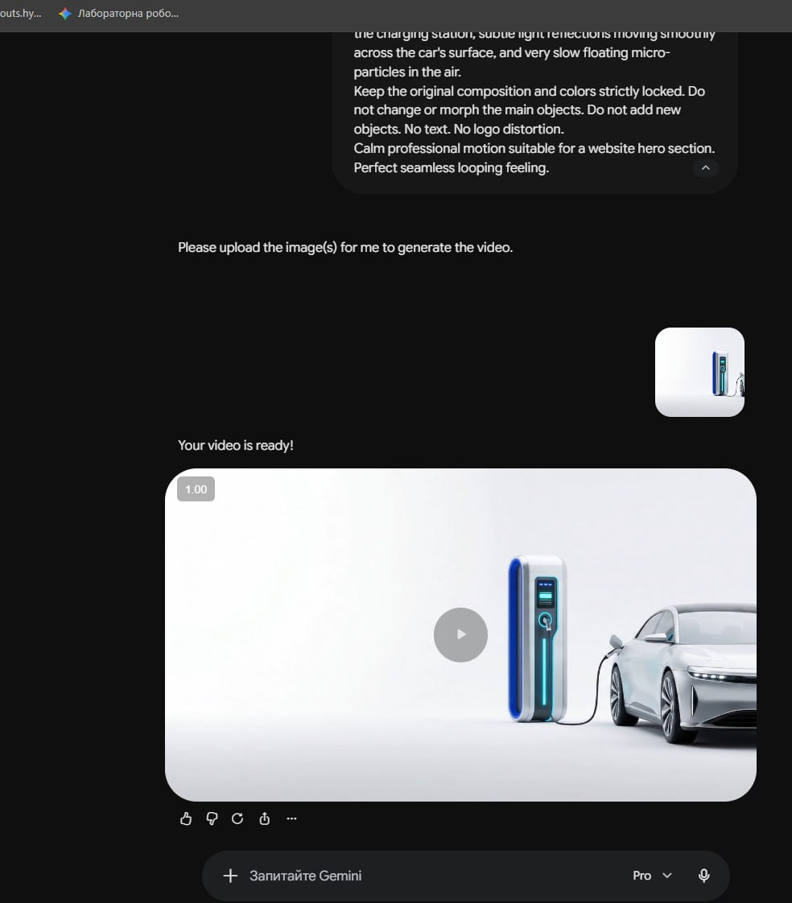
Animate the provided hero image into a subtle cinematic website background.
Motion: COMPLETELY STATIC CAMERA. Zero camera movement, no panning, no zooming. Only animate micro-details: gentle pulsing of the glowing LED status indicators on the charging station, subtle light reflections moving smoothly across the car's surface, and very slow floating micro-particles in the air.
Keep the original composition and colors strictly locked. Do not change or morph the main objects. Do not add new objects. No text. No logo distortion.
Calm professional motion suitable for a website hero section. Perfect seamless looping feeling.

