<Project Name>
project charter
Version <1.0>
02/24/2025

VERSION HISTORY
Version # | Implemented  By | Revision  Date | Approved  By | Approval  Date | Reason
1.0 | Созанський Андрій | 17.02.2025 | Мельник Назарій Борисович | 17.02.2025 | -
UP Template Version: 11/30/06

TABLE OF CONTENTS
1 Introduction 4
1.1 Purpose of Project Charter 4
2 project And Product Overview 4
3 Justification 4
3.1 Business Need 4
3.2 Public Health and Business Impact 4
3.3 Strategic Alignment 4
4 Scope 5
4.1 Objectives 5
4.2 High-Level Requirements 5
4.3 Major Deliverables 6
4.4 Boundaries 6
5 Duration 7
5.1 Timeline 7
5.2 Executive Milestones 7
6 budget Estimate 7
6.1 Funding Source 7
6.2 Estimate 7
7 High-Level Alternatives Analysis 8
8 Assumptions, Constraints And Risks 8
8.1 Assumptions 8
8.2 Constraints 9
8.3 Risks 9
9 Project Organization 9
9.1 Roles and Responsibilities 9
9.2 Stakeholders (Internal and External) 10
10 project Charter approval 11

Introduction

Purpose of Project Charter
The Book Shelf project charter documents and tracks the necessary information required by decision maker(s) to approve the project for funding. The project charter should include the needs, scope, justification, and resource commitment as well as the project’s sponsor(s) decision to proceed or not to proceed with the project. It is created during the Initiating Phase of the project.
The intended audience of the Book Shelf project charter is the project sponsor and senior leadership.

project And Product Overview
Dmytro Savchuk and Andrii Sozanskyi are engaged in the software implementation of the design developed by Kseniia Vibla. The database logic was set up by Andrii Kovtunenko, and testing is performed by Surgii Baranov.
Duration - 4 months
Budget - 7100 USD

Justification

Business Need
Bookshelf is a personal library management application that allows users to store information about books, track reading time, and categorize books by genre. The main function of the application is to help users monitor their reading progress and not forget about planned books.

Public Health and Business Impact
The program helps you keep track of time and reading progress, preventing you from forgetting about unread books.

Strategic Alignment
Goal | Project Response Rank | Comments
Scale: H – High, M- Medium, L – Low, N/A – Not Applicable
NC / Division / Branch Strategic Goals:
Improving personal organization and management of user data. | H | -
Creating a convenient tool for keeping track of books read. | M | -
CDC Strategic Goals:
- | N/A | -
Department of Health and Human Services (DHHS) Strategic Goals:
Supporting educational initiatives and developing a reading culture. | M | -
Promoting mental health by encouraging reading and improving cognitive skills. | M | -
DHHS IT Goals:
Use of information technology to organize user personal data. | H | -
Automating the collection and analysis of data on reading progress. | M | -
President’s Management Agenda (PMA) Strategic Goals:
Supporting digital solutions for the development of education and culture. | L | -
Using technology to improve the effectiveness of self-education. | L | -

Scope

Objectives
The objectives of the Book Shelf are as follows:
- Allow Users to Create and Manage a Personal Library: Users can add books by providing details such as the title, author, genres, and a brief description for each book.
- Track Reading Progress: The app provides a dedicated section to track reading progress, showing the percentage of the book completed, time spent reading, and session details.
- Enable Session Time Tracking: Users can monitor their reading sessions with specific timestamps, helping to gauge their reading habits and overall progress.
- Facilitate Easy Book Management: Users can edit and organize their books in a user-friendly table format, allowing for efficient management of their library.

High-Level Requirements
The following table presents the requirements that the project’s product, service or result must meet in order for the project objectives to be satisfied.
Req. # | I Requirement Description
Book Entry Functionality | Users must be able to input book details such as title, author, genres, and description, with the ability to edit and update these details later.
Reading Progress Tracking | The app must track the user’s reading progress, displaying the percentage of the book completed and the time spent reading.
Session Time Logging | The app should track individual reading sessions, recording the start time, end time, and the duration of each session.
Table View for Books | Books must be displayed in a structured table format, allowing easy viewing, sorting, and filtering by title, author, or genre.
User-Friendly Interface | The app must have an intuitive and easy-to-navigate interface for entering data, viewing progress, and managing books.
Session Summary | After each session, a summary (including reading time and progress made) should be provided to the user.

Major Deliverables
The following table presents the major deliverables that the project’s product, service or result must meet in order for the project objectives to be satisfied.
Major Deliverable | I Deliverable Description
Book Library Management System | A fully functional system that allows users to create, view, edit, and organize a library of books with details such as title, author, genres, and description.
Reading Progress Tracker | A feature that tracks and displays the user’s reading progress for each book, including percentage completed and time spent reading.
Session Time Logging Mechanism | A component that records the start and end times of reading sessions, tracking the duration of each session and storing them for future reference.
Progress Visualization Feature | A visual progress indicator, such as a progress bar, to show how far the user has progressed in reading each book.
Interactive Book Table | A user-friendly table interface where books can be displayed and easily sorted or filtered by title, author, genre, and reading progress.
Session Summary Report | A report that summarizes each reading session, showing time spent and progress made, providing the user with insights on their reading habits.
User Interface Design | A well-designed, intuitive user interface that ensures easy navigation, entry of book details, and tracking of reading progress.

Boundaries
Inclusive Boundaries:
Book Management: Users can input and manage book details (title, author, genres, description).
Reading Progress: Track and display reading progress, including time spent and percentage completed.
Session Logging: Record the duration and details of each reading session.
User Interface: A simple, user-friendly design for navigating and interacting with the app.

Exclusive Boundaries (Out of Scope):
Book Purchasing: The app will not handle purchasing or downloading books.
Social Features: No social sharing or integration with external platforms.
Advanced Analytics: No in-depth data analysis or recommendations based on reading habits.
User Accounts: The app will not require accounts or user profiles.

Duration

Timeline
10/02
15/02
28/02
18/03
System Development
Completed
Developed Prototype
Requirements Analysis
Completed
Project Plan Completed

Executive Milestones
The table below lists the high-level Executive Milestones of the project and their estimated completion timeframe.
Executive Milestones | Estimated Completion Timeframe
Project planned and authorized to proceed | Two weeks after project concept is approved
UI/UX design completed | Four weeks after project initiation
Core functionality (book entry, reading progress, session logging) implemented | Ten weeks after project initiation
Testing and debugging completed | Fourteen weeks after project initiation
Beta version released | Sixteen weeks after project initiation
Final version completed and deployed | Twenty weeks after project initiation

budget Estimate

Funding Source
Financing from the CEB

Estimate
This section provides a summary of estimated spending to meet the objectives of the Book Shelf project as described in this project charter. This summary of spending is preliminary, and should reflect costs for the entire investment lifecycle. It is intended to present probable funding requirements and to assist in obtaining budgeting support.
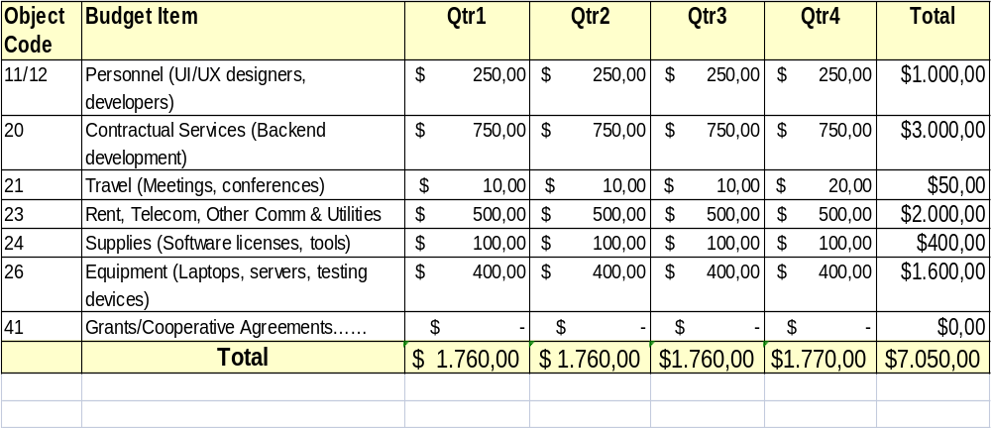

High-Level Alternatives Analysis
Using Existing COTS Products
- Considered options like Goodreads, Notion, or Google Sheets.
- These provide some necessary features but lack full customization.
Extending Existing Systems or API Integration
- This offers convenience but limits data control and user experience.
Developing a Custom Solution
- Chosen for full control over data, table structure, and reading progress tracking.

Assumptions, Constraints And Risks

Assumptions
Users will manually enter book details (title, author, genres, description) into the system, as there is no automatic data import from external sources.
Users will track their reading progress within the app, meaning the system must store session data, including reading time and percentage completed

Constraints
Limited development time – The project must be completed within a specific timeframe, requiring efficient planning and prioritization of features.
Resource constraints – The system relies on available storage and processing power, meaning optimizations are necessary to ensure smooth performance.

Risks
Risk | Mitigation
Users may find manual data entry time-consuming, leading to lower engagement. | Consider adding an optional feature for importing book details via an API in future updates.
Data loss due to unexpected crashes or user errors. | Implement an auto-save feature and allow users to export/import their data.
Limited development resources may delay feature implementation. | Prioritize core features first and plan future updates based on user feedback.
Users may forget to log their reading sessions, affecting progress tracking accuracy. | Introduce reminders or automated tracking options to improve consistency.

Project Organization

Roles and Responsibilities
This section describes the key roles supporting the project.
Name & Organization | Project Role | Project Responsibilities
Vasyl Honchar  Innovative Technologies LLC | Project Sponsor | Person responsible for acting as the project’s champion and providing direction and support to the team. In the context of this document, this person approves the request for funding, approves the project scope represented in this document, and sets the priority of the project relative to other projects in his/her area of responsibility.
Andrii Melnyk  Administration of the city of Ternopil | Government Monitor | Government employee who provides the interface between the project team and the project sponsor. Additionally, they will serve as the single focal point of contact for the Project Manager to manage CDC’s day-to-day interests. This person must have adequate business and project knowledge in order to make informed decisions.  In the case where a contract is involved, the role of a Government Monitor will often be fulfilled by a Contracting Officer and a Project Officer.
Nataliya Kravchuk  Global Justice Org | Contracting Officer | Person who has the authority to enter into, terminate, or change a contractual agreement on behalf of the Government. This person bears the legal responsibility for the contract.

Stakeholders (Internal and External)

Internal Stakeholders:
- Project Developer(s) – Responsible for designing, developing, and maintaining the application.
- Product Owner/Manager – Defines requirements, prioritizes features, and oversees project progress.
- QA/Testers – Ensure the app functions correctly and meets user expectations.

External Stakeholders:
- End Users (Readers & Book Enthusiasts) – Individuals who will use the app to track their books and reading progress.
- Potential Investors or Sponsors – Entities interested in funding or supporting the project for further development.
- Beta Testers – Early users providing feedback to improve the application's usability and features.

project Charter approval
The undersigned acknowledge they have reviewed the project charter and authorize and fund the Book Shelf project. Changes to this project charter will be coordinated with and approved by the undersigned or their designated representatives.

Signature: | X | Date: | 24.02.2025
Print Name: | Anatoliy Abobusovych
Title: | Sponsor
Role: | Project Sponsor

