man [object] //manual of all, structured like pages manual
info [object] //hypertext-based manual, but for not all Linux objects, is wrote info

whatis [object] //searching in NAME columns in manuals [object]
apropos [object] //searching everywhere in manuals [object]

whatis intro // manuals sections (basically 9).

[object] - command, system calls e.t.c.

echo Hello, world! //output in console text Hello, world!
echo “Hello, world! “ //output in console text Hello, world!
date //date
cal //calendar

//repeat all, that input in console
cat
Any test
Any test
Ctrl+D

keys
who -m //one letter key
who --me //multi letter key
who –help

-o //often output to standard output

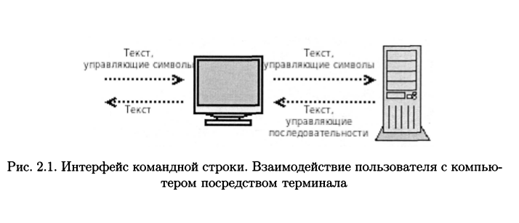
type [command] //type of command
type - a [command] //type of command in all variants
type -t [command] //type type of command

Files

file file //type of file

pwd //print working directory
car //print file to screen
ls -F //files different from catalogs

Как правило, с . начинаются имена конфигурационных файлов
и конфигурационных каталогов

что . текущего каталога. Следующее имя в списке, /.
/.. это имя-сылка на родитель ский каталог.
cd ~ //return to home catalog
cd ~user //return to user home catalog

mkdir catalog //create “catalog” catalog

mv [file] /catalog //copy file to catalog
cp [file] /catalog //copy file to catalog

HARDLINK

