Master’s thesis project plan

Tentative title:

The role of experience in ketamine therapy: Searching for EEG markers of ego dissolution in TR-D patients with ketamine infusion and investigating its links to treatment alleviation.

Description of research problem:

Depression is a severe mental disorder that affects around 5% of the adult world population (WHO, 2021). Approximately 30% of MDD patients do not experience any alleviation from either antidepressant therapy, talking therapy, or combinations (Zhdanova et al., Little, 2009). They are generally a high-maintenance clinical population, costing the US around $45 billion yearly (Mrazek et al., 2014). Therefore, finding new treatment options for this vulnerable group can be highly cost-efficient if the effects are lasting.

Ketamine has been shown to have fast-acting antidepressant effects when used in lower dosages, with a recent review finding ketamine to have a robust antidepressant effect 4 hours after administration (77%) and a medium effect 72 hours after treatment (43%) (Katalinic et al., 2013). In addition, as ketamine has been used extensively for clinical purposes, its safety is well documented (Hyde, 2015), making it a strong candidate for psychedelic therapy against depression.

There is a debate in the ketamine treatment field regarding the importance of the experience and the treatment outcome (Hyde, 2015). Many pharmacological companies like Johnson & Johnson and Seelos construct similarly structured compounds to patent with *less* psychedelic dissociation effects. They argue that this will make the substances more tolerable but equally efficient. There are mixed findings on their efficacy, and the role of experience in treatment outcomes is still in the air.

In order to better understand the role of experience, our research team will collect EEG data from patients receiving ketamine infusion at Østfold Sykehus. We will also administer questionnaires regarding their mood and expectations before their treatment and questions about their psychedelic experience after the infusion. We will then use this data as predictors of treatment outcome, e.g., six months later, and consider the role of ego dissolution. This preliminary study strives to establish the role of ego dissolution in ketamine treatment for TR-D patients. Thus, future studies could use control groups that receive S-ketamine, which has fewer “psychedelic effects,” and compare it to the efficiency of another group with racemic ketamine.

Theories / Litterature

*EEG-markers of ketamine*

Some researchers claim that there are no good markers for dissociation when using EEG frequency spectrum analysis (Chamadia et al., 2016). However, other studies have found reduced alpha power in humans' precuneus and temporal-parietal junction (Vlisides et al., 2018) or complete flatline in sheep (Nicol et al., 2020). The latter study used 24 mg/kg, which is around 24x as much as humans receive, so it is possible that they were completely anesthetized. Another interesting study by Williams et al. (2018) administered a placebo or naltrexone before 0.5 mg/kg ketamine, and these participants only varied in antidepressant effects, not the degree of dissociation. Furthermore, Tagliazucchi et al. (2021) argue in their study that using a baseline EEG screening to estimate the likelihood of mystical experiences with positive clinical effects could potentially be helpful. However, it is still unclear whether such a marker exists or can be used in ketamine administration. Thus, two questions remain: Can we measure markers of ego dissolution in TR-D patients, and does ego dissolution predict improved symptom alleviation? EEG screening for patients receiving ketamine treatment should only be used if both are true, at least concerning ego-dissolution.

Other findings:

* **Shuttler et al. 1987**:
  + EEG slowing was *most significant* for the racemic mixture compared to the enantiomeric versions.
  + There was a decrease in median frequency of around 7.6 Hz.
* **Maximow et al. 2006**:
  + S-ketamine compared with propofol treatment in high anesthetic dosages
  + Observed higher gamma-band frequencies in the ketamine group compared to propofol
* **Akeju et al. 2016:**
  + Anesthetic levels of ketamine
  + Increased alternating gamma and theta oscillations and decreased alpha/beta frequencies.
* **Farnes et al. 2019:**
  + Sub-anesthetic levels of ketamine measure complexity in spontaneous and response-evoked brain activity (the latter uses TMS).
  + Found increased signal diversity in spontaneous EEG activity, especially when participants kept their eyes open.
* **Castro-Zaballa et al. 2019:**
  + Researchers compared sub-anesthetic levels of ketamine with REM-sleep gamma-band activity. They also compared this activity with quiet wakefulness, alert wakefulness, and NREM sleep.
  + Found high gamma power and decreased cortical coherence during ketamine and REM.
* **Salle et al. 2016:**
  + Double-blinded sub-anesthetic and placebo-controlled study.
  + Measured the frequency-specific current source density (CSD) and found ketamine-induced decreased theta, alpha, and delta frequencies and increased gamma

*Ego dissolution and treatment alleviation*

There are still debates about whether dissociation and ego dissolution are side effects to be avoided or beneficial aspects of the psychedelic experience. For instance, one study administered a placebo or naltrexone before 0.5 mg/kg ketamine, and these participants only varied in antidepressant effects, not in the degree of dissociation (Williams et al., 2018). Additionally, Sumner et al. (2021) found a greater antidepressant effect for the participants who experienced greater changes in phenomenology. Some argue that the enantiomer esketamine is better for patients because it limits the amount of dissociation since it is four times as effective as the racemic version (Correia-Melo et al., 2018). However, a study by Bahji et al. (2021) demonstrated that racemic ketamine –considered *more* dissociation-inducing – had higher remission rates and lower dropout rates. An ayahuasca study found a strong positive correlation between ego dissolution and changes in affect, satisfaction with life, and mindfulness (Uthaug et al., 2018). Furthermore, a meta-analysis of classic psychedelic drugs found positive correlations between ego dissolution and therapeutic remission (Kaluzna et al., 2022). However, the included studies varied greatly and did not measure ketamine-induced ego dissolution. Roseman et al. (2017) performed a 25 mg of psilocybin study for 20 participants. They found that Oceanic Boundlessness and Dread of Ego Dissolution significantly explained 54% of the variance in depression symptoms five weeks later.

Methods

*Study design*

An experimental study with single trial measures and two population samples: TR-D patients and healthy volunteers. Both sample groups will receive a ketamine infusion of around 0.5 mg/kg for 1 hour and questionnaires before and after the experiment.

*Data collection*

Trained physicians will collect and sample the data at Kongsberg and Østfold hospitals. We will monitor and manage the EEG equipment ourselves, as well as the questionnaires. We will perform the EEG analysis and questionnaire statistics, and a biochemist, Dr. Attila Szabo, will perform the saliva analysis.

*Analysis plan*

To test if ego-dissolution is a significant predictor of symptom alleviation, we will perform a multiple regression with ego-dissolution scores, stress levels, and pre-infusion mood and expectancy as predictors of improvement in symptom alleviation. We will perform a Pearson correlation between ego-dissolution scores and different spectral frequencies to check for EEG markers of ego dissolution. We might also perform a regression to check if ego-dissolution scores can predict specific spectral EEG frequencies and vice versa. This part is speculative, so our methods might change.

Distribution of the work

Birger Bang and I, Andreas Massey, will collect the EEG data and write the thesis based on our findings, supervised by Andre Sevenius, our external supervisor, and Carsten Bundt, our internal supervisor. Ingrid Autran at Østfold hospital will administer the ketamine infusions to the patients, and Gernot Walter Ernst will do the same at Kongsberg hospital. Attila Szabo will perform the saliva analyses, although this might not be used in the current thesis.

Ethical approval

We have received approval from REK and NSD to perform our study at Østfold hospital. However, We will submit an updated application to administer ketamine to healthy volunteers at Kongsberg hospital before the 1st of September. We are also developing a cooperation agreement between Østfold hospital and the medical faculty.

Economical resources

We are entirely funded by Andre Sevenius’ lab, with at least 1000 kr per participant available if necessary. This will cover travel expenses and food after they have fasted for the saliva samples.

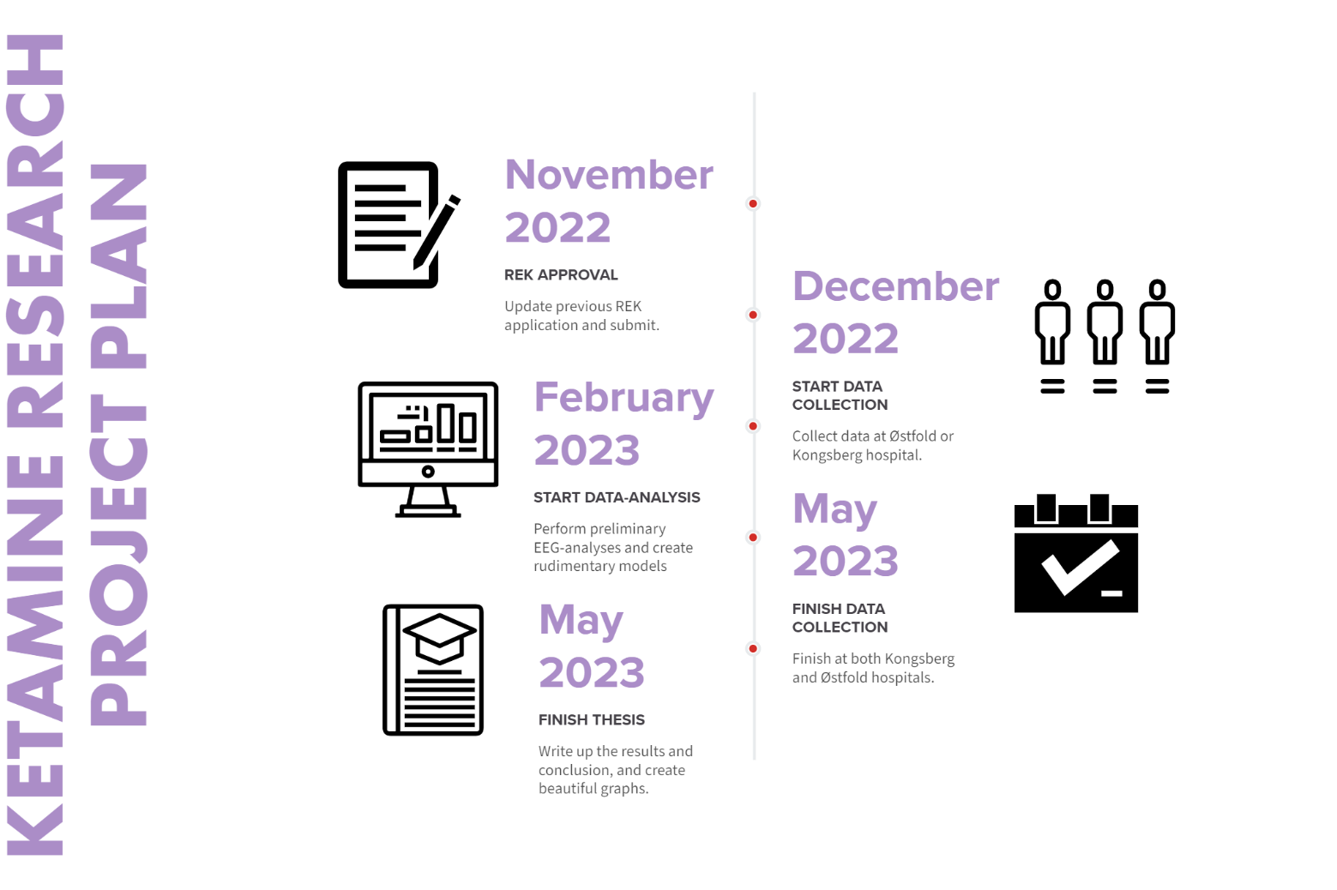

Supervisor signature:_____________________ Date: _____________

Student signature: _______________________ Date: _____________