**Canned**

**Cool Band Names Studio**

**Design Document**

**April 11 2017**

**Gold Ver.**

# **Design details:**

**Canned**

**You're a garbage can, not a garbage can't**

**A story of a shelved AI trying to see the world**

**Target Audience:**

Our game is targeted ESRB rating of E, as the light-hearted theme of our game will be suitable for people of all ages. Additionally, the charming aesthetic of the game will appeal to all genders. This game will especially be attractive to those who enjoy stealth and puzzle games that requires thinking, but still want something with a light-hearted aesthetic as it does not involve any combat or violence.The game will be built in GameMaker: Studio and will available for PC. It will be a single player experience.

#### **Setting**:

##### **Time:**

Our game is set in the time period of the relatively near future. This allows for the existence of new technologies introduced in the game, such as automated cameras and mobile trash cans.

##### **Location:**

The majority of the game is set inside an advanced underground research facility, NASA (Norther Alberta Science Administration). The building is located in a secluded part of northern Canada, where top scientists are researching/designing general purpose AI. The four floors (levels) in this building are key locations in the game, which will be explained in details under **Level Design**. The final key location appearing in the game is the “outside world”, which is shown through a cutscene at the very end of the game. This will depict nature, showing trees and mountains, in stark contrast to the inside of the facility.

##### **Backstory:**

GAR-8, a.k.a Garb, was originally programmed to be a general purpose AI, but was disposed of by scientists due to its “malfunction”. Ever since it had a chance to see the picture of the world outside of the facility - trees, mountains, nature - Garb got caught up on this concept of “outside”. This desire to see the world overrode its original programming. Deemed unfit for its intended purpose, researchers decided to shelve the unit down in the cold storage. However, Tom, the guard decided that Garb is not worth the effort, and throws him away into the garbage can. Broken and miserable, but with an ever strong desire to see the outside world, it uploads itself into the garbage can and was able to gain mobility, though at the expenditure of unassisted sight. Even then, Garb has not given up on the idea of wanting to see nature. its goal now is to escape the facility, relying on the skill to hack into facility’s devices, and to see the outside world.

#### **Characters:**

##### **GAR-8 (Garb):**

General Artificial Reasoner. Protagonist of the game and player character. A strong fixation with the outside world has made it useless in the eyes of its creators, Garb possesses the skills it had in the original body such as hacking. Even without sight, it is full of curiosity and hope, anticipating the time that it will finally get to see nature. Due to its nature of being an AI, Garb will have access to certain cameras in the facility, but will also require to hack into a control box to gain access to some.

##### **NPCs:**

**Dave**:

Dave is an old researcher who took part in testing of GAR units. He noticed that Garb has potential, but admits that he isn't fit for its intended purpose and decide to shelve him. He later meets Garb again when it gets onto the second floor. Impressed with its everstrong desire to leave the facility, he decides to give Garb a hand.

**Tom:**

A guard who originally was ordered to shelve Garb in the storage, but instead decided to throw it out. He shows up in the opening cutscene and in one of the game level.

Several named NPCs will show up throughout the game (Ralph, Sam, Anja, Sunny), however they do not play a significant role storywise and are present to set the atmosphere of the facility.

**Enemies:**

There will be three enemy NPCs appearing in the game: Guards, Researchers, and Janitors. They will act as obstacles and provide backstory for the game, details about them will be explained under **Mechanics**.

#### **Narrative**

**Choices**:

Our game will follow a linear storyline and players will not have choices within the plot. They will have a choice in how they will solve the puzzles - they could try to be as stealthy as possible, or go head on into darkness. The ending will be done in a way that the fate of Garb is ambiguous. Thus player choice also comes into play after the game is finished, as it is up to them to interpret the ending in their own way.

We want this game to feel like a journey between the player and Garb, and convey a sense of hopefulness. The game will start with a dark and miserable mood. However, as the game progresses, the mood will become brighter and hopeful, reflected by changes in level environments.

**Key Events**

**Introduction:**

The first key event in the game is the opening cutscene. Here, you see the back of Garb in its AI form staring at a picture of nature. Two scientists beside it are testing other GAR (general artificial reasoner) units. Once they get to Garb, Dave asks him test questions, yet Garb only answers with the word “outside” as it got mesmerized by the concept of it. Even though one of the researchers - Dave - realized its potential, he decides to shelve Garb as it isn't fit for its intended purpose as a GAR unit. He gives Garb to Tom, a guard, to put him in the underground storage. However, thinking that it isn't worth the effort he throws Garb into a garbage can. Broken and miserable, but still with a strong desire to leave the facility, Garb uploads itself onto the garbage can, granting itself mobility. Scene fades to black, and the game starts.

**Meeting Dave:**

In the research level, Garb will meet Dave again as he is about to get caught by the janitor. Dave takes hold of the janitor, Sunny, and checks inside the garbage can. Recognizing Garb, he takes it into his office and asks him if it still wants to go outside. Garb confirms this with enthusiasm. Impressed with its determination, Dave decides to give Garb a hand by helping him escape the level.

**Floors:**

Arriving at each of the floors (Cold Storage, Second storage, Research area, Main floor) are key events throughout the game. The change in the environment and mood at each level will convey that players are getting closer to their destination. Each floor will become cleaner and brighter in mood, indicated by changing environmental (art) and sound design.

**Ending:**

As Garb comes out of the facility, the screen will be pitch black, as there are no cameras outside to hack into and thus preventing Garb from being able to see. While Garb stands in front of the facility disappointed, Dave comes out from the building. He understands that Garb can only see through cameras, and presents it with a portable camera that will allow it to see the outside world. They bid farewell and Dave goes back into the building. Finally being able to see the world, it walks down the path and the final cutscene begins. This cutscene shows Garb’s back and the world of lush greeneries in the background. As it moves forward, a beeping sound comes from its body, indicating that its battery is at a critical level. Its body wobbles as it moves further. The scene ends with Garb rolling off into the distance with its battery beeping, telling the players that its fate is undetermined. Roll credits.

**Worldbuilding elements:**

Information and backstory about the setting, facility, and Garb will be incorporated directly within the game levels by NPC dialogues.

**Dialogues:**

**INTRO CINEMATIC**

*Still on picture, with a slow zoom out*

Dave: Unit, what is your designation?

GAR-7: General Artificial Reasoner 7.

Dave: What is your purpose?

GAR-7: To compute and assist.

Dave: Where can you be used?

GAR-7: Anywhere.

*Looking at GARB*

Dave: Unit, what is your designation?

GAR-8: Outside!

Dave: [Hmm] What is your purpose?

GAR-8: Outside!

Dave: [Sigh] Where can you be used?

GAR-8: Outside!

*Dave & Researcher*

Researcher: Is this unit defective?

Dave: No, it’s just… stuck.

Researcher: We cannot release this unit .”

Researcher: It is broken.

Dave: No! No, it shows promise...

*GARB given to Tom (Guard)*

Researcher: Very well, we will not destroy it.

Researcher: Tom, take this to Level 4 Storage.

Tom: Fine…

GAR-8: Outside?

*Level 4 Storage*

Tom: You’re not worth the effort

[Crash]

-Cut to game-

**Level 3 Room 1** (room_level3_room1)

Room start, 2+ Guards

Guard to another Guard, before they start their pathing routes:

Guard (Ralph): “Good morning Sam.”

Guard (Sam): “ Mornin’ Ralph.”

**Level 3 Room 2** (room_level3_room2)

Room start, 3 Guards, 1 Researcher

Guard(Tom) talking to Researcher by the elevator

Researcher: “Tom, Did you put that GAR unit into storage?”

Guard(Tom): “I did. Should have just canned it though, if you ask me.”

Researcher: “I agree. Although unique, it is defective.”

Researcher: “Besides Dave is retiring in a month, let us entertain him until then.”

Guard(Tom): “I guess…”

Researcher: “ We will need you upstairs soon.”

Guard(Tom): “I will be right up, I just need to grab something first”

*\*Researcher leaves through elevator\**

**Level 2 Room 2** (room_level2_room2)

Room Start, 3 Researchers, Dave (unique), 1 Janitor

->Pudding drone paths to Dave’s office

Dave is pathing between 3 different Researchers

Researcher(Sarah): “Dave, can you have a look at this?”

*\*Dave pauses with Sarah for a few seconds\**

Researcher(Alison): “What do you think of this, Dave?”

*\*Dave moves to Alison for a few seconds\**

Researcher(Luke): “.......help…” (smaller font)

*\*Dave moves to Luke for a few seconds\**

-> This is Dave’s path, dialogue does not repeat

If GARB is spotted by Dave

Dave: “What is this doing here?”

*\*GARB caught noise\**

Dave: “Let’s see what we have-”

*\*cut to Dave’s office\**

If GARB makes it to the elevator, Janitor(Sunny) that was hidden from cameras captures you

Janitor(Sunny): “What?... What is this trash can doing here?”

*\*GARB caught noise\**

*\*Dave hears, exclamation point pops up, paths to Sunny\**

Dave: “Wait! Can I see what’s in there?”

Janitor(Sunny): “Lose something Dave...Again?”

Dave: “... Yes.”

*\*cut to Dave’s office\**

**Level 2 Dave’s Office** (room_level2_office)

Room Start

->Pudding drone is on the table

Dave talks to GARB, GARB is by the door, player has no control

0Dave: “GAR-8! You’re suppose to be in storage!”

1Dave: “Why are you broken? Tom must have thrown you in here...”

2Dave: “...”

3Dave: “No one else saw that you have a ‘ghost’.”

4Dave: “I do. You are doing more.”

5Dave: “More than what any of the GAR products are suppose to do.”

*Dave turns away moves up, GARB looks at Dave*

6Dave: “This is amazing, a breakthrough! The amount we could learn from you!”

7Dave: “Think of the possibilities!”

8Dave: “First we will disassemble you, then-”

*Dave looks back at GARB*

9Dave: “...”

*Walks back to GARB

10Dave: “GAR-8… Garb… I can’t keep you here.”

11Dave: “It wouldn’t be right.”

12Dave: “Not for something that is *alive*.”

13Dave: “...”

14Dave: “Do you still want to go outside?”

*\*GARB chirps cheerfully\**

15Dave: “Great! Let me give you a hand”

*\*cut to Level 2 Room 2\**

**Level 2 Room 2** (room_level2_room2)

After Dave’s Office in-game cutscene

->Dave and Garb just outside of Dave’s Office

Dave calls out

Dave: “Hey Sunny! Do you want some pudding? I have extra.”

Sunny: “Do you even have to ask?”

Dave: “And, by the way, have you seen ‘The Measure of a Man’?”

*\*Sunny moves to Dave, both enter his office\**

-> The elevator is now able to be used freely

**Outside** (room_level1_ending)

Room Start, all dark

->player can’t move

GARB: Outside!

GARB: Outside?

GARB: Outside...

Dave comes out of the building

*\*Door noise\**

Dave: “It was obvious how you could move about, but I had to think of how you could see.”

Dave: “How you could get past all those people.”

Dave: “It was the cameras!”

Dave: “But more importantly, it was you.”

Dave: “So, I have this-”

*\*Thunk as camera is put on Garb\**

Dave: “I hope it helps.”

-> very simple hacking puzzle pops up

Hacking puzzle completed

Dave: “Can you see now?”

*\*GARB chirps happily\**

Dave: “The world is more beautiful than what a mere picture can capture.

Dave: “Go. Experience it in for yourself, Garb.”

Dave: “Satisfy your ‘ghost’. See it all.”

Dave: “ And good luck.”

*\*GARB chirps\**

Player can move around, everything is revealed, player cannot go back inside

When player goes to the end of the road in the room, cut ending cinematic.

#### **Mechanics:**

##### **Main Mechanics:**

The main mechanics of the game is to reveal the path to the exit of the room by using limited sight, and navigate to it undetected. Rooms are micro-levels that present new puzzles of increasing difficulty to the player. Each room will start with majority of the space covered in darkness representing Garb’s lack of sight. The cameras will already be active and revealing parts of the room. Players will always be able to know where Garb is at all times, as it will be outlined. Using the cameras strategically placed around the room, players must navigate to the exit. Cameras will remove the darkness and reveal the dangers and obstacles of the room. Players will only be able to remove the darkness through cameras. Control Boxes appear once every level of the game. These control boxes will have a hacking minigame in order to access the guard’s body cameras. Although our game is a stealth game, it will not incorporate any combat. Thus, players will have to strategically avoid enemies instead of fighting them.

##### **Enemy NPCs:**

There are three enemy NPCs that appear in this game. If caught by these enemies, the player will be returned to the beginning of the room. All NPCs will react to thrown garbage.

- **Guards** (low difficulty): Easiest enemy to avoid as they have body cameras that are allowed to be hacked into and function as mobile vision for Garb. Body cameras are connected to control boxes. However the body camera control box will always have a hacking minigame. Garb will be able to hide in front of guards just by standing still, however it will not be able to move in front of them, otherwise Garb will be caught. They will appear throughout the game in every floor.

- **Researchers** (mid difficulty): Researchers function the same way as guards, but without body cameras. People cannot know their location at all times They first appear on the third floor, but will appear predominantly on the research level.

- **Janitors** (high difficulty): Hardest enemy in the game to avoid. They have no body cameras. There is an instant failure mechanic if detected by the janitor regardless of whether Garb is moving or not. Janitors will also react to thrown garbage however, will hover around thrown garbage area longer than guards and researchers. They will appear only on the very last floor (main lobby).

Garb will be able to throw garbage to distract the NPCs. Garbage will be thrown in the direction faced and will travel a max distance before stopping unless it collides with an object first.

Players that are detected “?” can stop or run away to avoid being caught “!”.

When caught “!” the room will restart.

Players will use the keyboard to control the game. Arrow keys will be used for movement. "E" will be used to interact with control boxes placed around the room. “Space” will be used to throw garbage, and “Shift” will make Garb stop moving instantly.

##### **Smaller Mechanics:**

The hacking minigame will involve solving a simple connect the wires that will enable the guards body camera vision to be visible. There is only one in each level.

**Challenges:**

Using limited vision of the in-game world to traverse through levels and rooms will be the main challenge to the players. They also have to avoid enemy NPCs with varying difficulty. Players will overcome these challenges by strategically using game mechanics to their advantage, including hacking, garbage throwing, and deducting where a NPC will be based on what’s currently visible. The tutorial level will familiarize players with these mechanics.

#### **Level Design:**

* There will be four floors, or “themes” of levels in the game. Each of these floors will have two rooms within them. The rooms are self contained puzzles that Garb will have to navigate through. The exits of each room will be normal doors however the ending of a floor will be marked by an elevator. Each floors will have at least one hacking mini game. This game can be finished in 8 minutes of gameplay, however, with the difficulty, it is aimed to be completed in 18 minutes

**Tutorial - Cold Storage:**

* Starts with a cutscene (around 30 seconds), introducing Garb and the premise of the game.
* When revealed by cameras, the place is gloomy, dirty, and has an industrial feel to it. There is trash scattered around the floor and some puddles of water.
* 2 rooms: one to introduce the players to the basic controls and mechanics of the game, and another to introduce the first enemy - the guard.
* Estimated time of completion is around 3 minutes.
* The music is be slow and gloomy.

**Level 2 - Storage Area:**

* 2 rooms
* Majority of the enemies will be guards, but will have one researcher on the second room to foreshadow the next level.
* Will be cleaner and a bit brighter than the previous level, but still dark and dingy.
* 3-5 minutes for the player to complete the level.

**Level 3 - Research area:**

* Researchers will appear predominantly, and guards will be present as well.
* Will be much cleaner and brighter than the first two floors in terms of environment and mood. Will resemble research facilities and office
* The path to the elevator will be more difficult and intricate. It will also be populated with more enemies.
* 2 rooms. On the last room of the level, the cutscene with Dave will occur.
* 5 - 8 minutes for the player to complete the level.

**Level 4 - Main Office/Lobby:**

* Final and hardest level. Will include all the previous enemies shown and introduce Janitors as the new enemy.
* Will be the cleanest level, with potted plants
* 2 levels
* As the player completes and exits the level, the final cutscene plays (around 30 seconds), leading directly to the ending.
* 5 - 8 minutes for the player to complete the level

#### **Music/Sound:**

Our music and sound design will change throughout the game to match the theme of each floor and show progression through the game. The tone of the music will turn from dark and gloomy to a more peppy hopeful sound as Garb approaches the outside world.

The sound effects for dialogue are simple one syllable vocals, with tone appropriate to what is being said. Garb speaks in high, intonated beeps of varying pitch depending on the mood. Interaction effects always have a rhythm.

**Music and Sound Credits**

**Soporific - Kevin MacLeod (incompetech.com)**

**Licensed under Creative Commons: By Attribution 3.0 License**

[**http://creativecommons.org/licenses/by/3.0/**](http://creativecommons.org/licenses/by/3.0/)

**Laser Groove- Kevin MacLeod (incompetech.com)**

**Licensed under Creative Commons: By Attribution 3.0 License**

[**http://creativecommons.org/licenses/by/3.0/**](http://creativecommons.org/licenses/by/3.0/)

**Chill Wave- Kevin MacLeod (incompetech.com)**

**Licensed under Creative Commons: By Attribution 3.0 License**

[**http://creativecommons.org/licenses/by/3.0/**](http://creativecommons.org/licenses/by/3.0/)

**Wisps of Whorls- Kevin MacLeod (incompetech.com)**

**Licensed under Creative Commons: By Attribution 3.0 License**

[**http://creativecommons.org/licenses/by/3.0/**](http://creativecommons.org/licenses/by/3.0/)

**Comfortable Mystery 3- Kevin MacLeod (incompetech.com)**

**Licensed under Creative Commons: By Attribution 3.0 License**

[**http://creativecommons.org/licenses/by/3.0/**](http://creativecommons.org/licenses/by/3.0/)

**Fluorescent Lights Shutting Down - FreqMan (freesound.org)**

**Licensed under Creative Commons: By Attribution 3.0 License**

[**http://creativecommons.org/licenses/by/3.0/**](http://creativecommons.org/licenses/by/3.0/)

**Foundation - Clark Powell (CREA Soundtrack)**

**With permission from original artist**

[**https://clarkpowell.bandcamp.com/**](https://clarkpowell.bandcamp.com/)

#### **Art:**

In order to convey the feeling of an advanced science facility, we want the art style of our game to be neat and clean. Thus we will likely be staying away from 8-bit style and gravitate toward smooth, vectorized style. Our game will use 2D graphics.

**Character Sprites:**

All the character sprites will be built using Adobe Illustrator. Garb is designed in a way to appear charming and likeable, in order to foster a bond between the character and players. We admit that it is difficult to tell that it is a garbage can, thus this information will be conveyed in the intro cutscene. Each NPCs will be designed so that they can be differentiated by different appearance. Guards will be wearing a blue caps as well as blue uniforms with a body camera attached to it. Researchers will be wearing traditional white lab coats, and janitors will be wearing grey coveralls.

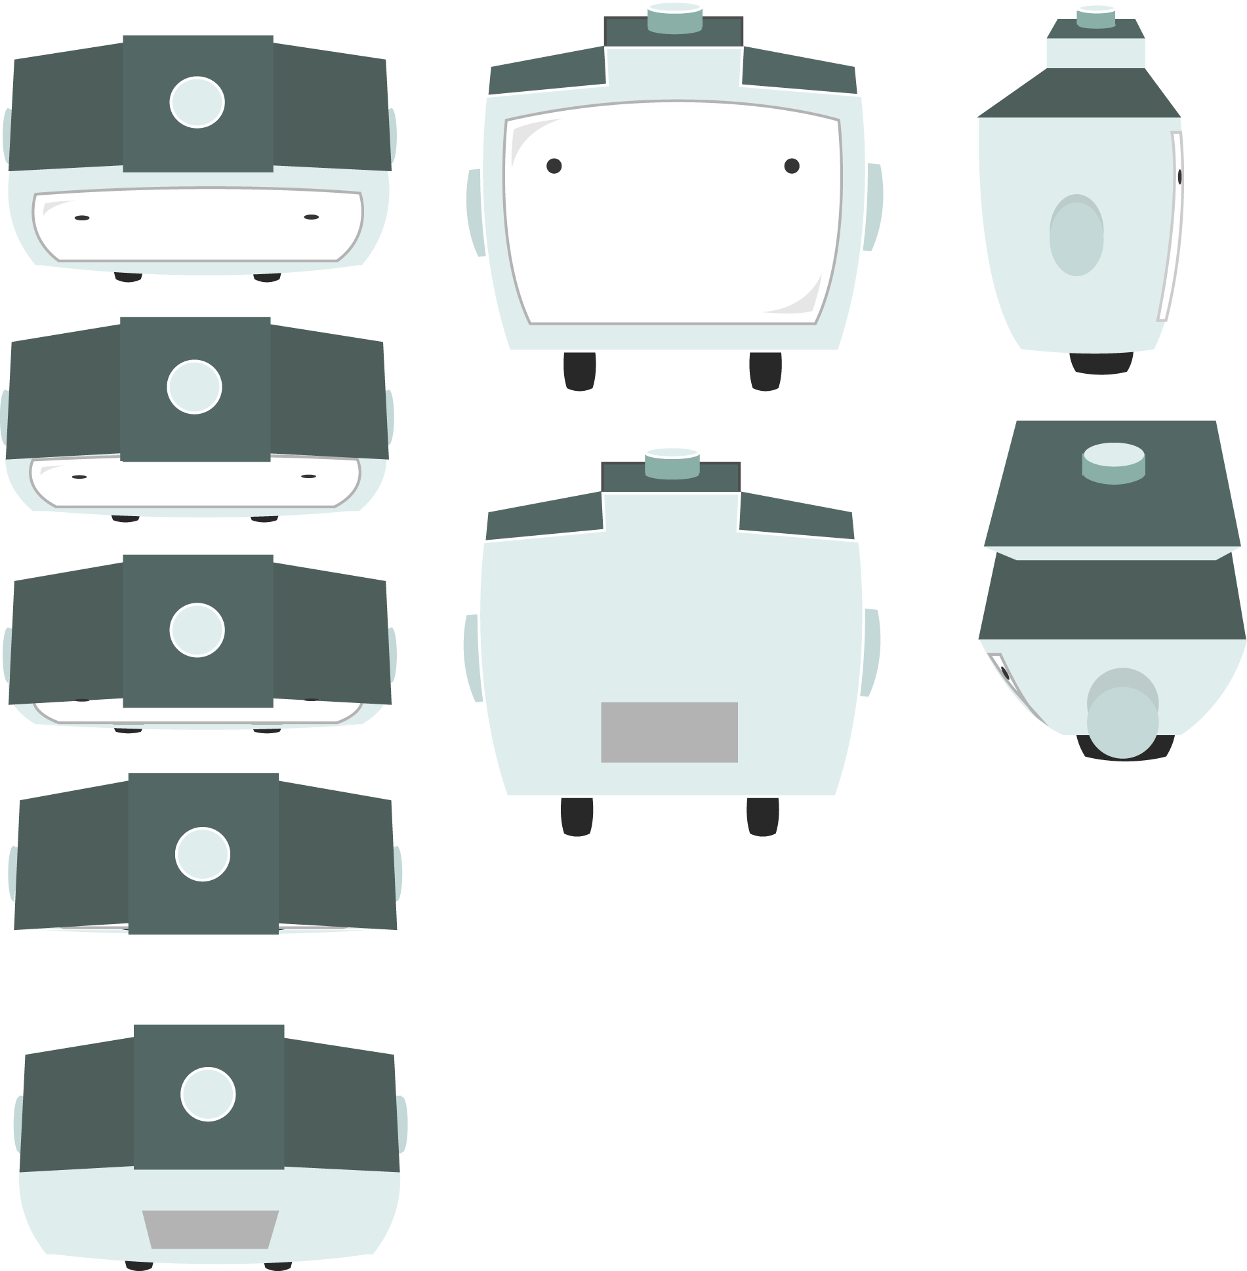

Concept and turn-around views of G.A.R.B

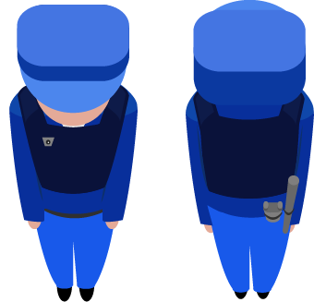

Guards concept

##### **Environment:**

Levels will have a top-down view, with a slight tilt to give it an illusion of depth. 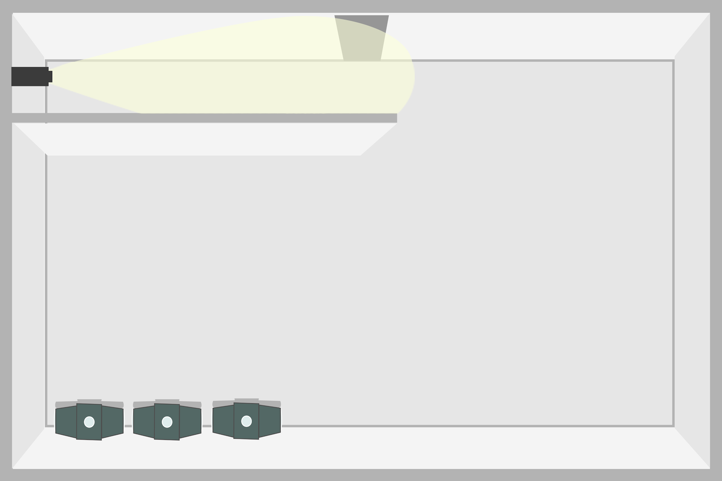

Example of a top-down view. The GAR units at the bottom are place holders to test the in-game perspective.

##### **Cutscenes:**

There are two major narrative cutscenes - one at the beginning of the game and another at the end.

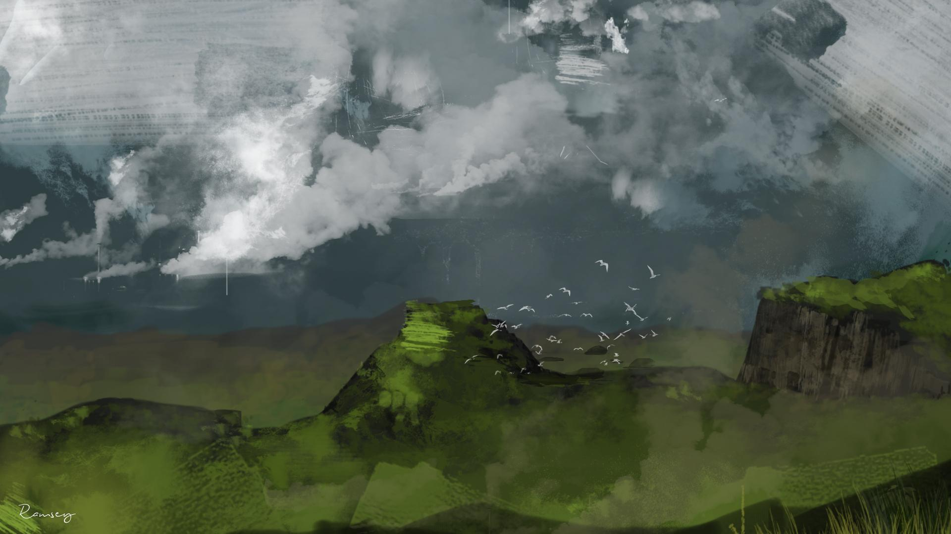

Shown here is a previous work and example of what the artstyle is going to look like for said cutscenes. Shots will be done in a more painterly style and placed at the beginning and end of the game to cinematically progress the narrative. Some aspects of them may be animated (some layers in Photoshop) to push them to be more dynamic and integrated with the rest of the game.

They will be an in-game cutscene as well which will carry on the in game art style rather than painterly one.

# **Production Details**

**Milestones and Internal Deadlines**:

**M1**: Team formation Jan 13 @ 6pm

**M2**: Concept pitch Jan 24 @ 10am

**M3**: Design document - Jan 31 @ 6pm

**M4**: Vertical slice I - labs of Feb 13 week.

* Get the tutorial level done (1 room on L1). Include:

1. Programming:
   1. Cameras, NPCs (guards), access points, limited vision (dark fog).
   2. Player: interaction with access points, garbage tossing, movement speed (should be slower than NPCs) & control, hiding, camera movement.
2. Sound:
   1. 1 main theme/background music, 1 elevator track.
3. Art:
   1. Create character sprites (Garb and NPC - at least for guards and if allowed by time, include janitors) by February 9th
   2. Background (for one level- walls, floor tiles, access points (2), cameras (room, body), environmental details (trash, etc), hacking puzzle if allowed by time)

Estimated Time: 5-10 hours/ each part

**M5**: Vertical slice II - labs of Feb 27 week

Finish another room in L1. Work on another room on L2

1. Programming:
   1. NPCs (scientists, janitors)
2. Sound:
   1. Background music for second level
   2. Ambient noises
3. Art:
   1. Complete researcher sprites by February 23. Add diagonal sides for Garb and possibly guards
   2. Garb elevator scenes if allowed by time
   3. Beginning and end cutscenes - plan storyboards for them
   4. More levels: 2-3?
   5. Levels:
4. Writing:
   1. Write cutscenes dialogues and some NPC dialogues if time

Estimated Time: 5-10 hours/ each part

**M6**: Beta release - Mar 21 @ 6pm

Finish all rooms (by Mar.19)

1. Programming:
   1. NPC pathing
   2. hacking puzzle (pop-up screen)
   3. Camera movement
   4. Bug fixes
   5. Implement some dialogues
2. Sound:
   1. Ambient noises for objects
   2. Music for cutscenes
   3. Music for each floors
3. Art:
   1. Cutscenes (beginning and end)
   2. All the sprites done (including diagonal ones)
   3. All level environmental design
4. Writing:
   1. All cutscenes dialogues
   2. All in game dialogues

Estimated Time: 5-10 hours/ each part

**M7**: Beta evaluation - Mar 28 @ 6pm (ind)

**M8**: Game trailer - Apr 6 @ 10am

**M9**: Gold release - Apr 11 @ 6pm

Finish all rooms on all floors.

1. Programming
   1. Bug fixes
   2. Level difficulty balance?
   3. Implement all dialogues to the game
2. Sound
   1. Polish and add remaining sounds (e.g. Find more appropriate sound for Garb movement)
3. Art
   1. Polish on sprites. Add more frames in between movement if necessary
   2. Polish level designs
   3. Polish and add an additional frame to cutscenes

Estimated Time: 3-6 hours/ each part

**M10**: Course evaluation - Apr 12 @ 6pm (ind)

#### **Contingency Plan:**

Following are some of the current contingency plans:

- Although each floors will have several micro-levels within, we will decrease the amount of them, or simplify them if restricted by time.

- If Voice Acting isn’t feasible for in-level dialogue, then unobtrusive speech bubble over the NPCs’ heads will be used.

- We will take out elevator cutscenes of Garb if we are restricted by time or the workload becomes too heavy to handle.

- We will be cutting some dialogues off if there are too many of them or take too long to implement them in the game.

- If the maze being done in real time is deemed too hard to do, the maze will pause the game around you and be given a timer that the maze must be completed in.

#### **Anticipated Challenges:**

- Deadlines for each milestones and the complete game may be stressful to follow, but we will create internal deadlines within our team to manage the workload throughout the production process.

- Designing levels so that they do not become redundant or frustrating to get through may be difficult, as we will have a few micro-levels within each floors. We will continuously brainstorm as a team to come up with novel levels as well as constantly play test them to assure their quality.

- Conflicts may arise within the team due to difference in ideas or miscommunication. We will resolve this by first hearing and weighing pros and cons of both sides of arguments. If not resolved, we will take this to our EP and at an extreme level, to the head instructor of the course.

- As all members of the team have different schedules and course loads, some members of the team may be overwhelmed or unable to complete given jobs in time. We will solve this by planning out reasonable internal deadlines and adjusting them to meet the group’s situation throughout the course.

- Learning and working with the game engine may be a challenge, as this is the first time that the course is using GameMaker and we do not have examples from previous students. We can solve this by researching games made with this engine and learning methods through labs and instructional videos, etc.

- Various technical aspects of the game could pose problems, such as deciding on screen resolution, game settings, and camera control.

**Team:**

Alex Michon: Programmer

Ty Robinson: Programmer / Lead Designer

Otman Maoued: Programmer/ Producer

Andrew Somerville: Sound

William Ramsey: Environmental Artist / Writer

Jiwon You: Character Artist / Writer

Shelby Carleton: Executive Producer