Lab requirements

This lab requires permissions to create Azure Active Directory (Azure AD) users, create custom Azure Role Based Access Control (RBAC) roles, and assign these roles to Azure AD users.

#### **Task 1: Implement Management Groups**

On the **Management groups** blade, click **+ Create**.

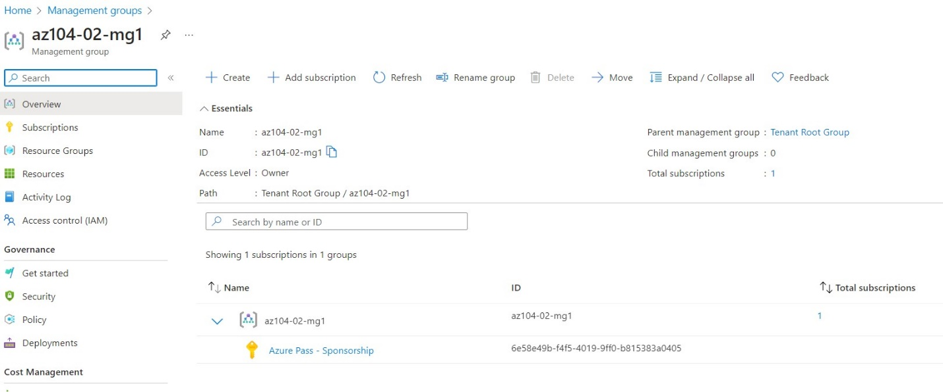

#### **Task 2: Create custom RBAC roles**

Replace the SUBSCRIPTION_ID placeholder in the JSON file with the subscription ID and run the following to create the custom role definition: New-AzRoleDefinition -InputFile $HOME/az104-02a-customRoleDefinition.json

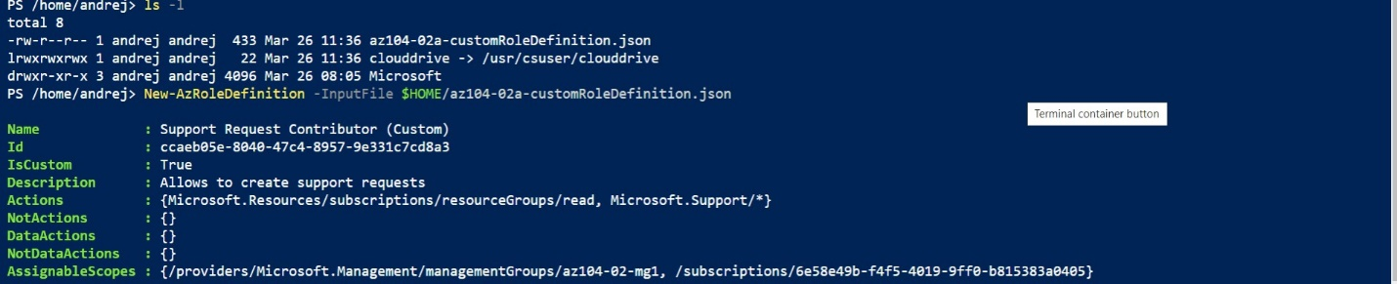

#### **Task 3: Assign RBAC roles**

In the Azure portal, search for and select **Azure Active Directory**, on the Azure Active Directory blade, click **Users**, and then click **+ New user**

1. In the **InPrivate** browser window, in the Azure portal, search and select **Resource groups** to verify that the az104-02-aaduser1 user can see all resource groups.

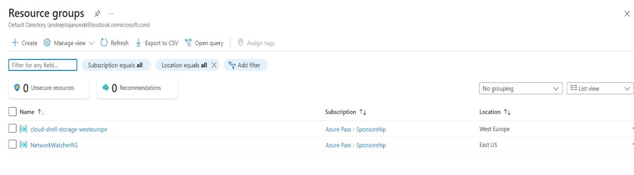

1. In the **InPrivate** browser window, in the Azure portal, search and select **All resources** to verify that the az104-02-aaduser1 user cannot see any resources.

