1.Create a file friends.txt with a list of names of three of your friends on separate lines. 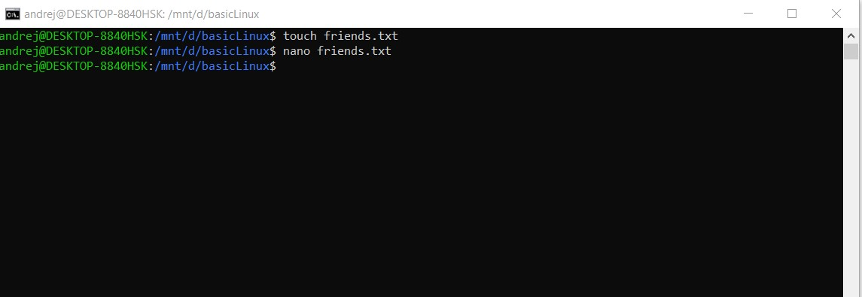

+opening GNU nano

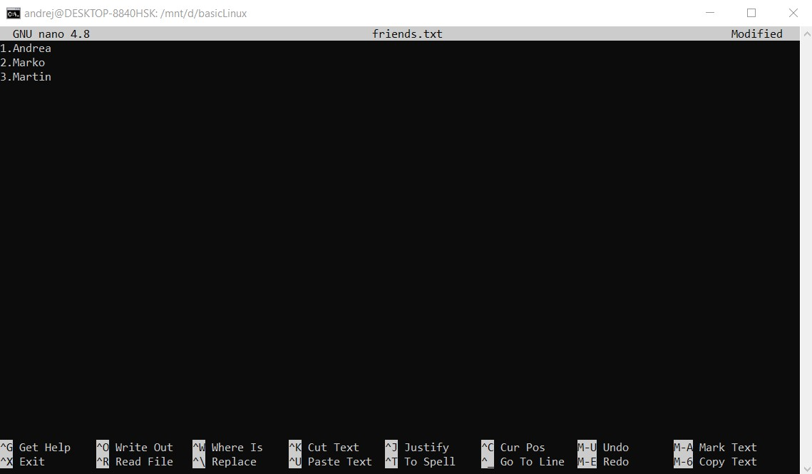

2.Display the contents of friends.txt on the console.

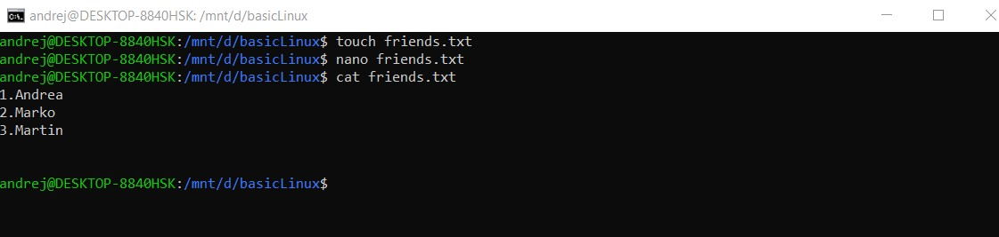

3.Rename file friends.txt to bestfriends.txt

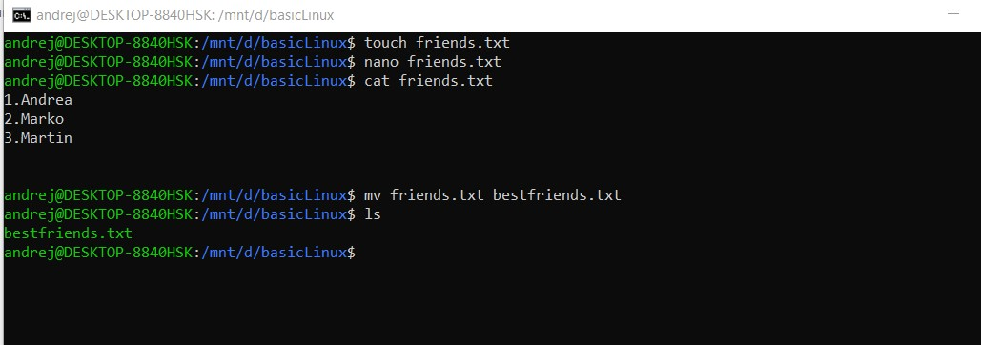

4.Make a copy of bestfriends.txt under the name sysadmins.txt

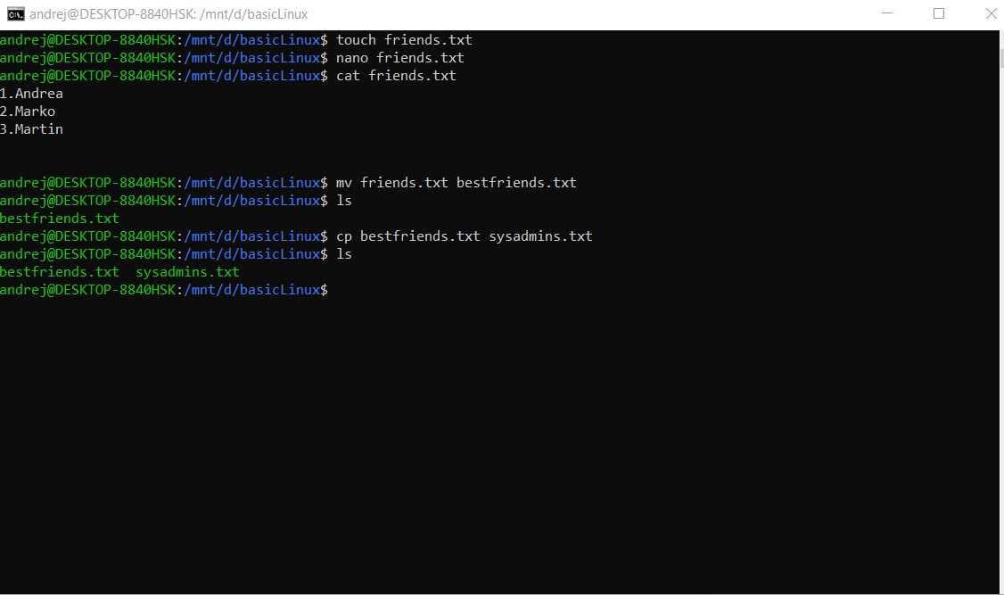

5.List all files whose name begins with letter 'b' and ends with extension txt.

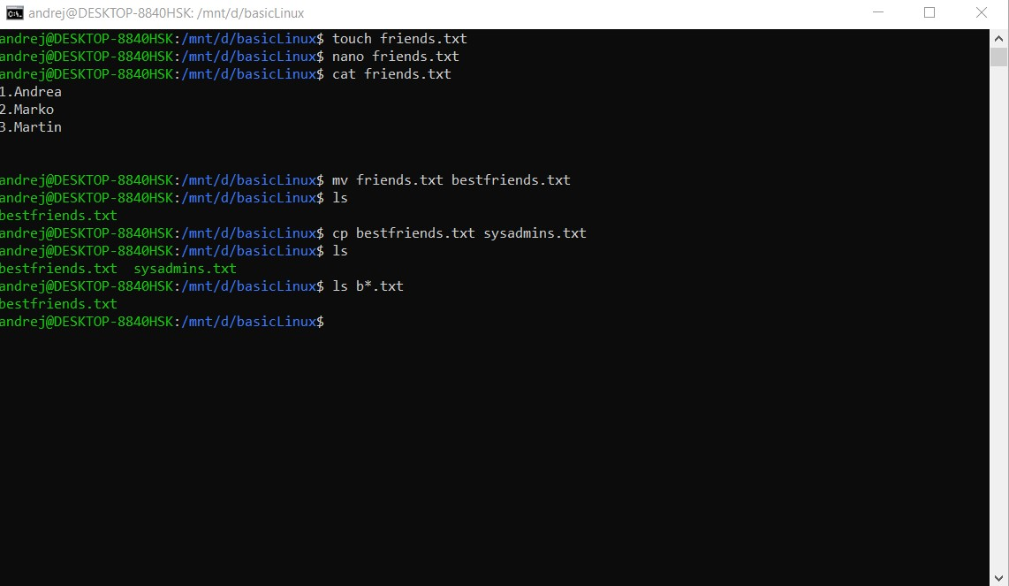

6.Write a command that will tell you how many bytes are taken up by file sysadmins.txt

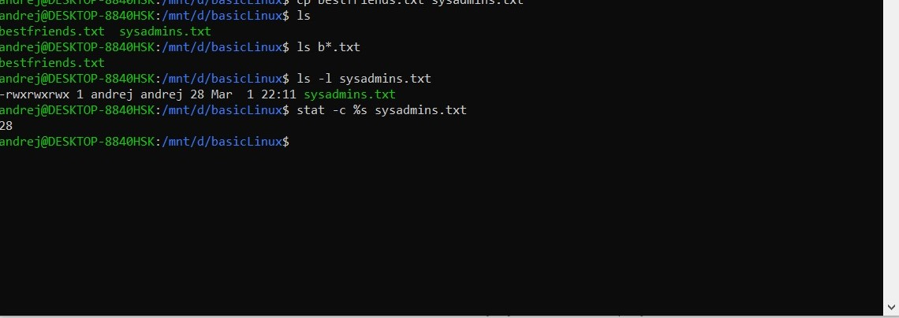

7.Create file cars.txt with a list of 5 brands of cars on separate lines.

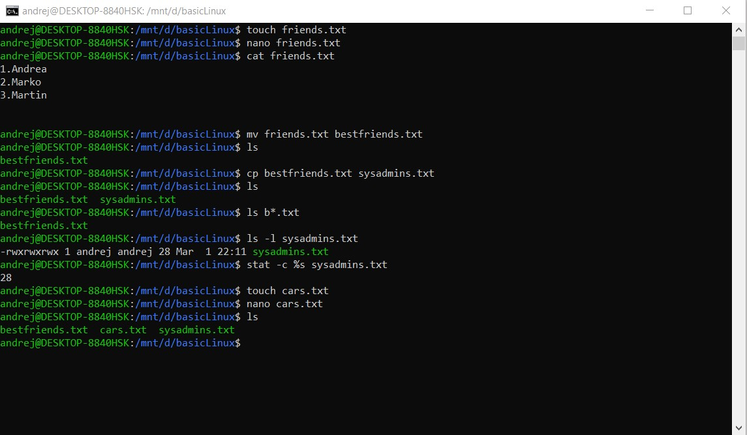

+ GNU nano

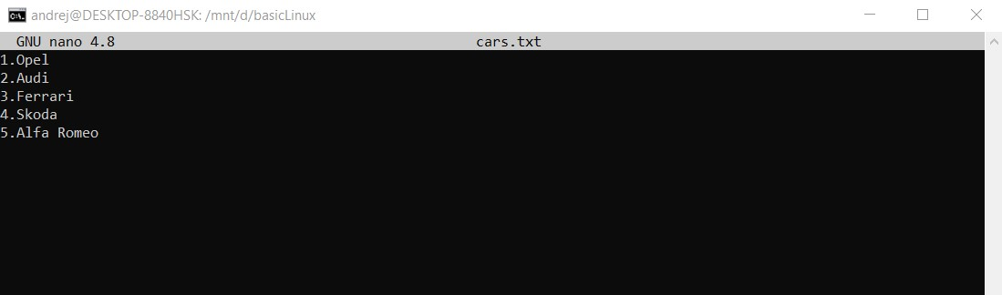

8.Check how many bytes are taken up by the file.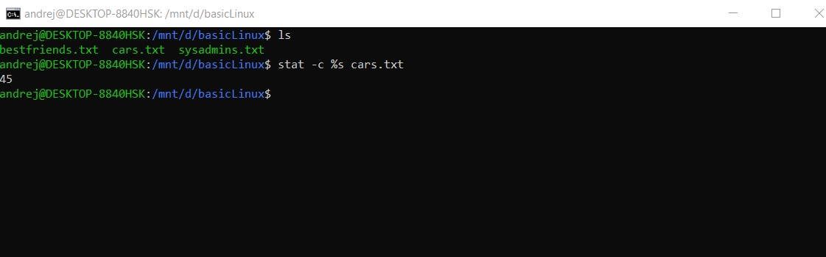

9.Copy the file cars.txt into directory /tmp AND

10.List all files with extension \*.txt in directory /tmp and verify that the file was copied properly.

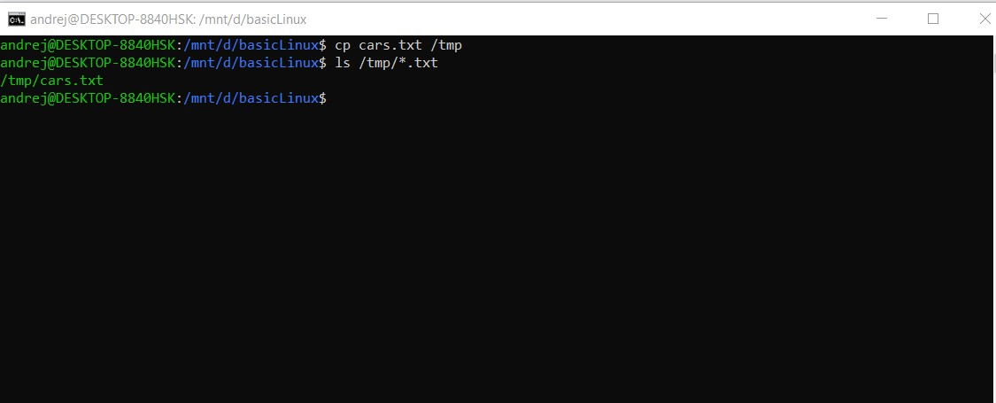

11.Without leaving your home directory rename file cars.txt located in /tmp to vehicles.txt in /tmp

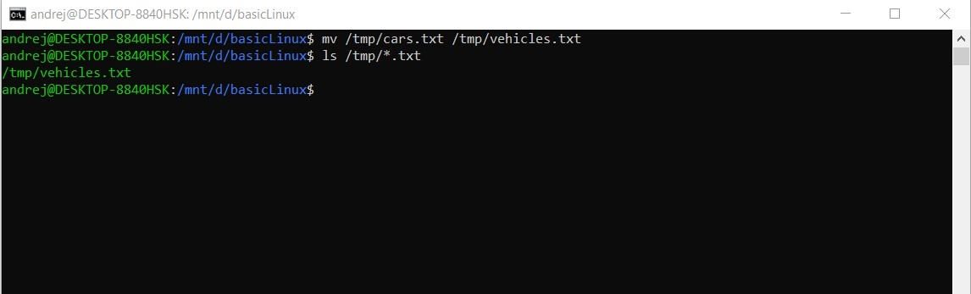

12.Display the contents of /etc/passwd file on the screen interactively (so you can search, scroll up and down)

