**“Fitness Application”**

**Project Proposal**

With the increasing popularity of fitness applications like Fitness Budd, run keeper, My Fitness App fitness apps have become very useful and extremely popular.

**Project description:**

“Fitness Application” is an application that is focused on providing fitness to people by using a single mobile application. The project will help users to get fitness training by selecting four different options like cardio, strength, yoga, and stretching.

Nowadays, people are switching to a healthy lifestyle to live life to the fullest therefore, fitness apps have become more and more common among people. The application will include four major types of fitness training options to the user after selecting one option as a cardio person can choose from a list of cardio.

When a choice is made a screen with a timer will be displayed. Individual can start their training by setting timer then a screen which contains video of training is started.

The goal of this project is to develop a mobile application that will be used to provide fitness training to users. The scope of the project is limited to the mobile application only.

The initial launch of the service will include the following functional and non-functional.

Functional requirements:

* Allow users to choose between four different types of training.
* Allow users to set timers according to their choice.
* Allow users to see a video of fitness training.
* Videos are short and are according to the timer set for training.

Non-functional requirements:

* The application will operate on a mobile device.
* Time to complete a given operation will take few minutes to execute.

The development team will consist of two members:

1. Avneet
2. Jasleen

User stories:

As a user, firstly I want a registration page to register and then login into the application, a toast message should also be displayed to give assurance that you successfully have login. Then, as a user, I want to be able to easily navigate a different kinds of fitness training choices available in a mobile application. Also, should have a list of options by selecting a type of training example yoga. Timers are necessary for obtaining training. Videos of training should follow a timer.

Sample layouts for proposed application:

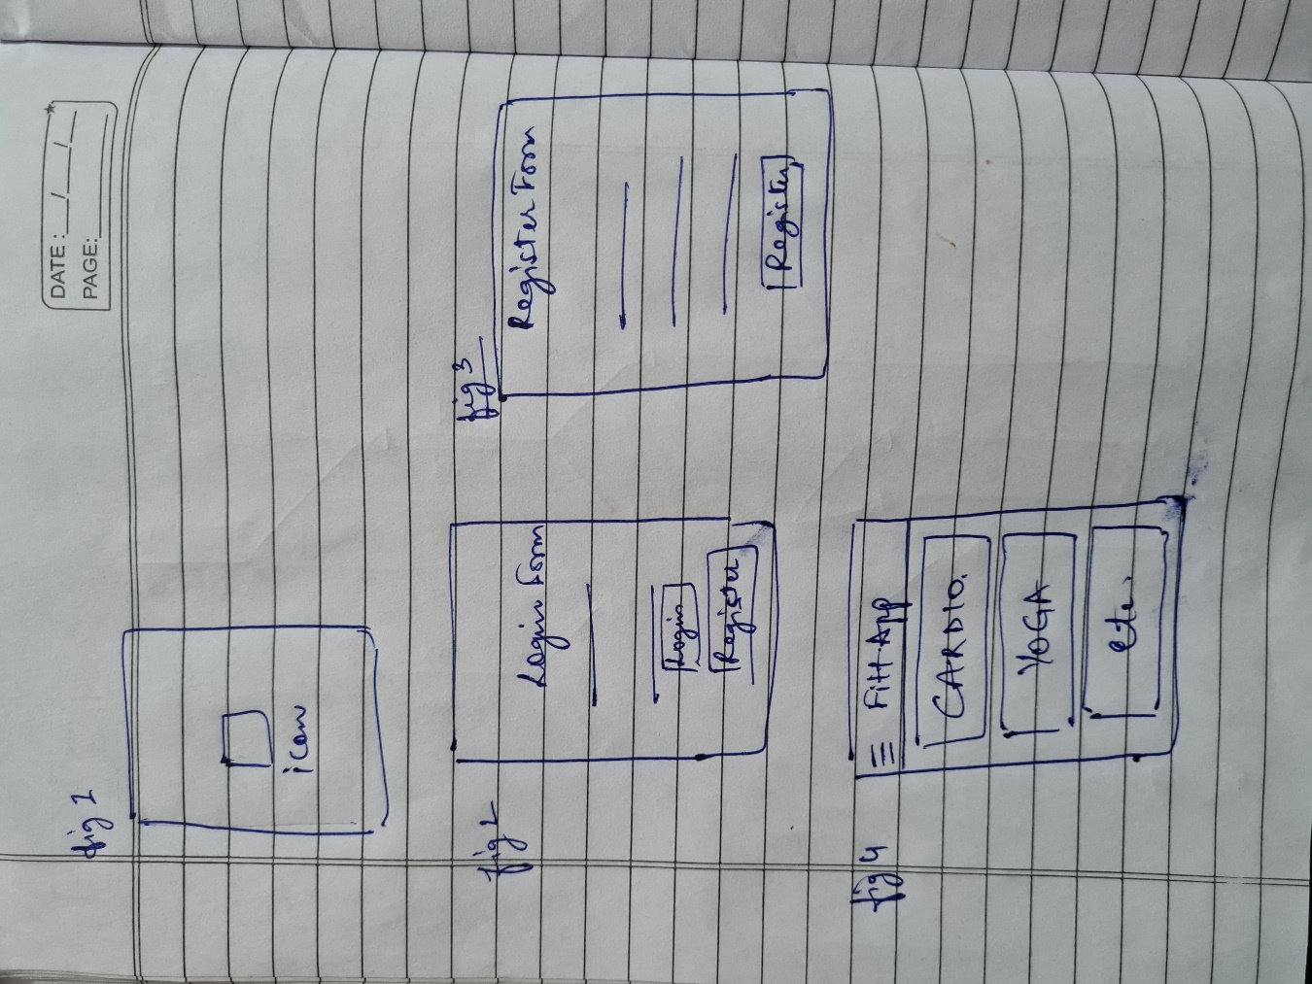

Platform:

Android Studio version 4.1.2

Language: Java