Socket Communication

To understand the IP and port of an emulator, read the links carefully: http://www.byteslounge.com/tutorials/how-to-connect-to-an-android-server-socket-in-the-emulator
https://developer.android.com/studio/run/emulator-console.html

1. Build an app (RPC server that runs on an emulator), and then launch it.
5554 is the port of the emulator.

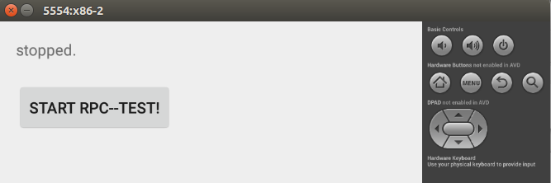

2. Disable authentication, delete the token from the .emulator_console_auth_token file or create an empty file if it doesn't exist.

3. Use telnet to connect the emulator, and set the redirect tcp port. (read this link carefully: http://www.byteslounge.com/tutorials/how-to-connect-to-an-android-server-socket-in-the-emulator)
This way, we can use : localhost (127.0.0.1) and 5050 to communicate with the RPC server Android app running on the emulator.

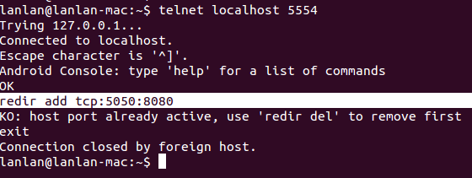

4. Build the RPC client whose SERVER PORT is 5050. It is a normal java class within jpf-centaur.

