create database assignment;

use assignment;

CREATE TABLE Ass_3(

emp_id int not null,

first_name varchar(50),

last_name varchar(50),

department varchar(20),

salary int not null,

hire_date date);

SELECT * FROM Ass_3;

insert into Ass_3(emp_id,first_name,last_name,department,salary,hire_date)

values

(1,"John","Doe","IT",60000,"2019-01-10"),

(2,"Jane","Smith","HR",55000,"2018-03-05"),

(3,"Emily","Jones","IT",62000,"2020-07-23"),

(4,"Michael","Brown","FINANCE",70000,"2016-05-14"),

(5,"Sarah","Davis","FINANCE",69000,"2017-11-18"),

(6,"David","Johnson","HR",48000,"2021-09-10");

# Find the average salary of employees in each department.

select department, avg(salary) as average_salary

from Ass_3

group by department;

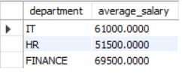

# Find the total number of employees hired after 2019.

SELECT count(hire_date) as "employees hired after 2019"

from Ass_3

where hire_date >"2019-01-10";



# List the departments and the total salary of all employees in each department, ordered by the total salary.

SELECT department, SUM(salary) AS "total salary in each deparment"

FROM Ass_3

GROUP BY department

ORDER BY sum(salary) ASC;

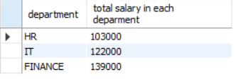

# Find the highest salary in the Finance department.

SELECT department, MAX(salary) AS highest_salary

FROM Ass_3

WHERE department = "Finance";



# Get the top 3 highest-paid employees.

select first_name , max(salary) as "highest paid employee "

from Ass_3

group by first_name order by max(salary) desc

limit 3;

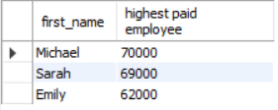

# Find the department with the minimum average salary.

SELECT department, AVG(salary) AS average_salary

FROM Ass_3

GROUP BY department

ORDER BY average_salary ASC

LIMIT 1;

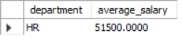

# Display the total number of employees in each department, ordered by the number of employees.

SELECT department, COUNT(*) AS total_employees

FROM Ass_3

GROUP BY department

ORDER BY total_employees DESC;

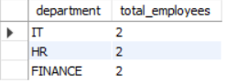

# Find the average salary of employees who were hired before 2020.

select hire_date, avg(salary) as "Average Salary"

from Ass_3

group by hire_date having

hire_date < "2020-01-01" ;

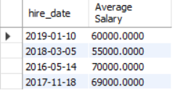

# List the names of employees in the IT department ordered by hire date, with the most recently hired employees first.

SELECT CONCAT(first_name,' ', last_name) AS full_name, hire_date

FROM Ass_3

WHERE department = 'IT'

ORDER BY hire_date DESC;

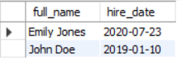

# Find the sum of salaries for all employees hired after January 1, 2019, ordered by salary.

SELECT SUM(salary) AS total_salaries

FROM Ass_3

WHERE hire_date > '2019-01-01';

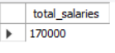

# Get the employee with the lowest salary in the HR department.

SELECT CONCAT(first_name, ' ', last_name) AS full_name, salary

FROM Ass_3

WHERE department = 'HR'

ORDER BY salary ASC

LIMIT 1;

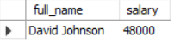

# Find the total salary paid to employees in each department, but limit the result to the top 2 highest-paying departments.

SELECT department, SUM(salary) AS total_salary

FROM Ass_3

GROUP BY department

ORDER BY total_salary DESC

LIMIT 2;

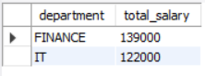

# List all employees hired after 2018, ordered by salary, and show only the first 4 employees.

SELECT CONCAT(first_name, ' ', last_name) AS full_name, salary

FROM Ass_3

WHERE hire_date > '2018-12-31'

ORDER BY salary DESC

LIMIT 4;

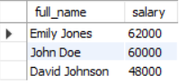

# Find the highest salary in the IT department, but limit the results to the top 1 result.

SELECT department, MAX(salary) AS highest_salary

FROM Ass_3

WHERE department = 'IT';



# Get the average salary of employees in each department and list only departments with an average salary greater than $60,000.

SELECT department, AVG(salary) AS average_salary

FROM Ass_3

GROUP BY department

HAVING average_salary > 60000;

