use assignment;

create table Sales(

SalesID int not null,

ProductID int not null,

CustomerID int not null,

SaleDate Date ,

Quantity int not null,

UnitPrice int not null,

Region varchar(10));

select * from Sales;

insert into Sales(SalesID,ProductID,CustomerID,SaleDate,Quantity,UnitPrice,Region)

values

(1,101,1001,"2024-01-05",5,200,"North"),

(2,102,1002,"2024-01-10",10,150,"East"),

(3,103,1003,"2024-02-15",2,300,"North"),

(4,104,1001,"2024-02-20",7,250,"West"),

(5,101,1004,"2024-03-05",1,200,"East");

# 1. Write a query to calculate the total sales (Quantity * UnitPrice) for each product.

SELECT ProductID, SUM(Quantity * UnitPrice) AS "Total Sales"

FROM Sales

GROUP BY ProductID;

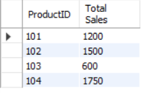

# 2. Write a query to find the total number of products sold in each region.

SELECT Region, SUM(Quantity) AS "Total Product Sold"

FROM Sales

GROUP BY Region;

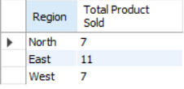

# 3. Write a query to get the average sales amount per product.

SELECT ProductID, AVG(Quantity * UnitPrice) As "Average Sales"

FROM Sales

GROUP BY ProductID;

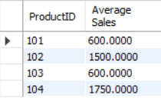

# 4. Find the regions where total sales are more than 3000.

SELECT Region, SUM(Quantity * UnitPrice) AS "Total Sales"

FROM Sales

GROUP BY Region

HAVING SUM(Quantity * UnitPrice) > 3000;

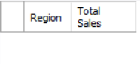

# 5. Write a query to get the maximum quantity sold for each product.

SELECT ProductID, MAX(Quantity) AS "Max. Quantity Sold"

FROM Sales

GROUP BY ProductID;

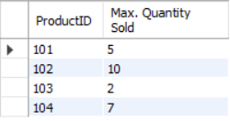

# 6. Write a query to calculate the average quantity of products sold per region.

SELECT Region, AVG(Quantity) AS "Avg. Quantity Sold"

FROM Sales

GROUP BY Region;

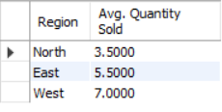

# 7. Find the product IDs that have generated a total sales amount of more than 1000.

SELECT ProductID, SUM(Quantity * UnitPrice) AS " Total Sales"

FROM Sales

GROUP BY ProductID

HAVING SUM(Quantity * UnitPrice) > 1000;

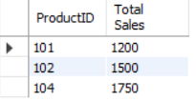

# 8. Write a query to get the total number of sales (rows) made for each customer.

SELECT CustomerID, COUNT(*) AS "Total Sales"

FROM Sales

GROUP BY CustomerID;

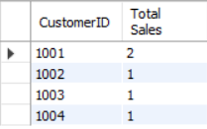

# 9. Find the products for which the average quantity sold is less than 5.

SELECT ProductID, AVG(Quantity) AS "Avg. Quantity Sold"

FROM Sales

GROUP BY ProductID

HAVING AVG(Quantity) < 5;

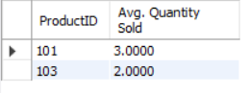

# 10. Write a query to find the sum of total sales for each customer in each region.

SELECT CustomerID, Region, SUM(Quantity * UnitPrice) AS "Total Sales"

FROM Sales

GROUP BY CustomerID, Region;

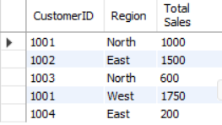

# 11. Write a query to calculate the total sales for each month.

SELECT MONTH(SaleDate) AS MONTH, SUM(Quantity * UnitPrice) AS "Total Sales"

FROM Sales

GROUP BY MONTH(SaleDate);

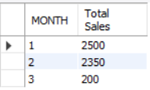

# 12. Find the regions where the average unit price is more than 200.

SELECT Region, AVG(UnitPrice) AS "Avg. UnitPrice"

FROM Sales

GROUP BY Region

HAVING AVG(UnitPrice) > 200;

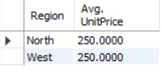

# 13. Write a query to get the minimum and maximum quantity sold per region.

SELECT Region, MIN(Quantity) AS "Min. Quantity Sold", MAX(Quantity) AS "Max. Quantity Sold"

FROM Sales

Group By Region;

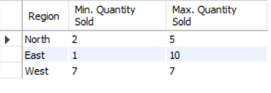

# 14. Find the customers who have made more than 2 purchases.

SELECT CustomerID, COUNT(*) AS "No. OF Purchase"

FROM Sales

GROUP BY CustomerID

HAVING COUNT(*) > 2;

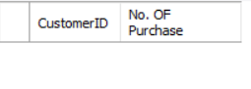

# 15. Write a query to find the total sales for each product and filter only those products where the total sales exceed 1500.

SELECT ProductID, SUM(Quantity * UnitPrice) AS "Total Sales"

FROM Sales

GROUP BY ProductID

HAVING SUM(Quantity * UnitPrice) > 1500;

