Lab 1
HLD vs LLD Walkthrough
Day 1 | System Design Training Program | Individual Worksheet
Case Study: RetailOrderHub
Name: _______________________________________
Date: _______________________________________

Objective
Practice distinguishing High-Level Design (HLD) from Low-Level Design (LLD) by classifying fifteen sample diagrams — including RetailOrderHub's own current architecture — and justifying each answer against the 5-point framework below.

Quick Reference — The 5-Point Framework
 | HLD | LLD
Focus | Overall system architecture | Component-level details
Audience | Architects, stakeholders | Developers, technical teams
Abstraction | Abstract and conceptual | Detailed and concrete
Output | Block diagrams, system overview | Class diagrams, pseudo-code
Purpose | Define system structure | Guide implementation

Instructions
Work through this worksheet on your own. For each of the 15 diagrams:
1. Look at the diagram and decide: is this HLD or LLD?
2. Check the box for your answer.
3. Write one sentence justifying your answer — reference at least one column from the framework table (Focus, Audience, Abstraction, Output, or Purpose).
4. Move to the next diagram. Don't look ahead or second-guess — first instinct is fine.
When you reach Diagram 1 (RetailOrderHub), there's an extra reflection question at the end — take a little more time with that one.
You'll compare answers with a partner after everyone finishes, so don't worry about being "right" — the goal is to practice the reasoning.

Diagram 1 — RetailOrderHub: Current Architecture
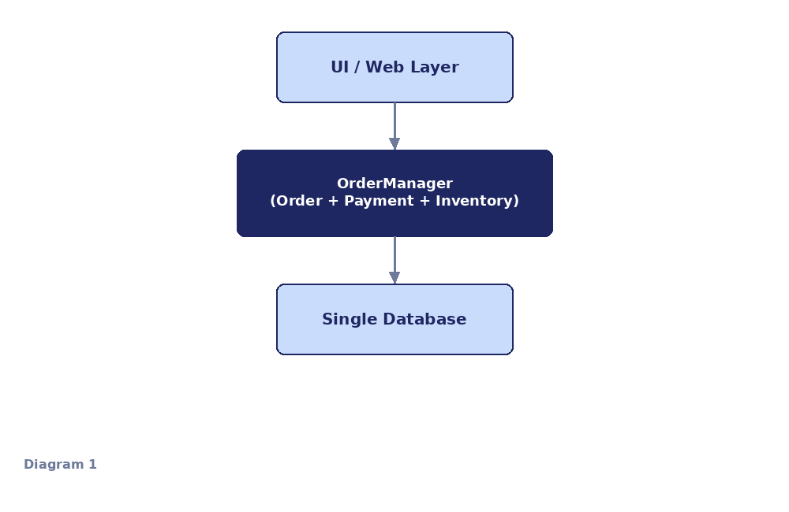
My classification: ☐ HLD ☐ LLD
Justification (which of the 5 framework points led you here?)
_______________________________________________________________________
_______________________________________________________________________
_______________________________________________________________________

Notes

Reflection
What would this system's LLD need to show that this HLD doesn't? Name at least two things.
_______________________________________________________________________
_______________________________________________________________________
_______________________________________________________________________

Diagram 2
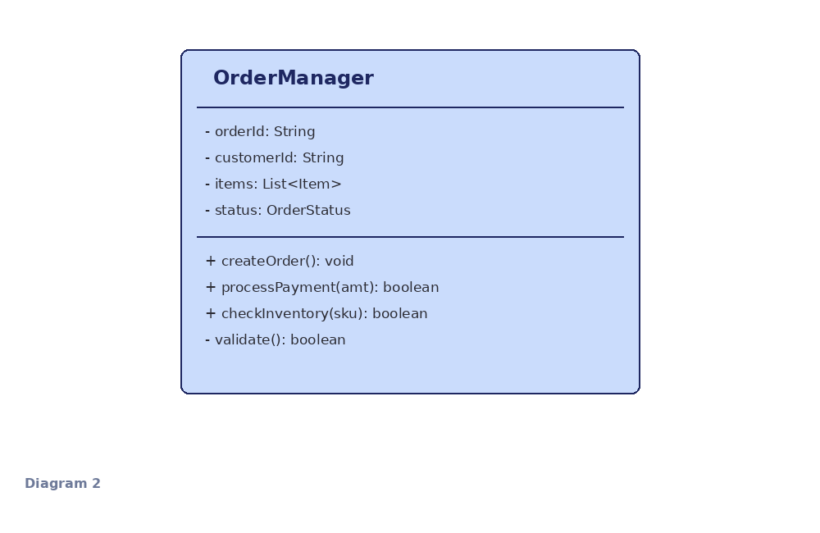
My classification: ☐ HLD ☐ LLD
Justification (which of the 5 framework points led you here?)
_______________________________________________________________________
_______________________________________________________________________
_______________________________________________________________________

Notes

Diagram 3
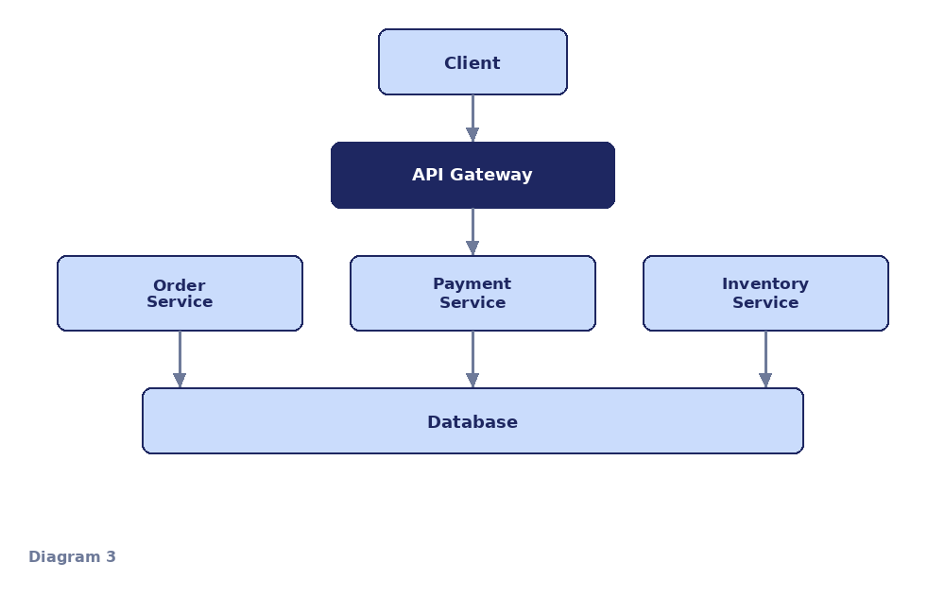
My classification: ☐ HLD ☐ LLD
Justification (which of the 5 framework points led you here?)
_______________________________________________________________________
_______________________________________________________________________
_______________________________________________________________________

Notes

Diagram 4
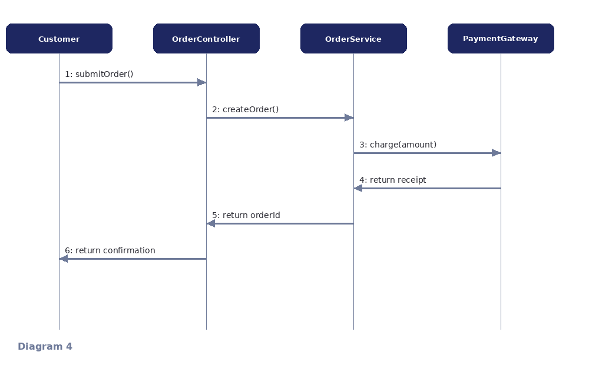
My classification: ☐ HLD ☐ LLD
Justification (which of the 5 framework points led you here?)
_______________________________________________________________________
_______________________________________________________________________
_______________________________________________________________________

Notes

Diagram 5
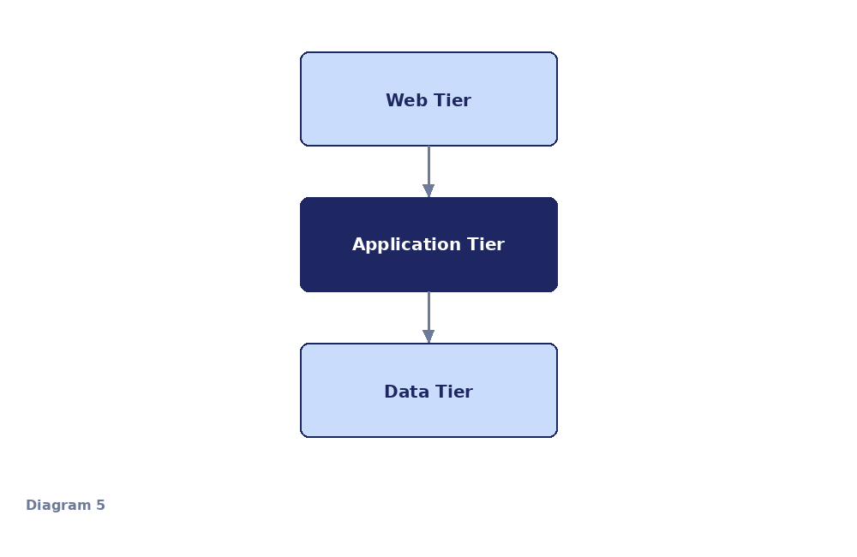
My classification: ☐ HLD ☐ LLD
Justification (which of the 5 framework points led you here?)
_______________________________________________________________________
_______________________________________________________________________
_______________________________________________________________________

Notes

Diagram 6
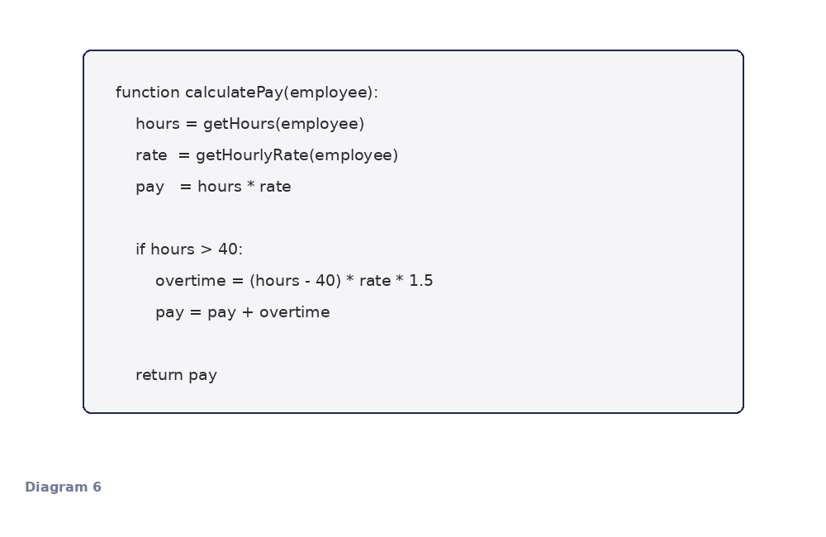
My classification: ☐ HLD ☐ LLD
Justification (which of the 5 framework points led you here?)
_______________________________________________________________________
_______________________________________________________________________
_______________________________________________________________________

Notes

Diagram 7
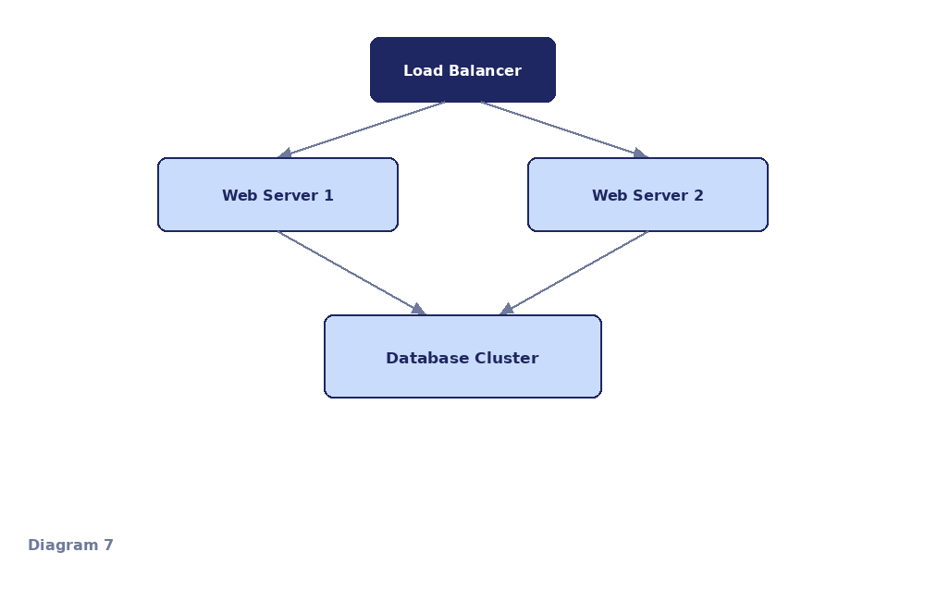
My classification: ☐ HLD ☐ LLD
Justification (which of the 5 framework points led you here?)
_______________________________________________________________________
_______________________________________________________________________
_______________________________________________________________________

Notes

Diagram 8
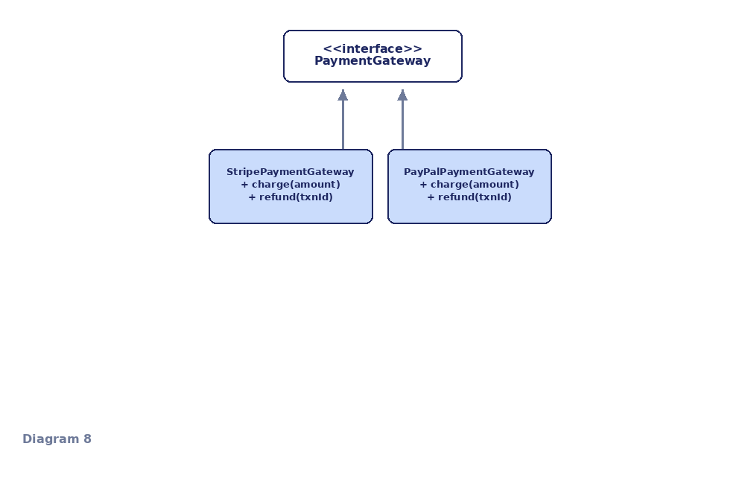
My classification: ☐ HLD ☐ LLD
Justification (which of the 5 framework points led you here?)
_______________________________________________________________________
_______________________________________________________________________
_______________________________________________________________________

Notes

Diagram 9
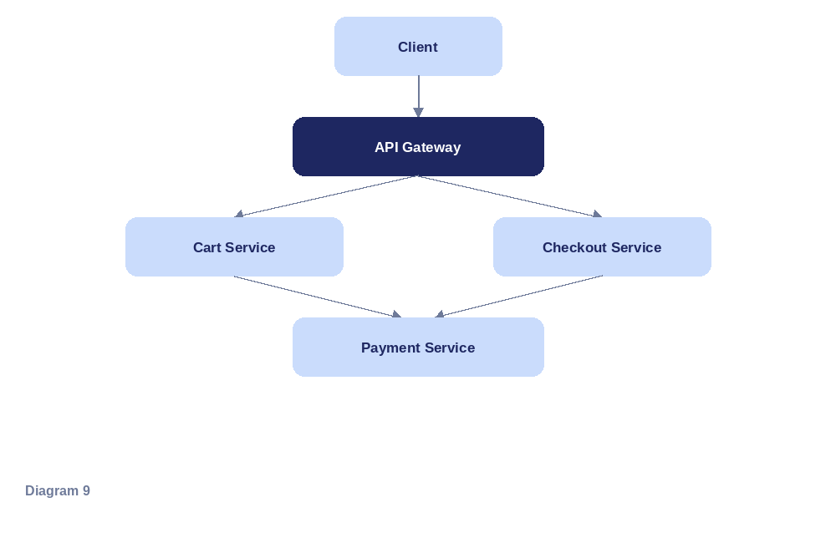
My classification: ☐ HLD ☐ LLD
Justification (which of the 5 framework points led you here?)
_______________________________________________________________________
_______________________________________________________________________
_______________________________________________________________________

Notes

Diagram 10
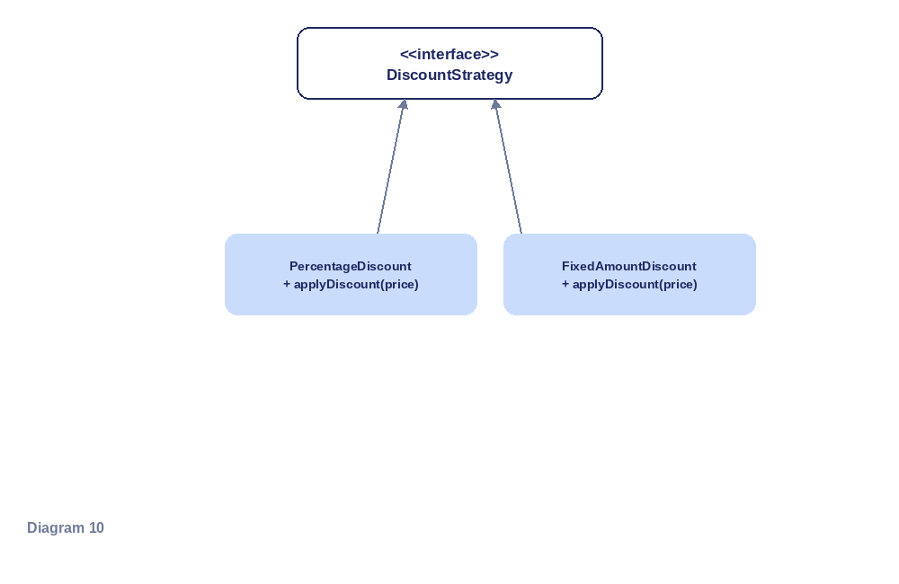
My classification: ☐ HLD ☐ LLD
Justification (which of the 5 framework points led you here?)
_______________________________________________________________________
_______________________________________________________________________
_______________________________________________________________________

Notes

Diagram 11
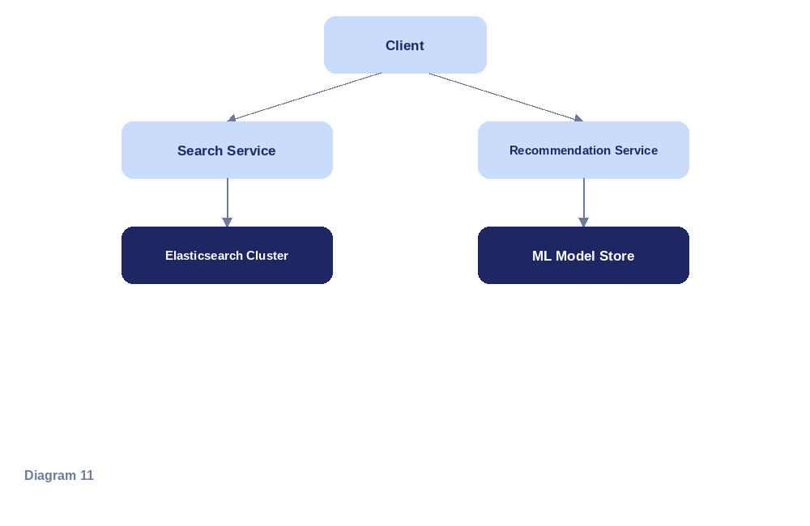
My classification: ☐ HLD ☐ LLD
Justification (which of the 5 framework points led you here?)
_______________________________________________________________________
_______________________________________________________________________
_______________________________________________________________________

Notes

Diagram 12
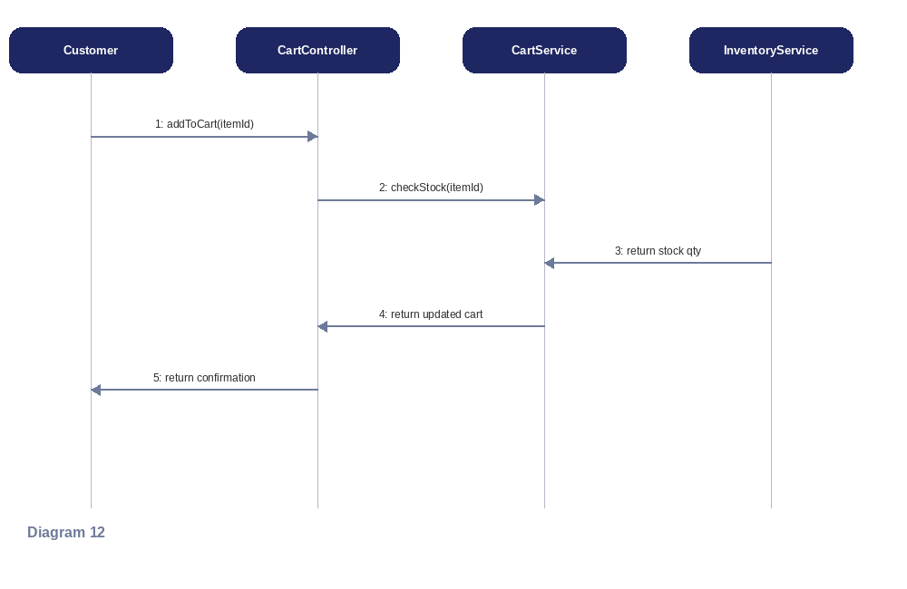
My classification: ☐ HLD ☐ LLD
Justification (which of the 5 framework points led you here?)
_______________________________________________________________________
_______________________________________________________________________
_______________________________________________________________________

Notes

Diagram 13
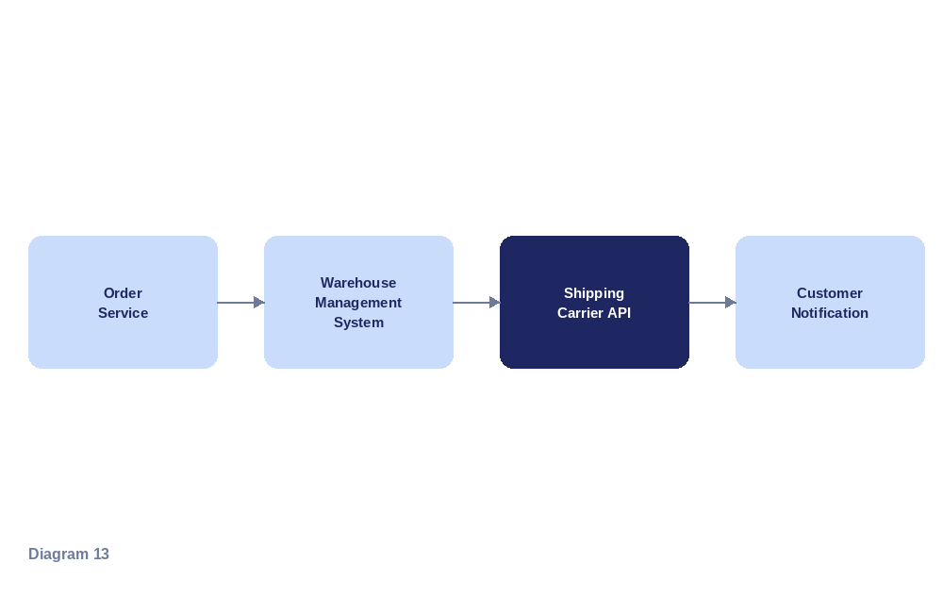
My classification: ☐ HLD ☐ LLD
Justification (which of the 5 framework points led you here?)
_______________________________________________________________________
_______________________________________________________________________
_______________________________________________________________________

Notes

Diagram 14
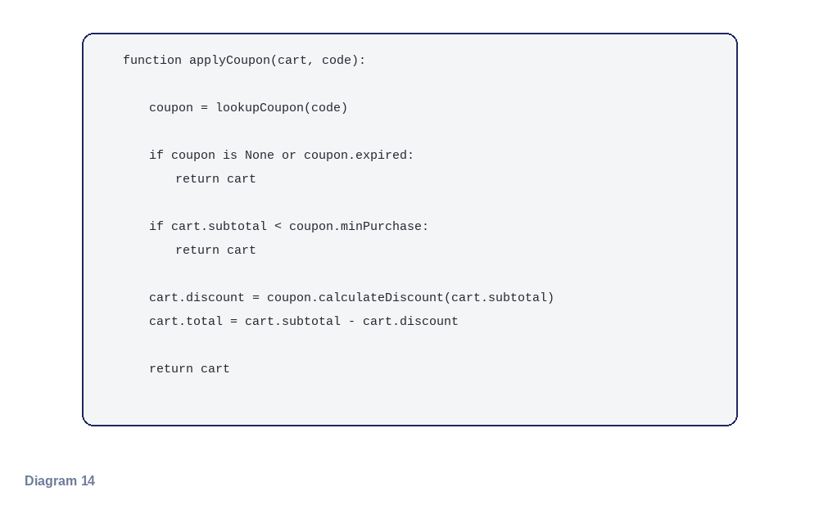
My classification: ☐ HLD ☐ LLD
Justification (which of the 5 framework points led you here?)
_______________________________________________________________________
_______________________________________________________________________
_______________________________________________________________________

Notes

Diagram 15
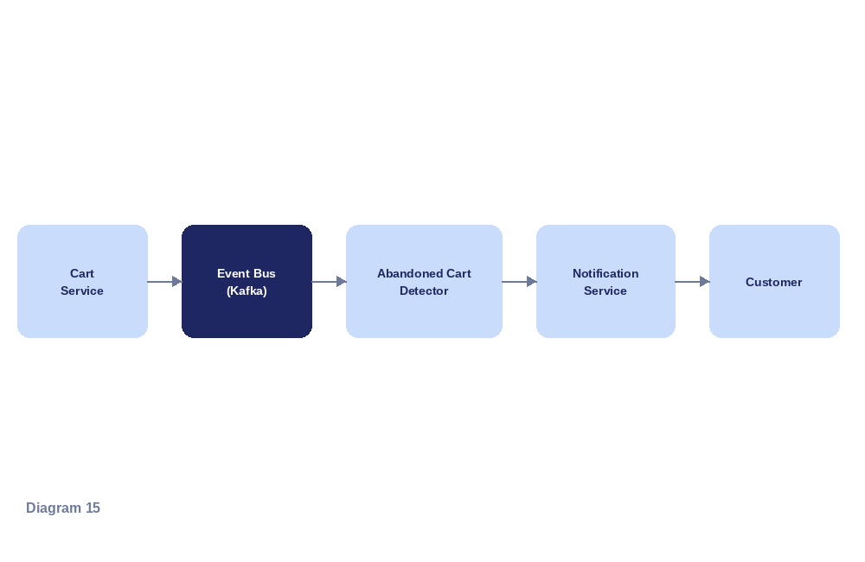
My classification: ☐ HLD ☐ LLD
Justification (which of the 5 framework points led you here?)
_______________________________________________________________________
_______________________________________________________________________
_______________________________________________________________________

Notes

Wrap-Up
Once everyone has finished, be ready to discuss:
• Which diagram was hardest to classify, and why?
• Did any diagram feel like it could reasonably be argued either way?
• For RetailOrderHub specifically — what's one design smell you'd expect its LLD to expose that the HLD hides?

