Walton Primo NF4

USER MANUAL

1.Using your phone safely
 On The Road
Using a phone while driving is illegal in many countries. Please follow local laws and drive safely at all times.
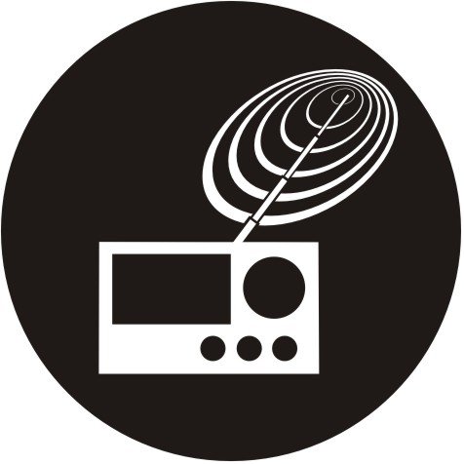 Near Sensitive Electronics
Don’t use your phone near sensitive electronic equipment – particularly medical devices such as pacemakers – as it could cause them to malfunction. It can also interfere with the operation of fire detectors and other automatic-control equipment.
For more information about how your phone affects pacemakers or other electronic equipment, please contact the manufacturer or your local distributor.
Your phone may cause interference when used near TVs, radios or automated office equipment.
 While Flying
Your phone can cause interference with aircraft equipment. So it’s essential you follow airline regulations. And if airline personnel ask you to switch off your phone, or disable its wireless functions, please do as they say.
 In Hospital
Your phone may interfere with the normal operation of medical equipment. Follow all hospital regulations and turn it off when you’re asked to by posted warnings or medical staff.
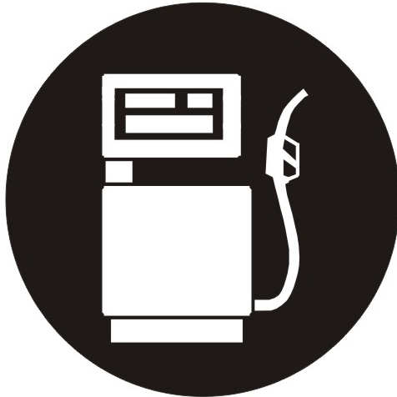 At a Petrol Station
Don’t use your phone at petrol stations. In fact, it’s always best to switch off whenever you’re near fuels, chemicals or explosives.
 Around Water
Keep your phone away from water (or any other liquid). It’s not a waterproof model.
 Making Repairs
Never take your phone apart. Please leave that to the professionals. Unauthorised repairs could break the terms of your warranty.
 Broken Antenna
Don’t use your phone if the antenna is damaged, as it could cause injury.
 Around Children
Keep your mobile out of children’s reach. It should never be used as a toy and it might not be good for their health.
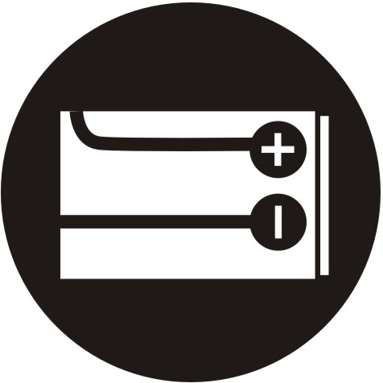 Original Accessories
Only use the original accessories supplied with your phone or those approved by the manufacturer. Using unapproved accessories may affect performance, make the warranty void, break national regulations on the use of mobile phones, or even cause injury.
 Near Explosives
Turn off your phone in or near areas where explosive materials are used. Always obey local laws and turn off your phone when requested.
 Emergency Calls
To make an emergency call your phone must be turned on and in an area where there’s network coverage. Dial the national emergency number and press ‘send’. Explain exactly where you are and don’t hang up until help has arrived.
 Working Temperature
The working temperature for the phone is between 0 Degree and 40 Degree Celcius. Please don’t use the phone outside the range. Using the phone under too high or too low temperature might cause problems.


At very high volume, prolonged listening to a mobile phone can damage your hearing.

3.Your Phone

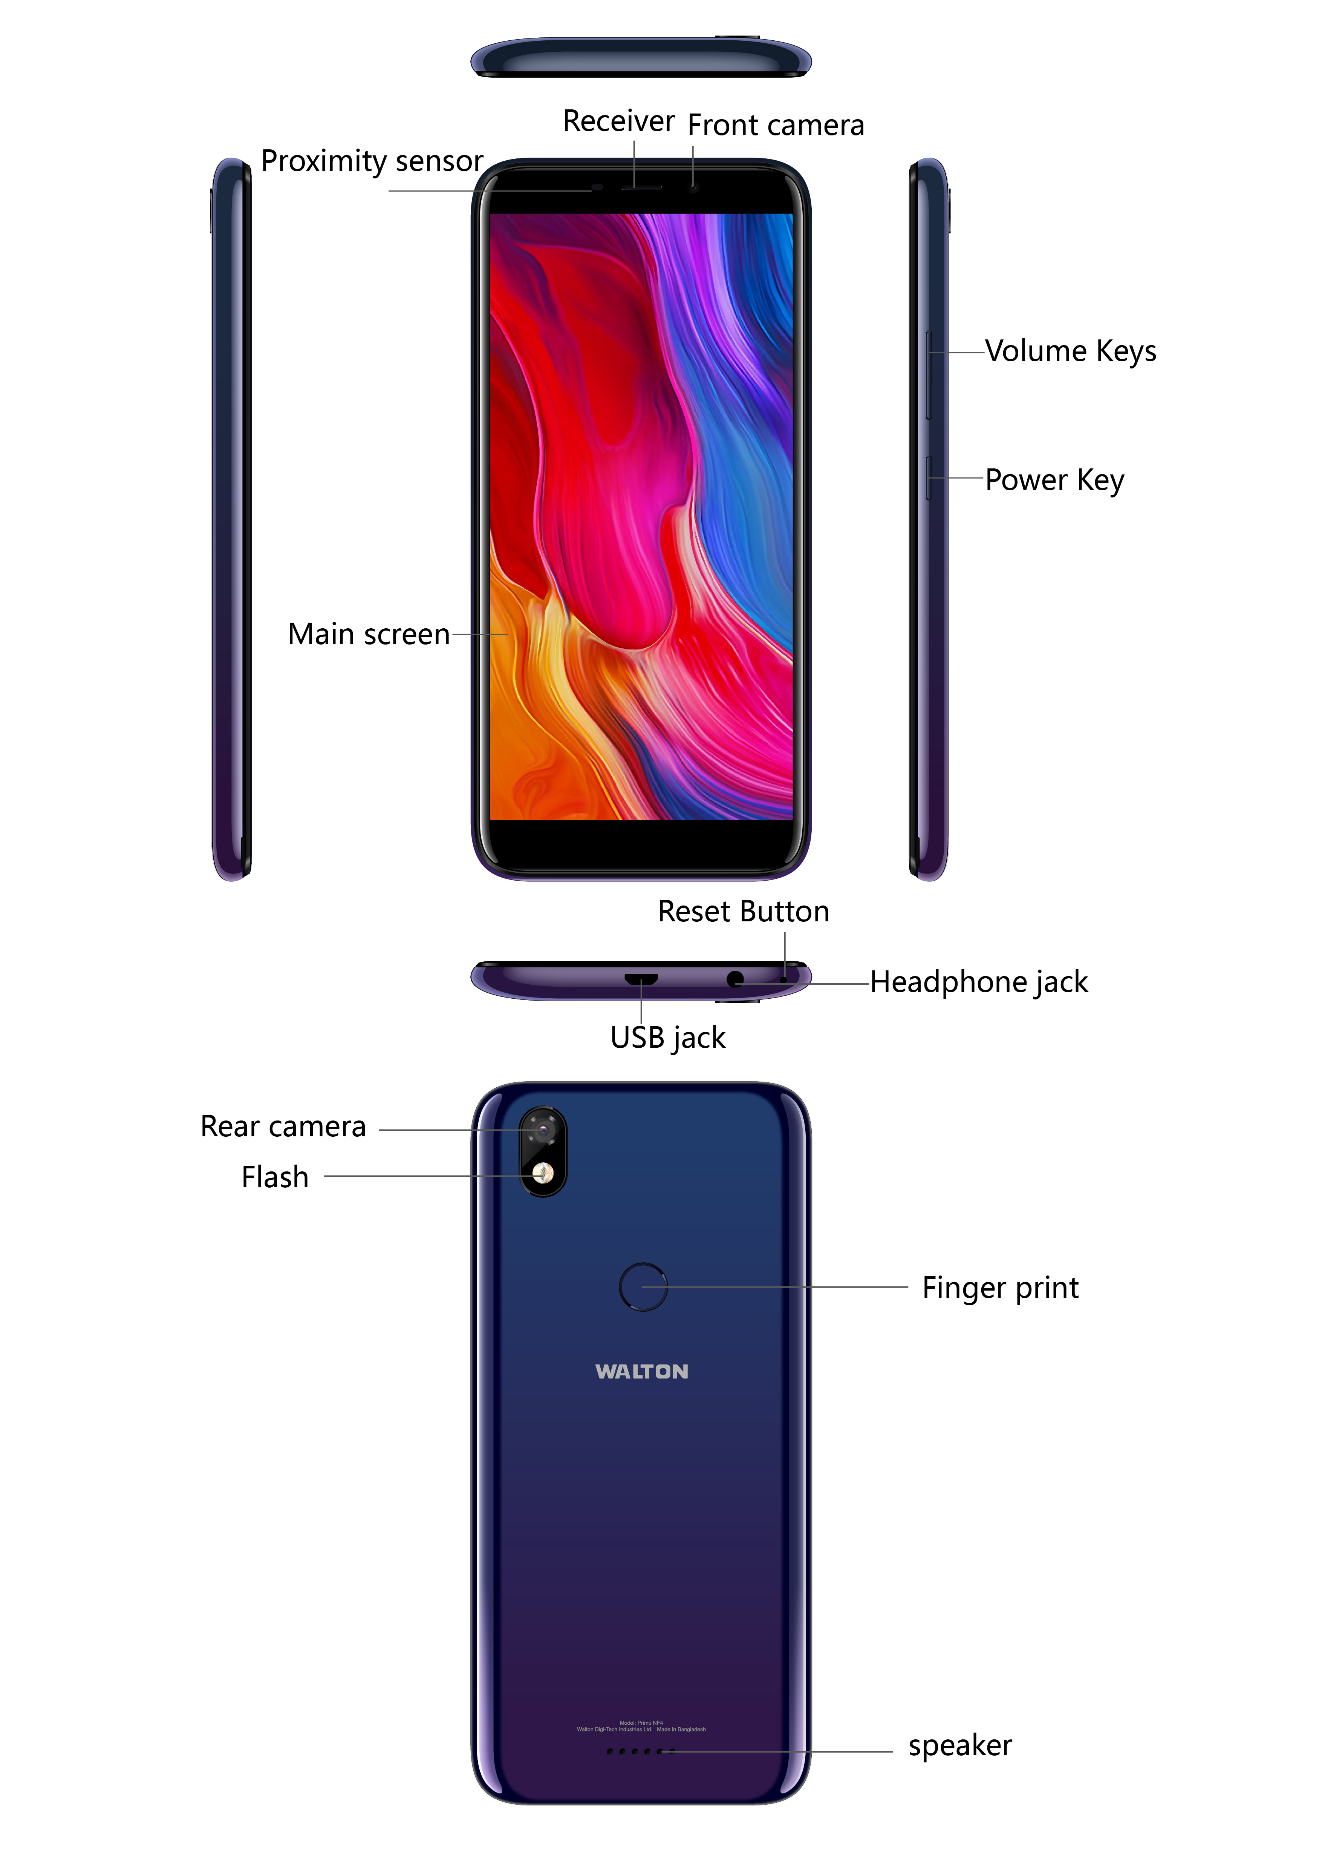

4.Description Icons
Icons | Descriptions | Icons | Descriptions
 | Shows the phone’s network signal strength. |  | Show the phone’s battery capacity.
 | Speaker has been activated. |  | You have unread SMS.
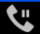 | Call on hold |  | Flight Mode
 | The ringing type is set on Vibration. | 4G/3G/G | Data network in use.
 | Wi fi is ON |  | A clock alarm is active.
 | You have missed calls. |  | Bluetooth ON

5.Fingerprint Functions
- Fingerprint lock

If you want to better security protection, you can set up the fingerprint locked by following steps.

In menu screen, select settings>Security>Fingerprint >Add fingerprint, then add a fingerprint successfully, Then you can unlock by input fingerprint.
- Privacy protection

Locked APP can only be opened by enrolled fingerprint or password.

In menu screen, select setting>Security>Fingerprint>Privacy protection> set ‘Lock APP’ on>Locked the Apps that you want.
- Take photos

You take a photo in framing interface according to the fingerprint
Removing the Battery

6.Charging the battery
The rechargeable Li-ion battery that comes with your phone is ready to be used, but is not charged. It is easy to do & can be done in 3 simple steps below:
- Connect the charger to your phone, and plug it into a socket.
- The battery indicator in the corner of the screen will scroll to show you it’s charging.
- When fully charged, the battery indicator will stop scrolling.
- Disconnect the charger from your mobile, and unplug.

7.Power ON/OFF
Press the power key to power-ON/OFF the phone.
When you turn your phone on, it’ll automatically check the SIM and show the following information on screen:
- Input SIM1 PIN: If you’ve set a PIN for your SIM1.
- Input SIM2 PIN: If you’ve set a PIN for your SIM2.

Note:
The PIN is supplied with your SIM. Please replace it with your own PIN code as soon as possible. Enter the wrong PIN three times, and your SIM will be locked. Then you’ll need to contact your network service provider to ask for a PUK code to unlock it. It is applicable for both the SIMs if you are using 2 SIM Cards.

8.Enter Main Menu
In Idle mode, press the Menu key to enter the main menu on the desktop and click the Home key to return.

9.Enter Sub Menu
Once at the main menu, click the icon to select the submenu, press Back Key to return to the previous menu, and press the Home Screen to return to the home screen.

10.Use Notification Panel
As a new notification appears in the notification area, slide down in the area to view the contents of the notification.

11.Expand Main Interface
The main interface may extend and exceed the screen width to provide more space for newly added shortcuts and tools.
Slide your finger horizontally on the main interface to extend to right area of the main interface.

12.Add icons on the main interface
You can long press the icon on the main menu until it’s enlarged and the mobile phone vibrates, and copies the icons in the main menu to the main interface.

13.Move icons on the main interface
- Long press the icon on the main interface until it’s enlarged and the mobile phone vibrates.
- Drag the icon to the desired position and then release it.

14.Delete icons on the main interface
- Long press the icon on the main interface until it’s enlarged and the mobile phone vibrates.
- Drag the icon to “Remove” to delete it.

15.Change wallpapers
- press menu to open the menu.
- Click WALLPAPERS to select the wallpaper and press “Set wallpaper” to complete.

16.Install APK through File Manager
APK is a supported file format for the Android mobile operating system.
- Please copy the downloaded APK file into the SD card, and then insert the SD card into the phone.
- In Idle mode, click Main Menu to enter the main menu.
- Click “File Manager” to enter the directory of SD card.
- Click the APK file you wish to install, and follow the installation wizard.

17.Wi-Fi
Your LTE mobile Phone supports Wi-Fi which allows you to connect with a Wireless connection.This is useful for surfing internet on phone

- Enter "Settings" interface & search WIRELESS & NETWORKS. Select the network you want to connect.

18.Taking Care of your Device
Your device is a product of superior design and craftsmanship and should be handled with care: The following suggestions will help you protect your phone:
- Always keep the small parts of the phone away from children.
- Keep the device dry. Precipitation, humidity, and all types of liquids or moisture can contain minerals that will rust electronic circuits. If your device does get wet, remove the battery, and allow the device to dry completely before replacing it.
- Do not use or store the device in dusty, dirty areas. Its moving parts and electronic components can be damaged.
- Do not store the device in high or cold temperature. High temperatures can shorten the life of electronic devices and damage batteries.
- Do not attempt to open the device other than as instructed in this guide.
- Do not drop, knock, or shake the device. Rough handling can break internal circuit boards and fine mechanics.
- Do not use harsh chemicals, cleaning solvents, or strong detergents to clean the device. Only use a soft, clean, dry cloth to clean the surface of the device.
- Do not paint the device. Paint can clog the moving parts and prevent proper operation.
- Use indoor chargers.
- If you are not customed to use Fingerprint key as Back key or not customed to use the phone with a single key,you can make the "Show the navigation bar" option checked in Settings->Display.

