Installation, Setup and Protractor tests run

Install **NodeJS** coming with the **npm** installer.

Install **Protractor** as stated on <https://www.protractortest.org/#/> like that:

npm install -g protractor

After that perform an update:

webdriver-manager update

and start the selenium webdriver at the end:

webdriver-manager start

After that create one scenario and one config .js, put them in a folder and run your first protractor test as stated on the Protractor’s site:

protractor conf.js

Install **WebStorm** by **JetBrains** from their official site:

<https://www.jetbrains.com/help/webstorm/install-and-set-up-product.html>

File/New Project/Angular CLI – from existing sources.

Create a Protractor run configuration after that:

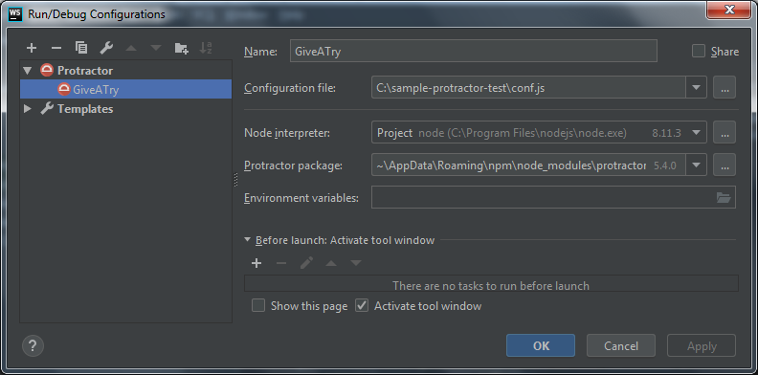

Congratulations, now you can run and debug your protractor tests.