Fall 2026 Extracurricular Activities Catalog

Saint David’s School is excited to offer a rich selection of extracurricular activities for the Fall 2026 season. Designed to spark curiosity and support students’ growth beyond the classroom, these programs provide opportunities to explore interests in sports, arts, technology, academics, and wellness. Students are encouraged to discover new passions, build confidence, and connect with their community as they choose the activities that will shape their fall experience.

SPORTS

Junior Basketball (id=11)
Levels Offered: Grades 3–6 Category: Sports
Description: Junior Basketball introduces students to teamwork, coordination, and athletic discipline. Participants learn dribbling, passing, shooting, and defensive techniques through structured drills and friendly scrimmages. The program emphasizes sportsmanship and confidence-building, helping young athletes develop both physical skills and a positive mindset.
Schedule: This program includes 8 lessons, beginning on September 9, with sessions every Monday from 2:30 p.m. to 3:30 p.m.
Cost: $180 Optional Extras: Uniform ($25)

Girls’ Soccer Training (id=12)

Levels Offered: Grades 4–7 Category: Sports
Description: Girls’ Soccer Training focuses on agility, endurance, and teamwork. Students practice ball control, passing, defensive positioning, and goal-scoring techniques in a supportive environment that encourages growth and camaraderie.
Schedule: This program includes 6 lessons, beginning September 9, held every Monday from 2:30 p.m. to 3:30 p.m.
Cost: $170 Optional Extras: Transportation ($30)


Junior Volleyball (id=13)
Levels Offered: Grades 5–8 Category: Sports
Description: Junior Volleyball teaches serving, passing, setting, and teamwork. Students participate in drills and friendly matches designed to build confidence and coordination.
Schedule: This program includes 7 lessons, starting September 9, held every Monday from 2:30 p.m. to 3:30 p.m.
Cost: $190 Optional Extras: Knee pads ($15)

MUSIC
Piano Foundations (id=21)
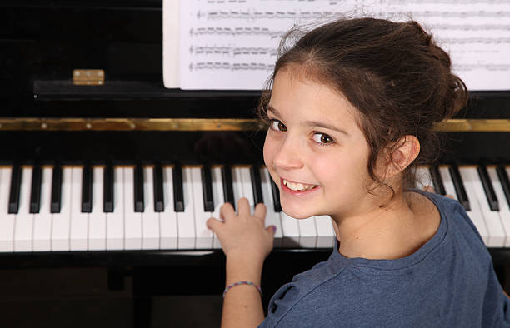
Levels Offered: Grades 1–5 Category: Music
Description: Piano Foundations offers young musicians a welcoming introduction to musical expression. Students explore rhythm, melody, and basic music theory while learning proper hand position and technique. Each lesson blends structured practice with creative activities that encourage students to experiment with sound.
Schedule: The course consists of 10 lessons, starting September 11, held every Wednesday from 2:30 p.m. to 3:30 p.m.
Cost: $250 Optional Extras: Sheet-music pack ($15)
ARTS

Creative Painting Studio (id=31)
Levels Offered: Grades 2–6 Category: Arts
Description: Creative Painting Studio encourages students to explore color, texture, and artistic expression. Each session introduces a new technique—watercolor, acrylic, or mixed media—while allowing students to develop their personal style.
Schedule: The studio runs for 7 lessons, starting September 14, with classes every Saturday from 10:00 a.m. to 11:30 a.m.
Cost: $220 Optional Extras: Paintbrush set ($12)

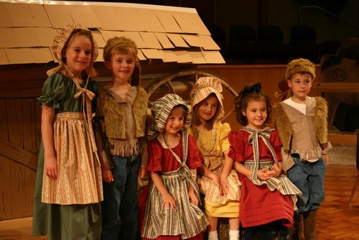
Drama & Theater Workshop (id=32)
Levels Offered: Grades 4–12 Category: Arts
Description: Drama & Theater Workshop helps students build confidence through acting exercises, improvisation, and scene work. Participants learn voice projection, character development, and stage presence.
Schedule: The workshop includes 9 lessons, beginning September 11, meeting every Wednesday from 2:30 p.m. to 3:30 p.m.
Cost: $240 Optional Extras: Costume materials ($20)


Digital Photography Basics (id=33)
Levels Offered: Grades 6–12 Category: Arts Description: Students learn composition, lighting, and camera settings while exploring creative storytelling through photography. Each session includes hands-on practice and mini-projects.
Schedule: The course includes 8 lessons, beginning September 14, held every Saturday from 10:00 a.m. to 11:30 a.m.
Cost: $260 Optional Extras: Photo editing software license ($25)

Hip-Hop Dance Basics (id=34)

Levels Offered: Grades 2–8 Category: Arts
Description: Hip-Hop Dance Basics teaches rhythm, coordination, and expressive movement through beginner-friendly choreography. Students build confidence while learning to move with energy and style.
Schedule: The course includes 8 lessons, starting September 9, held every Monday from 2:30 p.m. to 3:30 p.m.
Cost: $210 Optional Extras: Dance T-shirt ($12)

IT & TECHNOLOGY
Robotics Club
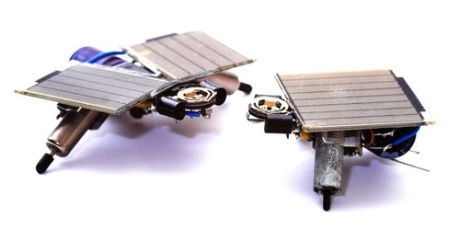
Levels Offered: Grades 4–8 Category: IT
Description: Robotics Club introduces students to engineering, coding, and problem-solving through hands-on robot-building challenges. Participants design, assemble, and program robots to complete tasks, learning teamwork and critical thinking along the way.
Schedule: This club offers 9 lessons, beginning September 14, meeting every Saturday from 8:00 a.m. to 9:30 a.m.
Cost: $300 Optional Extras: Robotics kit rental ($20)


Beginner Coding with Python
Levels Offered: Grades 6–12 Category: IT
Description: This course introduces students to programming fundamentals using Python. They learn variables, loops, conditionals, and simple algorithms while building small projects such as games and calculators.
Schedule: The course includes 10 lessons, starting September 14, held every Saturday from 8:00 a.m. to 9:30 a.m.
Cost: $280 Optional Extras: USB drive ($10)

3D Printing & Design
Levels Offered: Grades 5–12 Category: IT

Description: Students learn 3D modeling and printing fundamentals, creating their own small prototypes and designs. The activity encourages creativity, spatial reasoning, and hands-on experimentation.
Schedule: This course includes 9 lessons, beginning September 14, held every Saturday from 8:00 a.m. to 9:30 a.m.
Cost: $290 Optional Extras: Filament pack ($18)

ACADEMIC ENRICHMENT
Chess Strategy Lab

Levels Offered: Grades 3–12 Category: Academic Enrichment
Description: Chess Strategy Lab teaches students how to think ahead, analyze patterns, and develop strategic reasoning. Through puzzles, guided matches, and tournaments, students strengthen concentration and problem-solving skills.
Schedule: The lab includes 8 lessons, beginning September 11, with sessions every Wednesday from 2:30 p.m. to 3:30 p.m.
Cost: $160 Optional Extras: Tournament set ($18)

Creative Writing Circle

Levels Offered: Grades 5–12 Category: Academic Enrichment
Description: Creative Writing Circle helps students develop their voice through poetry, short stories, and narrative exercises. They learn structure, imagery, and revision techniques while exploring their imagination.
Schedule: The circle includes 6 lessons, beginning September 11, meeting every Wednesday from 2:30 p.m. to 3:30 p.m.
Cost: $150 Optional Extras: Writing journal ($8)

Advanced Math Problem-Solving
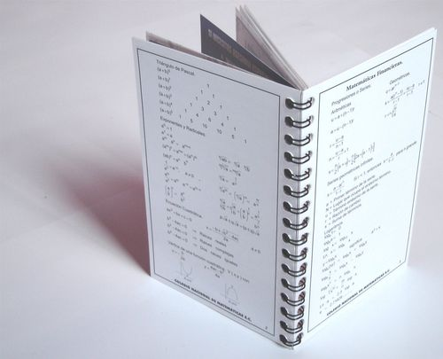
Levels Offered: Grades 6–12 Category: Academic Enrichment
Description: This course challenges students with logic puzzles, competition-style problems, and advanced reasoning tasks that strengthen analytical thinking and mathematical creativity.
Schedule: The course includes 10 lessons, starting September 11, meeting every Wednesday from 2:30 p.m. to 3:30 p.m.
Cost: $270 Optional Extras: Workbook ($12)

SCIENCE
Environmental Science Explorers
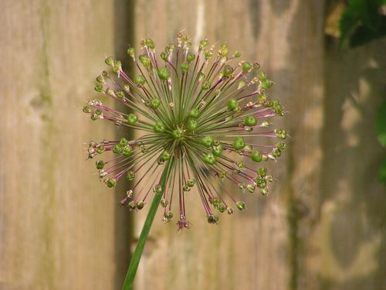
Levels Offered: Grades 3–8 Category: Science
Description: Students explore ecosystems, sustainability, and environmental stewardship through hands-on experiments and outdoor observations. The activity encourages curiosity and responsibility toward the natural world.
Schedule: This program includes 6 lessons, beginning September 14, held every Saturday from 10:00 a.m. to 11:30 a.m.
Cost: $200 Optional Extras: Field notebook ($6)


STEM Experiments Lab
Levels Offered: Grades 3–10 Category: Science
Description: STEM Lab engages students in hands-on experiments involving physics, chemistry, and engineering concepts. Each session includes a guided experiment and reflection to deepen understanding.
Schedule: The lab includes 10 lessons, beginning September 14, held every Saturday from 10:00 a.m. to 11:30 a.m.
Cost: $300 Optional Extras: Safety goggles ($12)

LIFE SKILLS
Junior Cooking & Nutrition

Levels Offered: Grades 3–8 Category: Life Skills
Description: Students learn basic cooking techniques, kitchen safety, and healthy eating habits. Each session includes hands-on preparation of simple, nutritious recipes that build confidence and independence.
Schedule: This course includes 8 lessons, starting September 14, held every Saturday from 8:00 a.m. to 9:30 a.m.
Cost: $300 Optional Extras: Apron ($10)

Gardening & Urban Farming
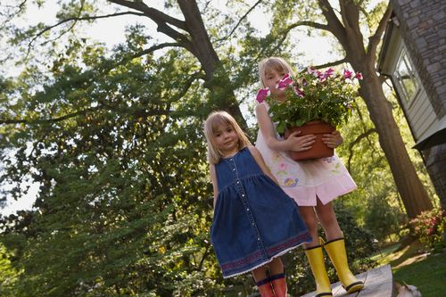
Levels Offered: Grades 2–8 Category: Life Skills Description: Students learn how to plant, care for, and harvest vegetables and herbs while exploring sustainability and ecology. The activity promotes responsibility and environmental awareness.
Schedule: The program includes 7 lessons, beginning September 11, meeting every Wednesday from 2:30 p.m. to 3:30 p.m.
Cost: $180 Optional Extras: Gardening gloves ($8)

LANGUAGE
Spanish Conversation Club
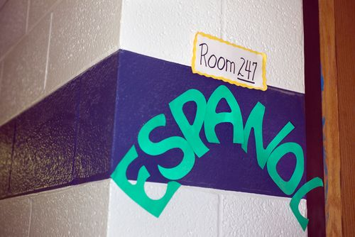
Levels Offered: Grades 4–12 Category: Language
Description: Students practice conversational Spanish through games, role-play, and cultural activities that build confidence and fluency. The club provides a relaxed environment for practicing vocabulary and pronunciation.
Schedule: The club includes 6 lessons, beginning September 9, held every Monday from 2:30 p.m. to 3:30 p.m.
Cost: $160 Optional Extras: Vocabulary flashcards ($10)

WELLNESS
Yoga & Mindfulness

Levels Offered: Grades 2–12 Category: Wellness Image:
Description: Yoga & Mindfulness teaches breathing techniques, stretching, and relaxation practices that help students manage stress and improve focus. The activity promotes emotional balance and physical well-being.
Schedule: The program includes 7 lessons, beginning September 9, held every Monday from 2:30 p.m. to 3:30 p.m.
Cost: $180 Optional Extras: Yoga mat ($15)

