**ADVANCED TECHNICAL TRAINING CENTRE**

**BARDANG EAST SIKKIM**



**MAJOR PROJECT SYNOPSIS**

ON

ATTC COMMUNITY FORUM

**PREPARED BY**

1. Andronicus Lepcha A18DCE-04
2. Sachin Kumar Sharma A19DCE-36
3. Manish Kumar Dhobi A18DCE-20
4. Rose Mary Rai A19DCE-L02

**UNDER THE SUPERVISION OF**

**Mr. Nirnay Pradhan**

DEPARTMENT OF COMPUTER SCIENCE & ENGINEERING

ADVANCED TECHNICAL TRAINING CENTRE

**SESSION @ 2020– 2021**

|  |  |  |
| --- | --- | --- |
| **S.NO** | **TITLE** | **PAGE NO** |
|  | **Abstract** |  |
| **1.** | **Chapter 1:Introduction** | 1 |
|  | 1.1 Introduction | 1 |
| **2.** | **Chapter 2: Design And Development** | 1-4 |
|  | 2.1Problem Definition | 1 |
|  | 2.2 Problem Analysis | 1 |
|  | 2.3 Modules | 2 |
|  | 2.4 Solution Strategy | 3 |
|  | 2.5 Proposed Methodology | 3 |
|  | 2.6 Software and Communication Interface | 3-4 |
| **3.** | **Chapter 3: Analysis Model** | 4 |
|  | 3.1 Iterative Waterfall Model | 5 |
|  | 3.2 Gantt Chart | 6 |
|  | 3.3 ER Diagram | 7 |
|  | 3.4 Data Flow Diagram  3.4.1 DFD level 0  3.4.2 DFD level 1 | 8 |
|  | 3.5 Use Case Diagram | 9 |
| **4.** | **Conclusion** | 10 |
| **5.** | **References** | 10 |

**CONTENTS**

**ABSTRACT**

ATTC Community Forum is web-based project where users can create their account and can make discussion on concern of ATTC. This project is made by using HTML, CSS, and Java Scripts languages for frontend and Python language for backend and Django framework is used to build the project. Django is an open-source python web framework used for rapid web development. In this project there are different modules used to make the ATTC Community Forum more comfortable to the users.

The modules include category, question, answer, search, votes, user registration, answer, profile. Whenever a user create an account on ATTC Community Forum then the user will be directly directed to the user profile page, and from their they can ask or answer any post created by the existing users and can also up/down vote the answer from other users. The admin can delete the suspicious account or the fake account and even delete the post if the topic is un-relevant to the college.

**CHAPTER 1**

**1.1 INTRODUCTION**

“ATTC Community Forum ” is a web-based platform where persons after creating their account can make discussions on various topics. It’s a community discussion forum, where all the teachers, staff, and students will able to both enter questions and get answers on various categories and other tags. For example, the categories can be related to sports, admission, accounts, subjects, etc.

Each type of question will be under a particular category and tags. Registered users will be allowed to enter questions, provide answers to the questions, and up vote or down vote to the existing posts.

We'll be using the standard rich text editor to enter questions and get answers in a formatted manner. Even the attachments can be made with particular posts through a form developed in Django and Python for the backend and HTML, CSS, and bootstrap for the frontend.

Modules

There are six main modules in our project.

* Category
* Post question
* User registration
* Post reply
* Search
* Votes

**CHAPTER 2**

**2.1 PROBLEM DEFINITION**

* We do not have any such platform for asking and answering questions.
* A small group of faculties answering and clearing all the doubts.
* Students are relying on fake news spread by someone unofficial faculties

**2.2 PROBLEM ANALYSIS**

During the period of lockdown due to COVID we as a student faced many problems regarding the college information and notices. The main problem was with the wrong information that was being delivered to students there was always being confusion about the information like college reopening date , examination date and many more related to college.

This problem isn’t for only our college but also for all the institution that was on lockdown and could not communicate between staffs and the students. It is also very hard to inform a news or genuine information to the students or their staffs through the calls, messages or social media ,if those notice or information is to be informed through calls , messages then it can take a lot of time to do and sometimes all people or students want receive the information correctly.

**2.3 MODULES**

* User verification
* Easy to use user interface
* Feedback (using up votes and down votes)
* Useful resources links
* Filter
* Media
* Email Verification

Category Module:

This module is the main module, by selecting the category user can post or view their questions easily. It can help the user to categorize the question so that they can get answers from the users of that category. They can retrieve the answers to their questions from the different users. It can be also used to find the answer to the related questions in that category.

Post Question Module:

This module is mainly for the registered users. Any user who has an account registered can both ask or answer any question and vote. Post questions are stored in the mysqlite3 database.

User Registration Module:

From this module, users can get registered in the forum by filling up the registration form. This Module helps to give detailed information about the newly entered user.

Post replies Module:

Each and every posted question on the forum can be answered by anyone user.

Search Module:

This module is used to search their queries, they can search their question and the system will give them the search result. The search result links to the questions that have the search keyword. Both registered and non-registered users can search over here

Votes Module:

All the answers will have the vote option (upvote and downvote), which can be only used by the registered user. This feature can help separate the most relevant and useful answers.

**2.4 SOLUTION STRATEGY**

* A verified mark will be there on the post maker

With the help of this feature we all can see is the post from a verified person or not mostly the verified mark will be on the teachers account and the executive body of the institution.

* Up Vote and Down Vote

This feature can help the person to see which of the post is mostly genuine if it has more Up Votes then they can say it’s more genuine.

**2.5 ROPOSED METHODOLOGY**

In this web-based Online Community Forum, there will be four types of users who will interact with this system and control the various activities. These four users will be the admin, staff, teachers, and students. Users will be responsible to enter questions in a particular forum, get their answers, make replies to existing posts, check votes of different posts, and make changes through their profile settings.

It’s the admin, who will have the authority to remove questions and answers posted by the registered users or even removing the users. Admin can keep track of the various activities of all the users. Among these, there are other features, like displaying the posts based on various parameters like recent posts, displayed in ascending or descending order, by date, etc.

**2.6 SOFTWARE AND COMMUNICATION INTERFACES**

Front end

*HTMl*

The Hypertext Markup Language or HTML is the standard mark up language for documents designed to be displayed in a web browser. It can be assisted by technologies such as cascading (CSS) and scripting language such as JavaScript.

Web browser receives HTML documents from a web server or from local storage and renders the documents into multimedia web pages. HTML describes the structure of a web page semantically and originally included cues for the appearance of the document.

*Bootstrap(Framework)*

Bootstrap is a free and open source front end development framework for the creation of websites and web apps. In computers, the word bootstrap means to boot: to load a program into a computer using a much smaller initial program to load in the desired program which is usually an operating system.

For back-end

*Python*

Python has a simple syntax similar to the English language. Python has syntax that allows developers to write programs with fewer lines than some other programming languages. Python runs on an interpreter system, meaning that code can be executed as soon as it is written.

It's often used as a scripting language for web application. This means that it can automate specific series of tasks, making it more efficient. Consequently, Python (and languages like it) is often used in software application, pages within a web browser, the shells of operating systems and some games.

*Django(Framework)*

Django is a high-level Python Web framework that encourages rapid development and clean, pragmatic design. Built by experienced developers, it takes care of much of the hassle of Web development, so you can focus on writing your app without needing to reinvent the wheel. It's free and open source.

*CSS*

Cascading Style Sheet: - Cascading Style Sheets is a simple mechanism for adding style e.g., fonts, colors, spacing) to Web documents

.

Visual Studio Code

It is a freeware source-code editor made by Microsoft for Windows, Linux and macOS. Users can change the theme, keyboard shortcuts, preferences, and install extensions that add additional functionality.

Software Features

1. Interaction will be easier

2. Users article can be viewed by others

3. Less time consuming

**CHAPTER 3**

**3.1 ITERATIVE WATERFALL MODEL**

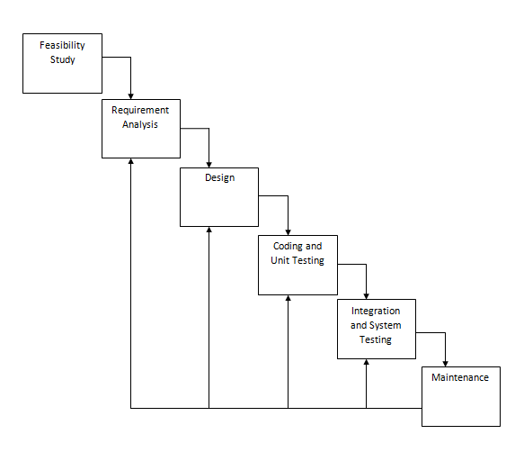

Fig 3.1: Iterative waterfall model

**3.2 GANTT CHART**

22/03 28/03 05/04 24/04 01/06 14/6 24/06

|  |  |  |  |  |  |  |
| --- | --- | --- | --- | --- | --- | --- |
| Feasibility Study |  |  |  |  |  |  |
|  |
| Requirements Analysis and Specification |  |  |  |  |  |  |
|  |
| Design |  |  |  |  |  |  |
|  |
| Coding and Unit Testing |  |  |  |  |  |  |
|  |
| Integration and System Testing |  |  |  |  |  |  |
|  |
| Documentation |  |  |  |  |  |  |
|  | | |  | | |

Proposed Activity Achieved Activity

Fig 3.2: Gantt chart

**3.4 ER DIAGRAM**

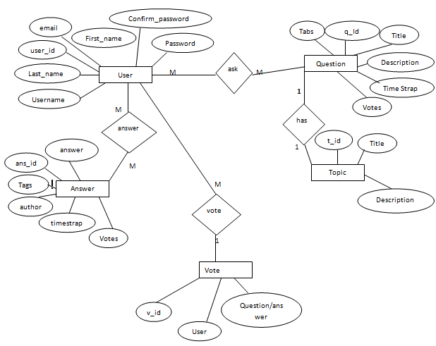

Fig 3.3: ER Diagram

**3.4 DFD LEVEL 0**

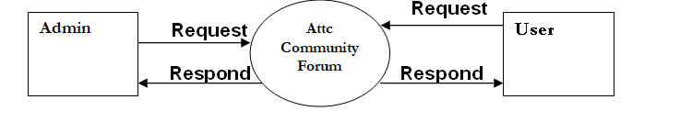

Fig 3.4: DFD Level 0

**3.4 DFD Level 1**

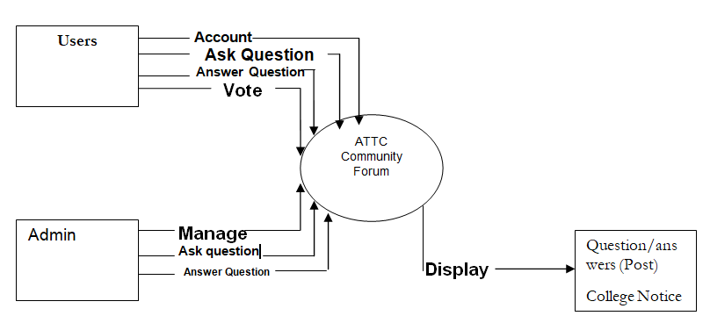

Fig 3.5: DFD Level 1

**3.5 USE CASE DIAGRAM**

**3.5 Use Case Diagram**

Users

Faculty (teachers/admin)

ATTC Community Forum

Fig 3.6: Use case diagram

**CONCLUSION**

ATTC community forum is a great tool to help both teachers and students maintain their communication beyond the classrooms. It’s also a great way for students to feel more engaged in participating in the group discussion; allow them to provide and share their opinions with others at any time and location.

**REFERENCES**

[**www.youtube.com**](http://www.youtube.com)

https://docs.djangoproject.com/en/3.2/