Technical design of the system

Tankons — Multiplayer Top-Down Tank Battle Game

Package diagram
The package diagram is divided into four main sections:

- GameController — the top-level coordinator that owns all sprite groups (players, shots, walls, particles, powerups) and drives the main update cycle. It delegates to the subsystem controllers and manages round resets.
- Controllers — includes PlayerController, which spawns and manages all tank entities and draws the scoreboard; LayoutController, which selects and renders maps and provides spawn and power-up coordinates; and PowerupController, which handles power-up spawning and pickup.
- Entities — the individual game objects: Player (tank movement, rotation, shooting, collisions), Shot (bullet physics and bouncing), Wall (static collision geometry), and Particle (explosion effect on tank death).
- Networking — contains Server, which runs the authoritative game instance and broadcasts state to all connected clients, and Client, which transmits local player input and mirrors server-driven game events.

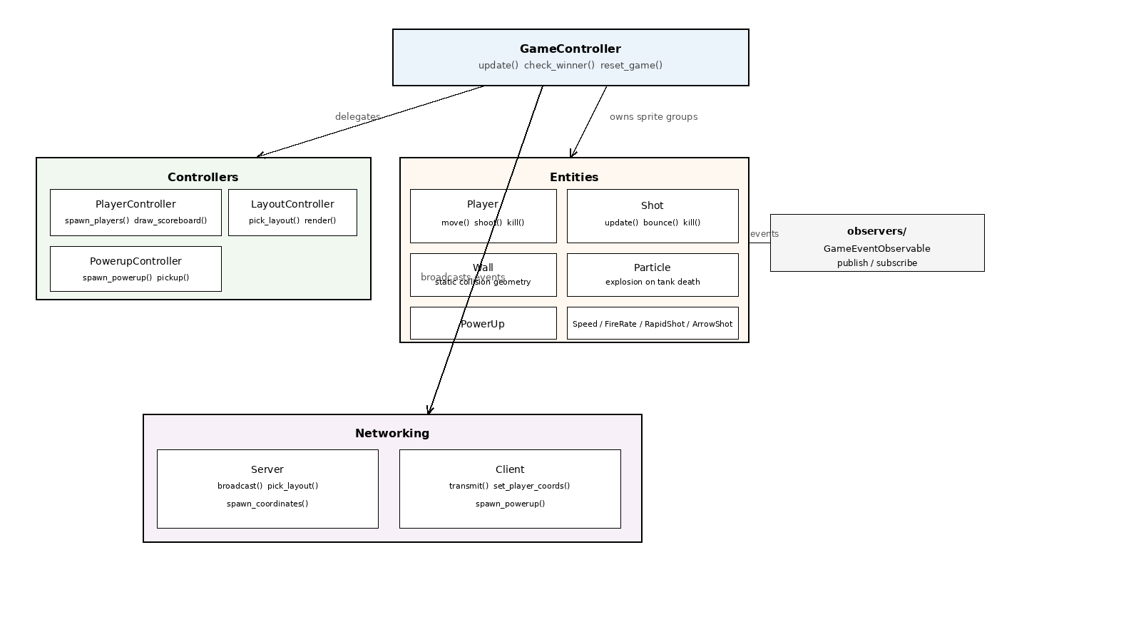

Class diagram
The following describes the class diagram, which illustrates the relationships between classes and their methods. The main classes are:

- Player — the main entity class. Stores position, angle, speed, shot cooldown, bounce count, and lists of active stat and weapon power-ups. Exposes update(), shoot(), kill_player(), and methods for adding and removing power-ups.
- Shot — describes a single bullet: direction vector, speed, radius, max_bounces, current bounce count, and a life countdown. The update() method advances the position each frame and handles wall reflection and lifetime expiry.
- PowerUp — base class for all power-up types. Concrete subclasses are Speed (stat), FireRate (stat), RapidShot (weapon), and ArrowShot (weapon). Weapon power-ups override shoot(); stat power-ups modify Player attributes for a fixed duration.
- GameController — orchestrates the full game session. Manages sprite groups, runs check_winner() each frame, triggers round resets, and routes networked events between Server/Client and the rest of the system.
- LayoutController — selects maps from a pool (no consecutive repeats), renders Wall sprites, and provides random spawn and power-up coordinates.

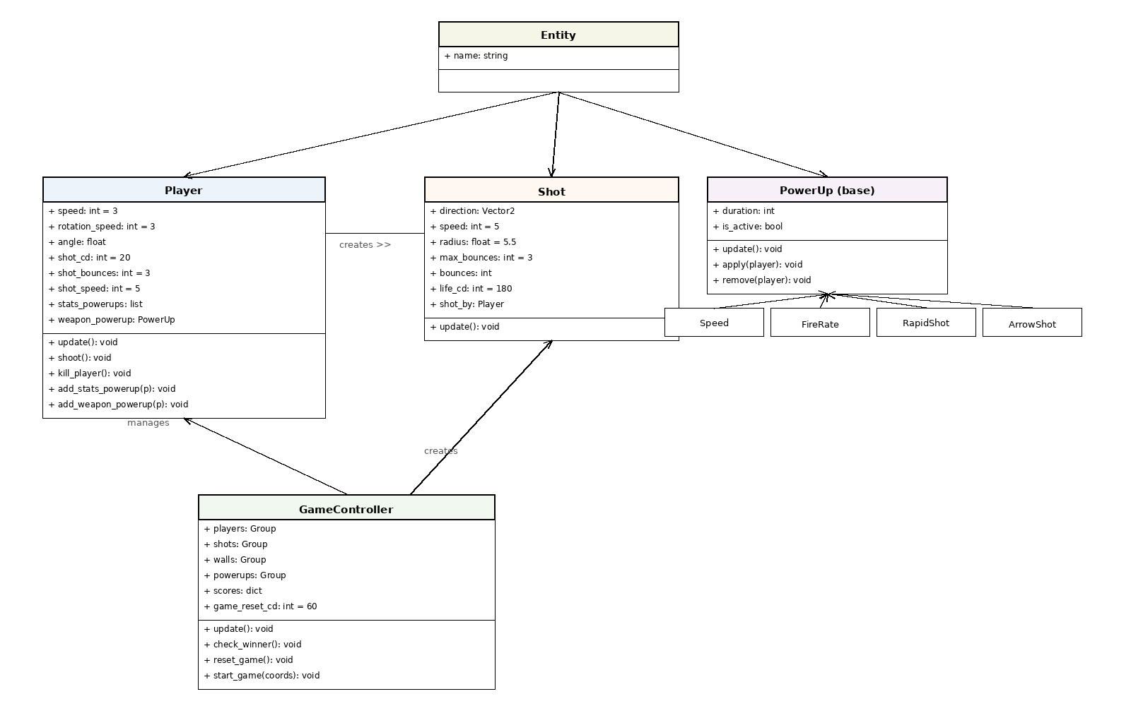

Sequence diagram
This sequence diagram describes the interaction flow between the player input, the game entities, and the event system in Tankons.

The process starts when the player presses a key. The Player entity reads input directly via pg.key.get_pressed() each frame. Depending on the key pressed, the player moves, rotates, or fires a shot.

When a shot is fired, the Player entity creates a Shot sprite and publishes a SHOT event via GameEventObservable. In a networked session the Server picks up this event and broadcasts it to all connected clients, which each instantiate the bullet locally.

When a tank is destroyed, kill_player() removes it from all sprite groups and publishes a RESET_ROUND event. The GameController waits for a short cooldown, then resets the round: all sprites are cleared, a new map is selected, fresh spawn coordinates are sampled, and a new round begins.

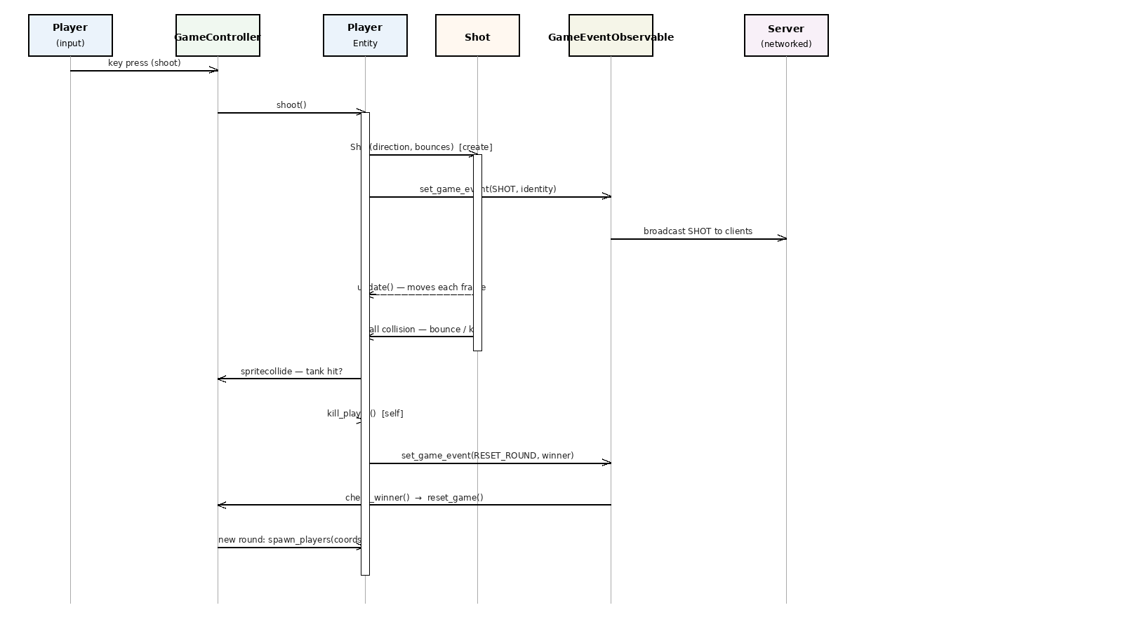

State diagram
This state diagram shows the lifecycle of a game session in Tankons. It represents the main states of the application and the possible transitions between them.

The process begins with Program Start. Depending on the command-line argument provided, the application enters one of three modes: Local (no argument), Server, or Client. In Server and Client modes the application first waits for all players to connect before a round can begin.

Once all players are ready, a Round becomes active. During a Round, players move, rotate, and shoot. A Round ends when only zero or one tanks remain alive. If one tank remains it is awarded a point; if none remain no points are awarded. After a short reset delay a new map is selected and all players are respawned, starting the next Round. This loop continues indefinitely.

From any active screen the user can close the application to reach the End state.

