Andrew Watts

ID# 01459646

Professor Li

Database Management Systems

9/30/2017

HW 1:

1. 3 customers are located in Florida.

SELECT CustomerState

FROM Customer_T

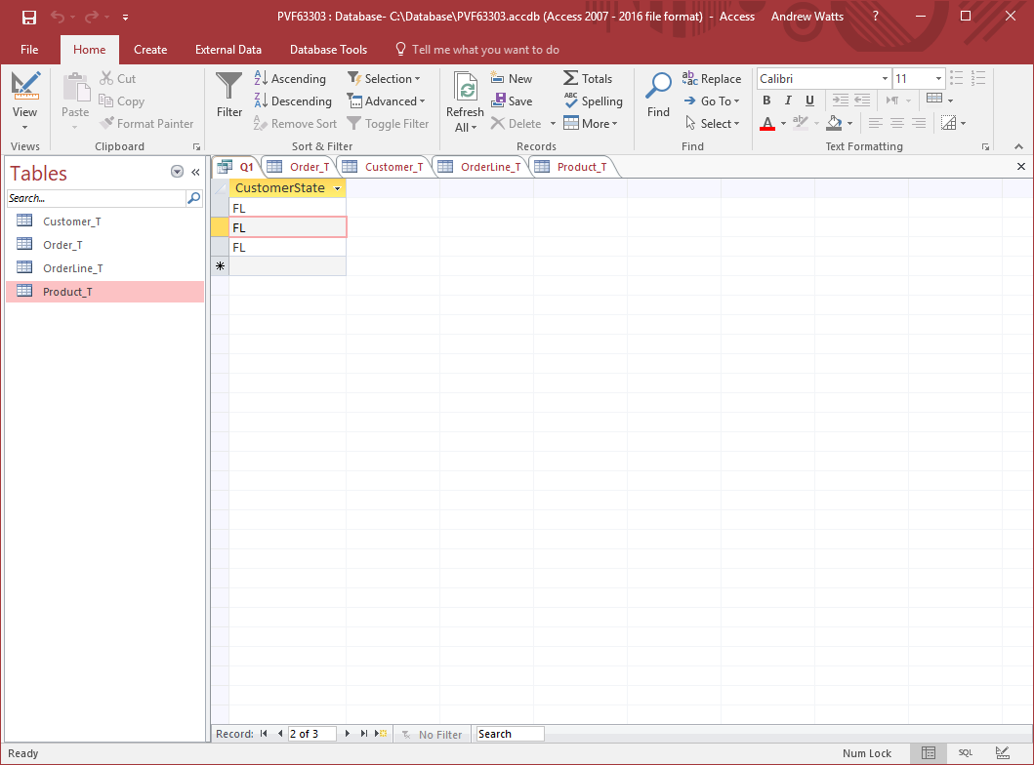WHERE CustomerState in ('FL');

SELECT CustomerState, count(CustomerState)

FROM Customer_T

WHERE CustomerState in ('FL')

GROUP BY CustomerState;

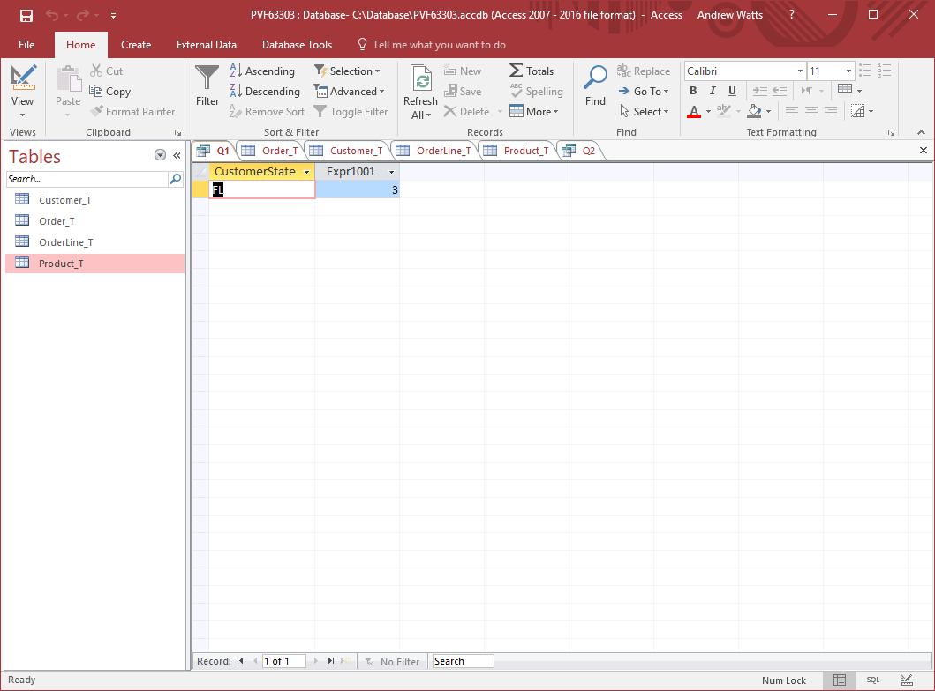

1. SELECT DISTINCT CustomerState FROM Customer_T

WHERE CustomerState IN (SELECT CustomerState

FROM Customer_T GROUP BY CustomerState

HAVING COUNT (CustomerState) > 0);

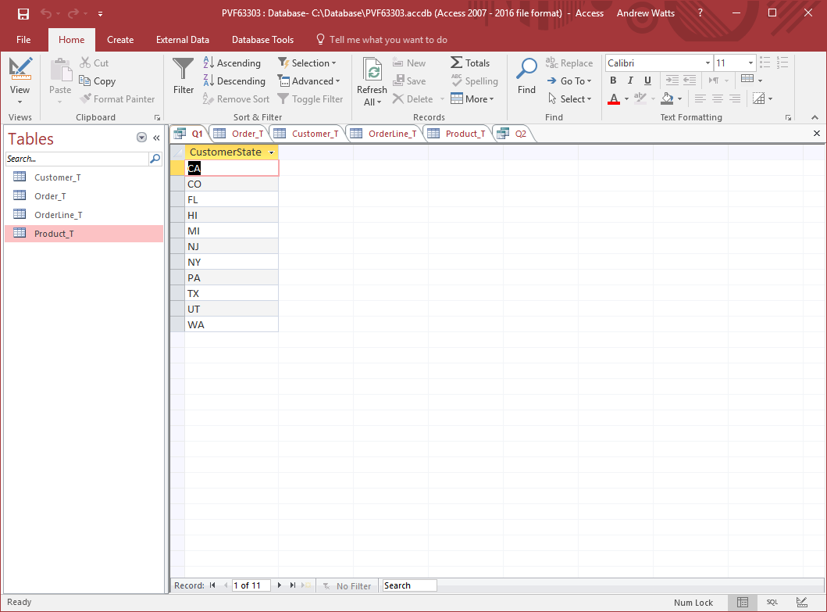

1. F

4. SELECT Customer_t.CustomerID, CustomerName, OrderID

from Customer_t left outer join Order_T

on Customer_t.CustomerID = Order_t.CustomerID;

