Homework 3 Solutions

1. Ross 3.19 p. 113

- Choose a random member of the class as a whole. Let A be the event that this person attends the success party, let W be the event that this person is a woman and let be the event that this person is a man. Then, using Bayes’s formula, we have
,
so about 44.3% of those attending the party were women.

- The percentage of the original class that attended the party is just the denominator from above, so , or 41.18%, of the original class attended the party.

2. Ross 3.26 p. 114

- If we assume there are an equal number of males and females, then the probability of a randomly chosen colorblind person being male is just (using M to denote the event of a person being male, to denote the event that the person is a female, C to denote the event of a person being colorblind)
.

- If we instead assume that there are twice as many males as females, then this probability becomes
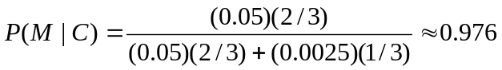.

3.

- Ross 3.42 p. 116
Let A, B, and C denote the events that a cake is baked by cook A, B, and C, respectively, and let F denote the event that a cake fails to rise. Then, the proportion of failures caused by A is just
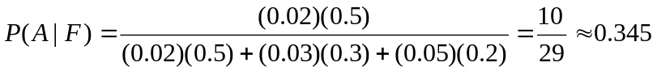

- Ross 3.55 p. 118
Let x be the number of sophomore girls that are present. We want sex and class to be independent when a student is selected at random; hence, we want . Using the numbers that we are given and then solving for x, this means that
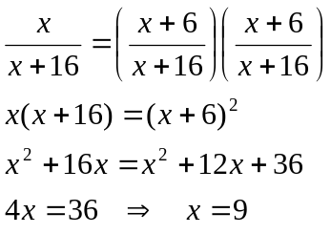
So, we need 9 sophomore girls to be present in order for sex and class to be independent in this scenario.

4. Ross 3.57 p. 118

- The probability that after 2 days the stock will be at its original price is just the probability of (move up day 1, move down day 2) plus the probability of (move down day 1, move up day 2). Since the changes on different days are assumed to be independent, each of these events has probability 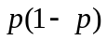. Hence, the probability of the stock being at its original price after 2 days is just 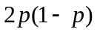.

- The probability that after 3 days the stock’s price will have increased by 1 unit is obtained by considering the probability of seeing the stock move up on 2 different days and move down on another, multiplied by the number of ways you can arrange 2 moves up among 3 total moves; in other words, the probability of the stock’s price having increased by 1 unit after 3 days is just 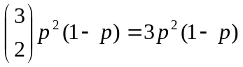.

- Out of the 3 ways to arrange 2 moves up and 1 move down, only 1 of the 3 ways does NOT have a move up on the first day. Hence, the probability of the stock’s price moving up the first day given that it increased by 1 unit after 3 days is just 2/3.

5. Ross 3.60 p. 118-19

- Based on the information from the problem, we can reasonably deduce that Smith’s parents both have one brown-eyed gene and one blue-eyed gene (else, the combination of Smith having brown eyes and Smith’s sister having blue eyes could not occur). Then the possible gene pairings for Smith would be {(Br, Br), (Br, Bl), (Bl, Br)}. Let X denote the number of blue-eyed genes that Smith received. The values of X corresponding to the above set of outcomes are just {0, 1, 1}. Then the probability of him having a blue-eyed gene is 2/3.

- Since Smith’s wife has blue eyes, then the probability that their first child has blue eyes depends entirely on Smith contributing a blue-eyed gene, and as such, this probability is
.

- First, we need to compute the probability that Smith has a blue-eyed gene given that his first child has brown eyes. Then, using this updated probability, we can compute the probability that his second child also will have brown eyes.
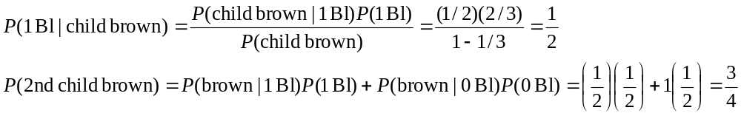

6. Ross 2.26 p. 58

Let 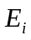 denote the event the initial outcome is i and the player wins. Then the desired probability is 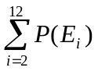. Before we go any further, note that 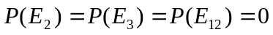, 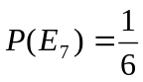, and 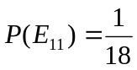. For any other value of i, define the event 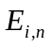 to be the event that the initial outcome is i and the player wins on roll n. It is clear that the are mutually exclusive for any value of i (since one cannot win on roll n if one has already won on roll 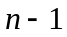, and so on). Hence, the probability of event should just be the sum over n of the events ; in other words, 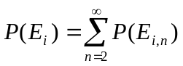. Then, all that is needed is to determine 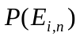 for i = 4, 5, 6, 8, 9, 10; but since the pairs (4, 10), (5, 9), and (6, 8) are identical in terms of probability, we can simplify matters by looking just at values i = 4, 5, 6 (taking care to double the probability for 4, 5, and 6 to reflect the fact that they’re pulling double-duty for 10, 9, and 8, respectively). Leaning back toward our original problem, this means that the probability of winning at craps can be expressed as
.
Now, if our initial outcome is i (where we restrict our attention to i being one of {4, 5, 6}), then in order for us to win on roll n, we would need to have rolled something other than i or 7 on all rolls between 1 and n (non-inclusive); i.e., we would need 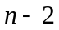 rolls that are not i or 7 sandwiched between our 2 rolls of i. This means that 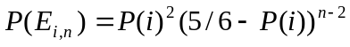 (where 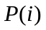 is just the probability of rolling i and since 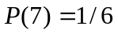). Substituting this expression into the sum for 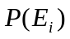 gives us
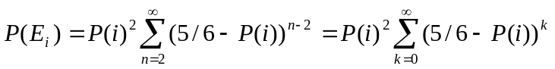,
where we have chosen to re-index the sum using 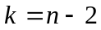. Note that the sum on the right-hand side is a geometric series with 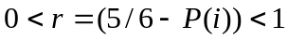; hence, the expression for should simplify to
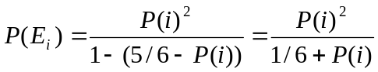.
Since 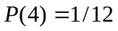, 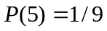, and 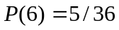, this means that 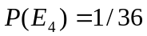, 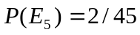, and 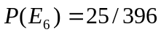; plugging these values back into our expression for 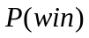 gives us
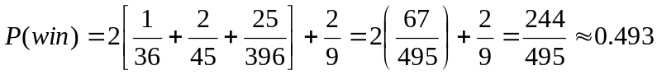.

7. Ross 3.89 p. 123

- Let 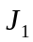, 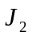, and 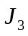 represent judges 1, 2, and 3, respectively. Then the probability of judge 3 voting guilty given that judges 1 and 2 voted guilty should just be the probability of all 3 voting guilty divided by the probability of the first 2 judges voting guilty (using the definition of conditional probability); the probability of all 3 voting guilty (as well as judges 1 and 2 voting guilty) can be decomposed into 2 components: the probability of all 3 (or judges 1 and 2) voting guilty and the defendant being guilty and the probability of all 3 (or judges 1 and 2) voting guilty and the defendant being innocent. In other words,
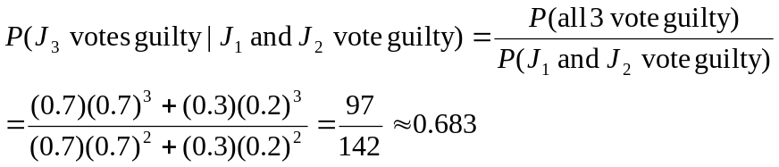

- Now, we want the probability of judge 3 voting guilty given that one of judges 1 and 2 voted guilty and the other not guilty. Again, we can decompose into the case where the defendant is guilty and the case where the defendant is innocent; this gives us the probability
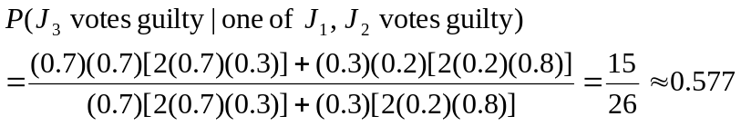

- Now, we want the probability of judge 3 voting guilty given that both judges 1 and 2 voted not guilty; as before, we decompose into a probability for when the defendant is guilty and another for when the defendant is innocent. So, the probability in this case is
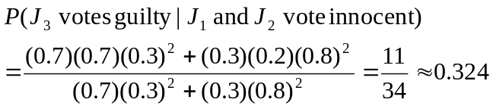

The events are conditionally independent given the guilt or innocence of the defendant.

8.

- We start off with probability 0.5 of the original fish being a piranha (or a goldfish). Once our sushi lover throws a piranha into the bowl, we have probability 0.5 of there being 2 piranhas (or 1 goldfish and 1 piranha). The probability of him removing a piranha when there’s 2 piranhas is naturally 1, and the probability of him removing a piranha when there’s 1 piranha and 1 goldfish is 0.5. Let 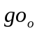, 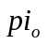, and 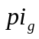 represent the events that a goldfish was originally in the bowl, a piranha was originally in the bowl, and a piranha was grabbed from the bowl respectively; then, the probability of the original fish being a piranha given that the fish he grabbed was a piranha should be
.

- Our sushi lover now throws a piranha and a goldfish into the bowl, so we have probability 0.5 of there being 2 piranhas and 1 goldfish (or conversely, 2 goldfish and 1 piranha). The probability of him removing a piranha when the original fish was a piranha is 2/3, and the probability of him removing a piranha when the original fish was a goldfish is 1/3. Using the same notation as before, the probability of the original fish being a piranha given that he removed a piranha is just
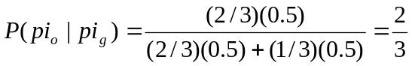.

(Side note: This suggests that, using the fact that our original bowl is equally likely to have a piranha or a goldfish, if our sushi lover tosses 1 piranha and n goldfish into the bowl, the probability of the original fish being a piranha given that he removes a piranha will be 2/3 for all values of n.)

