

<https://www.inc.com/geoffrey-james/3-entrepreneur-veterans-explain-how-military-experience-is-good-for-business.html>

* Swiss elite in 20th century: closed, protectionist, informal agreements.
* Strong right-wing parties, business orgs facilitated self-organization.
* Informal contracting bypassed federal state, reducing bureaucracy.
* Informal consensus between bank and business CEOs smoothed tensions.
* Pre-1990s elite profile: Swiss men with military service, right-wing affiliation.
* Military experience facilitated informal interactions, national cohesion during Cold War.



<https://ec.europa.eu/commission/presscorner/detail/en/ip_24_1508>

* Globalization era blurs nation state and capital boundaries, including Switzerland.
* Since late 20th century, decrease in top managers with military rank.
* Rise in importance of international education, especially MBA, and work experience in global financial centers.
* Trend perceived ambiguously by Swiss political and economic centers of power.
* In 2007, clause limiting foreigners on boards repealed.
* Switzerland's evolution reflects alignment with neoliberal capitalism of early 21st century.

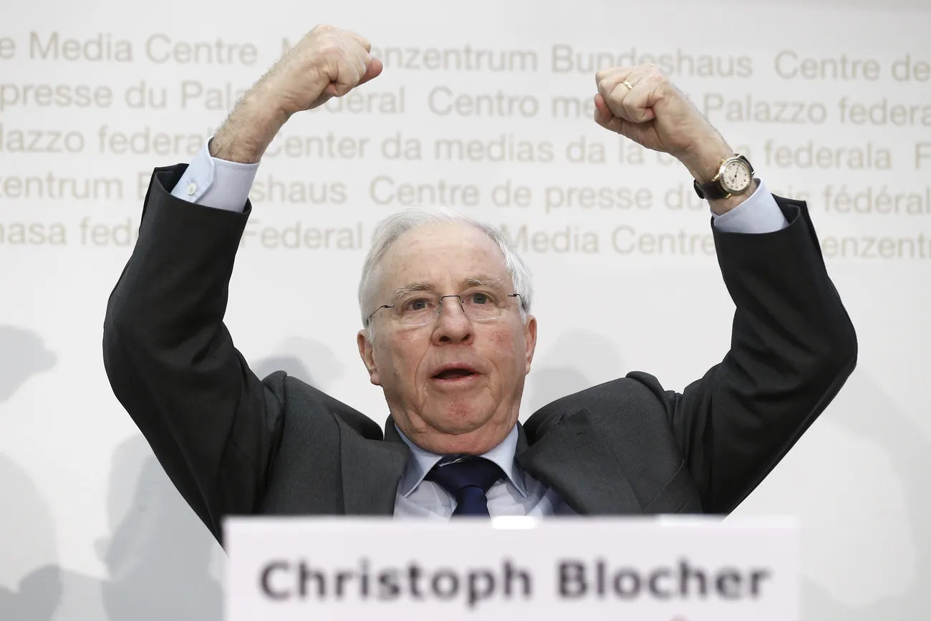

<https://www.swissinfo.ch/eng/politics/is-the-swiss-people-s-party-far-right/48995330>

* Since 1990s, industry-financier consensus weakened, giving way to political instruments.
* Parliamentary phase gains importance over informal bargaining.
* Association of Small and Medium Enterprises, Swiss People’s Party criticize Economiesuisse for favoring banking/pharmaceutical sectors, high executive salaries.
* Populist right-wing parties gain traction, pressuring transparency in business operations.
* Cancelation of golden parachute rule for executives and victory of popular initiative against EU worker movement.

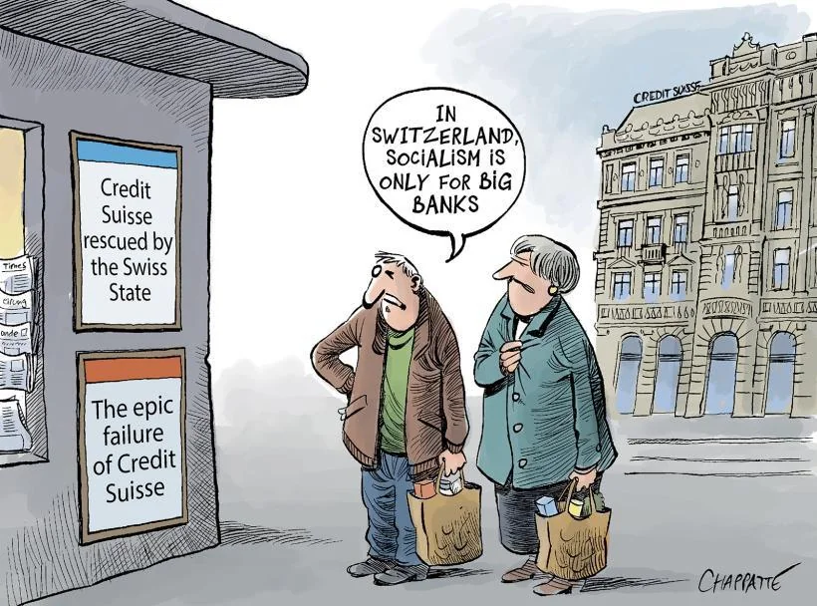

<https://www.reddit.com/r/Switzerland/comments/11wfuo6/is_switzerland_turning_to_red/>

* Credit Suisse's collapse in March 2023 leads to merger with UBS, monopolizing Swiss banking sector.
* Concerns arise over monopoly bank in private hands, "too big to fail" principle, and nationalized debts.
* Swiss state may struggle to cover UBS's potential losses in bankruptcy; no bank large enough to buy it out.
* FINMA finds UBS bailout plans incomplete, deeming it "too big to be rescued."
* Takeover results in 16 billion Swiss francs worth of Credit Suisse bonds written off, impacting Swiss financial debt market.
* Conflicts weaken and split business elite, empowering formal public governance instruments.