WEB TECHNOLOGY AND MOBILE APPLICATION
EXPERIMENT – 9
ANDRYAN DURAI JEBIN – 241801020
OUTPUT –
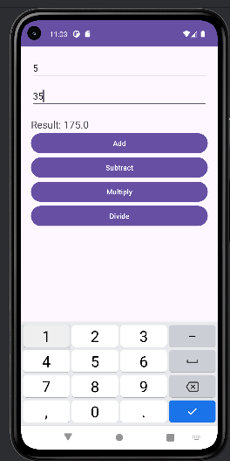
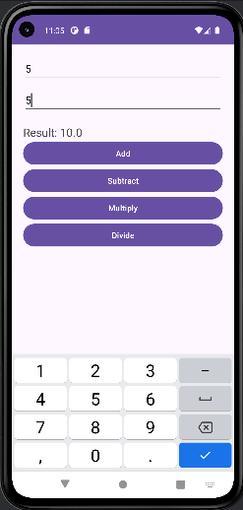
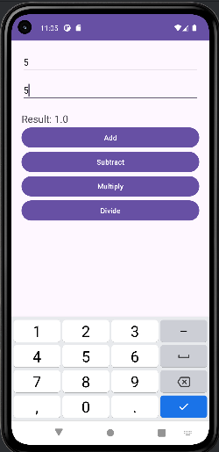

PROGRAM -
