Title: **Twilight sleep**Book Author: **Edith Wharton**Report Author: **Andrzej Krzyśków**

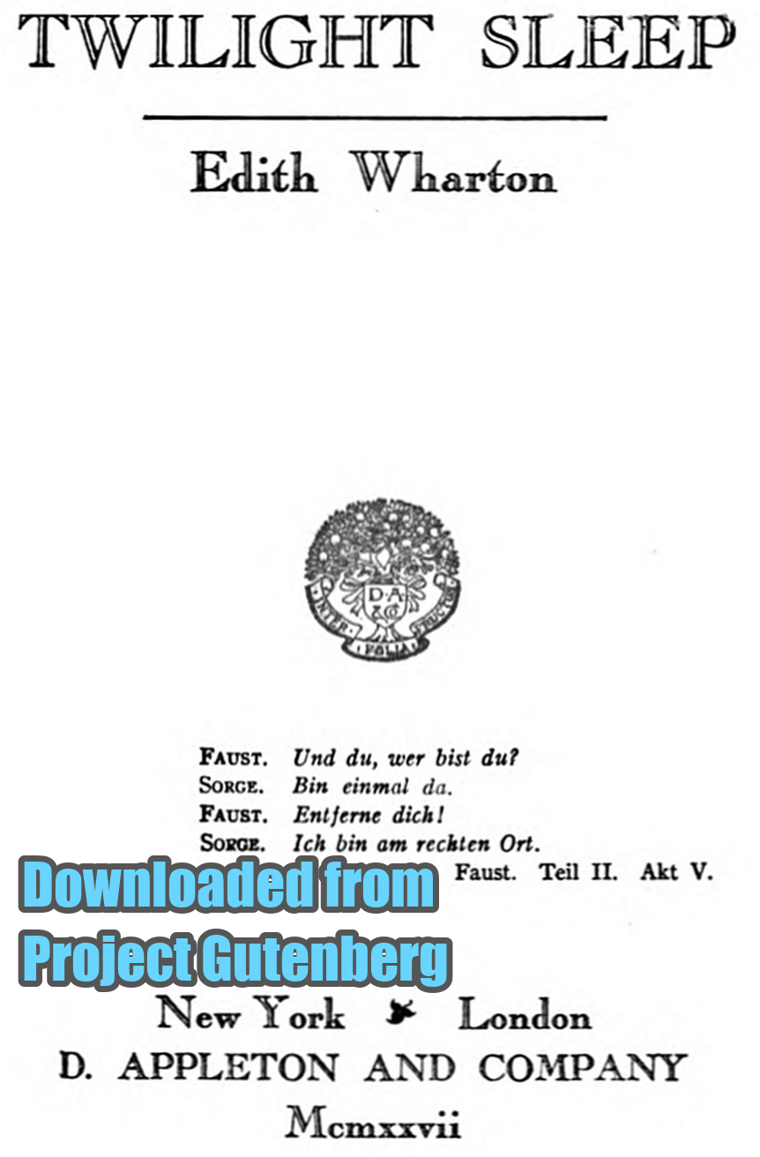

**Chapter I**

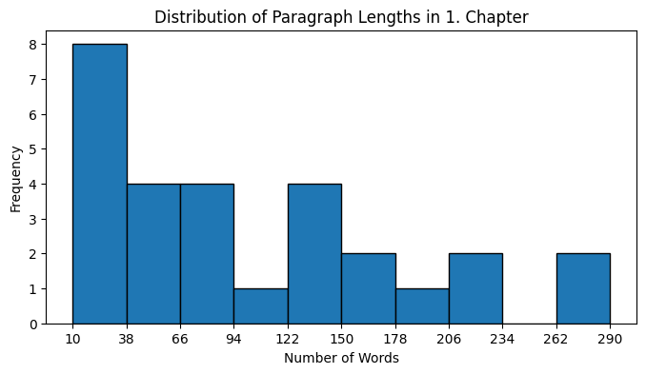

**Chapter II**

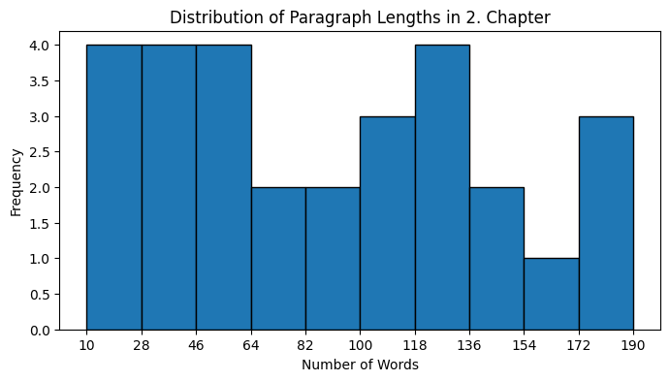

**Chapter III**

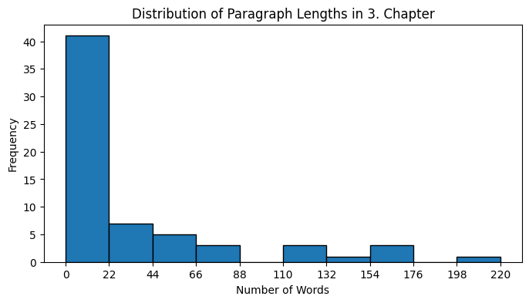

**Chapter IV**

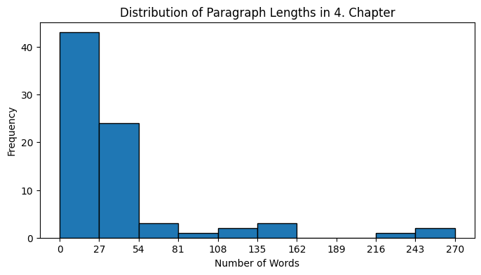

**Chapter V**

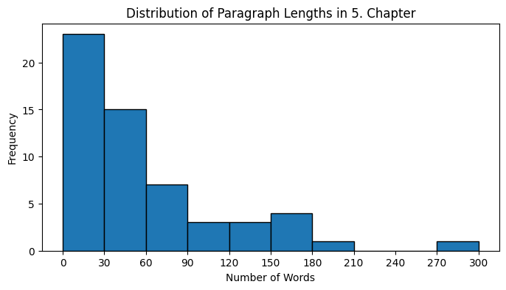

**Chapter VI**

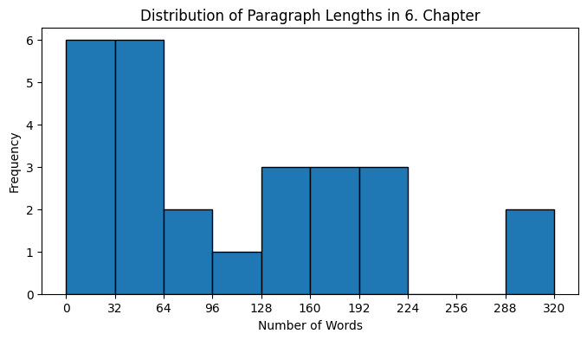

**Chapter VII**

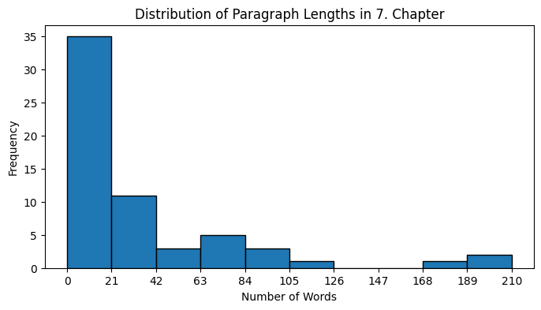

**Chapter VIII**

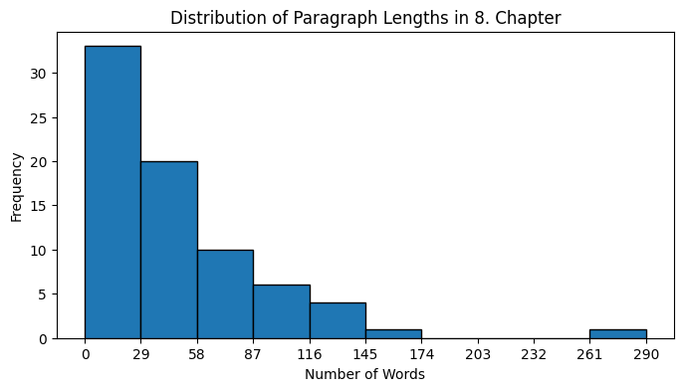

**Chapter IX**

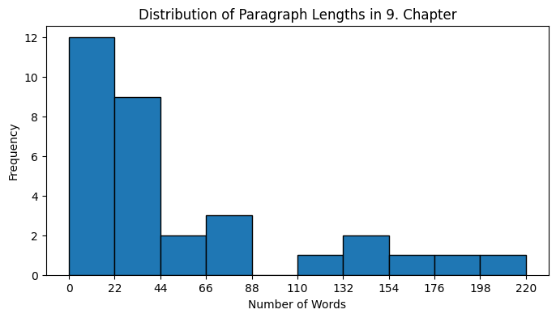

**Chapter X**

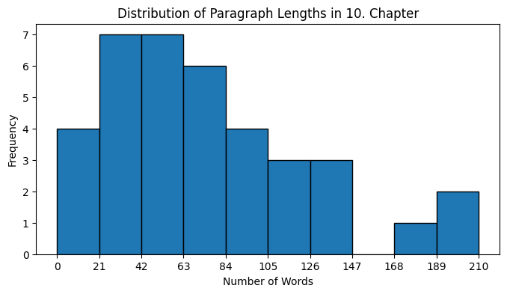

**Chapter XI**

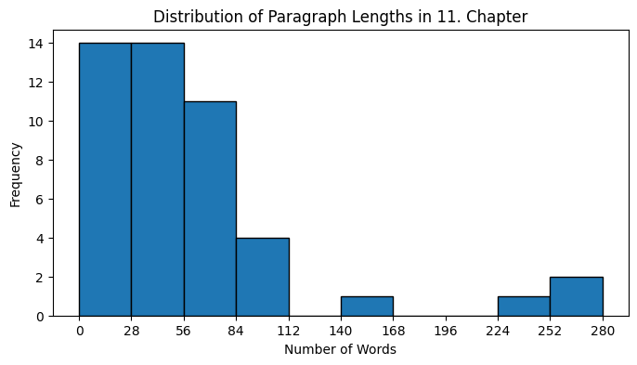

**Chapter XII**

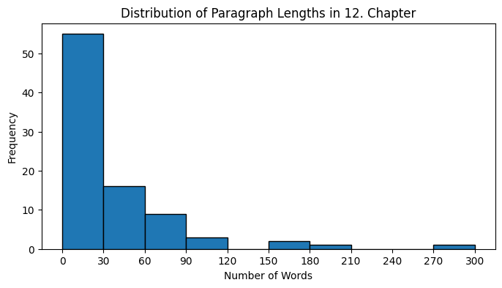

**Chapter XIII**

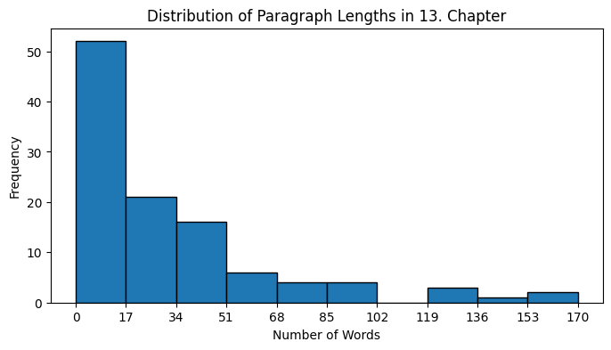

**Chapter XIV**

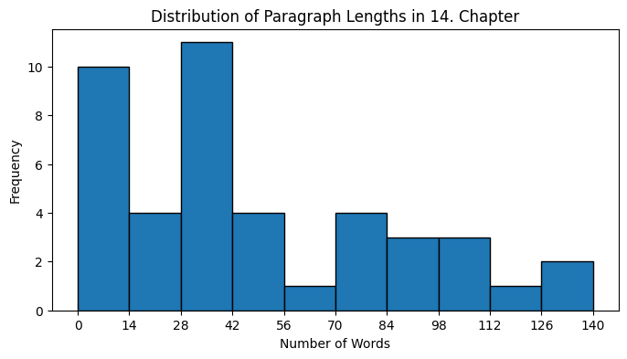

**Chapter XV**

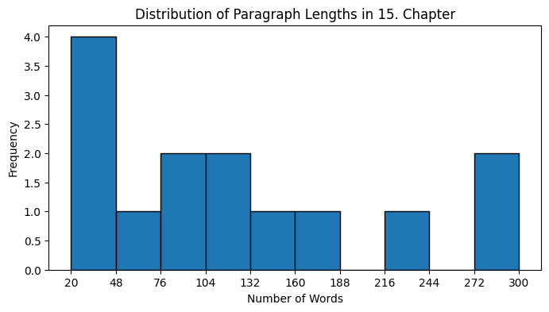

**Chapter XVI**

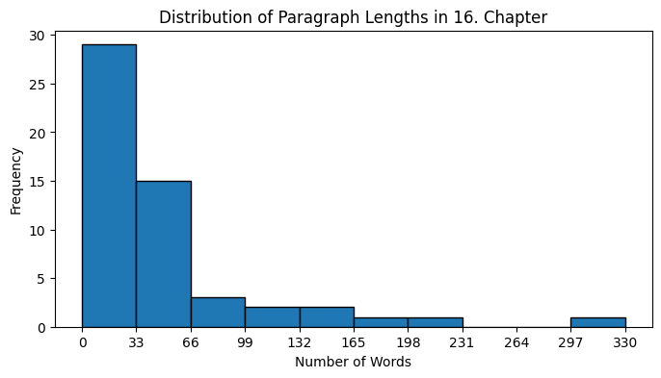

**Chapter XVII**

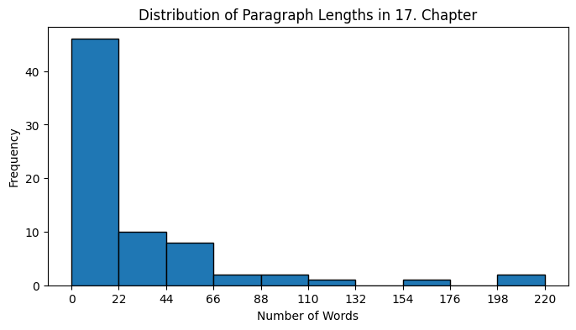

**Chapter XVIII**

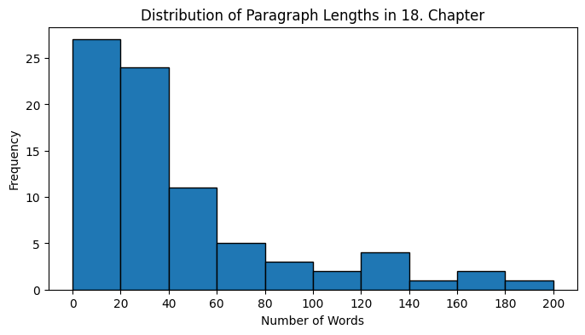

**Chapter XIX**

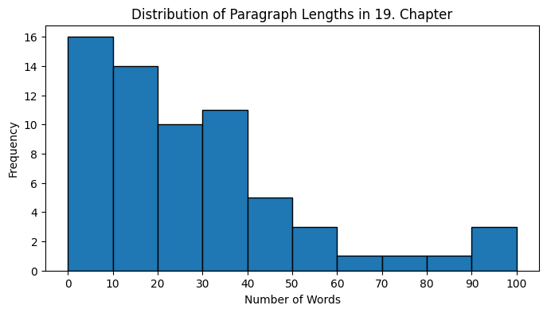

**Chapter XX**

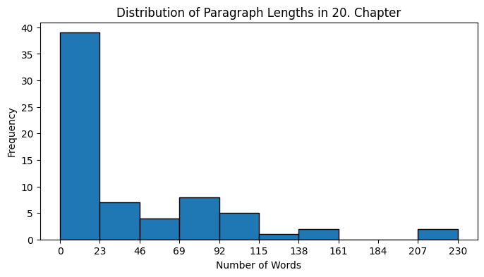

**Chapter XXI**

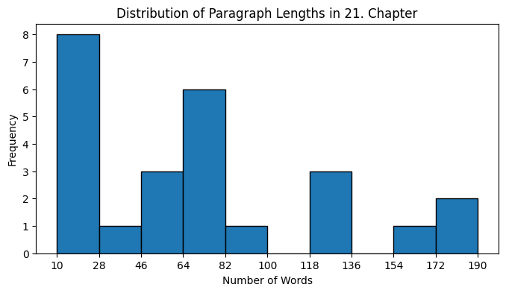

**Chapter XXII**

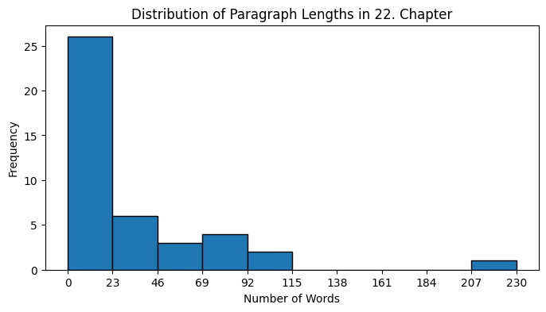

**Chapter XXIII**

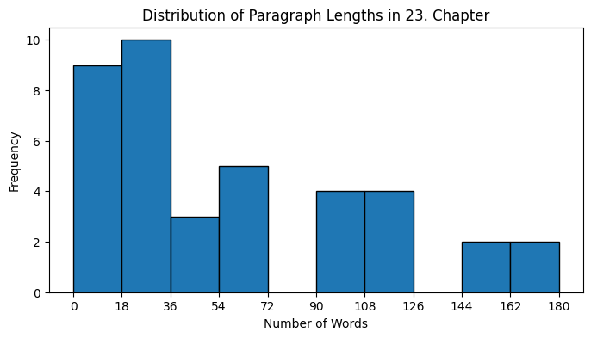

**Chapter XXIV**

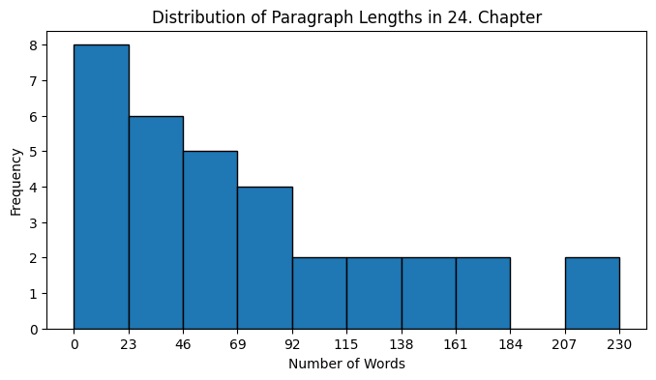

**Chapter XXV**

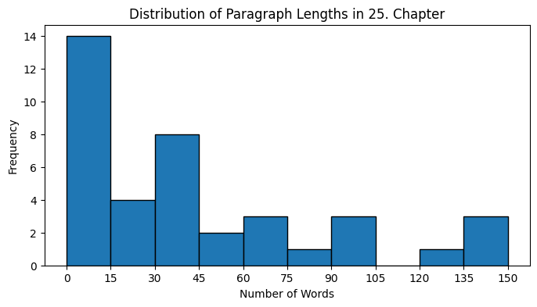

**Chapter XXVI**

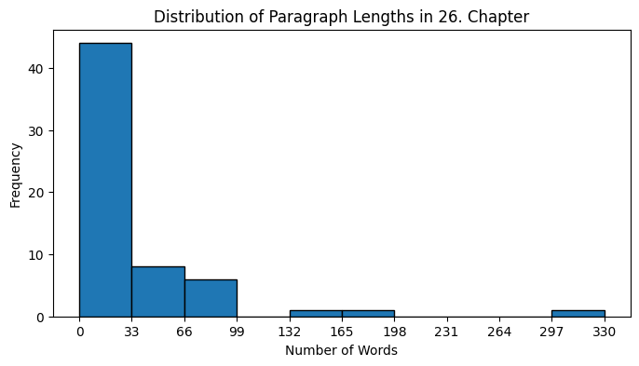

**Chapter XXVII**

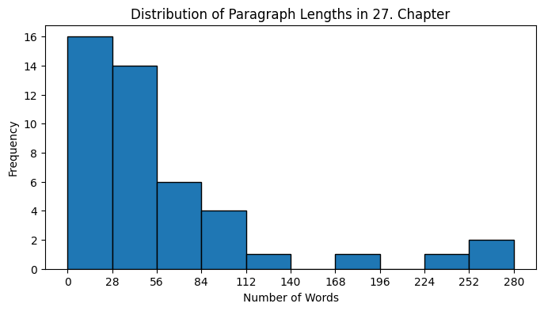

**Chapter XXVIII**

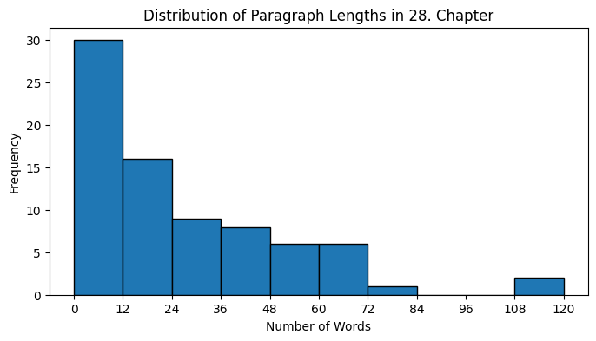

**Chapter XXIX**

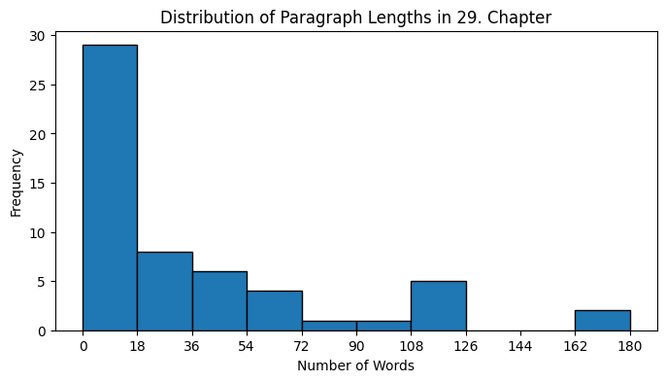

**Chapter XXX**

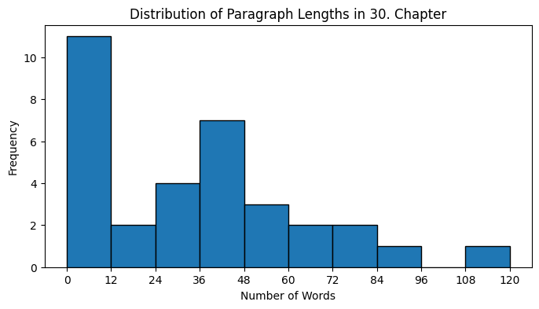

**Chapter XXXI**

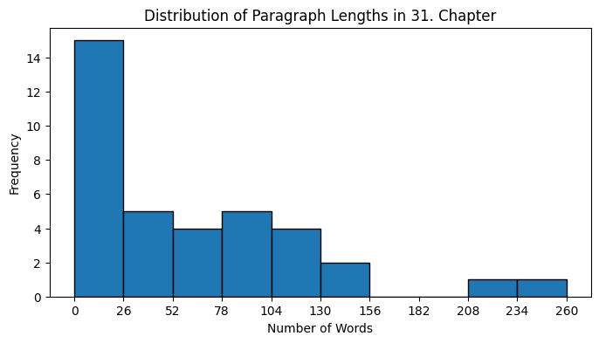

**Chapter XXXII**

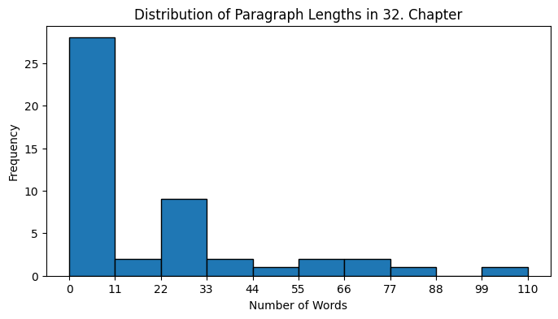

**Summary Page**

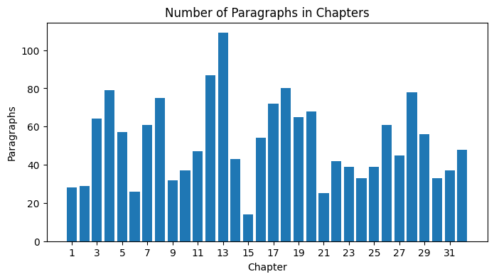

|  |  |  |  |  |  |  |
| --- | --- | --- | --- | --- | --- | --- |
| **Min Words in Paraghraph** | **Max Words in Paragraph** | **Total Number of Paragraphs** | **Avg. Number of Paragraphs in Chapters** | **Avg. Number of Words in Paragraphs** | **Total number of words** | **Avg. Number of Words in Chapters** |
| 1 | 334 | 1663 | 51 | 49 | 81918 | 2559 |