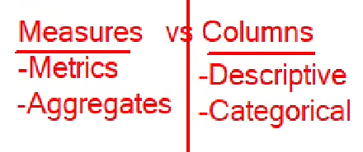

**Different types for different data.**

* Dedicated **calendar** table is needed when we have some tables with date related data and want to use each of them.