Software Requirements Specification (SRS)

# 1. Introduction

This document combines the requirements for both the agent-based ticketing app and supervisor/admin dashboard. It describes the functional and non-functional requirements for the Bus Ticketing System, which includes bus registration, ticket booking, queue handling, printing, and system-wide monitoring.

# 2. Overall Description

## 2.1 Product Perspective

A hybrid system including an Android-based Agent App and a web-based Admin/Supervisor dashboard. Agents use the mobile app to register buses, book passengers, and print tickets and queue slips. Admins and Supervisors use the dashboard to configure, monitor, and analyze operations.

## 2.2 Product Functions

The system includes the following major functions:  
- Agent login and ticketing workflow  
- Manual bus registration and queueing  
- Passenger seat assignment and printing  
- Supervisor dashboard for real-time monitoring  
- Admin control panel for configuration and reporting

## 2.3 User Characteristics

Agents: Basic smartphone and printer operation skills  
Supervisors: Familiar with web dashboards and analytics  
Admins: Full system access, technical understanding of operations

## 2.4 Constraints

Android-only mobile interface for agents; web dashboard for admins and supervisors  
ESC/POS-compatible Bluetooth thermal printer support  
Each agent is assigned to a fixed station and destination

# 3. Functional Requirements

* FR1: Admin can register Agents and Supervisors.
* FR2: Agent can log in using secure credentials.
* FR3: Agent can register a bus with number and capacity.
* FR4: System assigns queue number based on route and waiting buses.
* FR5: Agent can view queue for their assigned route. (Currently our system support assign Agents for departure Station, it should also support Agent with Specific Destination)
* FR6: Agent can book tickets with automatic seat assignment.
* FR7: Ticket and queue slip printing is available for agents.
* FR8: Supervisor can log in and access a live dashboard. (it can be one of the Operator staff that our system support).
* FR9: Supervisor can monitor agent activity, bus movement, and schedules.
* FR10: Admin and Supervisor can view system-wide analytics and reports.

# 4. Non-Functional Requirements

* NFR1: Agent app must support offline mode with syncing. (Very High Priority)
* NFR2: Support ESC/POS-compatible thermal printers (58mm or 80mm).
* NFR3: Backend response time must be < 2 seconds.
* NFR4: Data integrity must be preserved under concurrent actions.
* NFR5: Dashboard should update in near real-time for supervisors.
* NFR6: Communications should be encrypted using HTTPS.
* NFR7: Local Language Support

# 5. Use Case Diagram

The following diagram illustrates the main actors and their interactions with the system

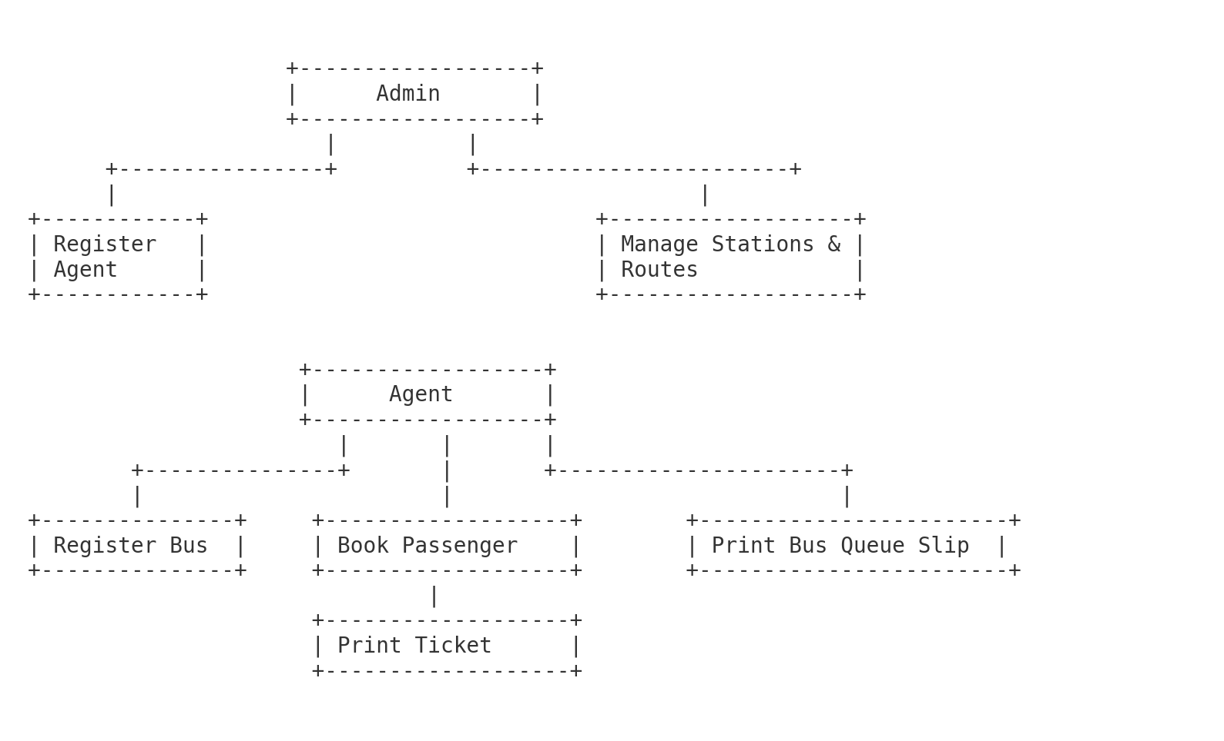

# 

**🎭 ACTOR: Admin**

**🧾 Use Cases:**

1. **Login** – Authenticate securely
2. **Register Agent** – Add new station-level users
3. **Register Supervisor** – Add oversight personnel
4. **Manage Stations & Routes** – Define and maintain transportation routes
5. **View System Reports** – Access summaries, logs, analytics
6. **Configure System Settings** – Set global app/system preferences

**🎭 ACTOR: Agent**

**🧾 Use Cases:**

1. **Login** – Secure access to agent panel
2. **Register Available Bus** – Manually add vehicle to queue
3. **View Bus Queue** – Check current buses awaiting dispatch
4. **Book Passenger Ticket** – Assign passengers and seats
5. **Print Ticket** – Generate physical passenger slip
6. **Print Queue Slip** – Give driver physical queue information

**🎭 ACTOR: Supervisor**

**🧾 Use Cases:**

1. **Login** – Secure dashboard access
2. **View Dashboard** – Overview of all stations, agents, routes
3. **Monitor Bus Queues** – Check which buses are where, in what order
4. **Monitor Agent Activity** – Track booking rates, recent actions
5. **Access Reports** – View analytics by route, station, agent
6. **View Schedules** – Access planned and live bus movements