https://github.com/ginomartelli/Wireless-Coverage-Prediction readme pas a jour

ajouter azimuth ? voir ce qu’il manque dans parser.py par rapport à l’api

api : https://api.lpwanmapper.com/apidocs/#/Auth/post_login

previous studies and method
https://pmc.ncbi.nlm.nih.gov/articles/PMC11360655/
https://arxiv.org/abs/1505.07062
https://ieeexplore.ieee.org/document/10007850
https://ieeexplore.ieee.org/document/9779262
https://ieeexplore.ieee.org/document/10574396
https://ieeexplore.ieee.org/document/9714331

overleaf : https://www.overleaf.com/5645656845dwrbgmxzkbck#dbf7c8

todo : https://docs.google.com/spreadsheets/d/1hss_oUUUP1r3d4MA8pTS3w_L92m9-wUM-oP_nc6zV4I/edit?usp=sharing

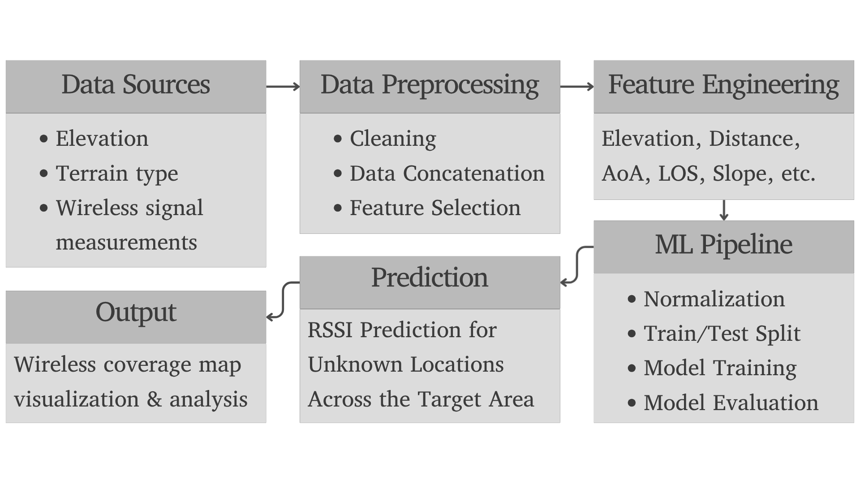

https://github.com/ginomartelli/Wireless-Coverage-Prediction

