MacBook M5 Cybersecurity Lab Setup

📌 Project Overview
This project documents the setup of a dedicated cybersecurity practice environment on an Apple Silicon MacBook Air M5, using UTM to run Kali Linux.
The goal was to build a reliable, repeatable lab on an ARM-based Mac where network discovery, traffic analysis, vulnerability assessment and other security exercises can be practised in a controlled environment.
The lab uses a private virtual network with a defined IPv4 range. It is designed to support additional virtual machines as targets are introduced, while keeping lab traffic separate from ordinary home or workplace devices.

🎯 Objectives
The project objectives were to:
- Assess virtualisation options compatible with Apple Silicon.
- Install and configure UTM on macOS.
- Deploy Kali Linux for ARM64 (aarch64) as a virtual machine.
- Configure a private virtual network for the lab.
- Assign and verify a consistent IPv4 address for Kali Linux.
- Test gateway access, internet connectivity and DNS resolution.
- Establish a clean recovery point before practical exercises.
- Record the configuration, decisions, issues and troubleshooting steps.
- Prepare a foundation for future network-security and penetration-testing exercises.

🛡️ Purpose of the Lab
The lab provides an isolated environment for learning and authorised security testing from a MacBook M5. It allows tools to be tested without using unauthorised external systems.
Planned uses include:
- Network discovery and reconnaissance
- Port scanning and service enumeration
- Vulnerability assessment
- Packet capture and traffic analysis
- Web application security testing
- Controlled exploitation practice
- Security-tool installation and experimentation

🏗️ Lab Architecture
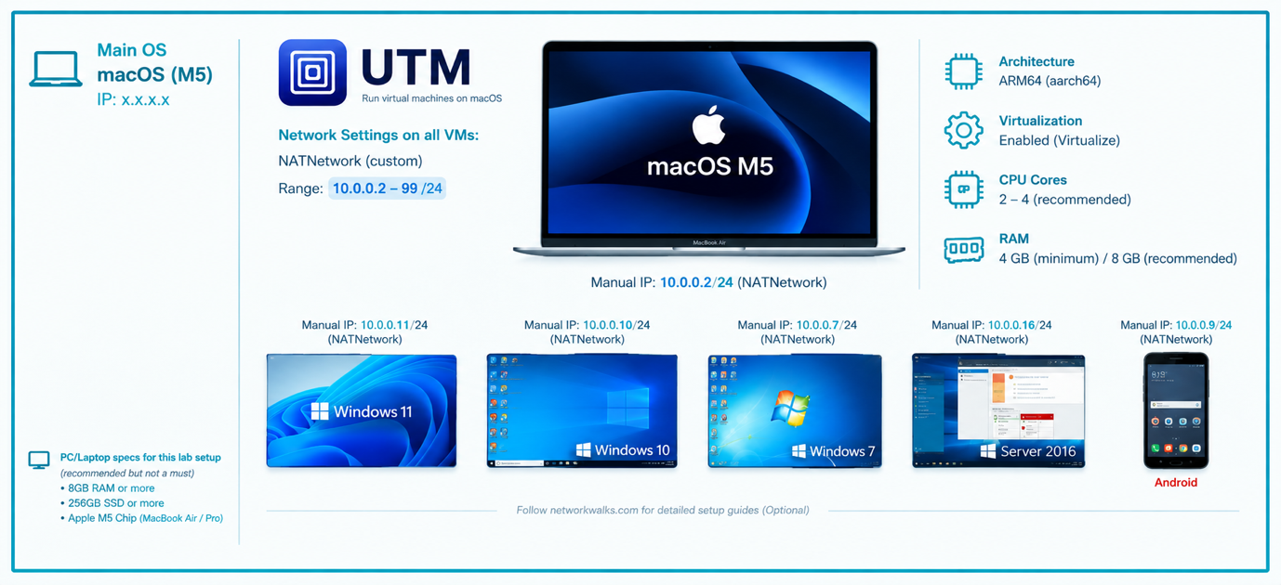
The MacBook acts as the host system. UTM provides the virtualisation layer, and Kali Linux runs as an ARM64 guest. Additional lab machines can be attached to the same virtual network when required.

⚙️ Lab Configuration
🧩 Component | ⚙️ Configuration
🖥️ Host OS | macOS (Golden Gate)
🧠 Host RAM | 16gb ram
⚡ Processor | Apple M5 (ARM64)
🧰 Virtualisation | UTM / QEMU
🐉 Security OS | Kali Linux ARM64 (aarch64)
🧠 Kali RAM | 6048 mb
🌐 Virtual Network | UTM custom private network
📡 Network Address | 10.0.0.0/24
🐧 Kali IP Address | 10.0.0.2/24
🚪 Default Gateway | 10.0.0.1 (configured example)
🌍 DNS Server | 8.8.8.8 (configured example)
🔮 Future VM Range | 10.0.0.3–10.0.0.99

🪜 Lab Setup Procedure

Step 1. Confirm Apple Silicon compatibility
The host is a MacBook Air with an Apple M5 processor. Because Apple Silicon uses ARM64 architecture, the virtual machine must use an ARM-compatible operating system image and a virtualisation method supported by the Mac.
Host architecture: Apple Silicon (ARM64)

Step 2. Test the virtualisation options
VirtualBox was considered first, but the Kali VM could not be started in the intended configuration. The attempt produced an architecture compatibility error indicating that an x86 guest was not supported on the ARM host. Rather than force an unsuitable configuration, UTM was selected as the alternative.

Step 3. Install UTM and configure the virtual network
UTM was installed and used to create the Kali virtual machine. The network was configured as a private custom network so that lab machines can use the same address range.
Network: Custom private network | IPv4 range: 10.0.0.0/24 | DHCP/address pool: 10.0.0.2–10.0.0.99 | Gateway: 10.0.0.1
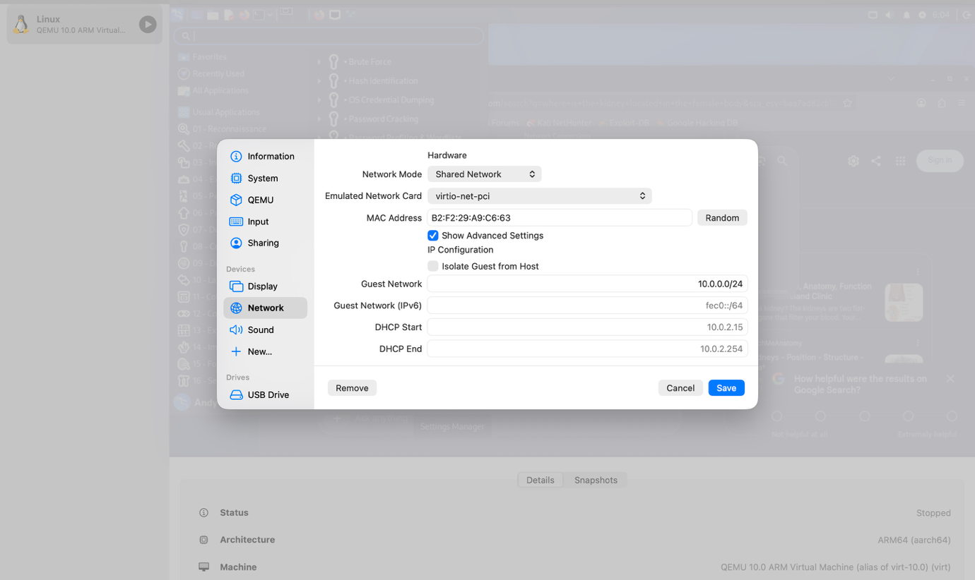
A shared lab subnet gives participating virtual machines a common network on which they can communicate. The exact UTM networking mode matters: Shared Network uses macOS virtual networking, while an emulated network uses a different backend. The selected mode and its addressing must be consistent across the VMs.
This design provides a starting point for adding target systems and testing communication between machines. Only attach systems intended for the lab.

Step 4. Create the Kali Linux virtual machine
Kali Linux was installed in UTM using an ARM64-compatible image. The VM was configured for virtualisation on Apple Silicon rather than x86 emulation.
Key VM settings:
Architecture: ARM64 (aarch64)
Virtualisation: Virtualize (where supported)
Network: Connect to the configured lab network
Machine and network devices: Use UTM/QEMU-compatible defaults unless a lab requirement calls for a change
Resources assigned to the VM:
Memory: 6048 MB

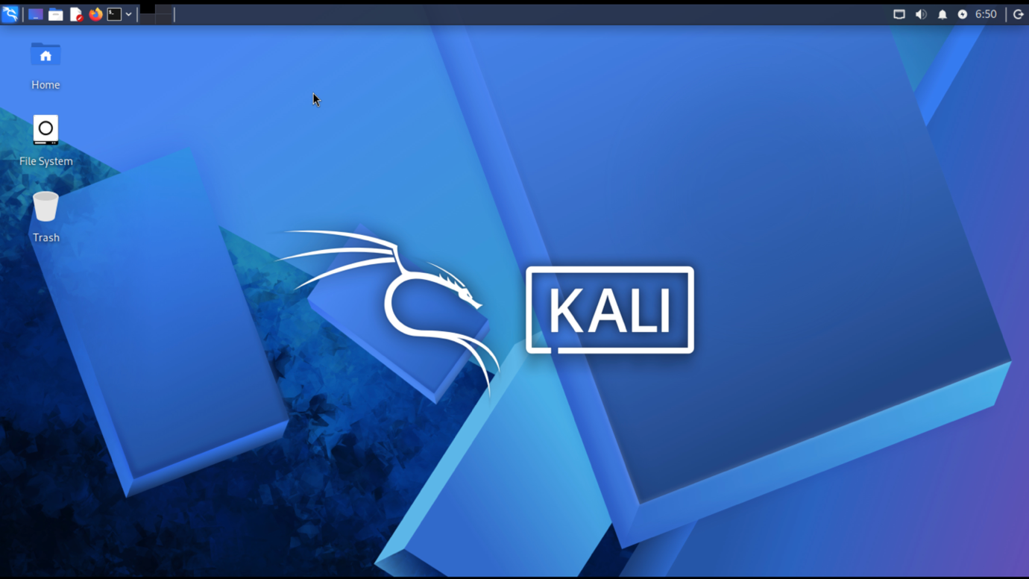
A shared directory can be configured in UTM when files need to move between macOS and Kali. Use it only for required lab files and avoid exposing sensitive host folders unnecessarily.

Step 5. Configure Kali's IPv4 settings
The Kali network connection was reviewed through NetworkManager. A consistent address was configured so the VM can be identified reliably during lab exercises.
Example lab addressing:
Kali IP address: 10.0.0.2
Subnet mask: 255.255.255.0 (/24)
Gateway: 10.0.0.1
DNS: 8.8.8.8 (or the DNS service provided by the network)
A stable address makes it easier to identify Kali in scan results, document traffic and configure future target machines. Confirm that the chosen address is not already in use and is valid for the selected UTM network.
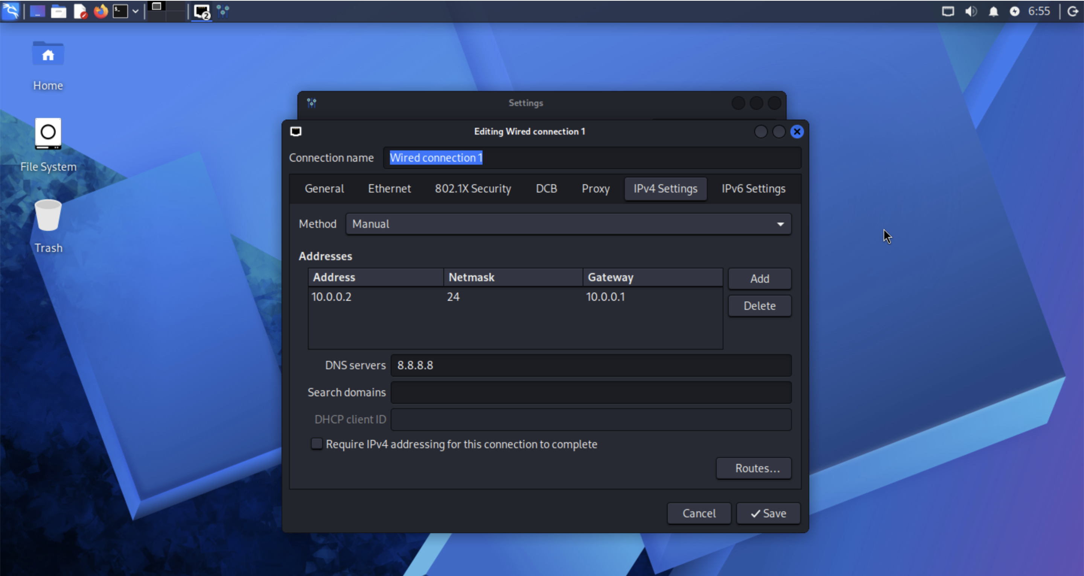

Step 6. Create a clean UTM recovery point
Once Kali is installed and its network configuration has been tested, create a clean recovery point using UTM's supported snapshot or backup approach for the VM.
Suggested name:
Kali - Clean Install and Network Baseline
The baseline should represent a working installation before tools, test data or potentially disruptive changes are introduced.
A known-good recovery point makes it easier to return to a consistent state after experiments. Confirm that the snapshot or backup can be restored before relying on it.
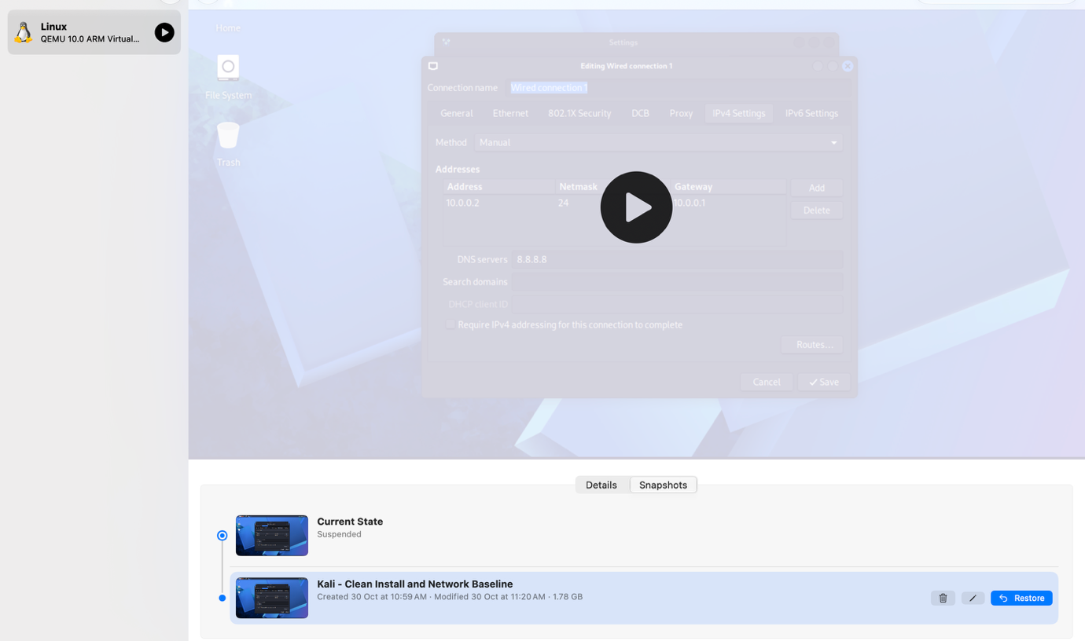

Lab Verification
✅ Test | 🧾 Command | 🎯 Expected result
Check Kali address | ip -br addr | Kali shows the intended IPv4 address
Check default route | ip route | Default route uses the configured gateway
Test gateway | ping -c 4 10.0.0.1 | Replies from the configured gateway
Test internet reachability | ping -c 4 8.8.8.8 | Replies if outbound access is enabled
Test DNS resolution | getent hosts kali.org | A resolved address is returned
Check Nmap | nmap --version | Installed Nmap version is displayed

Record the actual results after running each check. The examples below describe the expected checks, not a claim that every test has already passed.
Kali address:
10.0.0.2/24 (example; verify with ip -br addr)

Configured gateway:
10.0.0.1 (verify with ip route)

DNS resolver:
8.8.8.8 (verify with resolvectl status or NetworkManager)

Problems Encountered and Solutions
The main challenge was adapting a conventional virtual-machine lab workflow to an Apple Silicon Mac. The issues below document the decisions and checks used to make the environment workable.

Problem 1. VirtualBox guest architecture incompatibility
The initial VirtualBox approach did not work with the x86 Kali virtual machine on the ARM-based MacBook M5. The VM returned an architecture error stating that the x86 platform was not supported on the ARM host.
Resolution:
Use an ARM64 (aarch64) Kali image and run it through UTM's virtualisation support. Avoid treating x86 emulation and ARM virtualisation as interchangeable; choose an image that matches the host architecture where possible.
UTM was adopted as the practical alternative, allowing the lab to proceed without relying on the incompatible VirtualBox setup.
Before creating a VM, check the image architecture and confirm whether UTM is set to Virtualize or Emulate. Virtualize is preferable for a compatible ARM64 guest; emulation is generally slower.

Problem 2. UTM shared-network interface failed to start
When configuring the custom network, QEMU reported that it could not create the vmnet interface. The error included an invalid-looking address range and subnet mask, indicating that the network parameters were inconsistent.
Resolution:
- Review the custom network's address range and use a private /24 subnet for this lab.
- Set the network to 10.0.0.0/24.
- Use a valid host range within that subnet, such as 10.0.0.2–10.0.0.99.
- Keep the gateway within the same subnet, for example 10.0.0.1.
- Save the corrected network settings and fully shut down and restart the VM.
- The network started successfully after correcting the subnet configuration. If vmnet errors return, check UTM's network mode and macOS permissions rather than changing Kali's IP settings alone.
Do not use 10.0.0.0/2. The /2 prefix describes an exceptionally large network and does not match a small private lab. A /24 prefix is appropriate for this setup.

WHAT I Learned
Building this lab on an Apple Silicon Mac required more than following a standard virtual-machine installation guide. It involved identifying a platform limitation, selecting a compatible tool, and validating the network from both the host and guest sides.
The project strengthened several practical skills:

1. Choosing the right virtualisation approach
I learned to check CPU architecture before importing a virtual machine. An x86 guest image is not automatically compatible with an ARM host. Selecting an ARM64 Kali image and using UTM's virtualisation support was essential to getting the lab running.
The experience also reinforced the difference between virtualisation and emulation: matching the guest architecture to the host can provide a more suitable and efficient setup.
2. Building a segmented virtual lab network

I gained practical experience defining a private IPv4 subnet, setting a usable host range and gateway, and understanding how UTM's network mode affects communication between virtual machines and access to external networks.
I learned how VirtualBox virtual network adapters connect virtual machines to different types of networks and how network configuration affects communication between machines.

3. Configuring and troubleshooting IPv4
I practised checking interface addresses, subnet masks, default routes and DNS settings in Kali. I also learned to distinguish a guest operating-system configuration problem from a virtual network problem managed by UTM and macOS.

4. VM Snapshots
4. Planning for safe experimentation and recovery
A clean baseline provides a controlled starting point for future testing. Recovery planning reduces setup time and makes it easier to repeat exercises consistently.

5. Troubleshooting across host and guest systems
The VirtualBox compatibility issue and the UTM vmnet configuration error required separate investigations. This improved my ability to isolate the layer causing a problem instead of changing unrelated settings. Clear notes, commands and verification results also make the environment easier to maintain and reproduce.

Security and Ethical Use
This lab is intended for education and authorised testing. Keep target machines on the intended lab network, verify network boundaries before scanning, and obtain permission before testing any system outside the environment.

Tools and Resources
- UTM: https://mac.getutm.app/https://7-zip.org/download.html
- Kali Linux downloads (choose an ARM64 image): https://www.kali.org/get-kali/https://virtualbox.org/wiki/Downloads
- Apple Silicon / macOS virtualisation guidance: https://docs.getutm.app/https://kali.org/get-kali

Project Author
Andy Dela Quarshie Wright
SOC Level 1 Analyst
LinkedIn: https://www.linkedin.com/in/andywright-security

📌 Project Information
Project: Program Name: Cybersecurity at Networkwalks | Week: 01 | Project: Cybersecurity & Pentesting Lab Setup | Repository: GitHub

