The Shoe Mart Catalog Category Structure

# Overview

The Catalog structure of the website is rather complicated. There are 3 major functionalities associated with the catalog category structure

1. Catalog Category: used for Category/Product association and Layered Navigation

**As colored in red**

1. Menu Category: use for Top Menu/Sub-menu Navigation

**As colored in blue**

1. Brand Category: use for Brand Based Navigation

**As colored in green**

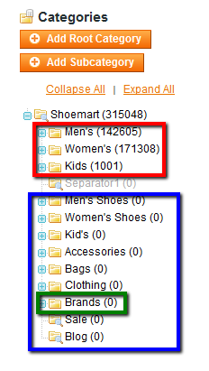

# Catalog Category

To begin with the most intuitive way to manage Magento categories is to treat them as a category tree corresponding to the warehouse category tree.

For example, the product “Men's Vitorio Black” (SKU=STA_m_VITORIO) belongs to the “Bicycle-Toe” category. The “Bicycle-Toe” falls into this category tree structure:

Men’s>>Shoes>>Dress Shoes>>Monk Strap>>Bicycle-Toes

The “Men's Vitorio Black” should also belongs to all parent categories of the “Bicycle-Toe” category.

This structure is very important for proper product/category association and layered navigation.

[Notice]: products only need to be associated with Catalog Categories. There is no need to associate products with Top Menu Categories or Brand Categories. The association between the other 2 types of category is logic-based and automatically processed in the store.

In addition, the 3 root level catalog categories have special significance. They support “Brand based Navigation”, i.e. each brand page will perform a look up through each Catalog Category tree and get product counts etc.

Catalog categories should not be part of the Navigation Menu. Only the root level Catalog categories (Men's, Women's and Kid's) should be marked as “Is Catalog Root”. This is a screen shot of the “General Information” tab of the category.

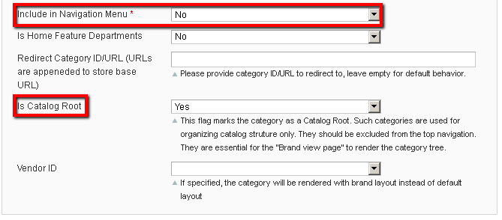

# Layered Navigation

Layered Navigation is based on Catalog categories. Once products and product attributes are properly configured, under the “Display Settings” tab of a Catalog category, the “Is Anchor” flag should be set to “Yes” to allow layered navigation view.

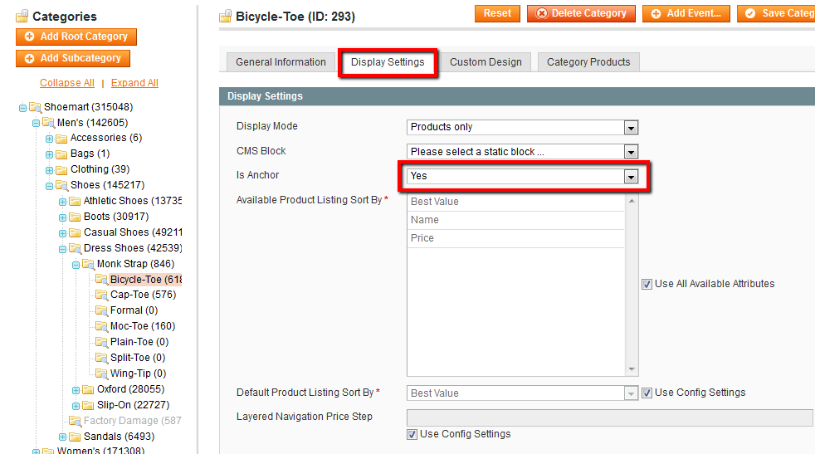

# Category Top Banner

If an image is uploaded to a category, the image will automatically be used as top banner. In addition, if a thumbnail image is also updated, it would be displayed to the left of the top banner.

The merchant logo should be uploaded as the thumbnail image.

# Menu Category

Menu Categories are created for Top Menu Navigation purpose only.

No product need to be associated with the Menu Category.

Each Menu Category should point to a Catalog Category that contains products.

For example, the "Accessory >> Men's >> Belt" is a category in the top menu, it should point to the Catalog Category "Men's >> Accessory >> Belt", i.e. id 187 as shown in the screen shot below.

Please note the redirect also takes valid URL string, relative to the store base URL.

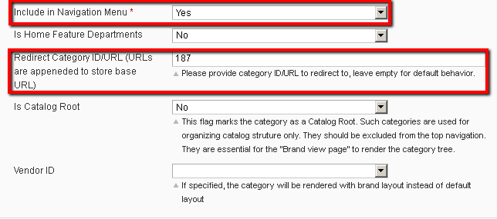

# Brand Category

Brand Categories provides special landing pages for each brand.

No product need to be associated with the Menu Category.

To associate a Brand Category with a specify vendor, please select vendor for the dropdown list:

Here is an example of the Bacco Bucci Brand category

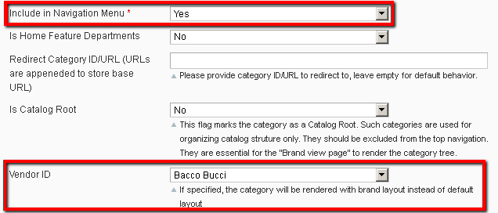

In addition, please also upload the banner image to the image field and the logo to the thumbnail field

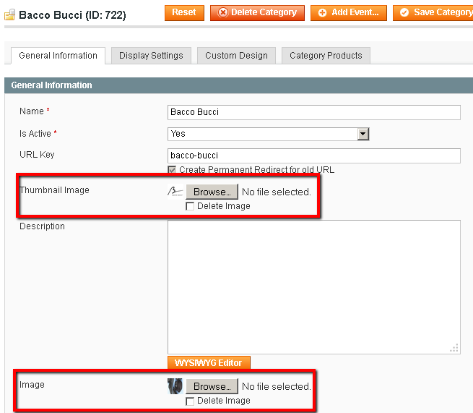

In addition, the left column of the brand page can be configured using a static block. To specify a static block, put the following script in the "Custom Design >> Custom Design" field:

<reference name="brand.view.left">

<block type="cms/block" name="brand.view.left.static.block" >

<action method="setBlockId"><block_id>**brand_left_block_bacco_bucci**</block_id></action>

</block>

</reference>

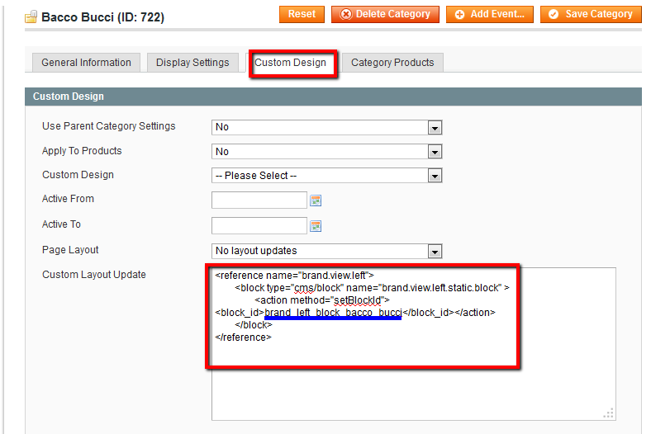

The block_id should corresponds to the same block under “CMS>>Static Blocks”

